Supplement Table S1. ANOVA results comparing differences between the first and second halves of the treatment when food appears in just two cells. Since ants/cell is measured proportionally, the summed proportions must be identical and therefore the effect of Half is zero. However, the lack of any significant interaction effects with this variable is consistent with ant search strategy not changing over time.
Factor | Linear | Uniform | Modular
Column | F_{1,62} = 0.722, p = 0.3988 | F_{1,62} = 0.156, p = 0.6943 | F_{1,62} = 11.53, p = 0.0012
Row | F_{2,62} = 7.752, p = 0.0010 | F_{2,62} = 7.230, p = 0.0015 | F_{2,62} = 3.986, p = 0.0235
Column x Row | F_{2,62} = 9.351, p = 0.0003 | F_{2,62} = 8.706, p = 0.0005 | F_{2,62} = 4.971, p = 0.0099
Half x Column | F_{1,62} = 0.282, p = 0.5974 | F_{1,62} = 0.318, p = 0.5746 | F_{1,62} = 0.061, p = 0.8051
Half x Row | F_{2,62} = 1.693, p = 0.1924 | F_{2,62} = 0.095, p = 0.9093 | F_{2,62} = 2.456, p = 0.0941

Supplement Figure S1. Experimental set up. The plastic boxes had 24 cells, so that two nests (residing in the blue boxes) could be tested in the same box. Connections between cells in the plastic boxes were created by melting holes in the dividers, located as indicated in Figure 1. Application of fluon kept the ants from escaping from either the nest box or foraging arena.

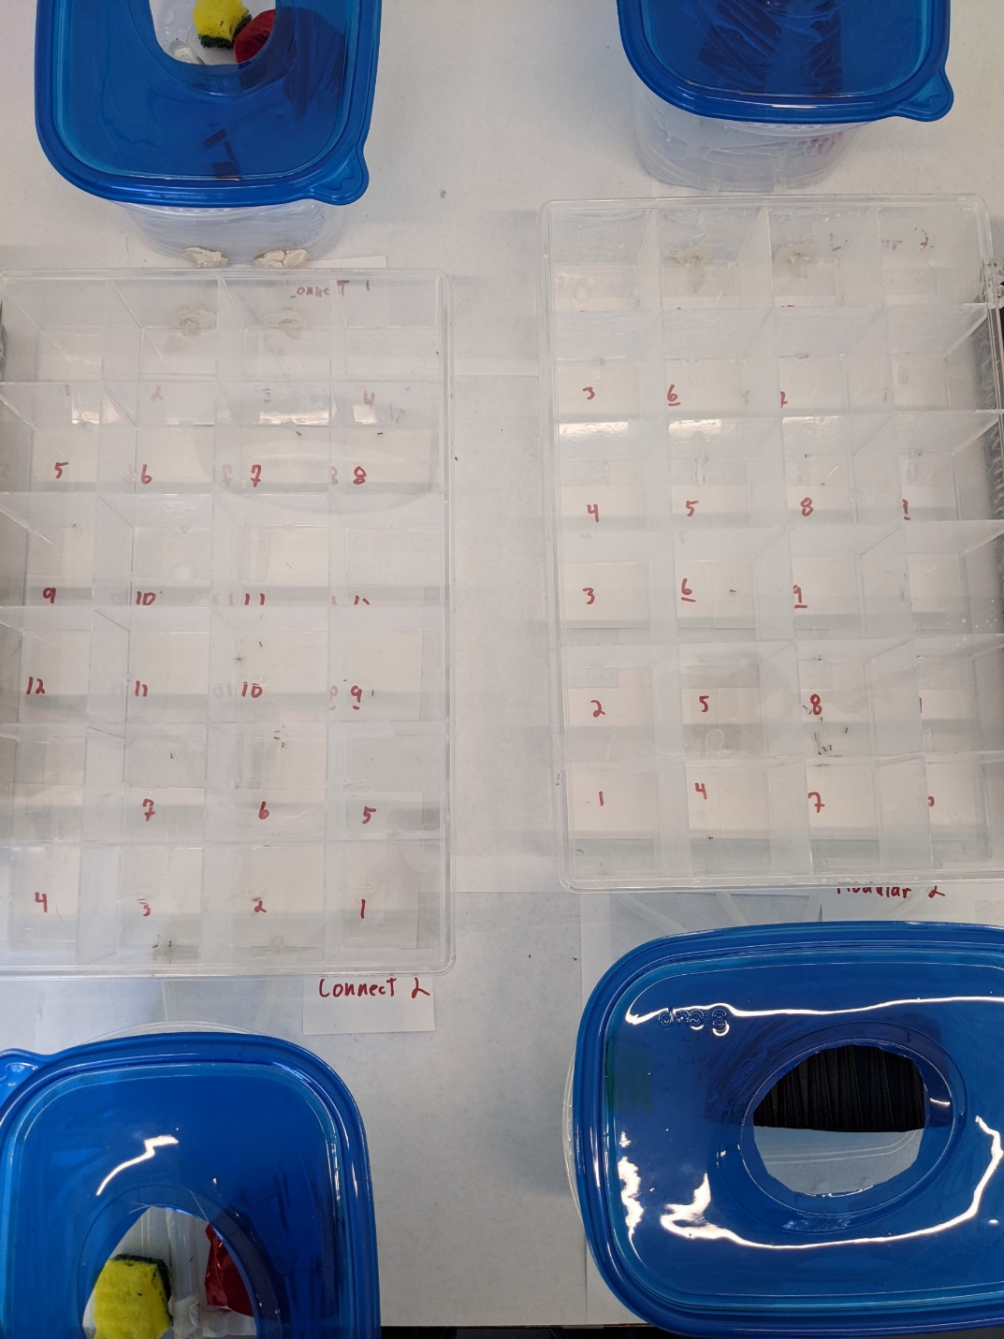

Figure S2. Mean proportional distributions (±SD) of ants by column and row. Blue = Linear network; Green = Uniform; Grey = Modular. Orange crosses are means of agents from simulations.
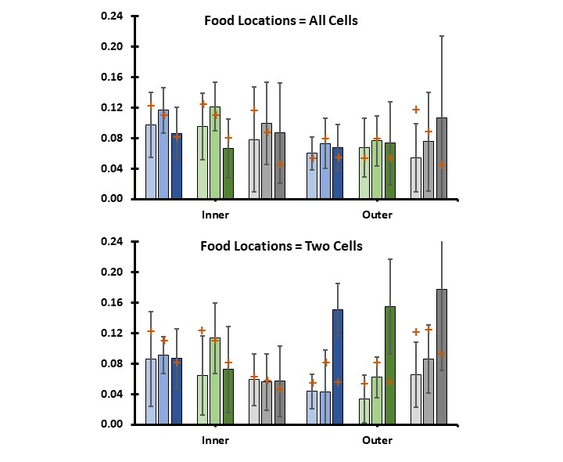
Figure S3. Agent loci values (from 80 agents) at the end of simulations. Loci: f = follow; d = distance; b = backtrack; a = activate; s = search; and r = recruit. f and d can vary between -1 and 1. The other four cannot be less than zero.
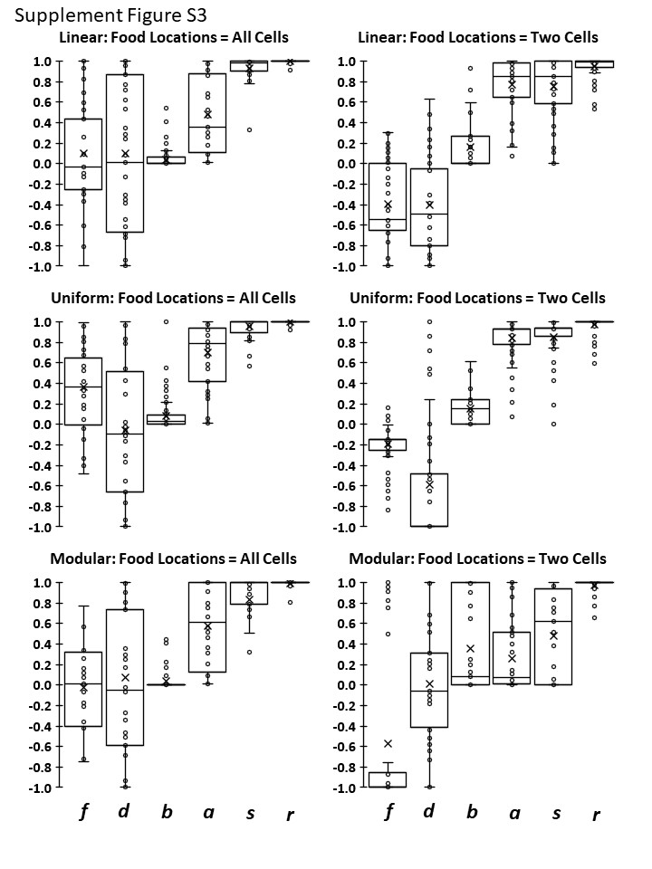
Figure S5. Proportional distribution of simulated agents in network cells when food could appear in any cell. Each position reflects the mean of two cells with identical distance from nest and number of connections to other cells.
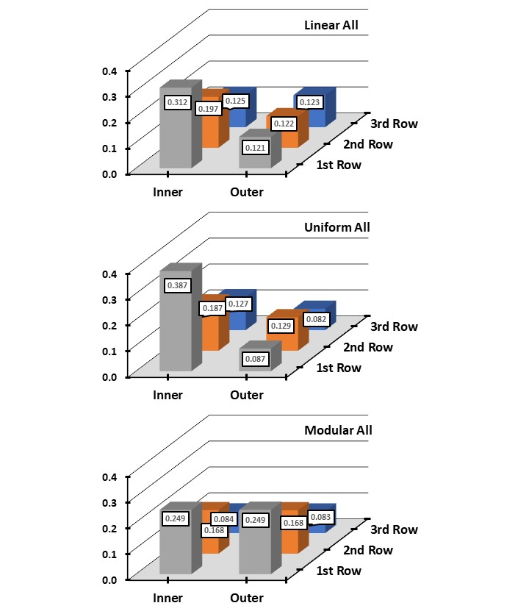
Figure S6. Proportional distribution of simulated agents in network cells when food could appear only in the two most distant cells. Each position reflects the mean of two cells with identical distance from nest and number of connections to other cells.
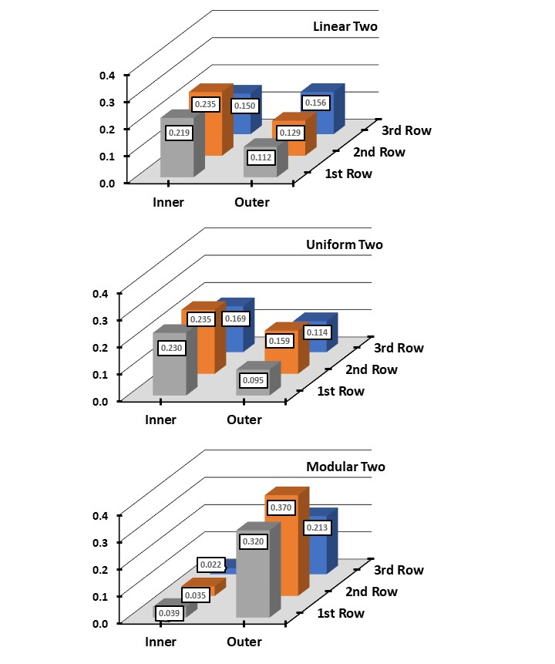
Figure S7. Proportional distribution of ants in network cells when food could appear in any cell. Each position reflects the mean of two cells with identical distance from nest and number of connections to other cells.
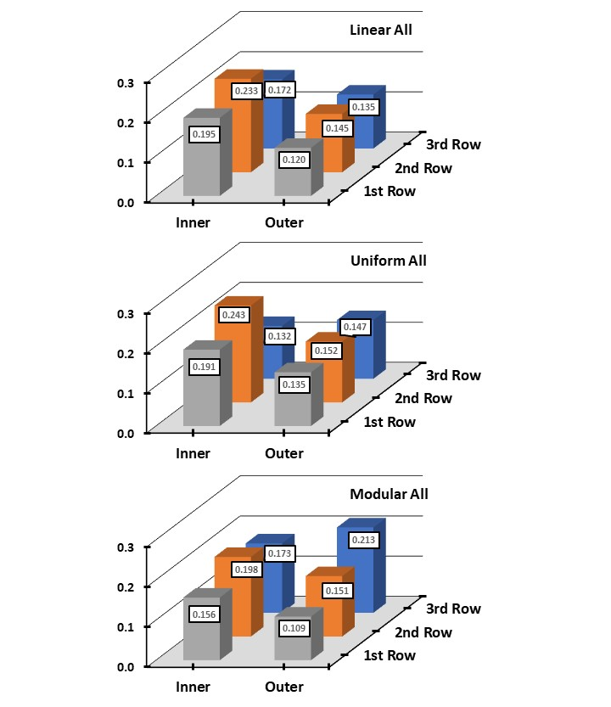
Figure S8. Proportional distribution of ants in network cells when food could appear only in the two most distant cells. Each position reflects the mean of two cells with identical distance from nest and number of connections to other cells.
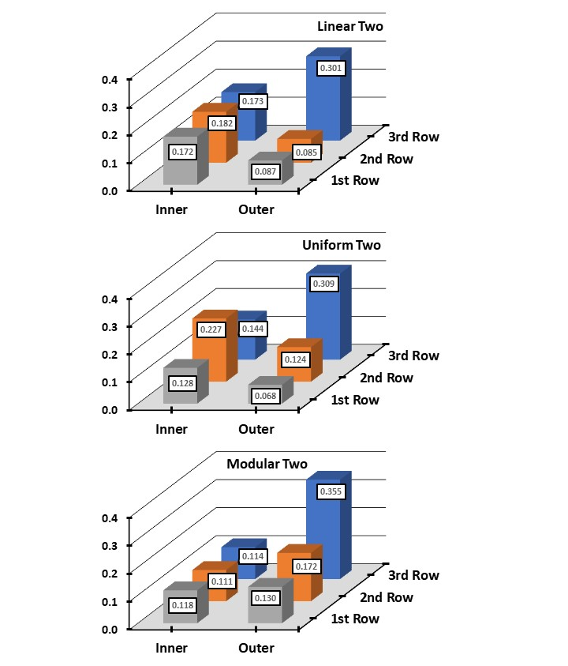
Figure S9. Comparison of cell means (±SD) by row from the first to second half of the treatment where food could only appear in the two most distant cells. There is no significant difference across the halves, indicating that the ants are not learning where the food will appear.
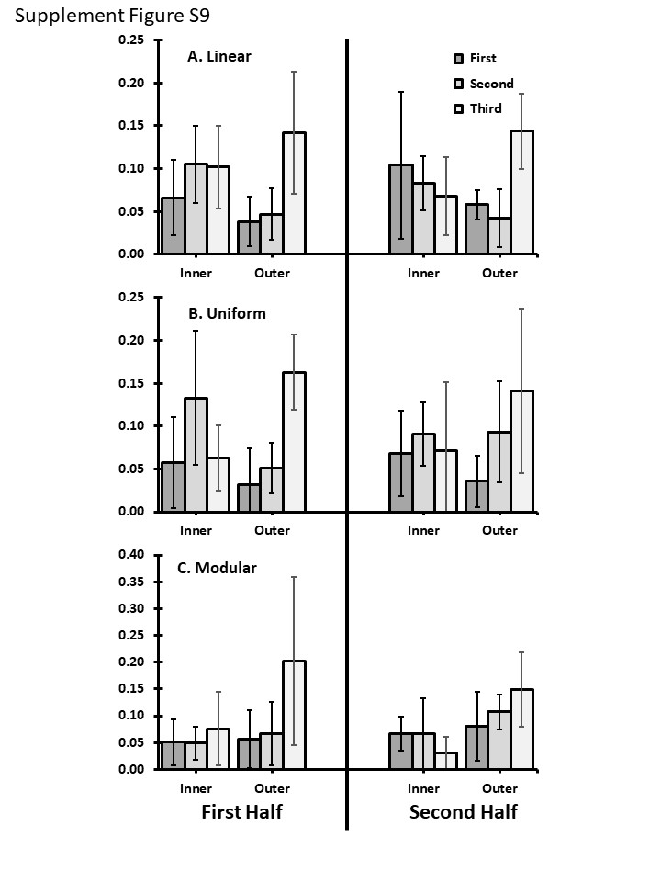
Figure S10. Relationship of the mean number of ants observed searching to how fast, on average, they encounter presented food.
