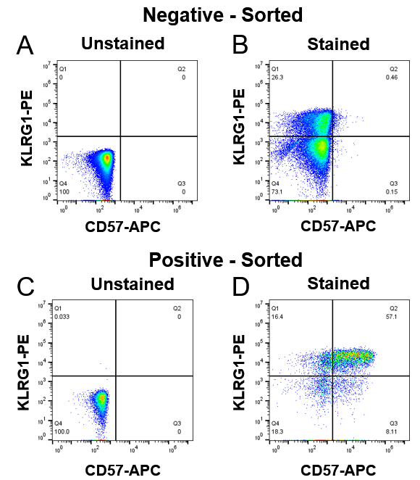

Supplemental Figure 1. Flow cytometry data demonstrating KLRG1 and CD57 expression of T cells based on sorted populations. A) Unstained control of negative sorted CD8⁺ T cells based on CD57 expression. B) Stained sample of negative sorted CD8⁺ T cells. T cells are 26.76% positive for KLRG1 and 0.71% positive for CD57. C) Unstained control of positive CD8⁺ T cells sorted based on CD57 expression. D) Stained sample of s CD57+ sorted CD8⁺ T cells. T cells are 73.5% for KLRG1 and 65.21% positive for CD57.

A B
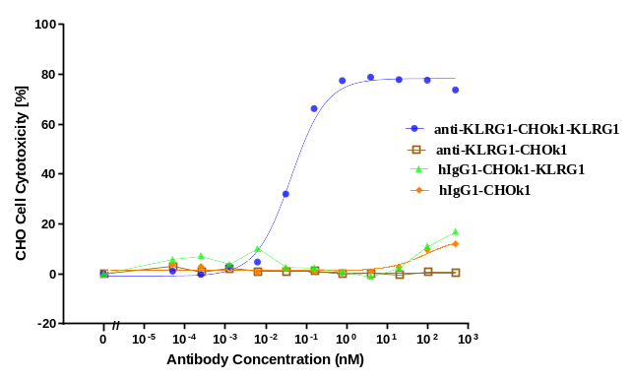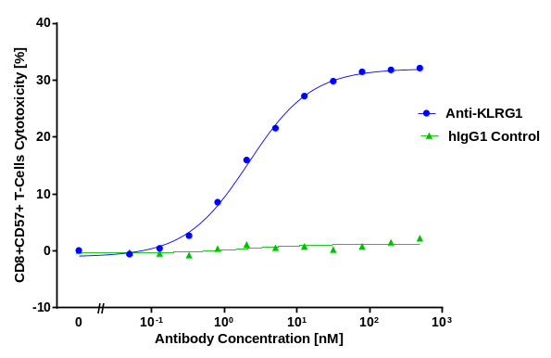

Supplemental Figure 2. Anti-KLRG1 Antibody-dependent Cellular Cytotoxicity of Human CD57+CD8+ T Cells and CHO-K1 expressing KLRG1. The ability of the anti-KLRG1 Ab to induce ADCC of target cells CHO-K1 expressing KLRG1 (3A) or CD57⁺CD8⁺ T Cells (3B) was evaluated in ADCC assays with human NK cells as effector cells. Target cells were labelled with a fluorescent tracker and incubated for 4 hours at 37°C with NK cells (1:5 CHO:NK cell ratio and 1:10 CD57⁺CD8⁺ T : NK cell ratio from the same donor) with a-KLRG1 or control antibody. Cytotoxicity was measured by flow cytometry in the gated target cell population by the update of SYTOXTM Dead Cell Stain. Anti-KLRG1 induced killing of CD8⁺CD57⁺ T cells with EC₅₀ values of 1.5 ± 0.5 nM n=3 donors. Anti KLRG1 induced killing of CHO-K1-KLRG1 cells with EC₅₀ values of 0.025 ± 0.016 nM n=3. There was no killing by the isotype control antibody or of CHO parental cells by a-KLRG1 Ab.
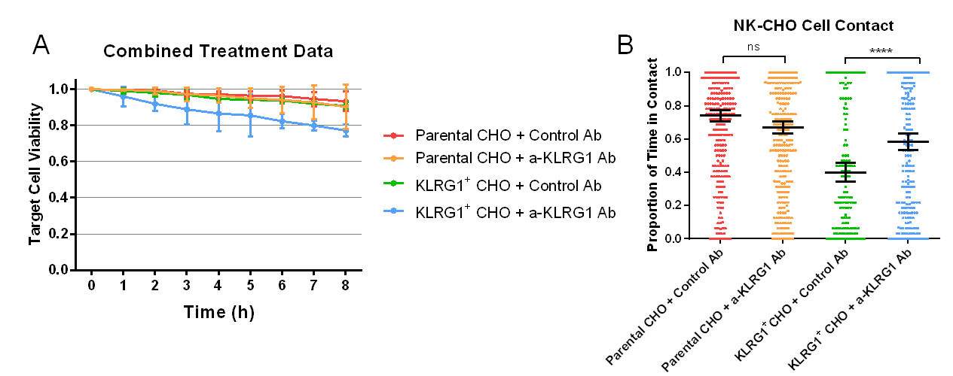
Supplemental Figure 3. Single cell droplet data of CHO cells combined with NK and either control or anti-KLRG1 antibody observed over 8 hours. A) Cytotoxicity data displaying CHO cell killing over time. B) Proportion of CHO cell lifespan in droplets in contact with NK cell(s). N: Parental = 317 cells, KLRG1⁺ = 235 cells.

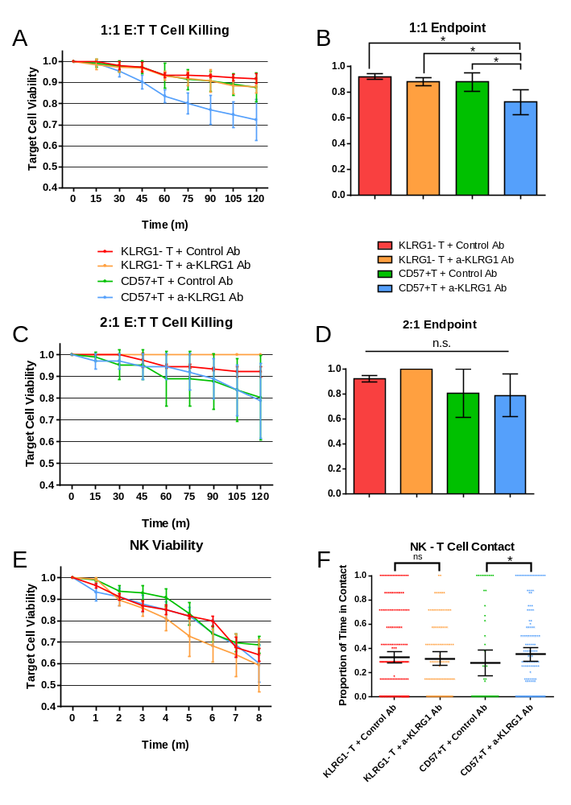
Supplemental Figure 4. Influence of anti-KLRG1 Ab on NK cell cytotoxicity towards T cells and NK cell viability and activity. A) T cell killing in droplets with only 1:1 E:T ratios observed. N: CD57⁺ T + a-KLRG1 Ab = 190, CD57⁺ T + Isotype Control = 153, KRLG1⁻ T + a-KLRG1 Ab = 107, KRLG1⁻ T + Isotype Control = 122 cells. B) Bar graph representation of 1:1 droplet T cell viability at 2-hour endpoint. C) T cell killing in droplets with only 2:1 E:T ratios observed. N: CD57⁺ T + a-KLRG1 Ab = 71, CD57⁺ T + Isotype Control = 49, KRLG1⁻ T + a-KLRG1 Ab = 39, KRLG1⁻ T + Isotype Control = 59 cells. D) Bar graph representation of 2:1 droplet T cell viability at 2-hour endpoint. E) Viability of NK cells co-encapsulated in droplets in each treatment condition. N: CD57⁺ T + a-KLRG1 Ab = , CD57⁺ T + Isotype Control = , KRLG1⁻ T + a-KLRG1 Ab = , KRLG1⁻ T + Isotype Control = cells. G) Scatter plot of proportion of T cell lifespan in contact with NK cells. * = p < 0.05. Error bars based on standard deviation.
Gene Name | Gene Count | Gene Name | Gene Count | Gene Name | Gene Count | Gene Name | Gene Count
EIF4G2 | 6566 | HNRNPD | 881 | TUBA1A | 558 | SP3 | 427
EIF5A | 2872 | SERF2 | 815 | EIF5 | 525 | PUM1 | 407
DDX3X | 2709 | SET | 780 | THRA | 524 | DHX15 | 387
YBX1 | 2583 | UBAP2L | 749 | PPP3CB | 479 | HNRNPM | 380
HNRNPA3 | 2159 | HNRNPU | 713 | ETF1 | 460 | PTP4A2 | 370
TMSB4X | 1937 | EIF1 | 701 | HNRNPR | 455 | MSL1 | 365
HNRNPA2B1 | 1906 | HMGB1 | 650 | SETD5 | 447 | HUWE1 | 348
UBE2D3 | 1733 | ARF6 | 595 | EIF4A2 | 447 | PFN2 | 334
HNRNPK | 1286 | RAB1A | 594 | SF1 | 446 | EIF5AL1 | 334
MBNL1 | 1206 | H2AFZ | 582 | CRK | 444 | USP34 | 333
PRRC2A | 1135 | HNRNPH1 | 580 | CAPRIN1 | 437 | CNOT1 | 330
DDX5 | 1016 | SYNCRIP | 579 | FXR1 | 434 | OAZ2 | 319
QKI | 958

Supplemental Table 1. Gene counts of the top 50 highest expressed genes observed in the calcium-postive sorted NK cell population.

Supplemental Movie 1. Example of single-cell droplet data, demonstrating an NK cell killing a KLRG1⁺ CHO-K1 cell. The CHO cell turns red from the binding of ethidium homodimer to intracellular DNA upon killing of the cell. Video is taken at 20X magnification.

Supplemental Movie 2. Visual demonstration of the Fluorescence Assisted Droplet Sorting (FADS) process. As droplets containing cells with an intracellular calcium increase pass by the laser of the sorting array (left), a fluorescent signal is measured in the software (right). This signal automatically sends an electric impulse back to the sorter, resulting in the active isolation of the corresponding droplet. This can be seen when droplets are pulled to the upper channel, occurring simultaneously to fluorescent signal increases observed in the software.

