Supplementary files
Questionnaire
Patient-rated tennis elbow evaluation (PRTEE:
Patient rated tennis elbow evaluation (PTREE) is a questionnaire used for the evaluation of tennis elbow specifically. In Canada in 1999, the first questionnaire was developed (which only considered the lateral elbow). This questionnaire was called the Patient-rated Forearm Evaluation Questionnaire (PRFEQ). JC MacDermid was the developer of the PRFEQ.It was latter updated and named as PRTEE.The PRTEE measure pain, functional activity of lateral epicondylitis patient. It consists of 15 questions. The first five concern the pain in the elbow and remaining ten questions concern with the function of the elbow. Its validity and reliability checked by (Lale Altan,2009) Turkish version. It’s a valid and reliable tool frequently used for the evaluation of lateral epicondylitis (LE)/ Tennis elbow (TE) patients.
Demographics:
Name: _____________________________ Date:______________
Gender: _________________ Residence of: _____________________
1. Pain in your affected arm
Rate the average amount of pain in your arm over the past week by circling the number that best describes your pain on a scale from 0-10. A zero (0) means that you did not have any pain and a ten (10) means that you had the worst pain imaginable.

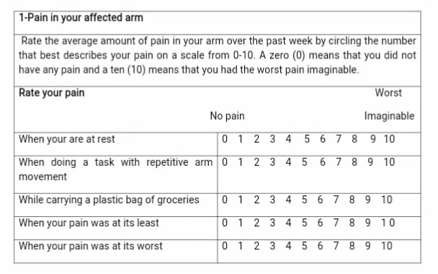

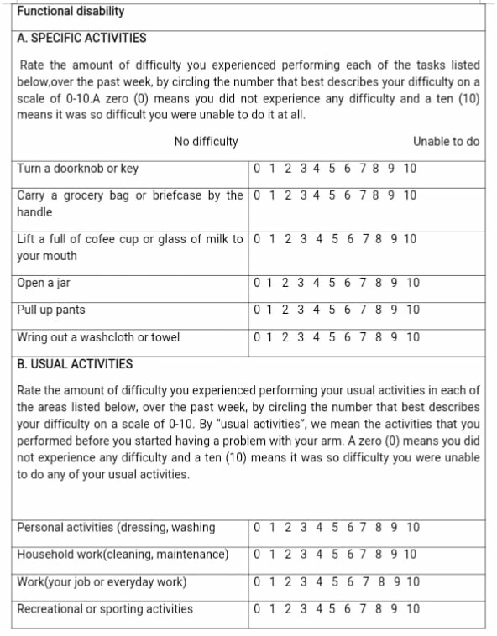

Consent Form (English)

Title: “Prevalence of lateral epicondylitis among in housewives in Lahore: A Cross-sectional Study”

You are invited to participate in a research study conducted by “______” of ________affiliated with “XYZ.”

Undertakings:
- The study has no potential harm and risk associated with participants in this research.
- The data collected will not be disclosed to anyone and will be coded in order to protect your identity.
- You may choose not to participate and withdraw yourself from the study at any time.
- Refusal or withdrawal from the study will not affect your quality of treatment.
- Your agreement to participate indicates that you have read and understood the nature of the study and that all your inquiries concerning the activities have been answered to your satisfaction.
- If you have any questions or concerns about your rights as a research participant, please contact the “Faculty Review Board” or the researcher.
- Any additional information about the study results will be provided to you.
- I have read this consent form and have been given the opportunity to ask questions.
I agree.

Name: _____________________ Date: ______________________

Signature: __________________

STROBE Statement—Checklist of items that should be included in reports of cross-sectional studies
 | Item No | Recommendation | Page  No
Title and abstract | 1 | (a) Indicate the study’s design with a commonly used term in the title or the abstract | 1,2
Title and abstract | 1 | (b) Provide in the abstract an informative and balanced summary of what was done and what was found | 1,2
Introduction
Background/rationale | 2 | Explain the scientific background and rationale for the investigation being reported | 4
Objectives | 3 | State specific objectives, including any prespecified hypotheses | 5
Methods
Study design | 4 | Present key elements of study design early in the paper | 6
Setting | 5 | Describe the setting, locations, and relevant dates, including periods of recruitment, exposure, follow-up, and data collection | 6
Participants | 6 | (a) Give the eligibility criteria, and the sources and methods of selection of participants | 6
Variables | 7 | Clearly define all outcomes, exposures, predictors, potential confounders, and effect modifiers. Give diagnostic criteria, if applicable | 6
Data sources/ measurement | 8* | For each variable of interest, give sources of data and details of methods of assessment (measurement). Describe comparability of assessment methods if there is more than one group | 6
Bias | 9 | Describe any efforts to address potential sources of bias | 6
Study size | 10 | Explain how the study size was arrived at | 6
Quantitative variables | 11 | Explain how quantitative variables were handled in the analyses. If applicable, describe which groupings were chosen and why | 6
Statistical methods | 12 | (a) Describe all statistical methods, including those used to control for confounding | 7
Statistical methods | 12 | (b) Describe any methods used to examine subgroups and interactions | 7
Statistical methods | 12 | (c) Explain how missing data were addressed | 7
Statistical methods | 12 | (d) If applicable, describe analytical methods taking account of sampling strategy | 7
Statistical methods | 12 | (e) Describe any sensitivity analyses | 7
Results
Participants | 13* | (a) Report numbers of individuals at each stage of study—e.g. numbers potentially eligible, examined for eligibility, confirmed eligible, included in the study, completing follow-up, and analyzed | 8
Participants | 13* | (b) Give reasons for non-participation at each stage | 8
Participants | 13* | (c) Consider use of a flow diagram | 8
Descriptive data | 14* | (a) Give characteristics of study participants (eg demographic, clinical, social) and information on exposures and potential confounders | 8
Descriptive data | 14* | (b) Indicate number of participants with missing data for each variable of interest | 8
Outcome data | 15* | Report numbers of outcome events or summary measures | 8
Main results | 16 | (a) Give unadjusted estimates and, if applicable, confounder-adjusted estimates and their precision (eg, 95% confidence interval). Make clear which confounders were adjusted for and why they were included | 9,10
Main results | 16 | (b) Report category boundaries when continuous variables were categorized | 9,10
Main results | 16 | (c) If relevant, consider translating estimates of relative risk into absolute risk for a meaningful time period | 9,10
Other analyses | 17 | Report other analyses done—eg analyses of subgroups and interactions, and sensitivity analyses | 10
Discussion
Key results | 18 | Summaries key results with reference to study objectives | 10
Limitations | 19 | Discuss limitations of the study, taking into account sources of potential bias or imprecision. Discuss both direction and magnitude of any potential bias | 10
Interpretation | 20 | Give a cautious overall interpretation of results considering objectives, limitations, multiplicity of analyses, results from similar studies, and other relevant evidence | 10
Generalizability | 21 | Discuss the generalizability (external validity) of the study results | 10
Other information
Funding | 22 | Give the source of funding and the role of the funders for the present study and, if applicable, for the original study on which the present article is based | 11

*Give information separately for exposed and unexposed groups.

