Supplementary Information

miRNA-microbiome interplay is related to Bos indicus feed efficiency
Priscila S. N. de Oliveira¹, Bruno G. N. Andrade², Tainã F. Cardoso³, Liliane C. Conteville^{3,} Gabriel A. C. Pena³, Wilson Malago-Jr³, Jennifer J. Bruscadin³, Juliana J. Pascoal⁴, Lauro F. Almeida⁵, Luiz A. Josahkian⁵, Henrique T. Ventura⁵, Giovana A. Maciel⁶, Gerson B. Mourão⁷, Luiz L. Coutinho⁷, James Reecy⁸ and Luciana C. A. Regitano^{3*}

Supplementary Figures:
Figure S1. Rarefaction curves of Bacterial 16S samples using the Shannon-Wiener index.
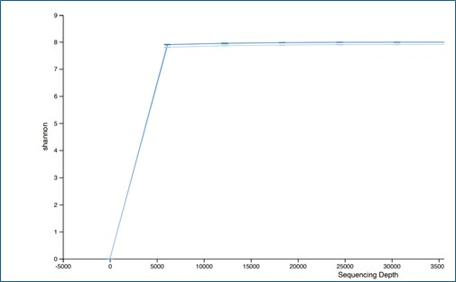

Figure S2. Taxa dendogram and module colors of coexpression network analysis (WGCNA) revealed eight miRNA module eigengenes (ME) in the efficient group.
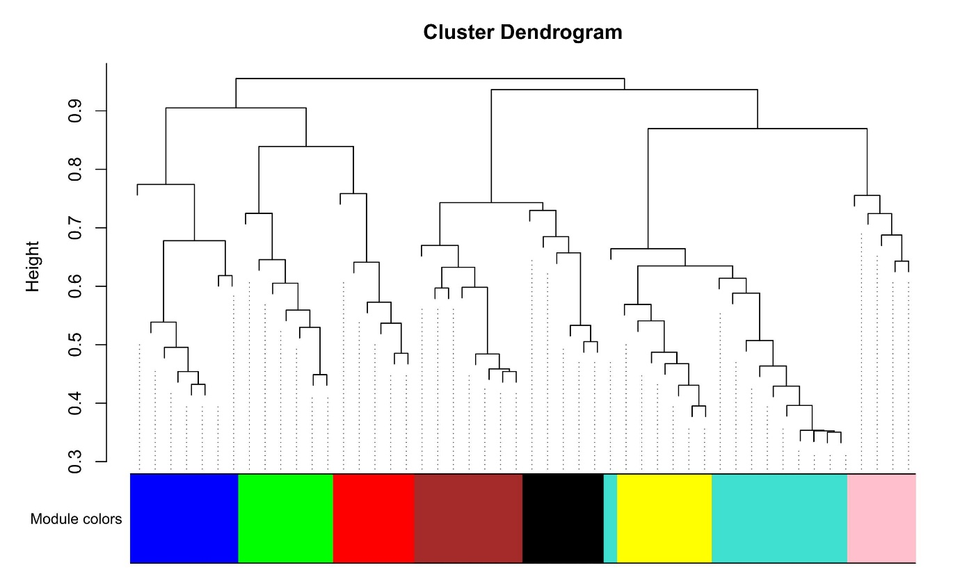

Figure S3. Taxa dendogram and module colors of coexpression network analysis (WGCNA) revealed six ASV module eigengenes (ME) in the efficient group.

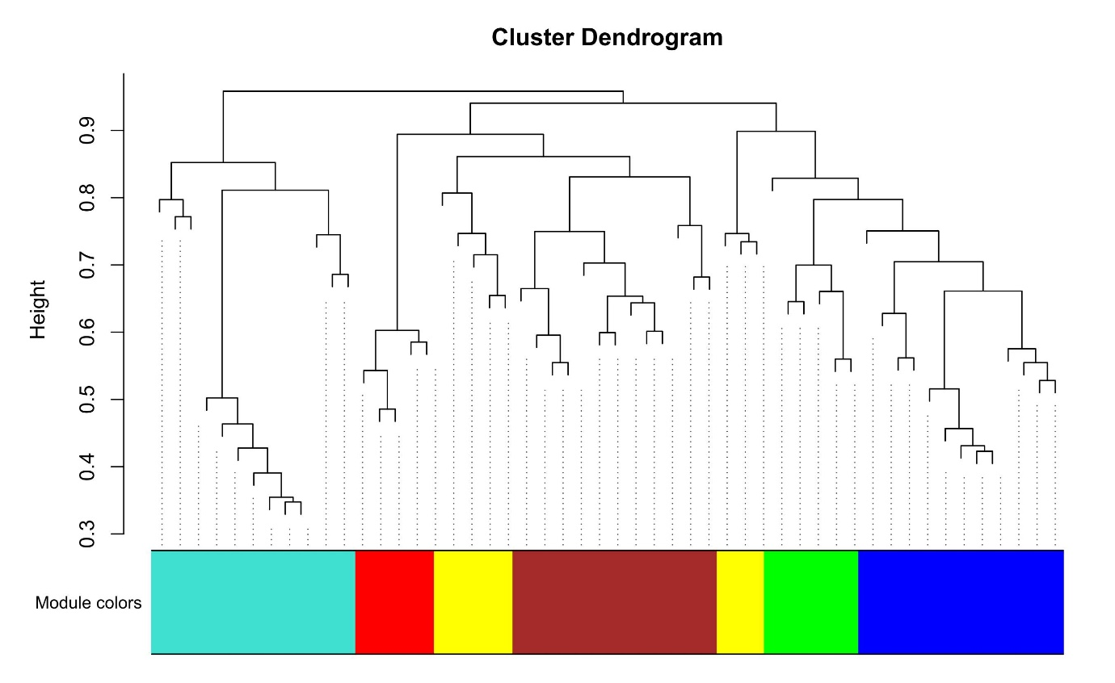

Figure S4. Taxa dendogram and module colors of coexpression network analysis (WGCNA) revealed six miRNA module eigengenes (ME) in the inefficient group.
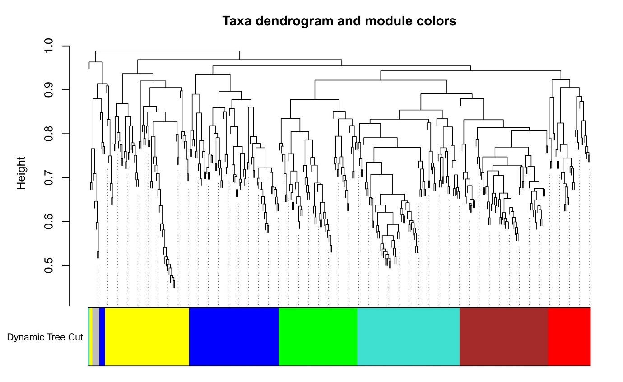

Figure S5. Taxa dendogram and module colors of coexpression network analysis (WGCNA) revealed seven ASVs module eigengenes (ME) in the inefficient group.
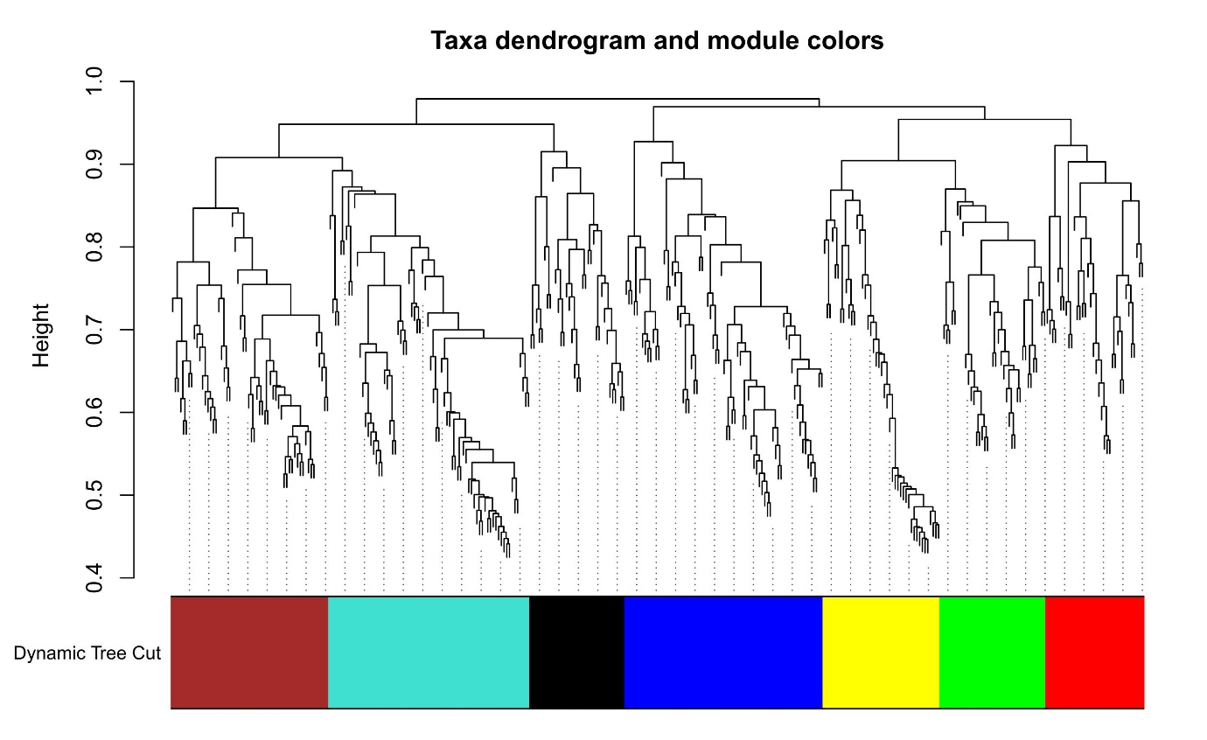

Supplementary Tables legends:
Table S1. Primer set used to amplify 16S hypervariable regions.
Table S2. Ful list of expressed fecal miRNAs identified by STAR software between efficient and inefficient Nelore cattle groups.
Table S3. Differentially expressed fecal miRNAs identified by DEseq software between efficient and inefficient Nelore cattle groups.
Table S4. Signalling pathways constructed by WebGestalt software for each differentially expressed miRNA’s target genes list.
Table S5. Amplicon Sequence Variants (ASVs) identified in eficient and inefficient Nelore cattle groups.

