Supplementary Material

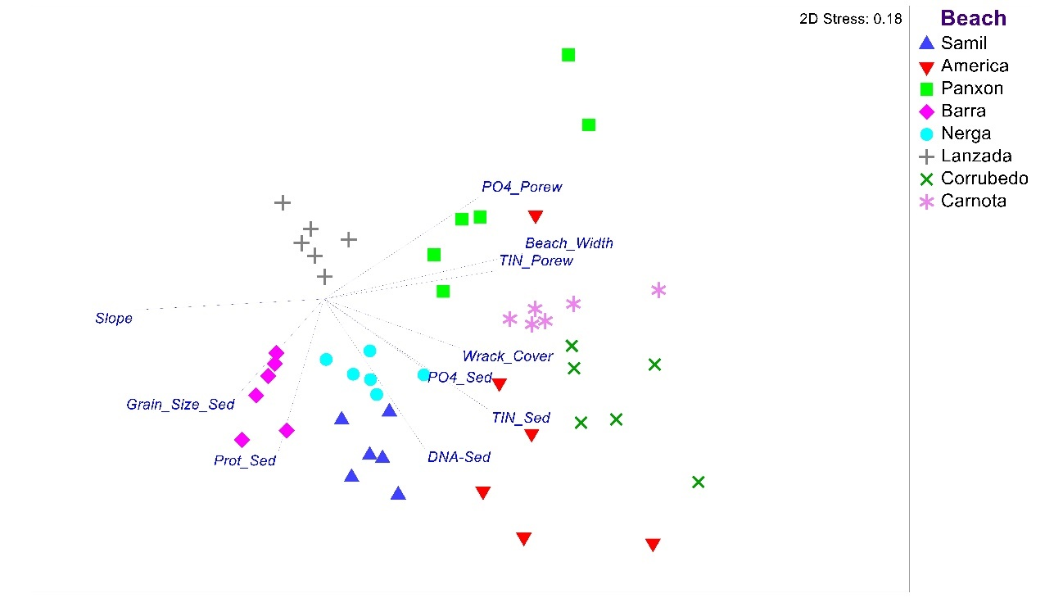

Fig. SU1. Ordination (non-metric multidimensional scaling) of environmental attributes of beaches in Galicia, NW Spain. Vector overlays illustrate correlations of individual variables with the spatial pattern amongst samples based on similarities across the full suite of variables measured (cf. Table SU3).

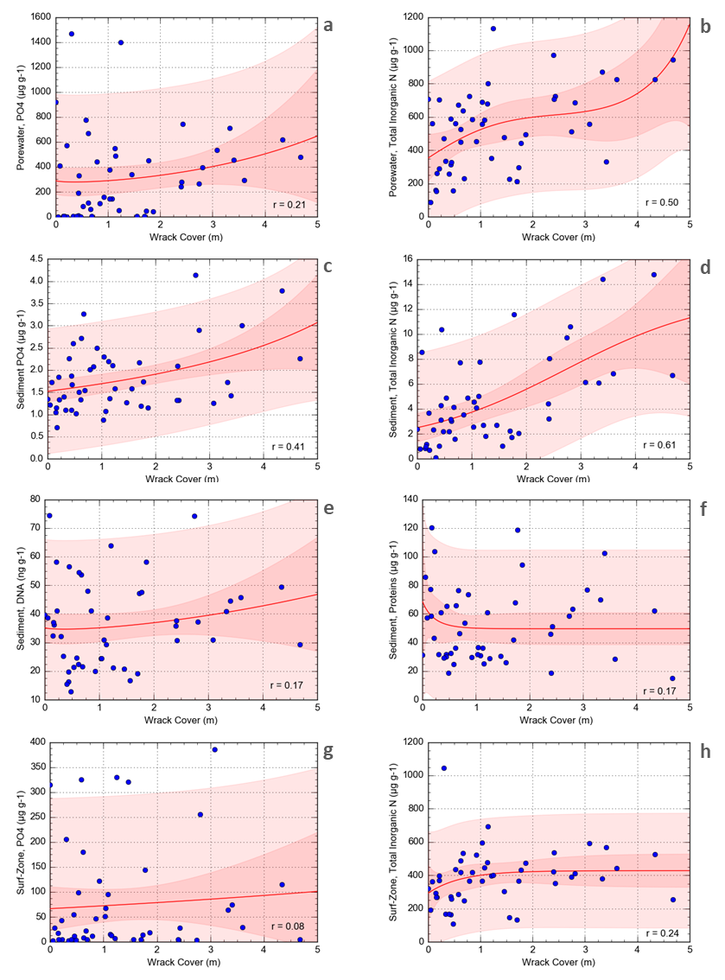

Figure SU2. Relationships between algal wrack and measured geo-chemical properties of sediments, porewater and surf-zone water.

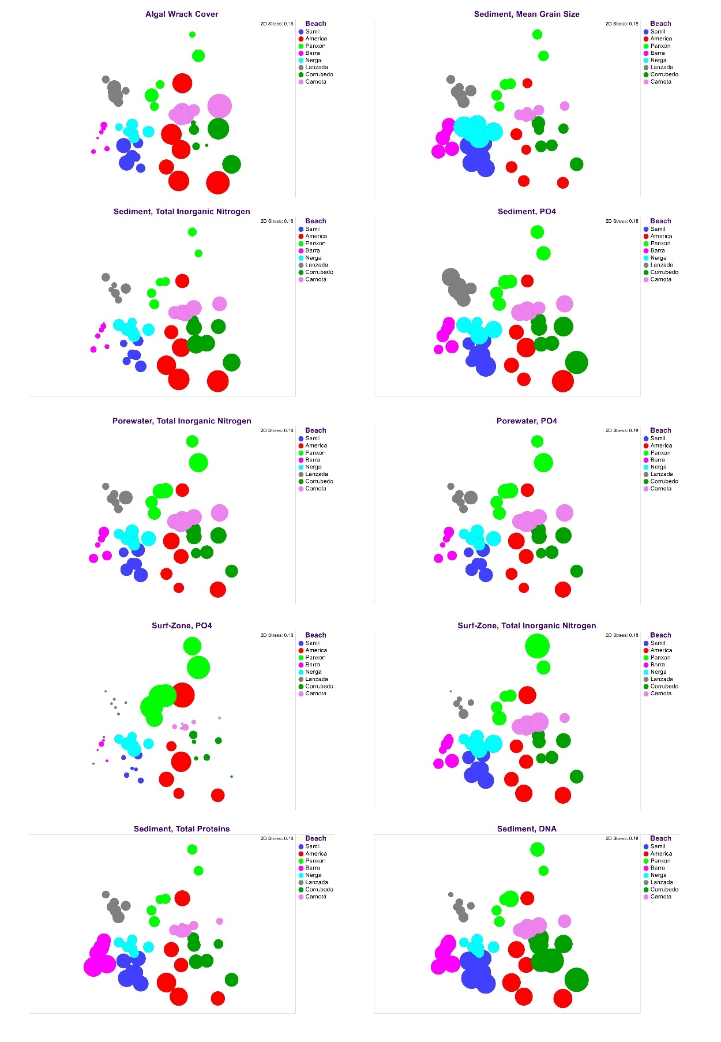
Fig. SU3. NMDS (non-metric multidimensional scaling) ordinations displaying beach samples based on their resemblance in environmental attributes. The size of ‘bubbles’ is scaled to the value of individual factors displayed (one per panel).

Table SU1. Environmental attributes of beaches sampled (see Fig. 1A for locations).

 | Wrack Cover  (m) |  | Sediment,  Grain Size (microns) |  | Beach Slope  (°) |  | Dean’s Parameter  (Ω)
 | mean | (se) | mean | (se)
Samil | 1.16 | (0.22) | 1030.33 | (6.99) | 4.95 |  | 0.50
America | 3.12 | (0.34) | 388.57 | (26.58) | 4.16 |  | 1.12
Panxon | 0.70 | (0.23) | 340.77 | (7.65) | 4.22 |  | 1.21
Barra | 0.18 | (0.04) | 523.29 | (61.89) | 5.08 |  | 0.95
Nerga | 0.84 | (0.11) | 1276.09 | (65.05) | 4.66 |  | 0.40
Lanzada | 0.88 | (0.24) | 366.52 | (41.50) | 4.38 |  | 4.26
Corrubedo | 1.31 | (0.61) | 442.25 | (46.82) | 2.21 |  | 2.40
Carnota | 2.37 | (0.53) | 336.16 | (17.04) | 3.29 |  | 2.52
 | Sediment,  PO₄ (μg g⁻¹) |  | Sediment,  Total Inorganic Nitrogen (μg g⁻¹) |  | Porewater,  PO4 (μg L⁻¹) |  | Porewater,  Dissolved Inorganic N (μg L⁻¹)
 | Mean | (se) | mean | (se) | Mean | (se) | Mean | (se)
Samil | 2.08 | (0.34) | 2.85 | (0.37) | 70.56 | (12.2)5 | 468.46 | (53.83)
America | 2.14 | (0.41) | 10.59 | (1.56) | 528.03 | (48.76) | 619.31 | (87.18)
Panxon | 1.41 | (0.05) | 2.42 | (0.19) | 927.82 | (177.65) | 664.68 | (101.85)
Barra | 1.09 | (0.09) | 0.77 | (0.15) | 3.43 | (0.56) | 215.24 | (38.60)
Nerga | 1.61 | (0.29) | 4.21 | (0.35) | 183.29 | (40.84) | 526.20 | (52.17)
Lanzada | 1.88 | (0.23) | 1.87 | (0.33) | 4.49 | (0.87) | 278.27 | (63.40)
Corrubedo | 2.40 | (0.40) | 7.82 | (0.98) | 385.32 | (46.16) | 609.61 | (72.84)
Carnota | 1.76 | (0.19) | 5.86 | (0.79) | 463.59 | (75.09) | 804.77 | (51.46)
 | Surf-zone,  PO₄ (μg L⁻¹) |  | Surf-zone,  Dissolved Inorganic N (μg L⁻¹) |  | Sediment,  Proteins (μg g⁻¹) |  | Sediment,  DNA (ng g⁻¹)
 | Mean | (se) | mean | (se) | Mean | (se) | Mean | (se)
Samil | 19.51 | (5.86) | 445.86 | (25.69) | 73.15 | (4.78) | 53.08 | (3.28)
America | 172.95 | (50.83) | 485.86 | (36.53) | 82.31 | (9.46) | 41.76 | (2.82)
Panxon | 279.38 | (27.60) | 462.67 | (118.33) | 30.70 | (1.53) | 26.80 | (3.08)
Barra | 5.78 | (2.39) | 264.48 | (33.36) | 84.44 | (9.88) | 35.08 | (2.29)
Nerga | 81.66 | (11.47) | 440.10 | (46.61) | 32.29 | (0.96) | 23.48 | (1.73)
Lanzada | 4.66 | (0.25) | 160.59 | (19.55) | 32.06 | (4.18) | 17.08 | (1.22)
Corrubedo | 21.09 | (5.98) | 365.03 | (24.38) | 51.09 | (5.41) | 59.52 | (5.05)
Carnota | 11.47 | (3.83) | 455.90 | (62.15) | 32.03 | (6.00) | 33.56 | (1.75)

Table SU2. Faunal data in the substrate of the swash zone at the studied beaches. Abundances, species richness, percentage of deposit feeders and filter feeders calculated as the average of samples (n= 9) collected at random at each beach.

Beaches | Abundance  (m⁻² ±SD) | Total number of spp | Species richness (±SD) | % Deposit feeders | % Filter feeders
Samil | 2377 (±1374) | 9 | 3.1 (±1.3) | 74.4 | 19.0
America | 10561 (±835) | 14 | 6.2 (±1.7) | 10.1 | 88.6
Panxon | 3832 (±1999) | 9 | 4.3 (±1.1) | 51.0 | 43.1
Barra | 285 (±286) | 5 | 1.7 (±0.7) | 62.1 | 6.9
Nerga | 2034 (±2587) | 8 | 2.3 (±1.4) | 89.7 | 1.6
Lanzada | 796 (±462) | 7 | 3.3 (±1.2) | 21.3 | 62.5
Corrubedo | 3547 (±1262) | 13 | 5.9 (±1.3) | 52.9 | 41.8
Carnota | 2348 (±1392) | 10 | 3.9 (±1.8) | 16.7 | 79.9

Table SU3. Summary of distance-based linear modelling (DISTLM) relating variation in density (top) and species richness (bottom) of the swash fauna among beaches to a suite of environmental predictors. (Pseudo-F, P and Prop. refer to marginal tests; ‘top models’ are solutions with a delta AICc of 2).

Density (Total No. Individuals)
Variable | Pseudo-F | P | Prop. | # in Top Models
Sediment, Total Inorganic Nitrogen (μg g⁻¹) | 13.801 | 0.018 | 0.697 | 5
Surf-zone, PO₄ (μg L⁻¹) | 2.932 | 0.134 | 0.328 | 3
Wrack Cover (m) | 10.060 | 0.022 | 0.626 | 0
Pore-water, PO₄ (μg L⁻¹) | 2.446 | 0.179 | 0.290 | 1
Surf-zone, Dissolved Inorganic N (μg L⁻¹) | 3.055 | 0.143 | 0.337 | 0
Porewater, Dissolved Inorganic N (μg L⁻¹) | 1.773 | 0.239 | 0.228 | 0
Sediment, PO₄ (μg g⁻¹) | 1.615 | 0.244 | 0.212 | 0
Sediment, Proteins (μg g⁻¹) | 0.804 | 0.505 | 0.118 | 1
Wave Height (m) | 0.987 | 0.245 | 0.141 | 0
Sediment, DNA (ng g⁻¹) | 0.564 | 0.497 | 0.086 | 0
Sediment, Grain Size (mean, microns) | 0.353 | 0.559 | 0.056 | 0
Beach Width (m) | 0.270 | 0.619 | 0.043 | 2
Wave Period (s) | 0.277 | 0.607 | 0.044 | 0
Dean’s Parameter (Ω) | 0.313 | 0.622 | 0.050 | 0
Beach-Slope (deg) | 0.264 | 0.565 | 0.042 | 0
Number of Species
Variable | Pseudo-F | P | Prop. | # in Top Models
Sediment, Total Inorganic Nitrogen (μg g⁻¹) | 47.494 | 0.002 | 0.888 | 2
Sediment, PO₄ (μg g⁻¹) | 9.826 | 0.025 | 0.621 | 2
Wrack Cover (m) | 10.413 | 0.024 | 0.634 | 0
Porewater, Dissolved Inorganic N (μg L⁻¹) | 5.351 | 0.068 | 0.471 | 0
Pore-water, PO₄ (μg L⁻¹) | 2.241 | 0.172 | 0.272 | 2
Beach-Slope (deg) | 4.810 | 0.075 | 0.445 | 0
Beach Width (m) | 4.112 | 0.089 | 0.407 | 0
Sediment, DNA (ng g⁻¹) | 2.932 | 0.136 | 0.328 | 0
Surf-zone, Dissolved Inorganic N (μg L⁻¹) | 2.899 | 0.138 | 0.326 | 0
Wave Period (s) | 1.353 | 0.284 | 0.184 | 0
Surf-zone, PO₄ (μg L⁻¹) | 0.579 | 0.478 | 0.088 | 0
Sediment, Grain Size (mean, microns) | 0.375 | 0.588 | 0.059 | 0
Sediment, Proteins (μg g⁻¹) | 0.079 | 0.785 | 0.013 | 1
Wave Height (m) | 0.202 | 0.657 | 0.033 | 0
Dean’s Parameter (Ω) | 0.000 | 0.999 | 0.000 | 0

