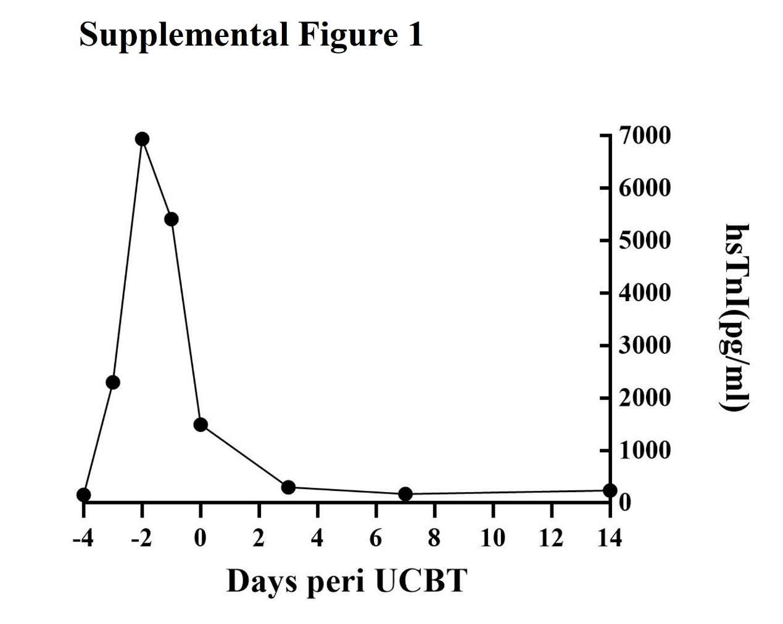
Supplemental Figure1 The levels of hypersensitive troponin I of the patient 4 conditioned with dose-adjusted cyclophosphamide.

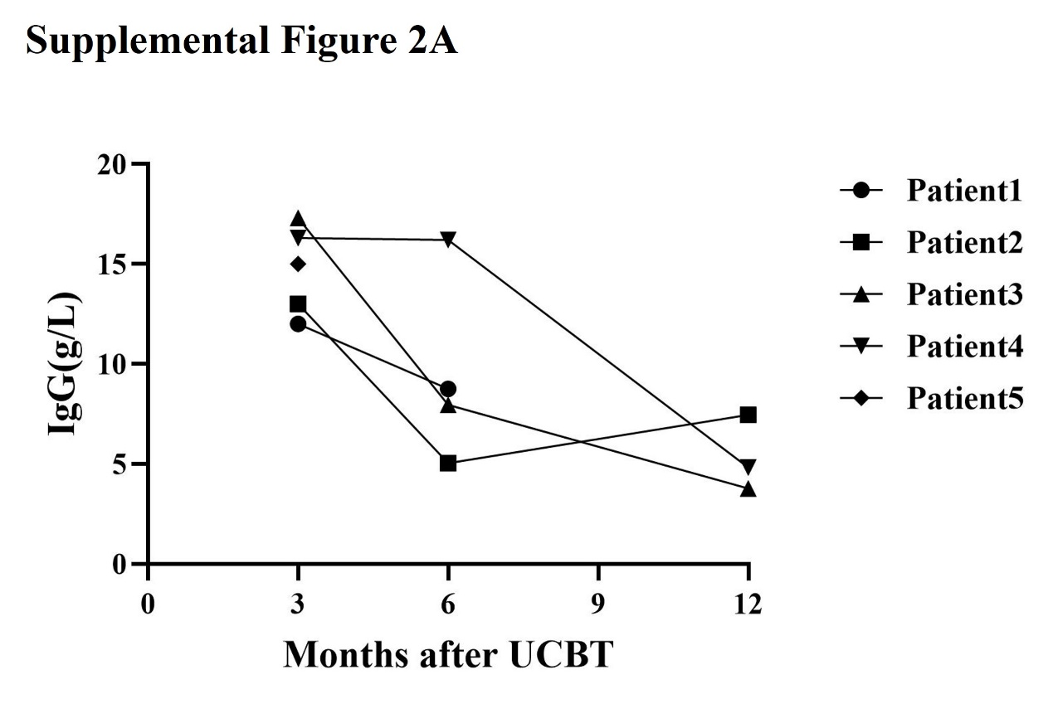
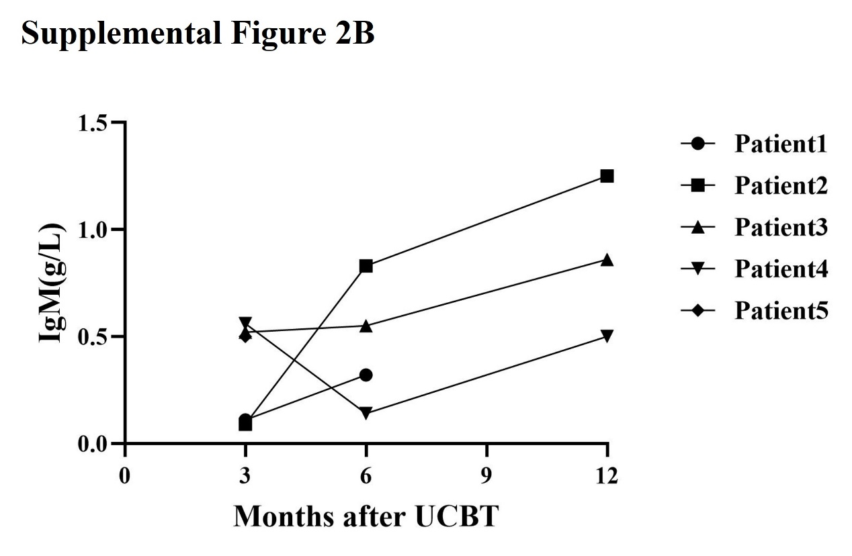
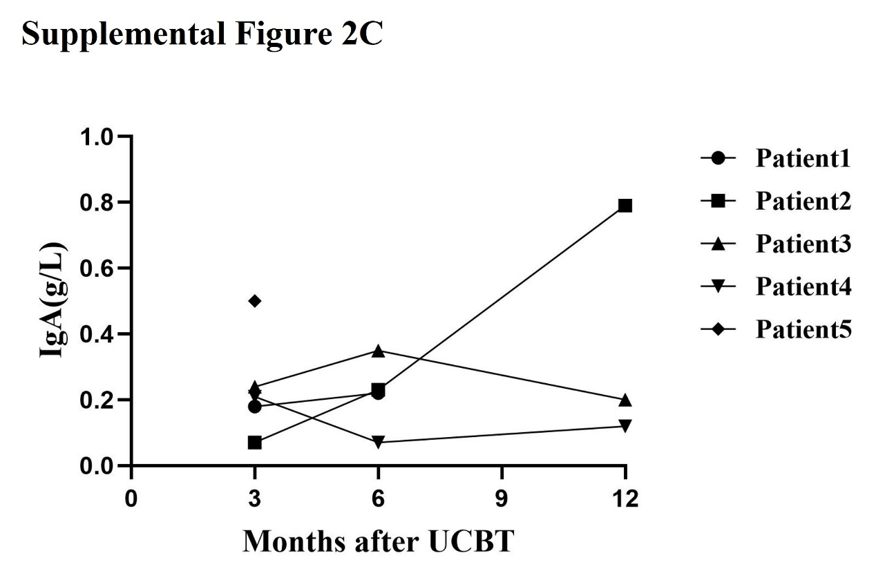
Supplemental Figure2 Reconstitution of immunoglobulin in infants under 6 months of age with rare non malignant diseases after UCBT. Recovery of the levels of (A) IgG, (B) IgM, and (C) IgA.

Supplemental Table1 Reconstitution of lymphocyte subsets at 3, 6, and 12 months after UCBT
Lymphocyte subtype(counts) | Months+3 Median(range) | Months+6 Median(range) | Months+12 Median(range)
CD3+ | 660 (319–3502) | 1093 (480–2128) | 2750 (2177–4283)
CD3+CD4+ | 363 (219–1564) | 456 (255–791) | 1215 (728–1946)
CD3+CD8+ | 286 (63–1626) | 648(48–1179) | 1066 (914–2222)
CD16+CD56+ | 163 (97–1051) | 712 (47–1084) | 599 (183–1756)
CD19+ | 336 (9–965) | 435 (114–789) | 977 (673–1317)

