ID | SMILES | MW | TPSA (Å²) | LogP | Rotatable Bonds | HBA | HBD
0 | O=c1[nH]c2ccc(Nc3nc4nonc4nc3N/N=C/c3cc4c(cc3[N+](=O)[O-])OCO4)cc2[nH]1 | 476.36 | 214.05 | 1.2 | 6 | 11 | 4 | 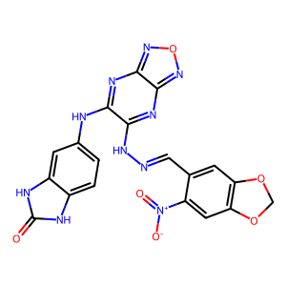
2 | C[C@@H](Nc1ccc(C(=O)Nc2ccc3ccccc3c2)cc1[N+](=O)[O-])c1ccc2[nH]c(=O)[nH]c2c1 | 467.48 | 135.6 | 3.62 | 7 | 4 | 4 | 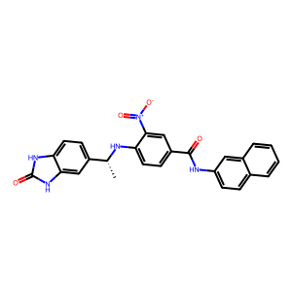
4 | Oc1ccc2c(c1)oc1c(-c3ccc(O)c(O)c3)c3c(O)nn(C4CCCC4)c3nc12 | 417.41 | 124.77 | 3.47 | 2 | 7 | 4 | 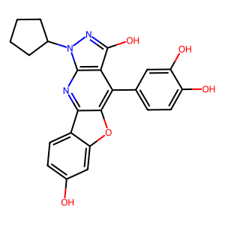
11 | Oc1ccc2c(c1)oc1c(-c3ccc(O)c(O)c3)c3c(O)nn(C4CCCCC4)c3nc12 | 431.44 | 124.77 | 3.76 | 2 | 7 | 4 | 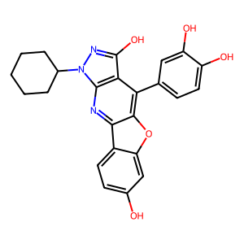
14 | Oc1ccc(-c2c3oc4c(O)c(O)ccc4c3nc3c2c(O)nn3C2CCCCCC2)cc1O | 461.47 | 145 | 3.78 | 2 | 8 | 5 | 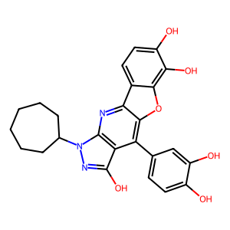
17 | Oc1ccc(-c2c3oc4cc(O)ccc4c3nc3c2c(O)nn3C2CCCC2)cc1 | 401.41 | 104.54 | 3.84 | 2 | 6 | 3 | 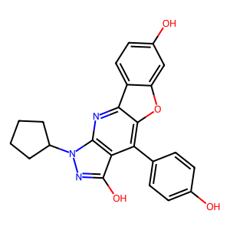
18 | Oc1ccc(-c2c3oc4cc(O)ccc4c3nc3c2c(O)nn3C2CCCCCC2)cc1 | 429.47 | 104.54 | 4.43 | 2 | 6 | 3 | 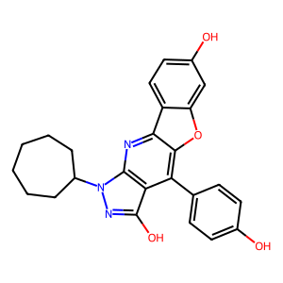
20 | Cc1c(O)ccc2c1oc1c(-c3ccc(O)c(O)c3)c3c(O)nn(C4CCCCC4)c3nc12 | 445.47 | 124.77 | 4.16 | 2 | 7 | 4 | 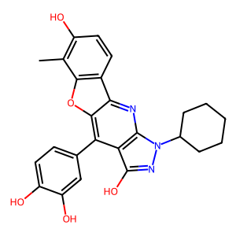
22 | O=C1C[C@@H](c2cccc3cccnc23)c2c(cc(O)c3c(=O)c(O)c(-c4ccc(O)c(O)c4)oc23)O1 | 483.43 | 150.32 | 3.14 | 2 | 9 | 4 | 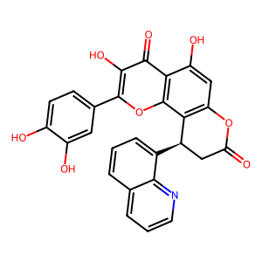
26 | Cc1[nH]c2ccnn2c(=O)c1CC(=O)Nc1ccc2[nH]nc(C(N)=O)c2c1 | 365.35 | 151.03 | 0.67 | 5 | 5 | 4 | 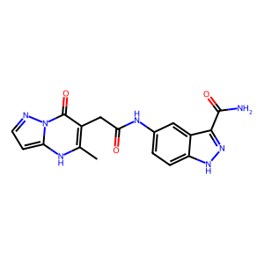
29 | Oc1ccc(-c2c3oc4c(O)c(O)ccc4c3nc3c2c(O)nn3C2CCCCCCC2)cc1 | 459.49 | 124.77 | 4.44 | 2 | 7 | 4
30 | Cc1c(O)ccc2c1oc1c(-c3ccc(O)cc3)c3c(O)nn(C4CCCCCCC4)c3nc12 | 457.52 | 104.54 | 5.1 | 2 | 6 | 3 | 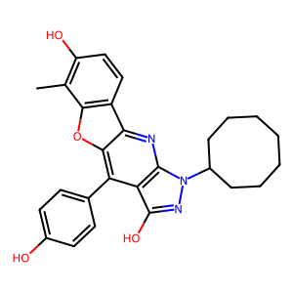
31 | COc1ccc2cc(S(=O)(=O)NN(Cc3cccc(C(=N)N)c3)C(=O)N3CCC(C)CC3)ccc2c1 | 509.62 | 137.2 | 2.86 | 9 | 6 | 3 | 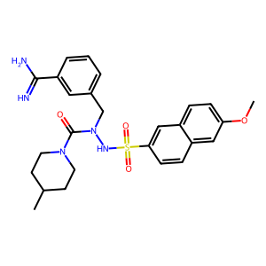
32 | COc1cc(-c2c3oc4cc(O)ccc4c3nc3c2c(O)nn3C2CCCCC2)cc(O)c1O | 461.47 | 134 | 3.84 | 3 | 8 | 4 | 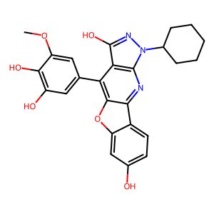
35 | Oc1ccc(-c2c3oc4c(O)c(O)ccc4c3nc3c2c(O)nn3C2CCCCC2)cc1Cl | 465.89 | 124.77 | 4.32 | 2 | 7 | 4 | 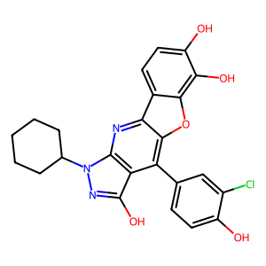
41 | COc1cc(-c2c3oc4cc(O)ccc4c3nc3c2c(O)nn3C2CCCCCCC2)cc(O)c1O | 489.52 | 134 | 4.44 | 3 | 8 | 4 | 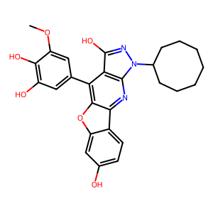
Table 2. ADME properties of top 16 compounds

