Figure 6:Behavior evolution of three players at initial stage
From Page.20 ,By Use Matlab.R2019a

clc;clear;
K2=0.5,dC=0.5,O1=0.5,S2=0.5,N2=0.5,K1=0.5,L1=3,L2=0.5,D=0.5,E=0.5,F=0.5,a=0.5,S1=0.5,N1=0.5,M=2,I1=0,I2=0.5,O2=0,G=0.5,R1=0.5,C1=1,C2=0.5;for i=0.1:0.2:1
for j=0.1:0.2:1
for k=0.1:0.2:1
[t,y]=ode45(@(t,y) sanfang(t,y,K1,L1,L2,D,E,F,a,S1,N1,R1,K2,O1,S2,N2,C1,M,I1,I2,O2,G,C2,dC),[0 50],[i j k]);
plot3(y(:,1),y(:,2),y(:,3),'linewidth',1);
set(gca,'YTick',[0:0.2:1],'XTick',[0:0.2:1],'ZTick',[0:0.2:1])
hold on
axis([0 1 0 1 0 1])
view([45 10])
end
end
end
grid on

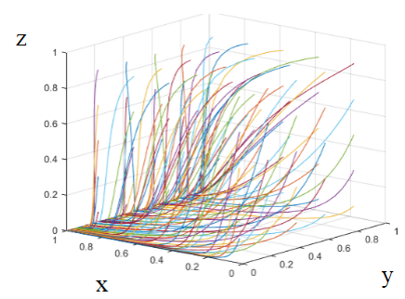

Figure 6: Behavior evolution of three players at initial stage

Figure 7: Behavior evolution of three players at development stage
From Page.21 ,By Use Matlab.R2019a

clc;clear;
K2=0.7,dC=1.5,O1=0.2,S2=1,N2=0.5,K1=0.8,L1=1.5,L2=0,D=1.5,E=0.4,F=1,a=0.5,S1=1,N1=0.8,M=0.9,I1=0.7,I2=0.5,O2=0.8,G=0.8,R1=0.5,C1=1.5,C2=0.9;for i=0.1:0.2:1
for j=0.1:0.2:1
for k=0.1:0.2:1
[t,y]=ode45(@(t,y) sanfang(t,y,K1,L1,L2,D,E,F,a,S1,N1,R1,K2,O1,S2,N2,C1,M,I1,I2,O2,G,C2,dC),[0 50],[i j k]);
plot3(y(:,1),y(:,2),y(:,3),'linewidth',1);
set(gca,'YTick',[0:0.2:1],'XTick',[0:0.2:1],'ZTick',[0:0.2:1])
hold on
axis([0 1 0 1 0 1])
view([45 10])
end
end
end
grid on

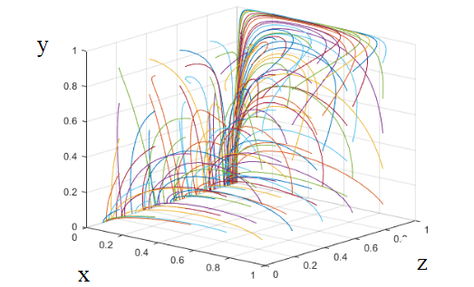

Figure 7: Behavior evolution of three players at development stage

Figure 8:Behavior evolution of three players at mature stage
From Page.22 ,By Use Matlab.R2019a
clc;clear;
K2=0.7,dC=0.8,O1=0.9,S2=0.8,N2=1,K1=3,L1=0.5,L2=0.3,D=0.2,E=0.4,F=0.6,a=0.5,S1=1.5,N1=0.6,M=0.9,I1=1.5,I2=0.5,O2=0.8,G=0.6,R1=2.5,C1=0.5,C2=0.5;for i=0.1:0.2:1
for j=0.1:0.2:1
for k=0.1:0.2:1
[t,y]=ode45(@(t,y) sanfang(t,y,K1,L1,L2,D,E,F,a,S1,N1,R1,K2,O1,S2,N2,C1,M,I1,I2,O2,G,C2,dC),[0 50],[i j k]);
plot3(y(:,1),y(:,2),y(:,3),'linewidth',1);
set(gca,'YTick',[0:0.2:1],'XTick',[0:0.2:1],'ZTick',[0:0.2:1])
hold on
axis([0 1 0 1 0 1])
view([45 10])
end
end
end
grid on

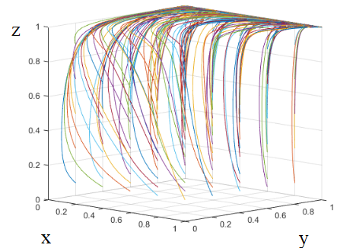

Figure 8: Behavior evolution of three players at mature stage

Figure 9 (a):Behavior trends of three players at initial stage
From Page.23 ,By Use Matlab.R2019a

clc;clear;
K1=6,dC=0.3,O1=0.2,S1=0.3,N1=0.2,C1=0.1,K2=3,L1=1,L2=0.9,D=0.9,E=0.5,F=0.2,a=0.5,S2=0.4,N2=0.3,R=0.2,M=0.5,I1=0.8,I2=0.4,O2=0.1,G=0.4,C2=0.1;
K1 = 6
dC = 0.3000
O1 = 0.2000
S1 = 0.3000
N1 = 0.2000
C1 = 0.1000
K2 = 3
L1 = 1
L2 = 0.9000
D = 0.9000
E = 0.5000
F = 0.2000
a = 0.5000
S2 = 0.4000
N2 = 0.3000
R = 0.2000
M = 0.5000
I1 = 0.8000
I2 = 0.4000
O2 = 0.1000
G = 0.4000
figure(1)
%%%%%% line1
[t,y]=ode45(@(t,y) sanfang(t,y,K1,M,O1,S1,N1,C1,K2,L1,L2,D,E,F,a,S2,N2,R,I1,I2,O2,G,C2,dC),[0 10],[0.1 0.1 0.1]);
plot(t,y(:,1),'c-.','LineWidth',1.5);
hold on
%%%%%% line2
[t,y]=ode45(@(t,y) sanfang(t,y,K1,M,O1,S1,N1,C1,K2,L1,L2,D,E,F,a,S2,N2,R,I1,I2,O2,G,C2,dC),[0 10],[0.1 0.1 0.1]);
plot(t,y(:,2),'b--','LineWidth',1.5);
hold on
%%%%%% line3
[t,y]=ode45(@(t,y) sanfang(t,y,K1,M,O1,S1,N1,C1,K2,L1,L2,D,E,F,a,S2,N2,R,I1,I2,O2,G,C2,dC),[0 10],[0.1 0.1 0.1]);
plot(t,y(:,3),'r-','LineWidth',1.5);
hold on
%%%%%% line1
axis([0 10 0 1 0 1])
set(gca,'XTick',[0:1:10],'YTick',[0:0.2:1] ,'ZTick',[0:0.1:1])%%[0:坐标轴的单位长度:1]
xlabel('$Time$', 'interpreter','latex');
ylabel('$probability$','interpreter','latex', 'rotation',90);
zlabel('$z$','interpreter','latex','rotation',360);
grid on
legend('government x=0.1','enterprises y=0.1', 'senior executives z=0.1');

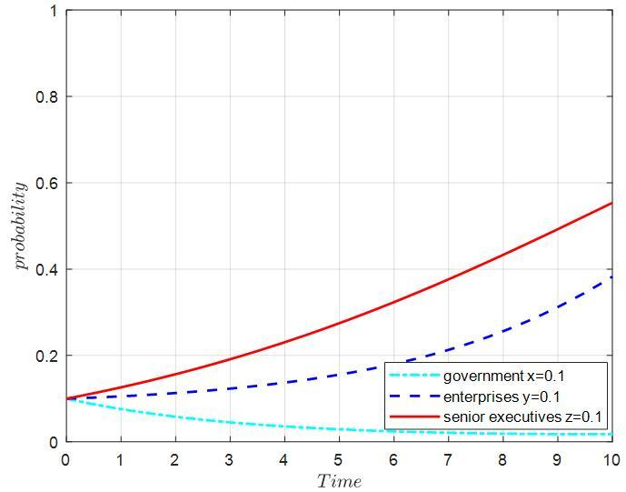

(a)
Figure 9: Behavior trends of three players at initial stage

Figure 9 (b):Behavior trends of three players at initial stage
From Page.23 ,By Use Matlab.R2019a

clc;clear;close all;
K1=6,dC=0.3,O1=0.2,S1=0.3,N1=0.2,C1=0.1,K2=3,L1=1,L2=0.9,D=0.9,E=0.5,F=0.2,a=0.5,S2=0.4,N2=0.3,R=0.2,M=0.5,I1=0.8,I2=0.4,O2=0.1,G=0.4,C2=0.1;
K1 = 6
dC = 0.3000
O1 = 0.2000
S1 = 0.3000
N1 = 0.2000
C1 = 0.1000
K2 = 3
L1 = 1
L2 = 0.9000
D = 0.9000
E = 0.5000
F = 0.2000
a = 0.5000
S2 = 0.4000
N2 = 0.3000
R = 0.2000
M = 0.5000
I1 = 0.8000
I2 = 0.4000
O2 = 0.1000
G = 0.4000
figure(1)
%%%%%% line1
[t,y]=ode45(@(t,y) sanfang(t,y,K1,M,O1,S1,N1,C1,K2,L1,L2,D,E,F,a,S2,N2,R,I1,I2,O2,G,C2,dC),[0 10],[0.5 0.5 0.5]);
plot(t,y(:,1),'c-.','LineWidth',1.5);
hold on
%%%%%% line2
[t,y]=ode45(@(t,y) sanfang(t,y,K1,M,O1,S1,N1,C1,K2,L1,L2,D,E,F,a,S2,N2,R,I1,I2,O2,G,C2,dC),[0 10],[0.5 0.5 0.5]);
plot(t,y(:,2),'b--','LineWidth',1.5);
hold on
%%%%%% line3
[t,y]=ode45(@(t,y) sanfang(t,y,K1,M,O1,S1,N1,C1,K2,L1,L2,D,E,F,a,S2,N2,R,I1,I2,O2,G,C2,dC),[0 10],[0.5 0.5 0.5]);
plot(t,y(:,3),'r-','LineWidth',1.5);
hold on
%%%%%% line1
axis([0 10 0 1 0 1])
set(gca,'XTick',[0:1:10],'YTick',[0:0.2:1] ,'ZTick',[0:0.1:1])%%[0:坐标轴的单位长度:1]
xlabel('$Time$', 'interpreter','latex');
ylabel('$probability$','interpreter','latex', 'rotation',90);
zlabel('$z$','interpreter','latex','rotation',360);
grid on
legend('government x=0.5','enterprises y=0.5', 'senior executives z=0.5');

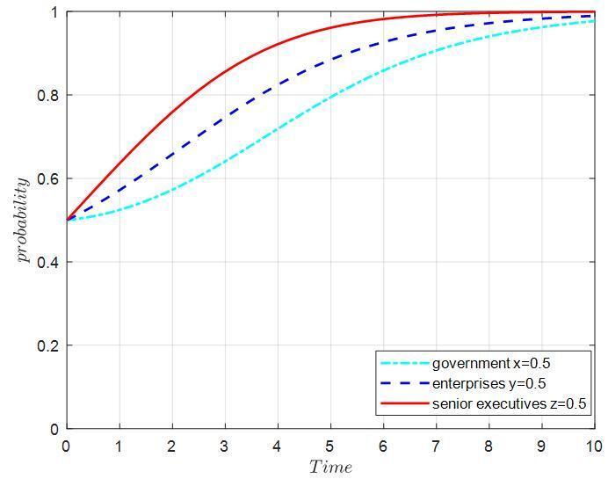

(b)
Figure 9: Behavior trends of three players at initial stage

Figure 9 (c):Behavior trends of three players at initial stage
From Page.23 ,By Use Matlab.R2019a

clc;clear;close all;
K1=6,dC=0.3,O1=0.2,S1=0.3,N1=0.2,C1=0.1,K2=3,L1=1,L2=0.9,D=0.9,E=0.5,F=0.2,a=0.5,S2=0.4,N2=0.3,R=0.2,M=0.5,I1=0.8,I2=0.4,O2=0.1,G=0.4,C2=0.1;
K1 = 6
dC = 0.3000
O1 = 0.2000
S1 = 0.3000
N1 = 0.2000
C1 = 0.1000
K2 = 3
L1 = 1
L2 = 0.9000
D = 0.9000
E = 0.5000
F = 0.2000
a = 0.5000
S2 = 0.4000
N2 = 0.3000
R = 0.2000
M = 0.5000
I1 = 0.8000
I2 = 0.4000
O2 = 0.1000
G = 0.4000
figure(1)
%%%%%% line1
[t,y]=ode45(@(t,y) sanfang(t,y,K1,M,O1,S1,N1,C1,K2,L1,L2,D,E,F,a,S2,N2,R,I1,I2,O2,G,C2,dC),[0 10],[0.9 0.9 0.9]);
plot(t,y(:,1),'c-.','LineWidth',1.5);
hold on
%%%%%% line2
[t,y]=ode45(@(t,y) sanfang(t,y,K1,M,O1,S1,N1,C1,K2,L1,L2,D,E,F,a,S2,N2,R,I1,I2,O2,G,C2,dC),[0 10],[0.9 0.9 0.9]);
plot(t,y(:,2),'b--','LineWidth',1.5);
hold on
%%%%%% line3
[t,y]=ode45(@(t,y) sanfang(t,y,K1,M,O1,S1,N1,C1,K2,L1,L2,D,E,F,a,S2,N2,R,I1,I2,O2,G,C2,dC),[0 10],[0.9 0.9 0.9]);
plot(t,y(:,3),'r-','LineWidth',1.5);
hold on
%%%%%% line1
axis([0 10 0 1 0 1])
set(gca,'XTick',[0:1:10],'YTick',[0:0.2:1] ,'ZTick',[0:0.1:1])%%[0:坐标轴的单位长度:1]
xlabel('$Time$', 'interpreter','latex');
ylabel('$probability$','interpreter','latex', 'rotation',90);
zlabel('$z$','interpreter','latex','rotation',360);
grid on
legend( 'government x=0.9','enterprises y=0.9', 'senior executives z=0.9');

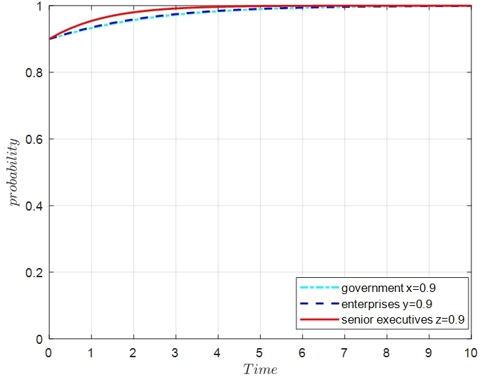
(c)
Figure 9: Behavior trends of three players at initial stage

Figure 10(a):Behavior trends of three players at development stage
From Page.23 ,By Use Matlab.R2019a

clc;clear;close all;
K1=6,dC=0.3,O1=0.2,S1=0.3,N1=0.2,C1=0.1,K2=3,L1=1,L2=0.9,D=0.9,E=0.5,F=0.2,a=0.5,S2=0.4,N2=0.3,R=0.2,M=0.5,I1=0.8,I2=0.4,O2=0.1,G=0.4,C2=0.1;
K1 = 6
dC = 0.3000
O1 = 0.2000
S1 = 0.3000
N1 = 0.2000
C1 = 0.1000
K2 = 3
L1 = 1
L2 = 0.9000
D = 0.9000
E = 0.5000
F = 0.2000
a = 0.5000
S2 = 0.4000
N2 = 0.3000
R = 0.2000
M = 0.5000
I1 = 0.8000
I2 = 0.4000
O2 = 0.1000
G = 0.4000
%%%%%% line1
for F=0.1
[t,y]=ode45(@(t,y) sanfang(t,y,K1,M,O1,S1,N1,C1,K2,L1,L2,D,E,F,a,S2,N2,R,I1,I2,O2,G,C2,dC),[0 10],[0.4 0.4 0.4]);
plot(t,y(:,1),'c-.','LineWidth',1.5);%%注意这里是三维
hold on
%%%%%% line1
end
for F=0.1
[t,y]=ode45(@(t,y) sanfang(t,y,K1,M,O1,S1,N1,C1,K2,L1,L2,D,E,F,a,S2,N2,R,I1,I2,O2,G,C2,dC),[0 10],[0.4 0.4 0.4]);
plot(t,y(:,2),'b--','LineWidth',1.5);%%注意这里是三维
hold on
end
%%%%%% line1
for F=0.1
[t,y]=ode45(@(t,y) sanfang(t,y,K1,M,O1,S1,N1,C1,K2,L1,L2,D,E,F,a,S2,N2,R,I1,I2,O2,G,C2,dC),[0 10],[0.4 0.4 0.4]);
plot(t,y(:,3),'r-','LineWidth',1.5);%%注意这里是三维
hold on
end

axis([0 10 0 1 0 1])
set(gca,'XTick',[0:1:10],'YTick',[0:0.2:1] ,'ZTick',[0:0.1:1])%%[0:坐标轴的单位长度:1]
xlabel('$Time$', 'interpreter','latex');
ylabel('$probability$','interpreter','latex', 'rotation',90);
zlabel('$z$','interpreter','latex','rotation',360);
grid on
legend('government x=F-50%','enterprises y=F-50%', 'senior executives z=F-50%');%%图例小标签

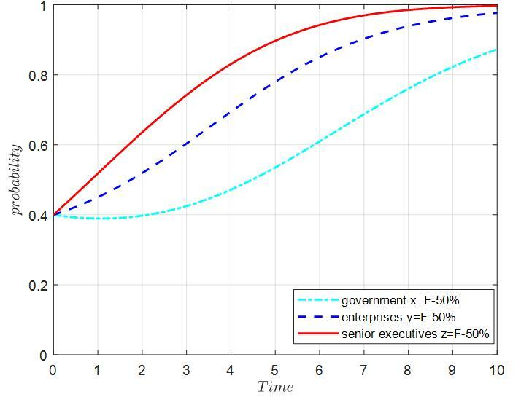
(a)
Figure 10: Behavior trends of three players at development stage

Figure 10(b):Behavior trends of three players at development stage
From Page.23 ,By Use Matlab.R2019a

clc;clear;close all;
K1=6,dC=0.3,O1=0.2,S1=0.3,N1=0.2,C1=0.1,K2=3,L1=1,L2=0.9,D=0.9,E=0.5,F=0.2,a=0.5,S2=0.4,N2=0.3,R=0.2,M=0.5,I1=0.8,I2=0.4,O2=0.1,G=0.4,C2=0.1;
K1 = 6
dC = 0.3000
O1 = 0.2000
S1 = 0.3000
N1 = 0.2000
C1 = 0.1000
K2 = 3
L1 = 1
L2 = 0.9000
D = 0.9000
E = 0.5000
F = 0.2000
a = 0.5000
S2 = 0.4000
N2 = 0.3000
R = 0.2000
M = 0.5000
I1 = 0.8000
I2 = 0.4000
O2 = 0.1000
G = 0.4000
%%%%%% line1
for F=0.2
[t,y]=ode45(@(t,y) sanfang(t,y,K1,M,O1,S1,N1,C1,K2,L1,L2,D,E,F,a,S2,N2,R,I1,I2,O2,G,C2,dC),[0 10],[0.4 0.4 0.4]);
plot(t,y(:,1),'c-.','LineWidth',1.5);%%注意这里是三维
hold on
%%%%%% line1
end
for F=0.2
[t,y]=ode45(@(t,y) sanfang(t,y,K1,M,O1,S1,N1,C1,K2,L1,L2,D,E,F,a,S2,N2,R,I1,I2,O2,G,C2,dC),[0 10],[0.4 0.4 0.4]);
plot(t,y(:,2),'b--','LineWidth',1.5);%%注意这里是三维
hold on
end
%%%%%% line1
for F=0.2
[t,y]=ode45(@(t,y) sanfang(t,y,K1,M,O1,S1,N1,C1,K2,L1,L2,D,E,F,a,S2,N2,R,I1,I2,O2,G,C2,dC),[0 10],[0.4 0.4 0.4]);
plot(t,y(:,3),'r-','LineWidth',1.5);%%注意这里是三维
hold on
end
axis([0 10 0 1 0 1])
set(gca,'XTick',[0:1:10],'YTick',[0:0.2:1] ,'ZTick',[0:0.1:1])%%[0:坐标轴的单位长度:1]
xlabel('$Time$', 'interpreter','latex');
ylabel('$probability$','interpreter','latex', 'rotation',90);
zlabel('$z$','interpreter','latex','rotation',360);
grid on
legend('government x=F','enterprises y=F', 'senior executives z=F');%%图例小标签

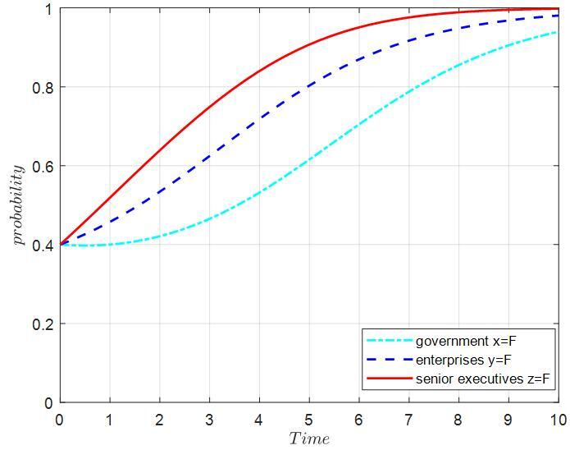

(b)
Figure 10: Behavior trends of three players at development stage

Figure 10(c):Behavior trends of three players at development stage
From Page.23 ,By Use Matlab.R2019a

clc;clear;close all;
K1=6,dC=0.3,O1=0.2,S1=0.3,N1=0.2,C1=0.1,K2=3,L1=1,L2=0.9,D=0.9,E=0.5,F=0.2,a=0.5,S2=0.4,N2=0.3,R=0.2,M=0.5,I1=0.8,I2=0.4,O2=0.1,G=0.4,C2=0.1;
K1 = 6
dC = 0.3000
O1 = 0.2000
S1 = 0.3000
N1 = 0.2000
C1 = 0.1000
K2 = 3
L1 = 1
L2 = 0.9000
D = 0.9000
E = 0.5000
F = 0.2000
a = 0.5000
S2 = 0.4000
N2 = 0.3000
R = 0.2000
M = 0.5000
I1 = 0.8000
I2 = 0.4000
O2 = 0.1000
G = 0.4000
%%%%%% line1
for F=0.4
[t,y]=ode45(@(t,y) sanfang(t,y,K1,M,O1,S1,N1,C1,K2,L1,L2,D,E,F,a,S2,N2,R,I1,I2,O2,G,C2,dC),[0 10],[0.4 0.4 0.4]);
plot(t,y(:,1),'c-.','LineWidth',1.5);%%注意这里是三维
hold on
%%%%%% line1
end
for F=0.4
[t,y]=ode45(@(t,y) sanfang(t,y,K1,M,O1,S1,N1,C1,K2,L1,L2,D,E,F,a,S2,N2,R,I1,I2,O2,G,C2,dC),[0 10],[0.4 0.4 0.4]);
plot(t,y(:,2),'b--','LineWidth',1.5);%%注意这里是三维
hold on
end
%%%%%% line1
for F=0.4
[t,y]=ode45(@(t,y) sanfang(t,y,K1,M,O1,S1,N1,C1,K2,L1,L2,D,E,F,a,S2,N2,R,I1,I2,O2,G,C2,dC),[0 10],[0.4 0.4 0.4]);
plot(t,y(:,3),'r-','LineWidth',1.5);%%注意这里是三维
hold on
end

axis([0 10 0 1 0 1])
set(gca,'XTick',[0:1:10],'YTick',[0:0.2:1] ,'ZTick',[0:0.1:1])%%[0:坐标轴的单位长度:1]
xlabel('$Time$', 'interpreter','latex');
ylabel('$probability$','interpreter','latex', 'rotation',90);
zlabel('$z$','interpreter','latex','rotation',360);
grid on
legend( 'government x=F+50%','enterprises y=F+50%','senior executives z=F+50%');%%图例小标签

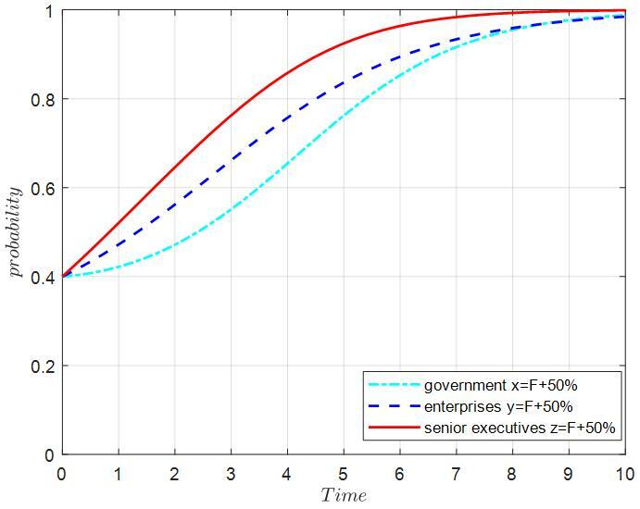
(c)
Figure 10: Behavior trends of three players at development stage

Figure 11(a):Behavior trends of three players at mature stage
From Page.24 ,By Use Matlab.R2019a

clc;clear;close all;
K1=6,dC=0.3,O1=0.2,S1=0.3,N1=0.2,C1=0.1,K2=3,L1=1,L2=0.9,D=0.9,E=0.5,F=0.2,a=0.5,S2=0.4,N2=0.3,R=0.2,M=0.5,I1=0.8,I2=0.4,O2=0.1,G=0.4,C2=0.1;
K1 = 6
dC = 0.3000
O1 = 0.2000
S1 = 0.3000
N1 = 0.2000
C1 = 0.1000
K2 = 3
L1 = 1
L2 = 0.9000
D = 0.9000
E = 0.5000
F = 0.2000
a = 0.5000
S2 = 0.4000
N2 = 0.3000
R = 0.2000
M = 0.5000
I1 = 0.8000
I2 = 0.4000
O2 = 0.1000
G = 0.4000
%%%%%% line1
for O1=0.1
[t,y]=ode45(@(t,y) sanfang(t,y,K1,M,O1,S1,N1,C1,K2,L1,L2,D,E,F,a,S2,N2,R,I1,I2,O2,G,C2,dC),[0 10],[0.4 0.4 0.4]);
plot(t,y(:,1),'c-.','LineWidth',1.5);%%注意这里是三维
hold on
%%%%%% line1
end
for O1=0.2
[t,y]=ode45(@(t,y) sanfang(t,y,K1,M,O1,S1,N1,C1,K2,L1,L2,D,E,F,a,S2,N2,R,I1,I2,O2,G,C2,dC),[0 10],[0.4 0.4 0.4]);
plot(t,y(:,1),'b--','LineWidth',1.5);%%注意这里是三维
hold on
end
%%%%%% line1
for O1=0.3
[t,y]=ode45(@(t,y) sanfang(t,y,K1,M,O1,S1,N1,C1,K2,L1,L2,D,E,F,a,S2,N2,R,I1,I2,O2,G,C2,dC),[0 10],[0.4 0.4 0.4]);
plot(t,y(:,1),'r-','LineWidth',1.5);%%注意这里是三维
hold on
end

axis([0 10 0 1 0 1])
set(gca,'XTick',[0:1:10],'YTick',[0:0.2:1] ,'ZTick',[0:0.1:1])%%[0:坐标轴的单位长度:1]
xlabel('$Time$', 'interpreter','latex');
ylabel('$probability$','interpreter','latex', 'rotation',90);
zlabel('$z$','interpreter','latex','rotation',360);
grid on
legend('enterprises y：O1-50%', 'enterprises y：O1','enterprises y：O1+50%');%%图例小标签

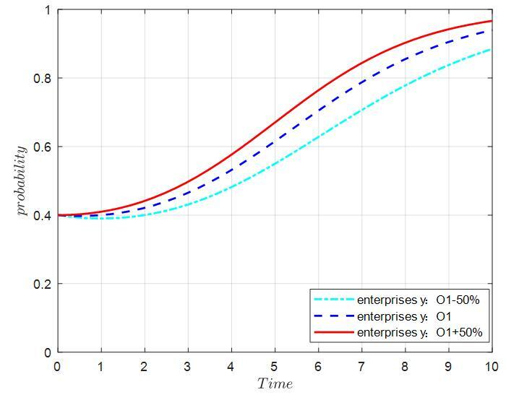
(a)
Figure 11: Behavior trends of three players at mature stage

Figure 11(b):Behavior trends of three players at mature stage
From Page.24 ,By Use Matlab.R2019a

clc;clear;close all;
K1=6,dC=0.3,O1=0.2,S1=0.3,N1=0.2,C1=0.1,K2=3,L1=1,L2=0.9,D=0.9,E=0.5,F=0.2,a=0.5,S2=0.4,N2=0.3,R=0.2,M=0.5,I1=0.8,I2=0.4,O2=0.1,G=0.4,C2=0.1;
K1 = 6
dC = 0.3000
O1 = 0.2000
S1 = 0.3000
N1 = 0.2000
C1 = 0.1000
K2 = 3
L1 = 1
L2 = 0.9000
D = 0.9000
E = 0.5000
F = 0.2000
a = 0.5000
S2 = 0.4000
N2 = 0.3000
R = 0.2000
M = 0.5000
I1 = 0.8000
I2 = 0.4000
O2 = 0.1000
G = 0.4000
%%%%%% line1
for O2=0.01
[t,y]=ode45(@(t,y) sanfang(t,y,K1,M,O1,S1,N1,C1,K2,L1,L2,D,E,F,a,S2,N2,R,I1,I2,O2,G,C2,dC),[0 10],[0.4 0.4 0.4]);
plot(t,y(:,3),'c-.','LineWidth',1.5);%%注意这里是三维
hold on
%%%%%% line1
end
for O2=0.1
[t,y]=ode45(@(t,y) sanfang(t,y,K1,M,O1,S1,N1,C1,K2,L1,L2,D,E,F,a,S2,N2,R,I1,I2,O2,G,C2,dC),[0 10],[0.4 0.4 0.4]);
plot(t,y(:,3),'b--','LineWidth',1.5);%%注意这里是三维
hold on
end
%%%%%% line1
for O2=0.19
[t,y]=ode45(@(t,y) sanfang(t,y,K1,M,O1,S1,N1,C1,K2,L1,L2,D,E,F,a,S2,N2,R,I1,I2,O2,G,C2,dC),[0 10],[0.4 0.4 0.4]);
plot(t,y(:,3),'r-','LineWidth',1.5);%%注意这里是三维
hold on
end

axis([0 10 0 1 0 1])
set(gca,'XTick',[0:1:10],'YTick',[0:0.2:1] ,'ZTick',[0:0.1:1])%%[0:坐标轴的单位长度:1]
xlabel('$Time$', 'interpreter','latex');
ylabel('$probability$','interpreter','latex', 'rotation',90);
zlabel('$z$','interpreter','latex','rotation',360);
grid on
legend('senior executives z：O2-90%', 'senior executives z：O2','senior executives z：O2+90%');%%图例小标签

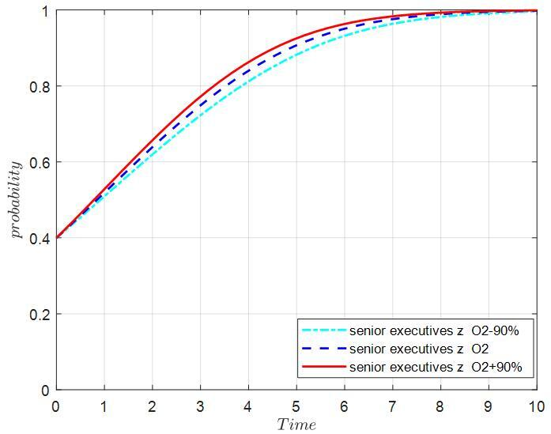
(b)
Figure 11: Behavior trends of three players at mature stage

Figure 11(c):Behavior trends of three players at mature stage
From Page.24 ,By Use Matlab.R2019a

clc;clear;close all;
K1=6,dC=0.3,O1=0.2,S1=0.3,N1=0.2,C1=0.1,K2=3,L1=1,L2=0.9,D=0.9,E=0.5,F=0.2,a=0.5,S2=0.4,N2=0.3,R=0.2,M=0.5,I1=0.8,I2=0.4,O2=0.1,G=0.4,C2=0.1;
K1 = 6
dC = 0.3000
O1 = 0.2000
S1 = 0.3000
N1 = 0.2000
C1 = 0.1000
K2 = 3
L1 = 1
L2 = 0.9000
D = 0.9000
E = 0.5000
F = 0.2000
a = 0.5000
S2 = 0.4000
N2 = 0.3000
R = 0.2000
M = 0.5000
I1 = 0.8000
I2 = 0.4000
O2 = 0.1000
G = 0.4000
%%%%%% line1
for L1=0.11
[t,y]=ode45(@(t,y) sanfang(t,y,K1,M,O1,S1,N1,C1,K2,L1,L2,D,E,F,a,S2,N2,R,I1,I2,O2,G,C2,dC),[0 10],[0.4 0.4 0.4]);
plot(t,y(:,1),'c-.','LineWidth',1.5);%%注意这里是三维
hold on
%%%%%% line1
end
for L1=0.3
[t,y]=ode45(@(t,y) sanfang(t,y,K1,M,O1,S1,N1,C1,K2,L1,L2,D,E,F,a,S2,N2,R,I1,I2,O2,G,C2,dC),[0 10],[0.4 0.4 0.4]);
plot(t,y(:,1),'b--','LineWidth',1.5);%%注意这里是三维
hold on
end
%%%%%% line1
for L1=0.49
[t,y]=ode45(@(t,y) sanfang(t,y,K1,M,O1,S1,N1,C1,K2,L1,L2,D,E,F,a,S2,N2,R,I1,I2,O2,G,C2,dC),[0 10],[0.4 0.4 0.4]);
plot(t,y(:,1),'r-','LineWidth',1.5);%%注意这里是三维
hold on
end

axis([0 10 0 1 0 1])
set(gca,'XTick',[0:1:10],'YTick',[0:0.2:1] ,'ZTick',[0:0.1:1])%%[0:坐标轴的单位长度:1]
xlabel('$Time$', 'interpreter','latex');
ylabel('$probability$','interpreter','latex', 'rotation',90);
zlabel('$z$','interpreter','latex','rotation',360);
grid on
legend('government x：O1-50%+O2-90%', 'government x：O1+O2','government x：O1+50%+O2+90%');%%图例小标签

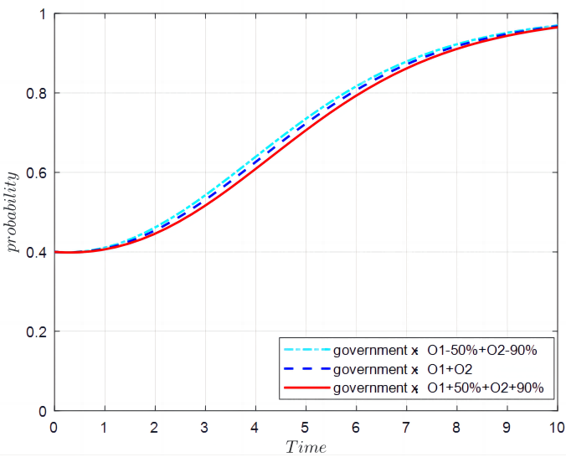
(c)
Figure 11: Behavior trends of three players at mature stage

Figure 12(a):Behavior trends of three players at mature stage
From Page.25 ,By Use Matlab.R2019a

clc;clear;close all;
K1=6,dC=0.3,O1=0.2,S1=0.3,N1=0.2,C1=0.1,K2=3,L1=1,L2=0.9,D=0.9,E=0.5,F=0.2,a=0.5,S2=0.4,N2=0.3,R=0.2,M=0.5,I1=0.8,I2=0.4,O2=0.1,G=0.4,C2=0.1;
K1 = 6
dC = 0.3000
O1 = 0.2000
S1 = 0.3000
N1 = 0.2000
C1 = 0.1000
K2 = 3
L1 = 1
L2 = 0.9000
D = 0.9000
E = 0.5000
F = 0.2000
a = 0.5000
S2 = 0.4000
N2 = 0.3000
R = 0.2000
M = 0.5000
I1 = 0.8000
I2 = 0.4000
O2 = 0.1000
G = 0.4000
%%%%%% line1
for S1=0.15,N1=0.1
[t,y]=ode45(@(t,y) sanfang(t,y,K1,M,O1,S1,N1,C1,K2,L1,L2,D,E,F,a,S2,N2,R,I1,I2,O2,G,C2,dC),[0 10],[0.4 0.4 0.4]);
plot(t,y(:,1),'c-.','LineWidth',1.5);%%注意这里是三维
hold on
%%%%%% line1
end
N1 = 0.1000
for S1=0.3,N1=0.2
[t,y]=ode45(@(t,y) sanfang(t,y,K1,M,O1,S1,N1,C1,K2,L1,L2,D,E,F,a,S2,N2,R,I1,I2,O2,G,C2,dC),[0 10],[0.4 0.4 0.4]);
plot(t,y(:,1),'b--','LineWidth',1.5);%%注意这里是三维
hold on
end
N1 = 0.2000
%%%%%% line1
for S1=0.45,N1=0.3
[t,y]=ode45(@(t,y) sanfang(t,y,K1,M,O1,S1,N1,C1,K2,L1,L2,D,E,F,a,S2,N2,R,I1,I2,O2,G,C2,dC),[0 10],[0.4 0.4 0.4]);
plot(t,y(:,1),'r-','LineWidth',1.5);%%注意这里是三维
hold on
end
N1 = 0.3000

axis([0 10 0 1 0 1])
set(gca,'XTick',[0:1:10],'YTick',[0:0.2:1] ,'ZTick',[0:0.1:1])%%[0:坐标轴的单位长度:1]
xlabel('$Time$', 'interpreter','latex');
ylabel('$probability$','interpreter','latex', 'rotation',90);
zlabel('$z$','interpreter','latex','rotation',360);
grid on
legend('enterprises y：S1+N1-50%', 'enterprises y：S1+N1','enterprises y：S1+N1+50%');%%图例小标签

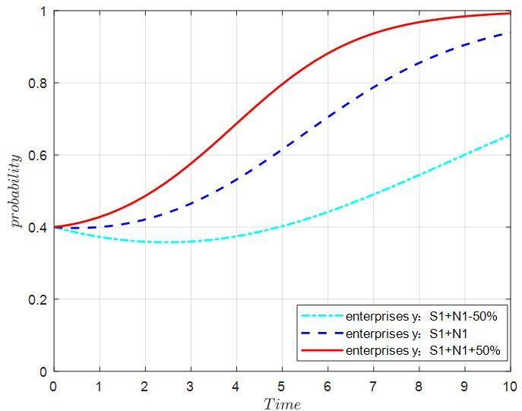
(a）
Figure 12: Behavior trends of three players at mature stage
Figure 12(b):Behavior trends of three players at mature stage
From Page.25 ,By Use Matlab.R2019a

clc;clear;close all;
K1=6,dC=0.3,O1=0.2,S1=0.3,N1=0.2,C1=0.1,K2=3,L1=1,L2=0.9,D=0.9,E=0.5,F=0.2,a=0.5,S2=0.4,N2=0.3,R=0.2,M=0.5,I1=0.8,I2=0.4,O2=0.1,G=0.4,C2=0.1;
K1 = 6
dC = 0.3000
O1 = 0.2000
S1 = 0.3000
N1 = 0.2000
C1 = 0.1000
K2 = 3
L1 = 1
L2 = 0.9000
D = 0.9000
E = 0.5000
F = 0.2000
a = 0.5000
S2 = 0.4000
N2 = 0.3000
R = 0.2000
M = 0.5000
I1 = 0.8000
I2 = 0.4000
O2 = 0.1000
G = 0.4000
%%%%%% line1
for G=0.2
[t,y]=ode45(@(t,y) sanfang(t,y,K1,M,O1,S1,N1,C1,K2,L1,L2,D,E,F,a,S2,N2,R,I1,I2,O2,G,C2,dC),[0 10],[0.4 0.4 0.4]);
plot(t,y(:,3),'c-.','LineWidth',1.5);%%注意这里是三维
hold on
%%%%%% line1
end
for G=0.4
[t,y]=ode45(@(t,y) sanfang(t,y,K1,M,O1,S1,N1,C1,K2,L1,L2,D,E,F,a,S2,N2,R,I1,I2,O2,G,C2,dC),[0 10],[0.4 0.4 0.4]);
plot(t,y(:,3),'b--','LineWidth',1.5);%%注意这里是三维
hold on
end
%%%%%% line1
for G=0.6
[t,y]=ode45(@(t,y) sanfang(t,y,K1,M,O1,S1,N1,C1,K2,L1,L2,D,E,F,a,S2,N2,R,I1,I2,O2,G,C2,dC),[0 10],[0.4 0.4 0.4]);
plot(t,y(:,3),'r-','LineWidth',1.5);%%注意这里是三维
hold on
end

axis([0 10 0 1 0 1])
set(gca,'XTick',[0:1:10],'YTick',[0:0.2:1] ,'ZTick',[0:0.1:1])%%[0:坐标轴的单位长度:1]
xlabel('$Time$', 'interpreter','latex');
ylabel('$probability$','interpreter','latex', 'rotation',90);
zlabel('$z$','interpreter','latex','rotation',360);
grid on
legend('senior executives z：G-50%', 'senior executives z:G','senior executives z：G+50%');%%图例小标签

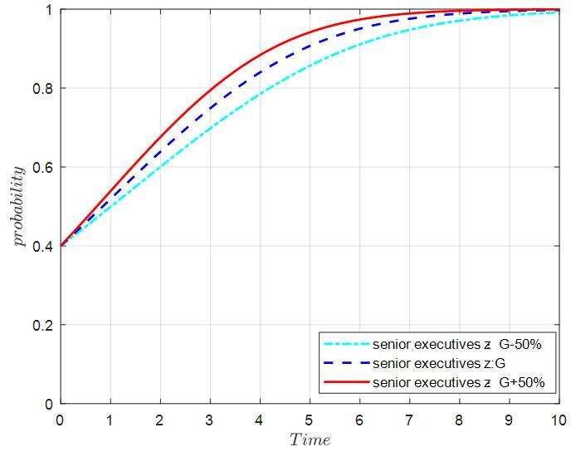
(b)
Figure 12: Behavior trends of three players at mature stage

Figure 12(c):Behavior trends of three players at mature stage
From Page.25 ,By Use Matlab.R2019a

clc;clear;close all;
K1=6,dC=0.3,O1=0.2,S1=0.3,N1=0.2,C1=0.1,K2=3,L1=1,L2=0.9,D=0.9,E=0.5,F=0.2,a=0.5,S2=0.4,N2=0.3,R=0.2,M=0.5,I1=0.8,I2=0.4,O2=0.1,G=0.4,C2=0.1;
K1 = 6
dC = 0.3000
O1 = 0.2000
S1 = 0.3000
N1 = 0.2000
C1 = 0.1000
K2 = 3
L1 = 1
L2 = 0.9000
D = 0.9000
E = 0.5000
F = 0.2000
a = 0.5000
S2 = 0.4000
N2 = 0.3000
R = 0.2000
M = 0.5000
I1 = 0.8000
I2 = 0.4000
O2 = 0.1000
G = 0.4000
%%%%%% line1
for S2=0.2,N2=0.15
[t,y]=ode45(@(t,y) sanfang(t,y,K1,M,O1,S1,N1,C1,K2,L1,L2,D,E,F,a,S2,N2,R,I1,I2,O2,G,C2,dC),[0 10],[0.4 0.4 0.4]);
plot(t,y(:,1),'c-.','LineWidth',1.5);%%注意这里是三维
hold on
%%%%%% line1
end
N2 = 0.1500
for S2=0.4,N2=0.3
[t,y]=ode45(@(t,y) sanfang(t,y,K1,M,O1,S1,N1,C1,K2,L1,L2,D,E,F,a,S2,N2,R,I1,I2,O2,G,C2,dC),[0 10],[0.4 0.4 0.4]);
plot(t,y(:,1),'b--','LineWidth',1.5);%%注意这里是三维
hold on
end
N2 = 0.3000
%%%%%% line1
for S2=0.6,N2=0.45
[t,y]=ode45(@(t,y) sanfang(t,y,K1,M,O1,S1,N1,C1,K2,L1,L2,D,E,F,a,S2,N2,R,I1,I2,O2,G,C2,dC),[0 10],[0.4 0.4 0.4]);
plot(t,y(:,1),'r-','LineWidth',1.5);%%注意这里是三维
hold on
end
N2 = 0.4500

axis([0 10 0 1 0 1])
set(gca,'XTick',[0:1:10],'YTick',[0:0.2:1] ,'ZTick',[0:0.1:1])%%[0:坐标轴的单位长度:1]
xlabel('$Time$', 'interpreter','latex');
ylabel('$probability$','interpreter','latex', 'rotation',90);
zlabel('$z$','interpreter','latex','rotation',360);
grid on
legend('government x：S2+N2-50%', 'government x：S2+N2','government x：S2+N2+50%');%%图例小标签

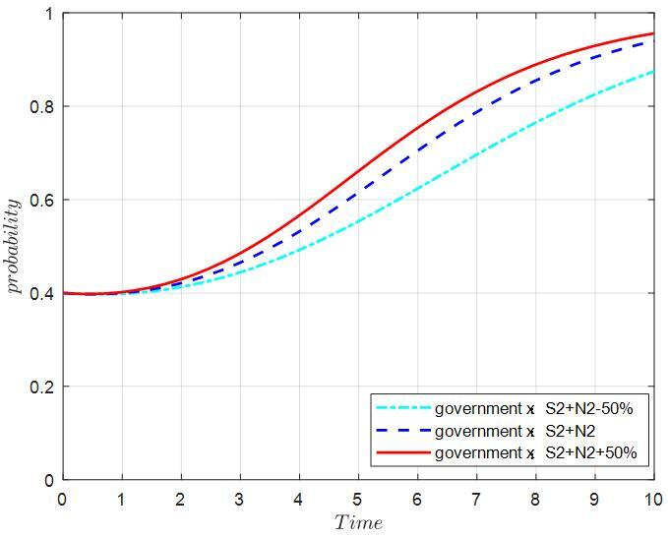
(c)
Figure 12: Behavior trends of three players at mature stage

