Table 1 Characteristics of study participants
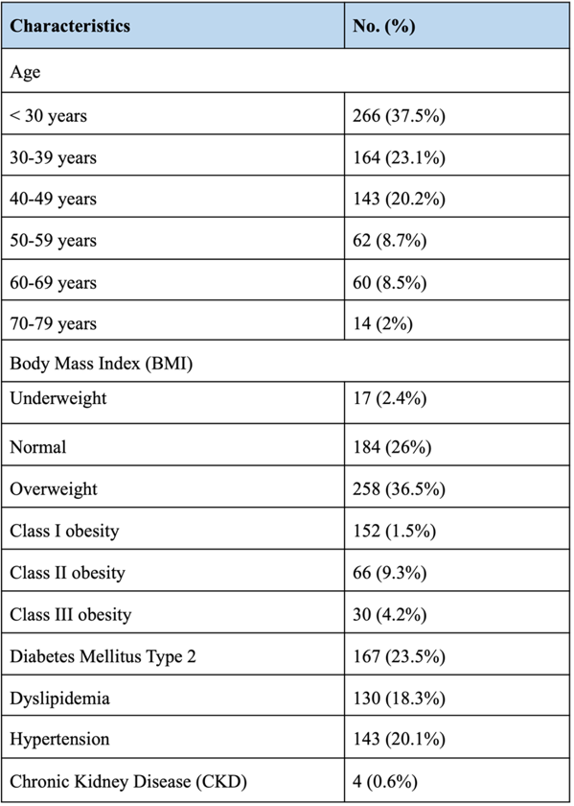
Table 2 Determinants of changing or maintaining smoking status
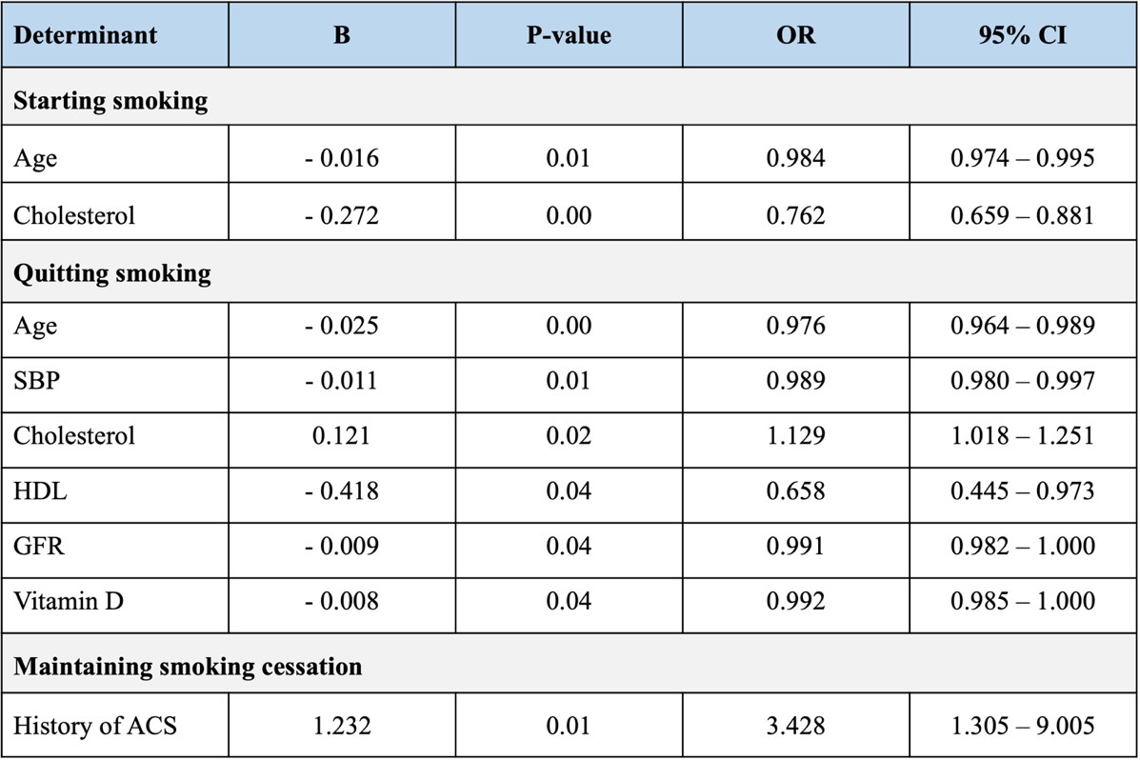
Table 3 Association of change in smoking status (continuing smoking and quitting smoking) with subjects comorbidities assessed at the end of follow-up period.

