Global huge grain production potential adapted to future climate change
Yansui Liu^{1, 3} , Zongfeng Chen¹, Xueqi Liu^{2,}*

1 Institute of Geographic Sciences and Natural Resources Research, Chinese Academy of Sciences, Beijing 100101, China
2 Agricultural Information Institute, Chinese Academy of Agricultural Sciences, Beijing 100086, China
3 College of Resources and Environment, University of Chinese Academy of Sciences, Beijing 100190, China

* Corresponding author:
Xueqi Liu, liuxueqi02@caas.cn

The Supplementary Information contains Supplementary Tables 1-10 and Figures 1-7.

Supplementary Tables

Supplementary Tab. 1 | The incremental slope of rice yield, 2020 rice yield, the rice increased yield and the proportion of rice yield in the top 10 countries over the past 40 years
Country | Incremental slope of rice yield (10⁵t/yr) | 2020 rice yield (10⁵t) | Rice increased yield (10⁵t) | Proportion of rice increased yield (%)
India | 24.28 | 1865.00 | 1061.88 | 31.97%
China | 12.32 | 2118.60 | 719.50 | 21.66%
Bangladesh | 9.87 | 549.06 | 340.85 | 10.26%
Vietnam | 9.01 | 427.65 | 311.18 | 9.37%
Indonesia | 6.12 | 546.49 | 249.97 | 7.53%
Thailand | 4.69 | 302.31 | 128.63 | 3.87%
Myanmar | 4.54 | 259.83 | 126.65 | 3.81%
Philippines | 3.30 | 192.95 | 116.48 | 3.51%
Cambodia | 2.63 | 112.48 | 95.31 | 2.87%
Nigeria | 1.86 | 81.72 | 70.82 | 2.13%

Supplementary Tab. 2 | The incremental slope of maize yield, 2020 maize yield, the maize increased yield and the proportion of maize yield in the top 10 countries over the past 40 years
Country | Incremental slope of maize yield (10⁵t/yr) | 2020 maize yield  (10⁵t) | Maize increased yield  (10⁵t) | Proportion of maize increased yield (%)
United States | 55.12 | 3584.47 | 1898.00 | 34.37%
China | 53.07 | 2606.70 | 1980.70 | 35.87%
Brazil | 18.96 | 1039.64 | 835.92 | 15.14%
Ukraine | 13.11 | 302.90 | 274.40 | 4.97%
Argentina | 10.11 | 583.96 | 519.96 | 9.42%
India | 5.82 | 287.66 | 218.09 | 3.95%
Indonesia | 5.37 | 246.87 | 206.96 | 3.75%
Russia | 5.32 | 138.79 | 117.44 | 2.13%
Mexico | 4.04 | 274.25 | 150.50 | 2.73%
Ethiopia | 3.39 | 100.22 | 85.66 | 1.55%

Supplementary Tab. 3 | The incremental slope of wheat yield, 2020 wheat yield, the wheat increased yield and the proportion of wheat yield in the top 10 countries over the past 40 years
Country | Incremental slope of wheat yield (10⁵t/yr) | 2020 wheat yield (10⁵t) | Wheat increased yield  (10⁵t) | Proportion of wheat increased yield (%)
India | 16.74 | 1078.61 | 760.31 | 23.39%
Russia | 15.68 | 858.96 | 397.30 | 12.22%
China | 14.68 | 1342.50 | 790.40 | 24.32%
Ukraine | 4.36 | 249.12 | 54.05 | 1.66%
Pakistan | 4.15 | 252.48 | 143.91 | 4.43%
Germany | 3.37 | 221.72 | 109.18 | 3.36%
Australia | 2.87 | 144.80 | 36.24 | 1.12%
France | 2.87 | 301.44 | 63.63 | 1.96%
Egypt | 2.05 | 91.02 | 73.65 | 2.27%
Uzbekistan | 1.80 | 61.58 | 51.15 | 1.57%

Supplementary Tab. 4 | The incremental slope of soybean yield, 2020 soybean yield, the soybean increased yield and the proportion of soybean yield in the top 10 countries over the past 40 years
Country | Incremental slope of soybean yield (10⁵t/yr) | 2020 soybean yield  (10⁵t) | Soybean increased yield (10⁵t) | Proportion of soybean increased yield (%)
Brazil | 27.29 | 1217.98 | 1066.42 | 53.21%
United States | 17.32 | 1147.49 | 658.27 | 32.85%
Argentina | 14.67 | 487.97 | 452.97 | 22.60%
India | 3.49 | 112.26 | 107.84 | 5.38%
Paraguay | 2.60 | 110.24 | 104.87 | 5.23%
Ukraine | 1.66 | 27.98 | 27.21 | 1.36%
Canada | 1.60 | 63.59 | 56.69 | 2.83%
China | 1.56 | 196.00 | 116.60 | 5.82%
Russia | 1.46 | 43.08 | 38.02 | 1.90%
Bolivia | 0.85 | 28.29 | 27.82 | 1.39%

Supplementary Tab. 5 | Considering CO2 fertilization effect, the potential yield and yield gaps (the difference with the average actual yield during 2011-2020) of rice, maize, wheat and soybean across different continents under the optimal scenarios in 2020s, 2050s and 2080s .
Continent | Future period | Rice potential yield(10⁷t） | Rice yield gaps (10⁷t) | Maize potential yield(10⁷t） | Maize yield gaps (10⁷t) | Wheat potential yield(10⁷t） | Wheat yield gaps (10⁷t) | Soybean potential yield(10⁷t） | Soybean yield gaps (10⁷t)
Global | 2020s | 105.39 | 31.43 | 124.30 | 25.13 | 129.81 | 51.83 | 40.43 | 9.07
Global | 2050s | 111.36 | 37.40 | 127.08 | 30.87 | 135.56 | 54.62 | 41.45 | 10.08
Global | 2080s | 114.08 | 40.12 | 129.61 | 34.12 | 138.80 | 57.14 | 42.46 | 11.10
Asia | 2020s | 93.10 | 26.40 | 61.21 | 10.64 | 43.83 | 28.80 | 6.87 | 3.98
Asia | 2050s | 98.67 | 31.97 | 61.31 | 14.11 | 47.29 | 28.90 | 7.06 | 4.16
Asia | 2080s | 100.90 | 34.19 | 61.02 | 16.64 | 49.82 | 28.61 | 7.33 | 4.44
Africa | 2020s | 6.20 | 3.11 | 3.36 | 15.51 | 22.54 | 0.76 | 0.44 | 0.20
Africa | 2050s | 6.37 | 3.28 | 3.19 | 15.74 | 22.77 | 0.59 | 0.45 | 0.21
Africa | 2080s | 6.70 | 3.61 | 2.84 | 15.70 | 22.72 | 0.24 | 0.47 | 0.23
Europe | 2020s | 0.58 | 0.17 | 32.09 | 0.07 | 11.79 | 7.88 | 0.90 | 0.00
Europe | 2050s | 0.64 | 0.23 | 33.99 | 0.56 | 12.28 | 9.78 | 0.94 | 0.03
Europe | 2080s | 0.65 | 0.24 | 35.94 | 0.32 | 12.04 | 11.73 | 1.00 | 0.09
Oceania | 2020s | 0.02 | -0.04 | 6.35 | -0.01 | 0.05 | 3.95 | 0.00 | 0.00
Oceania | 2050s | 0.02 | -0.04 | 6.39 | -0.01 | 0.06 | 3.98 | 0.00 | 0.00
Oceania | 2080s | 0.02 | -0.04 | 6.80 | 0.00 | 0.06 | 4.40 | 0.00 | 0.00
North America | 2020s | 2.14 | 0.94 | 18.88 | 0.39 | 39.59 | 9.95 | 15.68 | 4.62
North America | 2050s | 2.28 | 1.08 | 19.77 | 1.61 | 40.81 | 10.83 | 16.00 | 4.94
North America | 2080s | 2.33 | 1.13 | 20.56 | 2.39 | 41.60 | 11.63 | 16.50 | 5.43
South America | 2020s | 3.34 | 0.85 | 2.42 | -1.47 | 12.02 | 0.50 | 16.53 | 0.28
South America | 2050s | 3.38 | 0.88 | 2.44 | -1.14 | 12.35 | 0.53 | 16.99 | 0.74
South America | 2080s | 3.48 | 0.98 | 2.44 | -0.93 | 12.56 | 0.53 | 17.16 | 0.91

Supplementary Tab. 6 | Without considering CO2 fertilization effect, the potential yield and yield gaps (the difference with the average actual yield during 2011-2020) of rice, maize, wheat and soybean across different continents under the optimal scenarios in 2020s, 2050s and 2080s.
Continent | Future period | Rice potential yield(107t） | Rice yield gaps (107t) | Maize potential yield(107t） | Maize yield gaps (107t) | Wheat potential yield(107t） | Wheat yield gaps (107t) | Soybean potential yield(107t） | Soybean yield gaps (107t)
Global | 2020s | 100.61 | 26.65 | 126.85 | 22.16 | 120.14 | 47.67 | 38.93 | 7.57
Global | 2050s | 101.33 | 27.36 | 128.87 | 24.18 | 121.26 | 48.80 | 38.86 | 7.50
Global | 2080s | 101.99 | 28.03 | 128.88 | 24.20 | 121.80 | 49.34 | 38.84 | 7.48
Asia | 2020s | 88.90 | 22.19 | 42.83 | 9.64 | 59.03 | 26.61 | 6.62 | 3.73
Asia | 2050s | 89.71 | 23.00 | 43.85 | 10.67 | 58.69 | 26.28 | 6.75 | 3.85
Asia | 2080s | 90.40 | 23.69 | 44.37 | 11.19 | 59.13 | 26.72 | 6.80 | 3.90
Africa | 2020s | 5.92 | 2.84 | 22.02 | 15.00 | 3.30 | 0.70 | 0.43 | 0.18
Africa | 2050s | 5.84 | 2.76 | 22.16 | 15.14 | 3.11 | 0.51 | 0.42 | 0.18
Africa | 2080s | 5.81 | 2.72 | 21.51 | 14.49 | 3.29 | 0.69 | 0.43 | 0.18
Europe | 2020s | 0.55 | 0.14 | 11.52 | -0.20 | 31.06 | 6.86 | 0.87 | -0.04
Europe | 2050s | 0.56 | 0.14 | 11.53 | -0.19 | 32.28 | 8.08 | 0.86 | -0.05
Europe | 2080s | 0.56 | 0.14 | 11.81 | 0.09 | 32.53 | 8.32 | 0.91 | 0.01
Oceania | 2020s | 0.02 | -0.04 | 0.05 | -0.01 | 6.38 | 3.97 | 0.00 | 0.00
Oceania | 2050s | 0.02 | -0.04 | 0.05 | -0.01 | 6.44 | 4.03 | 0.00 | 0.00
Oceania | 2080s | 0.02 | -0.04 | 0.05 | -0.01 | 6.21 | 3.80 | 0.00 | 0.00
North America | 2020s | 2.03 | 0.83 | 38.67 | -0.54 | 18.02 | 9.08 | 15.09 | 4.02
North America | 2050s | 2.03 | 0.82 | 39.52 | 0.31 | 18.42 | 9.49 | 15.02 | 3.96
North America | 2080s | 2.03 | 0.83 | 39.57 | 0.36 | 18.33 | 9.39 | 14.95 | 3.88
South America | 2020s | 3.19 | 0.69 | 11.75 | -1.74 | 2.35 | 0.44 | 15.93 | -0.32
South America | 2050s | 3.17 | 0.68 | 11.75 | -1.74 | 2.32 | 0.41 | 15.81 | -0.44
South America | 2080s | 3.18 | 0.68 | 11.57 | -1.92 | 2.32 | 0.41 | 15.76 | -0.49

Supplementary Tab. 7 | Different potential grain productivity types in rice-growing countries across different continents in the future.
Continent | Considering CO₂ fertilization effect |  |  |  | Without considering CO₂ fertilization effect
Continent | Steady increased production type |  | Fluctuating increased production type | Overloaded production type | Steady increased production type | Fluctuating increased production type | Overloaded production type
Global | 79 | 10 |  | 13 | 69 | 11 | 22
Asia | 79 | 10 |  | 13 | 16 | 5 | 7
Africa | 30 | 1 |  | 5 | 29 | 2 | 5
Europe | 7 | 2 |  | 1 | 6 | 1 | 3
Oceania | 7 | 2 |  | 1 | 1 | 0 | 2
North America | 13 | 0 |  | 0 | 12 | 0 | 1
South America | 6 | 2 |  | 4 | 5 | 3 | 4

Supplementary Tab. 8 | Different potential grain productivity types in maize-growing countries across different continents in the future.
Continent | Considering CO₂ fertilization effect |  |  |  | Without considering CO₂ fertilization effect
Continent | Steady increased production type |  | Fluctuating increased production type | Overloaded production type | Steady increased production type | Fluctuating increased production type | Overloaded production type
Global | 85 | 18 |  | 23 | 83 | 17 | 26
Asia | 17 | 5 |  | 6 | 15 | 17 | 26
Africa | 36 | 3 |  | 0 | 36 | 3 | 0
Europe | 11 | 8 |  | 10 | 11 | 6 | 12
Oceania | 0 | 1 |  | 3 | 0 | 1 | 3
North America | 13 | 0 |  | 2 | 13 | 0 | 2
South America | 8 | 1 |  | 2 | 8 | 1 | 2

Supplementary Tab. 9 | Different potential grain productivity types in wheat-growing countries across different continents in the future.
Continent | Considering CO₂ fertilization effect |  |  |  | Without considering CO₂ fertilization effect
Continent | Steady increased production type |  | Fluctuating increased production type | Overloaded production type | Steady increased production type | Fluctuating increased production type | Overloaded production type
Global | 82 | 10 |  | 15 | 69 | 22 | 16
Asia | 82 | 10 |  | 15 | 22 | 6 | 6
Africa | 13 | 5 |  | 6 | 9 | 10 | 5
Europe | 32 | 2 |  | 2 | 28 | 5 | 3
Oceania | 2 | 0 |  | 0 | 2 | 0 | 0
North America | 6 | 1 |  | 1 | 3 | 0 | 0
South America | 3 | 0 |  | 0 | 5 | 1 | 2

Supplementary Tab. 10 | Different potential grain productivity types in soybean-growing countries across different continents in the future.
Continent | Considering CO₂ fertilization effect |  |  |  | Without considering CO₂ fertilization effect
Continent | Steady increased production type |  | Fluctuating increased production type | Overloaded production type | Steady increased production type | Fluctuating increased production type | Overloaded production type
Global | 46 | 4 |  | 16 | 44 | 3 | 19
Asia | 17 | 0 |  | 4 | 16 | 1 | 4
Africa | 11 | 0 |  | 3 | 11 | 0 | 3
Europe | 7 | 3 |  | 6 | 6 | 2 | 8
Oceania | 0 | 0 |  | 0 | 0 | 0 | 0
North America | 6 | 0 |  | 2 | 5 | 0 | 2
South America | 5 | 1 |  | 1 | 6 | 0 | 2

Supplementary Figures
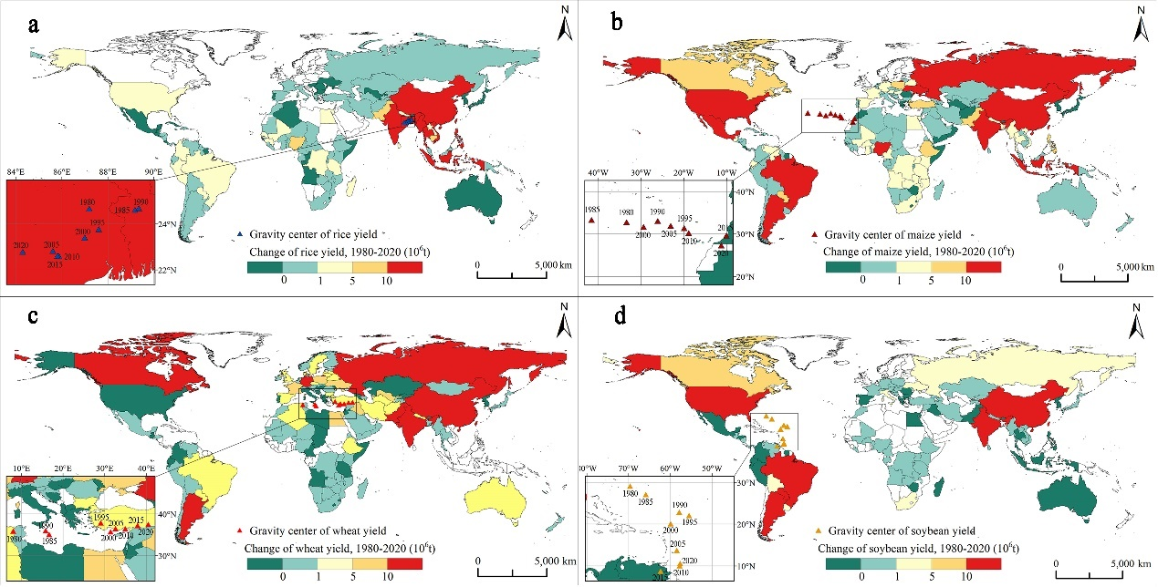
Supplementary Fig. 1 | Global distribution patterns of yield changes for four staple crops during 1980-2020. The changes in yields for rice (a), maize (b), wheat (c) and soybean (d). The triangular points in (a), (b), (c) and (d) represent the barycenter of each crop’s yield at 5-year intervals from 1980 to 2020.

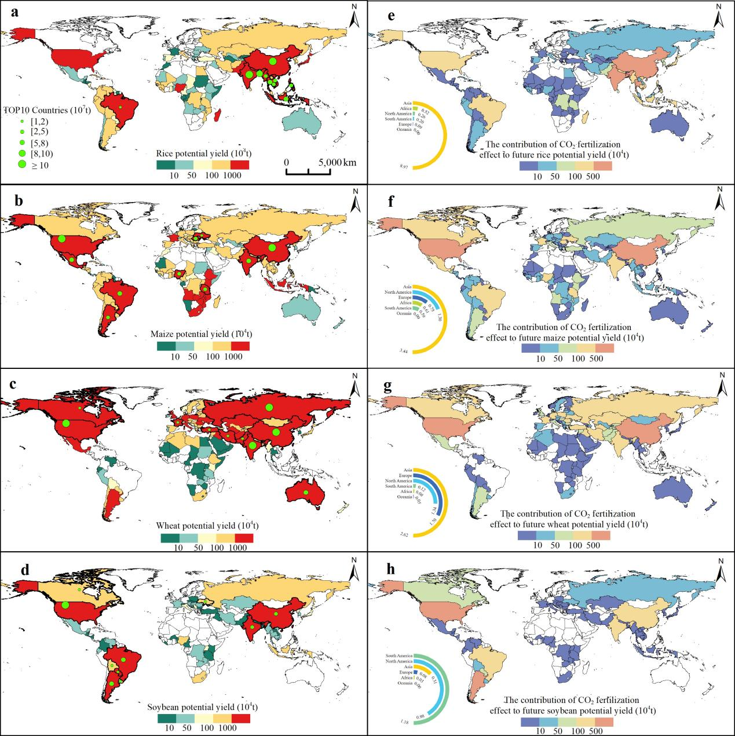
Supplementary Fig. 2 | Considering the CO2 fertilization effect, The potential yield patterns of rice (a), maize (b), wheat (c) and soybean (d) in the mid-term future (2050s) under the optimal scenarios of RCP8.5, RCP8.5, RCP6.0 and RCP6.0, respectively. The contribution amount patterns of CO2 fertilization effect to future potential yield for rice (e), maize (f), wheat (g) and soybean (h) under the optimal scenarios in the 2050s.

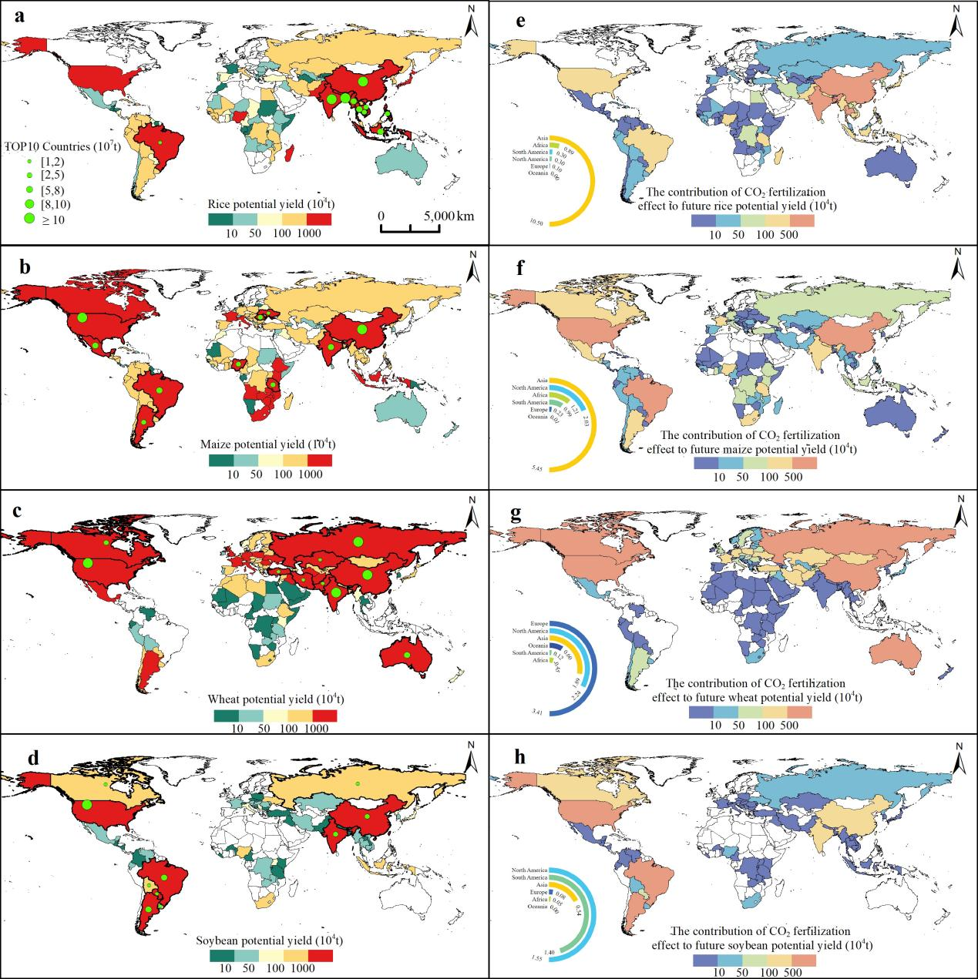
Supplementary Fig. 3 | Considering the CO2 fertilization effect, The potential yield patterns of rice (a), maize (b), wheat (c) and soybean (d) in the long-term future (2080s) under the optimal scenarios of RCP8.5, RCP8.5, RCP6.0 and RCP6.0, respectively. The contribution amount patterns of CO2 fertilization effect to future potential yield for rice (e), maize (f), wheat (g) and soybean (h) under the optimal scenarios in the 2080s.

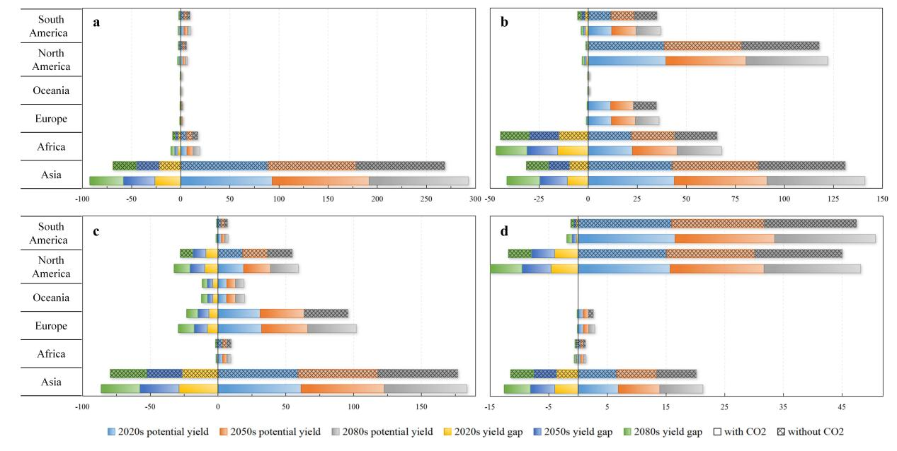
Supplementary Fig. 4 | The potential yield and yield gaps of rice (a), maize (b), wheat (c) and soybean (d) under the optimal scenarios across each continent in the 2020s, 2050s and 2080s, respectively.

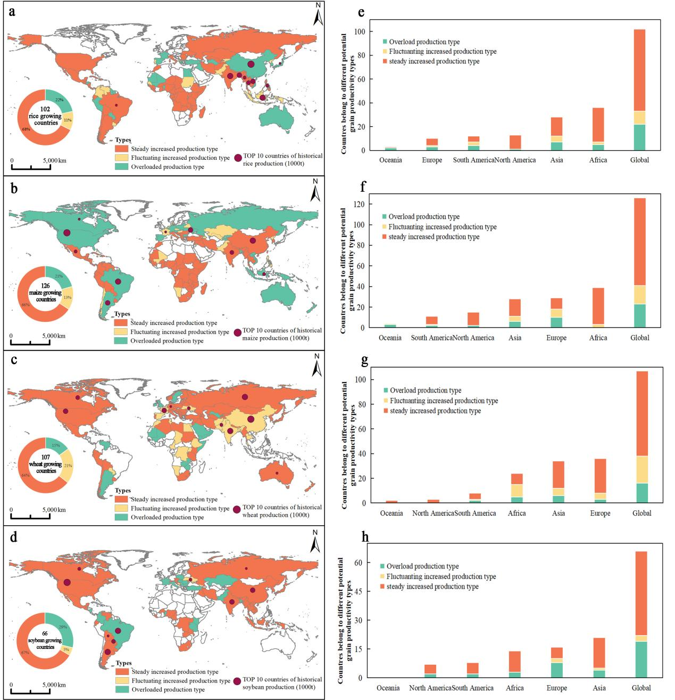
Supplementary Fig. 5 | The future spatial distribution of potential grain productivity types for four staple crops without considering CO2 fertilization effect. The spatial distribution of potential grain productivity types for rice (a), maize (b), wheat (c) and soybean (d) in the future. The inset pies in (a)-(d) represent the yields of the top 10 countries in historical production for corresponding crops. Countries of different continents belong to different potential grain productivity types for rice (e), maize (f), wheat (g) and soybean (h).

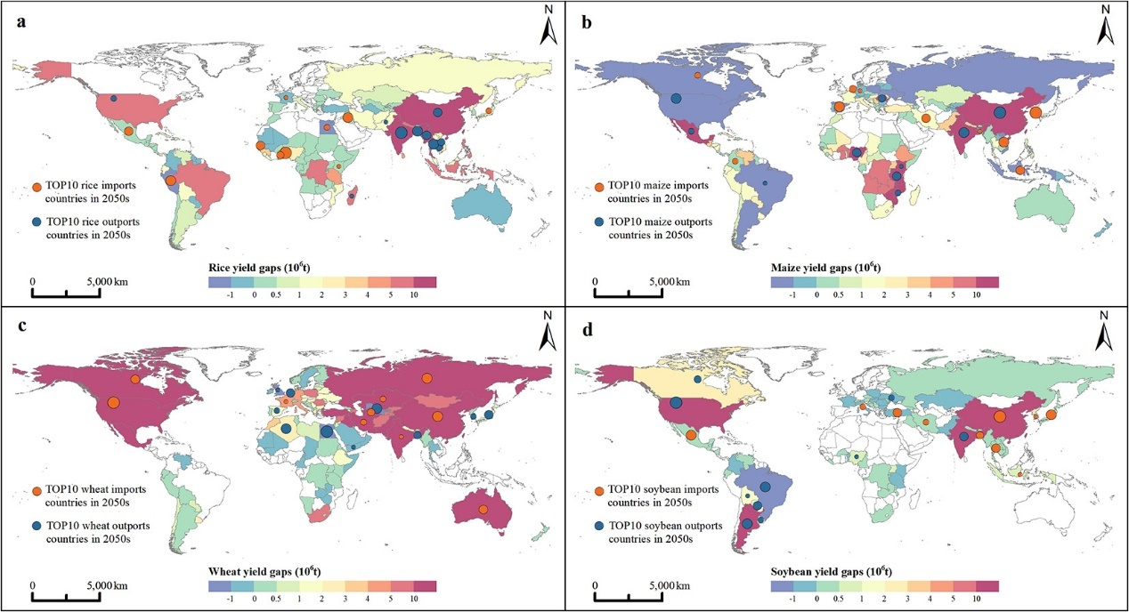
Supplementary Fig. 6 | Considering the CO₂ fertilization effect, the yield gaps pattern of rice (a), maize (b), wheat (c) and soybean (d) in the mid-term(2050s) future under the optimal scenarios of RCP8.5, RCP8.5, RCP6.0 and RCP6.0, respectively.

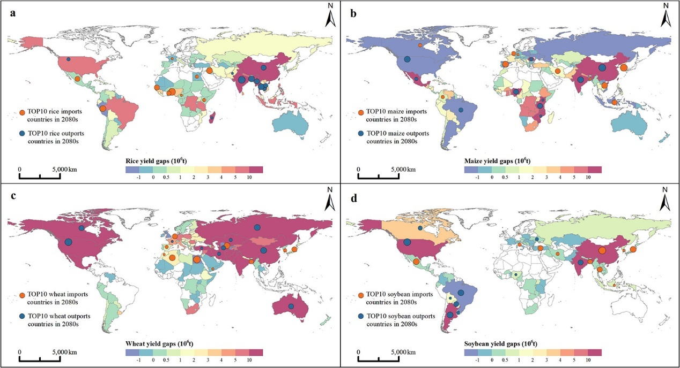
Supplementary Fig. 7 | Considering the CO₂ fertilization effect, the yield gaps pattern of rice (a), maize (b), wheat (c) and soybean (d) in the long-term(2080s) future under the optimal scenarios of RCP6.0, RCP8.5, RCP6.0 and RCP6.0, respectively.

