Supplementary information.
Uniform impact on individual megakaryocytes is essential for efficient in vitro platelet production
Andrei K. Garzon Dasgupta^{1, +}, Anaïs Pongérard^{1, +}, Léa Mallo¹, Anita Eckly¹, François Lanza¹, Olivier Boiron², Yannick Knapp³ and Catherine Strassel^{1,*}

¹Université de Strasbourg, INSERM, EFS Grand-Est, BPPS UMR-S1255, FMTS, F-67065 Strasbourg, France
² CNRS, Université Aix-Marseille, Ecole Centrale Marseille, IRPHE UMR7342, F-13000 Marseille, France
³Université Avignon, LAPEC EA4278, F-84000 Avignon, France
*catherine.strassel@efs.sante.fr
⁺these authors contributed equally to this work

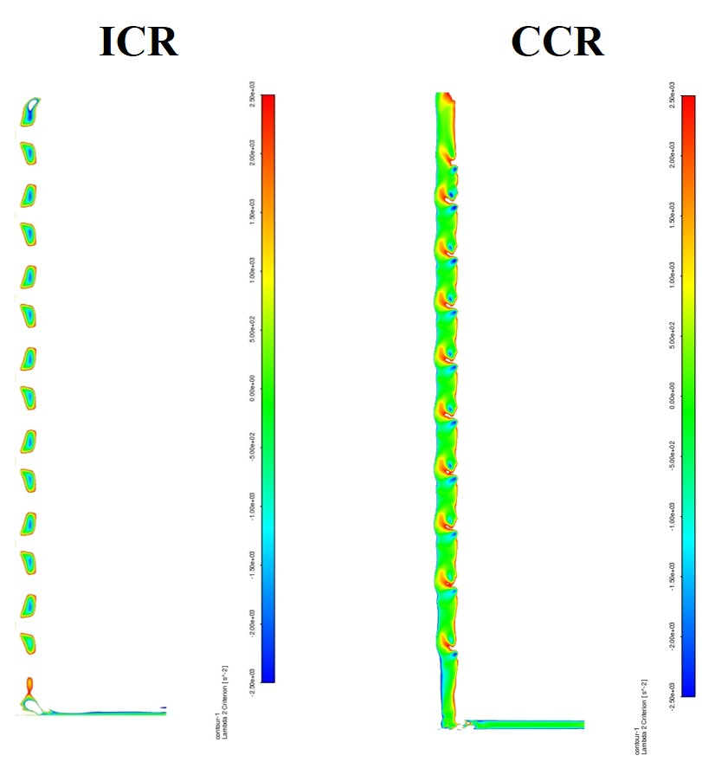
Figure S1. λ₂ criterion for vortex identification shows regular structures along the height

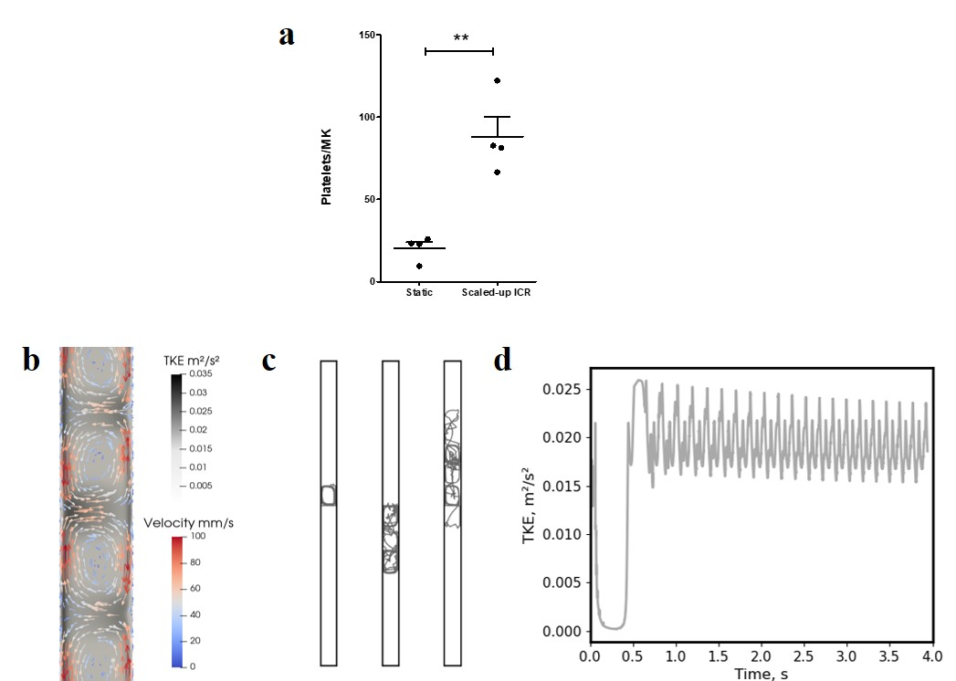
Figure S2. Scaled-up “ICR” Taylor-Couette system. a Platelet yield for the scaled-up TC configuration. Paired t-test. p=0.0059 b CFD analysis of the Turbulent kinetic energy (TKE) and Velocity fields in the “ICR” system. c Representative particle trajectories. d The impact of turbulent kinetic energy on a single particle along the trajectory

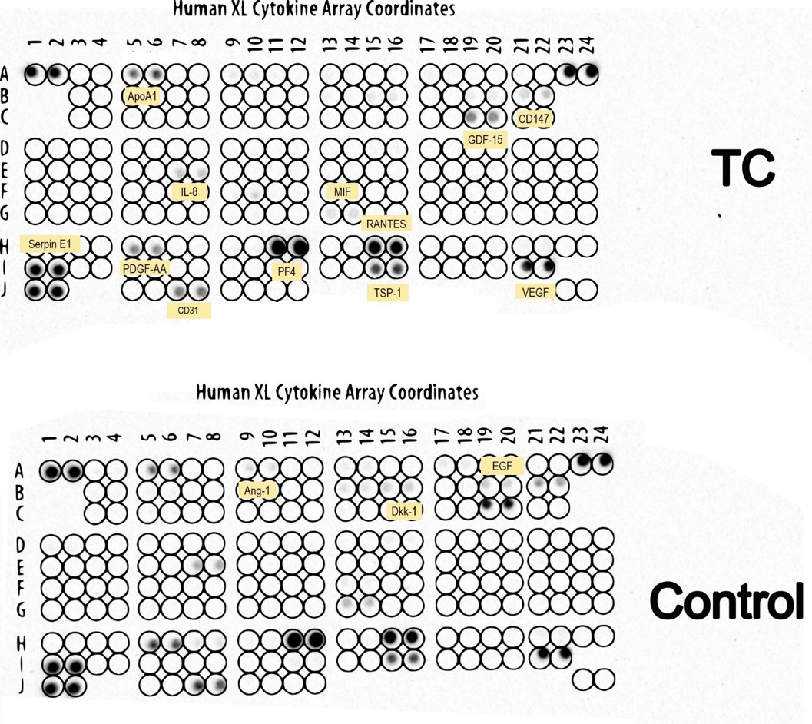
Figure S3. Similar levels of cytokines in the medium after Taylor-Couette liberation of platelets (TC) and static condition (Control).

