Climate policy portfolios that accelerate emission reductions

8 July 2024

SUPPLEMENTARY INFORMATION 2 (SI2): CLIMATE POLICY VIGNETTES OF SELECT COUNTRIES
1. Country selection strategy 2
2. Effect of climate policy density 2
United States of America 2
China 4
Brazil 5
3. Effect of policy sectoral coverage 6
Israel 6
Russia 8
Norway 9
4. Effect of policy instrument type 11
Estonia 11
Israel 12
Indonesia 12
5. Effect of emission reduction targets 14
The United States of America 14
Mexico 14
6. Effect of energy ministries 16
United States of America 16
7. Effect of independent advisory bodies 16
United Kingdom 16

Country selection strategy
We selected countries for policy vignettes to help interpret the results of the econometric analysis (Table S3). We grouped countries into terciles (Fast, Medium, Slow) on the dependent variable: emission intensity reductions. We grouped countries into terciles (High, Medium, Low) on each of the independent variables: climate policy density, policy sectoral coverage (diversity index), policy instrument type (diversity index). We then selected countries in the High group on the independent variable and the Fast group on the dependent variable (for examples) or the Slow group on the dependent variable (for counter-examples).
Table S3. Summary of country selection.
To illustrate policy density effect | To illustrate policy sectoral coverage effect | To illustrate policy instrument type effect ¹ | To illustrate targets and institutions interaction effect
USA  (High policy density, Fast emission intensity reduction) | ISRAEL  (High energy sector specialisation, Fast emission intensity reduction) | ESTONIA  (High market-based instrument type specialisation, Fast emission intensity reduction) | USA  (High policy density and absolute emissions targets and energy ministry, Fast emission intensity reduction)
CHINA  (High + fast catchup in policy density, Medium emission intensity reduction) | RUSSIA  (High buildings sector specialisation, Fast emission intensity reduction) | ISRAEL  (High regulatory instrument type specialisation, Fast emission intensity reductions) | UK  (High policy density and independent body, Fast emission intensity reduction)
BRAZIL  (Low policy density, Slow emission intensity reduction) | NORWAY  (Low sectoral specialisation, Slow emission intensity reduction) | INDONESIA  (Low instrument type specialisation, Slow emission intensity reduction) | MEXICO  (High policy density, no absolute emissions targets, Slow emissions intensity reduction)
¹ Voluntary instruments comprise 23% of the sample so are not included.
² Only 8% of policies target the industrial sector so are not included.

Effect of climate policy density
Our econometric analysis indicates a positive association between the overall climate policy density of a country and its carbon emission intensity. Below, we illustrate this pattern with selected country vignettes. For this purpose, we portray two countries with High climate policy density and relatively Fast emission intensity reduction (USA and China) and one country with Low climate policy density and relatively Slow emission intensity reduction (Brazil).

United States of America
In the USA, increasing policy density has coincided with relatively Fast carbon emission intensity reductions.

Figure S4. Historical development of the United States’ climate policy portfolio
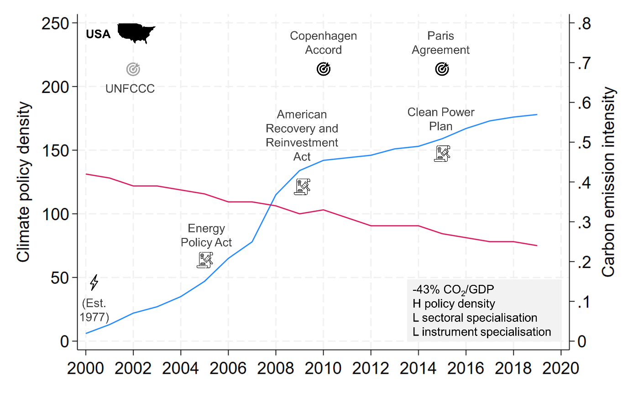
Note: Based on policy data from the IEA Policies and Measures Database (PMD) and carbon emission data from the IEA CO2 Emissions From Fuel Combustion Database. Data on targets, energy ministries and advisory bodies retrieved from various sources (see Table S1 in SI1: Data & Models).

Historically, the electricity and heat production sectors have contributed most to the USA’s GHG emissions, followed by transport and buildings. Whereas emissions from the latter have remained stable, the country was successful in significantly decreasing emissions from electricity and heat. The decrease can be traced back to a significant reduction in the combustion of coal and oil and a strong uptake of natural gas and renewable energy (Jensen & Grieger, 2022).
Key federal climate policies in the USA since 2000 include the 2005 Energy Policy Act and the 2009 American Recovery and Reinvestment Act. These two have been identified as key policies fostering renewable energy production and improving energy efficiency (Le Quéré et al., 2019; Pischke et al., 2018). The Clean Power Plan adopted in 2015 represents a further key federal climate policy. It triggered the adoption of state-level policies that promoted the expansion of renewable energy and reduced emissions from coal and oil power plants (Grant et al., 2014; Pischke et al., 2018).
Overall, the USA exemplifies the positive association between the adoption of energy related climate policies, a reduction in energy generation from oil and coal, an expansion of renewable energy and equivalent carbon emission reductions in the electricity and heat sector.

China
China’s carbon emission intensity has been in steady decline since 2005. This trend has coincided with a sharp increase in climate policy adoption. According to the IEA, China had adopted 210 climate policies and measures in 2019, a number which is only exceeded by the USA.

Figure S5. Historical development of China’s climate policy portfolio.
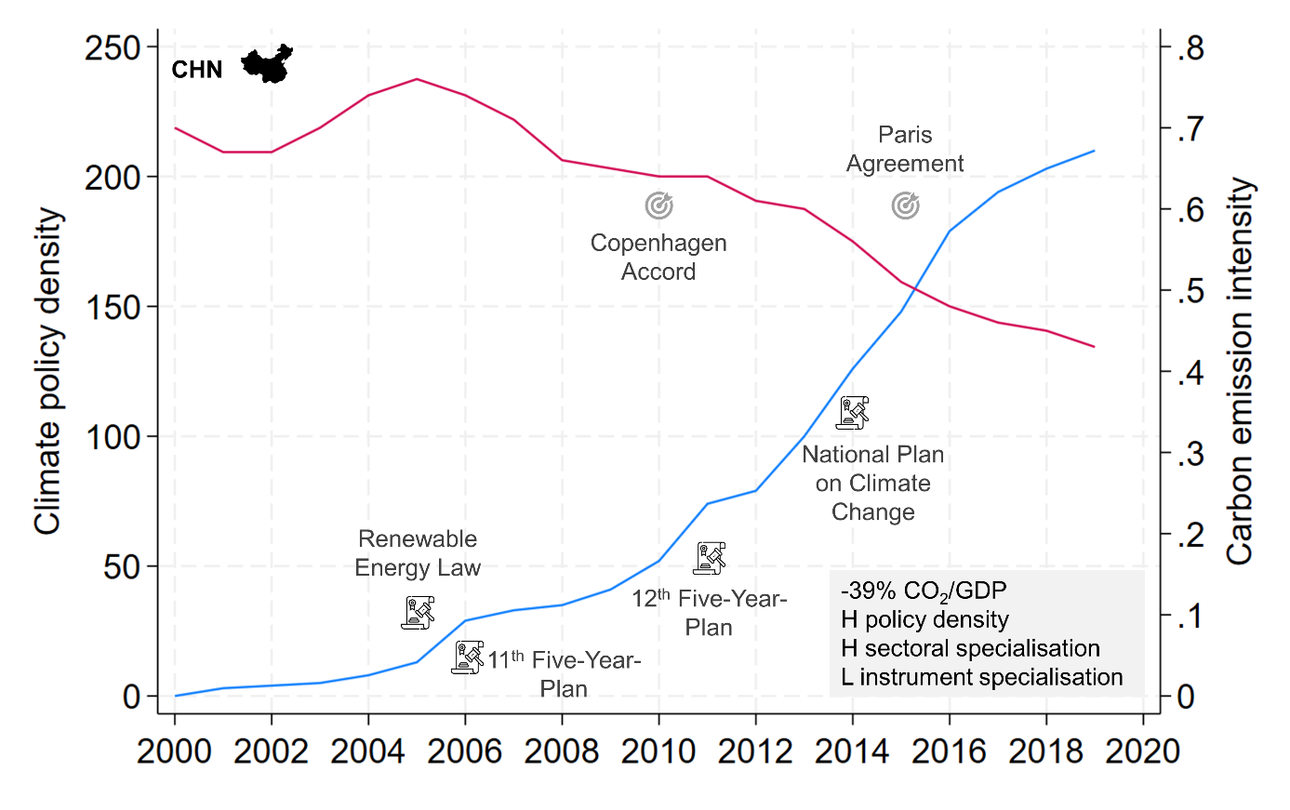
Note: Based on policy data from the IEA Policies and Measures Database (PMD) and carbon emission data from the IEA CO2 Emissions From Fuel Combustion Database. Data on targets, energy ministries and advisory bodies retrieved from various sources (see Table S1 in SI1: Data & Models).

While China was successful in improving its carbon emission intensity, its greenhouse gas emissions have grown by more than 75% since 2000 due to its strong economic growth and energy demand. Historically, emissions from electricity and heat have contributed the largest share, followed by manufacturing and construction. Combustion of coal has been the largest driver of emissions from the energy sector. While energy generation from coal grew in absolute terms, its relative share decreased significantly due to a significant expansion of renewable energies (Erbach & Jochheim, 2022).
China's policy portfolio has a broad sectoral coverage (Sandalow et al., 2022). After ratifying the Kyoto Protocol in 2002, China adopted a Renewable Energy Law in 2005, which included renewable energy targets and established feed-in-tariffs for renewable energy. The 11th Five-Year-Plan (2006-2010) added the first national target for improving energy efficiency, including instructions for subnational political elites to implement measures to achieve them. In response to the financial crisis in 2008, China adopted an economic stimulus, which included financial support for the solar power manufacturing industry. Climate policy ambition increased with the 12th Five-Year-Plan (2011-2015), which included an emission reduction target and led to the publication of a climate work plan and the National Plan on Climate Change (2014-2020). In 2015, China submitted an Intended-Determined Contribution (INDC) to the UNFCCC, which included several more specific climate targets. China’s ambition to reduce its carbon dioxide emissions will be challenging to achieve given its equally ambitious industrial development goals; it is telling that its climate policies have been criticised for not significantly reducing GHG emissions Fast enough to achieve the goals set by the Paris Agreement (Climate Action Tracker, 2022; Gallagher et al., 2019).
Overall, our analysis suggests that Chinese policy efforts have led to decreased carbon emission intensity despite the strong growth in absolute emissions. This applies especially for the energy sector. The Chinese government has implemented several policies to reduce emissions in this sector, which has contributed to improved efficiency and a reduction of carbon dioxide emissions from the energy sector (Zhao et al., 2015).

Brazil
Climate mitigation in Brazil has been characterised by a comparatively Slow increase in climate policy density and simultaneously Slow reduction in emission intensity.

Figure S6. Historical development of Brazil’s climate policy portfolio.
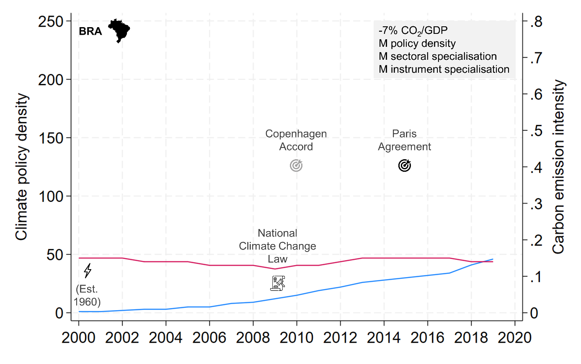
Note: Based on policy data from the IEA Policies and Measures Database (PMD) and carbon emission data from the IEA CO2 Emissions From Fuel Combustion Database. Data on targets, energy ministries and advisory bodies retrieved from various sources (see Table S1 in SI1: Data & Models).

Greenhouse gas emissions from mostly all sectors in Brazil have increased over the last decades. The main driver of carbon emissions has been deforestation (Viola & Basso, 2015). By some margin, emissions from transport represent the second largest source of greenhouse gas emissions and have also increased over time. In addition, energy consumption in Brazil grew significantly in the last two decades. Especially the combustion of oil, amplified by the discovery of deep indigenous oil reserves in 2011, has contributed to increasing emissions from the electricity and heat sector (Viola & Basso, 2015).
With regard to policy efforts to mitigate climate change, Brazil has experienced different phases since 2000. In the beginning of the 21st century, Brazil witnessed increasing policy efforts to reduce carbon emissions under the first Lula administration (Viola & Basso, 2015). Most prominently, it adopted the National Climate Change Law in 2009, which represents the country’s flagship climate legislation. These efforts mostly addressed emissions from deforestation and neglected other sectors (Pischke et al., 2018). Nevertheless, they are largely responsible for the reduction in carbon emission intensity until 2009 (Viola & Basso, 2015). After 2011, Brazil experienced a sharp U turn in its policy efforts. Under the Rousseff and Temer administrations, existing climate policy was significantly weakened (Kahlen et al., 2022). The situation worsened under Bolsonaro’s presidency from 2016, which led to a further weakening of relevant regulations and the adoption of new policies that dismantled the institutional and legal framework to reduce deforestation (Kahlen et al., 2022).
Overall, Brazil represents an exemplary case where a Slow increase in climate policy density coincided with mostly stable carbon emission intensity. This applies especially for the 2010s, where the country dropped its policy efforts to halt deforestation (Brazil’s largest driver of carbon emissions) and neglected to adopt ambitious policies to reduce emissions from transport or energy.

Effect of policy sectoral coverage
Our econometric analysis indicates that countries that concentrated their climate policies on specific sectors experienced relatively Fast reductions in carbon emission intensity. In the following, we present three exemplar cases for this pattern. In two cases, High policy specialisation on one sector correlates with relatively Fast carbon emission intensity reduction (Israel and Russia), and in one case (Norway), Low sector specialisation is associated with relatively Slow emission intensity reduction.

Israel
Although Israel adopted significantly less climate policies compared to other states (16 policies by 2019), its carbon emission intensity has decreased since 2000. This, at first glance, contradictory finding could be explained by the country’s focus on the adoption of climate policies targeting the energy sector, which has produced the largest share of carbon emissions. Throughout the study period, more than 50% of the countries’ climate policies addressed electricity and heat production. The increase of such policies over time coincided with a marked reduction in carbon emission intensity in the energy sector.
Historically, the electricity and heat sector has contributed the largest share of carbon dioxide emissions in Israel, followed by some margin by emissions from transport. Combustion of oil and coal have mostly driven the emissions. The discovery of large natural gas reserves in Israel in 2009 led to a strong increase in energy generation from gas and a subsequent reduction in coal combustion. Renewable energy has contributed only a minor share to the overall energy mix so far.

Figure S7. Historical development of Israel’s climate policy portfolio.
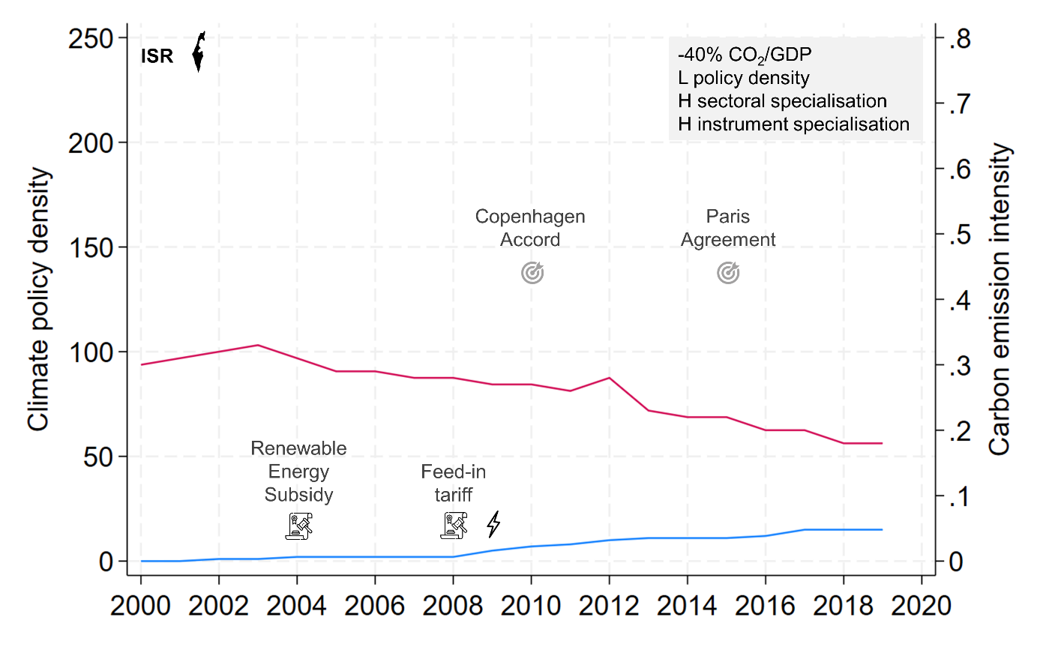
Note: Based on policy data from the IEA Policies and Measures Database (PMD) and carbon emission data from the IEA CO2 Emissions From Fuel Combustion Database. Data on targets, energy ministries and advisory bodies retrieved from various sources (see Table S1 in SI1: Data & Models).

Policies adopted in Israel to mitigate carbon emissions in the energy sector mostly include those supporting the uptake of renewable energy. They included adopting a subsidy for electricity generation from wind and photo-voltaic in 2004, introducing a feed-in-tariff for solar and wind power in 2008 and launching a solar tendering round in 2017. Whereas the first two created financial incentives to invest in renewable energy, the later reduced bureaucratic burdens (Ashwarya, 2021).
The renewable energy production sector has indeed increased in recent years, mostly with regard to solar energy (Ashwarya, 2021). Nevertheless, the share of renewable energy generation in Israel still remains very Low compared to other OECD countries: less than 5% of electricity were produced by renewables in 2018 (Ersoy et al., 2021; Solomon et al., 2018). In fact, the decrease in carbon emissions from the energy sector can mostly be explained by the replacement of coal combustion by natural gas. The discovery of indigenous natural gas also hampered renewable energy expansion and it has only recently gained new momentum (Michaels & Tal, 2015).
Overall, Israel’s decline in carbon emission intensity is largely a result of emission reduction from the energy sector, which has contributed the largest share of the country’s carbon emissions. Israel’s climate policies have focused on that sector primarily to promote the expansion of renewable energy. While energy generation from renewables has increased, the relatively strong decrease in emission intensity is mostly due to energy generation switching from coal to natural gas.

Russia
Russia provides a counter example of concentrated but misaligned policy coverage with >80% of all policies targeting the buildings sector while emissions predominantly came from the two upstream energy sectors (54% of 2000-2019 emissions). Building sector policies accumulated in the period 2008-2015 which also post-dates observed reductions in emission intensity. The country has a Low energy efficiency in almost all sectors and thus its level of carbon emission intensity is comparatively High.

Figure S8. Historical development of Russia’s climate policy portfolio.
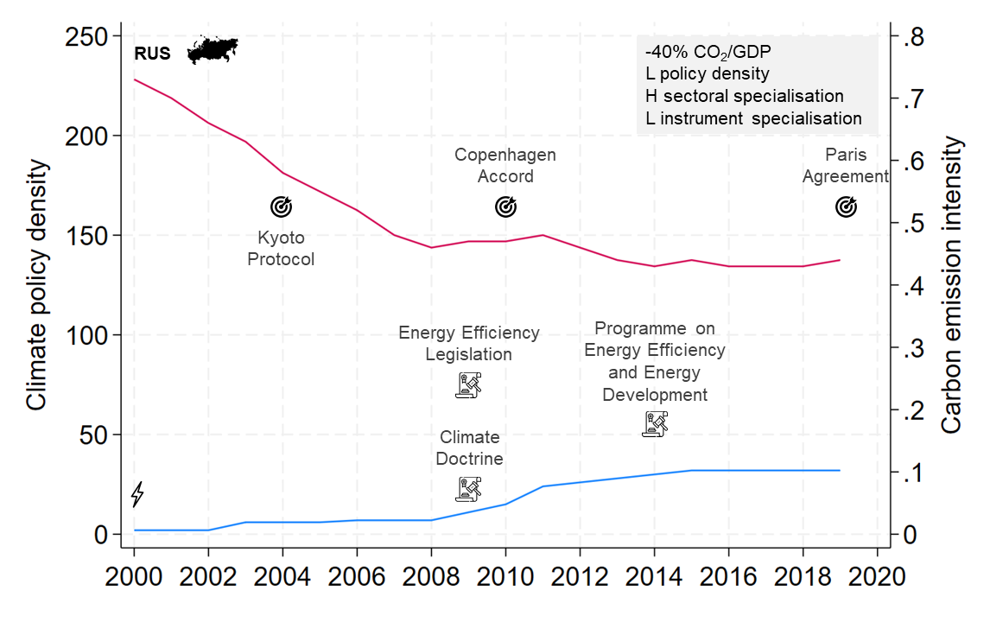
Note: Based on policy data from the IEA Policies and Measures Database (PMD) and carbon emission data from the IEA CO2 Emissions From Fuel Combustion Database. Data on targets, energy ministries and advisory bodies retrieved from various sources (see Table S1 in SI1: Data & Models).

Russia has one of the largest shares of global carbon emissions in the world, which is mostly due to the heavy utilization of fossil fuels for energy generation. Today, solar and wind energy account for less than 1% of electricity generation. Reduction in carbon emission intensity until 2009 is mostly due to the economic recession in the 1990s (Li & Jiang, 2019). Since 2009, the level of emission intensity has stagnated (Mitrova & Melnikov, 2019).
Despite ratifying the Kyoto Protocol in 2004 and the Paris Agreement in 2019, Russia’s policy efforts to decarbonize its economy have been very limited (Mitrova & Melnikov, 2019; NewClimate Institute, 2022b). Key Russian climate policies have included the non-binding Climate Doctrine, adopted in 2009, which provided guidelines and set climate-related targets. In the same year, it adopted the Energy Efficiency Legislation, which aimed at energy saving and increasing energy efficiency. The legislation was updated in 2014 by the State Programme on Energy Efficiency and Energy Development, which aimed specifically on increasing the efficiency of the use of Russian fuel and energy resources. In 2015, the Energy Ministry submitted a draft for the Russian Energy Strategy Up to 2035, which took six years to be finally adopted in 2021. During this time, its ambition to mitigate Russia’s greenhouse gas emission had been significantly reduced. It now aims to increase the share of non-hydro renewable energies to 4.5% by 2024, which is very unlikely to be achieved (Mitrova & Melnikov, 2019; NewClimate Institute, 2022b).
Overall, carbon emission intensity has stagnated at a comparatively High level since 2009. Russia’s climate policies have focused on emissions from buildings rather than the largest emitting sector – electricity and heat. In fact, Russia since 2009 represents an exemplary case where Low policy focus on the largest emitting sector coincides with comparatively Low emission intensity reduction.

Norway
Norway is a counter example of a country with broad and balanced sectoral coverage including both economy-wide policies (e.g. carbon tax) and sectoral policies (e.g. emissions trading in the industry sector, electric vehicle incentives in the transport sector). The country has experienced a comparatively Slow emission intensity reduction and a moderate increase of its climate policy portfolio, which has been characterised by a Low sectoral specialisation (i.e., policies have not focused on a specific sector, such as transport). However, the slow reduction in emission intensity has to be seen against the background of a comparatively low level of emission intensity already in 2000.

Figure S9. Historical development of Norway’s climate policy portfolio.
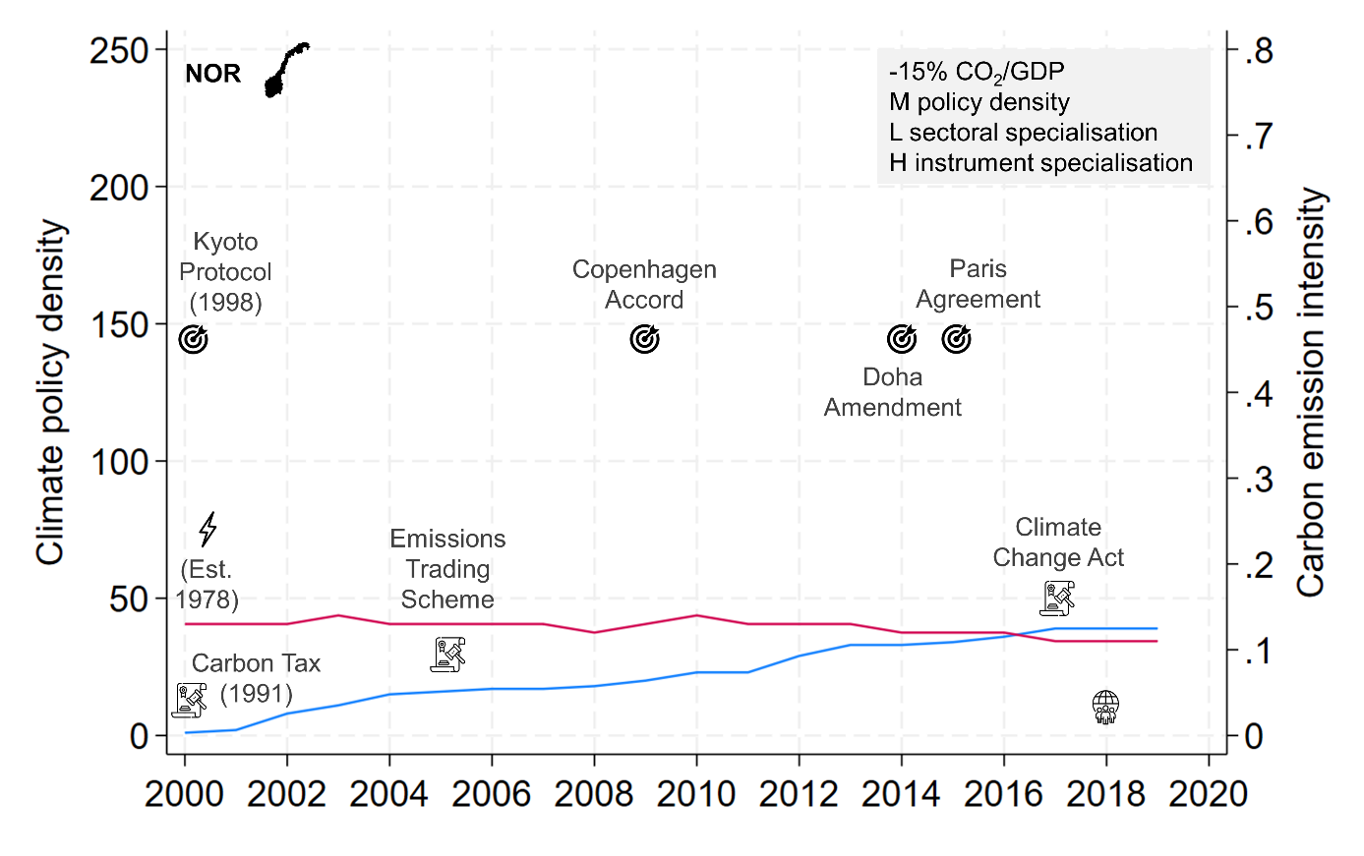
Note: Based on policy data from the IEA Policies and Measures Database (PMD) and carbon emission data from the IEA CO2 Emissions From Fuel Combustion Database. Data on targets, energy ministries and advisory bodies retrieved from various sources (see Table S1 in SI1: Data & Models).

Most of Norway’s energy sector, especially electricity generation, is already heavily decarbonised due to the historically large share of hydropower. Thus, Norway did not experience the same need to target the energy sector than countries with a Higher dependency on energy generated from fossil fuels (e.g., Mexico and Indonesia). Further emission reduction in Norway must therefore mostly be achieved in other sectors, which already have a comparatively Low emission intensity (Farstad et al., 2022). The largest share of greenhouse gas emissions in the country stems from the oil and gas industry, transport and manufacturing (IEA, 2022).
Norway has historically been one of the world’s climate policy leaders. It adopted a carbon tax as early as 1991 and significantly increased the carbon price in 2012. It established an emission trading scheme in 2005, which was incorporated into the EU Emissions Trading Scheme (ETS) in 2008. To foster the uptake of renewable energy specifically, it created a green certificate system in cooperation with Sweden in 2012. Norway has also targeted the transport sector for two decades by incentivizing the purchase of electric vehicles and heavily taxing passenger combustion cars (Ćetković & Skjærseth, 2019). In 2017, Norway adopted the Climate Change Act, which commits Norway to reduce its greenhouse gas emissions by 55% by 2030 and around 90% by 2050. Since 2019, the country has further committed to reduce emissions not covered by the ETS by 40% below 2005 levels by 2030 (Farstad et al., 2022).
Overall, these efforts have resulted in a climate policy portfolio that quite equally targets the different sectors responsible for greenhouse gas emissions.

Effect of policy instrument type
Our econometric analysis indicates that countries that have specialised on policy instruments (i.e., have predominantly implemented a specific type of policy instrument) experienced relatively Fast carbon emission intensity. In the following, we present three representative cases for this pattern. In two cases, specialisation on a policy instrument coincided with relatively Fast emission intensity reduction (Estonia and Israel), and in one case, Low specialisation coincided with relatively Slow emission intensity reduction (Indonesia).

Estonia
Estonia achieved a significant decline in its carbon emission intensity in the period before 2018, which coincided with an increase in its climate policy density. The country made comparatively High use of market-based instruments, such as taxes and/or subsidies. Throughout the study period, more than half of its climate policies were market-based policy instruments.

Figure S10. Historical development of Estonia’s climate policy portfolio.
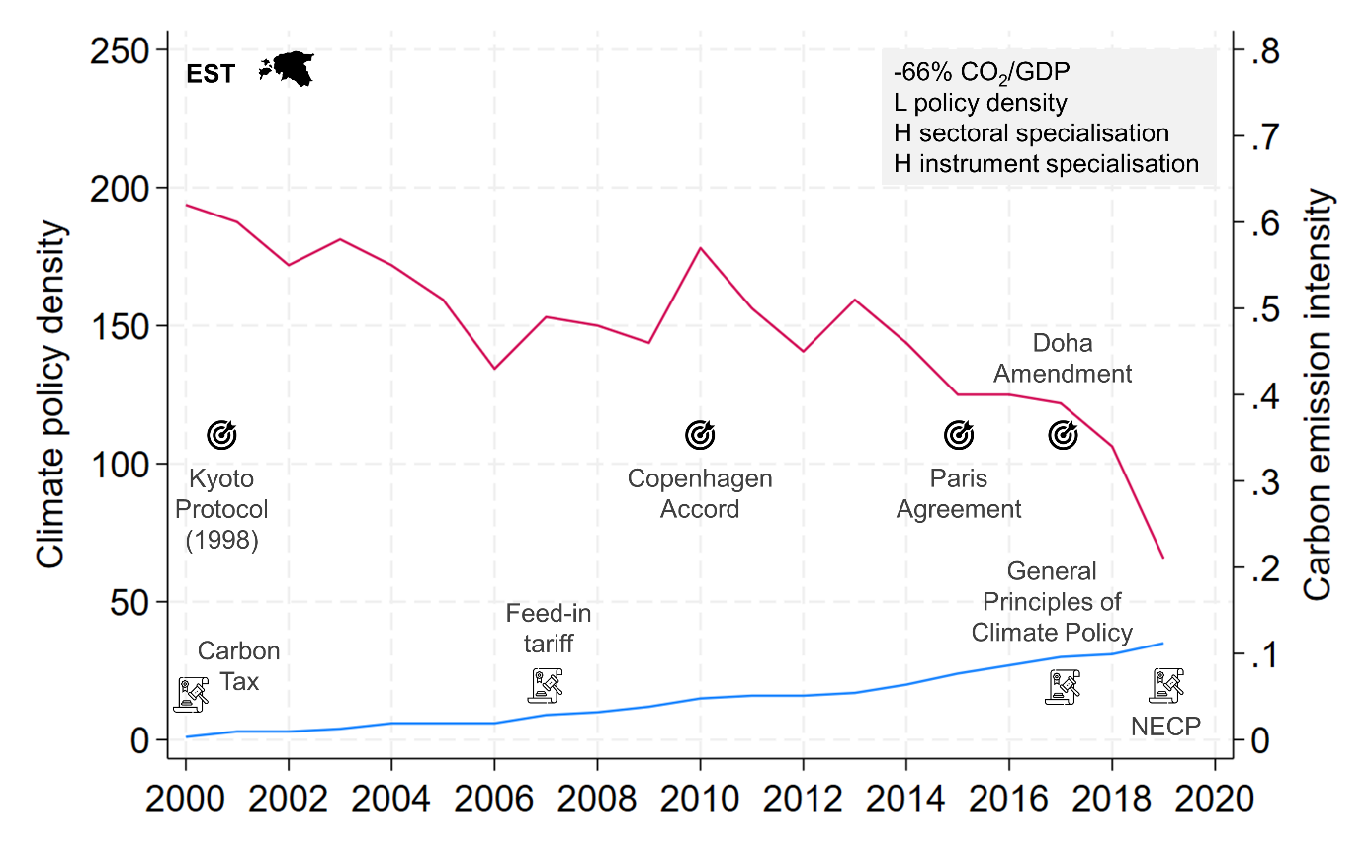
Note: Based on policy data from the IEA Policies and Measures Database (PMD) and carbon emission data from the IEA CO2 Emissions From Fuel Combustion Database. Data on targets, energy ministries and advisory bodies retrieved from various sources (see Table S1 in SI1: Data & Models).

Among OECD countries, Estonia has a relatively carbon intensive economy due to its historically High dependency on oil shale for electricity generation, its High transport emissions and the large stock of old and energy inefficient buildings constructed in the Soviet era (Tatomir, 2022).
Since becoming an EU member state, Estonia has transposed several EU directives, such as the Energy Efficiency Directive and the Renewable Energy Directive, into national law. In response to the EU’s 2020 climate and energy package and 2030 climate framework, Estonia has developed its own national climate strategy to put it on a pathway to achieving a Low-carbon economy. Key national climate policy in Estonia include the ‘General Principles of Climate Policy until 2050’ adopted in 2017, the 2030 National Energy and Climate Plan (NECP) adopted in 2019, and most recently the Strategy Estonia 2035, adopted in 2021, which aims to achieve climate neutrality by 2050 (Tatomir, 2022).
Estonia was one of the first countries in the world to adopt a carbon tax in 2000 (Andersen, 2019; Valdmaa, 2014). Further market-based policy instruments include a feed-in tariff adopted in 2007 to promote the expansion of renewable energy, a subsidy program for electric vehicles between 2011 and 2014, and several subsidies to improve the energy efficiency of buildings (Kanger et al., 2020; Tatomir, 2022). In addition, Estonia is part of the EU Emission Trading System (ETS), which covers a large share of Estonia’s carbon dioxide emissions, mostly from the energy sector (Tatomir, 2022). However, Estonia still lacks effective carbon prices in comparison to other OECD countries and continues to subsidize the oil shale industry, which suggests that there is room to intensify the impact of market-based instruments on carbon intensity in the future (Kanger et al., 2020; Tatomir, 2022).
Overall, Estonia indeed employed primarily market-based instruments to mitigate climate change and their adoption coincides with a relatively Fast emission intensity reduction.

Israel
Israel represents a case where a comparatively strong focus on regulatory instruments has coincided with relatively Fast reduction in emission intensity. Since 2012, more than half of the country’s policies employed regulatory instruments. For instance, this included setting up a net-metering regulation framework in 2013, adopting rules for solar energy actions in 2017 and adopting a set of rules to enhance energy efficiency in buildings in 2011. Overall, these changes mostly served to facilitate the expansion of renewable energy.
However, renewable energies have only played a minor role in reducing emission intensity until 2019. In fact, emission intensity reduction has mostly been attributed to the replacement of coal energy generation by natural gas (Michaels & Tal, 2015). Renewable energies still compete with fossil fuels and will need further policy support (Ersoy et al., 2021).

Indonesia
The level of emission intensity has remained mostly stable in Indonesia, whereas the number of climate policies has increased steadily. Contrary to Estonia that specialised in a certain type of policy instrument, Indonesia has equally employed regulatory, market-based and voluntary instruments.

Figure S11. Historical development of Indonesia’s climate policy portfolio.
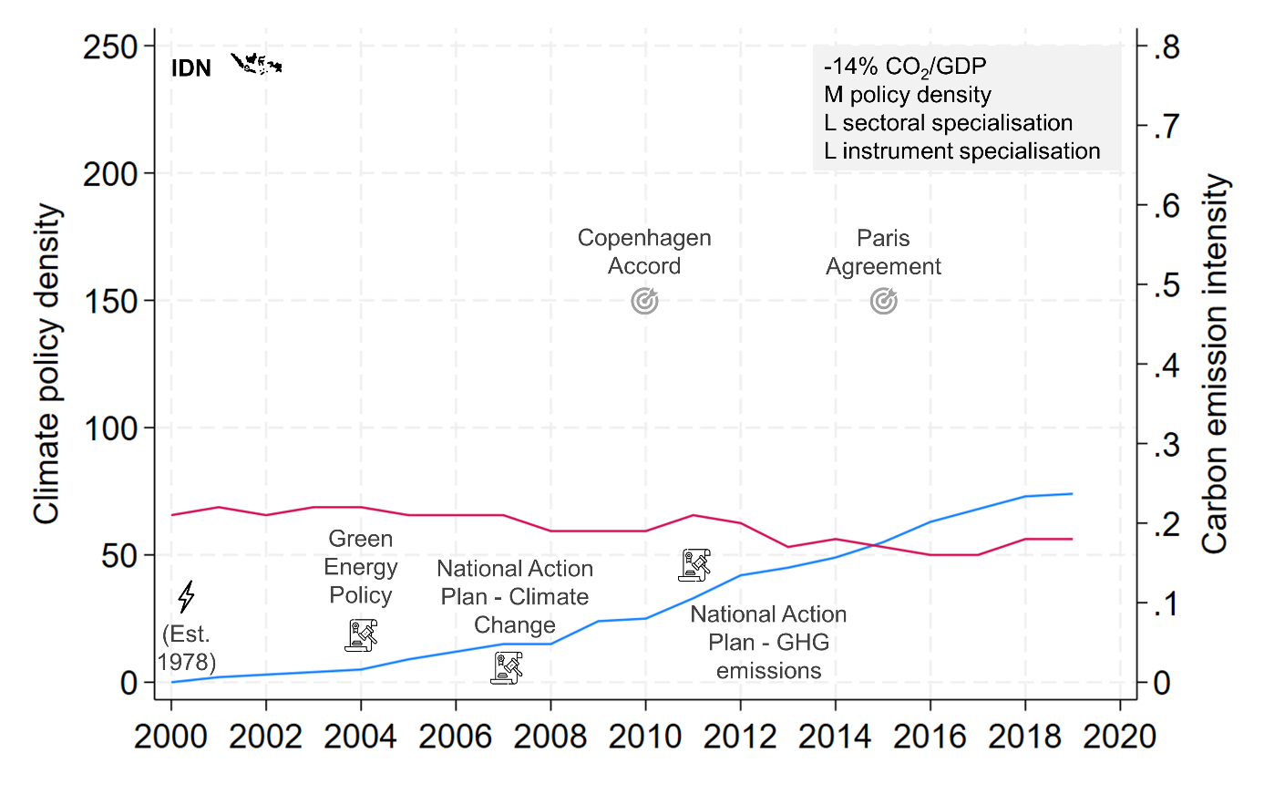
Note: Based on policy data from the IEA Policies and Measures Database (PMD) and carbon emission data from the IEA CO2 Emissions From Fuel Combustion Database. Data on targets, energy ministries and advisory bodies retrieved from various sources (see Table S1 in SI1: Data & Models).

Energy generation from coal has been identified as the strongest factor explaining the stagnation in carbon dioxide emissions. Enormous coal reserves and a powerful coal industry have inhibited efforts to reduce energy generation from coal and increase the uptake of renewables (Jakob et al., 2020).
Nevertheless, there have been policy efforts to foster the expansion of renewable energy, including feed-in-tariffs for several renewable energy sources such as solar or biogas since 2009. Key climate policies in Indonesia include the Green Energy Policy adopted in 2004, the National Action Plan Addressing Climate Change in 2007, the National Action Plan to reduce GHG emissions (RAN-GRK) in 2011, the Long-term Strategy on Low Carbon and Climate Resilience (LTS-LCCR) 2050 in 2020 and the New and Renewable Energy Law adopted in 2022 (Nachmany et al., 2015).
Until now, the impact of these policies on renewable energy development has been Low (NewClimate Institute, 2021). Apart from the strong influence of the coal industry on government decision-making in Indonesia, other governance issues have been identified, such as weak central leadership in developing climate policies and conflicts between various government institutions (Resosudarmo et al., 2013).
Overall, Indonesia has developed a climate policy portfolio that, in contrast to other countries such as Estonia, does not specialise in targeting a high-emitting sector or a type of policy instrument. This and issues with policy implementation have coincided with stagnating emission intensity.

Effect of emission reduction targets
Our econometric analysis indicates that the positive association between policy density and emission intensity reduction is stronger if a country adopted absolute emission reduction targets. The two cases presented below are representative of this pattern. In the case of the USA, the presence of absolute emission reduction targets since 2010 coincides with a relatively strong association between climate policy density and emission intensity reduction. Whereas in Mexico such targets have been lacking and the relatively strong increase in climate policy density coincides with only relatively Slow emission intensity reduction.

The United States of America
The USA is an exemplary case for this pattern, at least for the second half of our study period. In the 2000s, the USA did not possess a legally-binding absolute emission reduction target. Under the Bush administration, the USA only adopted an emission intensity target of cutting GHG emissions intensity (ratio of GHG emissions to GDP) by 18 percent by 2012 in 2002. While a target was in place, it did not specify absolute emission reduction levels (Abraham‐Dukuma et al., 2022; Pischke et al., 2019). The situation changed under the Obama administration: in 2010, the USA adopted an absolute emission target of 17 percent below 2005 levels in 2020. In addition, sector specific targets were adopted, most prominently reducing emissions in the power sector of 32 percent below 2005 levels by 2030 within the Clean Power Plan in 2015 (Schreurs, 2016).
Overall, the presence of absolute emission reduction targets from 2010 coincides with the strong uptake in climate policies and simultaneous reduction in carbon emission intensity in the USA.

Mexico
In contrast to the USA, Mexico has only Slowly reduced its carbon emission intensity despite a comparatively strong increase in its climate policy density. In fact, Mexico’s carbon dioxide emissions grew over the last decade with transport and electricity generation being the largest emitters. The latter is strongly reliant on fossil fuels, mainly natural gas and oil, due to Mexico’s long legacy of oil dependence. Only recently have renewables increased and then quite Slowly (Averchenkova & Guzman Luna Sandra, 2018; Natorski & Solorio, 2023).

Figure S12. Historical development of Mexico’s climate policy portfolio.
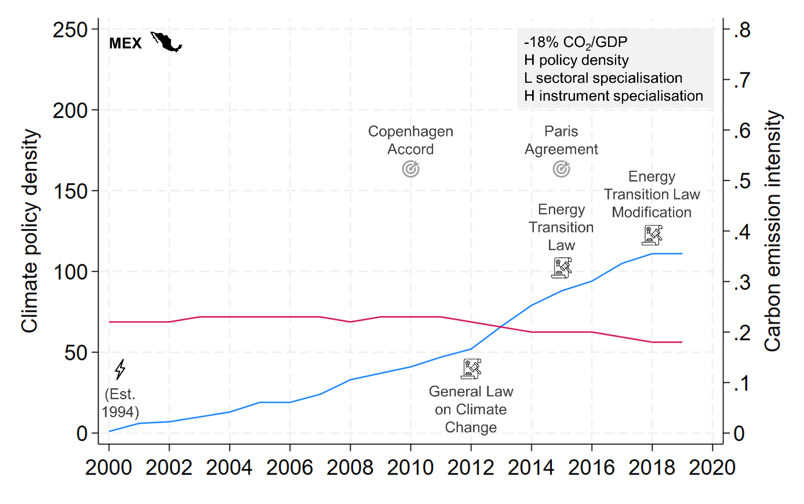
Note: Based on policy data from the IEA Policies and Measures Database (PMD) and carbon emission data from the IEA CO2 Emissions From Fuel Combustion Database. Data on targets, energy ministries and advisory bodies retrieved from various sources (see Table S1 in SI1: Data & Models).

On paper, Mexico has signalled a High level of policy ambition to reduce its carbon emissions. The country ratified the UNFCCC as early as 1993 and the Kyoto Protocol in 2000. It was the first developing economy to submit an intended Nationally Determined Contribution (NDC) and pledged to reduce its greenhouse gas emissions voluntarily (Averchenkova & Guzman Luna Sandra, 2018; Solorio, 2021). With the 2012 General Law on Climate Change, Mexico was one of the first countries that adopted a climate change act, which included longer-term objectives for climate policy (Averchenkova & Guzman Luna Sandra, 2018; Solorio, 2021). In 2015, Mexico adopted the Energy Transition Law, which is based on its climate change act and outlines the transition of the energy sector. It was modified in 2018 to accommodate for Mexico’s NDCs submitted in 2015 (Averchenkova & Guzman Luna Sandra, 2018).
Specifically on renewable energy, Mexico has adopted more policies than any other Latin American country. However, they do not aim to achieve specific renewable energy targets and mostly represent guidelines rather than policy requirements (Pischke et al., 2019). Only very recently has Mexico liberalised its heavily nationalised energy sector, which led to a Faster uptake of renewable energy (Natorski & Solorio, 2023).
In contrast to most other high-emitting countries, Mexico has only adopted relative emission reduction targets (i.e., emission reduction relative to certain baselines) and refrained from committing to specific absolute emission reduction targets. Originally, the General Law on Climate Change adopted in 2012 pledged to reduce greenhouse gas emissions by 30% with respect to a business as usual scenario by 2020. Updates to Mexico’s targets have further reduced its ambition, making policy less transparent and less specific in terms of individual sector contributions (NewClimate Institute, 2022a; Solorio, 2021).
Overall, the case of Mexico shows a mismatch between climate policy density and carbon emission reduction, which has been attributed to the failure to implement adopted climate policies due to shortcomings in the design of adopted policies, weak administrative capacity, and uneven political leadership (Pischke et al., 2019; Solorio, 2021).

Effect of energy ministries
Our econometric analysis indicates that the positive association between climate policy density and emission intensity reduction is stronger if a country has established a dedicated energy ministry.

United States of America
The USA established its Department of Energy already in 1977. There is some evidence that the ministry played a crucial role in the Obama administration’s efforts to transform the energy sector and contributed to reducing electricity and heat production from coal and oil and improving energy efficiency (Nye, 2014). It also played a key role in launching the Clean Energy Ministerial as an intergovernmental platform to support the Obama administration’s goal of promoting clean energies (Tosun & Rinscheid, 2021).

Effect of independent advisory bodies
Our econometric analysis indicates that the positive association between climate policy density and emission intensity reduction is stronger if a country established an independent advisory body. The United Kingdom is representative for this pattern.

United Kingdom
The United Kingdom was characterised by relatively Fast emission intensity reduction and a gradually increasing stock of climate policies. The country further established an independent advisory body, the Committee on Climate Change (CCC), in 2008, which has further advanced the UK’s climate policy regime and its impact on emission reductions.

Figure S13. Historical development of the United Kingdom’s climate policy portfolio.
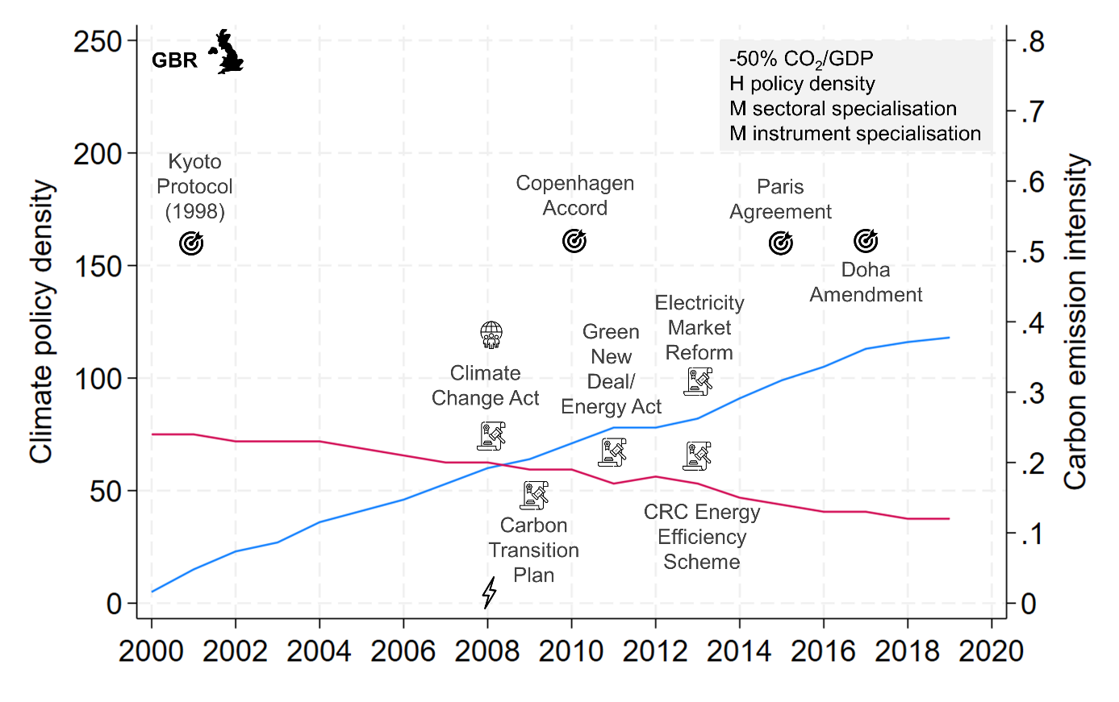
Note: Based on policy data from the IEA Policies and Measures Database (PMD) and carbon emission data from the IEA CO2 Emissions From Fuel Combustion Database. Data on targets, energy ministries and advisory bodies retrieved from various sources (see Table S1 in SI1: Data & Models).

The United Kingdom can be regarded as one of the most successful countries in reducing its greenhouse gas emissions. Most of the reductions have been achieved by the energy supply sector, due to a phase-out of coal and a significant expansion of nuclear and renewable energy (Gransaull et al., 2023). Prior to 2016, energy had been the largest emitting sector. Due to the strong reductions, its emissions have since become Lower than those of the transport sector and only slightly larger than those of the buildings sector. In fact, emissions from the non-energy sectors have remained mostly stable over time (Erbach & Szczepanski, 2022).
The sharp decline in greenhouse gas emissions can be linked to one of the most stringent and ambitious climate policy regimes (Gransaull et al., 2023). Its flagship is the Climate Change Act, which was adopted in 2008. This framework legislation included several innovative features, including legally-binding long-term mitigation targets, carbon budgets, an independent advisory body (the Committee on Climate Change), and regular and mandatory monitoring and reporting processes (Gransaull et al., 2023). The Act had been designed to stimulate further policy action and hold decision-makers accountable, which has resulted in several key policy actions in the aftermath. This has included the Electricity Market Reform of 2013, which established a carbon pricing scheme that was mainly responsible for the rapid phase-out of coal. It further led to the Low Carbon Transition Plan, adopted in 2009. Energy efficiency in buildings had been addressed by further flagship legislation, including the Green New Deal/Energy Act, adopted in 2011, and the CRC Energy Efficiency Scheme in 2013 (Rietig & Laing, 2017). The UK was part of the EU emissions trading system and then created its own scheme in 2021 after leaving the EU (Erbach & Szczepanski, 2022).
The Committee on Climate Change is perceived to have supported the long term emission reduction process (Averchenkova et al., 2021). It is staffed with party-independent technical experts backed by a secretariat with expertise across relevant climate-related areas (Averchenkova et al., 2021; Dudley et al., 2022). The CCC had a role shaping Electricity Market Reform. It also ensures the UK government is held to account for its progress in implementing climate policies (Averchenkova et al., 2021).
Overall, the UK represents an illustrative example for a strong climate policy regime and strong reduction of emission intensity. The existing literature suggests that the Committee on Climate Change had a conducive effect on the government adopting and implementing ambitious climate policy.

References
Abraham‐Dukuma, M. C., Dioha, M. O., Okpaleke, F. N., & Bogado, N. (2022). Improving the climate change mitigation regime of major emitting countries: The case of South Africa, China, Germany and the United States of America. Environmental Policy and Governance, 32(1), 43–55. https://doi.org/10.1002/eet.1961
Andersen, M. S. (2019). The politics of carbon taxation: How varieties of policy style matter. Environmental Politics, 28(6), 1084–1104. https://doi.org/10.1080/09644016.2019.1625134
Ashwarya, S. (2021). Israel’s Renewable Energy Strategy: A Review of its Stated Goals, Current Status, and Future Prospects. Perceptions, 26(2), 321–340. https://dergipark.org.tr/en/pub/perception/issue/68005/1055274#article_cite
Averchenkova, A., Fankhauser, S., & Finnegan, J. J. (2021). The influence of climate change advisory bodies on political debates: evidence from the UK Committee on Climate Change. Climate Policy, 21(9), 1218–1233. https://doi.org/10.1080/14693062.2021.1878008
Averchenkova, A., & Guzman Luna Sandra. (2018). Mexico’s General Law on Climate Change: Key achievements and challenges ahead. Grantham Research Institute on Climate Change and the Environment and Centre for Climate Change Economics and Policy, London School of Economics and Political Science. https://www.lse.ac.uk/granthaminstitute/publication/mexicos-general-law-on-climate-change-key-achievements-and-challenges-ahead/
Ćetković, S., & Skjærseth, J. B. (2019). Creative and disruptive elements in Norway´s climate policy mix: the small-state perspective. Environmental Politics, 28(6), 1039–1060. https://doi.org/10.1080/09644016.2019.1625145
Climate Action Tracker. (2022). China: November 2022 Update. https://climateactiontracker.org/countries/china/policies-action/
Dudley, H., Jordan, A., & Lorenzoni, I. (2022). Advising national climate policy makers: A longitudinal analysis of the UK Climate Change Committee. Global Environmental Change, 76, 102589. https://doi.org/10.1016/j.gloenvcha.2022.102589
Erbach, G., & Jochheim, U. (2022). China's climate change policies: State of play ahead of COP27. European Parliamentary Research Service. https://www.europarl.europa.eu/thinktank/en/document/EPRS_BRI(2022)738186
Erbach, G., & Szczepanski, M. (2022). United Kingdom climate change policies: State of play ahead of COP27. European Parliament. https://www.europarl.europa.eu/RegData/etudes/BRIE/2022/738189/EPRS_BRI(2022)738189_EN.pdf
Ersoy, S. R., Terrapon-Pfaff, J. C., Abu Hamed, T., & Kádár, J. (2021). Sustainable transformation of Israel's energy system: Development of phase model. Climate change, energy and environment. Friedrich-Ebert-Stiftung.
Farstad, F. M., Hermansen, E. A. T., Grasbekk, B. S., Brudevoll, K., & van Oort, B. (2022). Explaining radical policy change: Norwegian climate policy and the ban on cultivating peatlands. Global Environmental Change, 74, 102517. https://doi.org/10.1016/j.gloenvcha.2022.102517
Gallagher, K. S., Zhang, F., Orvis, R., Rissman, J., & Liu, Q. (2019). Assessing the Policy gaps for achieving China's climate targets in the Paris Agreement. Nature Communications, 10(1), 1256. https://doi.org/10.1038/s41467-019-09159-0
Gransaull, G., Rhodes, E., & Fairbrother, M. (2023). Institutions for effective climate policymaking: Lessons from the case of the United Kingdom. Energy Policy, 175, 113484. https://doi.org/10.1016/j.enpol.2023.113484
Grant, D., Bergstrand, K., & Running, K. (2014). Effectiveness of US state policies in reducing CO2 emissions from power plants. Nature Climate Change, 4(11), 977–982. https://doi.org/10.1038/nclimate2385
IEA. (2022). Energy Policy Review: Norway. International Energy Agency. https://www.iea.org/reports/norway-2022/executive-summary
Jakob, M., Flachsland, C., Christoph Steckel, J., & Urpelainen, J. (2020). Actors, objectives, context: A framework of the political economy of energy and climate policy applied to India, Indonesia, and Vietnam. Energy Research & Social Science, 70, 101775. https://doi.org/10.1016/j.erss.2020.101775
Jensen, L., & Grieger, G. (2022). United States climate change policies: State of play ahead of COP27. European Parliament. https://www.europarl.europa.eu/RegData/etudes/BRIE/2022/733708/EPRS_BRI(2022)733708_EN.pdf
Kahlen, L., Mooldijk, S., Jürgens, M., Höhne, N., Reynolds, C., Stockwell, C., Ramalope, D., & Hare, B. (2022). Climate Governance in Brazil: Assessment of the government’s ability and readiness to transform Brazil into a zero emissions society (CAT Climate Governance Series). NewClimate Institute; Climate Analytics. https://climateactiontracker.org/publications/climate-governance-in-brazil/
Kanger, L., Sovacool, B. K., & Noorkõiv, M. (2020). Six policy intervention points for sustainability transitions: A conceptual framework and a systematic literature review. Research Policy, 49(7), 104072. https://doi.org/10.1016/j.respol.2020.104072
Le Quéré, C., Korsbakken, J. I., Wilson, C., Tosun, J., Andrew, R., Andres, R. J., Canadell, J. G., Jordan, A., Peters, G. P., & van Vuuren, D. P. (2019). Drivers of declining CO2 emissions in 18 developed economies. Nature Climate Change, 9(3), 213–217. https://doi.org/10.1038/s41558-019-0419-7
Li, R., & Jiang, R. (2019). Is carbon emission decline caused by economic decline? Empirical evidence from Russia. Energy & Environment, 30(4), 672–684. https://doi.org/10.1177/0958305X18802786
Michaels, L., & Tal, A. (2015). Convergence and conflict with the ‘National Interest’: Why Israel abandoned its climate policy. Energy Policy, 87, 480–485. https://doi.org/10.1016/j.enpol.2015.09.040
Mitrova, T., & Melnikov, Y. (2019). Energy transition in Russia. Energy Transitions, 3(1-2), 73–80. https://doi.org/10.1007/s41825-019-00016-8
Nachmany, M., Fankhauser, S., Davidová, J., Kingsmill, N., Landesman, T., Roppongi, H., Schleifer, P., Setzer, J., Sharman, A., Singleton, C. S., Sundaresan, J., & Townshend, T. (2015). The 2015 Global Climate Legislation Study: Climate Change Legislation in Indonesia. Grantham Institute. https://www.lse.ac.uk/GranthamInstitute/wp-content/uploads/2015/05/INDONESIA.pdf
Natorski, M., & Solorio, I. (2023). Policy failures and energy transitions: the regulatory bricolage for the promotion of renewable energy in Mexico and Chile. Npj Climate Action, 2(1). https://doi.org/10.1038/s44168-023-00039-4
NewClimate Institute. (2021). Climate Governance in Indonesia. https://climateactiontracker.org/publications/climate-governance-in-indonesia/
NewClimate Institute. (2022a). Climate Action Tracker: Mexico. December 2022 Update. NewClimate Institute; Climate Analytics. https://climateactiontracker.org/countries/mexico/2020-09-22/
NewClimate Institute. (2022b). Climate Action Tracker on Russia: November 2022 Update. https://climateactiontracker.org/countries/russian-federation/policies-action/
Nye, D. E. (2014). The United States and Alternative Energies since 1980: Technological Fix or Regime Change? Theory, Culture & Society, 31(5), 103–125. https://doi.org/10.1177/0263276414537314
Pischke, E. C., Solomon, B. D., & Wellstead, A. M. (2018). A historical analysis of US climate change policy in the Pan-American context. Journal of Environmental Studies and Sciences, 8(2), 225–232. https://doi.org/10.1007/s13412-018-0476-7
Pischke, E. C., Solomon, B., Wellstead, A., Acevedo, A., Eastmond, A., Oliveira, F. de, Coelho, S., & Lucon, O. (2019). From Kyoto to Paris: Measuring renewable energy policy regimes in Argentina, Brazil, Canada, Mexico and the United States. Energy Research & Social Science, 50, 82–91. https://doi.org/10.1016/j.erss.2018.11.010
Resosudarmo, B. P., Ardiansyah, F., & Napitupulu, L. (2013). The Dynamics of Climate Change Governance in Indonesia. In D. Held, C. Roger, & E.-M. Nag (Eds.), Climate Governance in the Developing World (pp. 72–90). Polity Press.
Rietig, K., & Laing, T. (2017). Policy Stability in Climate Governance: The case of the United Kingdom. Environmental Policy and Governance, 27(6), 575–587. https://doi.org/10.1002/eet.1762
Sandalow, D., Meidan, M., Andrews-Speed, P., Hove, A., Yue Qiu, S., & Downie, E. (2022). Guide to Chinese Climate Policy: 2022. Oxford Institute of Energy Studies. https://chineseclimatepolicy.oxfordenergy.org/
Schreurs, M. A. (2016). The Paris Climate Agreement and the Three Largest Emitters: China, the United States, and the European Union. Politics and Governance, 4(3), 219–223. https://doi.org/10.17645/pag.v4i3.666
Solomon, A. A., Bogdanov, D., & Breyer, C. (2018). Solar driven net zero emission electricity supply with negligible carbon cost: Israel as a case study for Sun Belt countries. Energy, 155, 87–104. https://doi.org/10.1016/j.energy.2018.05.014
Solorio, I. (2021). Leader on paper, laggard in practice: policy fragmentation and the multi-level paralysis in implementation of the Mexican Climate Act. Climate Policy, 21(9), 1175–1189. https://doi.org/10.1080/14693062.2021.1894084
Tatomir, S. (2022). Estonia’s climate policy: challenges and opportunities. In OECD (Ed.), OECD Economic Surveys: Estonia 2022. OECD. https://www.oecd-ilibrary.org/sites/25d93653-en/index.html?itemId=/content/component/25d93653-en
Tosun, J., & Rinscheid, A. (2021). The Clean Energy Ministerial: Motivation for and policy consequences of membership. International Political Science Review, 42(1), 114–129. https://doi.org/10.1177/0192512120942303
Valdmaa, K. (2014). Development of the environmental taxes and charges system in Estonia: International convergence mechanisms and local factors. Policy Studies, 35(4), 339–356. https://doi.org/10.1080/01442872.2013.875152
Viola, E., & Basso, L. (2015). Brazilian Energy-Climate Policy and Politics towards Low Carbon Development. Global Society, 29(3), 427–446. https://doi.org/10.1080/13600826.2015.1028904
Zhao, X., Yin, H., & Zhao, Y. (2015). Impact of environmental regulations on the efficiency and CO2 emissions of power plants in China. Applied Energy, 149, 238–247. https://doi.org/10.1016/j.apenergy.2015.03.112

See also https://climatepolicydatabase.org/countries/indonesia.

