Climate policy portfolios that accelerate emission reductions
8 July 2024

SUPPLEMENTARY INFORMATION 1 (SI1): DATA & MODELS

1 Variables, data & descriptive statistics 2
1.1 Fossil CO₂ emissions and emission intensities 2
1.2 Climate policy portfolio and (inter-)governmental organisation variables 2
1.3 Measuring climate policy density: IEA PMD vs CCLW datasets 4
1.4 Policy density 4
2 Policy density models: robustness checks 15
2.1 Pre-2000 policies 15
2.2 Excluding China 15
2.3 One year lagged policy density 15
3 Interaction effects with long-term targets and (inter-)governmental organisations: interpreting coefficients 15

Variables, data & descriptive statistics
Table S1 summarises variables and data sources. Subsequent sections provide explanations and descriptive statistics.
Table S1. Summary of Data Sources.
Dependent variable
CO₂ emissions intensity (kgCO₂ per 2015 USD PPP) | IEA CO₂ Emissions From Fuel Combustion Database
Independent variables
Cumulative policy density | IEA Policies and Measures Database (PMD)
Policy instrument type diversity (HH index* 3 types) | IEA PMD + own coding
Policy instrument type diversity (HH index* 8 types) | IEA PMD + own coding
Policy sectoral coverage diversity (HH index*) | IEA PMD + own coding
Policy sectoral coverage diversity weighted (HH index**) | IEA PMD + own coding
Absolute 1990 emission-reduction target (dummy variable) | various inc. UNFCCC (Kyoto Protocol & Copenhagen Accord annexes, Paris Agreement INDCs & NDCs), Climate Action Tracker, Net Zero Tracker
Relative emission-reduction target (dummy variable)
Energy ministry (dummy variable) | Tosun (2018)
Independent advisory body (dummy variable) | various inc. Weaver, Lötjönen et al. (2019), Averchenkova, Fankhauser et al. (2021), Evans and Duwe (2021)
Membership of Clean Energy Ministerial (dummy variable) | Tosun and Mišić (2022)
Control variables
Rule of law (World Bank indicator) | World Bank, Worldwide Governance Indicators
Hodrick-Prescott GDP filter | Own estimation using World Bank, World Development Indicators
GDP per capita, PPP (constant 2017 international USD) | World Bank, World Development Indicators
Imports of goods and services (% of GDP) | World Bank, World Development Indicators
Services, value added (% of GDP) | World Bank, World Development Indicators
Temperature variation (annual difference from long-term average 1990-2019) | World Bank, Climate Change Knowledge Portal

Fossil CO₂ emissions and emission intensities
Overall, fossil CO₂ emissions for the BRIICS countries have been trending upwards from 2000 to roughly 2015, after which growth rates have slowed [Figures S1 A-C]. In contrast, European Union (EU) countries (with Poland as an exception), along with the UK and USA, have seen downward trends in fossil CO₂ emissions, particularly over the last decade. Among the rest of the OECD countries, Colombia, Korea, and Turkey have all seen clear upward trends.
For the dependent variable in our analysis, we use emission intensity (kgCO₂ per unit of GDP) rather than absolute emissions in order to account for the large variation in country size and levels of economic activity in our sample (Eskander and Fankhauser 2020). After controlling for GDP, almost all countries in our sample experience declining trends in emission intensity over the last two decades [Figures S2 A-C].

Climate policy portfolio and (inter-)governmental organisation variables
Our climate policy portfolio variables measure policy density (cumulative numbers), sectoral coverage, instrument type, and long-term emission-reduction targets. In addition, we include a set of variables on governmental and intergovernmental organisations. Table S2 defines each and provides examples. Subsequent sections explain variable construction and provide descriptive statistics.
Table S2. Definition of terms: Climate policies and (inter-)governmental organisations.
Term | Definition | Example
Climate policy | Law (legislated act), executive order, programme, intervention or initiative relevant to mitigation. | National Climate Change Law (Brazil). Flagship 2009 legislation establishing emission reduction and sectoral targets including on efficiency, renewables, biofuels (Viola and Basso 2015).
Climate policy sectoral coverage | GHG-emitting sector(s) targeted by a policy (energy, land use, buildings, transport, industry) or cross-sectoral, economy-wide. | Clean Power Plan (US). Federal 2015 policy limiting emissions in the energy supply sector (Pischke, Solomon et al. 2018).
Climate policy instrument | Type of instrument specified by a policy to reduce GHG emissions (i.e. the means to achieve mitigation). | Carbon Tax (Estonia). Market-based policy instrument introduced in 2000 setting a price on emissions (Valdmaa 2014).
Emission-reduction target | Absolute targets (compared to 1990 or other fixed reference year emission levels).  Relative targets (compared to business-as-usual, or reductions in emission intensity).  Net-zero targets. | Absolute: NDC Target (USA). The US committed to achieving 26-28% GHG emission reductions below 2005 levels by 2025 in its first NDC in 2016.  Relative: NDC Target (Chile). Chile committed to reduce GHG intensity of GDP by 30% below 2007 levels by 2030 in its first NDC in 2017.
Climate policy-relevant governmental organisation | Advisory body: formal organisation involved in policy design, implementation, monitoring. | Committee on Climate Change (UK). Independent advisory body established in 2008 to monitor and hold government to account on progress towards legislated targets (Dudley, Jordan et al. 2022).
Climate policy-relevant intergovernmental organisation | Climate forum: formal international organisation enabling climate relevant knowledge exchange and policy diffusion among governmental bodies. | Clean Energy Ministerial. Global forum for advancing and promoting policies among its member countries and companies (Tosun and Rinscheid 2023).

Data on climate policy variables (density, sectoral coverage and instruments) is derived from the IEA PMD. Since a comprehensive overview on types of national emission reduction targets is not available, we had to collect the data from various public sources, including UNFCCC (Kyoto Protocol & Copenhagen Accord annexes, Paris Agreement INDCs & NDCs), Climate Action Tracker, and Net Zero Tracker.
Data on the existence of an Energy Ministry is taken from Tosun (2018) and updated to 2019 based on various public sources. Information on independent advisory bodies was collected by Brendan Moore from various public sources (Moore, Oberthür et al. 2023). Membership in the Clean Energy Ministerial is derived from data provided by Tosun and Mišić (2022).

Measuring climate policy density: IEA PMD vs CCLW datasets
There are two main datasets relevant to climate policies: the International Energy Agency (IEA) Policies and Measures Database (PMD), and the Climate Change Laws of the World (Schaub et al., 2022).
The IEA PMD compiles past and existing energy-related climate policies and measures globally using data supplied by governments and IEA partner organisations (IEA 2023). The data we use covers the period from 2000 onwards and provides detailed information on the year a policy was adopted, the policy instrument types it employs (including carbon taxes, renewable energy incentives, energy efficiency standards, and information-based initiatives), and the sectors it targets for GHG emission reduction. There is a strong overlap between energy policy and climate mitigation policy classifications; typically climate mitigation policy has emission reductions as at least one of its objectives (Patt, Rajamani et al. 2022).
Eskander & Fankhauser (2020) use the Climate Change Laws of the World Database (CCLW) to construct their long-term and short-term policy density variables. They include a total of 1,092 climate laws and policies. Managed by the Grantham Research Institute, the CCLW dataset compiles parliamentary acts, executive orders, and policies of equivalent importance relevant to GHG emission reductions (https://climate-laws.org/) (CCLW 2023). These range from broad framework laws establishing long-term objectives and an overarching legal basis for mitigation to specific sectoral policies on energy, transport, and land use (Dubash, Mitchell et al. 2022).
Selection of policies for the CCLW database is based on legal documents, so it is particularly useful for assessing climate policy portfolios at a global level (Schaub et al., 2022). However, the CCLW database only captures active climate laws and not those that have been repealed (Eskander & Fankhauser, 2020) and thus has shortcomings for historical analysis. In contrast, the IEA PMD has more extensive coverage of climate policies and provides in-depth information on policy instrument types. As a result, the IEA PMD reports a larger number of climate policies and is more suitable for assessing policy portfolios for individual countries as it includes detailed information on policy instrument types and sectoral coverage.

Policy density
Figures S3 A-C show line plots of total policy density by country over time, showing clear upward trends for all countries in our dataset. Larger numbers of new climate policies can be observed in the years following 2006. The BRIICS economies along with certain OECD countries (Chile, Israel, Italy, and Lithuania) have been slow to start, but experienced a rapid increase in the overall number of climate policies from 2007 and onwards. The rest of the OECD countries have displayed more gradual adoption of climate policies over time. Focusing specifically on BRIICS, we observe that they experience an even steeper upward trend for total policy density from 2010 onwards. China is an important outlier given it has legislated annually a very large number of climate policies but mainly since 2011: e.g., 22 policies in 2011, 26 in 2014, and 31 in 2016. By 2018, countries with the largest numbers of climate policies are China, USA, Australia, UK, Canada, and Spain. China is the only country from the block of BRIICS economies that closely follows the larger OECD countries in terms of total policy density.
As our analysis runs from 2000, initial policy densities in all countries are set to zero in 2000. Although most policies have been implemented since then, some countries including Australia, Denmark, Finland, Korea, and Norway had introduced significant numbers of policies before 2000. We include robustness checks in our analysis that include these initial conditions; see below for details.

Figure S1A. Fossil CO₂ emissions (natural log) per country from 2000 to 2019 for OECD countries in the EU. Vertical axis rescaled by country to visualize trends in fossil CO₂ emissions.
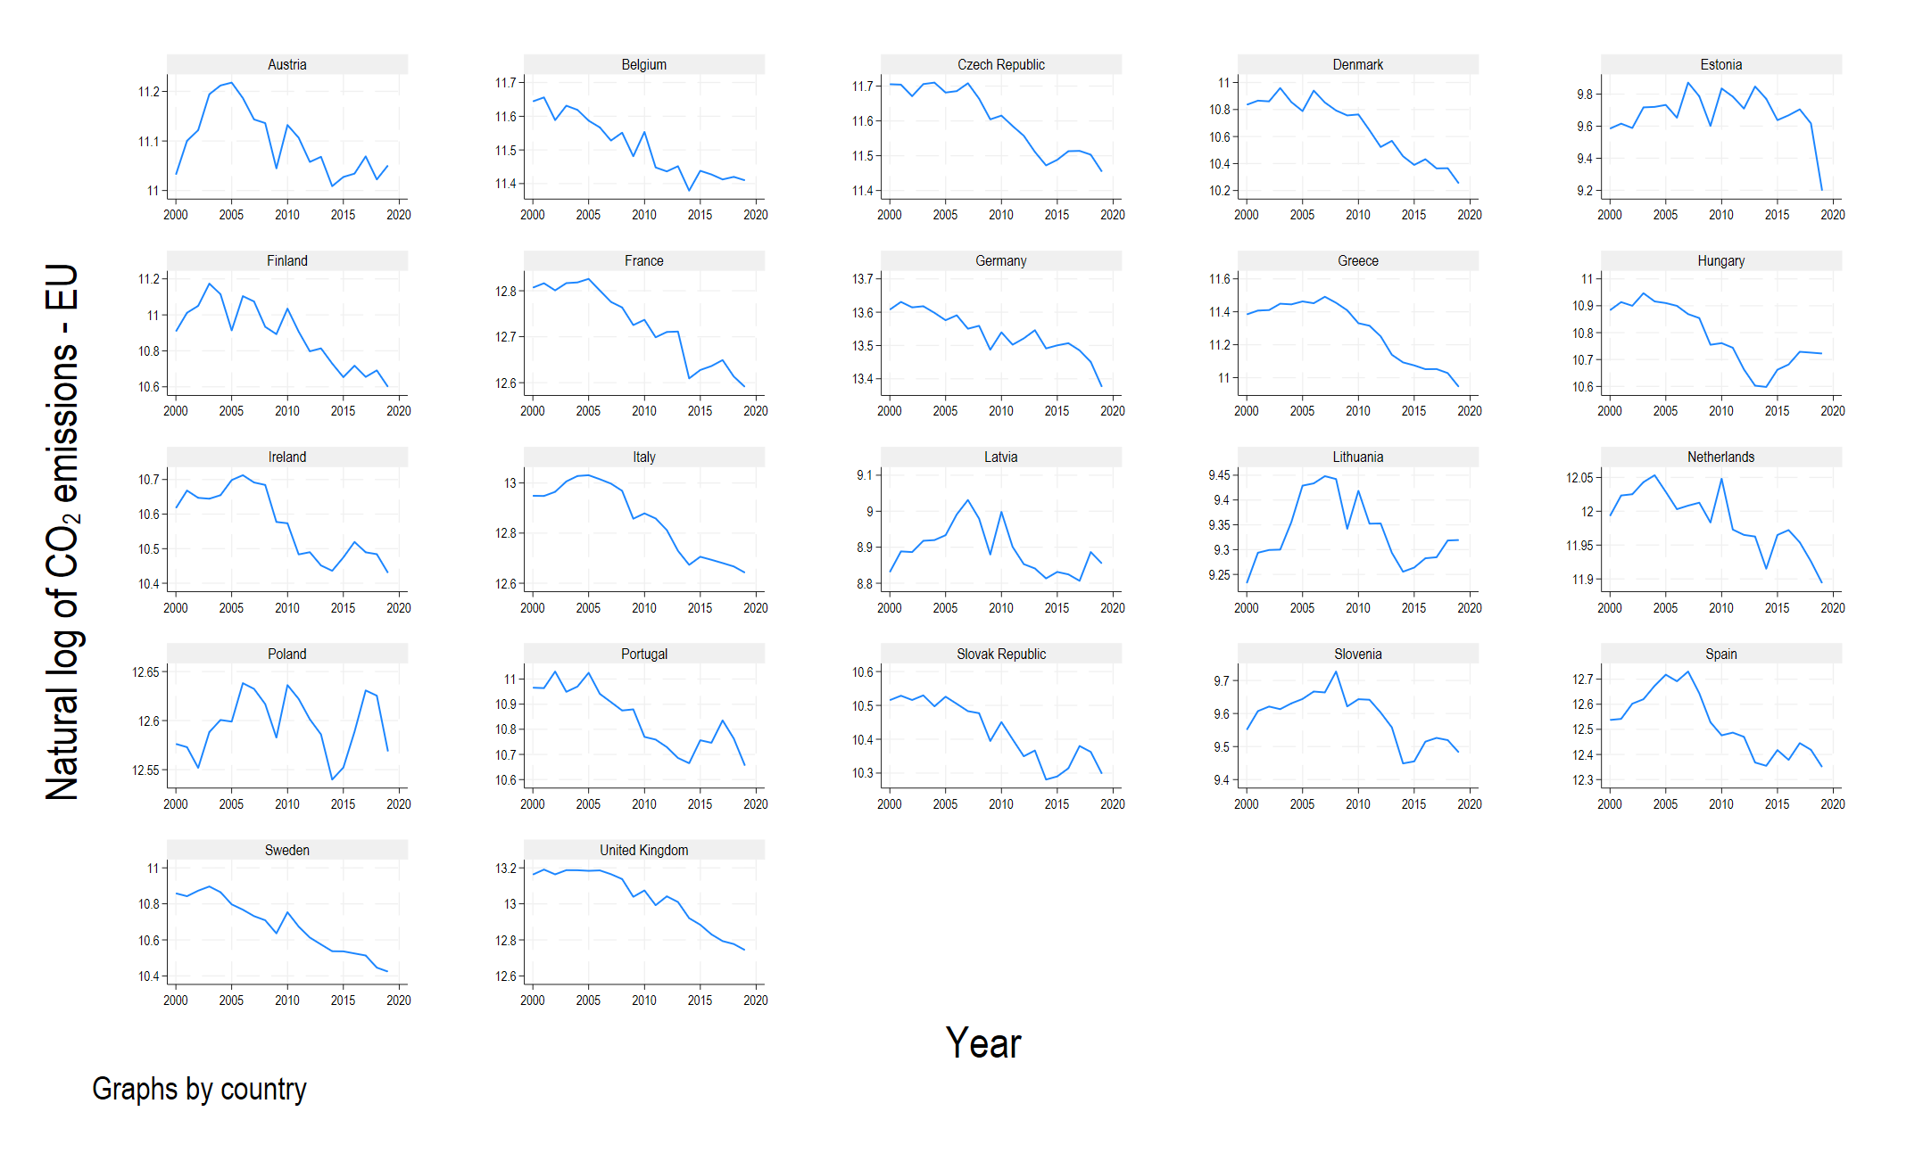

Figure S1B. Fossil CO₂ emissions (natural log) per country from 2000 to 2019 for non-EU OECD countries. Vertical axis rescaled by country to visualize trends in fossil CO₂ emissions.
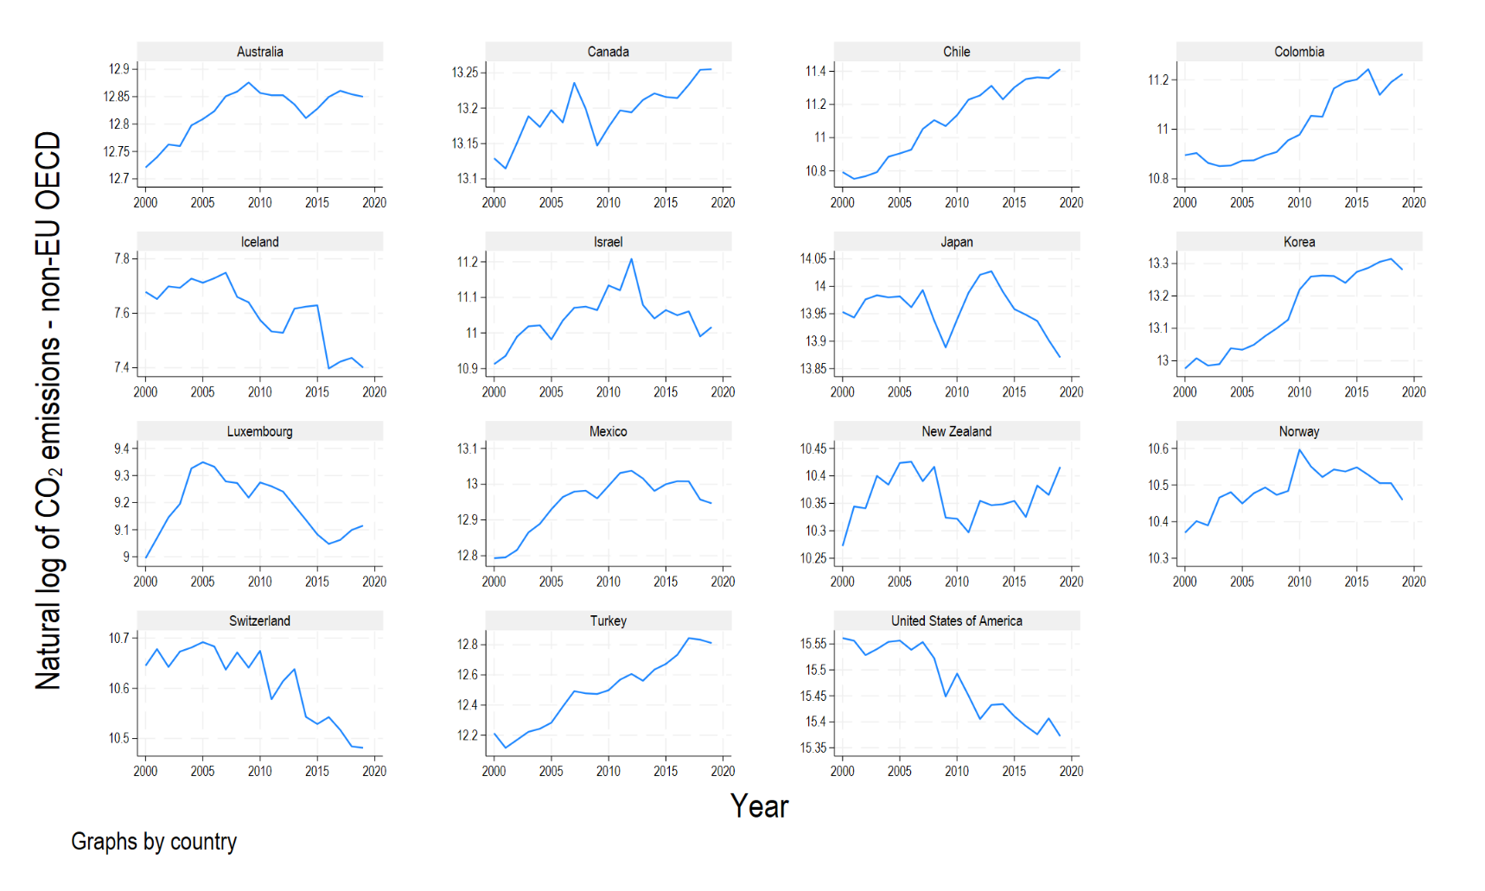

Figure S1C. Fossil CO₂ emissions (natural log) per country from 2000 to 2019 for BRIICS. Vertical axis rescaled by country to visualize trends in fossil CO₂ emissions.
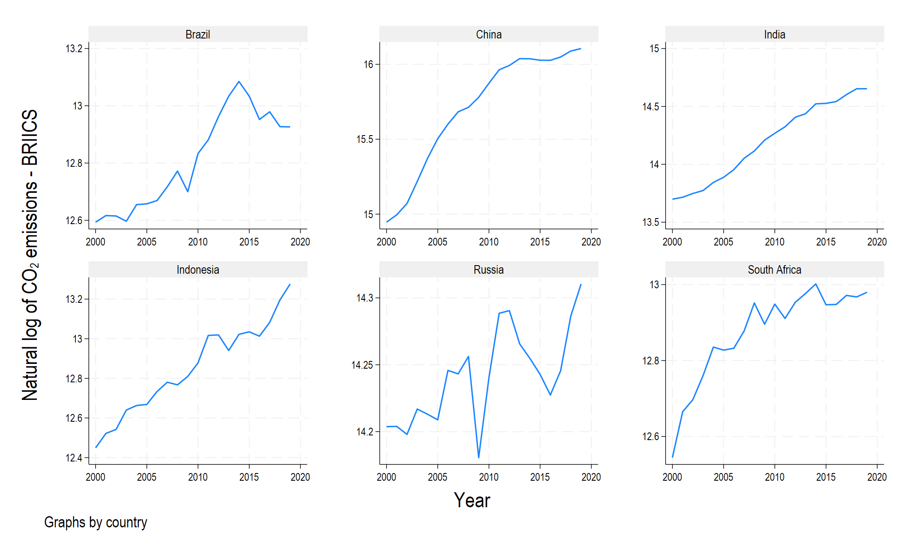

Figure S2A. Fossil CO₂ emissions intensity (CO₂/GDP) per country from 2000 to 2019 for OECD countries in the EU. Vertical axis rescaled by country group min max range to visualize country differences in the level and speed of reduction of emissions intensity.
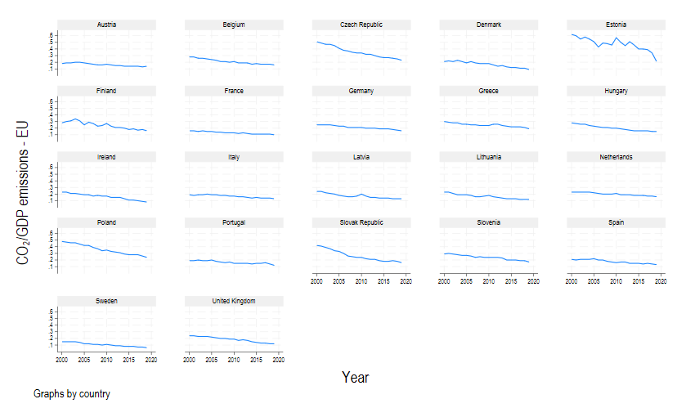

Figure S2B. Fossil CO₂ emissions intensity (CO₂/GDP) per country from 2000 to 2019 for non-EU OECD countries. Vertical axis rescaled by country group min max range to visualize country differences in the level and speed of reduction of emissions intensity.
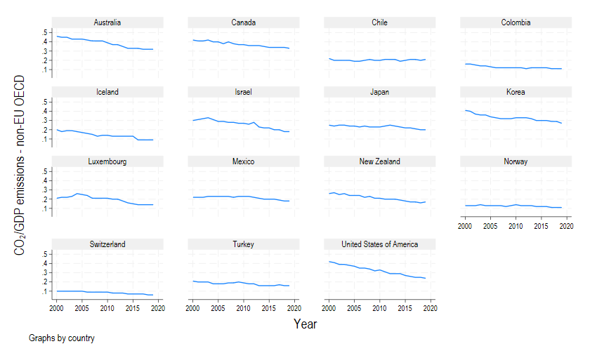

Figure S2C. Fossil CO₂ emissions intensity (CO₂/GDP) per country from 2000 to 2019 for BRIICS. Vertical axis rescaled by country group min max range to visualize country differences in the level and speed of reduction of emissions intensity.
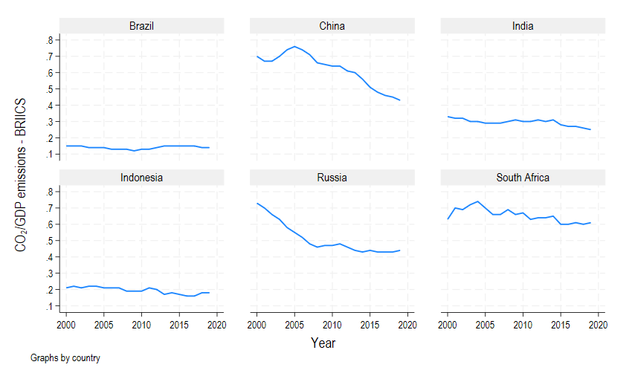

Figure S3A. Cumulative number of climate policies per country adopted from 2000 to 2019 for OECD countries in the EU. Vertical axis rescaled by country group min max range to visualize country differences in the level and speed of expansion of climate policies.
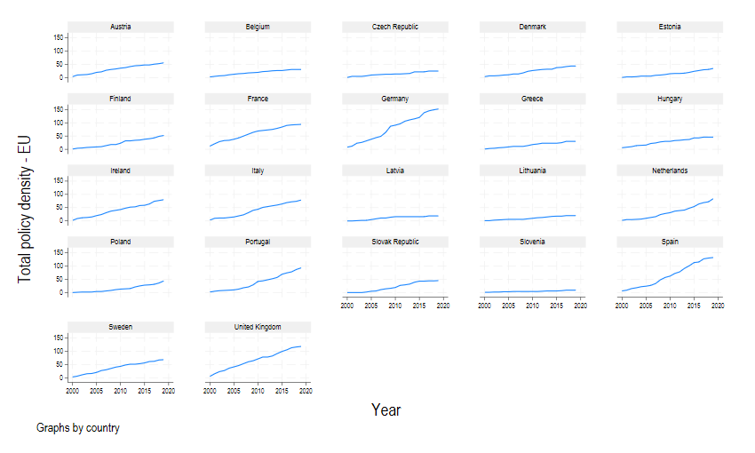

Figure S3B. Cumulative number of climate policies per country adopted from 2000 to 2019 for non-EU OECD. Vertical axis rescaled by country group min max range to visualize country differences in the level and speed of expansion of climate policies.
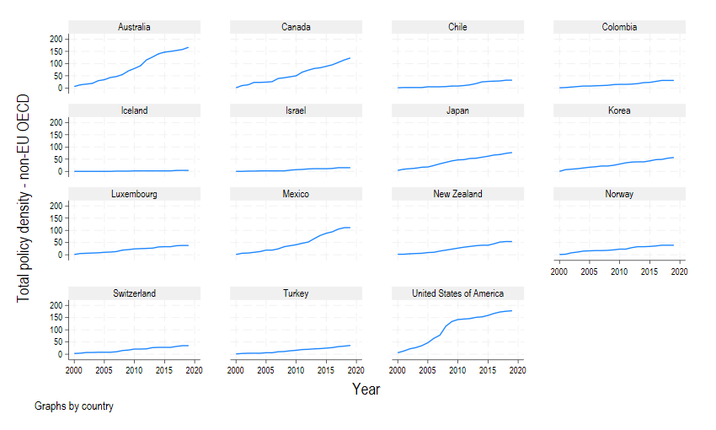

Figure S3C. Cumulative number of climate policies per country adopted from 2000 to 2019 for BRIICS. Vertical axis rescaled by country group min max range to visualize country differences in the level and speed of expansion of climate policies.
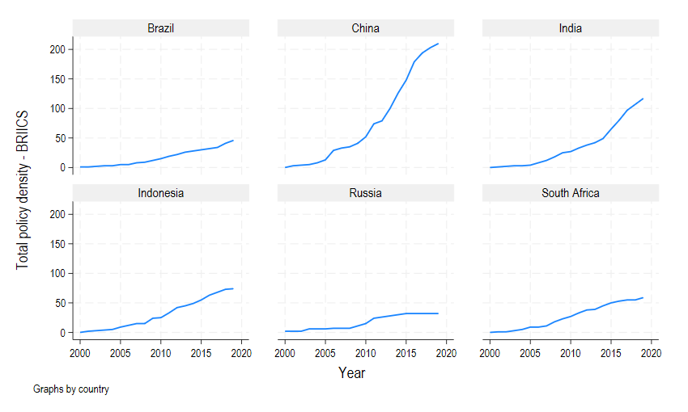

Policy density models: robustness checks

Pre-2000 policies
The total policy density variable included in our analysis measures the cumulative number of policies implemented from 2000 onwards. As a robustness check, we incorporate in our total policy density variable the cumulative number of policies implemented before 2000 and re-estimate the baseline regression model. Results provided in Extended Data Table ED6 show that the size and statistical significance of all coefficients in the re-estimated model remain the same.

Excluding China
Given our policy density variable is based on the IEA Policies and Measures Database (PMD), it has a different distribution to the same variable used in Eskander & Fankhauser (2020) which is based on the Climate Change Laws of the World (CCLW) database. This can be clearly observed in the case of China for which the IEA PMD reports at least 179 policies for the period 2000 - 2016 compared to only 5 legislations reported in the Climate Change Laws of the World database over the same time-period.
A similar pattern of differences between the two datasets can be observed for the rest of the BRIICS. More specifically, there are reported in the IEA dataset 32 polices for Brazil, 32 Russia, 80 for India, 53 for South Africa, and 63 for Indonesia. In contrast, there are reported in the Climate Change Laws of the World database 18 policies for Brazil, 12 for Russia, 9 for India, 7 for South Africa, and 18 for Indonesia.
According to Schaub, Tosun et al. (2022), the Climate Change Laws of the World database focuses on legislation and is particularly relevant for assessing how politics influence climate policy (e.g. democracy vs autocracy). In contrast, the IEA Policies and Measures Database centers more strongly on policy instruments and is more suitable for assessing policy design for individual countries.
We check whether our results change when we remove China from our sample. Results provided in Extended Data Table ED7, column 2, show that the coefficient for policy density remains negative and statistically significant.

One year lagged policy density
We perform an additional robustness test on our base model in which all independent variables are lagged by one year (Extended Data Table ED8), similar to Eskander & Fankhauser (2020). All the coefficients in the model with lagged (t-1) parameters are very similar to those in the base model, but with a slightly larger effect for policy density on emissions intensity.

Interaction effects with long-term targets and (inter-)governmental organisations: interpreting coefficients
As noted in Methods, our policy density models with interaction effect models are specified as:
$${ln⁡(\frac{CO2}{GDP})}_{it}=α+β_{1}{Pdens}_{it}^{}+β_{2}Χ_{it}+δ_{0}{dummy}_{it}+δ_{1}{Pdens*dummy}_{it}+θ_{ι}+η_{τ}+ε_{it}$$ | (1)
where ${ln⁡(\frac{CO2}{GDP})}_{it}$ stands for the natural log of emissions intensity per country i and year t; $α$ is the constant parameter; ${Pdens}_{it}^{}$ is the total policy density measuring the cumulative number of climate policies per country i for year t; $Χ_{it}$ stands for all controls; ${dummy}_{it}$ accounts for the presence/absence of climate governance institutions; ${Pdens*dummy}_{it}$ is the interaction term between policy density and the dummy; $θ_{ι}$ are the country fixed effects; $η_{τ}$ are year fixed effects; and $ε_{it}$ are the residuals that are independent and identically distributed (i.i.d.).
The coefficients $δ_{0}$ and $δ_{1}$ represent the intercept and slope parameters, respectively, for the effect of total policy density on emissions intensity when dummy=1, while $α$ and $β_{1}$ represent the intercept and slope parameters for the effect of policy density on emissions intensity when dummy=0. More specifically, the coefficient $δ_{0}$ captures the emission intensity differential, when total policy density is equal to 0, between i and t when dummy=0 and i and t when dummy=1. The coefficient $β_{1}$ measures the effect of total policy density on historical emissions intensity when dummy=0, while the coefficient $δ_{1}$ (interaction term) measures the difference in the effect of total policy density on emission intensity between i and t when dummy=1 and i and t when dummy=0. Therefore, the overall estimated effect of total policy density on historical emissions intensity when dummy=1 can be acquired by summing coefficients $β_{1}$ and $δ_{1}$ (on the condition that both coefficients reject the null hypothesis).
If the coefficient $δ_{1}$ of the interaction term does not reject the null hypothesis but the joint hypothesis (F test with H₀: $δ_{0}=0$ and $δ_{1}=0$) does reject the null, then the two slope terms ($β_{1}$ and $δ_{1}$) are effectively parallel to each other, and constantly differ by $δ_{0}$. This essentially indicates no difference in the effect of policy density between i and t when dummy=1 and i and t when dummy=0, except in the case that total policy density=0 (in which case they differ by $δ_{0}$). However, this case has no practical meaning in our analysis as we are interested in the difference in the effect of total policy density when climate policies exist.
If both $δ_{0}$ and $δ_{1}$ parameters are zero (this holds if we cannot reject the null hypothesis of the joint F test), then the coefficient $β_{1}$ captures the effect of total policy density on emissions intensity for all cases. This means that the effect of total policy density on emissions intensity reduction is identical between i and t when dummy=1 and i and t when dummy=0.
Finally, focusing on the interpretation of the regression model coefficients, in our base model (column 1, Table 2 in main text) the coefficient for policy density is equal to -0.000461. This is an order of magnitude smaller than in Eskander and Fankhauser (2020) for which the coefficient for current policy stock (t-1) is -0.0078 and for older policy stock (t-3) is -0.0179. Accounting for the fact that there are various differences in the samples used in the two studies (countries, time-period, and policy data), the difference in magnitude can be explained by the fact that we account for ‘policies’ (including, for example, informational and voluntary measures) which can be weaker than ‘laws’.
Indeed, once we control for the interaction between policies and absolute emission-reduction targets (or the Clean Energy Ministerial), the corresponding interaction coefficients are of the same order of magnitude (-0.00137 and -0.00109) to those for policy density in Eskander and Fankhauser (2020). This is specifically true for the case of EU OECD countries included in Appendix Table S2 in Eskander and Fankhauser (2020), which is more closely comparable to our analysis (recent laws -0.0046 and stock of laws -0.0083). This suggests that under the presence of absolute targets and membership of the Clean Energy Ministerial the effectiveness of policies increases to a comparable magnitude to that observed for ‘laws’ in Eskander and Fankhauser (2020).

Similar results to those for the Clean Energy Ministerial are found for membership of the IEA and EU-EFTA (Extended Data Table ED5). The coefficient for the interaction term for countries that are members of IEA is statistically significant, negative, and smaller in magnitude (in absolute terms) than the coefficient for the interaction term for members of the EU-EFTA, which is also negative and statistically significant.
The negative and statistically significant dummy coefficients for membership of the IEA and EU-EFTA indicate that these countries start off with lower emission intensities than the rest. In comparison, the dummy coefficients for energy ministries and membership of the Clean Energy Ministerial are statistically significant and positive, indicating that these countries start off with higher emission intensities than the rest, accounting for the fact that non-IEA and non-EU-EFTA were among the first to introduce dedicated energy ministries (such as Colombia, and the BRIICS excluding China) and are members of the Clean Energy Ministerial.

References
Averchenkova, A., S. Fankhauser and J. J. Finnegan (2021). "The influence of climate change advisory bodies on political debates: evidence from the UK Committee on Climate Change." Climate Policy 21(9): 1218-1233.
CCLW (2023). Climate Change Laws of the World Database. https://climate-laws.org, Grantham Research Institute on Climate Change and the Environment,.
Dubash, N. K., C. Mitchell, E. L. Boasson, M. J. Borbor-Cordova, S. Fifita, E. Haites, M. Jaccard, F. Jotzo, S. Naidoo, P. Romero-Lankao, M. Shlapak, W. Shen and L. Wu (2022). National and sub-national policies and institutions. Climate Change 2022: Mitigation of Climate Change. Working Group III contribution to the Sixth Assessment Report of the Intergovernmental Panel on Climate Change (IPCC). P. R. Shukla, J. Skea, R. Slade et al. Geneva, Switzerland, Intergovernmental Panel on Climate Change (IPCC): 1355-1450.
Dudley, H., A. Jordan and I. Lorenzoni (2022). "Advising national climate policy makers: A longitudinal analysis of the UK Climate Change Committee." Global Environmental Change 76: 102589.
Eskander, S. M. S. U. and S. Fankhauser (2020). "Reduction in greenhouse gas emissions from national climate legislation." Nature Climate Change 10(8): 750-756.
Evans, N. and M. Duwe (2021). Climate governance systems in Europe: the role of national advisory bodies. Berlin & Paris, Ecologic Institute & IDDRI.
IEA (2023). Policies & measures database. https://www.iea.org/policies/about, International Energy Agency.
Moore, B., S. Oberthür, M. Duwe, N. Kögel, N. Evans, I. v. Homeyer, K. Kulovesi, B. Kampman, A. Hilke, M. Mähönen and K. Varis (2023). Transformative procedural climate governance: Mechanisms, functions, and assessment criteria. . Brussels, Belgium, Vrije Universiteit Brussel.
Patt, A., L. Rajamani, P. Bhandari, A. I. Boncheva, A. Caparrós, K. Djemouai, I. Kubota, J. Peel, A. P. Sari, D. F. Sprinz and J. Wettestad (2022). International Cooperation. Climate Change 2022: Mitigation of Climate Change. Working Group III contribution to the Sixth Assessment Report of the Intergovernmental Panel on Climate Change (IPCC). P. R. Shukla, J. Skea, R. Slade et al. Geneva, Switzerland, Intergovernmental Panel on Climate Change (IPCC): 1451-1546.
Pischke, E. C., B. D. Solomon and A. M. Wellstead (2018). "A historical analysis of US climate change policy in the Pan-American context." Journal of Environmental Studies and Sciences 8(2): 225-232.
Schaub, S., J. Tosun, A. Jordan and J. Enguer (2022). "Climate Policy Ambition: Exploring A Policy Density Perspective." Politics and Governance 10(3): 13.
Tosun, J. (2018). "Investigating Ministry Names for Comparative Policy Analysis: Lessons from Energy Governance." Journal of Comparative Policy Analysis: Research and Practice 20(3): 324-335.
Tosun, J. and M. Mišić (2022). "Post-Communist Countries’ Participation in Global Forums on Climate Action." Problems of Post-Communism 69(4-5): 380-395.
Tosun, J. and A. Rinscheid (2023). "What drives engagement in the Clean Energy Ministerial? An assessment of domestic-level factors." Journal of European Public Policy 30(3): 469-487.
Valdmaa, K. (2014). "Development of the environmental taxes and charges system in Estonia: international convergence mechanisms and local factors." Policy Studies 35(4): 339-356.
Viola, E. and L. Basso (2015). "Brazilian Energy-Climate Policy and Politics towards Low Carbon Development." Global Society 29(3): 427-446.
Weaver, S., S. Lötjönen and M. Ollikainen (2019). Overview of national climate change advisory councils. Helsinki, Finland, University of Helsinki.

