Supplementary Information

Mixotrophy emerges as the optimal strategy in mature waters of the Amazon River plume
Ana Fernández-Carrera^{1*†}, Noémie Choisnard¹, Dirk Wodarg¹, Iris Liskow¹, Ajit Subramaniam², Joseph P. Montoya³, Maren Voss¹, Natalie Loick-Wilde^{1**}
Affiliations:
¹Department of Biological Oceanography. Leibniz Institute for Baltic Sea Research Warnemuende, 18119 - Rostock, Germany.
²Lamont-Doherty Earth Observatory, Columbia University, 10964 - Palisades NY, USA.
³School of Biological Sciences, Georgia Institute of Technology, 30332 - Atlanta GA, USA.
†Present address: Institute of Oceanography and Global Change. Universidad de Las Palmas de Gran Canaria, 35214-Taliarte, Spain.

Corresponding authors: *ana.carrera@ulpgc.es, **natalie.loick-wilde@io-warnemuende.de

Supplementary Video 1 2018 and Supplementary Video 2 2021 show the daily sea surface salinity (SSS) contours and geostrophic velocities for each cruise as well as the stations sampled each day. The shape of the symbols represents the dominant trophic position (TP) in seston, with inverted triangle for autotrophs and asterisk for mixotrophs. Both size fractions presented the same TP in all stations, except station 17.17 in 2021, where the large size fraction (>3 µm) was mixotrophic and the small (0.2−3 µm) autotrophic. Colors of the symbols represent the habitats ordered by apparent age: Riverine Input (RI, dark gray), Young Plume Core (YPC, red), Outer Plume Margin (OPM, purple), Western Plume Margin (WPM, yellow), modified Oceanic Water (MOW, dark cyan) and Oceanic Water (OSW, blue). Arrows for the geostrophic velocites have the same scale as in Figure 1 in order to see differences in the northern sections of the area of study, for this reason, arrows on the Amazon shelf, where velocities were close to 6 m/s are very long.

Table S1 in excel contains the physicochemical variables at station, and the trophic position of the samples taken during 2018 and 2021.

Apparent age of the Amazon River plume
During our cruise in 2018 and cruise EN640 in 2019, included in the habitat delineation by Pham et al (2024)¹, radium isotopes were analyzed underway and in discrete samples taken from the CTD^{2,3}. Radium, which desorbs from riverine particles as the salinity increases, has four isotopes with contrasting half-lifes (²²⁴Ra is 3.66 d; ²²³Ra is 11. 4 d; ²²⁸Ra is 5.75 yr; ²²⁶Ra is 1600 yr), hence the ratios of different isotopes provide chronometers for estimating water residence time⁴. We calculated the apparent age of the plume waters using the activity ratio of ²²⁴Ra/²²⁶Ra according to the equation proposed by Moore (2000)⁵:
$$t =\frac{LN\left(\frac{[{}_{}^{224}{Ra} / {}_{}^{226}{Ra]i}}{[{}_{}^{224}{Ra} / {}_{}^{226}{Ra]obs}}\right)}{λ_{224}-λ_{226}}×1$$
Where [²²⁴Ra/²²⁶Ra]_{i} corresponds to the initial activity ratio at the source of freshwater (i.e., time zero), [²²⁴Ra/²²⁶Ra]_{obs} corresponds to the observed activity ratio at each sampling point, and λ is the decay constant of each isotope calculated as LN(2) divided by the half-life of the isotope in days. We used an initial ratio of 7, which was estimated by averaging the activity ratio of measured ²²⁴Ra and ²²⁶Ra in surface waters with salinities between 5-9 on the Amazon shelf in May1990 by Moore et al (1995)⁶. Because this age is related to an arbitrarily defined time zero on the shelf close to the river mouth, age is apparent and not absolute.
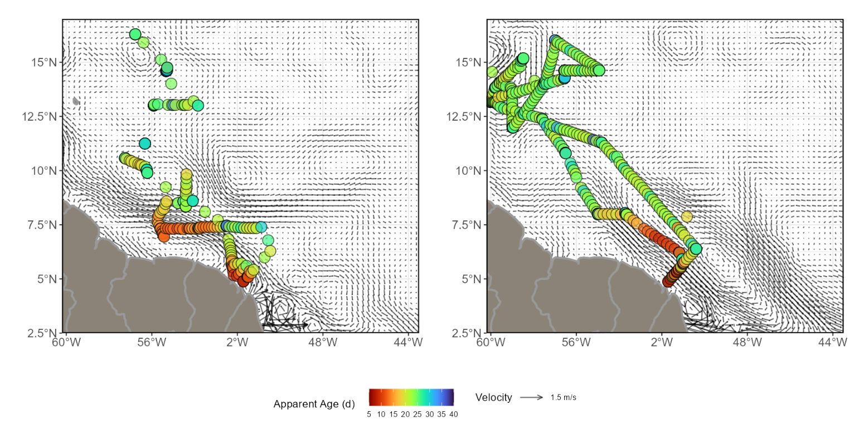
Figure S1. Color circles represent the apparent age of the plume estimated by radium isotopes measured underway and from CTD samples at surface during our cruise in 2018² and in 2019³ cruise include in Pham et al (2024)¹ for the habitat delineation along the Amazon River plume. The activity ratio on the Amazon shelf, representing time zero, was estimated using the average of the surface samples at salinities between 5 and 9 in Moore et al (1995)⁶. The arrows represent the median of the geostrophic velocity provided by the Copernicus Global Ocean Gridded L4 Sea Surface Heights for the duration of each cruise (doi: 10.48670/moi-00148).

Bulk carbon isotopes reveal phytoplankton as major sources of seston
Seston may contain a mixture of phytoplankton, microzooplankton, bacteria and detritus, whose contribution can be disentangled using carbon isotopes. The bulk C:N ratio, δ¹³C, and the relation between particulate carbon (bulk PC) and chlorophyll a (Chla) are commonly used to confirm the dominance of phytoplankton in the particle signature. Bulk PC showed a linear relationship with Chla concentration measured at the surface (Fig. S2), this significant linear relationship between the log-log of the two variables (bulk PC = 1.0 + 0.4 Chla, n = 27, R²adj = 0.35, p<0.001) suggests the dominance of phytoplankton biomass in the signature of seston (Fig. S2). It is to be noted that all mixotrophic samples showed this relationship between bulk PC and Chla, indicating that the higher TP of these samples is unlikely to be simply the result of a mixture of phytoplankton and herbivorous microzooplankton. Excluding the three autotrophic samples with bulk PC values higher or lower than those with similar Chla content (stations 12.01 and 17.01 in 2018 and 12.02 in 2021), the linear relationship was still significant with a more than twofold increase in R²adj (bulk PC = 1.1 + 0.5 Chla, n = 24, R²adj = 0.76, p<0.001). In addition, the bulk C:N ratio of seston ranged from 6.2 to 16.6, and in the majority of our samples, it is consistent with the ranges described for marine or freshwater algae and organic particulate matter⁷ with little or no imprint of bacteria or higher plant matter delivered by the river, including the three samples with anomalous bulk PC-Chla ratios (Fig. S2). These C:N values above 6 also suggest no contribution from microzooplankton in our samples, which typically have C:N ratios below 6.6⁸, and further support the fact that mixotrophic samples are not the result of mixing of different trophic levels in seston, but of the combined autotrophic and heterotrophic metabolism of mixotrophs.
The bulk δ¹³C of seston ranged between –31 and –27 ‰ in the RI habitat and between –26 and −17 ‰ in the other habitats (Fig. S2). Values in RI are consistent with previous studies reporting δ¹³C values of terrestrial material between −34 and −27 ‰ ^{9–11} in the region, implying that seston in the brackish waters of the river mouth are mostly of fluvial origin with little input from the adjacent marine materials. This fluvial signal observed in brackish waters (salinity < 6) disappears when salinity increases above 15, reflecting a shift to marine particles dominance in subsequent habitats. The depletion of δ¹³C depletion in the smaller size fraction relative to the large of 2021 reflects the phytoplankton group compositions, with picoseston generally more depleted (−26 to −23‰) than nano- and microseston (−24 to −17 ‰)¹²⁻¹³. This difference in the signatures of different phytoplankton could also explain the higher bulk δ¹³C measured at stations 6.04, 8.02 and 22.04 in 2018, and 24.01 in 2021 (above −19 ‰), where we found a dominance of diatoms and some contribution of Trichodesmium (Fig 2), a species known to have a bulk δ¹³C as high as −12.9 ‰ ¹³. In 2018, the total bulk samples collected presented a range of variation similar to that of the large size fraction collected in 2021, suggesting that the signature of the community was driven by larger plankton rather than picoplankton. Overall, these data suggest that our samples are also consistent with the bulk δ¹³C organic material derived from primary producers (Fig. S2).
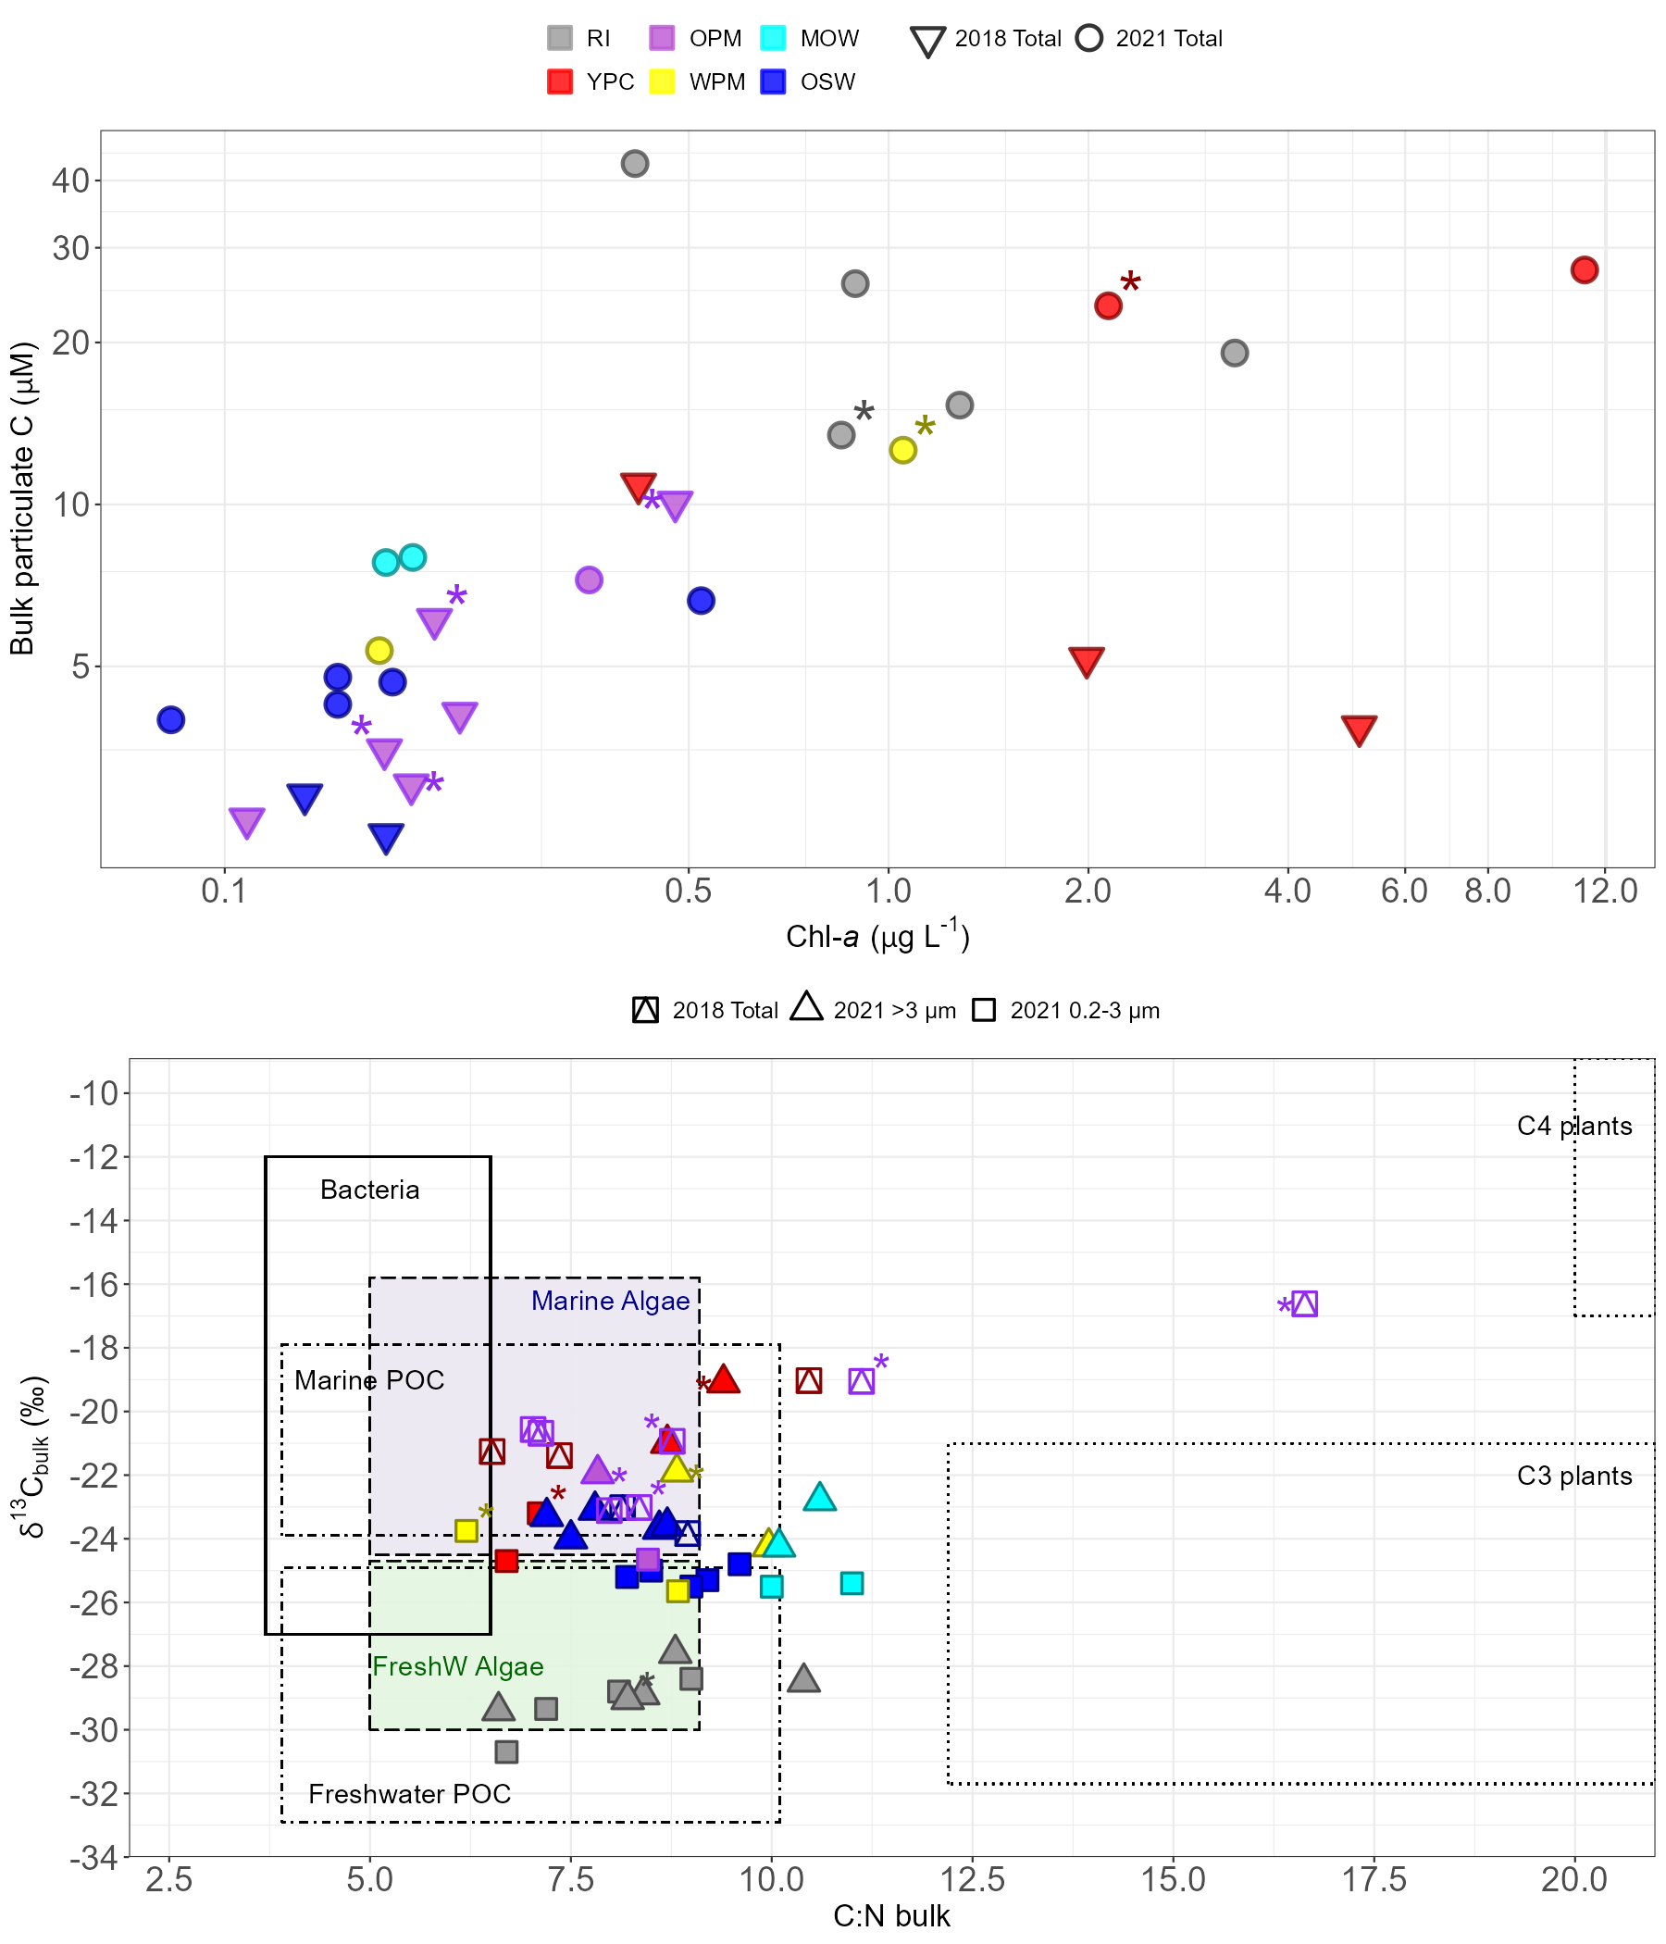
Figure S2. Carbon sources driving the signature of seston during 2018 and 2021 cruises along the Amazon River plume. The upper panel shows the log-log plot of total particulate carbon to chlorophyll a with natural values in the scales. The lower panel shows the bulk carbon isotopes expressed in delta notation (δ¹³C ‰ relative to VPDB) vs the C:N ratio, the boxes represent the ranges define in Lamb et al (2006)⁷ for various sources of carbon based on a literature revision⁷. Colors represent the different habitats defined by Pham et al (2024)¹ ordered by apparent age: Riverine Input (RI, gray), Young Plume Core (YPC, red), Outer Plume Margin (OPM, purple), Western Plume Margin (WPM, yellow), modified Oceanic Water (MOW, cyan) and Oceanic Water (OSW, blue). Mixotrophs are marked with an asterisk using the same colors as the symbols.
References
1. Pham, A. H. et al. Planktonic habitats in the Amazon Plume region of the Western Tropical North Atlantic. Frontiers in Marine Science vol. 11 (2024).
2. Peterson, Richard, Montoya, Joseph P., Subramaniam, A. Radium isotope measurements from CTD and underway water samples from the R/V Endeavor from 2018-05-06 to 2018-05-29. Biological and Chemical Oceanography Data Management Office (BCO-DMO). (Version 1) Version Date 2019-02-11. (2020) doi:10.26008/1912/bco-dmo.753837.1.
3. Peterson, R. N., Montoya, J., Subramaniam, A. Radium isotope (223Ra, 224Ra, and 226Ra) measurements from CTD and underway water samples collected on R/V Endeavor cruise EN640 from June-July 2019. Biological and Chemical Oceanography Data Management Office (BCO-DMO). (Version 1). (2021) doi:10.26008/1912/bco-dmo.846802.1.
4. Léon, M. et al. Use of 223Ra and 224Ra as chronometers to estimate the residence time of Amazon waters on the Brazilian continental shelf. Limnol. Oceanogr. 67, 753–767 (2022).
5. Moore, W. S. Ages of continental shelf waters determined from 223Ra and 224Ra. J. Geophys. Res. Ocean. 105, 22117–22122 (2000).
6. Moore, W. S., Astwood, H. & Lindstrom, C. Radium isotopes in coastal waters on the Amazon shelf. Geochim. Cosmochim. Acta 59, 4285–4298 (1995).
7. Lamb, A. L., Wilson, G. P. & Leng, M. J. A review of coastal palaeoclimate and relative sea-level reconstructions using δ13C and C/N ratios in organic material. Earth-Science Rev. 75, 29–57 (2006).
8. Steinberg, D. K. & Saba, G. K. Chapter 26 - Nitrogen Consumption and Metabolism in Marine Zooplankton. in (eds. Capone, D. G., Bronk, D. A., Mulholland, M. R. & Carpenter, E. J. B. T.-N. in the M. E. (Second E.) 1135–1196 (Academic Press, 2008). doi:https://doi.org/10.1016/B978-0-12-372522-6.00026-8.
9. Cai, D.-L., Tan, F. C. & Edmond, J. M. Sources and transport of particulate organic carbon in the Amazon River and estuary. Estuar. Coast. Shelf Sci. 26, 1–14 (1988).
10. Showers, W. J. & Angle, D. G. Stable isotopic characterization of organic carbon accumulation on the Amazon continental shelf. Cont. Shelf Res. 6, 227–244 (1986).
11. Mortillaro, J. M. et al. Fatty acid and stable isotope (δ13C, δ15N) signatures of particulate organic matter in the lower Amazon River: Seasonal contrasts and connectivity between floodplain lakes and the mainstem. Org. Geochem. 42, 1159–1168 (2011).
12. Brandenburg, K. M., Rost, B., Van de Waal, D. B., Hoins, M. & Sluijs, A. Physiological control on carbon isotope fractionation in marine phytoplankton. Biogeosciences 19, 3305–3315 (2022).
13. Carpenter, E. J., Harvey, H. R., Fry, B. & Capone, D. G. Biogeochemical tracers of the marine cyanobacterium Trichodesmium. Deep. Res. Part I-Oceanographic Res. Pap. 44, 27–38 (1997).

