Entry | Ar–X | PhB(OH)₂ |  | 4-MePhB(OH)₂
Entry | Ar–X | Time (h) | Yield (%)ª | Time (h) | Yield (%)ª
1 | 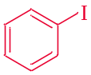 | 1 | 95 | 2.5 | 94
2 | 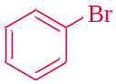 | 2 | 90 | 3.5 | 85
3 | 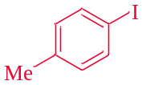 | 2.5 | 92 | 3.5 | 90
4 | 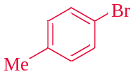 | 3 | 90 | 4.5 | 85
5 | 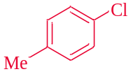 | 5 | 85 | 7 | 80
6 | 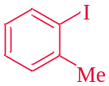 | 1.5 | 87 | 3 | 85
7 | 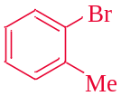 | 2.45 | 85 | 4 | 80
8 | 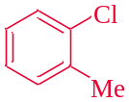 | 3.5 | 78 | 5.5 | 70
9 | 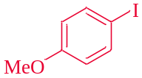 | 2 | 90 | 3.5 | 82
10 | 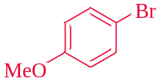 | 3.5 | 87 | 5 | 80
11 | 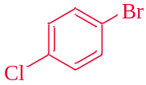 | 4 | 80 | 6 | 78
12 | 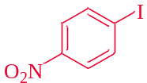 | 3 | 88 | 5.5 | 85
13 | 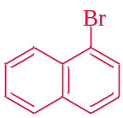 | 5 | 80 | 7 | 75
Table 3. The reaction of various aryl halides with phenylboronic acid derivatives and elemental Se in the presence of CuI as the catalyst.
ª Isolated yield.

Entry | Ar–X | PhB(OH)₂ |  | 4-MePhB(OH)₂
Entry | Ar–X | Time (h) | Yield (%)ª | Time (h) | Yield (%)ª
1 | 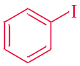 | 2.5 | 94 | 3.5 | 94
2 |  | 3.5 | 90 | 4 | 85
3 |  | 3.5 | 92 | 4.45 | 90
4 |  | 4 | 88 | 5 | 82
5 |  | 5.5 | 86 | 7 | 82
6 |  | 2.5 | 87 | 4 | 85
7 |  | 3.5 | 80 | 4 | 78
8 |  | 4.5 | 75 | 6 | 70
9 |  | 3 | 90 | 5 | 85
10 |  | 3.5 | 87 | 5 | 82
11 |  | 4.45 | 82 | 6.5 | 78
12 |  | 4 | 88 | 6 | 85
13 |  | 7 | 75 | 8.5 | 70
Table 5. The reaction of various aryl halides with phenylboronic acid derivatives and elemental Se in the presence of M-MCF@Gua-Cu as the catalyst.
ª Isolated yield.

