Copper catalyzed carbon–selenium bond formation via the coupling reaction of aryl halides, phenylboronic acid and Se

Zeinab Shirvandi*, Nadya Ghorashi & Amin Rostami*

* Department of Chemistry, Faculty of Science, University of Kurdistan, Zip Code 66177-15175, Sanandaj, Iran. Email: a.rostami@uok.ac.ir

Selected ¹H NMR spectra
Diphenyl selenide. Oil, ¹H NMR (500 MHz, DMSO): δ (ppm)= 7.66-7.62 (m, 4 H), 7.36-7.30 (m, 6 H) (Fig. S1).
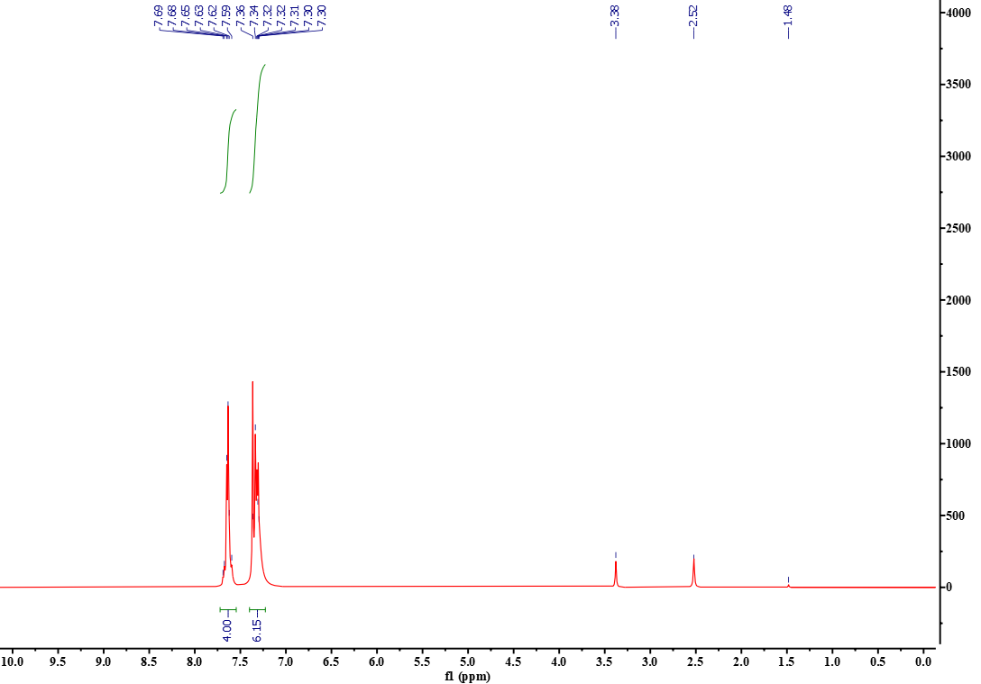
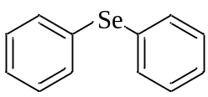
Figure S1. ¹H NMR spectrum of Diphenyl selenide.

Phenyl(p-methoxyphenyl) selenide. Oil, ¹H NMR (300 MHz, CDCl₃): δ (ppm)= 7.60-7.53 (m, 4H), 7.47-7.42 (m, 2H), 7.36-7.33 (m, 1H), 7.04-6.98 (m, 2H), 3.88 (s, 3H) (Fig. S2).

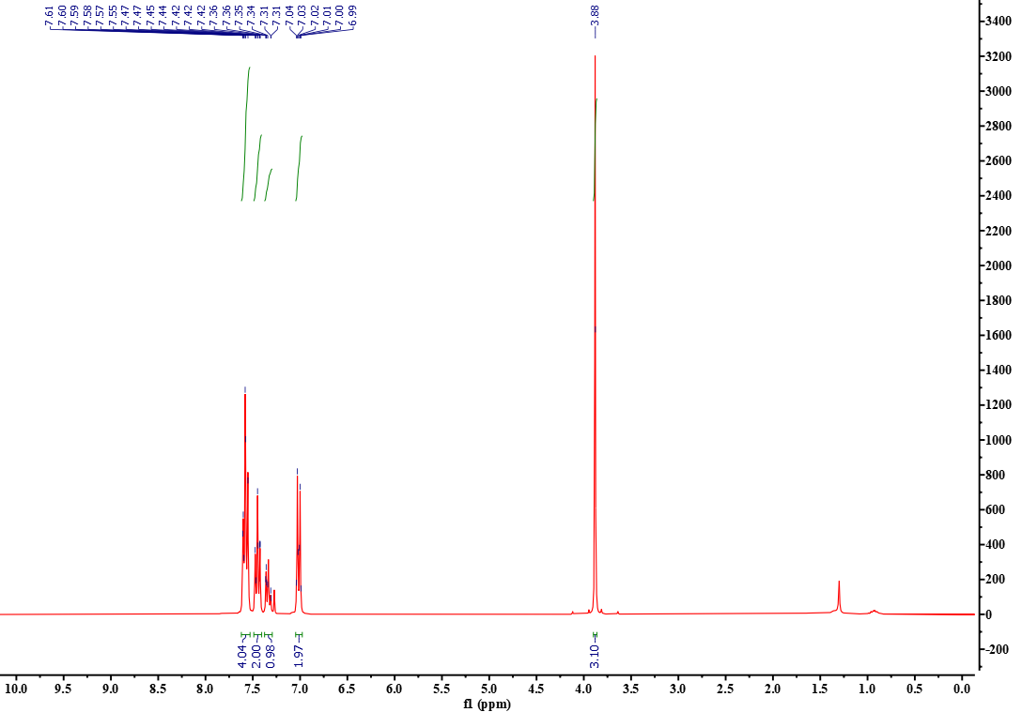
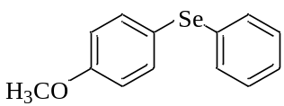
Figure S2. ¹H NMR spectrum of Phenyl(p-methoxyphenyl) selenide.

Di(p-tolyl) selenide. Yellow oil, ¹H NMR (300 MHz, CDCl₃): δ (ppm)= 7.29 (d, J= 8.1 Hz, 4H), 7.15 (d, J= 7.8 Hz, 4H), 2.37 (s, 6H) (Fig. S3).

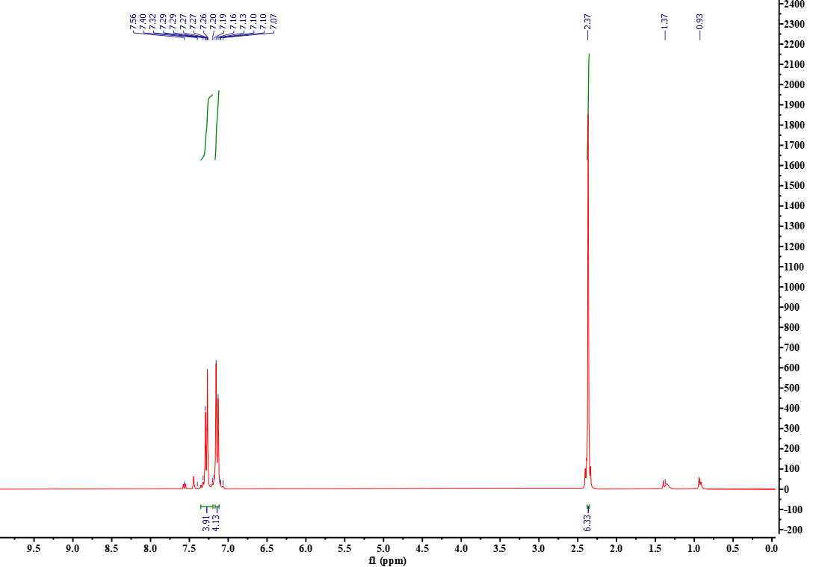
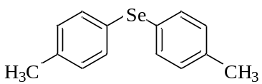
Figure S3. ¹H NMR spectrum of Di(p-tolyl) selenide.

Phenyl(p-tolyl) selenide. Yellow oil, ¹H NMR (300 MHz, CDCl₃): δ (ppm)= 7.467.42 (m, 4H), 7.29-7.25(m, 3H), 7.14 (d, J= 8.0 Hz, 2H), 2.36 (s, 3H) (Fig. S4).

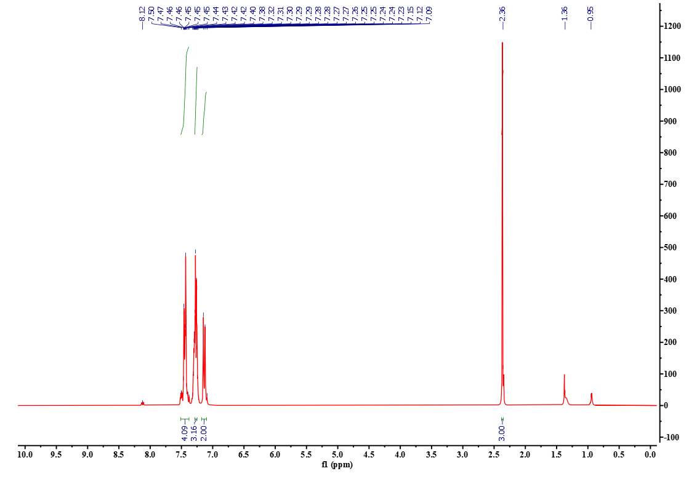
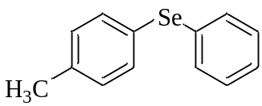
Figure S4. ¹H NMR spectrum of Phenyl(p-tolyl) selenie.

