Table 1: List of top 5 hit compounds with their PubChem ID, binding energies, and 2D structure.
S.No. | PubChem ID | Binding energy (kcal/mol) | 2D Structure
1 | 123629569 | -18.700 | 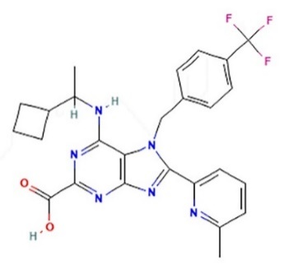
2 | 163388234 | -11.143 | 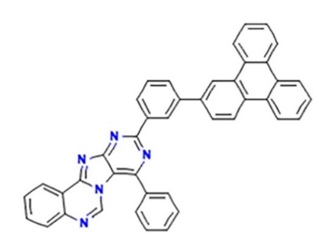
3 | 122589735 | -10.813 | 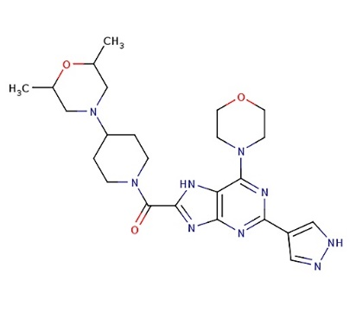
4 | 163555323 | -10.557 | 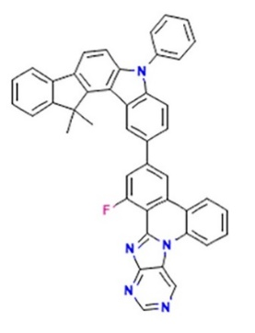
5 | 156185498 | -10.551 | 