Supplementary Information
Exploring Purine Analogues as Inhibitors against Katanin, a Microtubule Severing Enzyme using Molecular Modeling Approach
Vibhuti Saxena, Pruthanka Patil, Purva Khodke, and Bajarang Vasant Kumbhar*

Department of Biological Sciences, Sunandan Divatia School of Science, NMIMS (Deemed to be) University, Vile Parle (West), Mumbai- 400056, India

Equal Authors: Vibhuti Saxena and Pruthanka Patil

*Corresponding Author
Dr. Bajarang Vasant Kumbhar
Assistant Professor
Sunandan Divatia School of Science
Department of Biological Science
NMIMS (Deemed to be) University, Mumbai
Maharashtra-400056, India
Contact: (91-22) 4235 5963
Email: bajarang.kumbhar@nmims.edu, kumbharbajarang@gmail.com
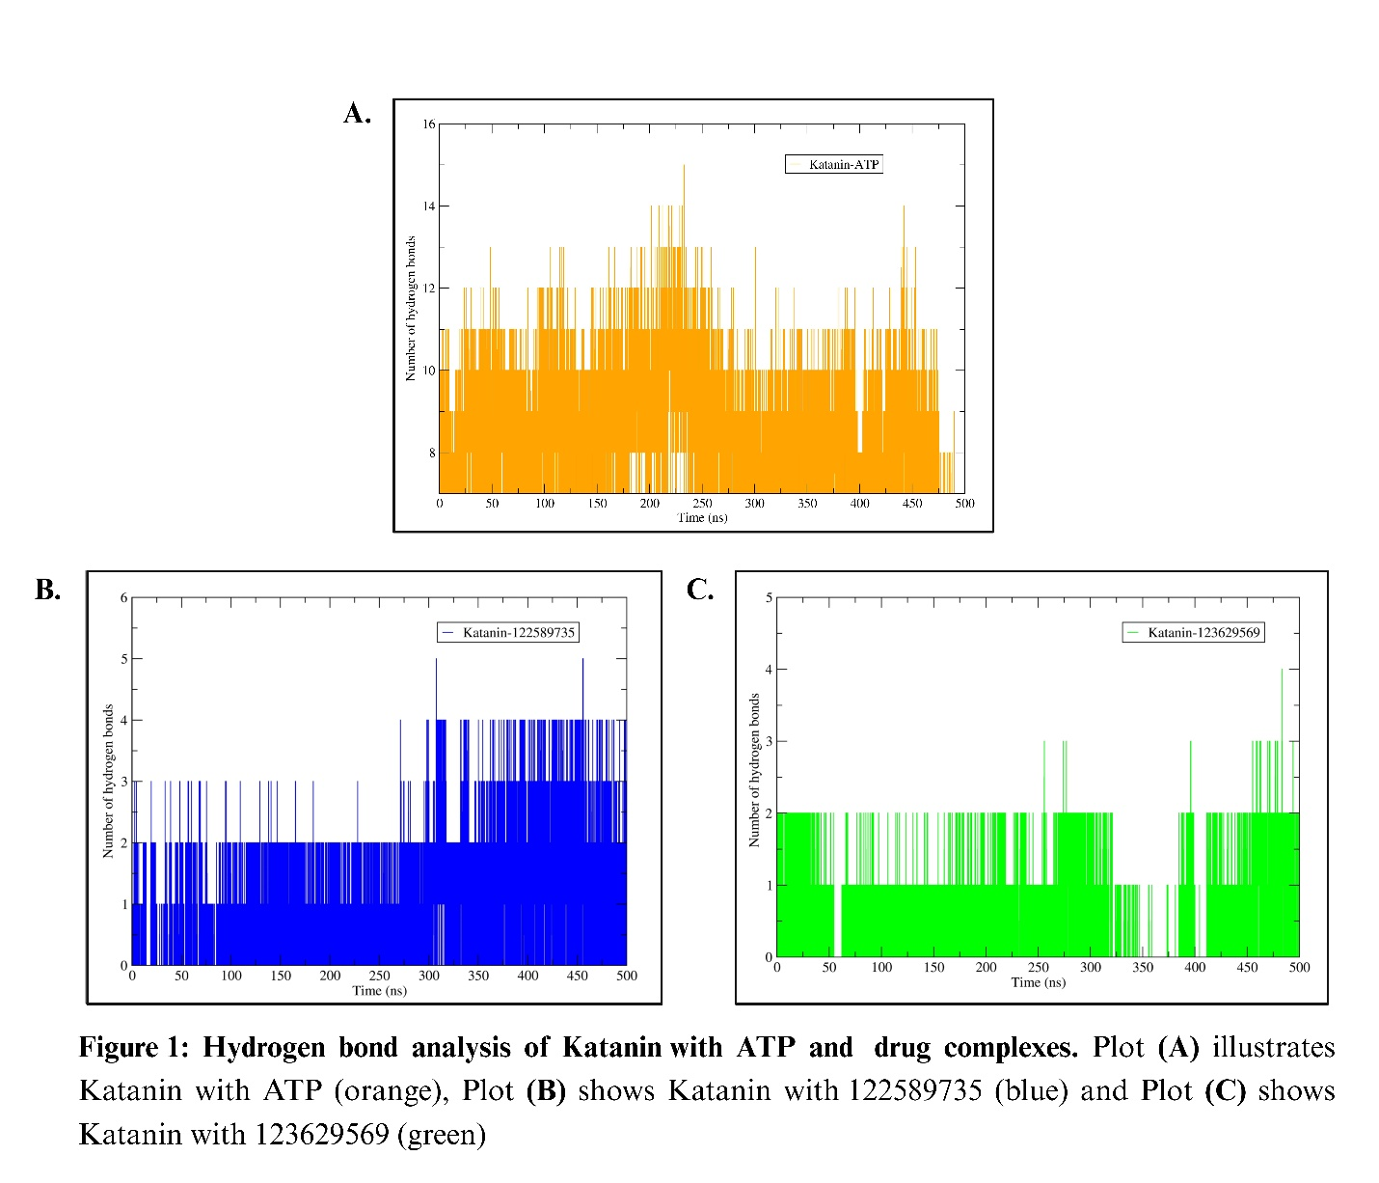

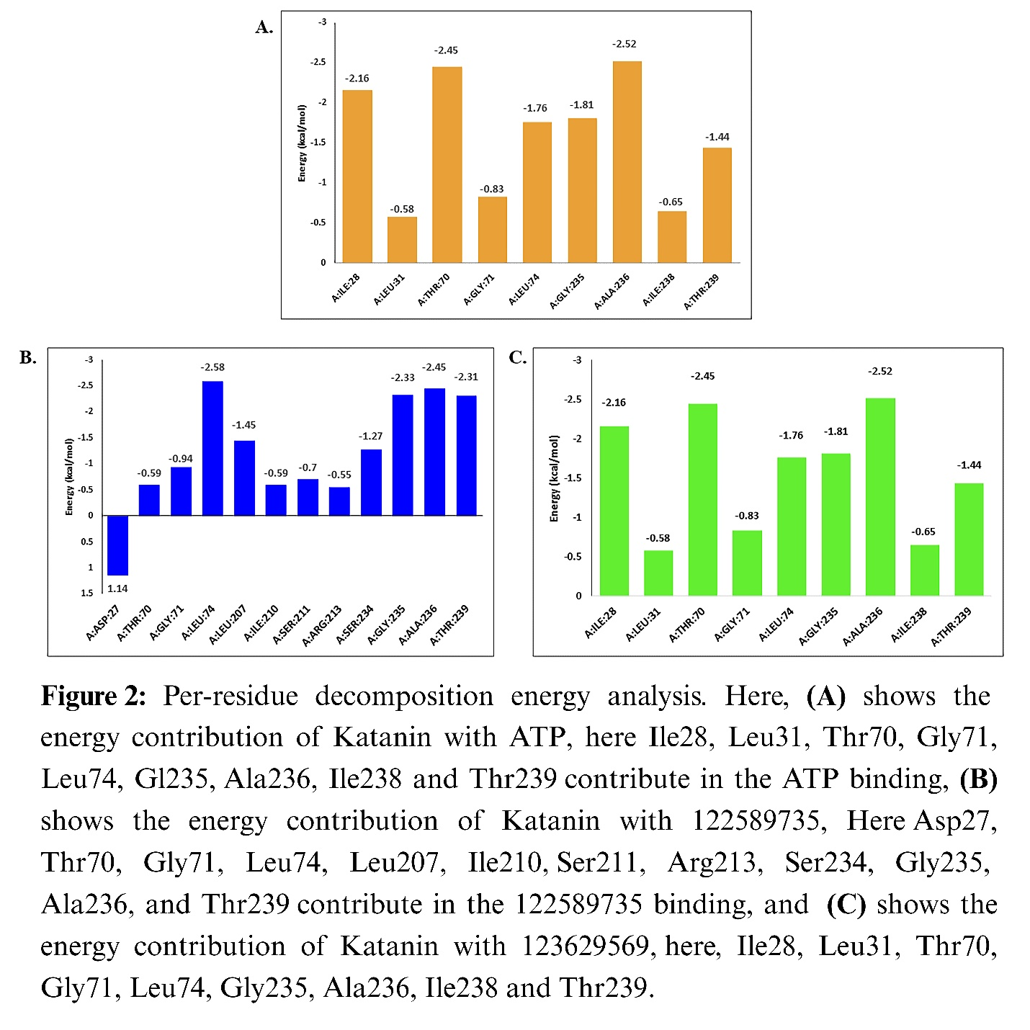
Supplementary Movie 1. MD simulation of katanin in apo form.
Supplementary Movie 2. MD simulation of katanin with ATP.
Supplementary Movie 3. MD simulation of katanin with 122589735 compound.
Supplementary Movie 4. MD simulation of katanin with 123629569 compound.

