Supporting Information
﻿S1 Key Hyperparameters setting of BART architecture
vocab_size: 4191,
d_model: 768,
encoder_layers: 6,
decoder_layers: 6,
encoder_attention_heads: 12,
decoder_attention_heads: 12,
decoder_ffn_dim: 3072,
encoder_ffn_dim: 3072,
activation_function: "gelu",
dropout: 0.1,
max_position_embeddings: 512,
forced_eos_token_id: 188

﻿S2 Additional Method
S2.1 ﻿ CLASS Token Preprocessing
We define ten tokens for ten reaction type labels, as shown below:
"RX_0", "RX_1", "RX_2", "RX_3", "RX_4", "RX_5", "RX_6", "RX_7", "RX_8", "RX_9", "RX_10".
S2.2 ﻿ ENZYME Token Preprocessing
The Enzyme Commission number (EC number) is a numerical classification scheme for enzymes based on the chemical reactions they catalyze. Each enzyme code consists of the letters "EC" followed by four numbers separated by periods, which represent progressively finer classifications of the enzyme. In order to better understand the classification of enzymes at different levels, four tokens are used as a group to represent an enzyme. For example, “E_1.1, E_2.14, E_3.14, E_4.52” are used to represent “EC1.14.14.52”. Each token begins with "E_". The first number indicates the level, and the second number represents the classification order. The two numbers are separated by periods.

S3 ﻿Additional Results
S3.1 Additional ablation experiments
Table S1 Ablation experiment of backward mode
Class | Batch size | Task_percent | Flag_dual | Learning_rate | Top1_accuracy (%)
FALSE | 32 | 1.0 | TRUE | 5.00E-05 | 40.8
FALSE | 32 | 0.5 | TRUE | 1.00E-04 | 41.9
FALSE | 32 | 0.5 | TRUE | 5.00E-05 | 42.1
FALSE | 32 | 1.0 | FALSE | 5.00E-05 | 41.9
FALSE | 64 | 1.0 | FALSE | 5.00E-05 | 41.4
TRUE | 64 | 0.5 | TRUE | 5.00E-05 | 52.3
TRUE | 64 | 0.5 | TRUE | 1.00E-04 | 54.0
TRUE | 64 | 1.0 | FALSE | 5.00E-05 | 52.6
TRUE | 64 | 1.0 | TRUE | 1.00E-04 | 51.5
TRUE | 64 | 0.5 | TRUE | 5.00E-05 | 49.6

Table S2 Ablation experiment of forward mode
Class | Batch size | Task_percent | Flag_dual | Learning_rate | Top1_accuracy (%)
FALSE | 64 | 1.0 | FALSE | 1.00E-04 | 76.1
FALSE | 64 | 1.0 | TRUE | 5.00E-05 | 74.8
FALSE | 64 | 1.0 | TRUE | 1.00E-04 | 80.7
FALSE | 64 | 0.5 | TRUE | 1.00E-04 | 80.6
FALSE | 32 | 0.5 | TRUE | 5.00E-05 | 80.0
TRUE | 32 | 0.5 | TRUE | 5.00E-05 | 71.0
TRUE | 64 | 1.0 | FALSE | 5.00E-05 | 78.9
TRUE | 64 | 1.0 | FALSE | 1.00E-04 | 80.6
TRUE | 64 | 1.0 | TRUE | 5.00E-05 | 79.6
TRUE | 64 | 1.0 | TRUE | 1.00E-04 | 81.1

S3.2 Model performance on the MIT dataset
Table S3 Ablation experiment of forward mode
TopK | Backward |  | Forward
 | Accuracy (%) | Max_accuracy (%) | Accuracy (%) | Max_accuracy (%)
1 | 47.3 | 61.8 | 83.1 | 83.9
3 | 60.8 | 75.9 | 92.9 | 93.3
5 | 64.5 | 80.6 | 94.4 | 94.8
10 | 68.7 | 84.9 | 95.4 | 95.8
50 | 74.4 | 90.9 | 97.1 | 97.3
100 | 76.2 | 91.9 | 97.4 | 97.5

S3.3 Round_trip accuracy
Due to the possibility of multiple different reactants synthesizing the same product and multiple different products being inferred from the same reactants, round-trip accuracy is used to evaluate our model. For the backward model, round-trip accuracy is calculated by comparing the ground-truth products with the products predicted by the forward model using the predicted reactants. Similarly, for the forward model, round-trip accuracy is calculated by comparing the ground-truth reactants with the reactants predicted by the backward model using the predicted products.
Table S4 Round_trip accuracy
Top-K | Round_trip accuracy
Top-K | 50k_Backward | 50k_Forward | 50k_class_Backward | 50k_class_Forward | Mit_Backward | Mit_Forward
1 | 0.243 | 0.152 | 0.308 | 0.286 | 0.286 | 0.182
3 | 0.497 | 0.266 | 0.568 | 0.561 | 0.561 | 0.337
5 | 0.650 | 0.397 | 0.708 | 0.712 | 0.712 | 0.466
10 | 0.936 | 0.739 | 0.922 | 0.922 | 0.922 | 0.756

S3.4 Tanimoto similarity

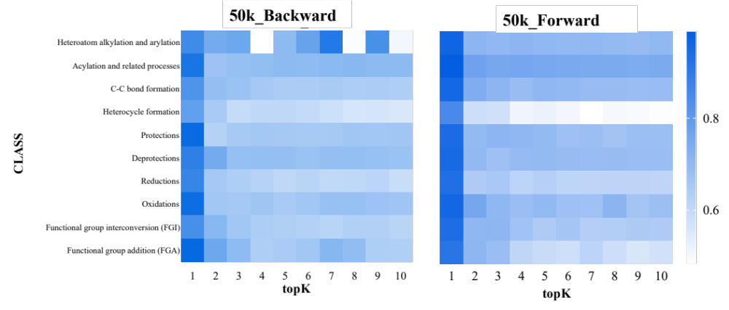
Figure S1 Tanimoto similarity of forward and backward mode on of different reaction classes

S3.5 Tanimoto similarity

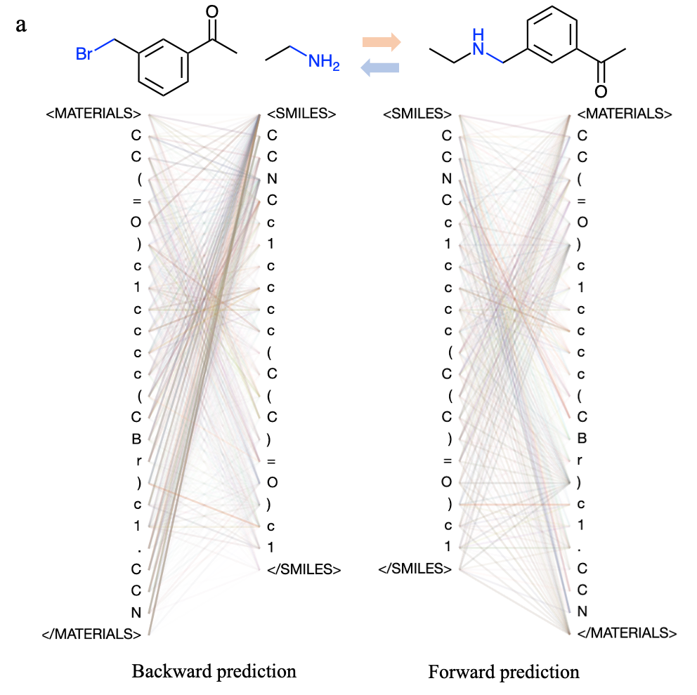

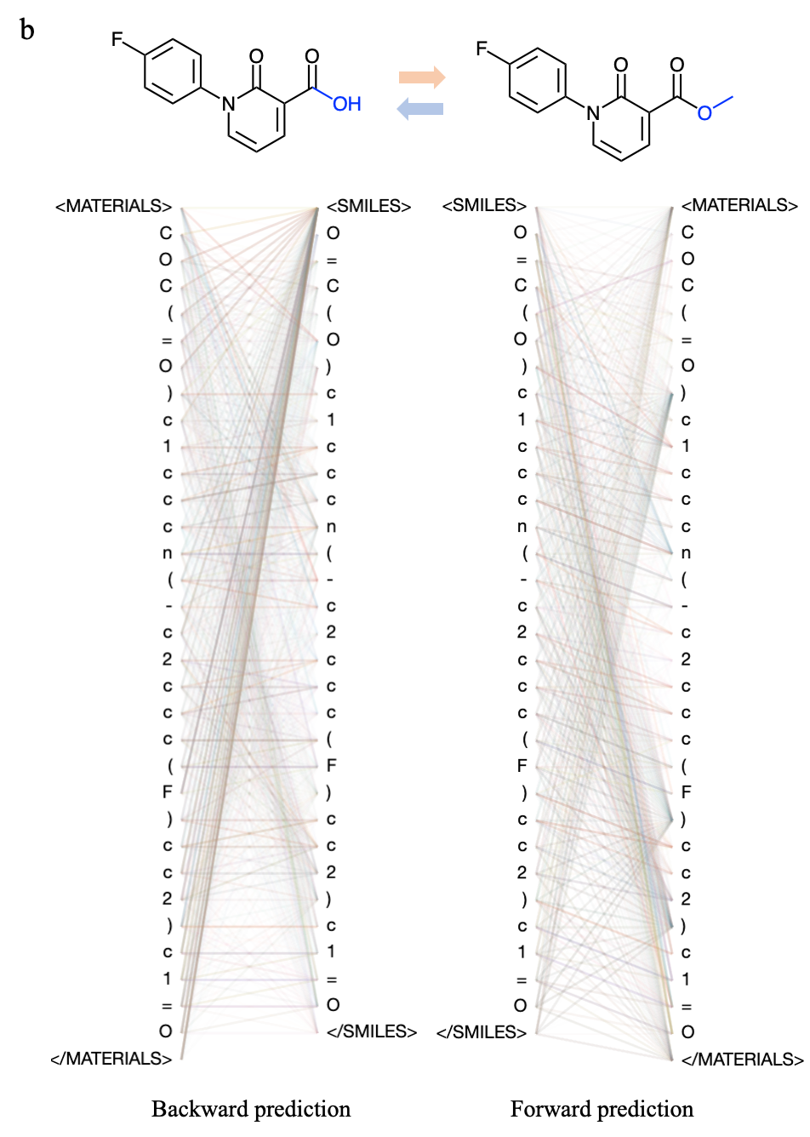
Figure S2 The attention weights of forward and backward organic synthesis. (a) Heteroatom alkylation and arylation. (b) Deprotections.

S3.6 Transfer-learning on different dataset.
We performed four types of fine-tuning on the metabolic dataset, which include direct fine-tuning using the USPTO dataset, as well as selecting reactions with similar reaction fingerprints and product molecular fingerprints to the metabolic dataset for pre-training.
Table S5
 | Top1 | Top3 | Top5 | Top10 | Top50 | Top100
Baseª | 21.9 | 39.1 | 46.9 | 53.1 | 62.0 | 65.6
Rxnfp^{b} | 20.8 | 34.9 | 44.3 | 50.5 | 63.0 | 65.1
Tanimoto^{c} | 19.3 | 35.9 | 43.2 | 50.5 | 59.9 | 64.1
ª Pretraining on the USPTO dataset.
^{b} Pretraining on a dataset (50,205 records) where reactions in the USPTO database have an RXNFP cosine similarity of ≥0.8 with those in the metabolism database.
^{c} Pretraining on a dataset (6,924 records) where the products of each reaction in the USPTO database have a maximum similarity of ≥0.8 with those in the metabolism database.
S3.7 Accuracy of enzyme-catalysed reaction

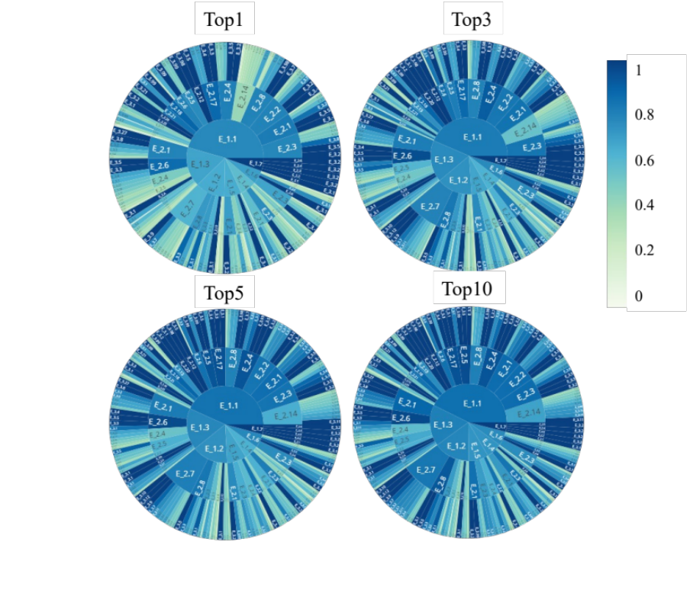
Figure S3 The hierarchical accuracy of enzyme catalytic product prediction.

