Supplementary Table 1. Multivariable Cox regression analysis of each model for distant metastasis-free survival: (a) LNN, LNR, and LODDS model, (b) N stage and LN involvement model
(a)
 |  |  | LNN model |  |  |  | LNR model |  |  |  | LODDS model
 |  | HR | 95% CI | P |  | HR | 95% CI | P |  | HR | 95% CI | P
Tumor | WD | 1 |  | 0.144 |  | 1 |  | 0.119 |  | 1 |  | 0.080
differentiation | Non-WD | 4.48 | 0.60-33.55 |  |  | 4.93 | 0.66-36.66 |  |  | 5.95 | 0.81-43.86
Perineural | Absent | 1 |  | 0.004 |  | 1 |  | 0.003 |  | 1 |  | 0.002
invasion | Present | 2.64 | 1.37-5.09 |  |  | 2.70 | 1.40-5.22 |  |  | 2.86 | 1.48-5.52
Postoperative | ≤37 | 1 |  | 0.033 |  |  |  |  |  | 1 |  | 0.035
CA 19-9 | >37 | 2.92 | 1.09-7.81 |  |  |  |  |  |  | 2.92 | 1.08-7.90
Adjuvant | No | 1 |  | 0.091 |  | 1 |  | 0.161 |  | 1 |  | 0.065
CCRT | Yes | 3.56 | 0.82-15.49 |  |  | 2.79 | 0.67-11.65 |  |  | 4.07 | 0.92-18.09
LNN | 0-1 | 1 |  | 0.004
 | ≥2 | 2.74 | 1.39-5.41
LNR | ≤4.8% |  |  |  |  | 1 |  | 0.015
 | >4.8% |  |  |  |  | 2.26 | 1.17-4.35
LODDS | ≤-0.92
 | >-0.92

(b)
 |  |  | N stage model |  |  | LN involvement model
 |  | HR | 95% CI | P |  | HR | 95% CI | P
Tumor | WD | 1 |  | 0.121 |  | 1 |  | 0.102
differentiation | Non-WD | 4.89 | 0.66-36.40 |  |  | 5.31 | 0.72-39.31
Perineural | Absent | 1 |  | 0.002 |  | 1 |  | 0.004
invasion | Present | 2.85 | 1.45-5.57 |  |  | 2.63 | 1.36-5.09
Postoperative | ≤37 | 1 |  | 0.043 |  | 1 |  | 0.077
CA 19-9 | >37 | 2.85 | 1.03-7.85 |  |  | 2.43 | 0.91-6.50
Adjuvant | No | 1 |  | 0.121 |  | 1 |  | 0.132
CCRT | Yes | 3.28 | 0.73-14.76 |  |  | 3.11 | 0.71-13.60
pN stage | 0 | 1
 | 1 | 1.46 | 0.69-3.10 | 0.323
 | 2 | 4.59 | 1.76-11.97 | 0.002
LN involvement | Absent |  |  |  |  | 1 |  | 0.087
 | Present |  |  |  |  | 1.84 | 0.91-3.71
LNN, metastatic lymph node number; LNR, metastatic lymph node ratio; LODDS, log odds of positive lymph node; LN, lymph node; HR, hazard ratio; CI, confidence interval; CCRT, concurrent chemoradiation therapy; CA 19-9, carbohydrate antigen 19-9; WD, well differentiated carcinoma.

Supplementary Figure 1. Flowchart of patient enrollment
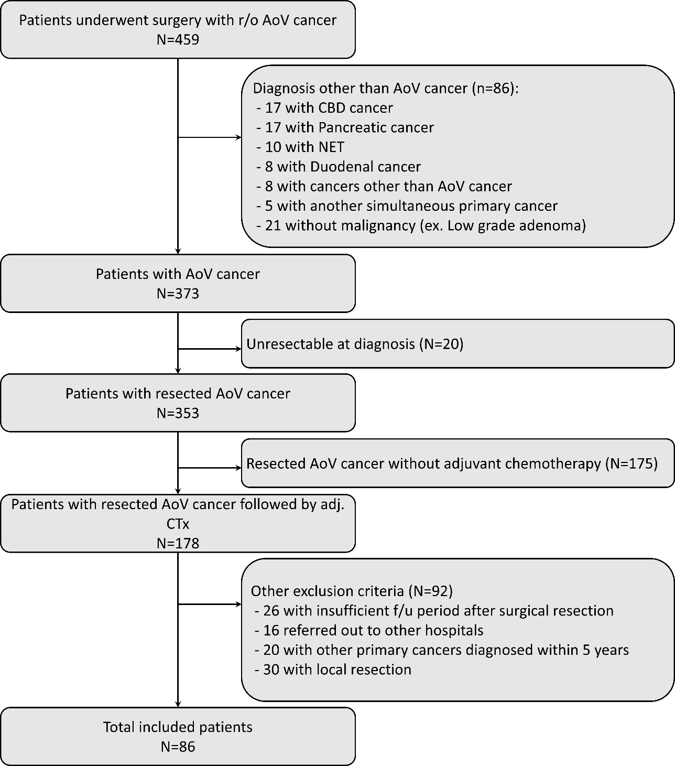
Supplementary Figure 2. Kaplan-Meier plot of distant metastasis-free survival according to (a) LNN, (b) LNR, (c) LODDS, (d) pN stage, and (e) LN involvement

(a) (b)

(c) (d)

(e)

LNN, metastatic lymph node number; LNR, metastatic lymph node ratio; LODDS, log odds of positive lymph node; LN, lymph node.

