Ferroelectricity in Hafnia: The Origin of Nanoscale Stabilization

Table of Contents
Section 1. Phase diagram of hafnia 2
Section 2. Effect of epitaxial strain and La-doping on phase stability 4
Section 3. Ferroelectric switching of 10% La-doped HfO₂ films grown on La_{0.7}S_{0.3}rMnO₃ / SrTiO₃ (110) 5
Section 4. LHO/YSZ films: X-ray studies 6
4.1 Film thickness measured using reflectivity 6
4.2 Growth-temperature dependence of crystal structure measured by the (010)_{o} diffraction 6
4.3 Thickness dependence of crystal structure measured using (110)_{o} diffraction 7
4.4 (010) diffraction 7
4.5 Thickness-dependent out-of-plane lattice constant d₁₁₁ 8
4.6 Lattice constants of orthorhombic LHO 8
Section 5. LHO/YSZ films: AFM studies and atomic terraces 10
Section 6. LHO/YSZ films: STEM studies 11
6.1 Evidence of LHO film as single crystal 11
6.2 Identification of structural twins 12
6.3 Domain distributions 14
6.4 Quantification of oxygen polar displacement 14
6.5 Atomic-scale compositional analysis of the LHO/YSZ film 16
Section 7. KPFM signal as a function of the mechanical load 17
Section 8. Interfacial lattice distortion from DFT. 18
Section 9. LHO/YSZ films: in-situ RHEED studies 20
9.1 One monolayer to two monolayer (one unit cell) transition of orthorhombic structure grown along the (111) direction 20
9.1.1 Bulk structures with (111) surface: 20
9.1.2 One (111) layer 20
9.2 Experimental observation of the transition 21
Section 10. Hafnia films of different doping grown on YSZ 23

Section 1. Phase diagram of hafnia
Consider part of the pressure-temperature (P-T) phase diagram [1] (Fig. S1a) that contains the tetragonal (t, space group P42/mnc) phase, the monoclinic (m, space group P2₁/c) phase, and the orthorhombic (o, space group Pbca) phases. The m-o phase boundary has a constant pressure, suggesting that the two phases are of about the same entropy but have a large difference in density. In fact, the density ratio between the m and the o phases is about 0.955. The m-t phase boundary has a negative slope, this suggests that the t phase has higher entropy (t is the high temperature phase) and the m/t density ratio is about 0.96. The t-o phase has a small positive slope because of a large difference in entropy and the o phase having a slightly larger density.
Since in epitaxial film growth the constraint is strain rather than stress, we need to construct the strain-temperature phase diagram. For the film grown along the (111) plane, we consider the volume-temperature (V-T) phase diagram as an approximation.
The V-T phase diagram can be obtained by plotting the equation of state $V=V\left(P,T\right)$ as a surface in the three dimensional $(P,V,T)$ space. We use the following linear expansion,
$$V=V_{0}-\frac{V}{k}P+Vα_{V}T,$$
where $k$ is the bulk modulus, $α_{V}$ is the volume thermal expansion. To make the relation more general, we introduce reduced variables $t=\frac{T}{T_{triple}},p=\frac{P}{P_{triple}}$, and $v=\frac{V}{V_{m_{0}}}$, where $T_{triple}$ and $P_{triple}$ are the temperature and pressure of the triple point of the three phases. $V_{m0}$ is the unit cell volume of the m phase (low T, low P). The key is the ratio $\frac{V_{t0}}{V_{m0}}=$0.96 and $\frac{V_{o0}}{V_{m0}}=$0.955. [1] Hence, the equation of state for each state becomes
$$v=v_{0}-\frac{P_{triple}}{k}p+α_{V}T_{triple}t.$$
The volume-temperature phase diagram can be plotted using the following parameters. $T_{triple}$= 1523 K, $P_{triple}$=3.8⨯10⁸ Pa [1], $k$=5.7⨯10¹⁰ Pa, $α_{V}$=15⨯10⁻⁶/K [2]. $v_{m0}=1$, $v_{t0}=$0.96, $v_{o0}=$0.955. The phase boundaries are decided according to the P-T phase diagram.
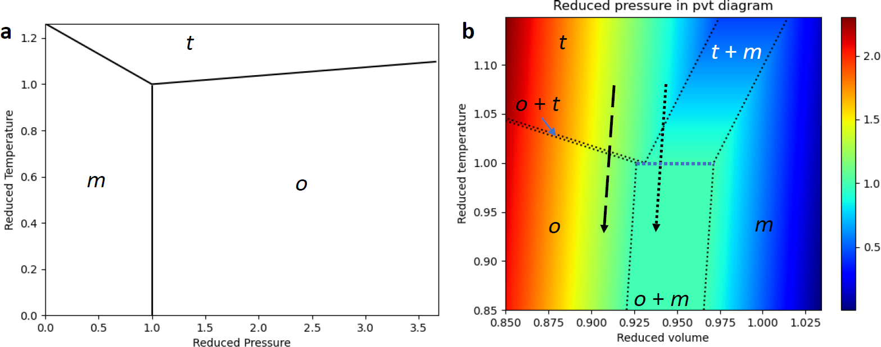
Figure S1. (a) Pressure-temperature phase diagram from Ref. [1]. (b) Volume-temperature phase diagram derived from (a) (see text), in which color represents reduced pressure. The dashed and dotted arrows indicate the cooling processes following the temperature-volume relation of thermal expansion.

As shown in Fig. S1b, above a certain temperature, only the t phase exists. During the cooling process, depending on the strain/volume, the final state may be either pure o phase or mixture of o and m phases.
During cooling from the t phase into o+m phases, o phase is normally preferred since there is a large energy barrier for the t→m transition due to the large volume change. [3] This effect is more significant when the cooling is faster, which is the mechanism of kinetic stabilization of the o phase. [3]
If the compressive strain is large enough, the final state of cooling is the o phase, no matter how fast the cooling is. This is the mechanism of thermodynamic stabilization of the o phase.
Notice that when the compressive strain is larger, the o-t phase boundary also moves toward the higher temperature direction, which is consistent with the observation that thinner films which have larger compressive strain, have higher T_{c}.

Section 2. Effect of epitaxial strain and La-doping on phase stability
The stabilization effects of lattice strain imposed on the (111) plane of HfO₂ and La-doping have been theoretically studied using DFT calculations. We converted the unit cell of m phase, o-FE phase and o-AFE phase into pseudo-hexagonal lattice with the (111) plane as the basal plane, as seen in Fig. S2(a-c). The total energy of the optimized structures was compared with the unstrained m phase, which is the ground state. The special quasirandom structure (SQS) method [4] was used to create the optimal solid solution supercell of the different phases of LHO with 8 at.% La concentration, which is close to the experimental concentration of 10 at. % La. From the energetics plotted in Fig. S2d, compression strain on the (111) plane leads to the stabilization of the two o phases over the m phase (area shaded in blue).
La-doping causes an expansion of lattice volume by 3.6%, 3.6% and 4.0% for the o-FE phase, the o-AFE phase and the m phase, respectively, making the (111) epitaxial strain even more effective for stabilizing the o phases at smaller strains. The o-AFE phase is computed to be slightly more energetically favorable than the o-FE phase in both HfO₂ and La_{0.08}Hf_{0.92}O₂ systems under YSZ (111) epitaxial strain (vertical dash line). The energy difference between these two phases is <18 meV/f.u. This implies that the o-AFE phase is likely to be the dominant phase under the epitaxial strain imposed by the YSZ (111) substrate.
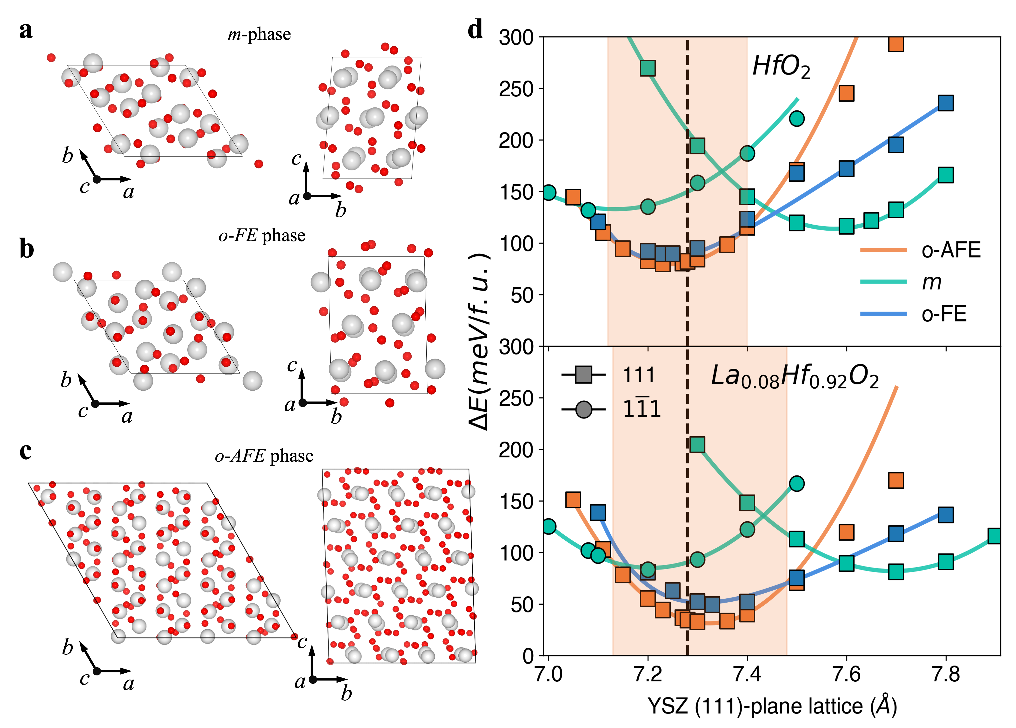
Figure S2. The effect of epitaxial strain and La-doping on the stability of the o-FE and m phases of HfO₂ and La_{0.08}Hf_{0.92}O₂. (a) Converted pseudo-hexagonal lattice of m-phase (P2₁/c). (b) Converted pseudo-hexagonal lattice of o-FE phase (Pca2₁). (c) Converted pseudo-hexagonal lattice of the o-AFE phase (Pbca). (d) Phase stability as a function of varying lattice parameter of the substrate imposing an epitaxial strain on the (111) plane of HfO₂. Top: phase stability of HfO₂. Bottom: phase stability of HfO₂ doped with 8 at. % La. The region where the o-AFE phase is stable is shaded in orange. The vertical dashed black line indicates the lattice constant 0.724 nm of YSZ for the (111) plane.

Section 3. Ferroelectric switching of 10% La-doped HfO₂ films grown on La_{0.7}S_{0.3}rMnO₃ / SrTiO₃ (110)
10% La doped HfO₂ (LHO) (111) films were grown on La_{0.7}S_{0.3}rMnO₃ / SrTiO₃ (110) substrate with 730 °C substrate temperature 70 mtorr O₂ background pressure. The thickness of LHO films was measured by X-ray reflectivity using a Rigaku SmartLab diffractometer. Fig. S3(a,b) shows the polarization switching of a 24 nm LHO film measured at 10 kHz.
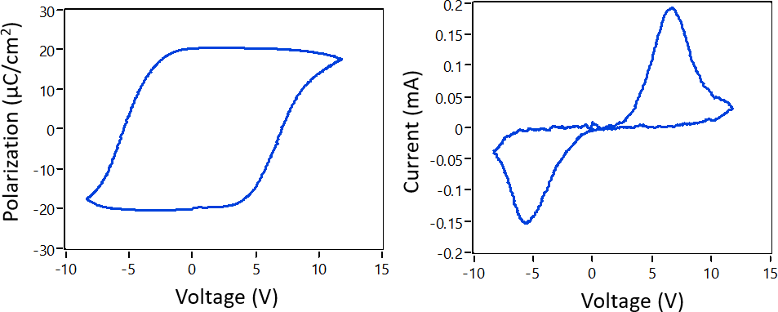
Figure S3. Ferroelectric switching of LHO films grown on La_{0.7}S_{0.3}rMnO₃ / SrTiO₃ (110). (a) polarization, (b) current as a function of voltage.

Section 4. LHO/YSZ films: X-ray studies

4.1 Film thickness measured using reflectivity
10 % La doped HfO2 (LHO) (111) films were grown on YSZ (111) substrate with different thickness, the optimal growth temperature (T_{s}, measured using an external pyrometer) between is around 730 ~ 750 °C, and the O₂ background pressure is fixed at 70 mTorr. The thickness of LHO films was measured by X-ray reflectivity using a Rigaku SmartLab diffractometer. Fig. S4 shows the X-ray reflectivity (XRR) of a 21.4 nm LHO film.
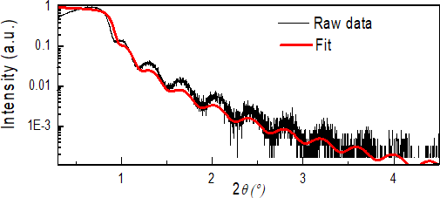
Figure S4. X-ray reflectivity measurement indicating flat top and bottom surfaces of the film and a film thickness of 21.4 nm grown with substrate temperature 750 °C.

4.2 Growth-temperature dependence of crystal structure measured by the (010)_{o} diffraction
The orthorhombic phase of LHO (111) / YSZ (111) film is characterized by the measurement of the {110}_{o} peaks at χ = 35° using the a Bruker D8 diffractometer with a 2D detector. The single {110}_{o} peak can be used to distinguish the orthorhombic (o) phase to the tetragonal (t) and the monoclinic (m) phases since it is forbidden for the t phase and split into two peaks for the m phase.
The temperature-dependence of o phase stability is investigated in LHO films (about 10 nm thick) grown at different temperatures, as shown in Fig. S5(a-e). With the increase of growth temperature above 800 ºC, the m phase peaks appear. As shown in Fig. S5e, the central peak ( $2θ=24.6°, χ = 35°$) corresponds to the LHO orthorhombic {110}_{o} peak. The small sharp peak is from the substrate. The two adjacent peaks ($2θ≈24.5°, χ ≈ 32.6°, 38.9°$) corresponds to the LHO monoclinic {110} peak.
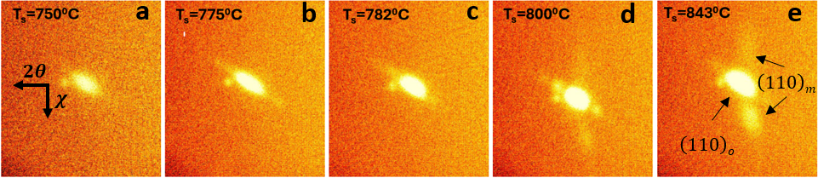
Figure S5. Growth-temperature dependence of X-ray diffraction near the {110}_{o} peak of LHO films. The thickness of the films is about 10 nm.

4.3 Thickness dependence of crystal structure measured using (110)_{o} diffraction
With growth temperature fixed at 750 °C, the dependence of o phase stability on the thickness of LHO (111) / YSZ (111) films has been investigated systematically (see Fig. S6). The single-crystal-like pure o phase of LHO can maintain until about 43 nm when the m phase appears. The thickness-dependent peak position of the {110} peak shows a shift of 2θ angle (see Fig. S6e), indicating strain relaxation (see Fig. S6f).
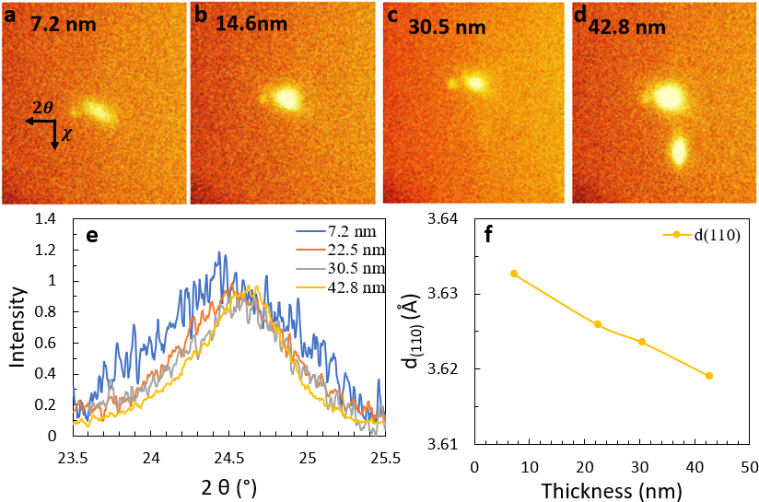
Figure S6. Thickness dependence of X-ray diffraction near the {110}_{o} peak of LHO films. (a-d) Image measured by the 2D detector near the {110} peak for different film thickness. (e) Integrated peak intensity plotted as a function of 2θ. (d) Spacing of the (110) plane calculated from the peak positions in (c). The substrate temperature is 750 °C during the growth.

4.4 (010) diffraction
Fig. S7a shows the 2D images near the (010)_{o} peak for a 21.4 nm LHO film. The single {010}_{o} peak is often used to distinguish the o phase from the t phase since it is forbidden for the t phase. Fig. S7b shows integrated intensity profile as a function of 2θ. From the peak position 2𝜃 = 17.41, one can derive the lattice constant b is 0.510 ± 0.001 nm.
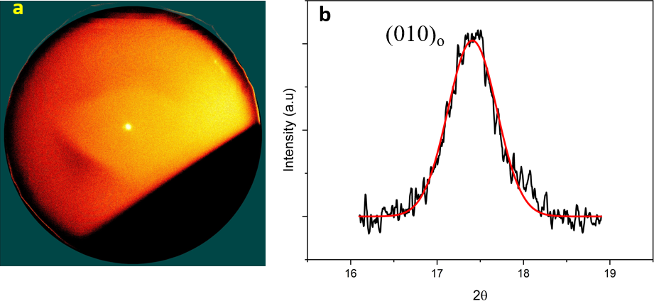
Figure S7. X-ray diffraction near the {010}_{o} peak for a 21.4 nm LHO film. (a) Image measured by the 2D detector. (b) Integrated peak intensity plotted as a function of 2θ. The substrate temperature is 750 °C during the growth.

4.5 Thickness-dependent out-of-plane lattice constant d₁₁₁
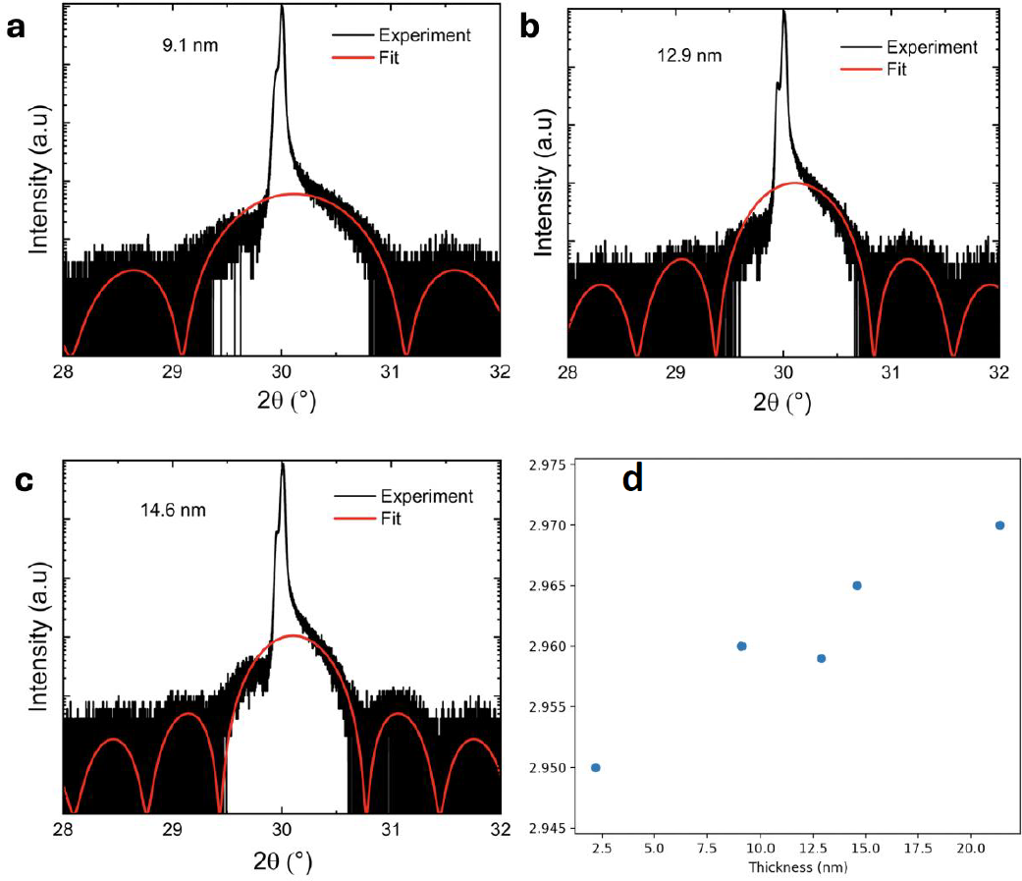
Figure S8. Specular θ-2θ X-ray diffraction results of (a) 9.1 nm (b) 12.9 nm and (c) 14.6 nm LHO/YSZ films, grown at optimal condition. (d) The thickness-dependent (111) plane spacing d₁₁₁ of LHO, calculated by the peak fitting.
The (111) peak positions of YSZ substrate and LHO film are close to each other, based on the θ-2θ X-ray diffraction, as shown in Fig. S8a-c, the Laue oscillation indicates the high-quality of single-crystalline LHO film. Moreover, gaussian peak fitting of two peaks are used to extract (111) plane spacing d₁₁₁ for LHO film. As shown in Fig. S8d, with the increase of the thickness, the d₁₁₁ increases monotonically, corresponding to relaxation of compressive strain in thicker films.

4.6 Lattice constants of orthorhombic LHO

Figure S9. Non-specular X-ray diffraction near YSZ (400) for a 21.4 nm LHO/YSZ film.
Lattice constants of orthorhombic LHO were measured using X-ray diffraction near the substrate peak YSZ (004). As shown in Fig. S10, two shoulders were observed beside the intense YSZ (004) peak in the middle. Peak fitting results in positions 72.71⁰, 74.18⁰, and 73.54⁰ for LHO (400)_{o}, YSZ (004), and LHO (004)_{o} respectively. The corresponding lattice constants are 5.20 ± 0.01 Å for LHO a axis, 5.11 ± 0.01 Å for LHO b and c axes, and 5.15 ± 0.01 Å for YSZ.

Section 5. LHO/YSZ films: AFM studies and atomic terraces
The surface topology is studied by atomic force microscope (AFM). Fig. S10a is the AFM image of LHO film with thickness of ~ 0.65 nm (520 shots). The double-layer LHO shows the atomic terraces, indicating the single-crystal nature for ultrathin film. Fig. S10b indicates that the height of the atomic step is about 0.3 nm, which corresponds to LHO monolayer along (111) direction.
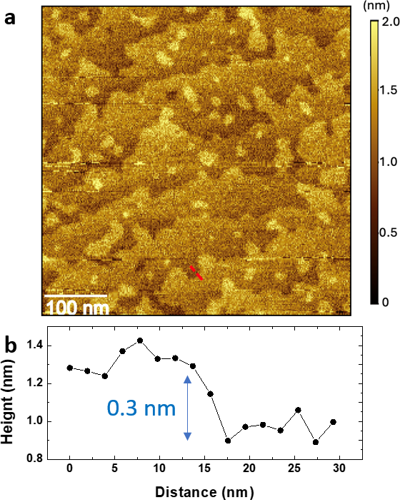
Figure S10. (a) AFM image of a 0.65 nm LHO film surface showing atomic terraces. (b) The height of the terrace 0.3 nm corresponds to LHO monolayer along (111) direction, measured along the dashed line in (a).

Section 6. LHO/YSZ films: STEM studies
Three TEM lamellae with different orientations were prepared using focused-ion beam (FIB) milling, enabling us to observe the atomic structures of LHO along different projections. Atomic resolution high-angle annular dark-field (HAADF) imaging was performed for the samples oriented along <110>_{YSZ}, <112>_{YSZ}, and <100>_{YSZ}, respectively.

6.1 Evidence of LHO film as single crystal
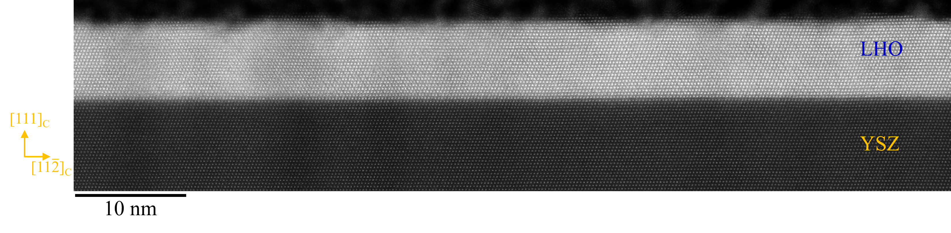
Figure S11. Large field of view STEM-HAADF image of 10 nm LHO film, viewed from the YSZ [1$\overline{\text{1}}$0] direction. The sharp LHO/YSZ interface demonstrates a good epitaxy without any mismatch dislocations or grain boundaries.
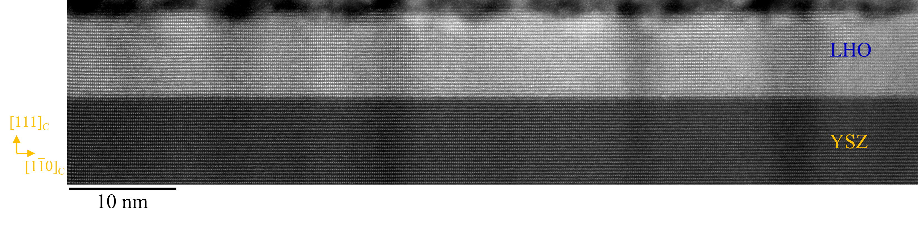
Figure S12. Large field of view STEM-HAADF image of 10 nm LHO film, viewed from the YSZ [11$\overline{\text{2}}$] zone axis. Atomically sharp interface demonstrates the good epitaxy between LHO/YSZ.

Fig. S11 shows a representative scanning transmission electron microscope (STEM) HAADF image of a 10 nm LHO film oriented along YSZ [1$\overline{\text{1}}$0] zone axis. No defects, grain boundaries, or impurity phases were apparent in the LHO film, which demonstrates a well-defined epitaxy of the LHO film with the YSZ substrate. We observe a similar good epitaxy of LHO film with the YSZ substrate in Fig. S12, which is projected along the YSZ [11$\overline{\text{2}}$] direction. We did not find any apparent phase separation or polycrystalline regions in the LHO film in any of the characterized samples, confirming the single-crystalline nature of the as-grown LHO film.
The single-crystalline structural integrity of the LHO film is preserved up to a thickness of at least 30 nm. We performed STEM characterization of a 30-nm thick LHO/YSZ film. Fig. S13(a, c) show the large field of view STEM HAADF images of the 30-nm LHO/YSZ film along the YSZ [1$\overline{\text{1}}$0] and [11$\overline{\text{2}}$] directions, respectively. Once again, we did not observe any impurity phases, indicating the single-crystalline quality of the LHO film. The zoomed-in STEM images of the interface of the 30-nm LHO/YSZ film in Fig. S13(b,d) show epitaxy of the LHO film with the YSZ substrate.

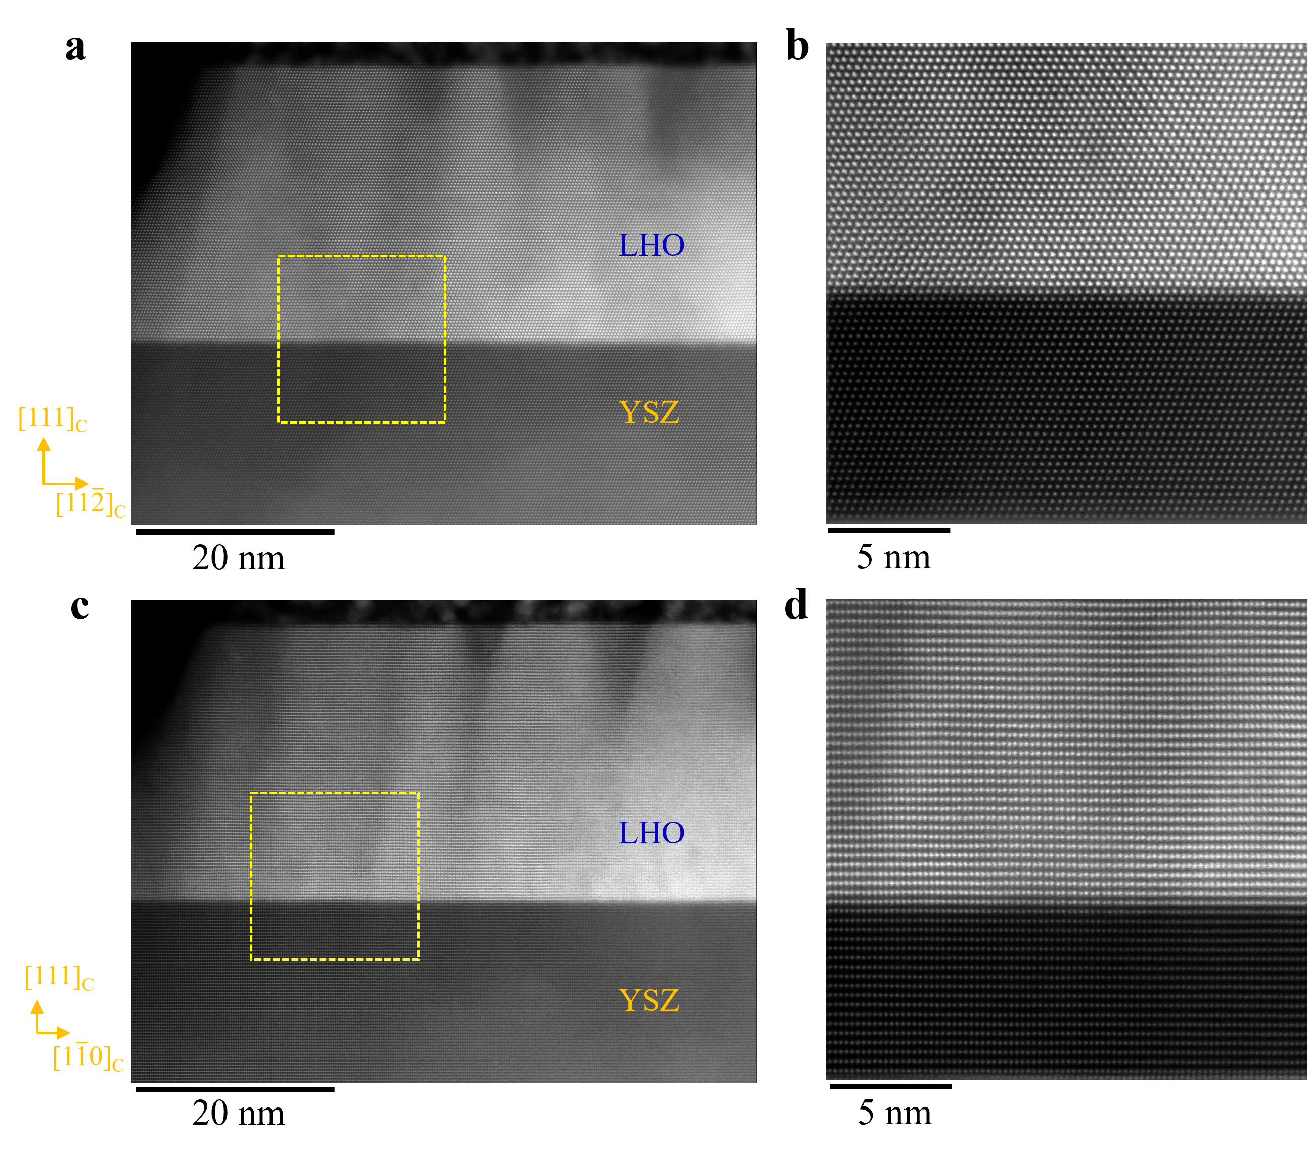
Figure S13. STEM images of 30 nm LHO film. (a) and (b) are viewed along the YSZ [-110] direction, (c) and (d) are viewed along the YSZ [11-2] direction.

6.2 Identification of structural twins
To verify the observed features of o-FE structural variants in LHO, we performed the STEM simulations using a DFT-optimized HfO₂/ZrO₂ heterostructure supercell. Due to the 3-fold symmetry of the YSZ (111) plane, there are three equal structural variants (twins) rotated by 120 degrees along the YSZ [111] direction with respect to each other. We find an excellent agreement between the simulated HAADF images and the experimental observations, as shown in Fig. S14-S15. The alternation of Hf spacings in Fig. S14(a,b) and Fig. S15(a,b), arise from the Q_{a} and Q_{b} distortions illustrated in Fig. 1b&c.
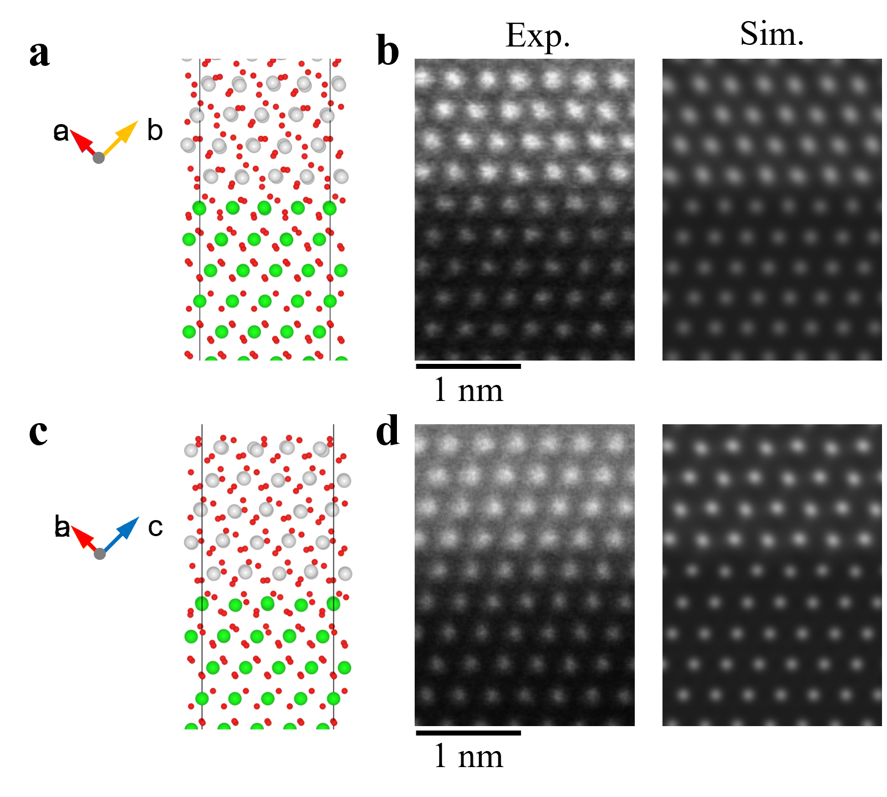
Figure S14. Experimental and simulated STEM HAADF images of the LHO/YSZ interface viewed along YSZ [1$\overline{\text{1}}$0] direction. (a, c). Schematic illustration of HfO₂/ZrO₂. The structural orientations are described by the arrows. These two variants (twins) are rotated by 120-degrees around YSZ [111]. (b, d). Comparison between the experimental HAADF image (left) and the simulated image (right) of the two twins shown in a, c, respectively.

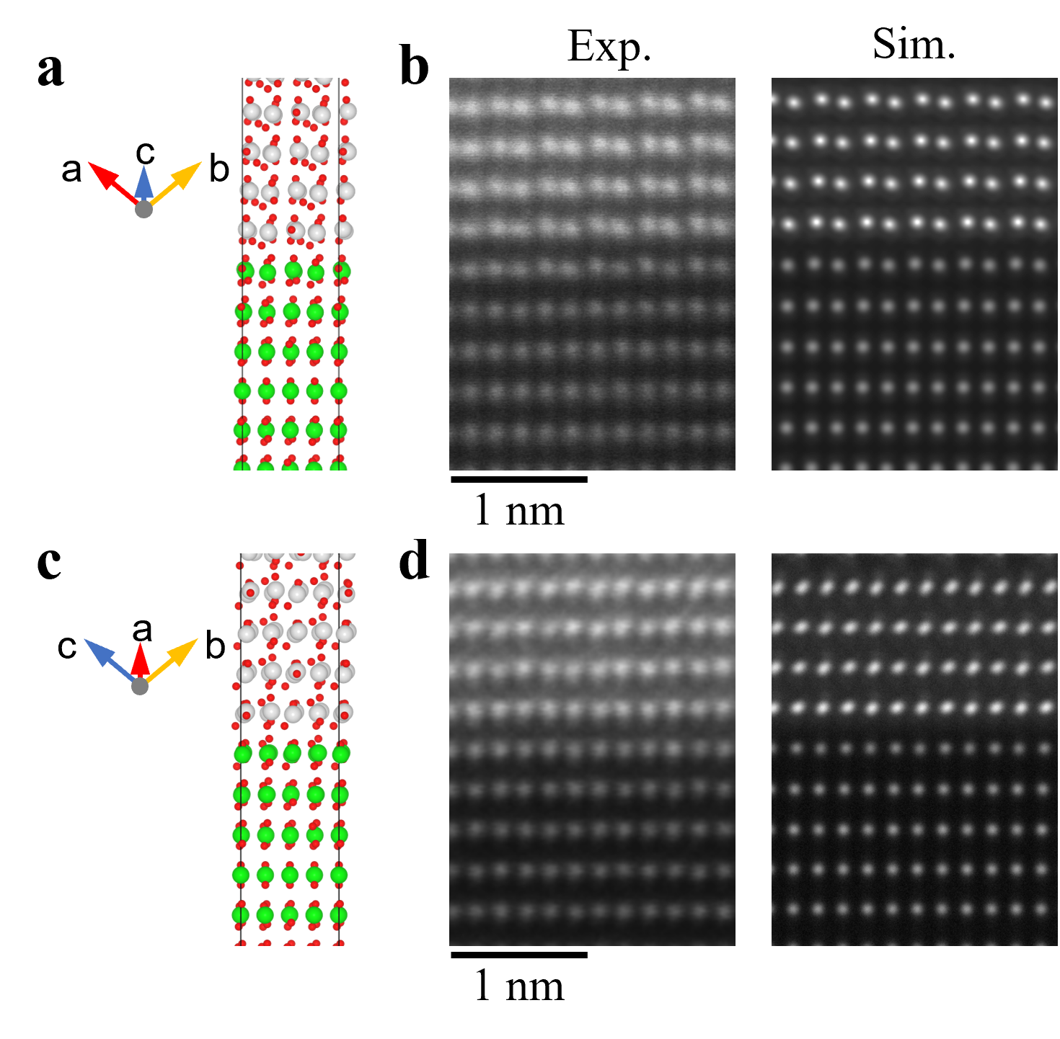
Figure S15 Experimental and simulated STEM HAADF images of the LHO/YSZ interface viewed along YSZ [1$1\overline{\text{2}}$] direction. (a, c). Schematic illustration of the HfO₂/ZrO₂ heterointerface. The structural orientations are described by the arrows. These two variants (twins) are related by a 120-degree rotation around YSZ [111]. (b, d). Comparison between the experimental (left) and simulated (right) HAADF images of the two structural variants (twins) viewed along the projections shown in (a, c), respectively.

6.3 Domain distributions
To map the ferroelectric domains in the LHO film, we need to tilt our sample such that we can observe the crystal along the LHO [100] projection. Fig. S16 shows a STEM-HAADF image acquired after tilting the sample by over 30 degrees to orient it along [100]. Since the YSZ and LHO regions overlap near the interface after tilting the sample, the sharp interface parallel to YSZ (111) plane cannot be resolved any more. Due to the ferroelectric distortion Q_{b}, Hf spacings show short-and-long alternations in Fig. S16a. A quantitative analysis of the nearest neighbor Hf spacing is shown in Fig. S15(b, c). From the variation in the atomic spacing of polar (blue) and nonpolar spacer layer (green) as depicted in Fig. S16(b, c), we can clearly find the coexistence of three o-FE structural variants consistent with STEM observations along YSZ [1$1\overline{\text{2}}$] and [1$\overline{\text{1}}$0] directions.

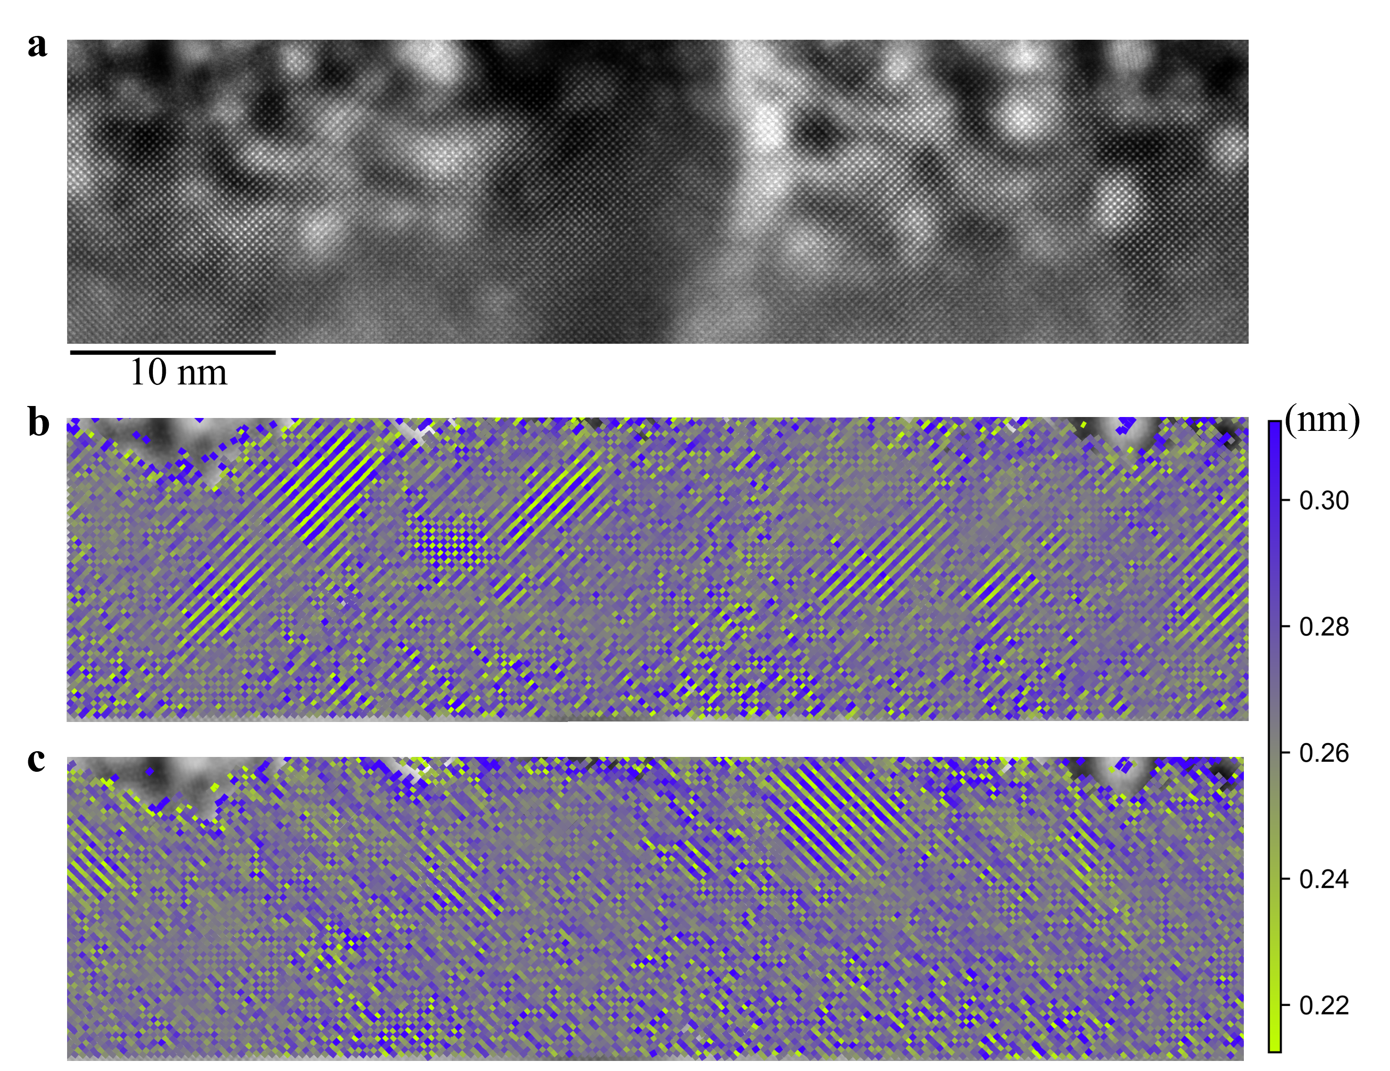
Figure S16. STEM observations of LHO/YSZ along LHO [1$00$] direction. (a). STEM-HAADF image of LHO/YSZ. The alternations of Hf spacing correspond to the ferroelectric distortion mode Q_{b}. (b, c). Quantitative analyses of the nearest Hf spacings. The three o-FE structural variants are rotated 90 degrees with respect to each other.

6.4 Quantification of oxygen polar displacement
To identify the exact polar states at these local regions, we need to resolve the subtle displacements of the in oxygen sublattice. However, due to the dynamic range limitations of the HAADF detector, the image contrast primarily reveals the heavy elements (Hf and Zr) which have strong Rutherford scattering, while the lighter oxygen columns are almost invisible. STEM-ABF imaging, which is sensitive to light elements [5], was conducted at the polar domains to provide a more definitive visualization of the positions of oxygen in atomic column. A representative image is shown in Fig. S17. By determining the ion positions, the polar domain pattern can be derived from the offsets of oxygen columns with respect to the centroid of its four nearest Hf atoms. Therefore, the polar vectors were measured using centrosymmetric t phase as the reference state.
Besides STEM-ABF imaging, differential phase contrast imaging (STEM-DPC) was also performed to reveal the positions of the oxygen columns at different locations in the LHO film in Fig. S18.
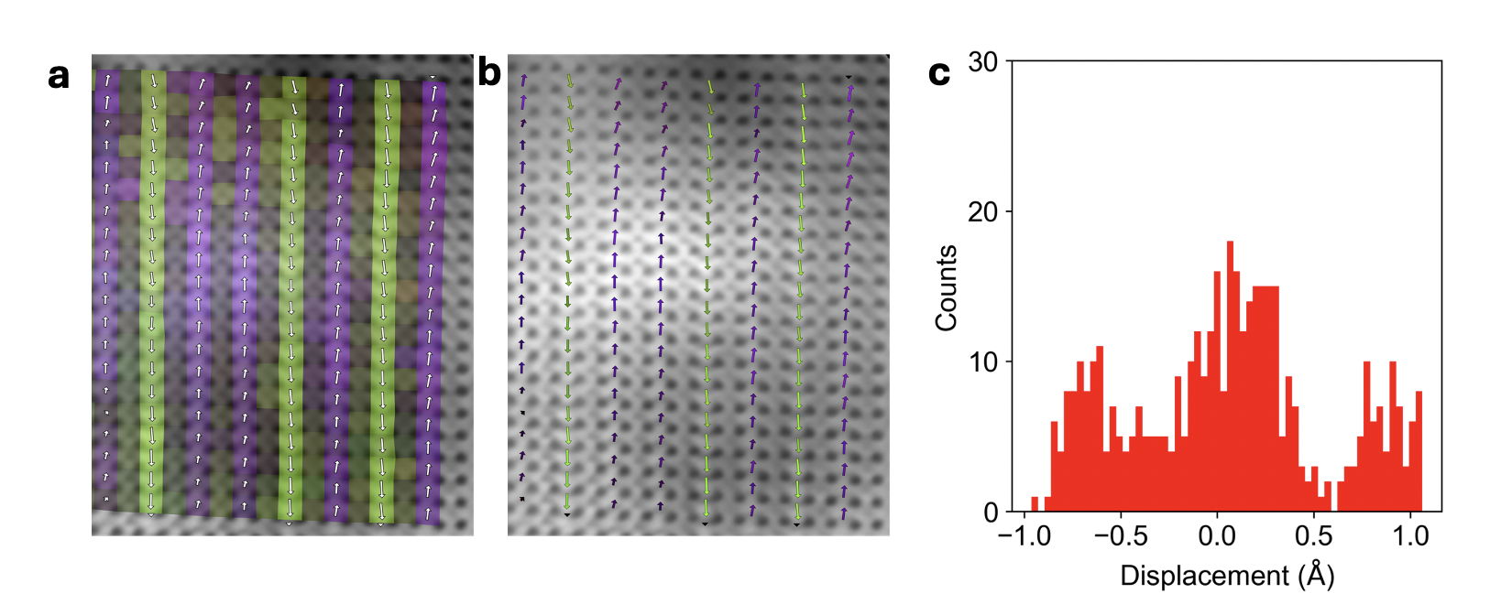
Figure S17. ABF-STEM image of LHO film viewed along [100] direction, The arrows in (a) and (g) indicate the displacement of oxygen columns with respect to the centroid of the neighboring Hf atoms. (c) A histogram showing the statistics of oxygen displacements. For easier visualization, the figures in (a) and (b) have been rotated by 45 degrees from the orientation shown in Fig. S15.
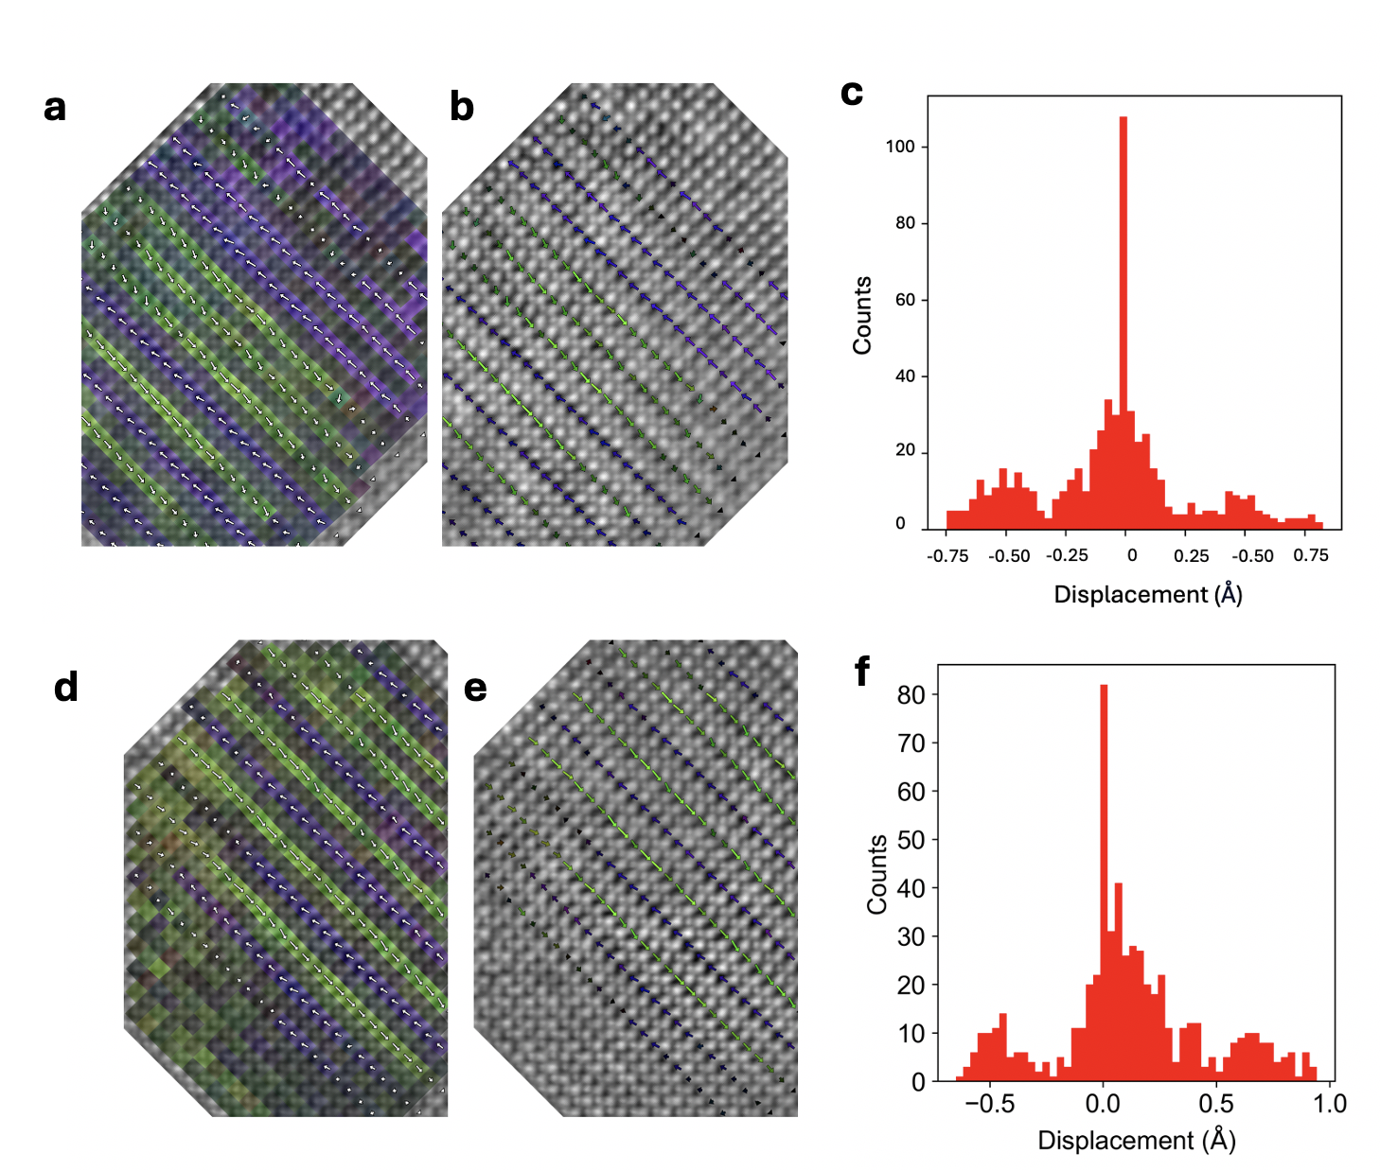
Figure S18. DPC-STEM images of the LHO film viewed along [100] direction and corresponding statistics of oxygen displacements at two different locations.

6.5 Atomic-scale compositional analysis of the LHO/YSZ film
To get the chemical information of the LHO/YSZ films, atomically resolved energy-loss spectroscopy (EELS) was acquired. As shown in Fig. S19, we examined the spatial distributions of each element using Digital Micrograph. All the spectrum images were analyzed after denoising using principal component analysis (PCA) denoising.

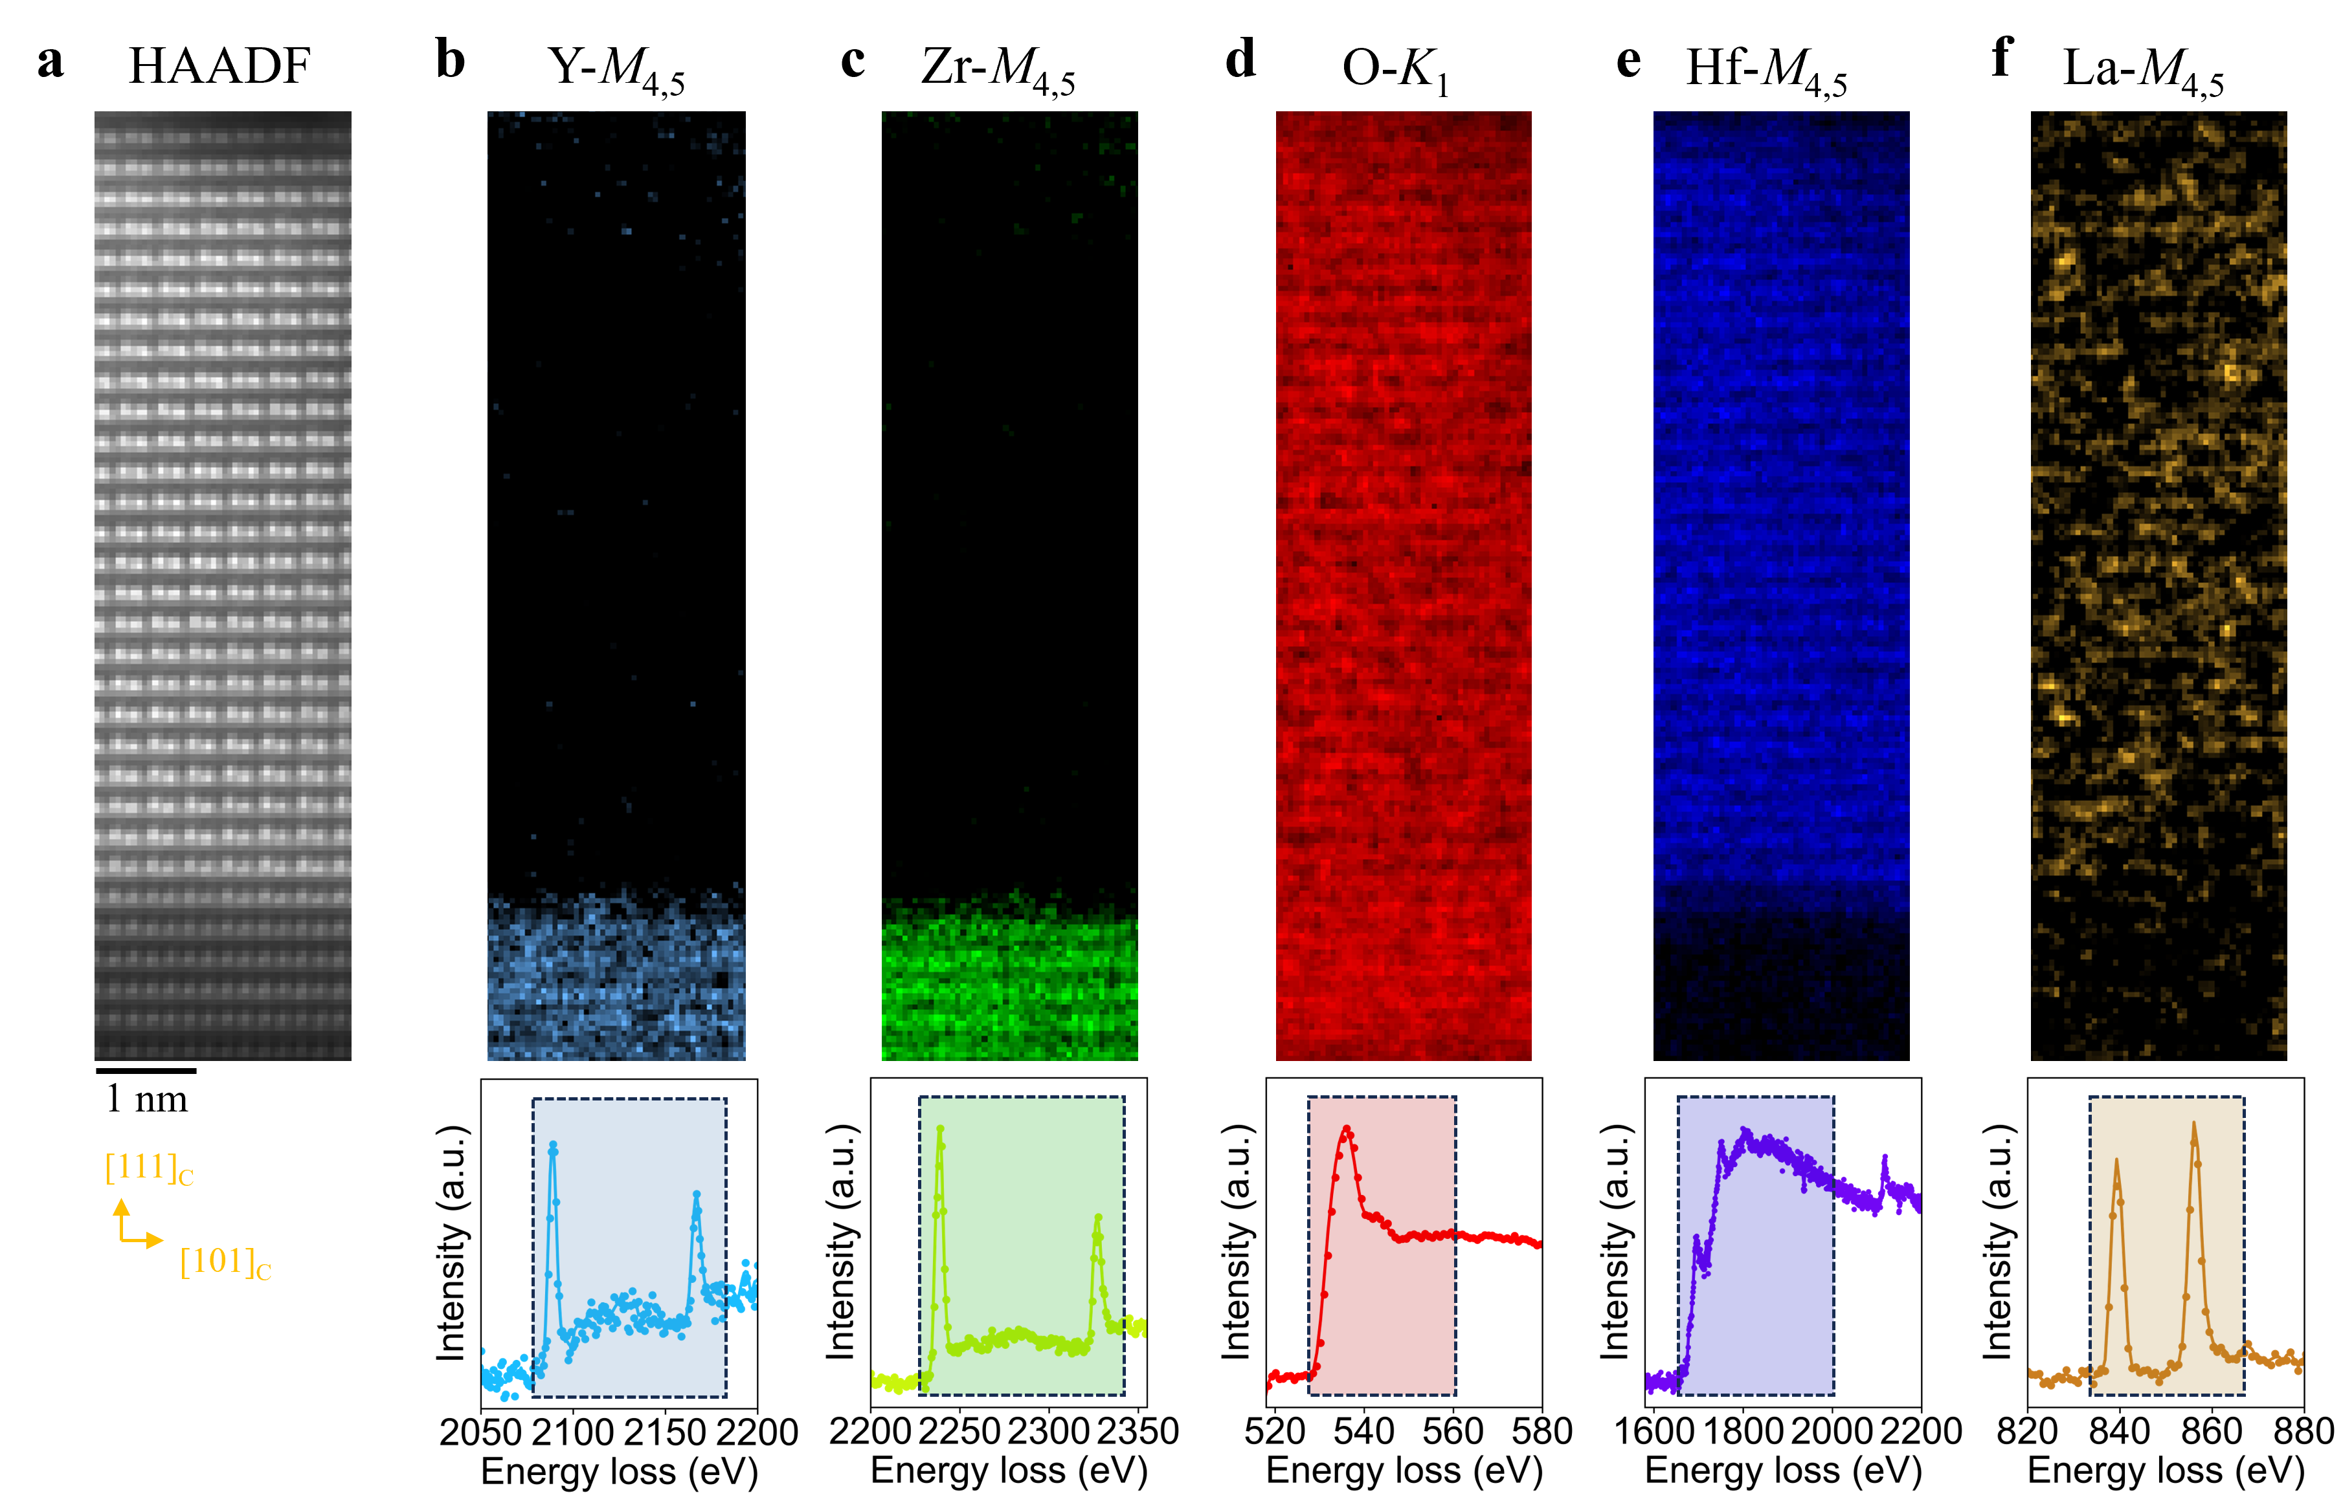
Figure S19. Core-loss EEL spectrum images of the LHO/YSZ film viewed along YSZ [1$1\overline{\text{2}}$] direction. (a). Simultaneously acquired STEM-HAADF image of LHO/YSZ. (b-f). Elemental distribution maps using Y-M_{4,5}, Zr-M_{4,5}, O-K₁, Hf-M_{4,5}, and La-M_{4,5}, core-loss edges. The energy ranges used for chemical-edge integration are shaded in different colors in the bottom panels.

Section 7. KPFM signal as a function of the mechanical load
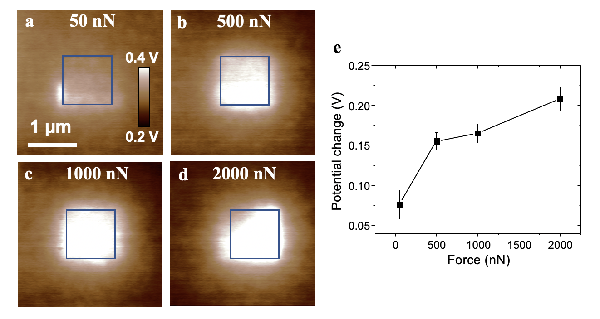
Figure S20. (a-d) KPFM images on the 1.4-nm-thick LHO film after mechanical writing in the center 1 x 1 µm² regions of 50 nN, 500 nN, 1000 nN, and 2000 nN, respectively. (e) The potential change after mechanical writing as a function of the applied mechanical load.

The potential change (ΔV) due to the mechanical poling increases with the increase of mechanical load. Fig. S20(a-d) shows a set of KPFM images obtained on the 1.4-nm-thick LHO film after mechanical writing in the center 1 x 1 µm² regions from 50 nN up to 2000 nN, and Fig. S20e displays the resulting ΔV as a function of the applied mechanical load, where it increases from ~0.07 V to ~0.21 V with the applied load increases from 50 nN to 2000 nN, suggesting that higher mechanical load induces more polarization switching due to the larger flexoelectric effect generated.

Section 8. Interfacial lattice distortion from DFT.

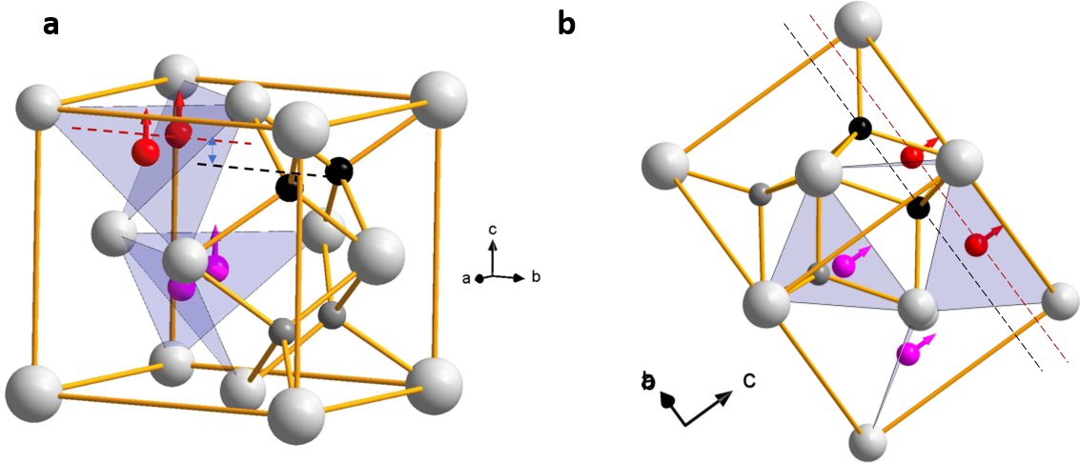
Figure S21. (a) Atomic structure of ferroelectric o phase HfO₂, in which gray atoms are Hf, red and purple atoms are oxygen atoms in polar layer, black and dark gray atoms are oxygen in non-polar layer. (b) The projection of individual atoms in [1-10] direction.
In addition to the characteristic distortions of Hf in the o-FE phase, the polarization amplitude is directly related to the oxygen displacement in the polar layer. For STEM images viewed along the [100]_{o} direction, the oxygen displacement can be quantified directly in b-c plane, but the thickness-dependent information is missing, since the out-of-plane direction of the films is along [111]. On the other hand, when viewed along [1$\overline{\text{1}}$0]_{o} direction (Fig. S21b), the oxygen displacement along c-axis can also be identified.
As shown in Fig. S22a, viewed along the [1$\overline{\text{1}}$0]_{o} direction, the oxygen in the polar layer and non-polar spacer layer are colored in red and purple in the model that was optimized using DFT calculation. The oxygen displacements emerge within the top two Zr layers (#0 and #-1), as shown in Fig. S22(b), corresponding to the ferroelectric proximity effect. Moreover, on the HfO₂ side of the interface, the oxygen displacements reach their “bulk” value (≈ 50 pm) in the first unit cell (layer #1 and #2). The oxygen displacement value (~ 50 pm) from DFT is close the experimental observation. (see Fig. S14 and Fig. S15 in Section 6).

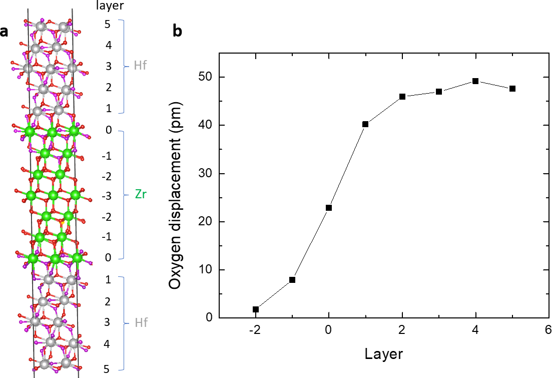
Figure. S22 (a) The atomic structure after DFT optimization, viewed along the [1$\overline{\text{1}}$0] direction. The layer 0 is the top Zr layer. (b) The thickness-dependent oxygen displacements.

Section 9. LHO/YSZ films: in-situ RHEED studies
The raw images of RHEED are captured in-situ during and after the growth of LHO film, along both [1$\overline{\text{1}}$0] and [11$\overline{\text{2}}$] directions respectively. The peak intensity and position were calculated by 1) averaging along vertical direction; 2) subtracting the background; and 3) gaussian fitting of individual peak profiles.

9.1 One monolayer to two monolayer (one unit cell) transition of orthorhombic structure grown along the (111) direction

9.1.1 Bulk structures with (111) surface:
The real space basis can be written a
$$\vec{a}=a\hat{i},\vec{b}=b\hat{j}, \vec{c}=c\hat{k},$$
where a,b,c are the lattice constants.
Correspondingly the reciprocal space basis can be found as
$${\vec{a}}^{*}=\frac{2π}{a}\hat{i},{\vec{b}}^{*}=\frac{2π}{b}\hat{j}, {\vec{c}}^{*}=\frac{2π}{c}\hat{k}.$$
Furthermore, consider the (111) plane that passes the origin, it should be a triangular lattice with basis like
$${\vec{a}}_{\left(111\right),bulk}^{*}=2π\left(\frac{\hat{i}}{a}-\frac{\hat{j}}{b}\right), {\vec{b}}_{\left(111\right),bulk}^{*}=2π\left(\frac{\hat{i}}{a}-\frac{\hat{k}}{c}\right).$$
The reciprocal point from combination of ${\vec{a}}_{\left(111\right),bulk}^{*}$ and ${\vec{b}}_{\left(111\right),bulk}^{*}$ will be those observed in RHEED, i.e., combinations of the (1$\overline{\text{1}}$0)_{o} and (10$\overline{\text{1}}$)_{o} diffractions include (11$\overline{\text{2}}$)_{o} etc.

9.1.2 One (111) layer
For this real space lattice, the basis are
$${\vec{a}}_{\left(111\right),one}=\frac{1}{2}\left(a\hat{i}-b\hat{j}\right),{\vec{b}}_{\left(111\right),one}=\frac{1}{2}(a\hat{j}-c\hat{k}), {\vec{c}}_{\left(111\right),one}=\frac{\hat{i}}{a}+\frac{\hat{j}}{b}+\frac{\hat{k}}{c},$$
where ${\vec{c}}_{\left(111\right),one}$ can be any vector that is perpendicular to the (111) plane.
We can then calculate the corresponding reciprocal space basis and find
$${\vec{a}}_{\left(111\right),one}^{*}=\frac{{\vec{b}}_{\left(111\right),one}×{\vec{c}}_{\left(111\right),one}}{\left({\vec{a}}_{\left(111\right),one}×{\vec{b}}_{\left(111\right),one}\right)⋅ {\vec{c}}_{\left(111\right),one}}=\frac{2}{3}\left(\frac{2\hat{i}}{a}-\frac{\hat{j}}{b}-\frac{\hat{k}}{c}\right)2π \\ {\vec{b}}_{\left(111\right),one}^{*}=\frac{{\vec{c}}_{\left(111\right),one}×{\vec{a}}_{\left(111\right),one}}{\left({\vec{a}}_{\left(111\right),one}×{\vec{b}}_{\left(111\right),one}\right)⋅ {\vec{c}}_{\left(111\right),one}}=\frac{2}{3}\left(\frac{\hat{i}}{a}+\frac{\hat{j}}{b}-\frac{2\hat{k}}{c}\right)2π \\ {\vec{c}}_{\left(111\right),one}^{*}=\frac{{\vec{a}}_{\left(111\right),one}×{\vec{b}}_{\left(111\right),one}}{\left({\vec{a}}_{\left(111\right),one}×{\vec{b}}_{\left(111\right),one}\right)⋅ {\vec{c}}_{\left(111\right),one}}=\frac{1}{3}\left(\frac{\hat{i}}{a}+\frac{\hat{j}}{b}+\frac{\hat{k}}{c}\right)2π.$$
Using RHEED, one observes a lattice based on ${\vec{a}}_{\left(111\right),one}^{*}$ and ${\vec{b}}_{\left(111\right),one}^{*}$, i.e., a combination of the 2/3(2$\overline{\text{1}}\overline{\text{1}}$)_{o} and 2/3(11$\overline{\text{2}}$)_{o} diffractions including (1$\overline{\text{1}}$0)_{o} etc. This is like a $\sqrt{3}×\sqrt{3}$ reconstruction with a 30-degree rotation from the bulk orthorhombic structure.

9.2 Experimental observation of the transition
Fig. S23(a,b) show the thickness-dependent line profile of RHEED pattern along [11$\overline{\text{2}}$] direction during growth, with the interval of 50 shots. The growth speed is ~ 1.2 nm/ 1000 shots. With the increase of thickness below 500 shots, the characteristic RHEED pattern $±\frac{2}{3}\left(\overline{2}\overline{2}4\right), ±\frac{1}{3}\left(\overline{2}\overline{2}4\right)$ peaks for 2D structure first appears. Further increase of thickness suppresses the intensity of $±\frac{2}{3}\left(\overline{2}\overline{2}4\right)$and $±\frac{1}{3}\left(\overline{2}\overline{2}4\right)$ peaks. RHEED pattern gradually transfers to bulk structure of o phase with $± (\overline{1}\overline{1}2)$ peaks. The rapid change of the RHEED patterns then corresponds to a one monolayer to two monolayer structural transition.
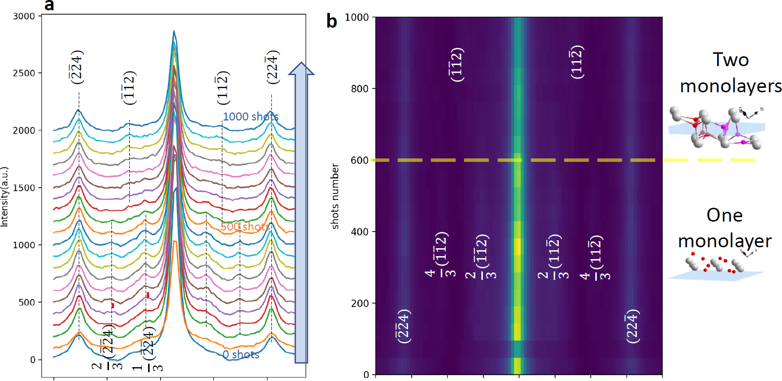
Figure S23. Thickness-dependent one-layer to two-layer (bulk) transition observed using in-situ RHEED patterns during growth at 730 ⁰C. (a) Integrated RHEED profile where the horizontal axis is the image pixel which is proportional to diffraction angles. (b) data in (a) plotted as an image.
Fig. S24 shows the comparison between the AFM images and RHEED patterns for YSZ bare substrate, 0.32 nm, and 0.64 nm LHO films. The atomic terraces can be identified for both YSZ (Fig. S24a) and 0.64 nm LHO (Fig. S24g), while the terraces are fragmented in 0.32 nm LHO (Fig. S24d). The dotted square box highlights the fragments of a layer on top of another fragmented layer, indicating double-monolayer LHO, which contributes to the weak but non-zero intensity of $\left(1\overline{1}0\right)$ peak intensity (see Fig. S24e). Meanwhile, the monolayer itself contributes to $±\frac{4}{3}\left(\overline{1}\overline{1}2\right), ±\frac{2}{3}\left(\overline{1}\overline{1}2\right)$ peaks (see Fig. S24f).
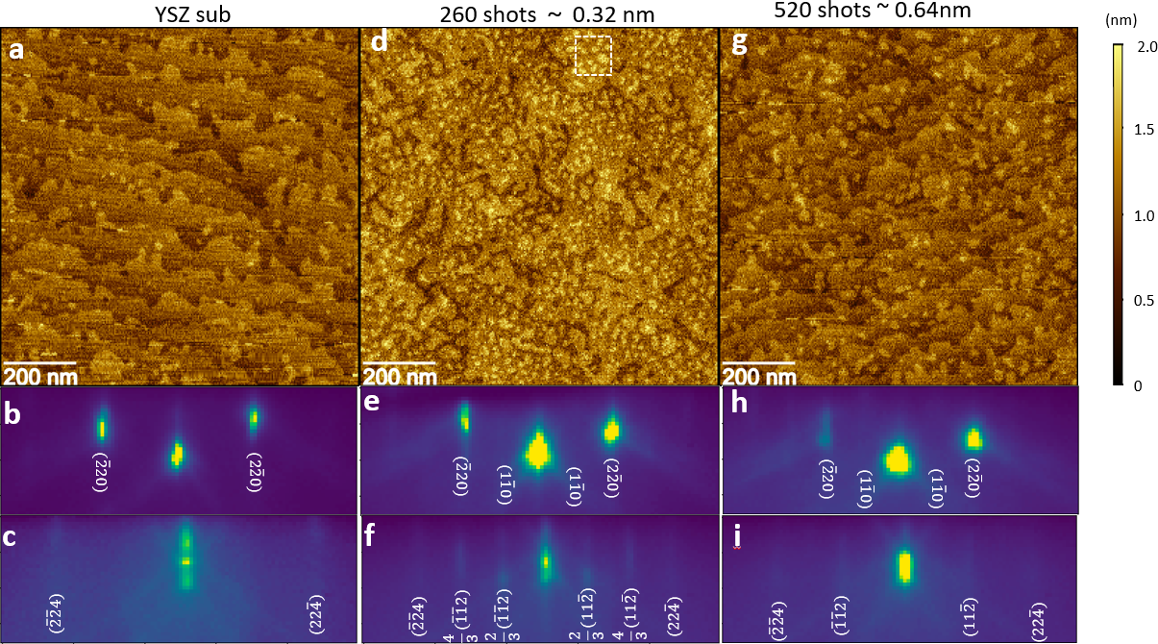
Figure S24. Comparison between AFM top row, and RHEED (e-beam along [11-2] for middle row, e-beam along [1-10] for the bottom row) for YSZ substrate (left column), LHO monolayer (mid column) and LHO double layers (right column) of LHO film.
Fig. S25a shows the AFM image of an LHO film with thickness of 0.32 nm. The histogram of height (Fig. S25b) exhibit peaks separated by around 0.3 nm, corresponding to the monolayer thickness of LHO along the (111) direction.
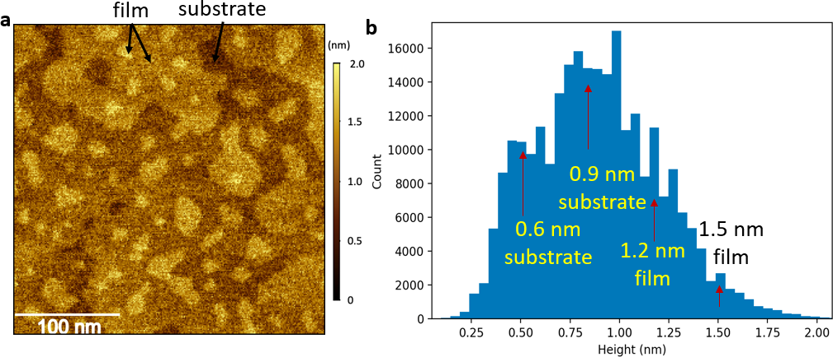
Figure S26. (a) AFM image of a 0.32 nm LHO film, with scan size 300 × 300 nm. (b) Height distribution on the surface in (a).

Section 10. Hafnia films of different doping grown on YSZ
Thin films of hafnia of different doping have been grown on YSZ substrate. The RHEED and AFM images are shown in Fig. S26. From the AFM images, only LHO/YSZ shows clear atomic terraces, indicating 2D film growth, while all films of other doping show small islands, which is corroborated by the RHEED images. For example, in Hf_{0.68}Zr_{0.32}O₂/YSZ, and Hf_{0.95}Y_{0.05}O₂/YSZ films of 2.7 nm, the diffraction of one monolayer with e-beam along the [1$\overline{\text{1}}$0] direction is still visible, indicating a large distribution of film thickness.
Figure S26. RHEED (top row) and AFM (bottom row) images of hafnia films of different doping. While LHO/YSZ shows 2D film growth mode, all other films show 3D island growth mode.

Different strain states can be seen from the specular θ-2θ X-ray diffraction of hafnia films, as shown in Fig. S27. Besides the sharp main peak YSZ (111), the shoulder corresponds to the (111) hafnia film diffraction. By fitting the diffraction with two peaks, one finds the spacings of the (111) planes are 0.2950 nm, 0.2925 nm, and 0.2942 nm for 2.2 nm LHO/YSZ, 2.5 nm Hf_{0.5}Zr_{0.5}O₂/YSZ, and 2.7 nm Hf_{0.95}Y_{0.05}O₂/YSZ respectively. Notice that LHO/YSZ has the largest value, which is consistent with the large atomic radius of La.
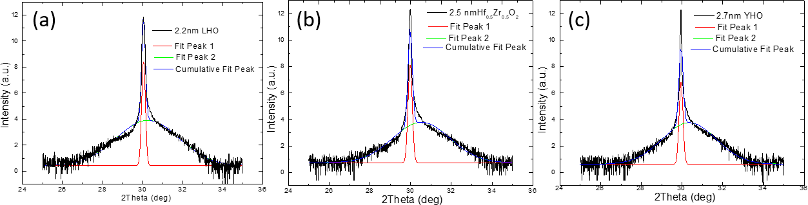
Figure S27. Specular θ-2θ x-ray diffraction results of (a) 2.2 LHO/YSZ, (b) 2.5 nm Hf_{0.5}Zr_{0.5}O₂/YSZ, and (c) 2.7 nm Hf_{0.95}Y_{0.05}O₂/YSZ.

References
[1] O. Ohtaka, H. Fukui, T. Kunisada, T. Fujisawa, K. Funakoshi, W. Utsumi, T. Irifune, K. Kuroda, and T. Kikegawa, Phase Relations and Volume Changes of Hafnia under High Pressure and High Temperature, Journal of the American Ceramic Society 84, 1369 (2001).
[2] R. P. Haggerty, P. Sarin, Z. D. Apostolov, P. E. Driemeyer, and W. M. Kriven, Thermal Expansion of HfO2 and ZrO2, Journal of the American Ceramic Society 97, 2213 (2014).
[3] M. H. Park, Y. H. Lee, H. J. Kim, Y. J. Kim, T. Moon, K. Do Kim, S. D. Hyun, T. Mikolajick, U. Schroeder, and C. S. Hwang, Understanding the Formation of the Metastable Ferroelectric Phase in Hafnia-Zirconia Solid Solution Thin Films, Nanoscale 10, 716 (2018).
[4] A. Zunger, S.-H. Wei, L. G. Ferreira, and J. E. Bernard, Special Quasirandom Structures, Phys Rev Lett 65, 353 (1990).
[5] R. Ishikawa, E. Okunishi, H. Sawada, Y. Kondo, F. Hosokawa, and E. Abe, Direct Imaging of Hydrogen-Atom Columns in a Crystal by Annular Bright-Field Electron Microscopy, Nat Mater 10, 278 (2011).

