Heatwave magnitude quantization and impact factors analysis over the Tibetan Plateau
Tongchang Zhang, Gang Deng, Xiuguo Liu *, Yan He, Qikai Shen, Qihao Chen
School of Geography and Information Engineering, China University of Geosciences, Wuhan, China

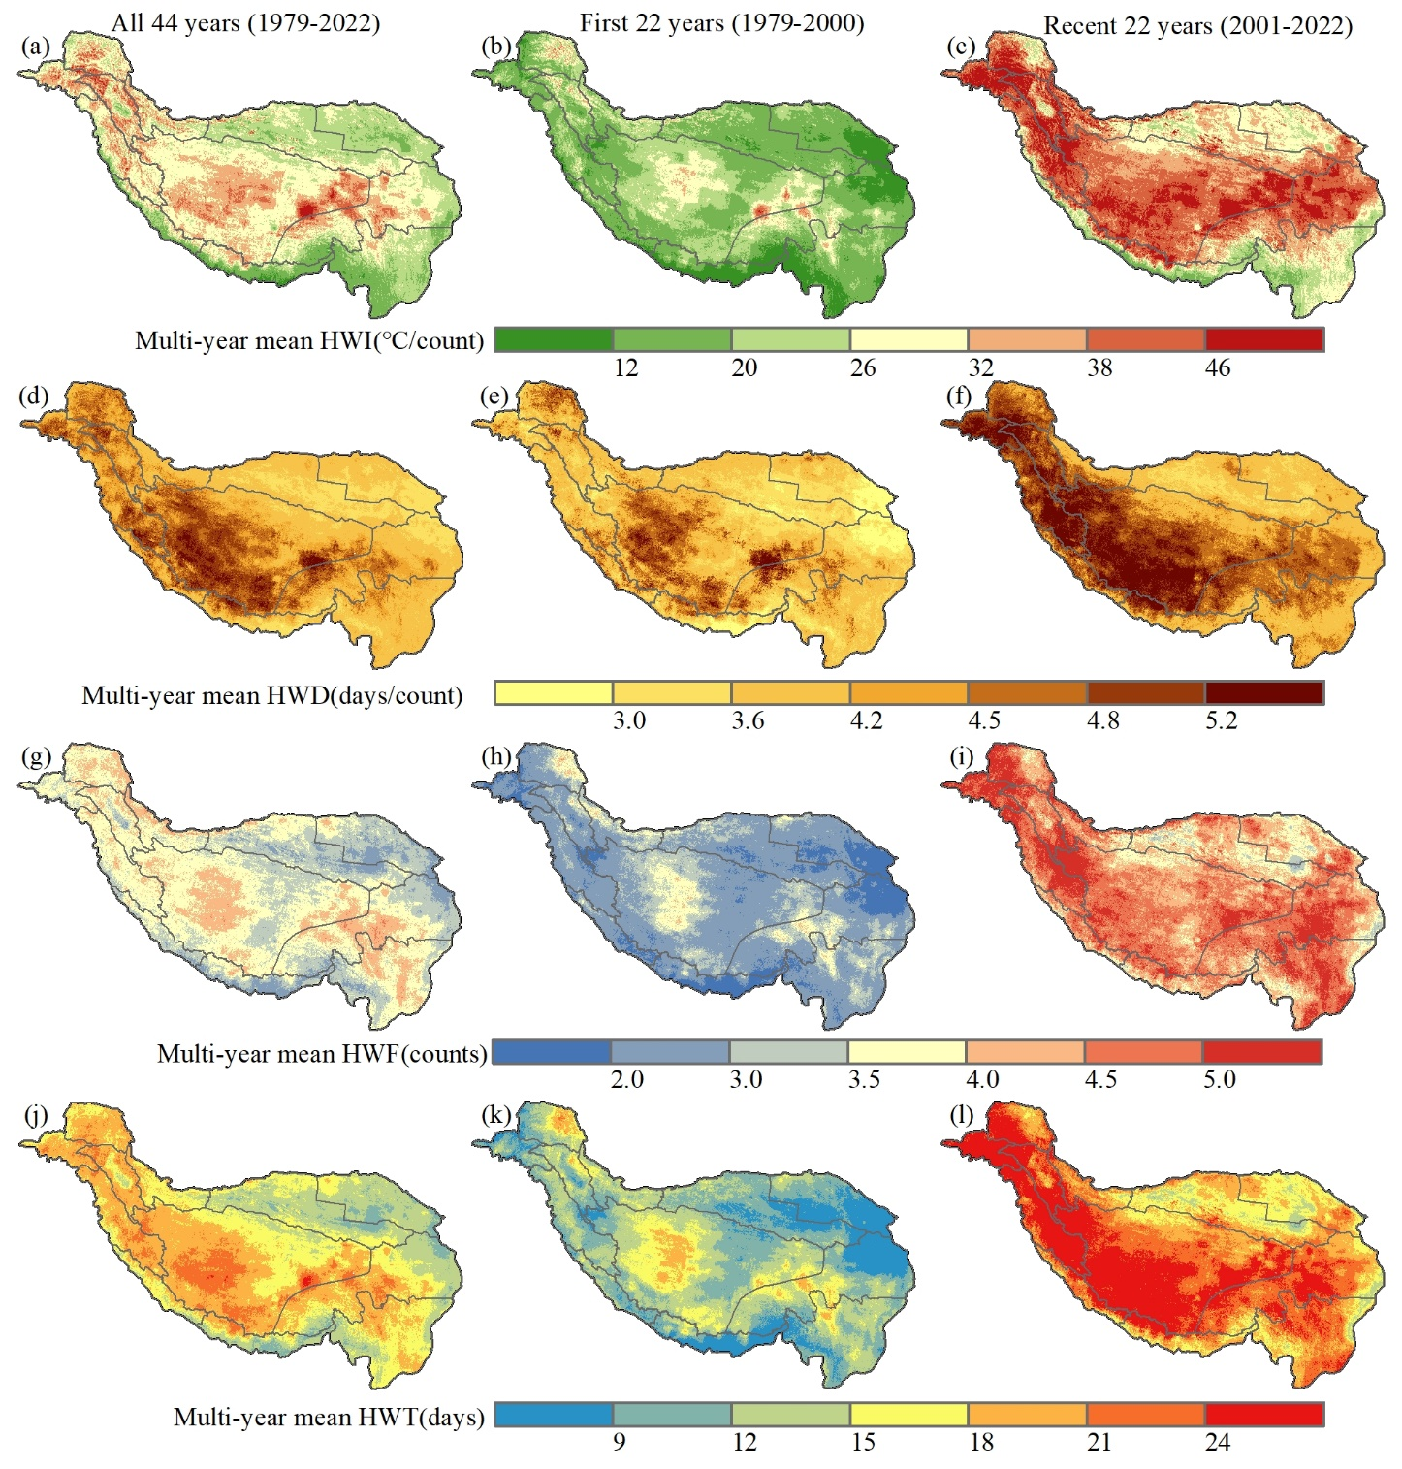
Supplementary Figure S1. Spatial distributions of the multi-year mean (a-c) HWI, (d-f) HWD, (g-i) HWF, (j-l) HWT over the Tibetan Plateau during all 44 years (1979-2022) (left column), the first 22 years (1979-2000) (middle column), and the recent 22 years (2001-2022) (right column).
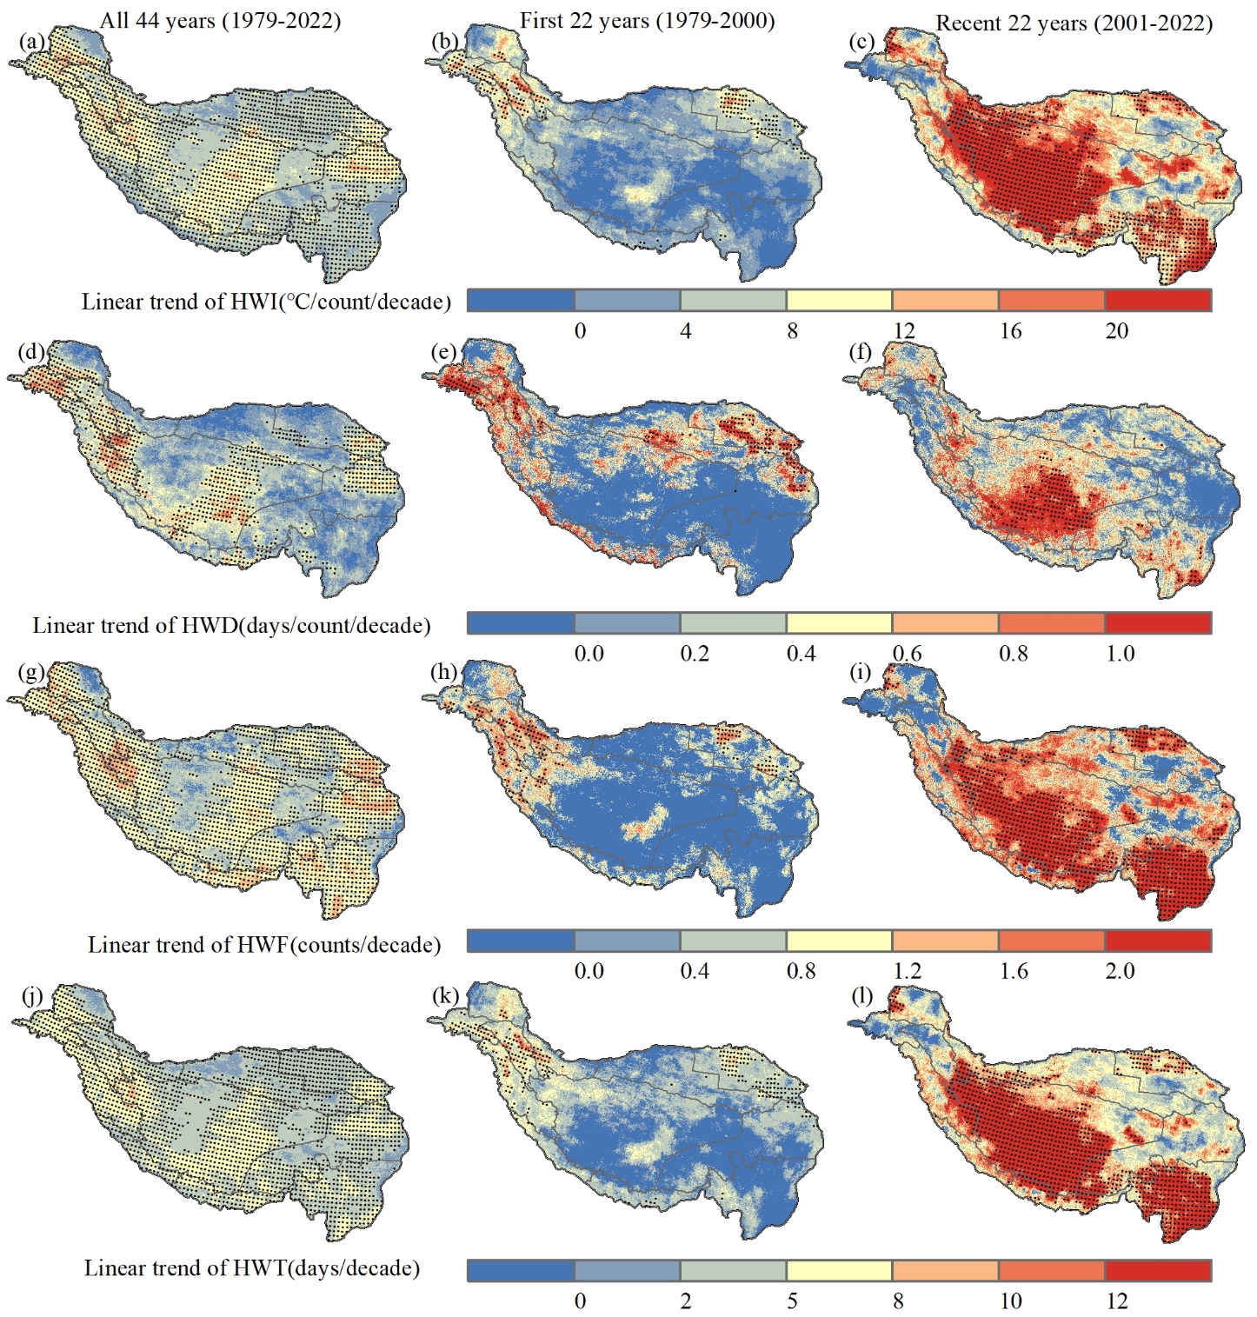
Supplementary Figure S2. Spatial distributions of the linear trends of heatwave indicators over all 44 years (1979-2022) (left column), the first 22 years (1979-2000) (middle column), and the recent 22 years (2001-2022) (right column) over the Tibetan Plateau. (a-c) HWI; (d-f) HWD; (g-i) HWF; (j-l) HWT. Dots indicate positive (negative) significance at the 0.05 level.
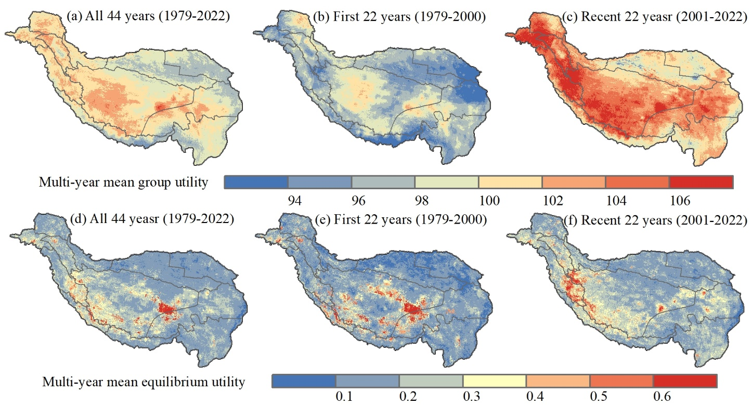
Supplementary Figure S3. Spatial distributions of the multi-year mean (a-c) group utility and (d-f) equilibrium utility over the Tibetan Plateau during all 44 years (1979-2022) (left column), the first 22 years (1979-2000) (middle column), and the recent 22 years (2001-2022) (right column).

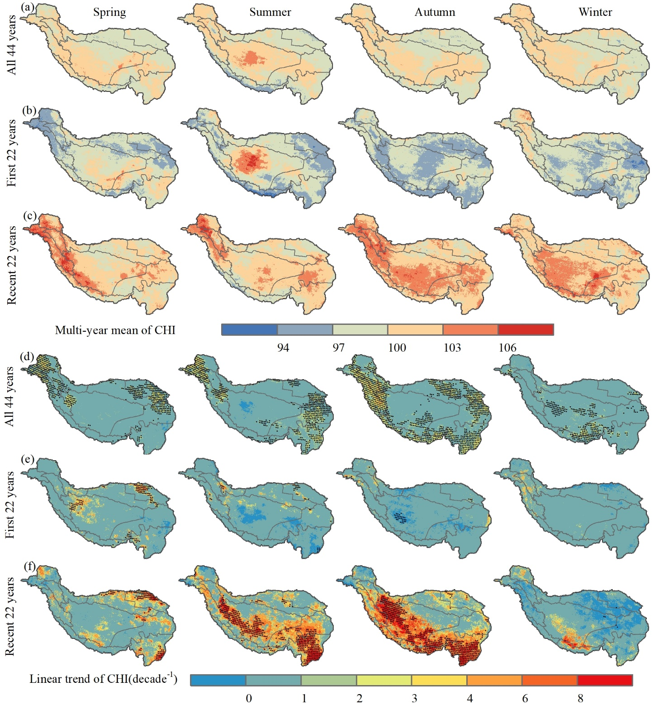
Supplementary Figure S4. Spatial patterns of (a-c) the multi-year mean CHI and (d-f) trends in the annual CHI over the Tibetan Plateau in each of four seasons during different periods. All 44 years (1979-2022); the first 22 years (1979-2000); the recent 22 years (2001-2022). Dots represent significance at the 95% confidence level. First, second, third and fourth columns are spring, summer, autumn and winter, respectively.

Supplementary Table S1 Standard deviation ellipse parameters for four seasons during different periods.
- All 44 years (1979-2022)
Season | Center X  (km) | Center Y  (km) | Area  (1×10⁴km²) | Long axis standard  distance (km) | Short axis standard  distance (km) | Rotation (°)
Spring | -1580 | 4184 | 139 | 1150 | 385 | 112.8
Summer | -1631 | 4331 | 112 | 1125 | 317 | 116.4
Autumn | -1600 | 4297 | 140 | 1197 | 373 | 113.7
Winter | -1735 | 4333 | 153 | 1076 | 453 | 116.0
- First 22 years (1979-2000)
Season | Center X  (km) | Center Y  (km) | Area  (1×10⁴km²) | Long axis standard  distance (km) | Short axis standard  distance (km) | Rotation (°)
Spring | -1315 | 4178 | 143 | 963 | 473 | 108.8
Summer | -1499 | 4299 | 136 | 1034 | 419 | 113.0
Autumn | -1456 | 4338 | 161 | 1209 | 424 | 112.1
Winter | -1576 | 4347 | 170 | 1150 | 469 | 112.2
- Recent 22 years (2000-2022)
Season | Center X  (km) | Center Y  (km) | Area  (1×10⁴km²) | Long axis standard  distance (km) | Short axis standard  distance (km) | Rotation (°)
Spring | -2131 | 4466 | 142 | 1081 | 420 | 117.6
Summer | -1825 | 4505 | 138 | 1472 | 299 | 113.9
Autumn | -1690 | 4269 | 135 | 1149 | 374 | 113.4
Winter | -1603 | 4158 | 112 | 902 | 396 | 107.4

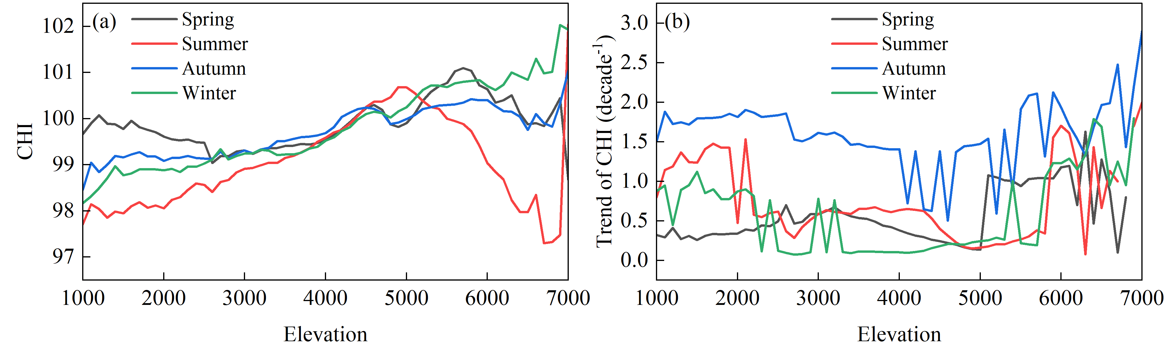
Supplementary Figure S5. (a) Multi-year average and (b) trends of the seasonal CHI from 1979 to 2022 under different elevations on the Tibetan Plateau.
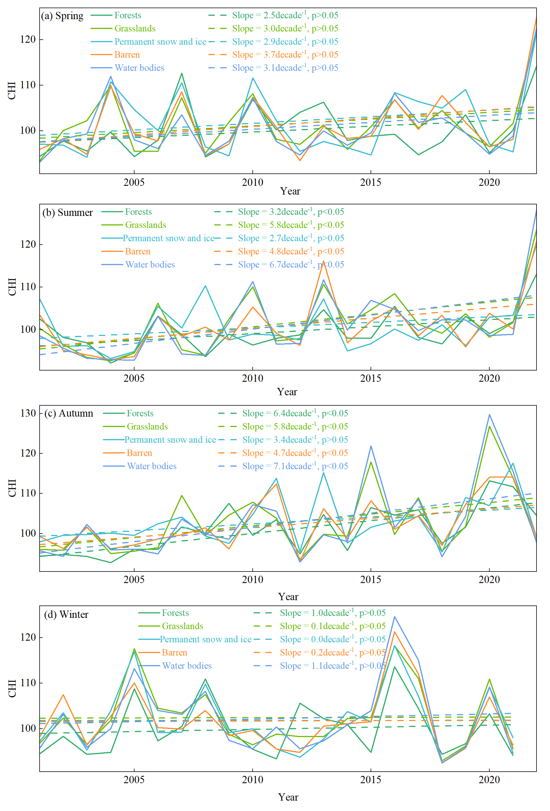
Supplementary Figure S6. Interannual variation and trends of the seasonal CHI under different land cover types from 2001 to 2022 for the Tibetan Plateau. (a) Spring, (b) Summer, (c) Autumn, (d) Winter.
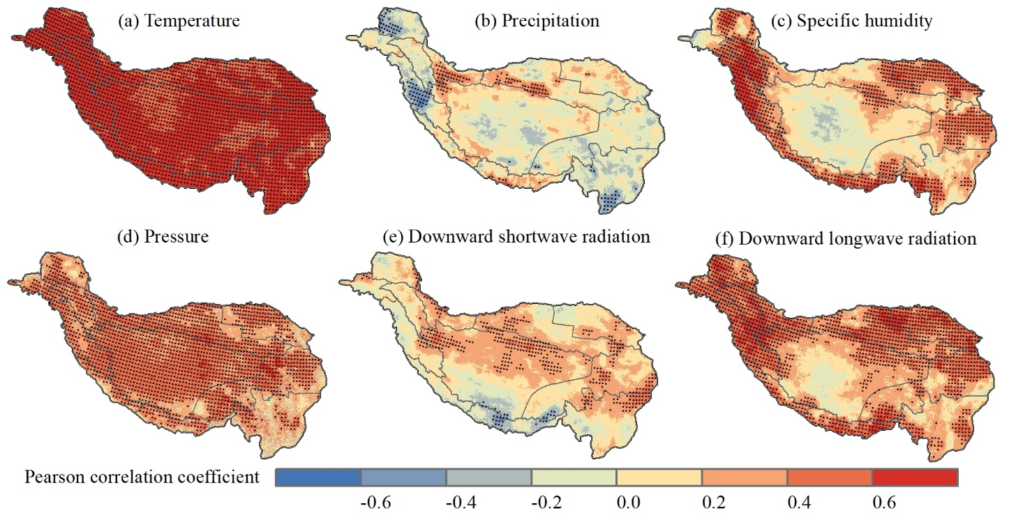
Supplementary Figure S7. Pearson correlation coefficient between CHI and climate factors. (a) temperature; (b) precipitation; (c) specific humidity; (d) pressure; (e) downward shortwave radiation; (f) downward longwave radiation. Dots indicate positive (negative) significance at the 0.05 level.
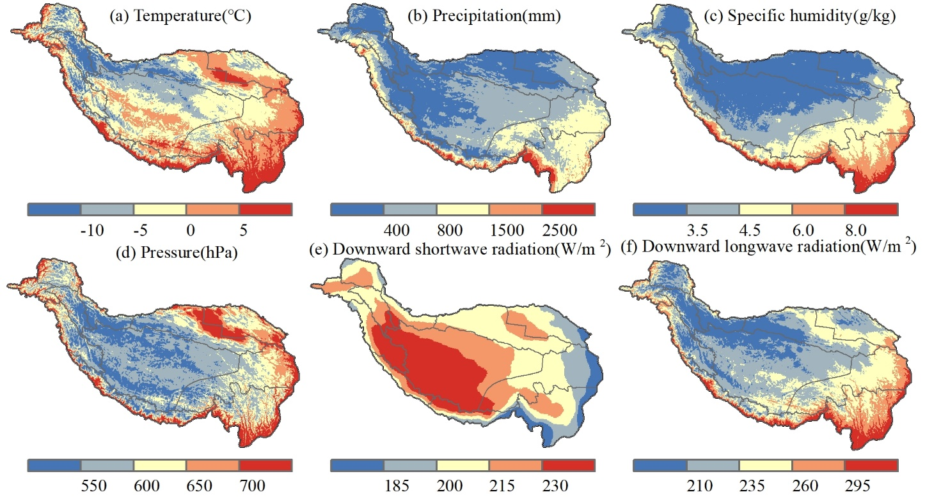
Supplementary Figure S8. Spatial distributions of the multi-year mean (a) temperature, (b) precipitation, (c) specific humidity, (d) pressure (e) downward shortwave radiation and (f) downward longwave radiation over the Tibetan Plateau from 1979 to 2022.

