Fine-tuning enzyme activity assays for monitoring the enzymatic PET-hydrolysis
Krisztina Boros¹, Blanka Eszter Nagy¹, Raluca Bianca Tomoiagă¹, Róbert Tőtős¹, Monica Ioana Toșa¹, Csaba Paizs¹, László Csaba Bencze^{1*}

Author address and affiliation:
¹ Enzymology and Applied Biocatalysis Research Center, Faculty of Chemistry and Chemical Engineering, Babeș-Bolyai University, Arany János Street 11, RO-400028 Cluj-Napoca, Romania

*Address for correspondence:
Assoc. Prof. Dr. László Csaba Bencze; e-mail: laszlo.bencze@ubbcluj.ro
Table of Contents
1. Molecular cloning of the lcc gene 3
2. Protein expression and isolation 4
3. Thermal denaturing profiles of the recombinant enzymes 4
4. HPLC method development 5
4.1. HPLC calibration for quantitative assessments 6
4.2. Analytical parameters for the novel HPLC method 8
5. Optimization of the UV-VIS method 9
6. Enzymatic PET-degrading activity assessment by HPLC 10
7. References 10

1. Molecular cloning of the lcc gene
The cloning of the synthetic codon-optimized lcc gene (Table S1) was performed using the NEBuilder HiFi DNA Assembly Kit (New England BioLabs). The primers presented in Table S2 and Phusion® DNA polymerase were used to amplify the insert and the vector with appropriate overlaps.
Table S1. The amino acid sequence of the leaf-branch compost cutinase and nucleotide sequence of the synthetic lcc gene.
Amino acid sequence (UniProt ID: G9BY57) | Nucleotide sequence (GenBank ID: HQ704839.1)
1 MSNPYQRGPN PTRSALTADG PFSVATYTVS  31 RLSVSGFGGG VIYYPTGTSL TFGGIAMSPG  61 YTADASSLAW LGRRLASHGF VVLVINTNSR  91 FDYPDSRASQ LSAALNYLRT SSPSAVRARL  121 DANRLAVAGH SMGGGGTLRI AEQNPSLKAA  151 VPLTPWHTDK TFNTSVPVLI VGAEADTVAP  181 VSQHAIPFYQ NLPSTTPKVY VELDNASHFA  211 PNSNNAAISV YTISWMKLWV DNDTRYRQFL  241 CNVNDPALSD FRTNNRHCQL EHHHHHH* | 1 ATGTCAAACC CGTATCAGCG TGGCCCGAAC CCGACCCGCA  41 GCGCGCTGAC CGCGGATGGC CCGTTCAGCG TGGCGACCTA  81 TACCGTGAGC CGCTTAAGTG TTAGCGGCTT TGGTGGCGGC  121 GTGATTTACT ACCCGACCGG CACGAGCCTG ACCTTTGGAG  161 GCATTGCAAT GAGCCCGGGT TATACCGCAG ATGCCAGCAG  201 CCTGGCGTGG CTGGGCCGCC GCCTGGCGAG CCACGGTTTT  241 GTGGTGCTGG TGATTAACAC CAACAGCCGT TTTGATTATC  281 CGGATTCGCG CGCGAGTCAG CTGTCAGCGG CGCTGAATTA  321 CCTGCGCACC TCCAGCCCGA GCGCCGTGCG CGCGCGTCTG  361 GATGCGAACC GCCTGGCGGT GGCCGGCCAT AGCATGGGTG  401 GCGGCGGCAC CCTGCGCATT GCGGAACAGA ACCCGAGCCT  441 GAAAGCCGCG GTTCCGCTGA CCCCGTGGCA TACCGATAAA  481 ACCTTCAATA CCAGCGTGCC GGTGTTAATT GTGGGCGCGG  521 AAGCCGATAC CGTTGCGCCA GTGAGCCAGC ATGCAATCCC  561 GTTTTATCAG AACCTGCCGA GTACCACCCC GAAAGTGTAT  601 GTGGAACTGG ATAACGCCAG CCATTTTGCG CCGAATAGCA  641 ATAACGCGGC GATTAGCGTG TATACCATTA GCTGGATGAA  681 ACTGTGGGTG GATAATGATA CCCGTTACCG CCAGTTTCTG  721 TGCAATGTTA ATGATCCGGC GCTGAGCGAT TTTCGTACCA  761 ACAATCGCCA CTGTCAGCTC GAGCACCACC ACCACCACCA  801 CTGA
*The His₆-tag at the end of the amino acid sequence is the result of cloning the lcc gene into the N-terminal His-tagged pET-21a(+) expression vector.
Table S2. List of primers used within the PCR amplification of the insert and the vector with appropriate overlaps.
Primer Name | Sequence | bp | T_{M} ($°$C)
F1_LCC_pET21a | 5’GAAGGAGATATACATATGTCAAACCCGTATCAGCGTGGCCC‘3 | 41 | 73
R1_LCC_pET21a | 5’GTGGTGGTGCTCGAGCTGACAGTGGCGATTG‘3 | 31 | 75
F2_pET21a | 5’CTCGAGCACCACCACCAC‘3 | 18 | 62
R2_pET21a | 5’CATATGTATATCTCCTTCTTAAAGTTAAACAAAATTATTTC‘3 | 41 | 61
After confirming the success of the amplification of the fragment and the linearization of the vector via agarose gel electrophoresis, the PCR reaction products were added to NEBuilder HiFi DNA Assembly Master Mix and the mixture was incubated at 50 °C for 15 minutes. Competent NEB® 5-alpha E. coli (NEB #C2987) cells were transformed via heat shock using the obtained recombinant plasmids. The colony PCR screening of the obtained bacterial colonies was carried out (Figure S1), followed by the DNA sequencing of the positive clones.
Figure S1. Agarose gel electrophoresis of the colony PCR reaction products for the identification of positive colonies containing the pET-21a(+) plasmid with the lcc gene inserted, resulting in amplified fragments of 960 bp (L1 to L5: selected colonies from the agar plates, C: positive control - lcc gene amplified from pET28a(+)-lcc plasmid).

2. Protein expression and isolation
The expression and isolation of the recombinant LCC enzyme was performed according to previous procedures^{[1]} with slight modifications. Briefly, the plasmid constructs was transformed into E. coli bas competent cells via heat shock. The cell membrane disruption was performed using lysozyme and French press. The desalting step was carried out as described in a previous study^{[1]}. The degree of protein expression and the purity of the obtained fraction was investigated by SDS-PAGE, while the protein concentration was determined using the Bradford method.
Figure S2. SDS-PAGE analysis of the fractions collected during the isolation of LCC (calculated M_{w} ~29 kDa) employing Ni-NTA affinity chromatography. (Lysate: supernatant after the centrifugation of the lysed cells, FT: Flow-through, W10: fractions washed off the column with 10 mM imidazole containing buffer, E100: fractions eluted with 100 mM imidazole containing buffer, DS&C: isolated protein fraction after FPLC-desalting and concentration steps.)

3. Thermal denaturing profiles of the recombinant enzymes
The thermal denaturing profile of LCC was determined by real-time protein unfolding experiments performed in a BioRad CFX96 Real-Time Thermal Cycler using differential scanning fluorimetry (DSF). Samples consisting of protein solutions at a concentration of 10 μΜ (in 20 mM Tris, 300 mM NaCl, pH 8 buffer) were mixed with 5 μL SYPRO™ Orange Protein Gel Stain (Thermo Fisher Scientific) solution (diluted to 200$×$ from a 5000$×$ stock using the previously mentioned buffer solution) to a final volume of 50 μL. The blank sample was similarly prepared by replacing the protein solution with 45 μL of the buffer solution. The obtained samples were loaded into a white-clear-Hard Shell 96-well PCR plate (Bio-Rad), followed by sealing the plate with optically clear Microseal® B sealing tape (Bio-Rad). The melting curve of the samples were then measured using the FAM and ROX channels of a Bio-Rad CFX96 system, with 450-490 nm and 560-590 nm excitation and 510-530 nm and 610-650 nm emission filters, respectively. The melting curve of the enzyme was measured on a temperature range from 20 °C to 95 °C, with an increment of 1 °C and the melting point (T_{M}) was determined by representing the first derivative of the fluorescence emissions as a function of temperature (-d_{RFU}/d_{T}). The obtained thermal denaturing profiles are presented in Fig. S3. The obtained T_{M} value is in accordance with the data presented in the literature.^{[2,3]}
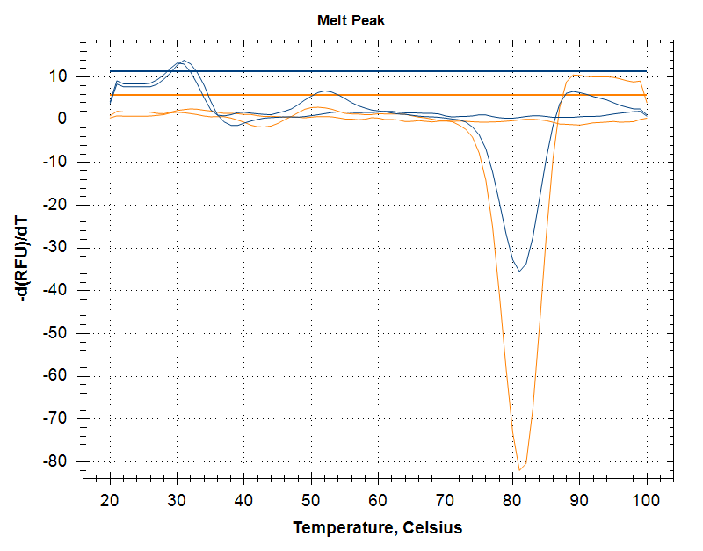
Figure S3. Thermal denaturing profile and melting point determination in case of LCC (T_{M} = 81°C).

4. HPLC method development
During the development of the upgraded reverse-phase HPLC method the following optimized conditions were identified: gradient elution using water (with 0.1% formic acid) and acetonitrile, with an increase of acetonitrile from 15 vol.% to 27.5 vol.% in 10 minutes, at a flow-rate of 1 mL/min, using a Phenomenex Luna C8(2) 5 μm, 4.6$×$150 mm column, with detection wavelength of 240 nm. The method allows the baseline separation of the aromatic reaction products and the internal standard (caffeine).
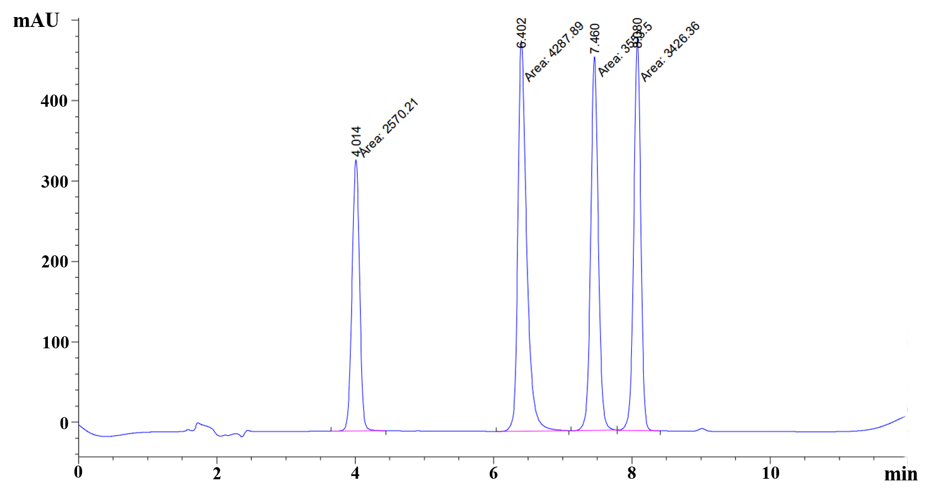
Figure S4. Baseline separation of the aromatic reaction products, TPA (R_{T} 6.4 min), MHET (R_{T} 7.5 min), BHET (R_{T} 8.1 min) and the internal standard (caffeine) (R_{T} 4.0 min). The injected sample contained 0.85 mM TPA, 0.85 mM MHET, 0.70 mM BHET and 2.11 mM caffeine.
The resolution of the developed HPLC method was calculated from the experimentally obtained chromatograms (e.g. such as the one presented Figure S4) using Eq. 1, while the obtained values are presented in Table S3.
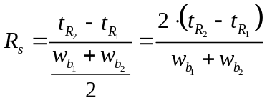
where t_{R} was the retention time (min) and w_{b} is the band width (min) corresponding to each peak.
Table S3: Resolution values for the novel HPLC method.
Peak | Retention time (R_{t}) | Band width (w_{b}) | Resolution (Rs) | Rs*
1th peak - internal standard - caffeine | 4.028 | 0.222
2nd peak -TPA | 6.226 | 0.234 | 9.640 | Rs₂₋₁
3rd peak - MHET | 7.267 | 0.223 | 4.556 | Rs₃₋₂
4th peak - BHET | 8.26 | 0.275 | 3.988 | Rs₄₋₃
*Rs_{y-x}: the resolution calculated between peak y and peak x

4.1. HPLC calibration for quantitative assessments
Figure S5. HPLC chromatograms from the separation of the mixtures of authentic samples containing TPA (R_{T} 6.4 min), MHET (R_{T} 7.5 min), BHET (R_{T} 8.1 min) and the internal standard (caffeine) (R_{T} 4 min) used at the lower concentration range (21-211 μM range).
Due to a minor break (Figure S6) in linearity, the calibration curves were separated into lower (21-211 μM range) and higher (0.18-1.69 mM) concentration ranges, improving the accuracy and reliability of the curve fitting the regression models.
Figure S6. Calibration curve for TPA (a), MHET (b) and BHET (c), representing the ratios of peak area specific to TPA, MHET and BHET and caffeine as a function of the molar concentration of TPA, MHET and BHET, respectively. Concentration range of 0.02-1.69 mM.
Table S4. The tgα values of the calibration curves and their relative deviation.
 | Degradation product | tgα₁ | tgα₂ | tgα₃ | Average | Relative deviation (%)*
Higher concentrations | TPA | 2.443 | 2.172 | 2.592 | 2.403 | 1.2
Higher concentrations | MHET | 2.175 | 1.662 | 2.323 | 2.053 | 1.3
Higher concentrations | BHET | 2.445 | 2.170 | 2.728 | 2.448 | 19.6
Lower concentrations | TPA | 2.493 | 2.218 | 3.009 | 2.573 | 5.8
Lower concentrations | MHET | 1.825 | 1.819 | 2.281 | 1.975 | 2.5
Lower concentrations | BHET | 2.455 | 2.187 | 2.919 | 2.520 | 23.1
Total concentration range | TPA | 2.332 | 2.206 | 2.760 | 2.433 | -
Total concentration range | MHET | 2.016 | 1.743 | 2.319 | 2.026 | -
Total concentration range | BHET | 1.943 | 1.852 | 2.347 | 2.047 | -
*Percentage difference of the average value of tgα obtained in lower/higher concentration range and the value of tgα in the total concentration range, relative to the latter.
The analysis of a specific sample with a pre-defined TPA, MHET and BHET content was performed over 3 consecutive days, using both the upgraded HPLC method and the general, reported HPLC method^{[1-3]}; aiming to observe variations between multiple measurements of the same sample (Fig. S7), thus evaluating the accuracy and reliability of the developed method.
Figure S7. The overlay of the HPLC chromatograms of the same sample analysed on 3 different days using a) the upgraded HPLC method and b) the conventional HPLC procedure^{[1-3]} .

4.2. Analytical parameters for the novel HPLC method
To assess the performance of the novel HPLC method several analytical parameters were calculated, such as the arithmetic mean (µ) of samples, the standard deviation (STD), accuracy, precision and the coefficient of variation (CV). For the calculation of the parameters, the following equations were used:
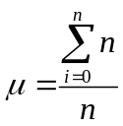
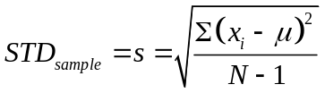
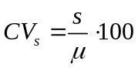
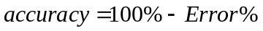
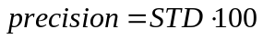
where n is the number of samples, x_{i} is the observed value of the sample items, s is the standard deviation of the sample, µ is the mean value of the observations (arithmetic mean), N is the number of observations.

5. Optimization of the UV-VIS method
The extinction coefficients for each aromatic PET hydrolysis product (TPA, MHET and BHET) have been determined at the selected 235 nm, using the authentic samples of each product (Fig. S8). The average value for the extinction coefficient, employed in the calculations of the PET-hydrolysis enzymatic activities, was derived from the three extinction coefficients determined.

Figure S8. Calibration curve for the calculation of the molar absorptivity at 235 nm.

6. Enzymatic PET-degrading activity assessment by HPLC
Figure S9. HPLC chromatograms of the LCC catalysed PET biodegradation after 26-hour reaction time, analysed by a) the upgraded and b) the conventional HPLC procedure.
Figure S10. The overlay of the HPLC chromatograms of samples taken at different reaction times from the PET-hydrolysis reaction monitored over 56 h, as part of the time-conversion profile assessment.

7. References
1 Dhaka, V. et al. Occurrence, toxicity and remediation of polyethylene terephthalate plastics. A review. Environ. Chem. Lett. 20, 1777-1800, doi:10.1007/s10311-021-01384-8 (2022).
2 Son, H. F. et al. Structural bioinformatics-based protein engineering of thermo-stable PETase from Ideonella sakaiensis. Enzyme Microb. Technol. 141, 1-8, doi:10.1016/j.enzmictec.2020.109656 (2020).
3 Austin, H. P. et al. Characterization and engineering of a plastic-degrading aromatic polyesterase. Proc. Natl. Acad. Sci. U S A 115, 4350-4357, doi:10.1073/pnas.1718804115 (2018).

