Patient-reported walking difficulty predicting the post-discharge overall function in patients with lung cancer undergoing minimally invasive surgery

Supportive Care in Cancer

Xin Tian, MB Peiyang Mao, MB Cheng Lei, MD Hongfan Yu, MM Wei Dai, MD, Xing Wei, MD Jingyu Zhang, MD Wei Xu, Qiuling Shi, MD

Correspondence: Qiuling Shi, School of Public Health, Chongqing Medical University, No. 1, Yixueyuan Road, Yuzhong District, Chongqing 400016, China
E-mail: qshi@cqmu.edu.cn
Tel.: +86 18290585397
Fax: +86-28-85420116

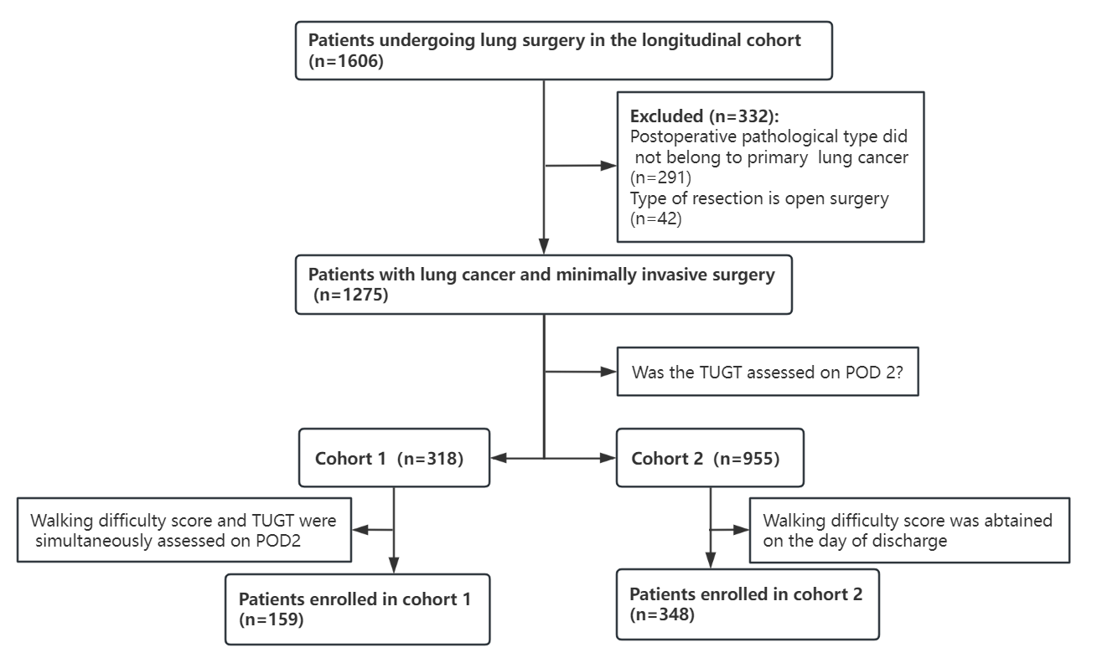

Supplementary Figure 1 Study flow diagram for the analytical sample

Supplementary Table 1 Frequency distribution of the walking difficulty score and TUGT value on POD2
Variables | Number of patients (n=159) | Percentage
TUGT on POD2 (s), n (%)
<13.5 | 95 | 59.75
≥13.5 | 64 | 40.25
Walking difficulty score on POD2, n (%)
0 | 15 | 9.43
1 | 19 | 11.95
2 | 24 | 15.09
3 | 30 | 18.87
4 | 33 | 20.75
5 | 19 | 11.95
6 | 9 | 5.66
7 | 8 | 5.03
8 | 2 | 1.26
POD2, postoperative day 2; TUGT, Timed Up and Go Test
Supplementary Table 2 The functional status and quality of life scores at different time points post-discharge of patients with no/mild and severe difficulty walking at discharge

Functional status | Time point | N (147) |  | Mean (SD)
Functional status | Time point | No/Mild | Severe | No/Mild | Severe
Physical Function | Discharge | 106 | 41 | 78.04 (13.49) | 66.19(14.97)
Physical Function | Two weeks after discharge | 71 | 35 | 82.63 (11.40) | 78.39(12.42)
Physical Function | Four weeks after discharge | 65 | 31 | 86.92 (9.13) | 84.92(9.86)
Emotional Function | Discharge | 105 | 41 | 79.10 (19.63) | 68.97(22.36)
Emotional Function | Two weeks after discharge | 70 | 34 | 84.92 (15.41) | 82.11(17.42)
Emotional Function | Four weeks after discharge | 65 | 30 | 86.54 (14.41) | 85.56(16.80)
Role Function | Discharge | 105 | 39 | 68.25(29.37) | 48.72(34.71)
Role Function | Two weeks after discharge | 69 | 35 | 63.77 (26.65) | 50.48(28.15)
Role Function | Four weeks after discharge | 65 | 31 | 69.74 (23.37) | 63.44(29.00)
QOL | Discharge | 101 | 39 | 51.90 (19.65) | 42.09(21.63)
QOL | Two weeks after discharge | 69 | 35 | 54.95(20.23) | 54.05(20.35)
QOL | Four weeks after discharge | 63 | 28 | 60.98(21.78) | 58.06(21.93)
SD, standard deviation; QOL, quality of life

Supplementary Table 3 Comparison of disparities in walking difficulty between different groups defined by threshold on the day of discharge
Demographic and clinical characteristics | Optimal threshold 4 |  | P
Demographic and clinical characteristics | No/Mild (n=248) | Severe (n=100) | P
Age (years), median [IQR] | 55 [47–64] | 57 [51–64] | 0.035 ª
BMI, median [IQR] | 22.52 [20.83–24.64] | 22.96 [20.99–25.75] | 0.277 ª
sex, n (%) |  |  | 0.491 ^{b}
Male | 89 (35.89) | 32 (32.00)
Female | 159 (64.11) | 68 (68.00)
Smoking history, n (%) |  |  | 0.859 ^{b}
Never smoked | 195 (78.63) | 80 (80.00)
Current smoker | 35 (14.11) | 12 (12.00)
Former smoker | 18 (7.26) | 8 (8.00)
Surgical history, n (%) |  |  | 0.528 ^{b}
Thoracic surgery | 11 (4.44) | 2 (2.00)
Non-thoracic surgery | 114 (45.97) | 49 (49.00)
No | 123 (49.60) | 49 (49.00)
Preoperative ECOG score, n (%) |  |  | 1.000^{c}
1 | 244 (98.39) | 99 (99.00)
>1 | 4 (1.61) | 1 (1.00)
ASA classification, n (%) |  |  | 0.984 ^{b}
Ⅰ | 228 (91.94) | 92 (92.00)
>Ⅰ | 20 (8.06) | 8 (8.00)
Surgical approach, n (%) |  |  | 0.652 ^{b}
Single-port | 83 (33.47) | 36 (36.00)
Multiple-port | 165 (66.53) | 64 (64.00)
Chest tube number, n (%) |  |  | 0.202 ^{b}
1 | 210 (84.68) | 79 (79.00)
2 | 38 (15.32) | 21 (21.00)
Postoperative pathological TNM stage, n (%) |  |  | 0.886^{b}
0-I | 227 (91.53) | 92 (92.00)
II–IV | 21 (8.47) | 8 (8.00)
FEV1 (L), median [IQR] | 2.36 [1.89–2.82] | 2.02 [1.56–2.75] | 0.015 ª
Operation time (min), median [IQR] | 90.00 [66.00–120.00] | 90.00 [67.50–125.00] | 0.870ª
Operative bleeding volume (mL), median [IQR] | 50.00 [50.00–100.00] | 50.00 [50.00–65.00] | 0.549 ª
Postoperative length of stay in hospital (days), median [IQR] | 3 [3–5] | 3 [2–4] | 0.018 ª
ASA, American Society of Anesthesiologists; BMI, body mass index; IQR, interquartile range; TNM, tumor, node, metastasis; ECOG, Eastern Cooperative Oncology Group

Mann–Whitney U test

Chi-square tests

Fisher exact probability test

