Supplementary:

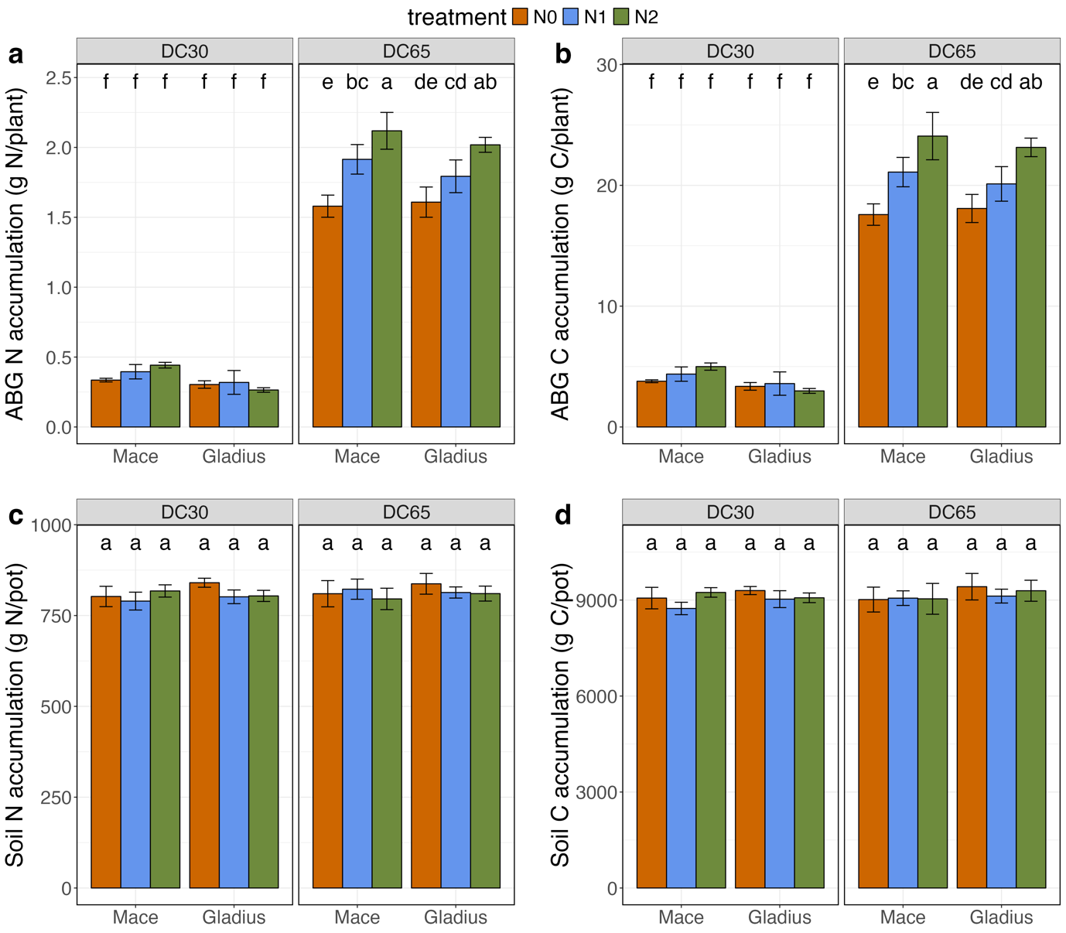
Figure S1. Gladius and Mace growth performance under N treatments at the stem elongation (DC30) and mid-anthesis (DC65) stages. The accumulation of (a) N and (b) C in the wheat-dried above-ground biomass (ABG) and the accumulation of (c) N and (d) C in the soil remained in the pot. N and C content between N treatments was statistically compared by ANOVA indicated on top of the bars.

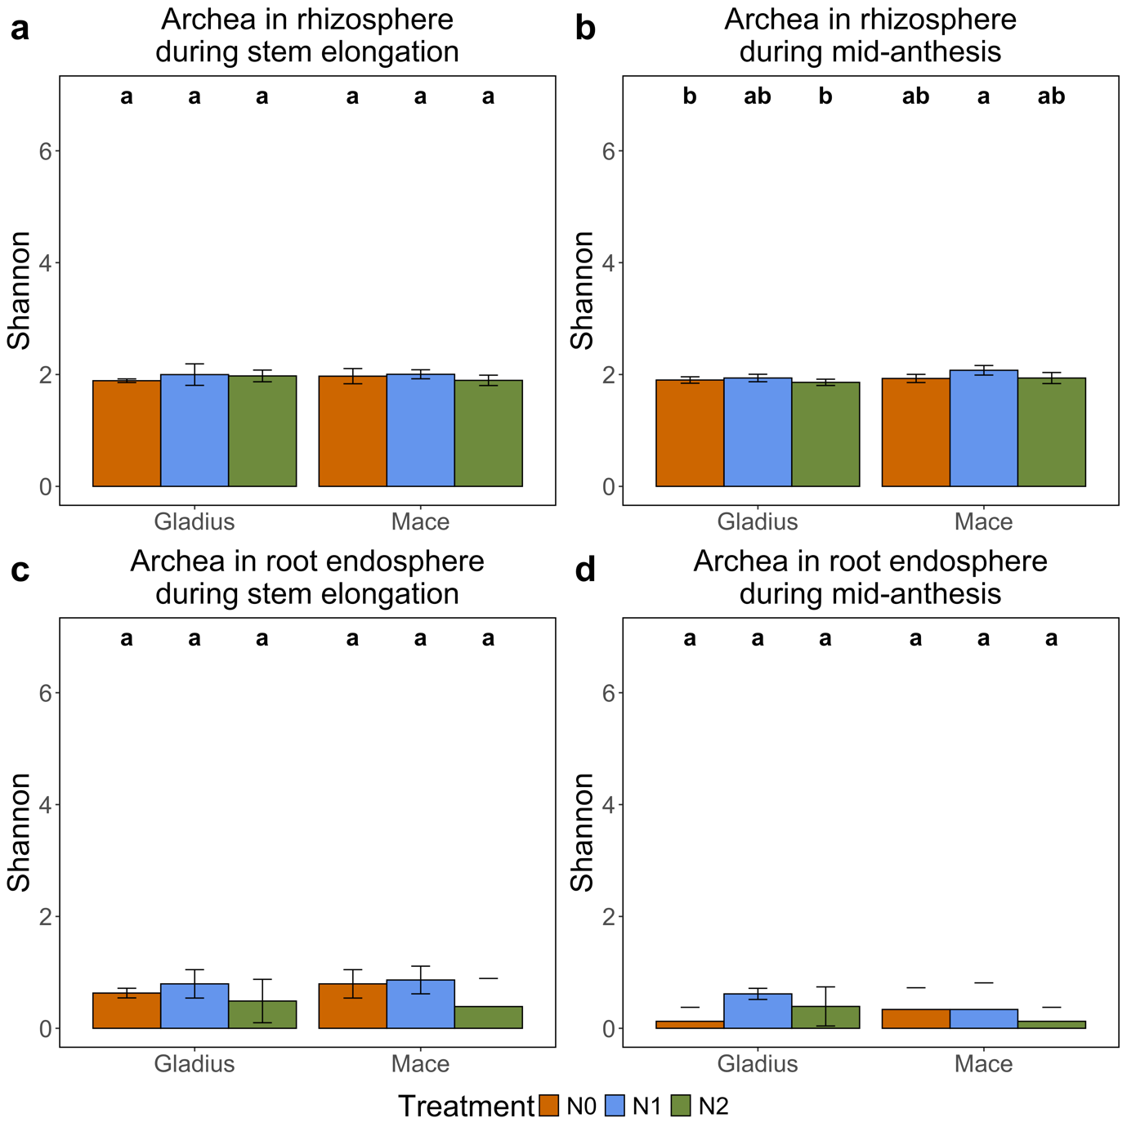
Figure S2. Wheat root-associated archaea estimated by Shannon index in the rhizosphere at (a) stem elongation and (b) mid-anthesis stages, and in the root endosphere at (c) stem elongation and (d) mid-anthesis stages. Kruskal-Wallis statistical test represented by the letters above the bar.

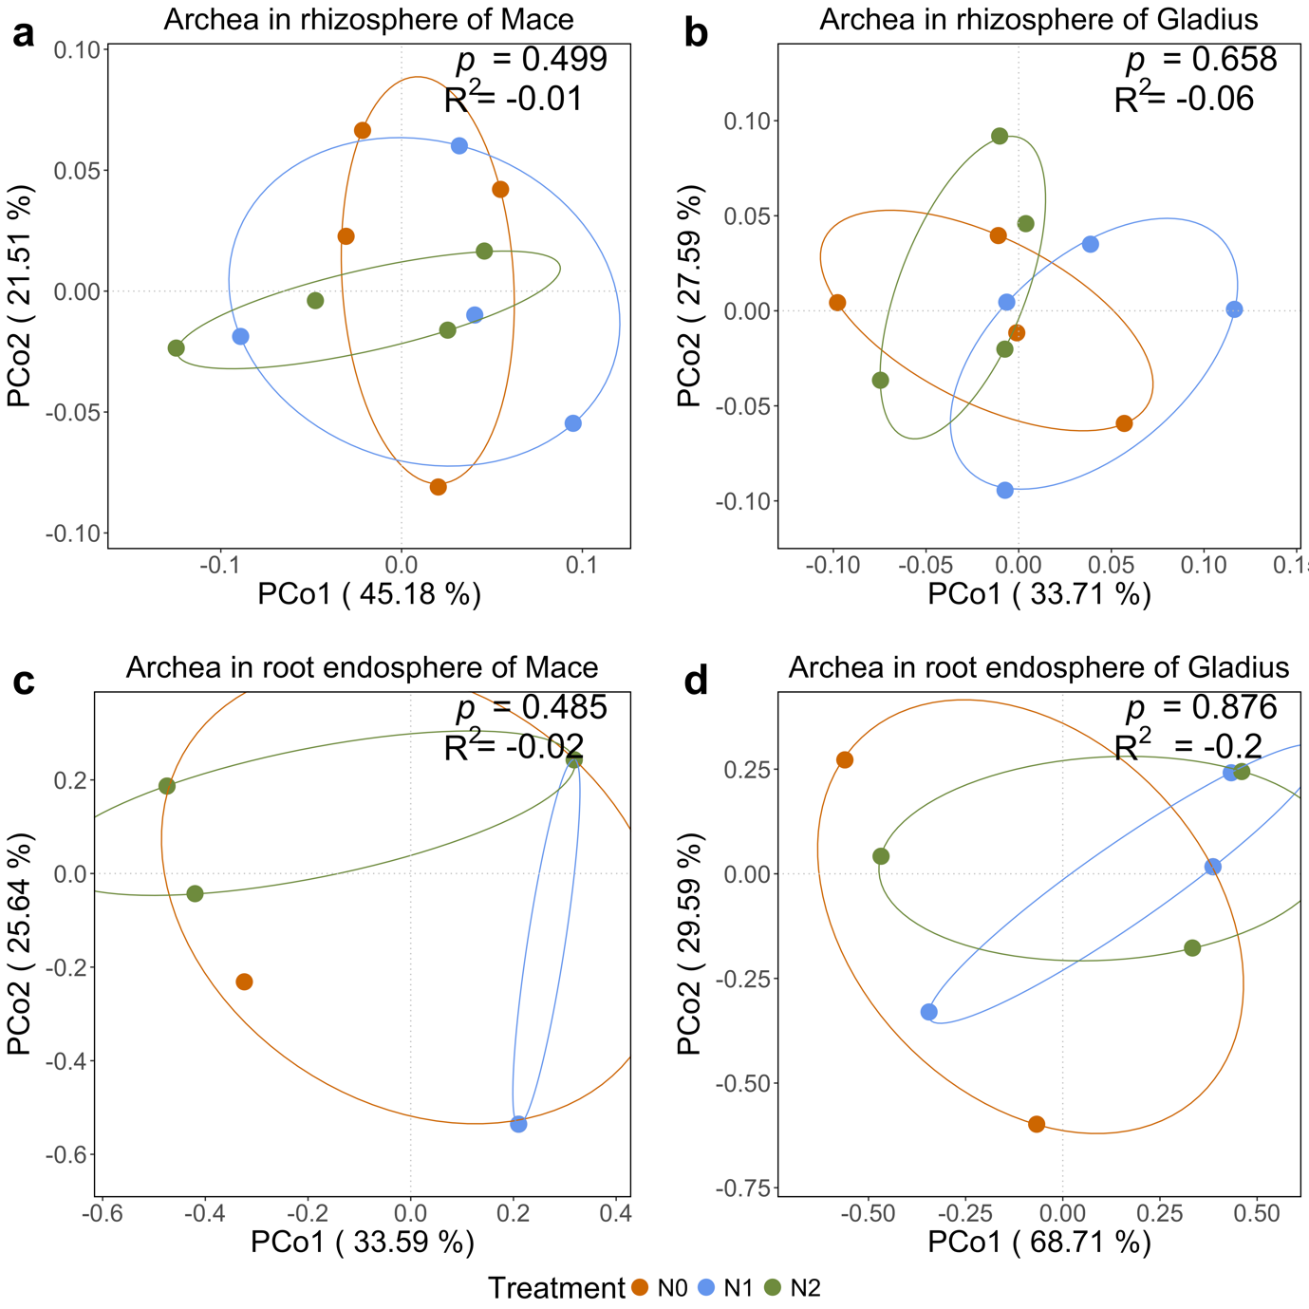
Figure S3. Principle coordinates analysis (PCoA) of wheat root-associated archaea ASVs, in the rhizosphere of (a) Mace and (b) Gladius, and in the root endosphere of (c) Mace and (d) Gladius. Sample similarity is measured by the non-parametric analysis of similarities (ANOSIM). The ANOSIM statistics are indicated on the top-right of each PCoA plot.

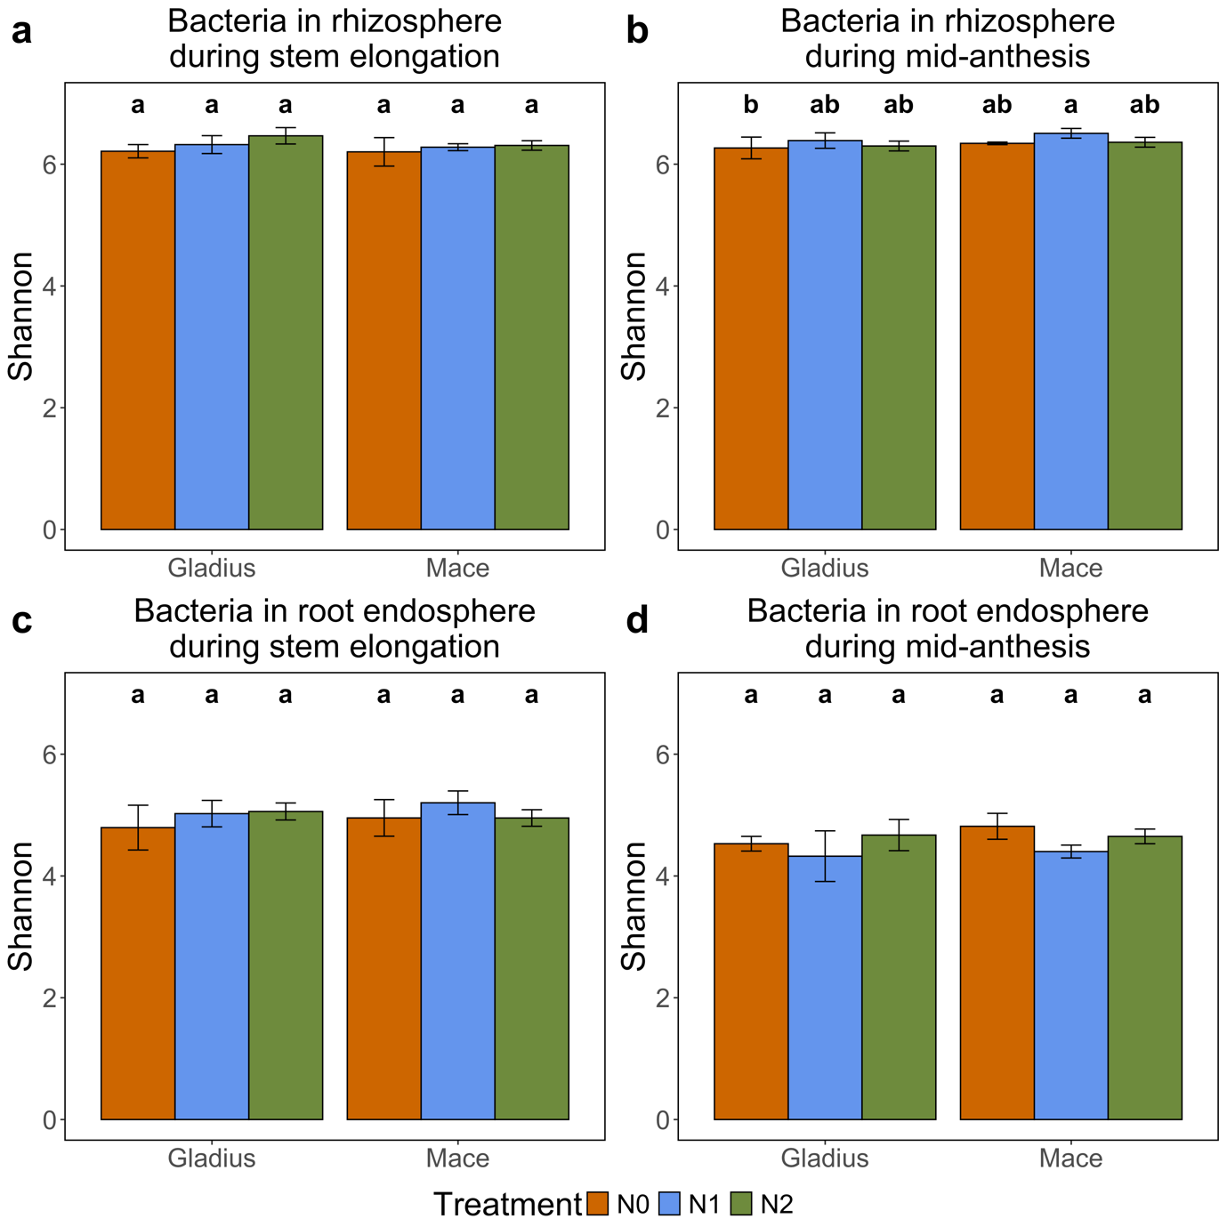
Figure S4. Wheat root-associated bacteria estimated by Shannon index in the rhizosphere at (a) stem elongation and (b) mid-anthesis stages, and in the root endosphere at (c) stem elongation and (d) mid-anthesis stages. The Kruskal-Wallis statistical test is represented by the letters above the bar.

Table S1. Samples description for different performed analyses.
Analysis | 16S amplicon sequencing |  | Metagenomic | Metabolomic (GC-MS)
Compartment | Rhizosphere | Root | Rhizosphere | Root
No. samples | 48 samples | 48samples | 16samples | 27samples
Description | 3x N treatments,  2x cultivars,  2x stages,  4 replicates | 3x N treatments,  2x cultivars,  2x stages,  4 replicates | 3x N treatments,  2x cultivars,  1x stages,  4 replicates | 3x N treatments,  2x cultivars,  1x stages,  5 replicates  Note: 3 plants were not sampled as they were damaged during the experiment. This included two sample of N2-treated Mace and one sample of N2-treated Gladius.

