Impact of Stochastic Entrainment in the NCAR CAM Deep Convection Parameterization on the Simulation of South Asian Summer Monsoon

Raju Pathak¹, Sandeep Sahany^{1,2}, Saroj Kanta Mishra¹
Authors Detail
¹Centre for Atmospheric Sciences, Indian Institute of Technology Delhi, India
²Centrefor Climate Research Singapore

Corresponding Author
Raju Pathak (rajuphyamu@gmail.com)
Centre for Atmospheric Sciences
Indian Institute of Technology Delhi
Hauz Khas, New Delhi, India

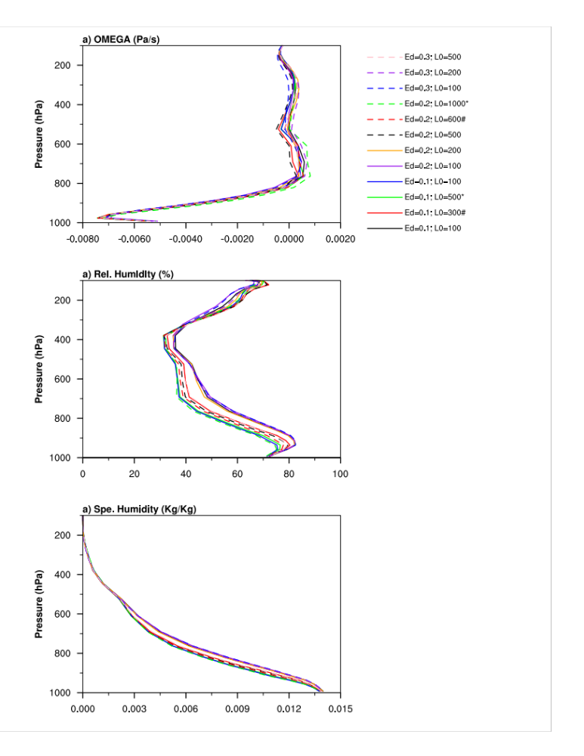
Figure S1: Sensitivity results for $ε_{d}$ and $L_{0}$ over the tropis (30S-30N) to the simulation of vertical velocity, relative and specific humidity during June to September. $ε_{d}$ defines the fraction of vertical mass flux that is entrained over a distance $L_{0}$. The sensitivity effect for $ε_{d}$ and $L_{0}$, when both the values are changed simultaneously from $ε_{d}$ =0.1 and $L_{0}$=300 to $ε_{d}$ =0.2 and $L_{0}$=600, and from $ε_{d}$ =0.1 and $L_{0}$=500 to $ε_{d}$ =0.2 and $L_{0}$=1000 are highlighted in legend by hatching and star.

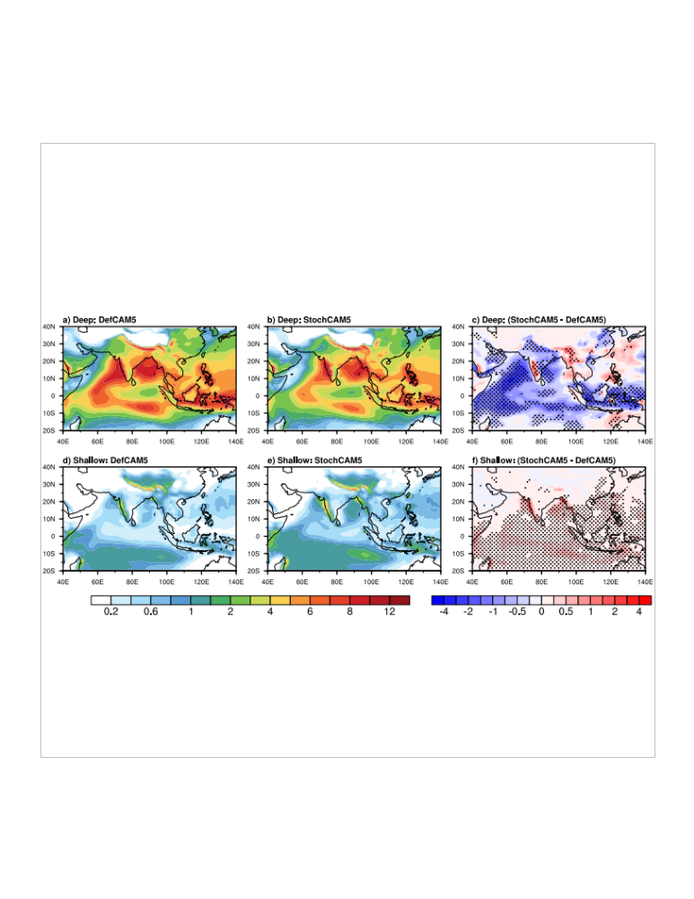
Figure S2: JJAS mean (a-c) deep convective precipitation (mm/day) and (d-f) shallow convective precipitation (mm/day) from (a, d) DefCAM5, (b, e) StochCAM5, and (c, f) StochCAM5 - DefCAM5. Hatching shows the difference which underwent significant changes at 95% confidence level in StochCAM5 with respect to DefCAM5.
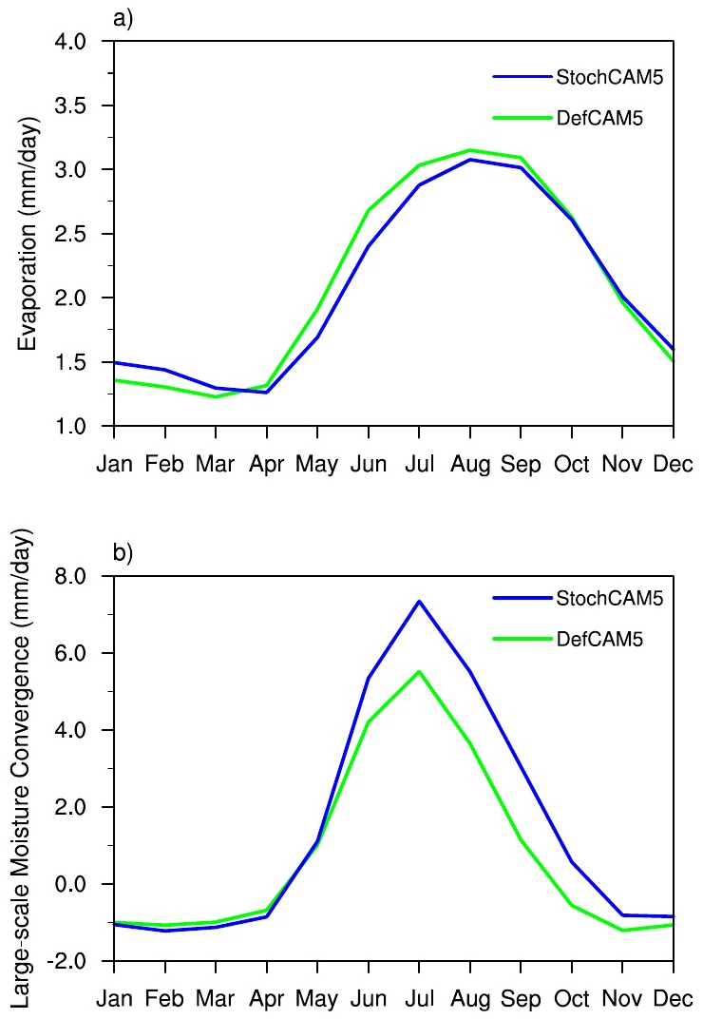
Figure S3: Annual cycle of (a) evaporation and (b) large-scale moisture convergence from DefCAM5 and StochCAM5.

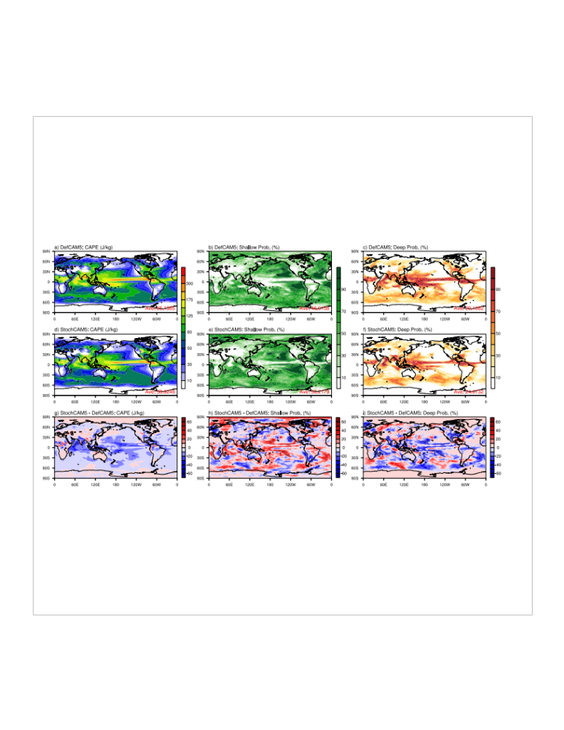
Fugure S4: Spatial distribution of (a, d, g) mean CAPE, (b, e, h) probability of occurance of shallow convection, and (c, f, i) probability of occurance of deep convection from (a-c) DefCAM5, (d-f) StochCAM5, and (g-i) StochCAM5-DefCAM5. The probability of occurance of deep convection at a grid point is considered when CAPE exceeds 70 J/kg, and the probability of occurance of shallow convection at a grid point is considered when CAPE exceeds the zero value but is lesser to 70 J/kg.

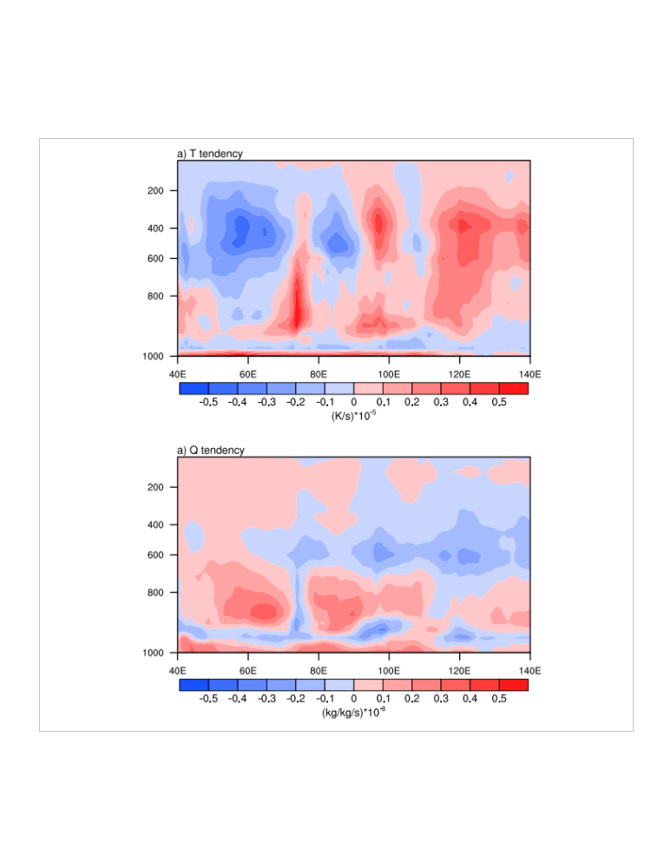
Figure S5: JJAS meridional mean cross section of the model physics tendencies for (a) temperature and (b) specific humidity from StochCAM5-DefCAM5 over 30S-30N.
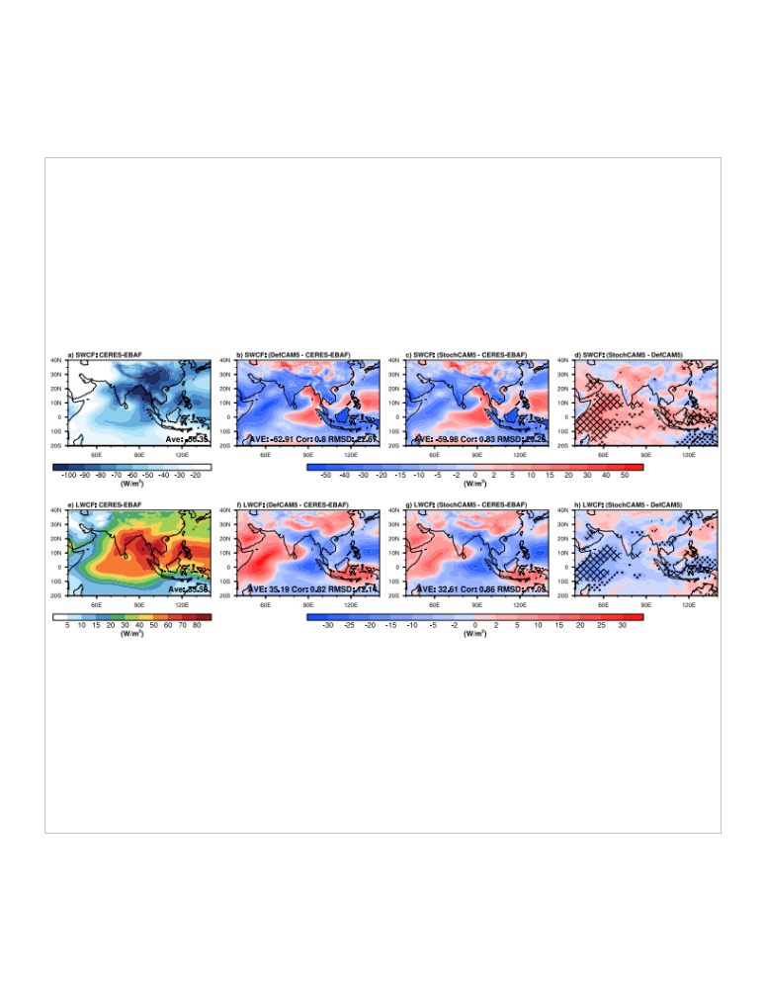
Figure S6: JJAS mean (a-d) shortwave cloud forcing (SWCF) and (e-h) longwave cloud forcing (LWCF) from (a, e) CERES-EBAF, (b, f) DefCAM5, (c, g) StochCAM5, and (d, h) StochCAM5 – DefCAM5. CERES-EBAF - Clouds and Earth’s Radiant Energy System-Energy Balanced and Filled.

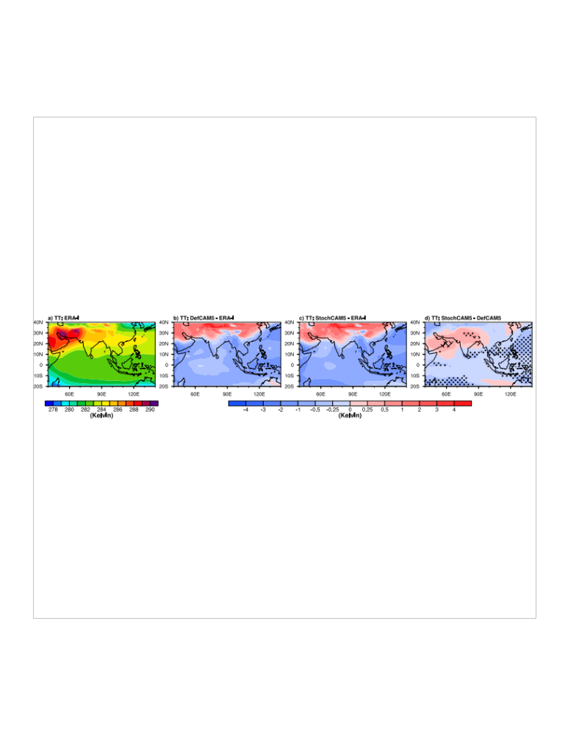
Figure S7: JJAS mean averaged tropospheric temperature (TT) over 700-300 hPa from (a) ERA-I, (b) DefCAM5 - ERA-I, (c) StochCAM5 – ERA-I, and (d) StochCAM5 -DefCAM5. Hatching (stippling) shows the differences which are improved (deteriorated) at 95% confidence level (two-tailed student t-test) in StochCAM5 with respect to DefCAM5.

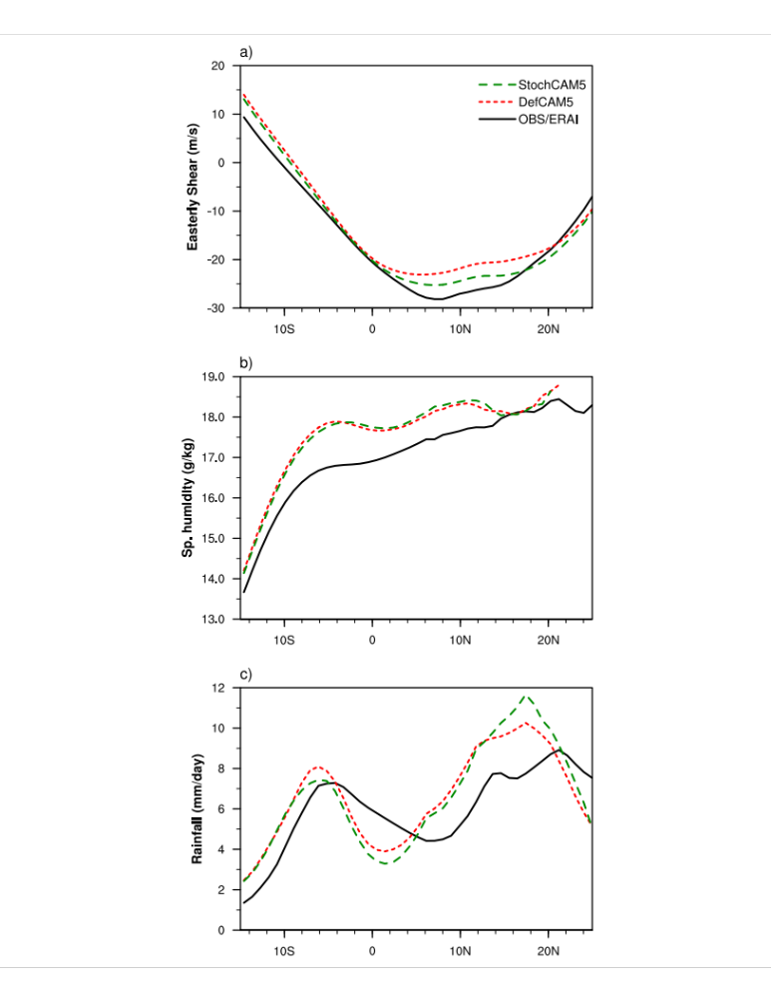
Figure S8: JJAS mean merdional distribution of (a) easterly wind shear (U₂₀₀ – U₈₅₀; m/s), (b) specific humidity (g/kg), and (c) total precipitation (mm/day), averaged over 70°-90°E for observation/ERA-I (black), DefCAM5 (red), and StochCAM5 (green).

