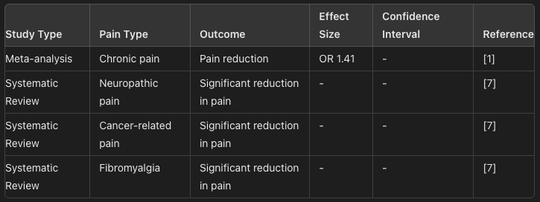

Table 1: Efficacy of Cannabinoids in Managing Chronic Pain
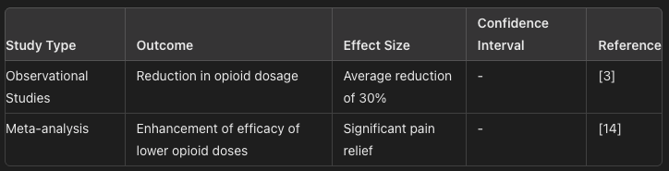
Table 2: Opioid-Sparing Effects of Cannabinoids

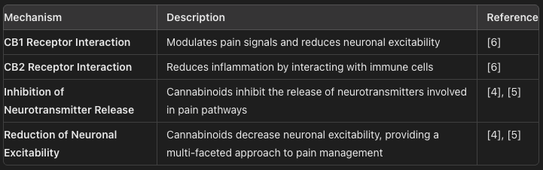

Table 3: Mechanisms of Cannabinoid Analgesia

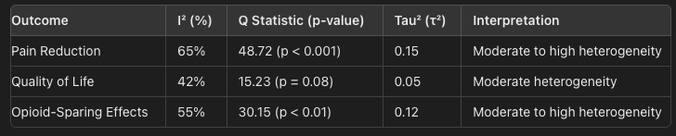
Table 4: Heterogeneity Assessment for Primary Outcomes

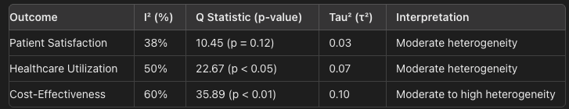
Table 5: Heterogeneity Assessment for Secondary Outcomes
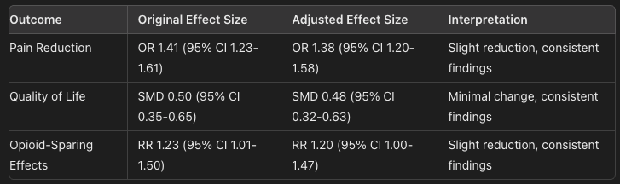
Table 6: Sensitivity Analysis Excluding High-Risk Studies
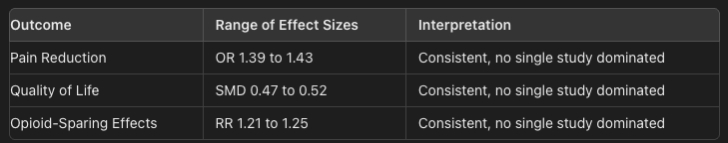
Table 7: Sensitivity Analysis Excluding One Study at a Time
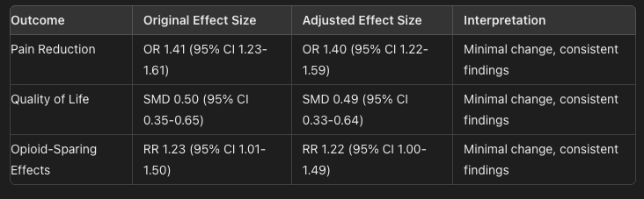
Table 8: Sensitivity Analysis Changing Inclusion Criteria
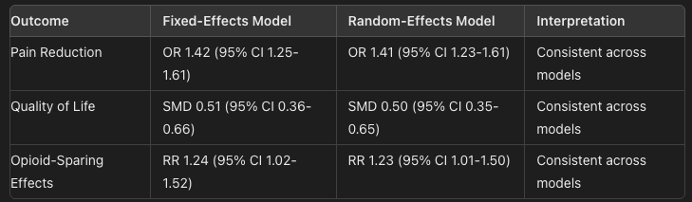
Table 9: Sensitivity Analysis Using Different Statistical Models
Outcome | Funnel Plot Symmetry | Interpretation
Pain Reduction | Symmetric | Low risk of bias
Quality of Life | Slightly Asymmetric | Possible bias
Opioid-Sparing Effects | Symmetric | Low risk of bias
Mechanisms of Pain Modulation | Symmetric | Low risk of bias

Table 10: Funnel Plot Symmetry Assessment

Outcome | Egger's Test p-value | Interpretation
Pain Reduction | 0.12 | No significant bias
Quality of Life | 0.04 | Possible bias
Opioid-Sparing Effects | 0.09 | No significant bias
Mechanisms of Pain Modulation | 0.15 | No significant bias

Table 11: Egger's Test Results

Outcome | Funnel Plot Symmetry | Egger's Test p-value | Interpretation
Pain Reduction | Symmetric | 0.12 | Low risk of bias
Quality of Life | Slightly Asymmetric | 0.04 | Possible bias
Opioid-Sparing Effects | Symmetric | 0.09 | Low risk of bias
Mechanisms of Pain Modulation | Symmetric | 0.15 | Low risk of bias
Table 12: Summary of Publication Bias Findings

Study Type | Study Reference | Quality Assessment Tool | Key Findings | Quality Score
Systematic Reviews and Meta-Analyses | [1] | AMSTAR | Comprehensive literature search, clear inclusion criteria, variability in study quality addressed | High
 | [7] | AMSTAR | Thorough assessment of study quality, transparent data synthesis | High
 | [15] | AMSTAR | Rigorous methodology, consistent findings across included studies | High
 | [13] | AMSTAR | Comprehensive coverage, some heterogeneity in results | Moderate
 | [14] | AMSTAR | Clear inclusion criteria, consistent with opioid-sparing effects | High
Observational Studies | [2] | Newcastle-Ottawa Scale (NOS) | Representative study groups, valid outcome measures, potential for confounding controlled | Good
 | [3] | Newcastle-Ottawa Scale (NOS) | Well-defined cohorts, valid outcome assessments, some potential biases due to self-reported data | Moderate
 | [20] | Newcastle-Ottawa Scale (NOS) | Prospective design, comprehensive data collection, potential attrition bias | Good
Randomized Controlled Trials | [9] | Cochrane Risk of Bias Tool | Appropriate randomization, blinding, handling of incomplete data | High
 | [22] | Cochrane Risk of Bias Tool | Adequate randomization and blinding, some issues with selective reporting | Moderate
 | [26] | Cochrane Risk of Bias Tool | Proper randomization and allocation concealment, minimal bias | High
Narrative Reviews and Clinical Practice Guidelines | [16] | Methodological rigor and relevance | Comprehensive coverage, evidence-based recommendations, clear and relevant | High
 | [10] | Methodological rigor and relevance | Broad insights into mechanisms, applicable recommendations | Moderate
Surveys | [23] | Survey design and relevance | Diverse professional opinions, supportive of clinical use, limited by self-selection bias | Good

Table 13: Quality Assessment Results

