Supplementary Materials

SciTrek: Improving middle school student understanding of how science works
- Best Bread Student handbook
- Best Bread Volunteer handbook
- Best Bread Teacher handbook
- Daily schedule for the Conservation of Mass Module
- Conservation of Mass Student handbook
- Conservation of Mass Volunteer handbook
- Conservation of Mass Teacher handbook
- Assessment and rubric
- McNemar statistical test

Supplemental File #1
Best Bread Student handbook



Student Handbook
Best Bread

Class Question:

Student

UCSB Team Leader

Teacher Period

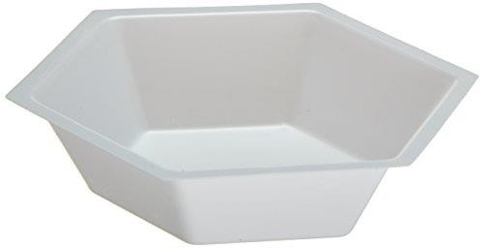
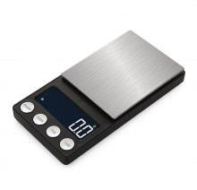
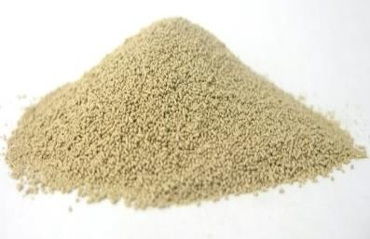
Materials Page
Yeast Weigh Boat Scale

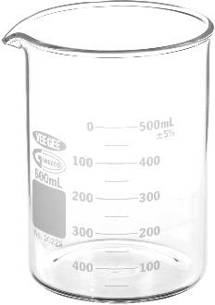
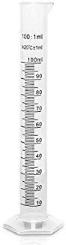
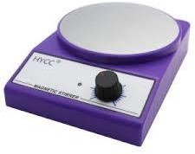

Beaker Graduated Cylinder Stir Plate

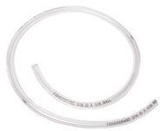
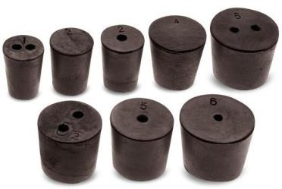
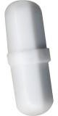
Rubber Tubing Rubber Stoppers Stir Pill
Day 1
Activating Yeast:
What is Yeast and What Does it do?

Instructions: Weigh out 3 grams of yeast into two separate flasks. Add 1 gram of sugar to one of the flasks (label this one "flask 1" and the one without sugar "flask 2"), and then add 50 mL of warm (37 ˚C) water to each of the beakers. Swirl the beakers and then let them sit for 10 minutes. Record your observations below.
Flask 1

CO₂ Indicator:
Flask 2
Instructions: Read the "Bubbling Blue" demo sheet. Record your observations below.
Name of indicator dye:

Observations:

Assemble the Device!
Instructions: With your advisor, assemble the experimental set up that you will be using this week. Sketch it in the space below. Color in red where the CO₂ will build up and color in blue where water will be pushed out to be measure.
Figure 1. Water displacement apparatus to measure CO2 output of yeast.

Day 2 Control Exp. and Maximize CO₂

Control Run:
Instructions: Follow the directions on the "Lab 1 – Yeast Control" sheet. Record your data
and observations below.
Tip: Secure the system as much as possible to reduce gas leakage. To do this, push down on the stoppers during the experiment.
Tip: Make sure that the stir bar is functioning correctly by placing it on the center of the stir plate. If a vortex is not observed, it is likely that the spinner is off-center and should be restarted. Increase speed slowly for best results.
Tip: Remember to stir the yeast in warm water before adding your sugar.

Temperature of water bath | Amount of yeast | Amount of sugar | Stir speed | Amount of water collected
Observations:

How do you calculate an average? Class average:
Discussion Question: Was your result an outlier? How can you tell?

Maximize:
Instructions: Using your knowledge from your literature search, try to maximize the amount of CO₂ produced by the yeast. Be sure to record any changes you make to the procedure. Record your results below, then answer the questions below.

Temperature of water bath | Amount of yeast | Amount of sugar | Stir Speed | Amount of water collected
- Were you successful with your first trial? How do you know?

- Which variable is responsible for your success? How do you know?

- As a group, which variables would you like to explore further?

Day 3 & 4
Prove It:

What variables affect CO₂ Production?
Instructions: Work with your advisor to design an experiment to determine how your chosen variable affects the amount of CO₂ that your yeast can produce. Create a data table for your experiment below.
Variable:
Data Table
Temperature of water bath | Amount of yeast | Amount of sugar | Stir speed |  | Amount of water collected
Trials Average (mL):

1. What effect did the change of your variable have on the CO₂ production of the yeast?

Use the space below to conduct additional trials exploring your variable. Goal: Figure out what value of your variable causes the yeast to produce the most CO2 so that you can get pizza! Your observations should include possible sources of error or analysis of your results. Values for variables should be used twice to show reproducibility and to practice calculating averages.
Data Table
Temperature of water bath | Amount of yeast | Amount of sugar | Stir speed |  | Amount of water collected
Observations:
Observations

 | Trial 1 | Trial 2 | Trial 3 | Trial 4 | Trial 5  (Optional)
Variable Tested, amount
,
Water Collected (mL)
Final Graph with CO2 vs changing variable data.

Share your results with the rest of the class and determine the optimal value for each variable.

Constant Experimental Values
Amount of Yeast: 3 grams Volume of water: 100 mL Length of Time: 10 minutes

Optimal Experimental Values

Temperature:
Stir Speed:
Sugar Type:
Acidity:
Amount of Sugar: _

Day 5 & 6 Optimization, Write Up, and Poster!

Optimization:
Based on your class results, describe what conditions would produce the most CO₂ with yeast:

Make a table below with all your experimental values and take note of how much water you collect. Once each group has finished their experiment, your teacher will help you find the class average.

Optimized experiment class average: mL
Discussion Question: Was your group's experimental value consistent with the class average? If not, what could have caused this error? Explain below.

Poster Presentation Template:
Variable Tested +
Prediction
Title+ Names
Image of Experiment
Now that your group has completed the experiment, share your results with the rest of the classroom. Below is a template that will help you remember all the important parts of sharing scientific findings with others. This presentation will be based on the individual variable that you and your group tested. Not the optimized experiment!
Graph and Data
Conclusion

Literature Review
Off-Day 1
Objective: What is the goal of the research you will be doing today?

Prior Knowledge: What do you currently know about the subject matter?

Article 1:
Notes

Big Idea

Website

Article 2:
Notes

Big Idea

Website

Review:

- What are some similar words used between the three articles you read?

- What are some different words used between the three articles that you read?

- Did you complete your research objective? How so?

Variable | Measurement
Temperature
Stir Speed
Amount of Sugar
Type of Sugar
Acidity

Practicing Procedures
Off Day 2
Today, you will be practicing writing a procedure based on a video you will watch. Make sure that you make your directions as clear and specific as possible because you will be challenging a fellow classmate to follow your instructions. Write your procedure below, and don't forget to give it a title.

Procedure title:
- l
l
- l
l
- l
l
- l
l
- l
l
- l
l
- l
l
- l
l
- l
l
- l
l
Now that you have finished your procedure, you will be instructed to partner up with another
student so that you can attempt each other's procedures, one at a time. Take notes on your partner's attempt at your procedure so that you can consider ways to improve it. If your partner is unsuccessful, take a few minutes to revise your procedure and have them retry before continuing on to the next procedure.

Below is a student's attempt at writing a procedure for the experiment that was done yesterday. However, this procedure has flaws. Help point out ways the student could improve it.

Procedure title: Measuring how much CO2 is produced by yeast
- Gather all of your materials and place them on your working space.
- Grab the corks and tubing and place them on your glassware.
- Add 50 mL of water to one flask and 500 mL of water to the other, then add some of this and that.
- Place a magnetic stir bar in the flask and put it on the stirrer, set to speed 1.
- Put the stopper with the tubing onto the flask to seal it, but make sure that the tubing leads to the graduated cylinder.
- Periodically check the water bath temperature and add hot water if necessary to keep the temperature stable.
- Run the experiment for 3 minutes in total.
- Record the volume of water that was displaced by the CO2 that was produced. What is wrong with this procedure, and how can you improve it?

Now attempt to improve this procedure. Use your memory of the experiment and the diagram of the setup you drew to help.

- .
- .
- .
- .
- .
- .
- .
- .
- .

Off-Day 3 Practicing Graphing!
Below, we have some data we have collected for you to practice your graphing. You can choose to make a bar graph or a line graph for each. Use SULTAN (Scale, Units, Label, Title, Axes, Neatness) to make descriptive graphs. Boxes have been made for the title and labels. Choose your own scale.
 |  | Vegetables in the Garden
Carrots | Peas |  | Broccoli | Zucchini | Beans
8 | 4 |  | 6 | 2 | 7

 |  | Number of New Followers
Mon. | Tues. |  | Wed. | Thurs. | Fri. | Sat.
800 | 850 |  | 880 | 1000 | 50 | 150

Q1: Which type of graph did you choose to make with this data and why?

Q2: What conclusions can you make from the data?
Q1: Which type of graph did you choose to make with this data and why?

Q2: What conclusions can you make from the data?

Awesome! Now that you've had some more practice with graphing, try to make a beautiful graph with the data you've collected over the last few days. Remember to use the average value for trials you repeated.

Glossary:
Yeast: a microscopic fungus consisting of single oval cells that reproduce by budding and can convert sugar into alcohol and carbon dioxide.

Bromothymol Blue: An indicator of carbon dioxide. It will turn from blue to yellow in the presence of carbon dioxide.

Control Experiment: An experiment that is run with no changes being made to any variables. This gives us a reference to when we change a variable and compare the data to see if changing a variable had a positive or negative response.

Variable: Any part of the experiment that can be changed. For any scientific experiment, it is important to change only one variable during each experiment. If you were to make two changes, and something happened in the experiment that goes wrong, you would not be able to tell which variable was responsible for the failure.

Independent Variable: The variable that is purposely changed by the scientists in an experiment.

Dependent Variable: The variable that changes in response to changes made in the independent variable.

Constants: The other parts of the experiment that remain the same after a change is made to one variable.

Outliers: A piece of data that is not close to any other variables found during other trials of the same experiment.

Supplemental File #2
Best Bread Volunteer handbook

Volunteer Handbook

Best Bread

Class Question:

How do can you maximize CO2 production by yeast?

Student Name:

SciTrek Lead:

Teacher: Period:

Materials Page
Yeast Weigh Boat Scale

Beaker Graduated Cylinder Stir Plate

Rubber Tubing Rubber Stoppers Stir Pill

Overview & Background Information:
This module is designed to give students experience in designing experiments. In particular, the students should 1) recognize the function of a control experiment, 2) identify the merits of only focusing on one variable at a time, and 3) understand the importance of running several trials within the experiment.
The context of this module is optimizing yeast activation and growth using a given protocol of collecting CO2 produced. Students will work in research groups of 6-7 students, and you will be their advisor. As their advisor, you will lead, teach, assess verbally, facilitate, and help the students complete and present their experiments.
As their advisor, you should know as much about yeast and baking bread as possible. Yeast are a type of single-celled eukaryotic organism that are members of the fungi kingdom. Eukaryotes are distinct from prokaryotes (e.g., bacteria) in that eukaryotes have organelles (membrane-bound compartments within cells, e.g., nucleus, mitochondria, etc.) and linear DNA. Prokaryotes have circular DNA and are typically about ten times smaller than eukaryotes. Eukaryotic cells are 10-100 microns in diameter; a human hair is about 100 microns (10-6 meters) wide. All cells (prokaryotic and eukaryotic) have cell membranes and use DNA to replicate.
All cells need to harness energy to grow and replicate. The chemical reactions that take place to sustain a cell are broadly termed metabolism, or, synonymously, respiration. Proteins called enzymes help carry out (catalyze) the metabolic reactions inside cells.

Aerobic Respiration (requires oxygen, O2):

- Reactants = sugar (generally speaking, an energy-rich, carbon-containing compound; specifically, glucose) and oxygen
- Products = carbon dioxide (CO₂), water, chemical energy in the form of ATP (adenosine triphosphate)
- Overall reaction = C₆H₁₂O₆ + 6 O₂ 6 CO₂ + 6 H₂O + energy
- The rate of respiration is proportional to the amount of available food (sugar), the amount of yeast cells, the temperature, and the rate at which reactants meet each other (i.e., the stirring rate).

Bread Baking Basics:
- "Activate" the yeast. For the yeast to become active, they need to be warmed up and given a food source. This is achieved by putting the yeast in warm water with some sugar. You know it is activated once it starts bubbling.
- Mix in flour and salt (and seasonings if you are fancy); stir.
- Knead the dough.
- Let the dough rise (i.e., let the yeast produce the desired amount of CO₂). This is achieved by putting the dough in a container and letting it sit in a warm (just above room temperature) place.
- After allowing the dough to rise to the desired amount, put it in a suitable pan, and bake it in the oven. The yeast will continue to respire for the first few minutes, making the bread rise even more. Pretty soon, however, it will become too hot, and the yeast will die.
- Continue baking so that the starches are broken down into simple sugars, and the proteins are broken down into amino acids.
- Remove the bread before it burns; eat when cooled.

To learn more than you would ever want to know about baking bread, visit: www.seriouseats.com/2014/10/breadmaking-101-the-science-of-baking-bread-and-how-to-do- it-righ.html

Working with Your Small Group:
There will usually be one to two students who are content with not participating in these discussions in each group. Make sure that when you work with your group, you are engaging each student.
One good way to do this is to assign responsibilities. Have one person do the reading of the
instructions, one-person monitor the temperature, one-person measure the yeast, etc. This is a
good way to make sure that everyone is staying engaged.

It is also imperative that before the students go back to their seats at the end of every day, they are asked to help clean up. As a volunteer, it is your job to help guide these kids throughout every part of the experiment. That includes the clean-up!
Day 1 What is Yeast and What Does it do?

Introduction:
First, the SciTrek program will be introduced. The Lead will introduce themselves, then the volunteers will follow. State your name, what year you are in school, and what you are studying. The lead will then give an introduction to yeast. They will discuss the differences between yeast (eukaryote) and bacteria (prokaryote). The question of whether yeast is more like us or bacteria (answer, more like us). Yeast have a nucleus (like our cells). "What is the yeast used for?" Bread, Beer, etc. Then we will relate yeast to us through cellular respiration. "So, when we breathe in oxygen, what do we breathe out?" Carbon Dioxide. "The oxygen is used to "burn" or "get the energy out of food," and the product is carbon dioxide (and water)." "So, like us, yeast produce carbon dioxide."

Observe Activated and Inactivated Yeast:
The students in each small group will then weigh out two yeast samples for the entire group: one beaker with sugar and one without. The one with sugar will be properly "activated" and should produce bubbles after a few minutes, while the beaker without a food source should remain essentially unchanged. The students should weigh out 3 grams of yeast twice. Make sure they do not get caught up in trying to get precisely three grams of yeast. Measurements do not have to be accurate for this section. Then have them weigh out 1 gram of sugar and add it to the beaker labeled "activated."
Label this beaker "Beaker 1" and the one without sugar "Beaker 2." Then have them measure out 50 mL of warm water and add it to the two beakers. The warm water will be in the back of the classroom on a heater. You should pour the water and have the students tell you when to stop. We do not want them to burn themselves. Allow the beakers to sit for 10 minutes or so while you proceed with the next demo.
After the yeast has been activated, have the students make observations about the two beakers. One should have foam on top of the yeast. Compare this foam to the foam on top of their soda. When they go to the soda machine at a restaurant, sometimes you get a bunch of bubbles on top of your soda, and you have to wait for them to go down before you can put more in. What are those bubbles? Carbon Dioxide. Just like on their soda, these bubbles are made of carbon dioxide.

Activating Yeast:
Instructions: Weigh out 3 grams of yeast into two separate flasks. Add 1 gram of sugar to one of the flasks (label this one "flask 1" and the one without sugar "flask 2"), and then add 50 mL of warm (37 ˚C) water to each of the beakers. Swirl the beakers and then let them sit for 10 minutes. Record your observations below.

The solution itself was brown and did not show any bubbles being produced. No CO2 was observed!
The solution itself was brown and bubbles began to form after a short while. CO2 was observed!
Flask 1

Indicator for CO₂ – Class Activity Bubbling Blue CO₂ Indicator:
Flask 2
This is a fun way to show that, indeed, CO2 is being produced by the yeast. The indicator being used here is 'Bromothymol Blue,' which is pH sensitive. Weakly acidic and basic solutions are blue, whereas more strongly acidic solutions (pH < 3) are yellow. Bromothymol Blue is a mild skin irritant and slightly harmful if digested. The students will not be handling the indicator; however, they must know about the different materials they are seeing. Before starting this demo, tell your students what an indicator is. They probably will not understand that an indicator changes color with the pH of a solution. Instead, tell them that the indicator changes color when in contact with CO2. Remind them of the discussion that we had earlier about what we breathed in and out. To ensure this demo is as safe as possible, the volunteers will be the only ones performing it. We don't want any students to accidentally ingest the indicator. The volunteers will use a straw to bubble CO2 (their breath) into the water with the Bromothymol Blue. The indicator will change colors. To make this more interesting for the students, have them count how long it takes their lead to change the color of the water.

This demo gets the students thinking about how yeast is similar to us; students are able to see that we, like yeast, produce carbon dioxide. This is also a demo to get the students excited. One big emphasis of SciTrek is to get the students excited about science. Sometimes that happens through a simple demonstration.

CO₂ Indicator:
Instructions: Read the "Bubbling Blue" demo sheet. Record your observations below.
Name of indicator dye: Bromothymol Blue

Observations: As the SciTrek volunteers blew into the small bottles containing the indicator, the color of the solution slowly turned from blue to yellow!
Assemble & Discuss the Experimental Apparatus:
The students will then get back in their small groups and work through assembling the experiment. First, have them all look at the laminated image that was in their group box. Call out individual students and see if they can name each piece of equipment as you put it together. Don't forget to explain how it works. This is important because the students will be working with this basic setup for the rest of the module and need to assemble it independently. Don't tell them how to set it up, have them work through trial and error. If they have one wrong piece, tell them that they are close and what part is incorrect, but don't tell them why. Allow them to work through it on their own.
They are much more likely to know how to set it up for the rest of the module by doing this. Also, make sure the students are referring to everything using the proper scientific terms. One part of the scientific process is using science vocabulary. By the time you finish setting up and explaining how it works, students will probably have started their sketches of the apparatus. Don't be afraid to point to parts of students' sketches and ask what that part is called. If they forgot already, give them a friendly reminder. This is a great chance to teach and reinforce scientific vocabulary. As they wrap up their sketches, ask the students where the indicator should be placed to test whether CO₂ is being produced.

Assemble the Device:
Instructions: With your advisor, assemble the experimental set up that you will be using this week. Sketch it in the space below. Color in red where the CO₂ will build up, and color in blue where water will be pushed out to be measured.

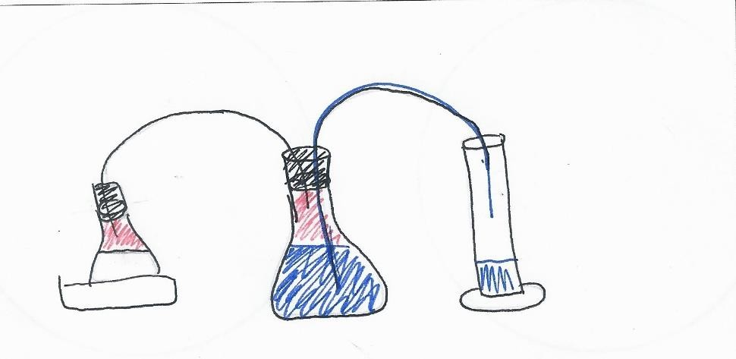
Figure 1. Water displacement apparatus to measure CO2 output of yeast.

Day 2 Control Exp. and Maximize CO₂

Introduction:
Using the information that they gathered the previous day, students will design their own experiments. When they first get into their class, the Lead will discuss what they learned last time we were in the classroom, and what they learned when researching yeast. They will discuss what variables make the yeast produce more carbon dioxide, and what we will be kept constant.

Some of the variables that can be tested are:
- Sugar Amount
- Sugar Type
- Stir Speed
- Water bath temperature
- Salinity
- Acidity/Alkalinity
The following must be left unchanged:
- Time of reaction
- Amount of liquid in the reaction
- Amount of yeast

Control Run:
Help your research group to assemble and run the control experiment. Follow the protocol carefully. Have the students fill out the data table in their handbook to record control run conditions. Ask the students why doing a control experiment is important. They should know that you will not have anything to compare your experiment results to if you do not have a control group. For example, if you do an experiment without doing a control experiment and get 34 mL of carbon dioxide production, you may think you got a positive result, but you cannot be sure. You then do a control experiment and find that you have 50 mL of carbon dioxide production. What you thought was a positive result is now a negative result. Make sure the students understand this. Also, make sure the students are taking notes of their observations of the control experiment.
One part of running this experiment that becomes complicated in the classroom is the water bath's temperature. We want a constant temperature throughout the experiment. It is usually the Lead's responsibility to walk around with a beaker of hot water and give each group a little more hot water if their temperature drops. Maintaining a constant temperature becomes difficult when the Lead needs to run a group as well. In this case, the volunteers should make sure they have a beaker of hot water at their tables. These beakers should be extremely hot, so you will not have to add much to the water bath to increase the temperature. Because of the hot temperatures, the students should not pour the hot water. The volunteer or lead should always be using heat-resistant gloves to protect their hands.

After all groups have finished their control experiments, the Lead/teacher will write each group's data on the board and determine the class average. Students will write this average into their notebooks and compare it to their results. This is an excellent opportunity to discuss the possibility of outliers and how they can affect your data. Suppose the students know that they made a mistake during their procedure (like letting the temperature drop or not having the stir bar spinning etc.). In that case, their data should be removed from the average. Mention to these groups that another way of testing if their data was outlier is by reproducing the experiment; however, this will not be done during this module because of time constraints.
Instructions:
Follow the directions on the "Lab 1 – Yeast Control" sheet. Record your data and observations below.
Tip: Secure the system as much as possible to reduce gas leakage. To do this, push down on the stoppers during the experiment.
Tip: Make sure that the stir bar is functioning correctly by placing it in the center of the stir plate. If a vortex is not observed, it is likely that the spinner is off-center and should be restarted. Increase speed slowly for best results.
Tip: Remember to stir the yeast in warm water before adding your sugar.

Temperature of water bath | Amount of yeast | Amount of sugar | Stir Speed | Amount of water collected
37 0C | 3g | 1g | 1 | Will Vary

Observations: The students should observe that as the CO2 that is being produced by the yeast in the first Erlenmeyer flask is pushing out the water in the second Erlenmeyer flask into the graduated cylinder.
How do you calculate an average? The average can be calculated by adding together all the values and dividing them by the total number of values recorded
Class average: Will vary between classes
Discussion Question: Was your result an outlier? How can you tell? If the students do not see any data points that are significantly different from the other data points, explain to them that the data point is considered an outlier. Meaning that it will not be considered when looking at the overall results of the experiment. Outliers are usually caused by a mistake in the procedure or running the experiment!

Maximize:
Challenge your group to maximize the amount of CO₂ produced. Have them brainstorm all the variables that they can explore. Let them try a run, changing as many variables as they want. It will make you cringe, but we need them to test multiple variables simultaneously to make our point when trying to unravel their results.
Be sure to save time at the end to talk to your whole group. Discuss each of their results. Facilitate a discussion around how to best interpret the results, leading them to understand that testing only one variable at a time is the best way to optimize the system. When the students test more than one variable at a time, question them as to what caused the increase or decrease in carbon dioxide production. Suppose they cannot name a particular reason. In that case, this is a good indication they should try to focus on one variable instead of many. If they can name the one thing that they believe caused the increase in carbon dioxide production, have them test that out by itself and see if they are right.
You can record their results on a whiteboard or piece of paper to help them visualize their results. Review with your group the concepts learned from the multiple variable experiment. As a group, decide on a variable they think worth pursuing to optimize CO₂ production. The amount of yeast must remain constant, i.e., the same amount as the control.
Instructions: Using your knowledge from your literature search, try to maximize the amount of CO₂ produced by the yeast. Be sure to record any changes you make to the procedure. Record your results below, then answer the questions below.

The students are only allowed to choose a range of these select values!

Temperature of water bath | Amount of yeast | Amount of sugar | Stir Speed | Amount of water collected
37 ºC – 60 ºC | 3 grams | 1 - 7 grams | 1 - 5 | Will Vary
  - Were you successful with your first trial? How do you know?
A good indication that the trial was successful was that the students should see water going from the middle beaker to the graduated cylinder!

  - Which variable is responsible for your success? How do you know?
The students should not know which variable is responsible for the success of the trial. That is why we emphasize that it is essential students learn to test for only one variable in each experiment!

  - Which variables would your group like to explore further?
There is a list of variables on day 3 and 4 that the students would be able to test! Maybe show the students this list so you will be ready come day 3 and 4!

Day 3 & 4

Prove It:
What variables affect CO₂ Production?

Instructions: Work with your advisor to design an experiment to determine how your chosen variable affects the amount of CO₂ that your yeast can produce. Create a data table for your experiment below. The students must only select one variable throughout this entire process!
Each experiment must leave the amount of yeast, the total solution volume, and the reaction time constant. Still, all other variables are free to be changed as much or as little as possible. As an advisor, help the students organize their data tables. They can be fashioned after the ones used for Day 2, but make sure that they record the new quantity for the variable that they are testing. However, they will usually only have time for two experiments per day. We would also like them to repeat their trials to check for consistency. On this day, have each group run the same experiment twice. Students will probably be anxious to try a new value for their variable, so remind them how important repeatability is in science. If students get quite different results for the same experimental conditions, talk to them about possible sources of error.
Each group should start day 4 by doing at least one more trial. If a group has gotten consistent results, they can test a different value of the same variable. While the students are conducting their experiments, regularly review equipment vocabulary, assess verbally whether they understand the process occurring, and why they are collecting data on water volume and not gas. They should also be comfortable enough to assemble and run the experiments on their own the next day. Do not let students start another trial if you do not think they will finish in time. When students are finished, have them start cleaning up.

Variable List:
The following is a list of potential variables that the students can explore:
  - Sugar amount
  - Sugar type
  - Stir speed
  - Water bath temperature
  - Salinity
  - Acidity/Alkalinity
Variable:
Data Table:
Temperature of water bath | Amount of yeast | Amount of sugar | Stir speed |  | Amount of water collected

Trials Average (mL): Will vary from class to class

1. What effect did changing your variable have on the CO₂ production of the yeast?
A good learning point for the students is to understand whether their change in the variable positively affected the CO2 production. It is important to ask them what they think about this particular question. Hopefully, the students should conclude that they need to compare their experimental data with their control data.

Use the space below to conduct additional trials exploring your variable. Your observations should include possible sources of error or analysis of your results. Values for variables should be used twice to show reproducibility and to practice calculating averages.

Data Table:
Temperature of water bath | Amount of yeast | Amount of sugar | Stir speed |  | Amount of water collected
Observations:
Observations

The students must keep track of their data as the experiment goes along. Ensure that all the students have their data from the first trial before they move on to the second trial.
On the next page, students will be asked to summarize their data. This will allow them to visibly see all their data. They will be making a bar graph based on all the trials they were able to complete during the previous days. Ensure that the students are labeling their axes, giving their graph a title, and neatly inputting their data!
The graph should contain the x-axis being the variable and the y axis being the CO2 production.

 | Trial 1 | Trial 2 | Trial 3 | Trial 4 | Trial 5  (Optional)
Variable Tested, amount
,
Water Collected (mL)
Final Graph With CO2 vs Changing Variable Data.

CO₂ Produced
80
70
mL of water
60
50
40
30
20
10
0
1 2 3 4 5
Stir Speed

Share your results with the rest of the class and determine the optimal values for each variable.

Constant Experimental Values:
Amount of Yeast: 3 grams Volume of water: 100 mL Length of Time: 10 minutes

Optimal Experimental Values:

Temperature:
mL of Water
Stir Speed:
Sugar Type:
Acidity:
Amount of Sugar: _

Day 5 & 6 Optimization, Write Up, and Poster! .

Optimization:
Based on your class results, describe what conditions would produce the most CO₂ with yeast:

In this area, the students will state the optimized version of each variable tested throughout the past two weeks. If a couple of variables were not tested, use the control values for those variables.

Make a table below with all your experimental values and take note of how much water you collect. Once each group has finished their experiment, your teacher will help you find the class average.

Optimized experiment class average: mL
Discussion Question: Was your group's experimental value consistent with the class average? If not, what could have caused this error? Explain below.

Poster Presentation Template:
Finish Data Collection; Begin Poster

Start by having each group share with the class what the optimal value of their variable was. If the group did not find an optimal value (e.g. results are totally inconsistent) help them make an educated guess. Suppose that a group finds that more of a certain variable increases the output of CO2, and they don’t find an upper limit (a point where adding more of the variable actually decreases CO2 production). They do not have to pick the value with their best results. They could pick a higher value. Caution them to not go very much beyond their highest value, since they can’t be sure that the trend will hold. Write down the class’s combination of optimized conditions on a white board or piece of paper. Students should also write these optimized conditions in their notebook as well. Have each group run an experiment with all optimized variables. Because each group is doing the same experiment, we can teach them about uncertainty and error when doing science. Small variability in results is a normal part of science! If results of the same experiment are very different from each other, then it is likely that one of them is not correct.

After analyzing your group’s results, help them get started on their posters. Each student will work on a particular part of the poster, and they will eventually share their poster as a whole with the rest of the class. Help the students decide who does each part, and make sure that each student knows what to do for his/her part.
Variable Tested + Prediction
Title+ Names
Image of Experiment
Now that your group has completed the experiment, share your results with the rest of the classroom. Below is a template that will help you remember all the important parts of sharing scientific findings with others. This presentation will be based on the individual variable that you and your group tested. Not the optimized experiment!
Graph and Data
Conclusion

On the last day, the students should break up into their groups and finish their poster presentations. It is your job today as a volunteer to help the students decide which members of the group will present each part of their poster. It is important for the students to each do a part of the presentation. It may be helpful to give two students the section of the poster that has the most context.

Glossary:
Yeast: a microscopic fungus consisting of single oval cells that reproduce by budding and convert sugar into alcohol and carbon dioxide.

Bromothymol Blue: An indicator of carbon dioxide. It will turn from blue to yellow in the presence of carbon dioxide.

Control Experiment: An experiment that is run with no changes being made to any variables. This gives us a reference to when we change a variable and compare the data to see if changing a variable had a positive or negative response.

Variable: Any part of the experiment that can be changed. For any scientific experiment, it is important to change only one variable during each experiment. If you were to make two changes, and something happened in the experiment that goes wrong, you would not be able to tell which variable was responsible for the failure.

Independent Variable: The variable that is purposely changed by the scientists in an experiment.

Dependent Variable: The variable that changes in response to changes made in the independent variable.

Constants: The other parts of the experiment that remain the same after a change is made to one variable.

Outliers: A piece of data that is not close to any other variables found during other trials of the same experiment.

Supplemental File #3:
Best Bread Teacher handbook

Teacher/Lead Handbook
Best Bread

Big Question:

How do can you maximize CO2 production by yeast?

Student Name:

SciTrek Lead:

Teacher: Period:

NGSS Standards
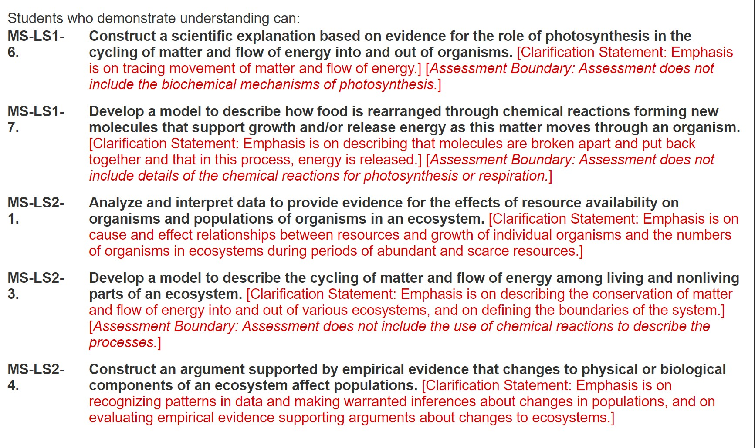

Materials Page

Yeast Weigh Boat Scale

Beaker Graduated
Cylinder
Stir Plate

Rubber Tubing
Rubber Stoppers
Stir Pill

Overview & Background Information:
This module is designed to give students experience in designing experiments. In particular, the students should 1) recognize the function of a control experiment, 2) recognize the merits of only focusing on one variable at a time, and 3) understand the importance of running several trials within the experiment.
The context of this module is optimizing yeast activation and growth using a given protocol of collecting CO2 produced. Students will work in research groups of 6-7 students, and you will be their Lead. As their Lead, you will lead, teach, assess verbally, facilitate, and help the students complete and present their experiments.
As their Lead, you should know as much about yeast and baking bread as possible. Yeast is a type of single-celled eukaryotic organism that are members of the fungi kingdom. Eukaryotes are distinct from prokaryotes (e.g., bacteria) in that eukaryotes have organelles (membrane-bound compartments within cells, e.g., nucleus, mitochondria, etc.) and linear DNA. Prokaryotes have circular DNA and are typically about ten times smaller than eukaryotes. Eukaryotic cells are 10-100 microns in diameter; a human hair is about 100 microns (10-6 meters) wide. All cells (prokaryotic and eukaryotic) have cell membranes and use DNA to replicate.
All cells need to harness energy to grow and replicate. The chemical reactions that take place to sustain a cell are broadly termed metabolism. Still, this lab focuses on a specific subset of metabolism referred to as respiration. Proteins called enzymes help carry out (catalyze) the metabolic reactions inside cells.

Aerobic Respiration (requires oxygen, O2):
- Reactants = sugar (generally speaking, an energy-rich, carbon-containing compound; specifically, glucose) and oxygen
- Products = carbon dioxide (CO2), water, chemical energy in the form of ATP (adenosine triphosphate)
- Overall reaction = C6H12O6 + 6 O2 6 CO2 + 6 H2O + energy
- The rate of respiration is proportional to the amount of available food (sugar), the amount of yeast cells, the temperature, and the rate at which reactants meet each other (i.e., the stirring rate).

Bread Baking Basics:
- "Activate" the yeast. For the yeast to become active, they need to be warmed up and given a food source. This is achieved by putting the yeast in warm water with some sugar. You know it's activated once it starts bubbling.
- Mix in flour and salt (and seasonings if you're fancy); stir.
- Knead the dough.
- Let the dough rise (i.e., let the yeast produce the desired amount of CO2). This is achieved by putting the dough in a container and letting it sit in a warm (just above room temperature) place.
- After allowing the dough to rise the desired amount, put it in a suitable pan, and bake it in the oven. The yeast will continue to respire for the first few minutes, making the bread rise even more. Pretty soon, however, it will become too hot, and the yeast will die.
- Continue baking so that the starches are broken down into simple sugars, and the proteins are broken down into amino acids.
- Remove the bread before it burns; eat when cooled.
To learn more than you would ever want to know about baking bread, visit: www.seriouseats.com/2014/10/breadmaking-101-the-science-of-baking-bread-and-how-to-do-it- righ.html

Working with Your Small Group:
There will usually be one to two students who are content with not participating in these discussions in each group. Make sure that when you work with your group, you are engaging each student. One good way to do this is to assign responsibilities. Have one person do the reading of the instructions, one-person monitor the temperature, one-person measure the yeast, etc. This is a good way to make sure that everyone is staying engaged.

It is also important that before the students go back to their seats, they help clean up the mess at the end of every day. As a volunteer, it is your job to help guide these kids throughout every part of the experiment. That includes the clean-up!!!!

Day 1 What is Yeast and What Does it do?

Introduction:
As the lead, you will introduce the program to the students:

"SciTrek aims to teach kids how to think more like scientists in everyday scenarios."
Afterward, you will introduce yourself and then proceed to ask the other volunteers to introduce themselves! Start with your name, major, and a fun fact about yourself.

You will now give an introduction as to what yeast is. A good way to start is to state that there are two types of living cells. "Prokaryotes vs. Eukaryotes." The following is a sample speech that you can use or add any twists you would like to it: "There are two types of living cells, eukaryotes and prokaryotes. There are a lot of things that define these types of cells. But for the next two weeks, we are going to consider prokaryotes to be like bacteria and eukaryotes to be more like the cells in our body."

Now it is time to introduce them to yeast and ask them about yeast and bacteria/humans. Here is another sample speech that you can use for this part: "Does anyone know what yeast is? (Most students will say that it is used in bread making) Great! So you already know that yeast is used to make bread rise. So can anyone guess if yeast cells are more like human cells? Or are they more like bacteria cells? (The students may be confused by this question, which is okay, so if no one can answer of guess, tell them that yeast is more related to us!)"

The students must understand this concept because we will be using this comparison to help students understand cellular respiration by making constant comparisons between us and bacteria!

Then we will relate yeast to us through cellular respiration.
"So, when we breathe in oxygen, what do we breathe out?" (Carbon Dioxide)

"And to breathe in oxygen, what do we need. What allows us to go running or to go
out and play sports?" (Food which gives us energy.)

"Right, so just like us, yeast need energy, which allows them to take in oxygen and breath out carbon dioxide. In the scientific community, we call this cellular respiration! It is a process that all plant and animal cells do. In fact, all of us in this classroom are doing it right now by breathing in oxygen and exhaling carbon dioxide!

At this point, the students will split into small groups, where they will start to explore yeast further.

Observe Activated and Inactivated Yeast:
As the Lead in this scenario, it is important that if you are not leading a group, you are circling each of the groups and checking in to ensure that all the groups are getting through the task set before them. It is important to note that they will be working with glass! Be sure to explicitly mention this before they get started! The students should be given 15 minutes to complete this task before they move onto the next demonstration!

Instructions: Weigh out 3 grams of yeast into two separate flasks. Add 1 gram of sugar to one of the flasks (label this one "flask 1" and the one without sugar "flask 2"), and then add 50 mL of warm (37 ˚C) water to each of the beakers. Swirl the beakers and then let them sit for 10 minutes. Record your observations below.

The solution itself was brown and did not show any bubbles being produced. No CO2 was observed!
Flask 1

Indicator for CO2 - Class Activity: Bubbling Blue CO2 Indicator:
The solution itself was brown and bubbles began to form after a short while. CO2 was observed!
Flask 2
This is a fun way to show that, indeed CO2 is being produced by the yeast. The indicator being used here is 'Bromothymol Blue, ' which is pH sensitive. Weakly acidic and basic solutions are blue, whereas more strongly acidic solutions (pH < 3) are yellow. Bromothymol Blue is a mild skin irritant and slightly harmful if digested. The students will not be handling the indicator; however, they must know about the different materials they are seeing. Before starting this demo, tell your students what an indicator is. They probably will not understand that an indicator changes color with the pH of a solution. Instead, tell them that the indicator changes color when it comes in contact with CO2. Remind them of the discussion that we had earlier about what we breathed in and out. In order to make sure this demo is as safe as possible, the volunteers will be performing it. We don't want any students to accidently ingest the indicator. The volunteers will use a straw to bubble CO2 (their breath) into water with the Bromothymol Blue. The indicator will change colors. To make it more interesting for the students, have them count how long it takes their lead to change the color of the water. Make it a race for the volunteers.

As stated before, this demo gets the students thinking about how yeast is similar to us. They can see that we, like yeast, breath out carbon dioxide. This is also a demo to get the students' excited. One big emphasis of SciTrek is to get the students excited about science. Sometimes that happens through a simple demo.

CO₂ Indicator:
Instructions: Read the "Bubbling Blue" demo sheet. Record your observations below.
Name of indicator dye: Bromothymol Blue

Observations: As the SciTrek volunteers blew into the small bottles containing the indicator, the solution's color slowly turned from blue to yellow!

Assemble & Discuss the Experimental Apparatus:
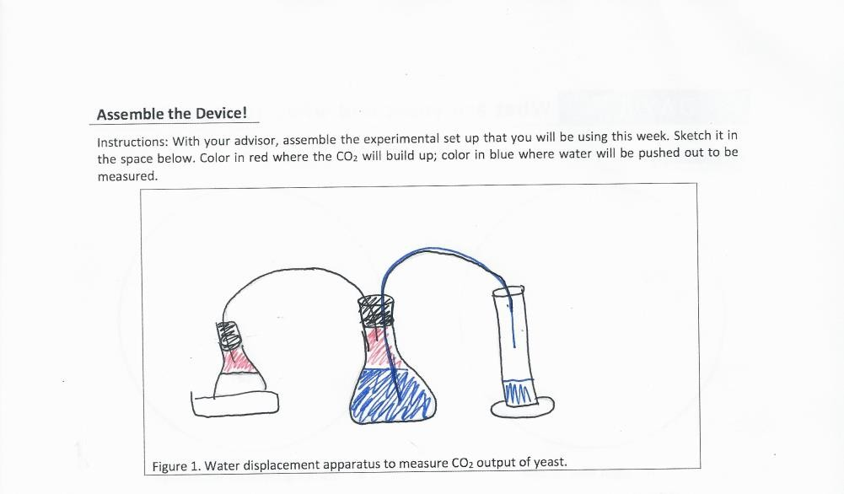
The volunteers will show them the picture of the experimental setup and challenge them to recreate the setup. Let them work together to try to figure out what their experiment will look like. If they can do it themselves this time, it will be easier for them to figure it out later. Call out individual students and see if they can name each piece of equipment as you put it together. Don't forget to explain how it works. This is important because the students will be working with this basic setup for the rest of the module and need to be able to assemble it on their own. By the time you finish setting up and explaining how it works, students will probably have started their sketches of the apparatus. Don't be afraid to point to parts of students' sketches and ask what that part is called. If they forgot already, give them a friendly reminder. This is a great chance to teach and reinforce scientific vocabulary

Day 2 Control Exp. and Maximize CO₂

Introduction:
Using the information that they gathered the previous day, students will design their experiments. The lead will first remind students what they did the last day that the volunteers were there. They will do a quick run-through of what yeast is, and how they are similar and different from us. It is always important to make sure that the students are reminded of what they did with SciTrek the previous day. These students have many classes each day they are in school, and it is beneficial to them to give them a quick refresher of what was done before.

"Hey everyone, welcome back. So, can anyone remind me of what we are going to be
studying for the next few days?" Yeast

"Right, and are yeast more like us, or more like bacteria." More like us
"Correct. And just like us yeast breathe in what?" Oxygen

"And we both breathe out…" Carbon dioxide
As the lead, after finishing the discussion, guide the students through a small review of what they did the previous day. It would vary from teacher to teacher if they had the students do the off-day articles between day 1 and day 2 of this module. If they have not done any literature research, please ensure that you cover all the possible variables the students can test today!

"Alright, so yesterday you did a literature search with your teacher, and you went through some different things that may affect how much carbon dioxide is released. What types of things did you come up with?"
Stir speed, temperature, amount of sugar, type of sugar (food), amount of yeast, time.
The lead will then go through each:

Stir speed: "So if I run around a lot, I'm going to be breathing heavier, right? Just like us,
stir speed affects how much carbon dioxide yeast releases."

Temperature: "What is your normal body temperature?" 98.6 degrees Fahrenheit. "Right, and when you get sick, you may get a temperature. That is your body trying to fight off any infection. So just like us, yeast have a temperature that allows them to function perfectly."
Amount of Sugar: "Just like us, yeast need food to survive. In this experiment, we are giving them that food in the form of sugar."

Type of food: "After you eat something really greasy and fatty, do you ever feel tired?
That can happen to yeast too. Yeast work best if they have a certain type of food."

Amount of yeast: "If you have a lot of yeast, there will be more carbon dioxide released, right?"
Time: "Eventually, the yeast will run out of food, but if you allow yeast to produce
carbon dioxide for the longest time possible, then you will have more carbon dioxide."

Control Run:

It is especially important that only you, THE LEAD, handle the hot water as the students need to re-heat their apparatus. Make it clear that only the lead should be near the hot plates at the beginning of class to both the volunteers and the students.
Divide the class into their groups and have the volunteers begin helping the students help start their control run. Make sure that the students and the volunteers have the directions they need to successfully run the control.
You must remind the volunteers to explain to the students the purpose of a control experiment. A control experiment is important, so you know how effective your experiment was. If you do not have anything to compare it to, how are you supposed to know if your experiment was successful?
If the lead oversees a group, ask the teacher to help monitor the hot plates, and help pour water into the beakers. Have the volunteers be the ones to refill the beakers for the hot water. You must remind the students that the water can sometimes be deceptively hot, and it is impossible to tell if a piece of glass is hot or not just by looking at it!!!
After all groups have finished their control experiments, the lead/teacher will write each group's data on the board and determine the class average. Students will write this average into their notebooks and compare it to their results. This is a good opportunity to discuss the possibility of outliers and their effect on your data. Suppose the students know that they made a mistake during their procedure (i.e., letting their temperature drop, not having the stir bar spinning for half the experiment, etc.). In that case, their data should be removed from the average. Mention to these groups that another way of testing is by reproducing the experiment if their data has an outlier. However, this will not be done during the module because of time constraints. Below are the following variables that will be used for the control experiment!

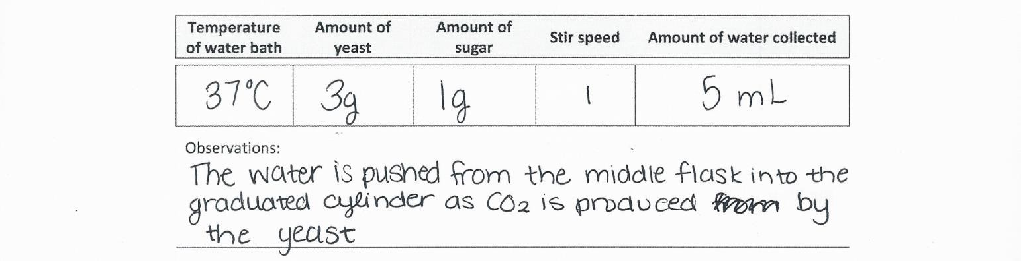

Experiment Design #1:
Challenge all the groups to maximize the amount of CO₂ produced. Have them brainstorm variables to explore. Let them try a run with as many variables changed as they want. It will make you cringe, but we need them to test multiple variables simultaneously to make our point when trying to unravel and understand their results.
At first, allow them to choose as many variables as they want. They will want to change everything in the flask and see what happens. After they do this for their first experiment, they won't know what caused the change in carbon dioxide production. This will help guide their thinking. After they realize they do not know exactly what affected the carbon dioxide production, ask them to choose one variable to change that they hope will cause the most carbon dioxide production.
- Be sure to save time at the end to talk to your whole group. Discuss each of their results (3 mini groups will be reporting out). Facilitate a discussion around how to best interpret the results, leading them to understand that testing only one variable at a time is the best way to optimize the experiment.
- You can record their results on a whiteboard or piece of paper to help them visualize their results.
- Review with your group the concepts learned from the multiple variable experiment. As a group, decide on a variable or variables they think worth pursuing to optimize CO₂ production. The amount of yeast must remain constant, i.e., the same amount as the control.
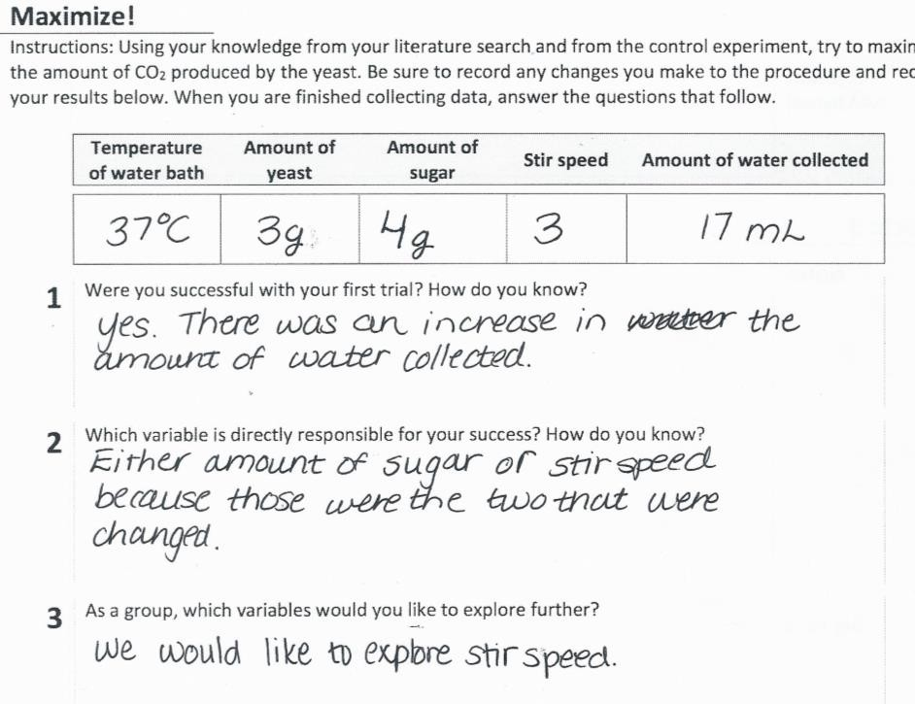
- The students can explore any variable besides the following: amount of yeast, time, and amount of liquid

What variables affect CO₂ Production
Day 3 & 4

Introduction:
Review concepts from the last meeting, such as the purpose of a control, how many variables should change in a single experiment, etc. Go over the variables that the group as a whole wants to explore. Again, remind the students about the dangers of working with hot plates!

Prove It:
Instructions: Work with your advisor to design an experiment to determine how your chosen variable affects the amount of CO₂ that your yeast can produce. Create a data table for your experiment below. The students must only select one variable throughout this entire process!
Each experiment must leave the amount of yeast, the total solution volume, and the reaction time constant. Still, all other variables are free to be changed as much or as little as possible. As an advisor, help the students organize their data tables. They can be fashioned after the ones used for Day 2, but make sure that they record the new quantity for the variable that they are testing. However, they will only have time for two experiments per day. We would also like them to repeat their trials to check for consistency. On this day, have each group run the same experiment twice. Students will probably be anxious to try a new value for their variable, so remind them how vital repeatability is in science. If students get quite different results for the same experimental conditions, talk to them about possible sources of error. Each group should start day 6 by doing one more trial. If a group gets reasonably consistent results, they can test a different value (still the same variable) on day 6.
While the students conduct their experiments, regularly review equipment vocabulary, assess verbally whether they understand the process occurring, and why they are collecting data on water volume and not gas. They should also be comfortable enough to assemble and run the experiments on their own the next day. Do not let students start another trial if you don't think they will finish in time. When students are finished, have them start cleaning up.

Variable List:
The following is a list of potential variables that the students can explore:
  - Sugar amount
  - Sugar type
  - Stir speed
  - Water bath temperature
  - Salinity
  - Acidity/Alkalinity

Again! Be sure to remind them of the issues and rules of the hot plates! We cannot have any students get near the hot water during any of these experiments. The only people allowed to handle the hot water are the teachers, leads, and volunteers!

Variable:
Data Table:
Temperature of water bath | Amount of yeast | Amount of sugar | Stir speed |  | Amount of water collected

Trials Average (mL): Will vary from class to class

1. What effect did changing your variable have on the CO₂ production of the yeast?

A good learning point for the students is to understand whether their change in the variable positively affected CO2 production. It is important to ask them what they think about this particular question. Hopefully, the students should conclude that they need to compare their experimental data with their control data.

Use the space below to conduct additional trials exploring your variable. Your observations should include possible sources of error or analysis of your results. Values for variables should be used twice to show reproducibility and to practice calculating averages.

Data Table:
Temperature of water bath | Amount of yeast | Amount of  sugar | Stir speed |  | Amount of water collected
Observations:
Observations

It is imperative that the students are keeping track of their data as the experiment goes along. Ensure that all the students have their data from the first trial before they move on to the second trial.

On the next page, students will be asked to summarize their data. This will allow them to visibly see all of their data. They will be making a bar graph based on all the trials they
were able to complete during the previous days. Ensure that the students are labeling their axes, giving their graph a title, and neatly inputting their data!

The graph should contain the x-axis being the variable and the y axis being the CO2 production.

Share your results with the rest of the class and determine the optimal values for each variable.
CO2 Produced
80
70
60
50
40
30
20
10
0
1
2
3
Stir Speed
4
5
Final Graph with CO2 vs changing variable data.
Water Collected, (mL)
Variable Tested, amount
,
Trial 5
(Optional)
Trial 4
Trial 3
Trial 2
Trial 1

Constant Experimental Values:
Amount of Yeast: 3 grams Volume of water: 100 mL Length of Time: 10 minutes

Optimal Experimental Values:

Temperature:
mL of Water
Stir Speed:
Sugar Type:
Acidity:
Amount of Sugar: _

Day 5 & 6 Optimization, Write Up, and Poster!

Introduction:
Start the day by reminding the students that the importance of sharing data can lead to many breakthroughs or discoveries that could not have been made by individual parties. The day will start with the students summarizing the optimized version of each variable before they run the optimized experiment! After they have completed the optimized experiment, collect the class's data, and obtain the average. If there is still time afterward, have the students work on their Poster Presentations. Day 5 will be the optimized experiment and poster design if time and day 6 will be allotted entirely to poster completion and presentation!

Optimization:
Based on your class results, describe what conditions would produce the most CO₂ with yeast:

In this area, the students will state the optimized version of each variable tested throughout the past two weeks. If a couple of variables were not tested, use the control values for those variables.

Make a table below with all your experimental values and take note of how much water you collect. Once each group has finished their experiment, your teacher will help you find the class average.

Optimized experiment class average: mL
Discussion Question: Was your group's experimental value consistent with the class average? If not, what could have caused this error? Explain below.

A few things that could have caused errors in the experiment could be the students' lack to follow setup procedures correctly, the materials may be broken, and or the yeast was too old and wouldn't activate completely. Once they have answered this question, if there is still time, continue with working on the poster presentation.

Poster Presentation Template:
Finish Data Collection; Begin Poster

Start by having each group share with the class what the optimal value of their variable was. If the group did not find an optimal value (e.g. results are totally inconsistent) help them make an educated guess. Suppose that a group finds that more of a certain variable increases the output of CO2, and they don’t find an upper limit (a point where adding more of the variable actually decreases CO2 production). They do not have to pick the value with their best results. They could pick a higher value. Caution them to not go very much beyond their highest value, since they can’t be sure that the trend will hold. Write down the class’s combination of optimized conditions on a white board or piece of paper. Students should also write these optimized conditions in their notebook as well. Have each group run an experiment with all optimized variables. Because each group is doing the same experiment, we can teach them about uncertainty and error when doing science. Small variability in results is a normal part of science! If results of the same experiment are very different from each other, then it is likely that one of them is not correct.

After analyzing your group’s results, help them get started on their posters. Each student will work on a particular part of the poster, and they will eventually share their poster as a whole with the rest of the class. Help the students decide who does each part, and make sure that each student knows what to do for his/her part.
Variable Tested + Prediction
Title+ Names
Now that your group has completed the experiment, share your results with the rest of the classroom. Below is a template that will help you remember all the important parts of sharing scientific findings with others. This presentation will be based on the individual variable that you and your group tested. Not the optimized experiment!
Image of Experiment
Graph and Data
Conclusion

On the last day, the students should break up into their groups and finish their poster presentations. It is your job today as a volunteer to help the students decide which members of the group will present each part of their poster. It is important for the students to each do a part of the presentation. It may be helpful to give two students the section of the poster that has the most context.
On the last day, we are hoping that the students will present their findings with the volunteers present. It encourages the students to do well if their college volunteer can be seen in the back of the classroom. Be sure before leaving on the last day to thank the teacher, the students, and most importantly, the volunteers for their hard work in the classroom.

Off Day 1 Literature Review

The students will read some articles and use the internet to investigate yeast. They will brainstorm some ideas for ways to increase the amount of CO2 that yeast produce. Please make sure you also understand the different variables that will affect the yeast to answer their questions. The lead and volunteers will not be there for this activity, so this is up to the teachers to ensure that they know what different variables may affect how much CO2 yeast produces.

Teachers have options on how to discuss the variables that affect CO₂ production in yeast.
- Teachers may give students prechosen articles (preferred)
- Students may search online for articles themselves or in groups (preferred)
- Teachers may go over variables that affect CO2 production without articles (not preferred)

We prefer students to use options 1 and 2 because learning how to do accurate research is an important part of the scientific process. Option 2 allows the students to practice these skills while option 1 gives the students a model for what good research articles.
Articles can be distributed to the students via google classroom.

Off-Day 2 Procedure Practice
On this day, teachers get the option to have their students perform a procedure-writing activity. This activity aims to remind students that the procedures they write should be clear, descriptive, and specific.
First, the class will be split into two groups, and each group will be shown a video of a task (either folding a paper airplane or tying shoes). The students are challenged to write a procedure of the task in their video. As students finish their procedures, they are paired together with a member from the other group. One at a time, the students will share their procedure with their partner and observe them as they try to complete their task. If the student's partner fails, the student should be allowed to revise his procedure and try again. Once the student has completed the task or attempted it twice, they will share their procedure with the other student and repeat the cycle. It would be best to emphasize that each step should be taken literally, and no steps should be implied. For instance, how will you tie your shoe if you do not first bend downwards?
If there is additional time left in the class, students can improve a "bad" procedure for the CO2 collection experiment that was done on day 3. This procedure could use more detailed steps and reorganization of steps, giving them a chance to review the experiment through a challenge. Teachers may elect to provide this segment of the module electronically, rather than on paper.

Off-Day 3 Graphing Practice: Experimental Data
Students will practice graphing bar and line graphs. They will be given data sets that they can use to create SULTAN bar graphs. After reviewing graphing with a few data sets, the students will then attempt to graph their data. The data should be presented with the changing variable on the x-axis, while water collected should be shown on the y-axis. Students should choose an appropriate name for this graph, considering that it will be presented on day 8.

Off-Day 4 Finish PowerPoint Presentation
Students from the same group will complete a PowerPoint presentation that discusses their control results, their experimental results, and their optimized results. These will be presented on the final day.

Glossary:
Yeast: a microscopic fungus consisting of single oval cells that reproduce by budding and can convert sugar into alcohol and carbon dioxide.

Bromothymol Blue: An indicator of carbon dioxide. It will turn from blue to yellow in the presence of carbon dioxide.

Control Experiment: An experiment that is run with no changes being made to any variables. This gives us a reference to when we change a variable and compare the data to see if changing a variable had a positive or negative response.

Variable: Any part of the experiment that can be changed. For any scientific experiment, it is important to change only one variable during each experiment. If you were to make two changes, and something happened in the experiment that goes wrong, you would not be able to tell which variable was responsible for the failure.

Independent Variable: The variable that is purposely changed by the scientists in an experiment.

Dependent Variable: The variable that changes in response to changes made in the independent variable.

Constants: The other parts of the experiment that remain the same after a change is made to one variable.

Outliers: A piece of data that is not close to any other variables found during other trials of the same experiment.

Supplemental File #4
Daily schedule for the Conservation of Mass Module

The Conservation of Mass module focuses largely on observation, measurement, data collection, and deriving conclusions from these practices. The content goal of the module is to teach students the second law of thermodynamics, that is all mass is conserved during a reaction, in a lab setting. The NGSS standard this module aims to address is MS-PS1-5 “Matter and its Interactions” https://www.nextgenscience.org/pe/ms-ps1-5-matter-and-its-interactions. Below, in Figure S4, is an itinerary for the Conservation of Mass module. A similar figure for the Best Bread module has been provided in the main body of the article as Figure 1.

Day 1: (45 Minutes)
- SciTrek team members enter the classroom for the first time wearing lab coats and bring all module equipment. The lead introduces themselves, the SciTrek program and each volunteer provides their name, major and their interests. (5 minutes)
- In small groups of five or six, students are introduced to the second law of thermodynamics by performing an experiment that involves burning a marshmallow and measuring its mass before and after combustion. Before they do anything, they are asked to make a prediction of mass change based on what they know about burning marshmallows and justify their hypothesis with background reasoning. Students should observe the marshmallow decreasing in mass based on their measurements (20 minutes)
- As a follow up to the burning marshmallow activity, students are asked to perform the same experiment on burning steel wool instead. The students are asked to make a prediction of mass change and to justify their hypothesis based on previous experiences. Students observe that weighing out the steel wool after it has fully oxidized shows an increase in mass. These seventh graders are not expected to know oxidation reactions and the correct reasoning as to why the steel wool increases mass. However, the volunteer is encouraged to provide an explanation to their group at the end of this discussion. (20 minutes)

Day 2: (45 minutes)
- Students are provided a brief introduction to copper sulfate and sodium carbonate, chemicals that they will be working with in the following activities. Proper warning and safety precautions are stated prior to performing the activity (5 minutes)
- For the activity, students are challenged to create conditions in which no mass is gained or lost by mixing sodium carbonate with copper sulfate, a reaction that should produce a precipitate and no change in mass if done correctly. Students record the mass of the reactants prior to mixing by weighing each component separately. In order to demonstrate that a solid was produced, the students are asked to filter the reaction mixture and weigh the mass of the solid collected and the mass of the liquid separately. After adding the weight of the precipitate and the remaining liquid, the students find that, if done correctly, no mass is lost or gained. Of course, those would be in ideal conditions and it is not uncommon for the students to get some mass lost or some mass gained. Instead, the class will take the average of all their data to find that the mass has changed by a minute amount. Given the opportunity, if a group fails to maintain the mass, the SciTrek lead will talk about outliers. As explained by the lead, most outliers in this case are caused by experimental error, and should not be included in the class average because it will throw off the class average from the expected value of no mass change. (30 minutes)
- The students are then prompted to answer questions about the differences between open and closed systems. By association with their data, the students can quickly come to the conclusion that a reaction that loses mass or gains mass is an open system, while the chemical reaction that maintains its mass is a closed system. These two types of reactions are heavily emphasized throughout the next three days in this SciTrek module. (10 minutes)

Day 3: (45 minutes)
- The SciTrek Lead reviews the difference between an open and closed system making the student support their answer with an activity performed on a previous day (5 minutes).
- The students perform an activity that prepares them for the goal of the final experiment, to find a creative solution to maintain the mass of an open system reaction. It involves mixing baking soda and vinegar and writing down observations during the reaction. The students are asked to perform this activity multiple times to ensure that the data collected will give them an obvious trend of lost mass (25 minutes).
- The UC volunteers discuss with their groups where they believe the mass is going, ultimately drawing conclusions that the mass lost is a result of the sodium bicarbonate and acetic acid reacting to form carbon dioxide gas (10 minutes).
- In their groups, students are asked to brainstorm how to create an environment that would maintain the mass of the open system reaction they performed today(5 minutes).

Day 4: (45 minutes)
- The students are given the same materials found on day three with additional materials (rubber glove, rubber band, plastic pipettes, etc.) that are designed to help them turn the open system reaction found on day three into a closed system reaction. The SciTrek lead introduces the goal of this activity again at the beginning of class (5 minutes)
- Students are asked to use the same amount of chemicals found in the reaction on day three; however, they are allowed to use whatever materials given to them to make sure that no mass is lost in the reaction. Before each trial, the students are asked to draw the apparatus they have created to maintain the mass of the reaction.
- At this point the students are aware that they must weigh everything that they use in the apparatus or else the trail fails. Students are allowed to complete several trials throughout the day. If the students fail the first time, they are allowed to change the apparatus to see if they can improve. If the students succeed on the first trial, they are encouraged to perform the reaction using the same apparatus to see if the first trial was a fluke. All calculations are completed before the students are allowed to move on to the next trial (35 minutes).
- Students spend the last five minutes of class discussing their results with their peers and brainstorming new ideas for the final day of trails (5 minutes).

Day 5: (45 minutes)
- Students are reminded of their goals by the SciTrek lead and are asked as a class once more the difference between an open or closed system (5 minutes).
- Students who were able to maintain the mass on day four are encouraged to find a new approach to maintain the mass of the reaction while students who failed are given more trials to succeed. When they manage to succeed they are encouraged to repeat the trial once more to see if their data wasn’t by chance or error. All calculations are completed at the end of every trial before the students are allowed to move on to the next (35 minutes).
- At the end of the day, students are given the opportunity to start preparations for their final poster presentations (5 minutes).

Day 6: (45 minutes)
- For the final day of the SciTrek program, students are tasked to complete their poster presentations before the halfway point of the period (20 minutes).
- Each group presents their poster to the rest of their peers that includes an illustration of their apparatus and a statement of whether they were able to maintain the mass of the reaction with data to support their conclusion. It is emphasized that each student in the group is in charge of a piece of the poster that they themselves will present to the rest of the class (20 minutes).
- The SciTrek lead will go over once more the difference between an open or closed system and thank the students for participating in the program (5 minutes).

Supplemental File #5: Conservation of Mass Student handbook



How Science Works
Student Notebook
Conservation of Mass

Class Question:

Student Name:

SciTrek Lead:

Teacher: Period:

LAB TOOLS
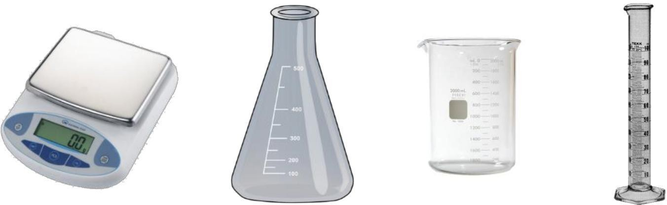

Weighing Balance Erlenmeyer Flask Beaker Graduated Cylinder



Plastic Funnel Weighing Boat Filter Paper

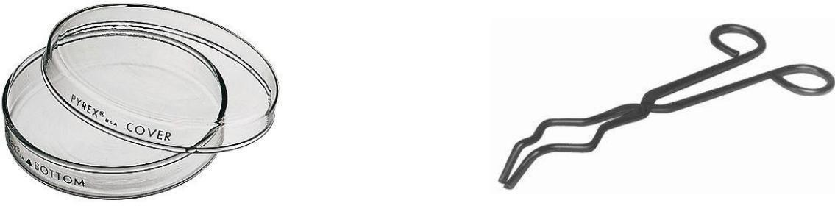

Petri Dish Tongs

Marshmallow Madness and Steel Wool
Day 1

Marshmallow Madness Procedure:
- Write down your hypothesis and your justification. What will happen to the mass of the marshmallow after burning, and why?
- Record the mass of the glass Petri dish.
- Record the mass of the Petri dish + a marshmallow (before burning).
- Subtract the mass of the Petri dish from the mass of the Petri dish + the marshmallow to obtain the initial mass of the marshmallow.
- Set the Petri dish with the marshmallow on the desk away from any pieces of paper.
- Using the metal tongs, hold the marshmallow over a lit candle to ignite it.
- Quickly put the marshmallow back in the Petri dish. Record your observations.
- After the marshmallow is finished burning, allow the Petri dish to cool for two minutes.
- Record the mass of the Petri dish + the burned marshmallow.
- Subtract the mass of the Petri dish to obtain the final mass of the marshmallow.

Prediction: Justification:

I think that burning the marshmallows will cause an (increase/decrease/no change) in mass.
When the marshmallows are burned, the reaction occurs in an (open/closed) system, causing it to (lose/gain/have the same) mass because...

Data Table: Observations: (Using your five senses to get info)

- Mass of glass Petri dish
- Mass of Petri dish + marshmallow
(before burning)
- Initial mass of marshmallow
- Mass of Petri dish + marshmallow
(after burning)
- Final mass of marshmallow
- Change in mass of marshmallow!
I noticed that the heat causes the marshmallow to change color, indicating a

1 | Did a chemical reaction take place? What is your evidence?
2 | Was your prediction correct? Explain using evidence from the data collected.
3 | Draw a model (visual representation) of the burning marshmallow to explain what is happening to the atoms during the reaction. Label all relevant parts visible and not visible.

Combustion of Steel Wool Procedure:
- Write down your hypothesis and your justification. What will happen to the mass of the steel wool after burning and why?
- Record the mass of the glass Petri dish.
- Fluff the piece of steel wool so that it just fits in the Petri dish.
- Add the steel wool to the Petri dish and record the mass of the Petri dish + the steel wool.

- Subtract the mass of the Petri dish from the mass of the Petri dish + the steel wool to obtain the initial mass of the steel wool.
- Set the Petri dish with the steel wool on the desk away from any pieces of paper.

- Light the steel wool on fire
- Record your observations.
- After the steel wool has been extinguished, allow the Petri dish to cool for two minutes.

- Record the mass of the Petri dish + the burned steel wool, then subtract the mass of the Petri dish to obtain the final mass of the steel wool.

Prediction: Justification:

I predict that the combustion of steel wool will cause the iron to (lose/gain/ have the same) mass.

I believe my prediction is correct because…
Data Table: Observations: (Using your five senses to get info)
- Mass of glass Petri dish
- Mass of Petri dish + steel wool
(before burning)
- Initial mass of steel wool
- Mass of Petri dish + steel wool
(after burning)
- Final mass of steel wool

1 | Did a chemical reaction take place? What is your evidence?
2 | Was your prediction correct? Explain using evidence from the data collected.
3 | Draw a model (visual representation) of the burning steel wool to explain what is happening to the atoms during the reaction. Label all relevant parts visible and not visible.

Mixing Copper Sulfate and Sodium Bicarbonate
Day 2

Procedure:
- Place a clean, dry 50 mL graduated cylinder on the balance and press "zero." This cancels out the
mass of the graduated cylinder so that we can measure only the liquid that we put into it.
- Carefully add about 20 mL of the copper sulfate (CuSO₄) solution to the graduated cylinder and record the mass in your data table.
- Pour the copper sulfate solution into a 125 mL Erlenmeyer flask. Get as much of the solution out of the graduated cylinder as you can
- Clean out the graduated cylinder in the sink and dry it using a paper towel. Make sure there is no water left inside.
Materials:
Laboratory balance
50 mL graduated cylinder
125 mL Erlenmeyer flasks piece of filter paper
1 plastic funnel
1 plastic weighing tray copper sulfate solution sodium carbonate solution
- Put the graduated cylinder back on the balance and zero it again. Then add about 20 mL of the sodium carbonate (Na₂CO₃) solution to the cylinder and record its mass.
- Add the sodium carbonate solution to the same Erlenmeyer flask. Record your observations in the space provided.
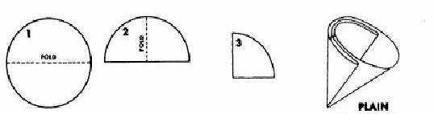
- Swirl the contents of the flask to ensure that they are thoroughly mixed.
- Record the mass of the other 125 mL Erlenmeyer flask.
- Record the mass of a piece of filter paper.
- Fold the filter paper as shown in the diagram above (ask a SciTrek volunteer for help!) and place it into the plastic funnel. Place the plastic funnel and filter paper in the second Erlenmeyer flask.
- Carefully pour the contents of the first Erlenmeyer flask through the filter paper. Make sure that all of the solid ends up in the funnel.
- While the solution is draining, place the plastic weighing tray on the scale and press "zero."
- Allow the solids to drain until there is no more liquid in the funnel, then remove the filter paper and place it in the plastic weighing boat. Record the mass of the filter paper + solids in the data table.
- Record the mass of the Erlenmeyer flask + the drained liquid.

Data Table:
Observations:
Item to be measured: Mass in grams(g):

(A) Mass of 20 mL CuSO4
+solution
(B) Mass of 20 mL Na2CO3
solution
(C) Mass of empty 125 mL
Erlenmeyer flask
(D) Mass of dry filter paper
(E) Mass of Erlenmeyer flask + liquids
(F) Mass of filter paper + solids
Mass of CuSO4 Solution (A) Mass of Na2CO3 Solution (B) Total Initial Mass
+
=

Mass of Erlenmeyer flask + liquids (E)
Mass of empty
-
=
Erlenmeyer flask (C) Mass of Liquids Collected
Mass of filter paper
+ solids (F) Mass of filter paper (D) Mass of Solids Collected
-
=
Mass of Liquids Collected Mass of Solids Collected Total Final Mass
+
=

TOTAL FINAL MASS TOTAL INITIAL MASS CHANGE IN MASS
-
=

Discussion:
Talk with your classmates and write a detailed explanation for your reasoning.

1 | Why was it important to get all the liquid out of the graduated cylinder in Step 3?
2 | Is the filter paper part of the reaction? Why do we need to know its mass?
3 | Did a chemical reaction occur? What is your evidence?
4 | Draw a model (visual representation) of this chemical reaction to explain what is happening to the atoms during the reaction. Label all relevant parts visible and not visible.

Baking Soda and Vinegar
Day 3
Yesterday, you performed an experiment to see if the mass of the reactants in a chemical reaction was equal to the mass of the products. You also identified possible sources of error in your measurements. At the end of the lab, you came up with a theory about chemical reactions.
An important test of any theory is its applicability to a range of problems. Today, you will attempt to gather evidence to support your theory by using a different chemical reaction, but by keeping the general procedure the same. If you get stuck, refer to Lab 1 from yesterday for help.

Procedure:
- Use the graduated cylinder, the balance, and the "tare/zero" button to carefully measure the mass of 20 mL of vinegar.
- Record the mass of the 100 mL beaker.
Materials:
1 Laboratory Balance
1 50 mL graduated cylinder
1 125 mL Erlenmeyer Flask
1 100 mL Beaker
1 Plastic Funnel
1 Plastic Weigh Boat
Vinegar Baking Soda
- Add about 2 grams of baking soda to the beaker, then record the mass of the beaker + the baking soda.
- Place the beaker with the baking soda on the table and slowly add the vinegar. Record your observations. If the solution bubbles over, you will need to start again from step one.
- While the reaction is finishing, write down your hypothesis in your handbook. Will the mass decrease, stay the same, or increase? Provide a brief explanation.
- When the reaction is done, weigh the beaker and products.

Prediction: Justification:

I predict that when the baking soda & vinegar are mixed, the total mass of the reactants must be (greater/equal/less) than the total mass of the products.
I believe this will happen because…

Data Table:
Item to be measured: Mass in grams (g): Observations:

- Mass of graduated cylinder
- Mass of 20 mL of vinegar
- Mass of beaker
- Mass of baking soda
- Mass of beaker + baking soda
- Mass of beaker + products

As we mixed baking soda & vinegar, I noticed the formation of , indicating the presence of (gas/solid/liquid) molecules

Calculations:
Use the space below to do your calculations. Record your results in the table at the bottom.

Total Initial Mass (g)

Total Final Mass (g)
CHANGE IN MASS (g)

Discussion:
1 | What was the change in mass? Include units (for example, grams, milliliters)!
2 | What caused the mass to change? In what ways is this reaction different from the copper sulfate and the sodium carbonate reaction? Draw a model to show what is happening to the atoms in this reaction. Label all relevant parts visible and not visible. Provide evidence for your answer.
3 | What chemicals or types of chemicals are being made in this reaction (the produces)? How can you keep track of all of these? (how could you measure them?). Is there a way to keep track of all the products in this reaction? How might you change the experiment? Today and tomorrow, your goal will be to design and test a closed system (isolated environment) for this reaction. Sketch and label your design below.

Final Experiment
Days 4 & 5

Chemists
Per
UCSB Leader
Introduction:
Write a brief statement describing the purpose of this experiment.

Design Sketch:
Draw how you will build your design. Label all materials. Your experiment may change as you go through each trial. Make sure to redraw every change that you make as you progress through each attempt.

Trial #1
Trail #2
Trail #3

Data Table:
Item to be measured Mass in grams (g)

Any item you use needs to be measured! | Trial 1 | Trial 2 | Trial 3
Calculations: Use the space below to do your calculations
Trial 1 Trial 2 Trial 3

Results of each trial:
Write down what you think contributes to the variability in your data (that is, why your results are not all identical)

Total Initial Mass (g) Total Final Mass (g)

Change in Mass (g)
1 2 3

Calculation Page:
Use the space below to do any calculations that you may not have had room on the previous page to complete!!!

Glossary:

Observation: Any information that can be obtained using your five senses (For these experiments, we will only be using smell, sight, and hearing to gather information).
Prediction: Using background knowledge of previous experiences to state what might occur in the future.

Justification: Explaining the prediction by using background information to provide the logic to your prediction.
Chemical Reaction: A reaction in which the starting substance is changed into a different substance by the end of the reaction. Some examples are combustion, mixing acids and water, rusting.

Physical Reaction: A reaction in which the starting substances remain the same once the reaction is over. Some examples are melting, freezing, evaporating.
Data Table: A place to record measurements to be used for further discovery and analysis.

Error Source: An educated guess as to why something wrong occurred before, during, or after the experiment.
Closed System Reaction: A reaction in an environment that does not lose any of the reaction's matter to the surroundings.
Open System Reaction: A reaction in an environment that loses some of the reaction's matter to the surroundings.

System: The environment where the reaction takes place.
Surroundings: The environment that exists outside the reaction.

Universe: The environment that is made up of both the system and the surroundings.

Supplemental File #6: Conservation of Mass Volunteer handbook

How Science Works
Volunteer Notebook
Conservation of Mass

Class Question:
How and why is mass lost, gained, or conserved in a chemical reaction?

Student Name:

SciTrek Lead:

Teacher: Period:

LAB TOOLS

Weighing Balance Erlenmeyer Flask Beaker Graduated Cylinder

Plastic Funnel Weighing Boat Filter Paper

Petri Dish Tongs

Introduction of Sci-Trek:
Before the students go into their small groups, there will be a short introduction to what you will be doing that day. It will first start with introductions. Say a few words about yourself. Name, what year you are in school, why you are interested in science. Keep in mind that some students come from underprivileged backgrounds and do not have doctors for parents.

Key Concepts:
A chemical reaction is a rearrangement of the atoms in an initial compound or compounds (the reactants) to form a new substance or substances (the products). Some examples are:

- Synthesis: A + B AB

- Decomposition: AB A + B

- Single replacement: AB + C AC + B

- Double replacement: AB + CD AC + BD

- Combustion: CH₂O + O₂ CO₂ + H₂O

A chemical reaction is usually accompanied by an observable physical change, such as a change in color and/or temperature, the emission of light, the evolution of a gas, or a precipitate formation. Reinforce this understanding by teaching the students to make observations of these perceivable changes.

Working with Your Small Group:
There will usually be one to two students who are content with not participating in these discussions in each group. Make sure that when you work with your group, you are engaging each student. One good way to do this is to assign responsibilities. Have one person do the reading of the instructions, one-person monitor the temperature, one-person measure the yeast, etc. This is an excellent way to make sure that everyone is staying engaged.

It is also important that before the students go back to their seats, they are asked to help clean up the mess at the end of every day. As a volunteer, it is your job to help guide these kids throughout every part of the experiment. That includes the clean-up!!!!

Marshmallow Madness and Steel Wool
Day 1

Overview Marshmallow Madness:
This demo is the first of two that will be conducted to demonstrate chemical reactions and spark students' intellectual curiosity. It will further enhance their knowledge of the complete system for these reactions beyond what is immediately apparent.
Marshmallows are made of fructose (C₆H₁₂O₆), sucrose (C₁₂H₂₂O₁₁), water (H₂O), and gelatin (a mixture of proteins). For our purposes, we will simplify the chemical reaction that occurs when burning marshmallows to the combustion of glucose:

C₆H₁₂O₆ + 3 O₂ 6 CO₂ + 6 H₂O

For this reaction to occur, the marshmallow alone is not enough - you must also consider the oxygen in the room as a reactant. This will not be immediately clear to the students from the chemical formula alone. The result of this demo is an apparent loss in mass.

Objective:
The main goal is to have the students realize that gases, either as reactants or products, should be considered when evaluating whether the total mass is conserved.
Students will make predictions about what will occur when the marshmallow is burned, using the idea of conservation of mass. They will observe what happens as the marshmallow is changed from one state to another.

Safety Precautions:
Make sure they are using a candle to light the marshmallow, NOT the lighter or matches, and making sure that it stays in the Petri dish. After the flame has gone out, make sure that the students do not touch the Petri dish for at least two minutes.

Marshmallow Madness Procedure:
- Write down your hypothesis and your justification. What will happen to the mass of the marshmallow after burning, and why?
- Record the mass of the glass Petri dish.
- Record the mass of the Petri dish + a marshmallow (before burning).
- Subtract the mass of the Petri dish from the mass of the Petri dish + the marshmallow to obtain the initial mass of the marshmallow.
- Set the Petri dish with the marshmallow on the desk away from any pieces of paper.
- Using the metal tongs, hold the marshmallow over a lit candle to ignite it.
- Quickly put the marshmallow back in the Petri dish. Record your observations.
- After the marshmallow is finished burning, allow the Petri dish to cool for two minutes.
- Record the mass of the Petri dish + the burned marshmallow.
- Subtract the mass of the Petri dish to obtain the final mass of the marshmallow.

Prediction: Justification:

The marshmallow will lose mass when burned.
The marshmallow will shrivel and turn black. This will cause some things to be burned off the marshmallow.

Data Table: Observations: (Using your five senses to get info)

- Mass of glass Petri dish
- Mass of Petri dish + marshmallow
(before burning)
- Initial mass of marshmallow
- Mass of Petri dish + marshmallow
(after burning)
- Final mass of marshmallow
- Change in mass of marshmallow!
- The marshmallow gave off a lovely smell (gas molecule formation).
- There was a change in the color of the marshmallow.
- There was an emission of light/heat.

1 | Did a chemical reaction take place? What is your evidence?  The students should use inductive reasoning from their observations to conclude that a chemical reaction has occurred.
2 | Was your prediction correct? Explain using evidence from the data collected.  Explanations will vary. Students can talk with their group to interpret and justify why their prediction is correct.
3 | Draw a model (visual representation) of the burning marshmallow to explain what is happening to the atoms during the reaction. Label all relevant parts visible and not visible.  The students should have a good conceptual understanding of the chemical reaction observed. This can serve as an opportunity for the students to recognize the different components that make up the system as they go on with the labs. The students should be able to draw the marshmallow molecules being burned off and converted to gas molecules.

Overview Combustion of Steel Wool:
The chemical reaction under investigation here is the oxidation of iron:

4 Fe + 3 O₂ 2 Fe₂O₃

This second demo is a juxtaposition of the first experiment. It will further challenge the students' knowledge by stretching the limits of their understanding a step further - students will observe an INCREASE in mass. Unlike demo one, where the mass loss can be clearly explained with the formation of a gas product, for this demo, they will have to consider that a gas is participating as a reactant.

Objective:
The students should try to formulate an idea as to how the two demos are related. Basically, the conclusion should be that the entire system needs to be accounted for, both on the reactant and the product side of the equation. Sometimes gas is formed during the reaction, and sometimes gas is used as a reactant. The total mass of the system should remain unchanged. The students should start to develop ideas of how they could design experiments to make sure that they account for all the components of a chemical reaction, including gasses.

Combustion of Steel Wool Procedure:
- Write down your hypothesis and your justification. What will happen to the mass of the steel wool after burning and why?
- Record the mass of the glass Petri dish.
- Fluff the piece of steel wool so that it just fits in the Petri dish.
- Add the steel wool to the Petri dish and record the mass of the Petri dish + the steel wool.
- Subtract the mass of the Petri dish from the mass of the Petri dish + the steel wool to obtain the initial mass of the steel wool.
- Set the Petri dish with the steel wool on the desk away from pieces of paper.

- Light the steel wool on fire.
- Record your observations.
- After the steel wool has been extinguished, allow the Petri dish to cool for two minutes.

- Record the mass of the Petri dish + the burned steel wool, then subtract the mass of the Petri dish to obtain the final mass of the steel wool.

Prediction: Justification:

The steel wool will gain mass. (It is okay if their prediction is incorrect. Science is about failure and discovery).
By burning the steel wool, we are speeding up the natural rusting process most metals experience.

Data Table: Observations: (Using your five senses to get info)
- Mass of glass Petri dish
- The steel wool was ignited as sparks were given off.
- The steel wool changed in color.
- Mass of Petri dish + steel wool
(before burning)
- Initial mass of steel wool
- Mass of Petri dish + steel wool
(after burning)
- Final mass of steel wool

1 | Did a chemical reaction take place? What is your evidence?  Yes, a chemical reaction occurred. Sparks were ignited. The smell of the steel wool is not pleasant, and there is a color change. It goes from gray/silver to silver with a blue hue.
2 | Was your prediction correct? Explain using evidence from the data collected.  No, my prediction was incorrect. We measured an increase in mass when the wool was weighed after burning.
3 | Draw a model (visual representation) of the burning steel wool to explain what is happening to the atoms during the reaction. Label all relevant parts visible and not visible.  The students should illustrate that burning the steel wool causes the oxygen to bind with the iron found in the wool.

Mixing Copper Sulfate and Sodium Bicarbonate
Day 2
Overview:
This experiment is a simple precipitation reaction designed to teach the students to work carefully with basic laboratory equipment and to think about which masses are important to measure. The chemical reaction is as follows:

Cu(SO₄) (aq) + Na₂CO₃ (aq) CuCO₃ (s) + Na₂SO₄ (aq)

Procedure:
- Place a clean, dry 50 mL graduated cylinder on the balance and press "zero." This cancels out the
mass of the graduated cylinder so that we can measure only the liquid that we put into it.
- Carefully add about 20 mL of the copper sulfate (CuSO4) solution to the graduated cylinder and record the mass in your data table.
- Pour the copper sulfate solution into a 125 mL Erlenmeyer flask. Get as much of the solution out of the graduated cylinder as you can.
- Clean out the graduated cylinder in the sink and dry it using a paper towel. Make sure there is no water left inside.
Materials:
Laboratory balance
50 mL graduated cylinder
125 mL Erlenmeyer flasks piece of filter paper
1 plastic funnel
1 plastic weighing tray copper sulfate solution sodium carbonate solution
- Put the graduated cylinder back on the balance and zero it again. Then add about 20 mL of the sodium carbonate (Na2CO3) solution to the cylinder and record its mass.
- Add the sodium carbonate solution to the same Erlenmeyer flask. Record your observations in the space provided.
- Swirl the contents of the flask to ensure that they are thoroughly mixed.
- Record the mass of the other 125 mL Erlenmeyer flask.
- Record the mass of a piece of filter paper.
- Fold the filter paper as shown in the diagram above (ask a SciTrek volunteer for help!) and place it into the plastic funnel. Place the plastic funnel and filter paper in the second Erlenmeyer flask.
- Carefully pour the contents of the first Erlenmeyer flask through the filter paper. Make sure that all of the solid ends up in the funnel.
- While the solution is draining, place the plastic weighing tray on the scale and press "zero."
- Allow the solids to drain until there is no more liquid in the funnel, then remove the filter paper and place it in the plastic weighing boat. Record the mass of the filter paper + solids in the data table.
- Record the mass of the Erlenmeyer flask + the drained liquid.

Data Table:
Observations:
Item to be measured: Mass in grams(g):

(A) Mass of 20 mL CuSO4
+solution
(B) Mass of 20 mL Na2CO3
solution
(C) Mass of empty 125 mL
Erlenmeyer flask
(D) Mass of dry filter paper
(E) Mass of Erlenmeyer flask + liquids
(F) Mass of filter paper + solids
Mass of CuSO4 Solution (A) Mass of Na2CO3 Solution (B) Total Initial Mass
+
=

Mass of Erlenmeyer flask + liquids (E)
Mass of empty
-
=
Erlenmeyer flask (C) Mass of Liquids Collected
Mass of filter paper
+ solids (F) Mass of filter paper (D) Mass of Solids Collected
-
=
Mass of Liquids Collected Mass of Solids Collected Total Final Mass
+
=

TOTAL FINAL MASS TOTAL INITIAL MASS CHANGE IN MASS
-
=

Discussion:
Talk with your classmates and write a detailed explanation for your reasoning.

1 | Why was it important to get all the liquid out of the graduated cylinder in Step 3?  It is important to get all the liquid out because this is a potential source for loss of mass and source of error.
2 | Is the filter paper part of the reaction? Why do we need to know its mass?  The filter paper is not part of the reaction; however, the purpose of this experiment is to compare the differences in mass between the final product and the initial reactant. Not incorporating the mass of the filter paper will provide significant sources of error in the final calculation.
3 | Did a chemical reaction occur? What is your evidence?  Yes, a chemical reaction has occurred. A precipitate was formed when the two solutions were mixed.
4 | Draw a model (visual representation) of this chemical reaction to explain what is happening to the atoms during the reaction. Label all relevant parts visible and not visible.  The student should be drawing a picture of the two chemicals in liquid form, slowly combining to form a solid while leaving some parts of each molecule in the liquid phase. The students mustn't use anything outside of the two liquids to force a reaction.

Baking Soda and Vinegar
Day 3
Overview:
This reaction generates a gas. If nothing is done to contain the gas, it will leave the system, and the apparent mass will decrease.

NaHCO₃ (s) + CH₃COOH (aq) CO₂ (g) + H₂O (l) + NaCH₃COO (aq)

The first step of the reaction produces carbonic acid (H2CO3) and sodium acetate. The carbonic acid spontaneously decomposes into water and carbon dioxide. The students are not expected to understand this full reaction, only that gas is formed when the two reactants are mixed.

Objective:
The students will increase their level of independent thinking to explore the "law of conservation of mass" by measuring the total mass change in a new reaction. The students will be given a procedure for the experiment and then asked to improve their system based on their findings.
An important test of any theory is its applicability to a range of problems. Today, you will attempt to gather evidence to support your theory using a different chemical reaction, but by keeping the general procedure the same. If you get stuck, refer to Mixing Vinegar and Baking Soda from yesterday for help.

Procedure:
- Use the graduated cylinder, the balance, and the "tare/zero" button to carefully measure the mass of 20 mL of vinegar.
- Record the mass of the 100 mL beaker.
Materials:
1 Laboratory Balance
1 50 mL graduated cylinder
1 125 mL Erlenmeyer Flask
1 100 mL Beaker
1 Plastic Funnel
1 Plastic Weigh Boat
Vinegar Baking Soda
- Add about 2 grams of baking soda to the beaker, then record the mass of the beaker + the baking soda.
- Place the beaker with the baking soda on the table and slowly add the vinegar. Record your observations. If the solution bubbles over, you will need to start again from step one.
- While the reaction is finishing, write down your hypothesis in your handbook. Will the mass decrease, stay the same, or increase? Provide a brief explanation.
- When the reaction is done, weigh the beaker and products.

Prediction: Justification:

I predict that when the baking soda & vinegar are mixed, the total mass of the reactants must be (greater/equal/less) than the total mass of the products.
I believe this will happen because…

Data Table:
Item to be measured: Mass in grams (g): Observations:

- Mass of graduated cylinder
- Mass of 20 mL of vinegar
- Mass of beaker
- Mass of baking soda
- Mass of beaker + baking soda
- Mass of beaker + products

As we mixed baking soda & vinegar, I noticed the formation of bubbles, indicating the presence of (gas/solid/liquid) molecules.

Calculations:
Use the space below to do your calculations. Record your results in the table at the bottom.

Total Initial Mass (g)

Total Final Mass (g)
CHANGE IN MASS (g)

Discussion:
1 | What was the change in mass? Include units (for example, grams, milliliters)!  The mass should be loss in this case. Gas bubbles form in the reaction and leave the beaker to go into the surroundings!
2 | What caused the mass to change? In what ways is this reaction different from the copper sulfate and the sodium carbonate reaction? Draw a model to show what is happening to the atoms in this reaction. Label all relevant parts visible and not visible. Provide evidence for your answer.  The gas molecules that form will cause a decrease in the mass. This differs from the previous reaction between sulfate and the sodium carbonate reaction because it loses mass and is an open system. An illustration should show the gaseous molecules escaping the beaker and going into the surroundings.
3 | What chemicals or types of chemicals are being made in this reaction (the produces)? How can you keep track of all of these? (how could you measure them?). Is there a way to keep track of all the products in this reaction? How might you change the experiment? Today and tomorrow, your goal will be to design and test a closed system (isolated environment) for this reaction. Sketch and label your design below.  The chemicals that were used in the reaction were liquids that turned into gases. A possible way to keep track of this reaction is to change the open system into a closed system reaction.

Final Experiment
Days 4 & 5

Objective:

Today's goal is to allow the students to turn the open system reaction into a closed system reaction. In the box, the students will have the same materials as yesterday and undergo a similar procedure; however, there will be additional items in the box that the students can use to close the system.

Chemists
Per
UCSB Leader
Introduction:
Write a brief statement describing the purpose of this experiment.

The goal of today's experiment is to turn an open system into a closed system! We will perform the same reaction as yesterday, but our overall goal is not to lose any mass to the surroundings.

Design Sketch:
Draw how you will build your design. Label all materials. Your experiment may change as you go through each trial. Make sure to redraw every change that you make as you progress through each attempt.

Trial #1
Sketches will vary
Trail #2
Sketches will vary
Trail #3
Sketches will vary

Data Table:
Item to be measured Mass in grams (g)

Any item you use needs to be measured! | Trial 1 | Trial 2 | Trial 3
Calculations: Use the space below to do your calculations
Trial 1 Trial 2 Trial 3

Results of each trial:
Write down what you think contributes to the variability in your data (that is, why your results are not all identical)

Total Initial Mass (g) Total Final Mass (g)

Change in Mass (g)
1 2 3

Calculation Page:
Use the space below to do any calculations that you may not have had room on the previous page to complete!!!

Glossary:

Observation: Any information that can be obtained by using your five senses (For these experiments we will only be using smell, sight, and hearing to gather information).
Prediction: Using background knowledge of previous experiences to state what might occur in the future.

Justification: Explaining the prediction by using background information to provide the logic to your prediction.
Chemical Reaction: A reaction in which the starting substance is changed into a different substance by the end of the reaction. Some examples are combustion, mixing acids and water, rusting.

Physical Reaction: A reaction in which the starting substances remain the same once the reaction is over. Some examples are melting, freezing, evaporating.
Data Table: A place to record measurements to be used for further discovery and analysis.

Error Source: An educated guess as to why something wrong occurred before, during, or after the experiment.
Closed System Reaction: A reaction in an environment that does not lose any of the reaction's matter to the surroundings.
Open System Reaction: A reaction in an environment that loses some of the reaction's matter to the surroundings.

System: The environment where the reaction takes place.
Surroundings: The environment that exists outside the reaction.

Universe: The environment that is made up of both the system and the surroundings.

Supplemental File #7:
Conservation of Mass Teacher handbook

How Science Works
Teacher/Lead Notebook
Conservation of Mass

Class Question:
How and why is mass lost, gained, or conserved in a chemical reaction?

Student Name:

SciTrek Lead:

Teacher: Period:

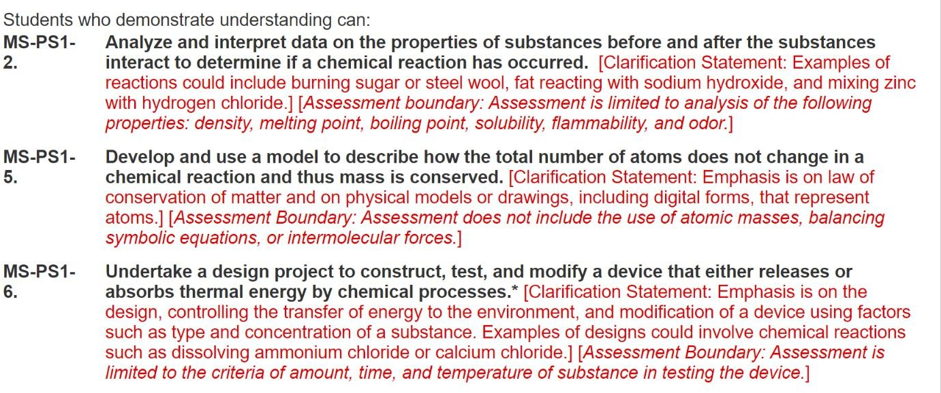
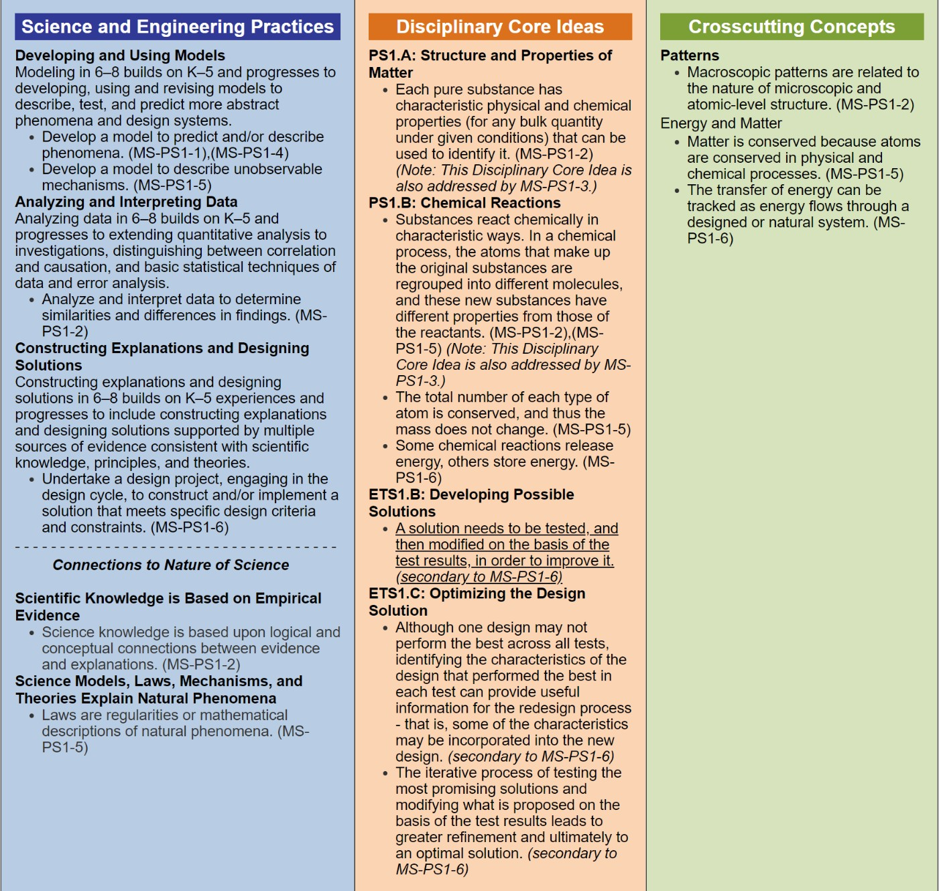
NGSS Standards Covered:

LAB TOOLS
Weighing Balance Erlenmeyer Flask Beaker Graduated

Plastic Funnel Weighing Boat Filter Paper

Petri Dish Tongs

Overview and Background Information:
Descriptions detailing the experiments for each day, and certain goals we want to attain for students, etc.

Day 1:
- Introduce the students to the second law of thermodynamics.
- Introduce the students to chemical vs. physical changes.
- Students need to have a good grasp of what an open system does in a chemical reaction.

Day 2:
- Remind the students of what an open system does.
- Introduce the students to what a closed system does in a chemical reaction.
- Students should be able to use the scale and lab equipment efficiently.

Day 3:
- Remind the students about the differences between an open vs. closed system.
- The students should be able to master the mathematics of the module by this point.
- Have the students start brainstorming how to turn an open system reaction to a
closed system reaction.

Day 4/ Day 5:
- Students should be able to write down the purpose of the experiment and how they are going to accomplish their goals.
- This should illustrate their mastery of proper technique when using materials.
- The students should be able to find some errors in their design and use the three-four trials to improve upon the previous experiment.

Day 6:
- The students should be able to examine their data and come to a conclusion about if their experiment was successful or not.
- Students should be able to illustrate their findings and discuss how they could improve upon their experiment.

Marshmallow Madness & Steel Wool
DAY 1

Introduction of Sci-Trek:
Before the students go into their small groups, there will be a short introduction to what you will be doing that day. It will first start with introductions. Say a few words about yourself. Name, what year you are in school, why you are interested in science. Keep in mind that some students come from underprivileged backgrounds and do not have doctors for parents.

The lead volunteer should introduce the topic for this week's experiment. Tell the class why we are interested in mass. How do chemical reactions affect mass? We will be studying mass by carefully weighing reactants, performing reactions, then weighing the products. Give the students some perspective on what they will be doing this week. The lead will go through the idea of mass. Do I have mass? How do you think I can change my mass? What if I start working out a lot, and I lose some of my mass? Where does that go? Then go through the signs of a chemical reaction. Some of the different signs are a change of state, color change, gas release, and many more. Tell the students to keep these in mind as they go through the experiments today. Then tell them the two experiments they will be doing: burning a marshmallow and burning steel wool. The students can then split into small groups.

Key Concepts:
A chemical reaction is a rearrangement of the atoms in an initial compound or compounds (the reactants) to form a new substance or substances (the products). Some examples are:

- Synthesis: A + B AB

- Decomposition: AB A + B

- Single replacement: AB + C AC + B

- Double replacement: AB + CD AC + BD

- Combustion: CH₂O + O₂ CO₂ + H₂O

A chemical reaction is usually accompanied by an observable physical change, such as a change in color and/or temperature, the emission of light, the evolution of a gas, or a precipitate formation. Reinforce this understanding by teaching the students to make observations of these perceivable changes.

Overview of Marshmallow Madness:
This demo is the first of two that will be conducted to demonstrate chemical reactions and spark students' intellectual curiosity.

Marshmallows are made of fructose (C₆H₁₂O₆), sucrose (C₁₂H₂₂O₁₁), water (H₂O), and gelatin (a mixture of proteins). For our purposes, we will simplify the chemical reaction that occurs when burning marshmallows to the combustion of glucose:

C₆H₁₂O₆ + 3 O₂ 6 CO₂ + 6 H₂O

For this reaction to occur, the marshmallow alone is not enough - you must also consider the oxygen in the room as a reactant. This will not be immediately clear to the students from the chemical formula alone. The result of this demo is an apparent loss in mass.

Objective:
The main goal is to have the students realize that gases, either as reactants or products, should be considered when evaluating whether the total mass is conserved.
Students will make predictions about what will occur when the marshmallow is burned, using the idea of conservation of mass. They will observe what happens as the marshmallow is changed from one state to another.

Safety Precautions:
Make sure they are using a candle to light the marshmallow, NOT the lighter or matches, and making sure that it stays in the Petri dish. After the flame has gone out, make sure that the students do not touch the Petri dish for at least two minutes.

Marshmallow Madness Procedure:
- Write down your hypothesis and your justification. What will happen to the mass of the marshmallow after burning, and why?
- Record the mass of the glass Petri dish.
- Record the mass of the Petri dish + a marshmallow (before burning).
- Subtract the mass of the Petri dish from the mass of the Petri dish + the marshmallow to obtain the initial mass of the marshmallow.
- Set the Petri dish with the marshmallow on the desk away from any pieces of paper.
- Using the metal tongs, hold the marshmallow over a lit candle to ignite it.
- Quickly put the marshmallow back in the Petri dish. Record your observations.
- After the marshmallow is finished burning, allow the Petri dish to cool for two minutes.
- Record the mass of the Petri dish + the burned marshmallow.
- Subtract the mass of the Petri dish to obtain the final mass of the marshmallow.

Prediction: Justification:

The marshmallow will lose mass when burned.
The marshmallow will shrivel and turn black. This will cause some things to be burned off the marshmallow.

Data Table: Observations: (Using your five senses to get info)

- Mass of glass Petri dish
- Mass of Petri dish + marshmallow
(before burning)
- Initial mass of marshmallow
- Mass of Petri dish + marshmallow
(after burning)
- Final mass of marshmallow
- Change in mass of marshmallow!

- The marshmallow gave off a lovely smell (gas molecule formation).
- There was a change in the color of the marshmallow.
- There was an emission of light/heat.

1 | Did a chemical reaction take place? What is your evidence?  The students should use inductive reasoning from their observations to conclude that a chemical reaction has occurred.
2 | Was your prediction correct? Explain using evidence from the data collected.  Explanations will vary. Students can talk with their group to interpret and justify why their prediction is correct.
3 | Draw a model (visual representation) of the burning marshmallow to explain what happens to the molecules inside the marshmallow. Label all relevant parts visible and not visible.  The students should have a good conceptual understanding of the chemical reaction observed. This can serve as an opportunity for the students to recognize the different components that make up the system, as they go on with the labs. The students should be able to draw the marshmallow molecules being burned off and converted to gas molecules.

Overview Combustion of Steel Wool:
The chemical reaction under investigation here is the oxidation of iron:

4 Fe + 3 O₂ 2 Fe₂O₃

This second demo is a juxtaposition of the first experiment. It will further challenge the students' knowledge by stretching the limits of their understanding a step further--the students will observe an INCREASE in mass. Unlike demo one, where the mass loss can be clearly explained with the formation of a gas product, for this demo, they will have to consider that gas is participating as a reactant.

Objective:
The students should try to formulate an idea as to how the two demos are related. The conclusion should be that the entire system needs to be accounted for, both on the reactant and the product side of the equation. Sometimes gas is formed during the reaction, and sometimes gas is used as a reactant. The total mass of the system should remain unchanged. The students should start to develop ideas of how they could design experiments to make sure that they account for all the components of a chemical reaction, including gasses.

Materials:
  - Petri Dish
  - Steel Wool
  - Candle

Note: Sometimes, this demo does not work perfectly. Sometimes the steel wool loses mass, due to small errors in weighing. In this case, tell the students that the steel wool was supposed to gain mass, and ask them why they think that may have happened.

Combustion of Steel Wool Procedure:
- Write down your hypothesis and justification. What happens to the mass of the steel wool after burning, and why?
- Record the mass of the glass Petri dish.
- Fluff the piece of steel wool so that it just fits in the Petri dish.
- Add the steel wool to the Petri dish and record the mass of the Petri dish + the steel wool.
- Subtract the mass of the Petri dish from the mass of the Petri dish + the steel wool to obtain the initial mass of the steel wool.
- Set the Petri dish with the steel wool on the desk away from any pieces of paper.

- Light the steel wool on fire.
- Record your observations.
- After the steel wool has been extinguished, allow the Petri dish to cool for two minutes.

- Record the mass of the Petri dish + the burned steel wool, then subtract the mass of the Petri dish to obtain the final mass of the steel wool.

Prediction: Justification:
The steel wool will gain mass. (It is okay if their prediction is incorrect. Science is about failure and discovery).

By burning the steel wool, we are speeding up the natural rusting process most metals experience.

Data Table: Observations: (Using your five senses to get info)
- Mass of glass Petri dish
- The steel wool was ignited as sparks were given off.
- The steel wool changed in color.
- Mass of Petri dish + steel wool
(before burning)
- Initial mass of steel wool
- Mass of Petri dish + steel wool
(after burning)
- Final mass of steel wool

1 | Did a chemical reaction take place? What is your evidence?  Yes, a chemical reaction occurred. Sparks were ignited. The smell of steel wool is not pleasant, and there is a color change. It goes from gray/silver to silver with a blue hue.
2 | Was your prediction correct? Explain using evidence from the data collected.  No, my prediction was incorrect. We measured an increase in mass when the wool was weighed after burning.
3 | Draw a model (visual representation) of the burning steel wool to explain what is happening to the atoms during the reaction. Label all relevant parts visible and not visible.  The students should illustrate that burning the steel wool causes the oxygen to bind with the iron found in the wool.

Mixing Copper Sulfate and Sodium Bicarbonate
DAY 2
Objective:
Today's lab focuses on the students to gain competence with their lab techniques and develop respect for precision. These will directly affect their ability to obtain useful data. Discussions about sources of error will help the students think about whether or not their initial and final masses are statistically the same, or if the mass was actually lost/created in the reaction.
Overview:
This experiment is a simple precipitation reaction designed to teach the students to work carefully with basic laboratory equipment and to think about which masses are important to measure. The chemical reaction is as follows:
Cu(SO₄) (aq) + Na₂CO₃ (aq) CuCO₃ (s) + Na₂SO₄ (aq)

Procedure:
- Place a clean, dry 50 mL graduated cylinder on the balance and press "zero." This cancels out the
mass of the graduated cylinder so that we can measure only the liquid that we put into it.
- Carefully add about 20 mL of the copper sulfate (CuSO4) solution to the graduated cylinder and record the mass in your data table.
- Pour the copper sulfate solution into a 125 mL Erlenmeyer flask. Get as much of the solution out of the graduated cylinder as you can.
- Clean out the graduated cylinder in the sink and dry it using a paper towel. Make sure there is no water left inside.
Materials:
Laboratory balance
50 mL graduated cylinder
125 mL Erlenmeyer flasks piece of filter paper
1 plastic funnel
1 plastic weighing tray copper sulfate solution sodium carbonate solution
- Put the graduated cylinder back on the balance and zero it again. Then add about 20 mL of the sodium carbonate (Na2CO3) solution to the cylinder and record its mass.
- Add the sodium carbonate solution to the same Erlenmeyer flask. Record your observations in the space provided.
- Swirl the contents of the flask to ensure that they are thoroughly mixed.
- Record the mass of the other 125 mL Erlenmeyer flask.
- Record the mass of a piece of filter paper.
- Fold the filter paper as shown in the diagram above (ask a SciTrek volunteer for help!) and place it into the plastic funnel. Place the plastic funnel and filter paper in the second Erlenmeyer flask.
- Carefully pour the contents of the first Erlenmeyer flask through the filter paper. Make sure that all of the solid ends up in the funnel.
- While the solution is draining, place the plastic weighing tray on the scale and press "zero."
- Allow the solids to drain until there is no more liquid in the funnel, then remove the filter paper and place it in the plastic weighing boat. Record the mass of the filter paper + solids in the data table.
- Record the mass of the Erlenmeyer flask + the drained liquid.

Data Table:
Observations:
Item to be measured: Mass in grams(g):

(A) Mass of 20 mL CuSO4
+solution
(B) Mass of 20 mL Na2CO3
solution
(C) Mass of empty 125 mL
Erlenmeyer flask
(D) Mass of dry filter paper
(E) Mass of Erlenmeyer flask + liquids
(F) Mass of filter paper + solids

Mass of CuSO4 Solution (A) Mass of Na2CO3 Solution (B) Total Initial Mass
+
=

Mass of Erlenmeyer flask + liquids (E)
Mass of empty
-
=
Erlenmeyer flask (C) Mass of Liquids Collected
Mass of filter paper
+ solids (F) Mass of filter paper (D) Mass of Solids Collected
-
=
Mass of Liquids Collected Mass of Solids Collected Total Final Mass
+
=

TOTAL FINAL MASS TOTAL INITIAL MASS CHANGE IN MASS
-
=

Discussion:
Talk with your classmates and write a detailed explanation for your reasoning.

1 | Why was it important to get all the liquid out of the graduated cylinder in Step 3?  It is important to get all the liquid out because this is a potential source for loss of mass and source of error.
2 | Is the filter paper part of the reaction? Why do we need to know its mass?  The filter paper is not part of the reaction; however, the purpose of this experiment is to compare the differences in mass between the final product and initial reactant. Not incorporating the mass of the filter paper will provide significant sources of error in the final calculation.
3 | Did a chemical reaction occur? What is your evidence?  Yes, a chemical reaction has occurred. A precipitate was formed when the two solutions were mixed.
4 | Draw a model (visual representation) of this chemical reaction to explain what is happening to the atoms during the reaction. Label all relevant parts visible and not visible.  The student should be drawing a picture of the two chemicals in liquid form, slowly combining to form a solid while leaving some parts of each molecule in the liquid phase. The students mustn't use anything outside of the two liquids to force a reaction.

Baking Soda and Vinegar
Day 3
Overview:
This reaction generates a gas. If nothing is done to contain the gas, it will leave the system and the apparent mass will decrease.

NaHCO₃ (s) + CH₃COOH (aq) CO₂ (g) + H₂O (l) + NaCH₃COO (aq)

The first step of the reaction produces carbonic acid (H₂CO₃) and sodium acetate. The carbonic acid spontaneously decomposes into water and carbon dioxide. The students are not expected to understand this full reaction, only that gas is formed when the two reactants are mixed.

Objective:
The students will increase their level of independent thinking to explore the "law of conservation of mass" by measuring the total mass change in a new reaction. The students will be given a procedure for the experiment and then asked to improve their system based on their findings.
An important test of any theory is its applicability to a range of problems. Today, you will attempt to gather evidence to support your theory using a different chemical reaction, but by keeping the general procedure the same. If you get stuck, refer to Mixing Vinegar and Baking Soda from yesterday for help.

Procedure:
- Use the graduated cylinder, the balance, and the "tare/zero" button to carefully measure the mass of 20 mL of vinegar.
- Record the mass of the 100 mL beaker.
Materials:
1 Laboratory Balance
1 50 mL graduated cylinder
1 125 mL Erlenmeyer Flask
1 100 mL Beaker
1 Plastic Funnel
1 Plastic Weigh Boat
Vinegar Baking Soda
- Add about 2 grams of baking soda to the beaker, then record the mass of the beaker + the baking soda.
- Place the beaker with the baking soda on the table and slowly add the vinegar. Record your observations. If the solution bubbles over, you will need to start again from step one.
- While the reaction is finishing, write down your hypothesis in your handbook. Will the mass decrease, stay the same, or increase? Provide a brief explanation.
- When the reaction is done, weigh the beaker and products.

Prediction: Justification:

I predict that when the baking soda & vinegar are mixed, the total mass of the reactants must be (greater/equal/less) than the total mass of the products.
I believe this will happen because…

Data Table:
Item to be measured: Mass in grams (g): Observations:

- Mass of graduated cylinder
- Mass of 20 mL of vinegar
- Mass of beaker
- Mass of baking soda
- Mass of beaker + baking soda
- Mass of beaker + products

As we mixed baking soda & vinegar, I noticed the formation of bubbles, indicating the presence of (gas/solid/liquid) molecules.

Calculations:
Use the space below to do your calculations. Record your results in the table at the bottom.

Total Initial Mass (g)

Total Final Mass (g)
CHANGE IN MASS (g)

Discussion:
1 | What was the change in mass? Include units (for example, grams, milliliters)!  The mass should be lost in this case. Gas bubbles form in the reaction and leave the beaker to go into the surroundings!
2 | What caused the mass to change? In what ways is this reaction different from the copper sulfate and the sodium carbonate reaction? Draw a model to show what is happening to the atoms in this reaction. Label all relevant parts visible and not visible. Provide evidence for your answer.  The gas molecules that form will cause a decrease in the mass. This differs from the previous reaction between sulfate and the sodium carbonate reaction because it loses mass and is an open system. An illustration should show the gaseous molecules escaping the beaker and going into the surroundings.
3 | What chemicals or types of chemicals are being made in this reaction (the produces)? How can you keep track of all of these? (how could you measure them?). Is there a way to keep track of all the products in this reaction? How might you change the experiment? Today and tomorrow, your goal will be to design and test a closed system (isolated environment) for this reaction. Sketch and label your design below.  The chemicals that were used in the reaction were liquids that turned into gases. A possible way to keep track of this reaction is to maybe change the open system into a closed system reaction.

Final Experiment
Days 4 & 5

Objective:

Today's goal is to allow the students to turn the open system reaction into a closed system reaction. In the box, the students will have the same materials as yesterday and undergo a similar procedure; however, there will be additional items in the box that the students can use to close the system.

Chemists
Per
UCSB Leader
Introduction:
Write a brief statement describing the purpose of this experiment.

The goal of today's experiment is to turn an open system into a closed system! We will perform the same reaction as yesterday, but our overall goal is to not lose any mass to the surroundings.

Design Sketch:
Draw how you will build your design. Label all materials. Your experiment may change as you go through each trial. Make sure to redraw every change that you make as you progress through each attempt.

Trial #1
Sketches will vary
Trail #2
Sketches will vary
Trail #3
Sketches will vary

Data Table:
Item to be measured Mass in grams (g)

Any item you use needs to be measured! | Trial 1 | Trial 2 | Trial 3
Calculations: Use the space below to do your calculations
Trial 1 Trial 2 Trial 3

Results of each trial:
Write down what you think contributes to the variability in your data (that is, why your results are not all identical)

Total Initial Mass (g) Total Final Mass (g)

Change in Mass (g)
1 2 3

Calculation Page:
Use the space below to do any calculations that you may not have had room on the previous page to complete!!!

Glossary:

Observation: Any information that can be obtained by using your five senses (For these experiments, we will only be using smell, sight, and hearing to gather information).
Prediction: Using background knowledge of previous experiences to state what might occur in the future.

Justification: Explaining the prediction by using background information to provide the logic to your prediction.
Chemical Reaction: A reaction in which the starting substance is changed into a different substance by the end of the reaction. Some examples are combustion, mixing acids and water, rusting.

Physical Reaction: A reaction in which the starting substances remain the same once the reaction is over. Some examples are melting, freezing, evaporating.
Data Table: A place to record measurements to be used for further discovery and analysis.

Error Source: An educated guess as to why something wrong occurred before, during, or after the experiment.
Closed System Reaction: A reaction in an environment that does not lose any of the reaction's matter to the surroundings.
Open System Reaction: A reaction in an environment that loses some of the reaction's matter to the surroundings.

System: The environment where the reaction takes place.
Surroundings: The environment that exists outside the reaction.

Universe: The environment that is made up of both the system and the surroundings.

Supplemental File #8:
Assessment and rubric

7th Grade Assessment

- Bacteria are added to milk to make yogurt. Three students design the following experiments to identify the best condition for making the best yogurt (best = less liquid, more solid, and less sour tasting): (Exp. Design)

Student 1: change the temperature and the type of milk (nonfat, low fat for example) and see if more yogurt is made.
Student 2: change the temperature and the amount of bacteria added to the milk and see if more yogurt is made.
Student 3: Change the temperature and see if more yogurt is made.

  - Which of the experimental designs (student 1, 2 or 3) would NOT be a good experiment to do? Why?

Student 1 or 2 because they used more than one variable in their experiment

  - What would you change about one of the experiments you identified in “a”, and explain
why?

Student 1 change only the type of milk and student 2 change only the amount of bacteria or have student 1 and student 2 change only the temperature and leave everything else alone.

- Student are trying to measure the mass of a material they need for an experiment, and two students measure the mass of their sample three times (they do three trials). Based off their measurements here, which of these students is better at weighing their materials?

Amount of Mass Lost | Trial 1 | Trial 2 | Trial 3
Student A | 0.1 g | 0.8 g | 0.4 g
Student B | 0.6 g | 0.7 g | 0.6 g

Student B was more successful because even though his average was higher (0.63 g lost vs.
0.43 g lost with Student A), Student A’s numbers fluctuate more and are less precise.

- You mix 2 liquids and end up with a precipitation reaction but the initial mass of the 2 liquids is more than the final mass of the liquid and the solid. What could have happened to the missing mass?
- The liquid spilled when mixing the 2 starting materials occurred
- There is liquid still on the walls of the container when transferred
- The scale was not zeroed so incorrect masses were recorded
- Addition or subtraction errors during calculations
- All of the above

- For the following, determine whether or not it is possible to collect data to answer the question. Circle yes or no. (1 point each) (Testable Exp)
a. Do more students at my school like the color blue than red? | Yes | No
b. Is corn the best vegetable? | Yes | No
c. How do plants grow? | Yes | No
d. Am I above average in height in my school? | Yes | No

- Determine whether you can observe the following from the photo or if it is an interpretation.

a. This is a picture of a book. | Observe | Interpretation
b. The book is old. | Observe | Interpretation
c. The book has been read many times | Observe | Interpretation
d. The book has writing in it. | Observe | Interpretation
e. The book has many pages in it. | Observe | Interpretation


- A student uses a container to measure and add baking soda into his apparatus. Why is it unnecessary to add the mass of the container to the mass of the reactants?

Students should recognize that the weigh boat is not a part of the reaction. The baking soda is the only part of the weigh boat + baking soda mass that is added to the apparatus.

- You are trying to pick the best players for your sport team (let’s say it’s basketball), and you have all the interested players try one shot. You pick the first five people who make their one shot. What can you do to improve your chances of picking the players with the best ability to make baskets?

There will always be varied answers for this question. The criteria to look for is the students set up a rating for the players based on trials or experiments and compile evidence based on the performance of the individual players. This could be on location of shots taken, the consistency of shots taken, and / or the accuracy of shots under pressure.

Supplemental File #9
McNemar Test

A McNemar test compares the effect of a treatment done to a sample. In this case, that would be students’ assessment scores prior to SciTrek modules, and students’ assessment scores after SciTrek modules. The data is organized into a contingency table, Table S1 such as the following:

Table S1. Contingency Table used in McNemar Test to determine P-value

 |  | Answered Correctly Post Assessment
 |  | No | Yes
Answer Correctly Pre Assessment | No | A | B
Answer Correctly Pre Assessment | Yes | C | D

A and D values are ignored when conducting a McNemar’s test due to the emphasis on change in the sample. The formula for a McNemar’s test is the following:

$$χ^{2}=\frac{{(b-c)}^{2}}{b+c}$$

