Supplementary Material

Contents

Supplementary Material…………………………………………………………………………...2
Supplementary Figure……………………………………………………………………………..3
Supplementary Table..………………………………………………………………………….…4

Supplementary Material

The Scheuer histological staging system:
Subjective assessment of two activity variables (portal/periportal and lobular activity) and fibrosis, with overall numerical grade (0‐4) and stage (0‐4).
Grade 1: Minimal activity
Grade 2: Mild activity
Grade 3: Moderate activity
Grade 4: Marked activity + bridging/multiacinar necrosis

Stage 0: No fibrosis
Stage 1: Fibrous portal expansion
Stage 2: Periportal fibrosis + occasional septae
Stage 3: Many septae + architectural distortion
Stage 4: Probable/Definite cirrhosis

Treatment process:
A cooled-shaft TA system with a 15-gauge, 18 cm-long cooled-shaft antenna was used in our study. The TA was performed by doctors with at least 5 years of experience in hepatic TA. All TA procedures were performed percutaneously under general anesthesia and real-time ultrasound guidance. The region of ablation was monitored by real-time US monitoring. TA emission was stopped when the hyperechoic zone covered the entire tumor including a safety margin.

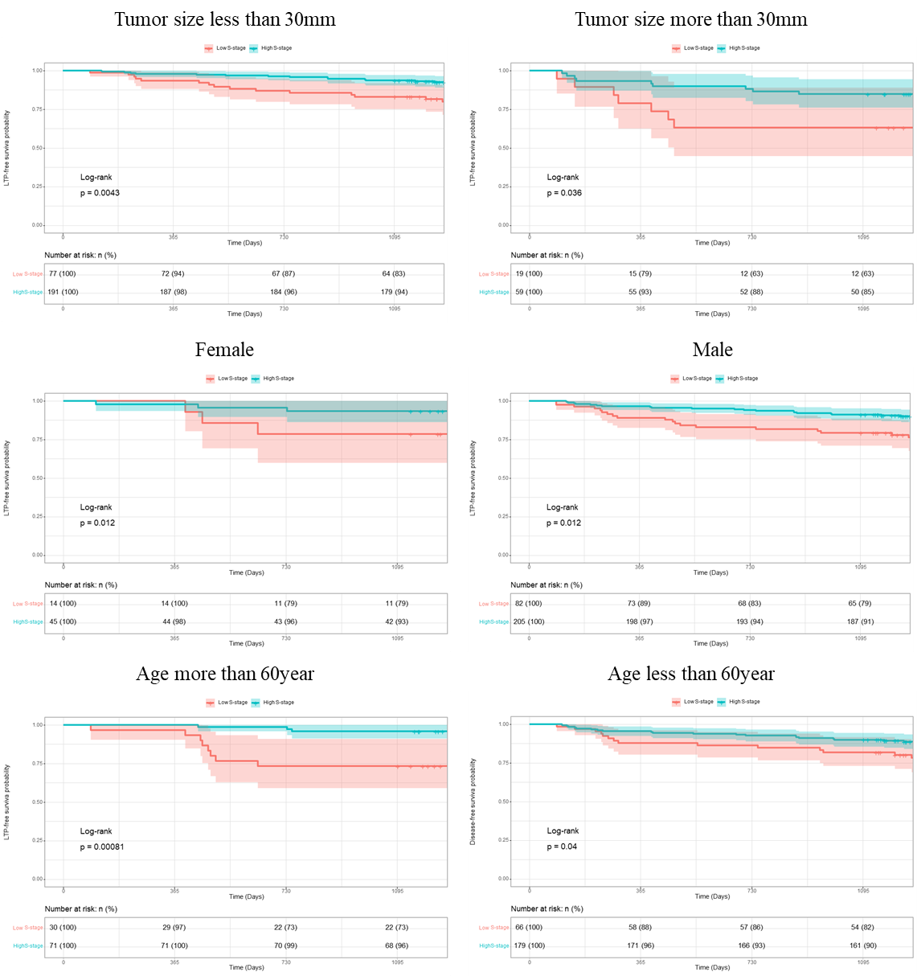
Supplementary Figure 1: Subgroup analysis of fibrosis groups on LTP

Table S1: Difference of ablation parameter between Low and High fibrosis groups after treatment (Original)
 |  | Low fibrosis group | High fibrosis group | p
 |  | N=96 | N=250
Clinical baseline
Sex (%) | Female | 14 (14.6%) | 45 (18.0%) | 0.551
 | Male | 82 (85.4%) | 205 (82.0%)
Age (year) |  | 55.85±9.90 | 54.66±9.86 | 0.313
BMI |  | 23.23±2.85 | 23.36±3.21 | 0.737
Child (%) | A | 95 (99.0%) | 238 (95.2%) | 0.183
 | B | 1 (1.0%) | 12 (4.8%)
ALT (U/L) |  | 31.51±12.19 | 36.71±16.78 | 0.006
AST (U/L) |  | 34.25±19.38 | 36.44±18.61 | 0.334
ALB (g/L) |  | 40.66±4.54 | 39.44±4.62 | 0.027
TB (μmol/L) |  | 13.39±8.14 | 15.86±11.26 | 0.051
DB (μmol/L) |  | 4.99±3.18 | 6.82±6.97 | 0.014
PLT (10^9/L) |  | 135.67±61.28 | 121.75±60.83 | 0.058
INR |  | 1.10±0.14 | 1.11±0.12 | 0.458
AFP (%) | ≤20U/L | 57 (59.4%) | 130 (52.0%) | 0.266
 | ＞20U/L | 39 (40.6%) | 120 (48.0%)
Tumor Size (mm) |  | 23.52±9.75 | 23.60±9.49 | 0.948
Ablation parameter
Ablation volume  after treatment (mL) |  | 32.01±26.78 | 31.91±25.94 | 0.974
Ablation energy (J) |  | 22580.00±9364.67 | 33978.24±13659.27 | <0.001
Note: Values are mean ± standard deviation or number (%).
ALT=Alanine aminotransferase; AST=Aspartate aminotransferase; ALB=Serum albumin; TB=Total bilirubin; DB=Direct Bilirubin; PTL=Platelets; INR=International normalized ratio; AFP=Alpha fetoprotein.

Table S2: Difference of ablation parameter between Low and High fibrosis groups after one-month (Original)
 |  | Low fibrosis group | High fibrosis group | p
 |  | N=47 | N=131
Clinical baseline
Sex (%) | Female | 5 (10.6%) | 21 (16.0%) | 0.511
 | Male | 42 (89.4%) | 110 (84.0%)
Age (year) |  | 55.57±9.08 | 55.49±9.30 | 0.956
BMI |  | 23.02±2.85 | 23.08±2.78 | 0.905
Child (%) | A | 47 (100.0%) | 125 (95.4%) | 0.307
 | B | 0 (0.0%) | 6 (4.6%)
ALT (U/L) |  | 30.60±12.15 | 36.08±16.26 | 0.036
AST (U/L) |  | 35.72±21.98 | 35.47±19.17 | 0.94
ALB (g/L) |  | 40.83±5.05 | 39.39±4.52 | 0.071
TB (μmol/L) |  | 12.38±7.25 | 15.08±10.90 | 0.117
DB (μmol/L) |  | 4.73±2.36 | 6.86±8.14 | 0.081
PLT (10^9/L) |  | 145.72±67.30 | 121.62±63.50 | 0.029
INR |  | 1.10±0.12 | 1.11±0.12 | 0.838
AFP (%) | ≤20U/L | 27 (57.4%) | 72 (55.0%) | 0.902
 | ＞20U/L | 20 (42.6%) | 59 (45.0%)
Tumor Size (mm) |  | 22.55±9.41 | 24.04±10.02 | 0.377
Ablation parameter
Ablation energy (J) |  | 21651.06±9029.61 | 34614.96±14432.53 | <0.001
Ablation volume  after treatment (mL) |  | 29.35±23.37 | 33.50±27.86 | 0.362
Ablation volume  after one-month (mL) |  | 19.87±15.93 | 25.08±20.53 | 0.117
Volume reduction rate |  | 0.33±0.06 | 0.24±0.06 | <0.001
Note: Values are mean ± standard deviation or number (%).
ALT=Alanine aminotransferase; AST=Aspartate aminotransferase; ALB=Serum albumin; TB=Total bilirubin; DB=Direct Bilirubin; PTL=Platelets; INR=International normalized ratio; AFP=Alpha fetoprotein.

