Appendix A

Initial Design Sketches

Figure A1
Initial Sketch of the Design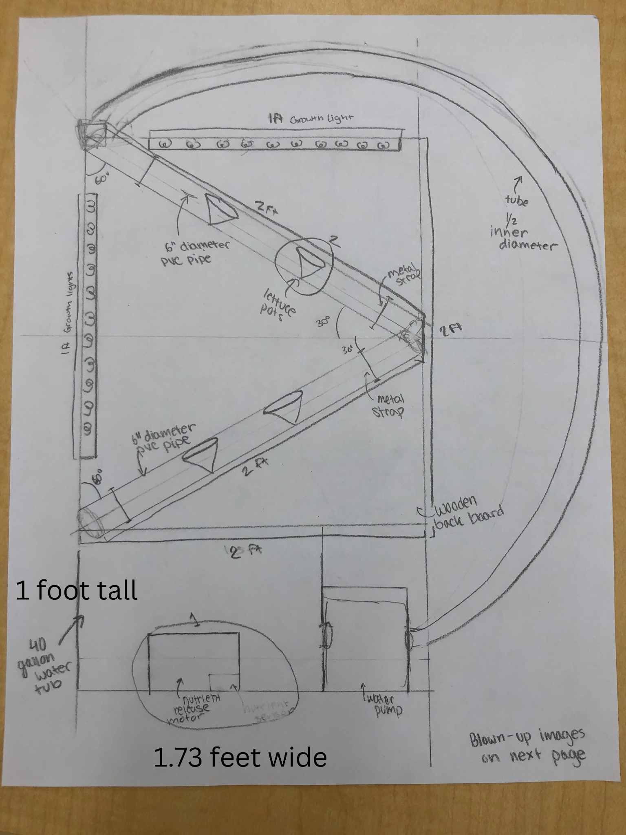
Figure A2
Original Designs for Lettuce Pots with Romaine Lettuce
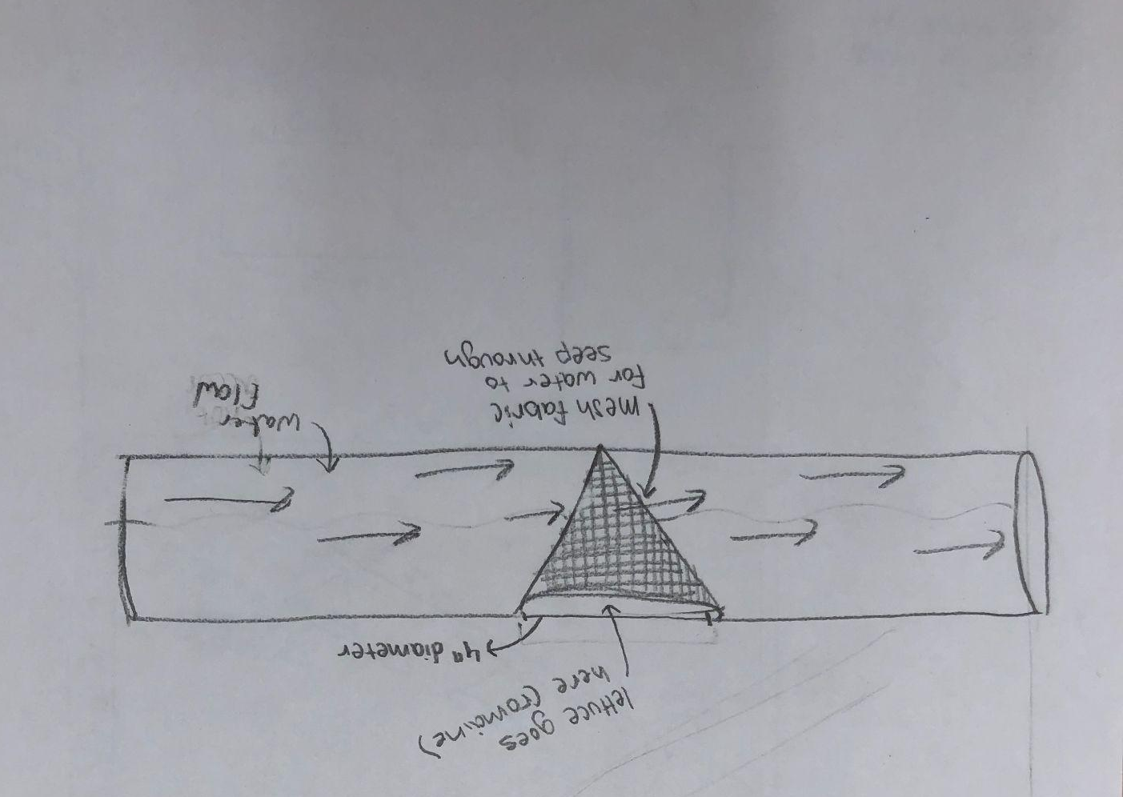

Appendix B

CAD Files Designs for the Project (Fusion File Linked)

Figure B1
3D View of the CAD Sketch of the original Design

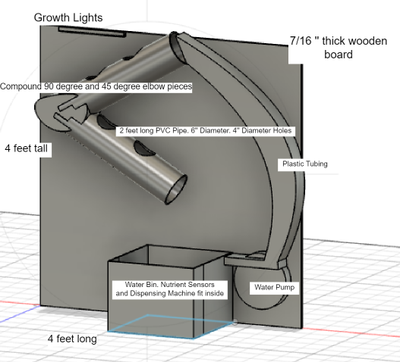

Figure B2
Front View of Original CAD Design
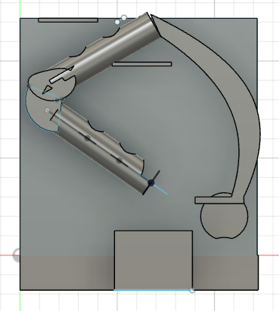

Appendix C

Steps of The Building Process

Figure C1
Initial Prototype
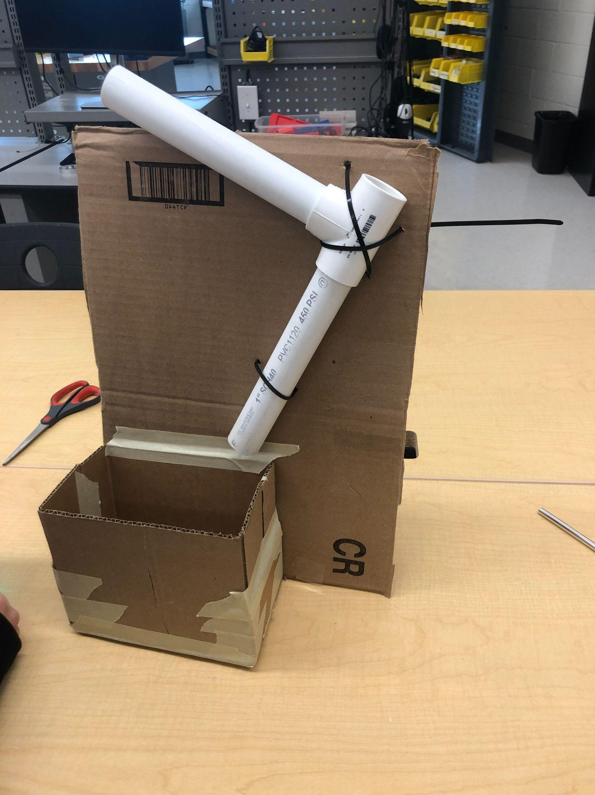

Figure C2
Cutting the Board

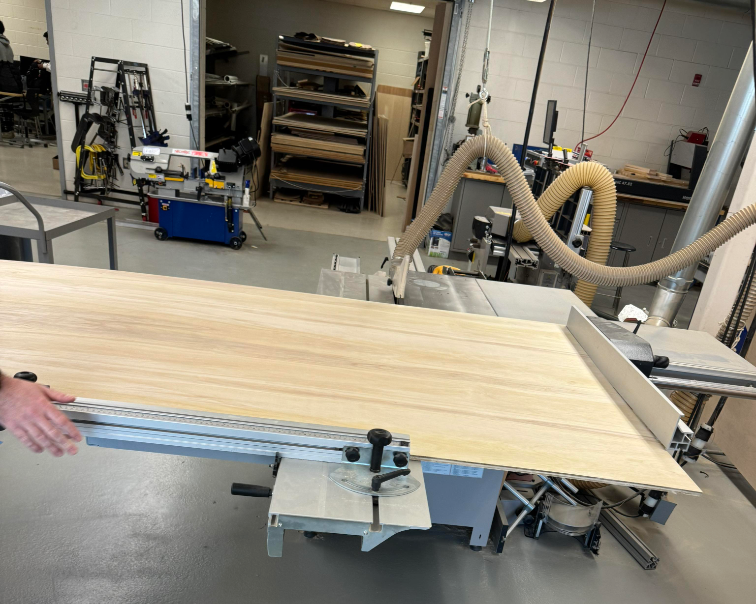

Figure C3
Attaching PVC to the Board
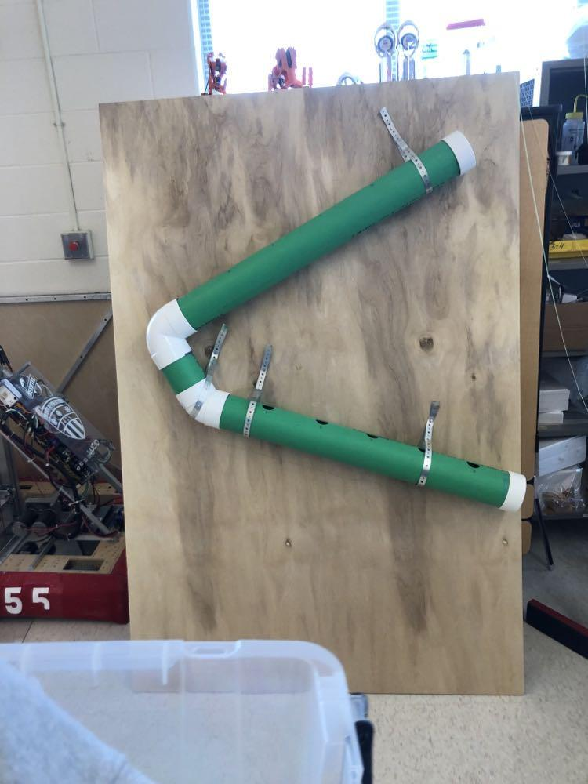

Appendix D

Final Design Images

Figure D1
Image of Overall Final Design
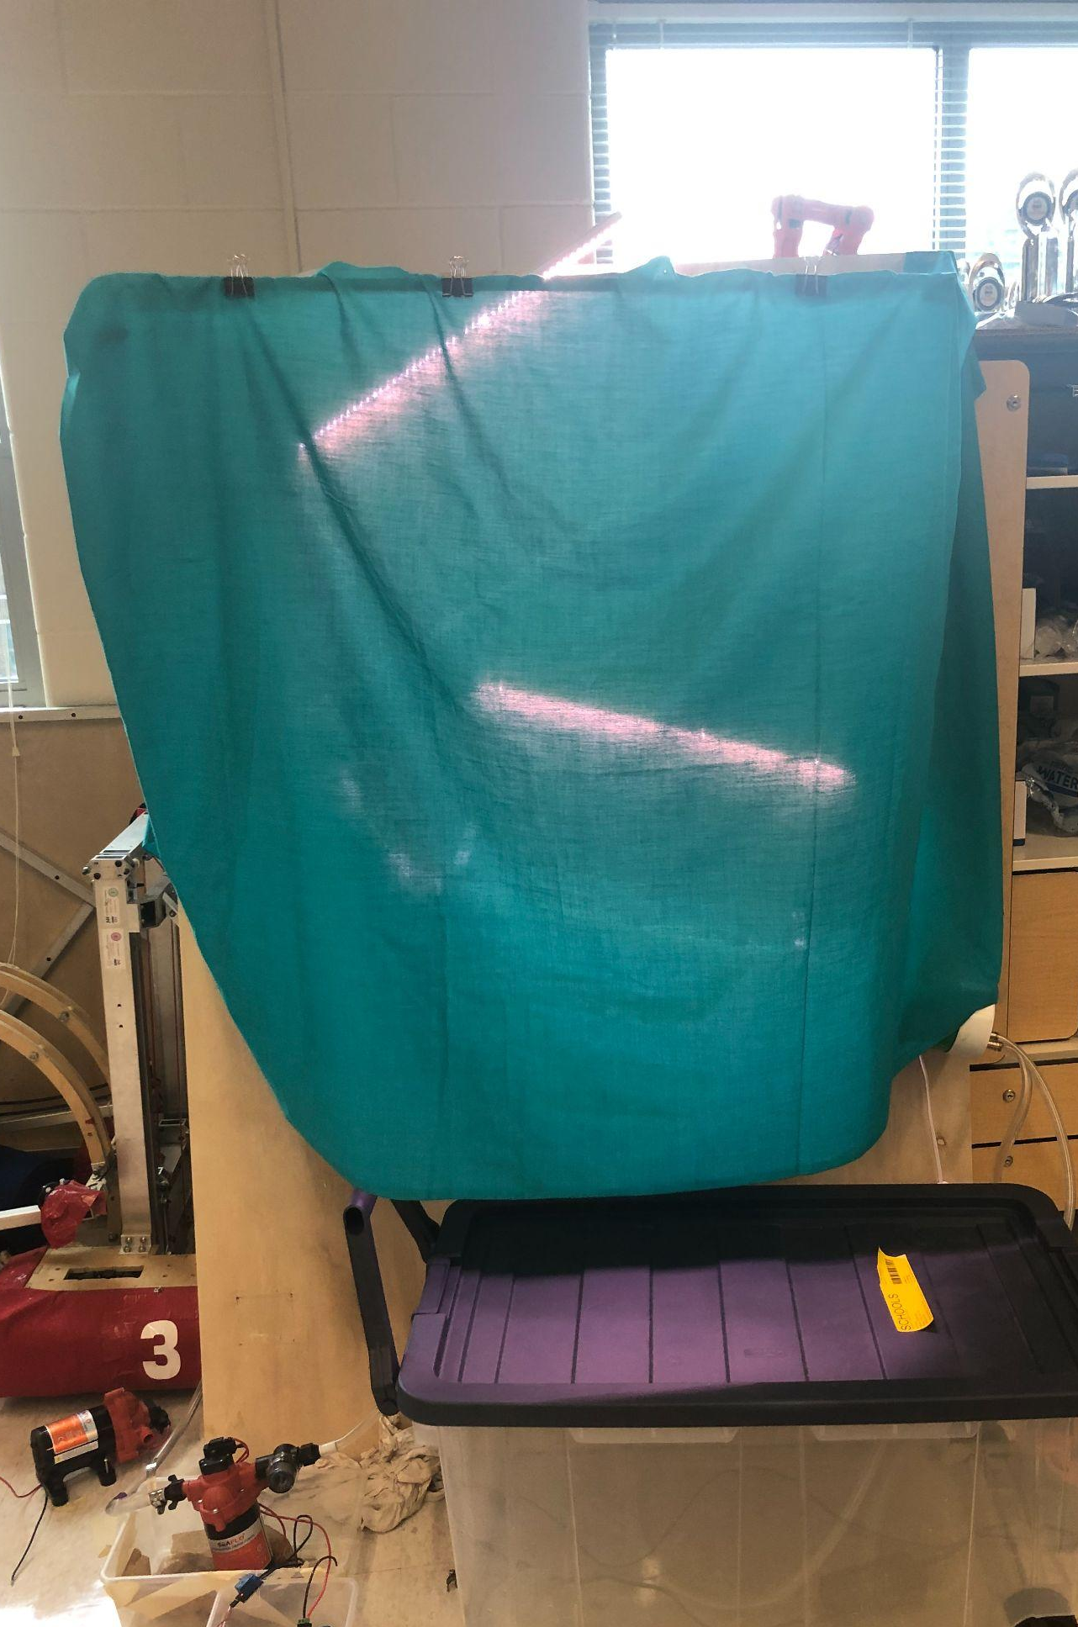

Figure D2
Early Lettuce Growth
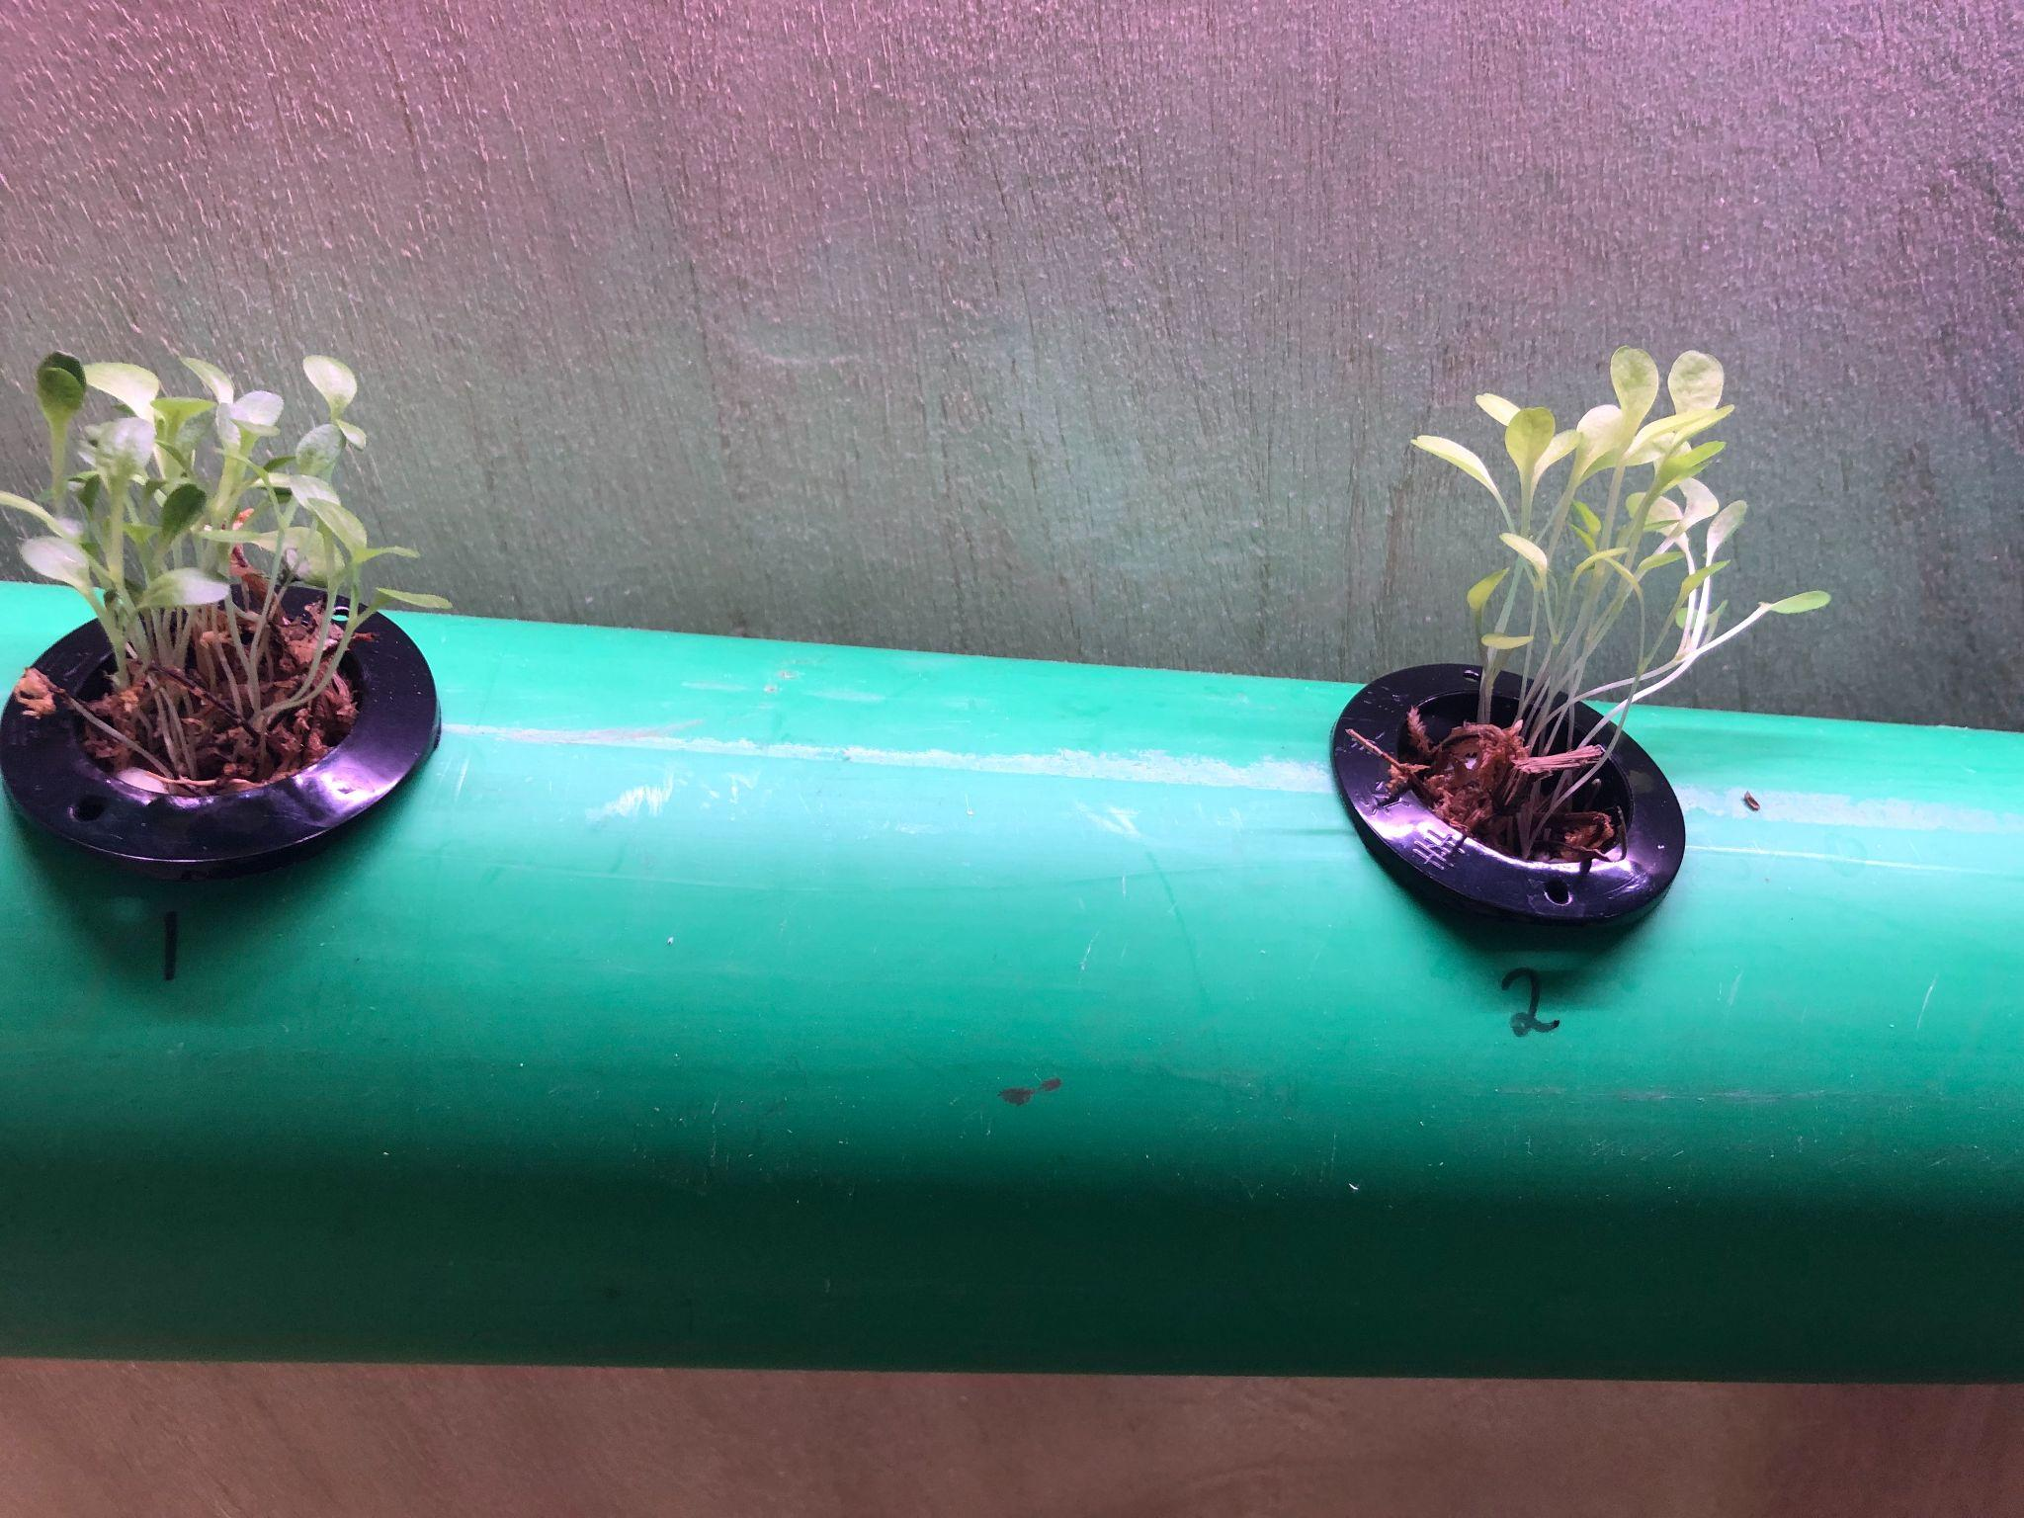

Figure D3
LED Growth Lights
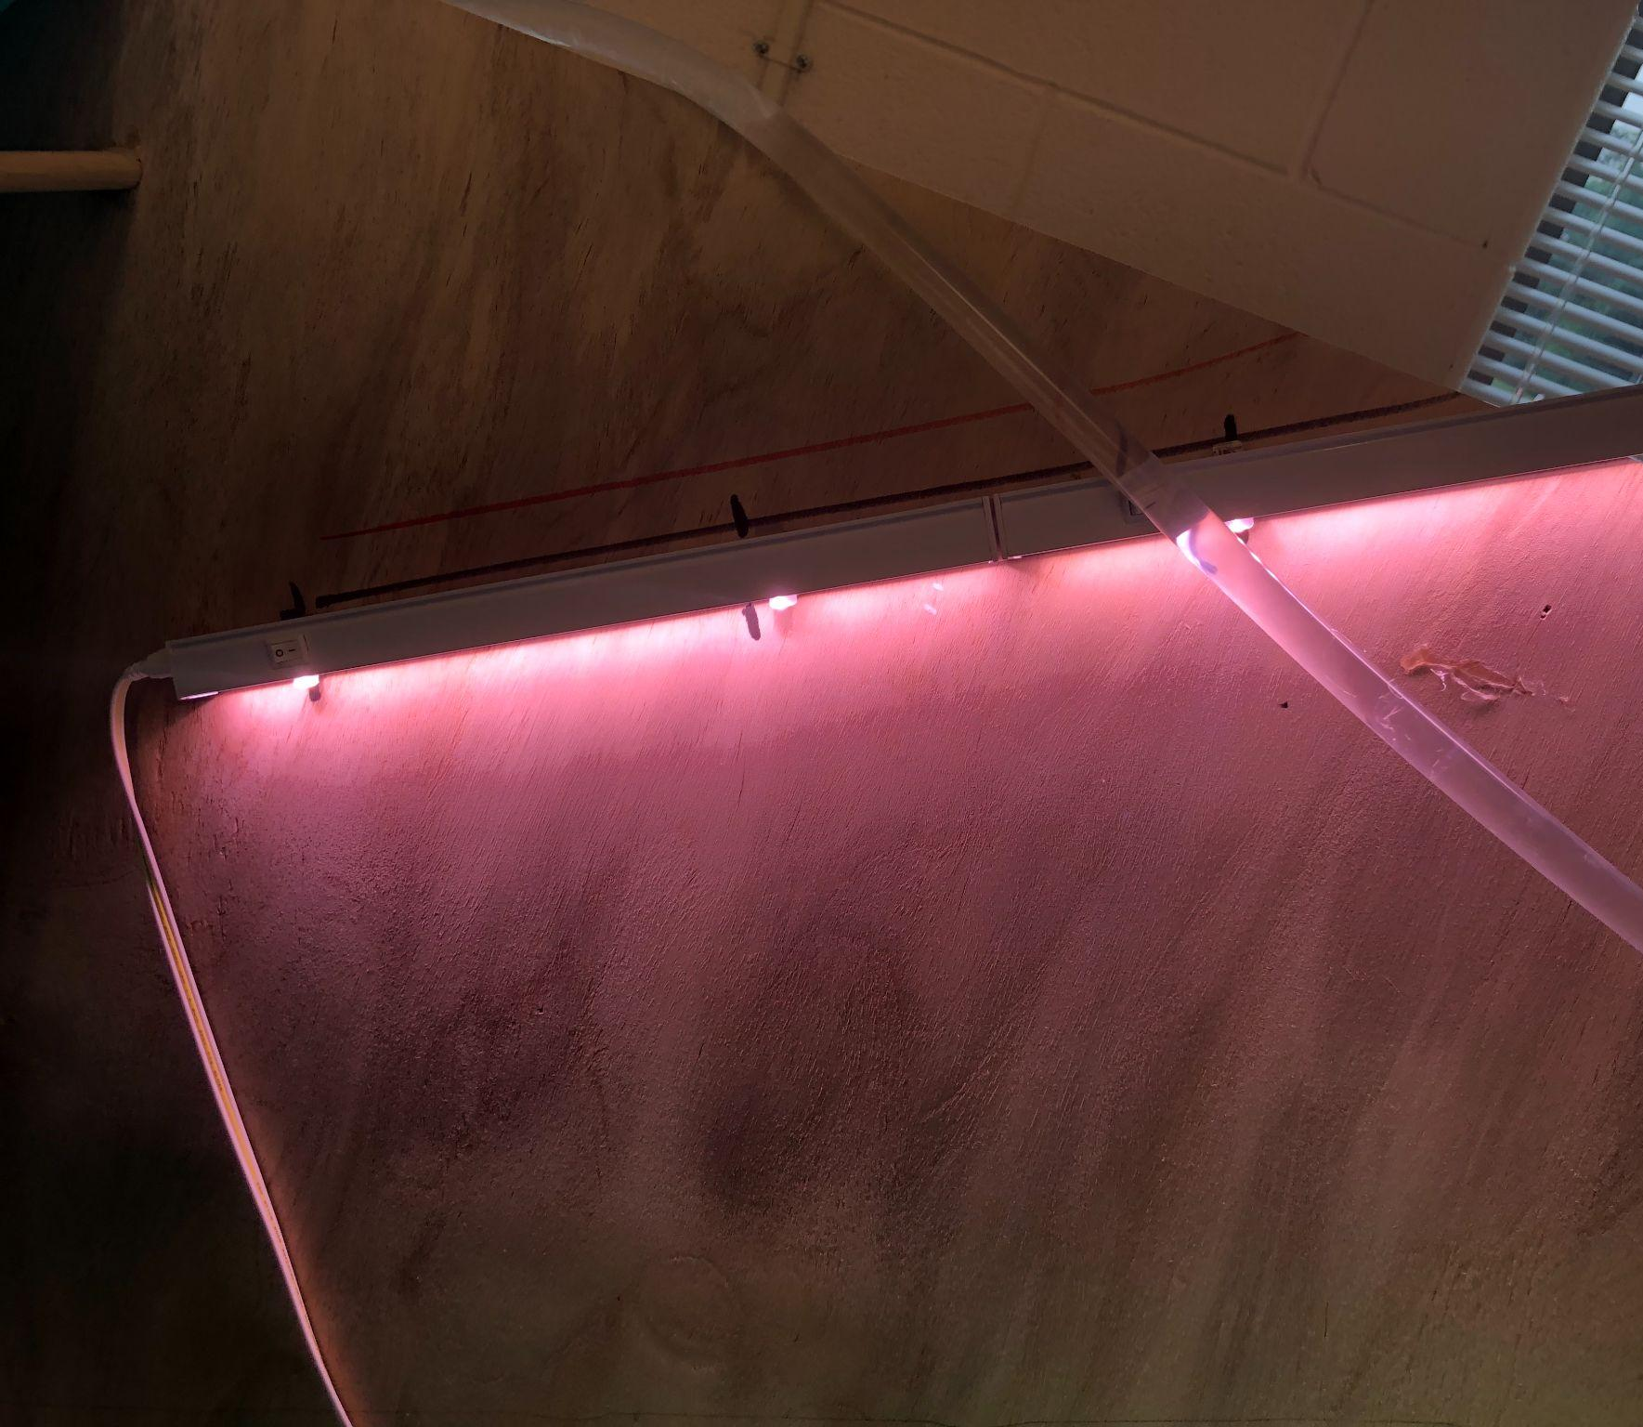

Figure D4
Water Pump Arduino Controller
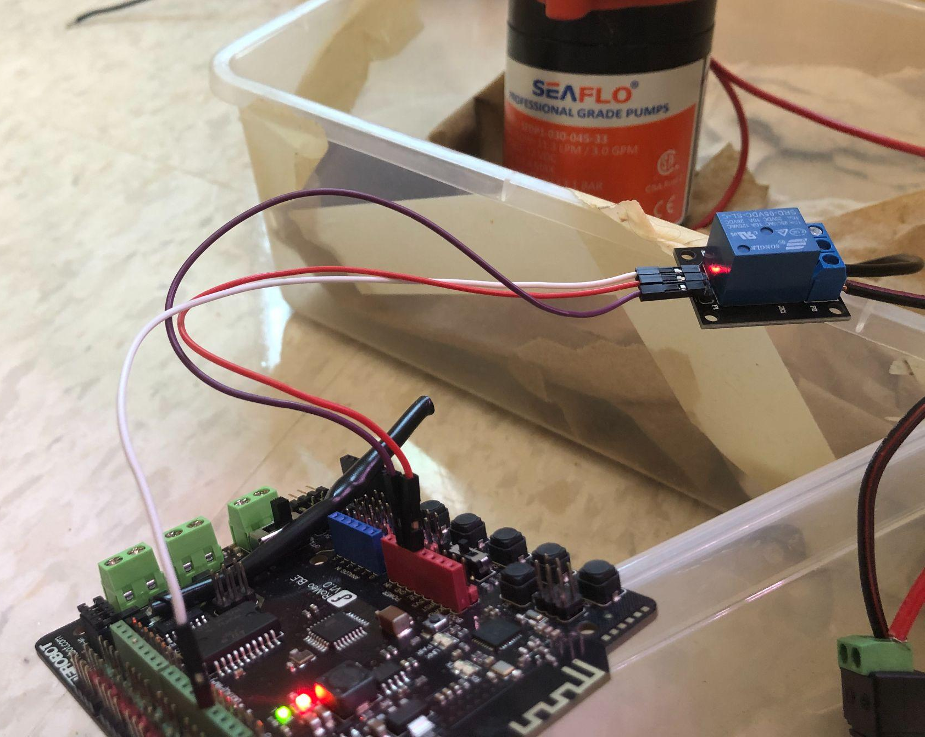

Figure D5
Water Outtake Taps
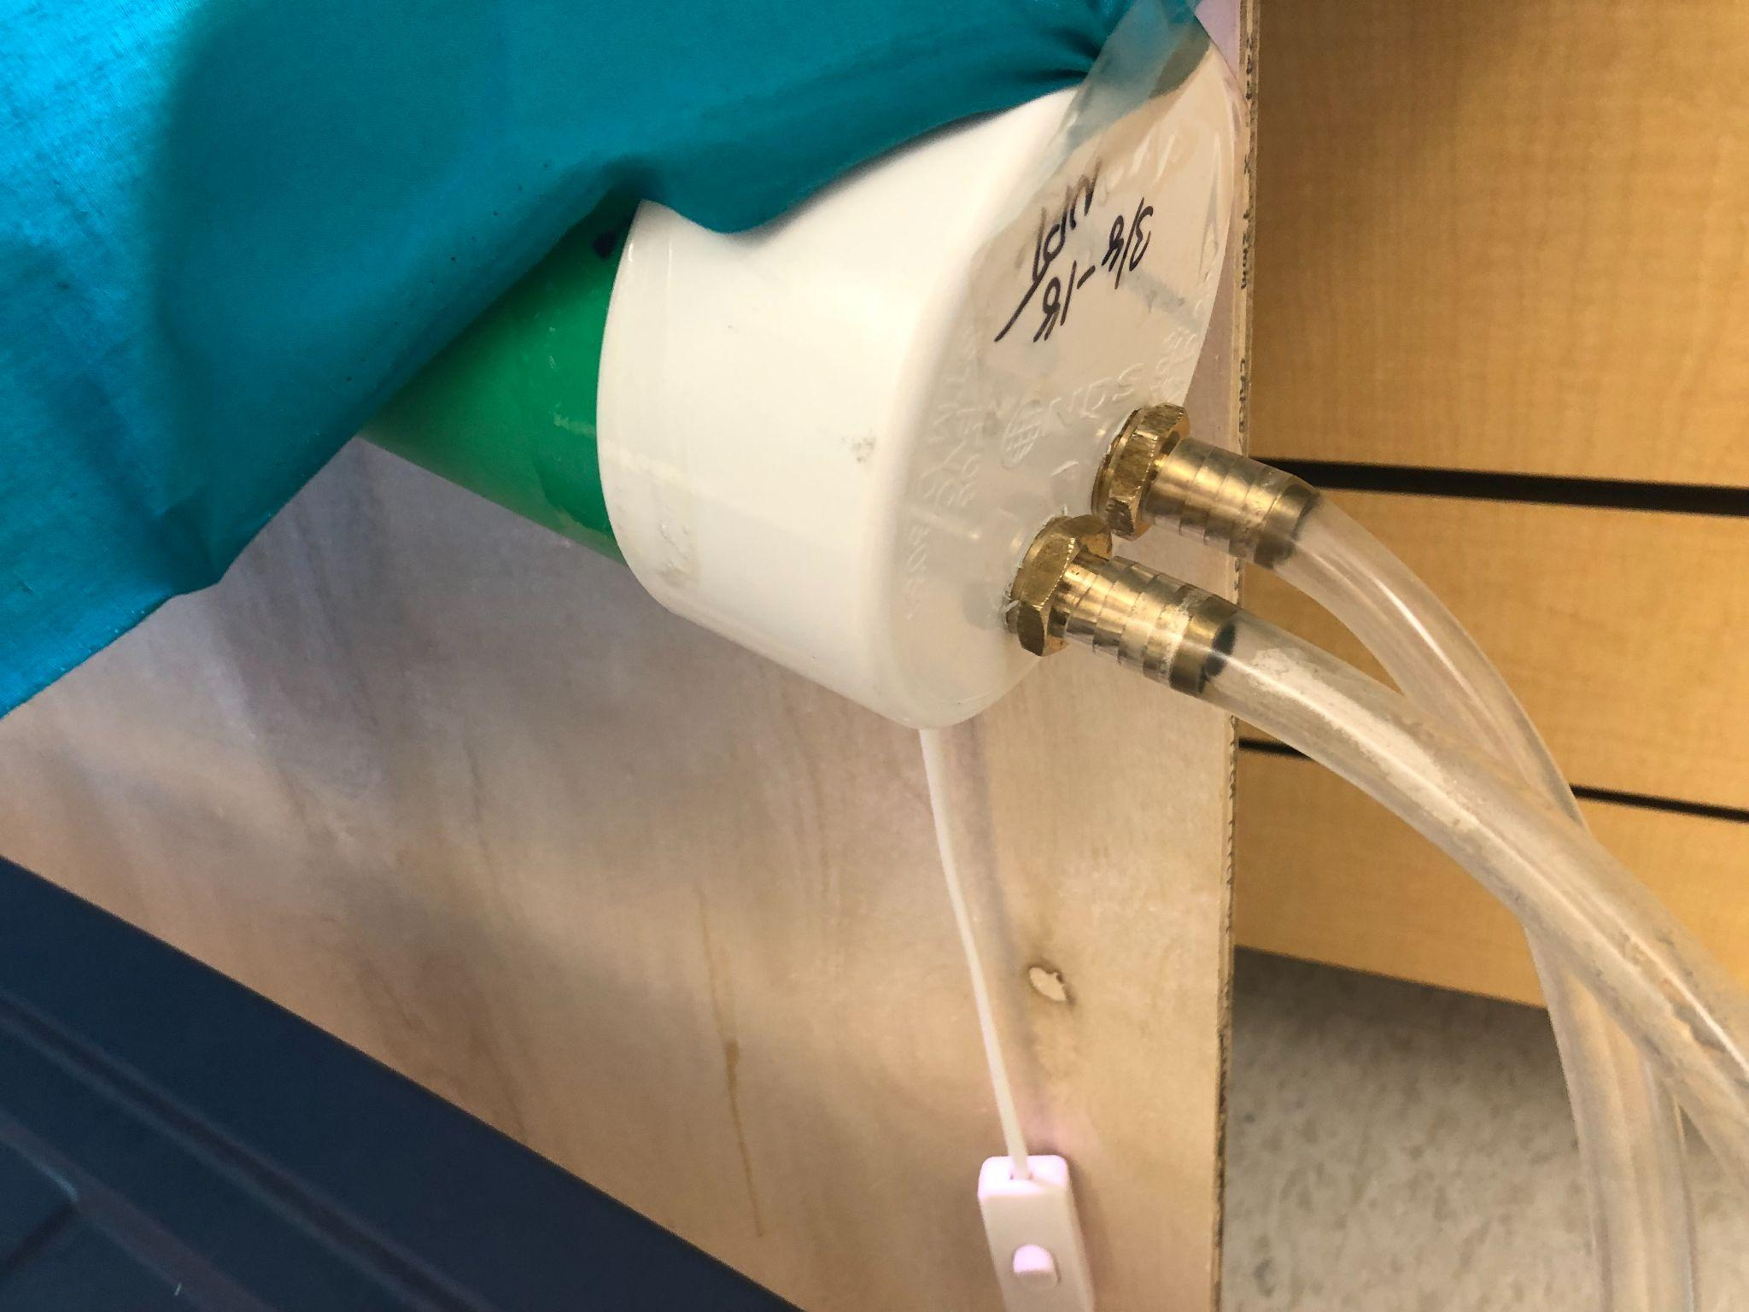

Appendix E (Bill of Materials)
Table E1
Final Bill of Materials
Material | Price per Component | Quantity | Total Cost | Link
4’’ Diameter PVC Pipe | $3.87 /ft. | 10 feet | $38.65 | link
Water Collection Tub | $44.98 | 1 | $44.98 | link
Nutrient Solution | $4.75/30 mL | 150ml | $23.75 | link
Water Pump with at least 10 feet range | $49.99 | 1 | $49.99 | link
UV Growth Lights | $7.50 | 4 | $29.99 | link
Plastic Tubing | $11.65 | 10 feet | $11.65 | link
3/4 in. x 25 ft. 28-Gauge Galvanized Pipe Hanger Strap | $9.62 | 1 | $9.62 | link
7/16’’ thick wooden board (at least 4 feet by 4 feet) | $14.90 | 1 board | $14.90 | link
4-inch 90-degree elbow | $4.95/piece | 1 | $4.95 | link
4-inch 45-degree elbow | $3.88/piece | 1 | $3.88 | link
(Marine Caulk) LifeSeal Sealant - White, 10.6 oz | $28.98/ bottle | 10.6oz | $28.98 | link
Arduino UNO R4 Minima | $22.54/ one | 1 | $22.54 | link
Female Power Plug to 2-Pin Terminal (Screw Down) Adapter | $6.44/ one | 1 | $6.44 | link
3 Channel Relay Module | $3.36/ one | 1 | $3.36 | link
Oakleaf Lettuce Seeds (1 gram packet) | $2.99/ packet | 1 | $2.99 | link
44’’ by 72’’ Solid Blue Fabric | $6.27 | 1 | $6.27 | link
Hydroponic Wicking Cotton Rope | $4.37 | 30 feet | $4.37 | link
PVC Primer and Glue | $10.94 | 8 oz of each | $10.94 | link
Sphagnum Moss | $7.97/bag | 432 in^3 | $7.97 | link
Total Cost: |  |  | $326.22

