Supplementary Fig 1. The study design of FMT experiment.

Supplementary Fig 2. The quality control of 16S rRNA sequencing. (a rarefaction curve; b species accumulation curves; c rank abundance curve)
Supplementary Fig 3. The significant differences in bile acid profiles between NC and MC group.

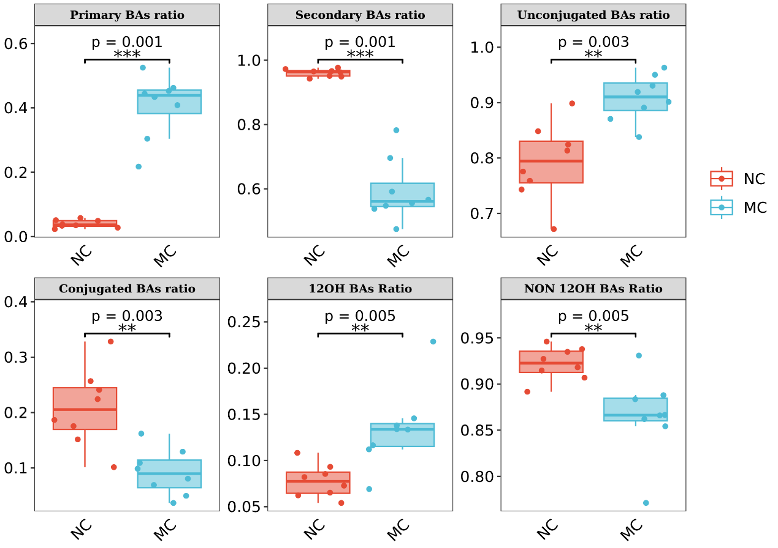
Supplementary Fig 4. The cecum BAs classes level of rats between NC and MC group.

Supplementary Fig 5. The effect of antibiotics treatment on gut microbiota. a The number of OTUs before and after antibiotics treatment; b The α-diversity index before and after antibiotics treatment. c Principal coordinate analysis (PCoA) score plots based on unweighted_unifrac distance before and after antibiotics treatment d Relative abundance of top 10 genus before and after antibiotics treatment; e NMDS analysis based on unweighted_unifrac distance before and after antibiotics treatment Pre-anti: before antibiotics treatment; Aft-anti: after antibiotics, n=16 individuals/group.

Supplementary Fig 6. The effect of FMT on gut microbiota. a The α-diversity index before and after FMT. b Relative abundance of top 10 genus before and after FMT; MC: model group; Aft-anti: after antibiotics; FMT-Con: recipient group supplied with fecal suspension from MC; FMT-H400: recipient group supplied with fecal suspension of 400μL from MC-HWGO; FMT-H800: recipient group supplied with fecal suspension of 800μL from MC-HWGO n=4 individuals/group.

