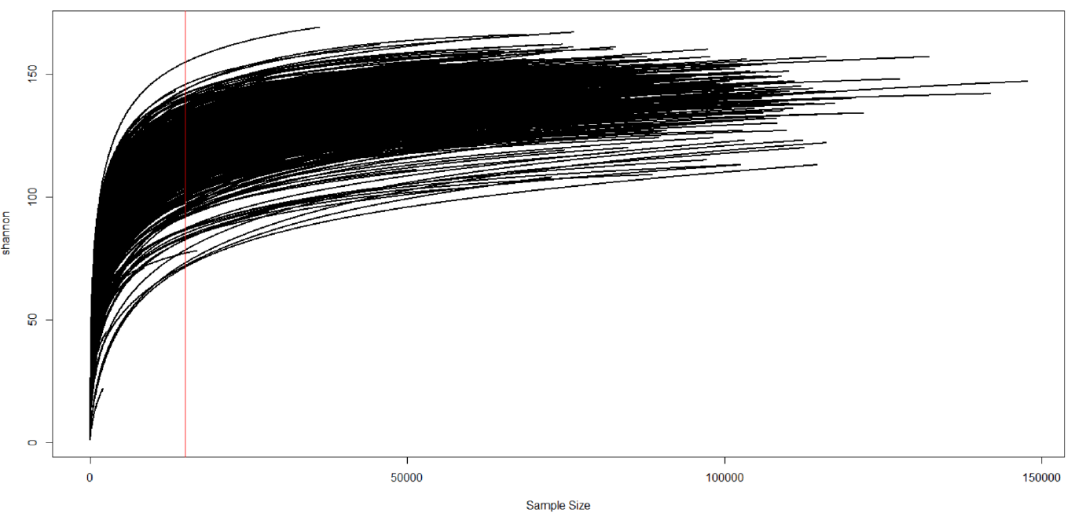
Additional file 2. Rarefaction curve of all samples. Shannon is displayed. The red line at 15 000 reads per sample indicates the read depth chosen for rarefication.

