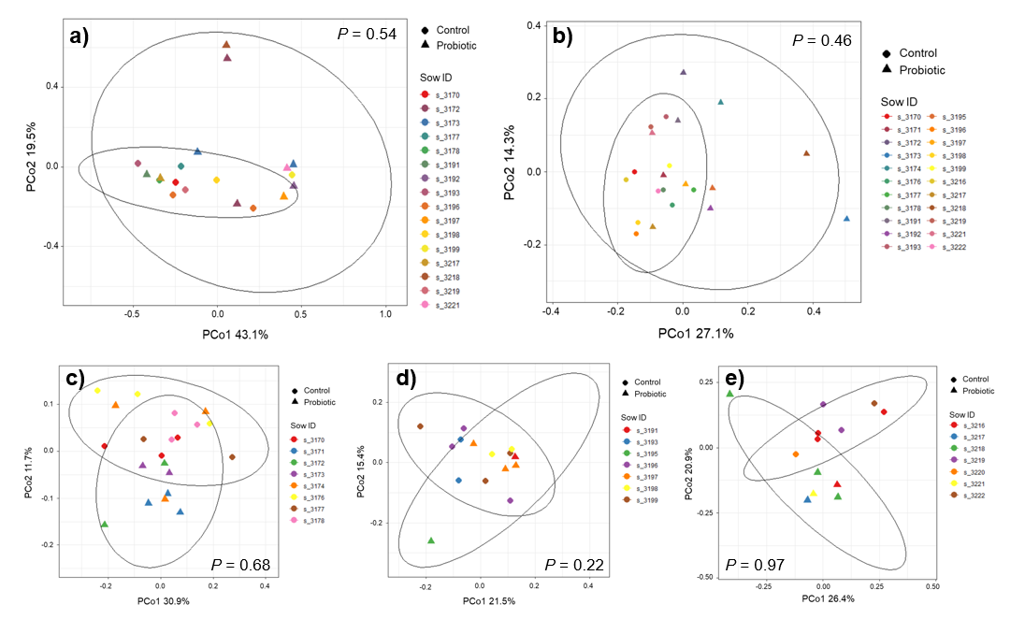
Additional file 3. Principal coordinates analysis (PCoA) of Bray-Curtis dissimilarity between the Control and Probiotic group on day 35. Bray-Curtis distance metrics were used to compare the composition of the microbiota between the two treatment groups in a) small intestinal mucosa, b) digesta of the proximal colon, and feces in round c) 1, d) 2, and e) 3. Nested permutational multivariate analysis of variance (PERMANOVA) on Bray-Curtis distance metrics with sow ID nested with treatment group was carried out using 999 permutations to test for significance of clustering pattern. P-values for the effect of sow are illustrated. P < 0.05 was considered significant whereas P < 0.10 was considered as a statistical tendency.

