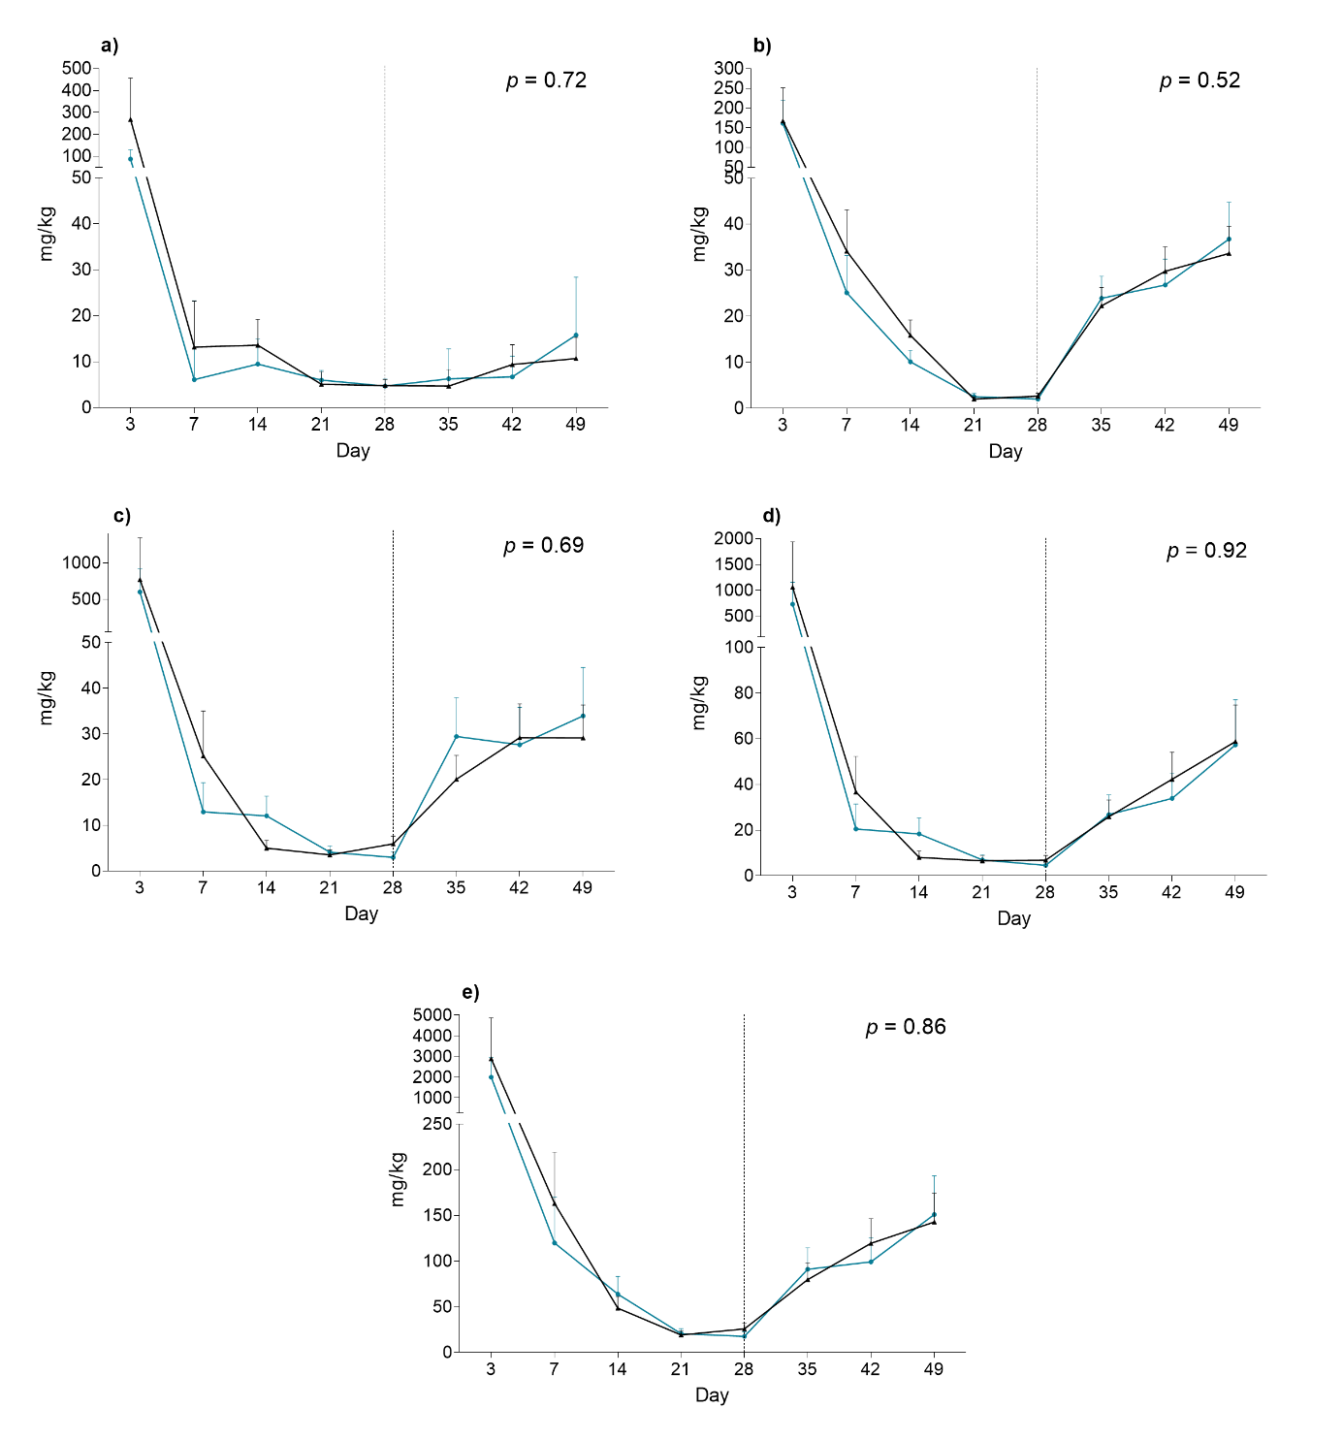
Additional file 8. Effect of early probiotic inoculation on the biogenic amines a) tyramine, b) agmatine, c) putrescine, d) cadaverine, and e) the total concentration of biogenic amines in feces (mg/kg). The dotted line illustrates the day of weaning. Values are presented as least square means and SE, and the P-value for effect of probiotic treatment is stated. Number of samples: Control d3 = 3, d7 = 12, d14 = 21, d21 = 26, d28 = 27, d35 = 27, d42 = 27, d50 = 28. Probiotic d3 = 6, d7 = 8, d14 = 15, d21 = 22, d28 = 18, d35 = 21, d42 = 20, d50 = 18.

