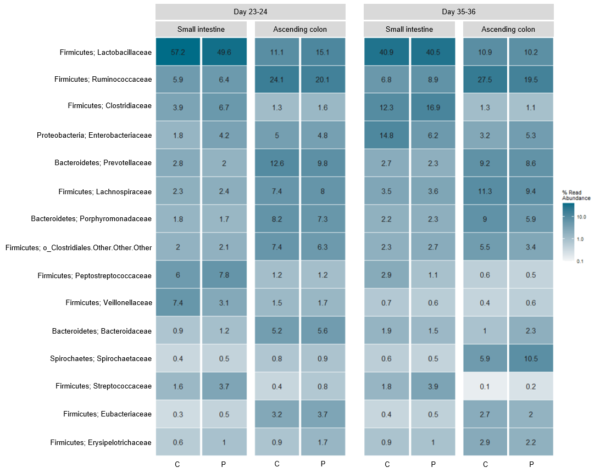
Additional file 6. Heatmap of digesta samples collected from the small intestine and ascending colon (CO1) at day 23-24 (pre-weaning) and day 35-36 (post-weaning). Pigs were administered placebo (C) or probiotics (P) during suckling (d1-28). The heatmap shows the relative abundance (%) of the 15 most abundant families in digesta. Colors represent relative abundance. Number of samples: Control d23-24 = 33, d35-36 = 26. Probiotic d23-24 = 32, d35-36 = 26.

