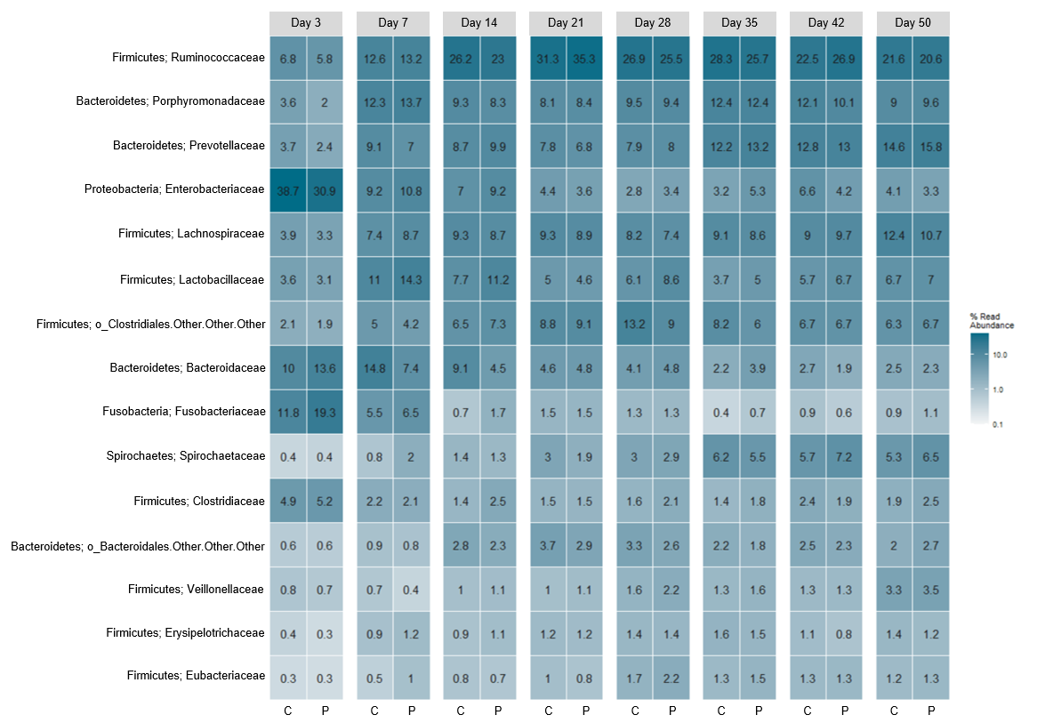
Additional file 4. Heatmap of fecal samples collected at day 3, 7, 14, 21, 28, 35, 42 and 50 from pigs administered placebo (C) or probiotics (P) during suckling (d1-28). The heatmap shows the relative abundance (%) of the 15 most abundant families in feces. Colors represent relative abundance. Number of samples: Control d3 = 21, d7 = 33, d14 = 29, d21 = 29, d28 = 28, d35 = 28, d42 = 28, d50 = 27. Probiotic d3 = 29, d7 = 32, d14 = 25, d21 = 24, d28 = 21, d35 = 21, d42 = 21, d50 = 21.

