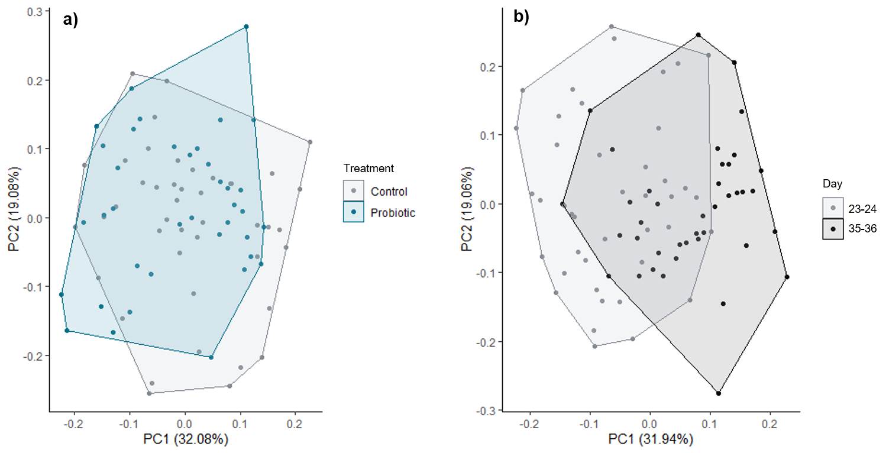
Additional file 7. Principle component analysis (PCA) plot on Log₂ transformed gene expression data discriminated between samples belonging to a) the two different treatment groups (Control and Probiotic), or b) the two different time points (day 23-24 or day 35-36). Number of samples: Control d23-24 = 22, Control d35-36 = 22. Probiotic d23-24 = 20, Probiotic d35-36 = 18.

