Fig. S1 The expression of tryptophan metabolism genes in different immune cell activities of colon cancer was explored by the TISCH database.
TISCH, Tumor Immune Single-cell Hub.

Fig. S2 Correlation between the risk score and clinicopathological characteristics in different clinical subgroups
A the relationship between transcriptomic expression profiles and clinical features of the five genes constructing the model. B the difference in risk scores between different typing states. Differences in risk scores between different clinical features C pathological stage. D tumor size. E number of lymph nodes and F metastasis. T, Tumor; N, Node; M, Metastasis; * p< 0.05, * p<0.01 and *** p< 0.001.

Fig. S3 Prognostic validation of the risk score model in other colon cancer.
A C-index values for different scoring models. B RMS for different scoring models.
C-index,concordance index. RMS, Restricted Mean Surviva.

Fig. S4 Validation of the tryptophan metabolic risk score model in other bowel cancer datasets and datasets for chemotherapy and immunotherapy
A OS of GSE39582(n=585). B RFS of GSE39582(n=585). C OS of GSE103479(n=156). D PFS of GSE19862(n=14) with bevacizumab. E OS of GSE107797(n=25)with ACT in melanoma patients. F PFS of GSE107797(n=25)with ACT in melanoma patients. OS,Overall Survival;RFS, Recurrence free survival. PFS, Progression-Free Survival. ATC, adoptive T cell therapy.

Fig. S5 Validation of the tryptophan metabolism risk score model in pan-cancer
Overall Survival analysis for the TCGA pan-cancer cohort A HNSC. B KIRC. C LAML. D LIHC. E PAAD. F READ.G SARC. H THCA. I UVM. HNSC, Head and Neck squamous cell carcinoma; KIRC, Kidney renal clear cell carcinoma; LAML, Acute Myeloid Leukemia; LIHC, Liver hepatocellular carcinoma; PAAD, Pancreatic adenocarcinoma; READ, Rectum adenocarcinoma; SARC, Sarcoma; THCA, Thyroid carcinoma; UVM, Uveal Melanoma.

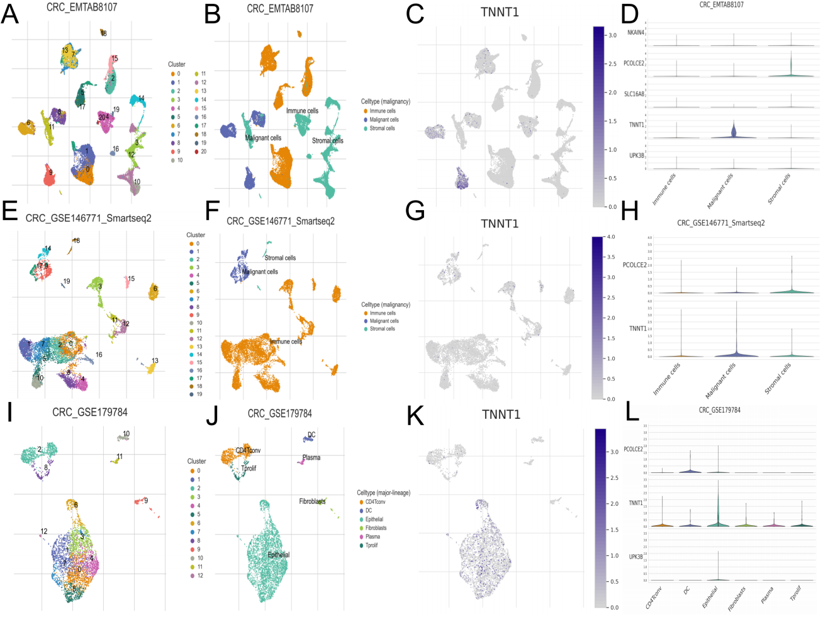

Fig. S6 Expression of signature genes of tryptophan metabolism in epithelial and malignant cells in colon cancer.

A UMAP of EMTAB8107. B cell annotation of EMTAB8107. C projection of TNNT1 in subsets of malignant EMTAB8101 cells. D expression of characteristic gene in EMTAB8107 cell subset. E UMAP of GSE146771. F cell annotation of GSE146771. G projection of TNNT1 in GSE146771 malignant cell subset H expression of characteristic gene in GSE146771 cell subset. I UMAP of GSE179784. J cell annotation of GSE179784. K projection of TNNT1 in GSE179784 epithelium. L expression of characteristic genes in subsets of GSE179784 cells. UMAP, uniform manifold approximation and projection.

