The significance of reproduction-related traits for wet meadow species survival in a fragmented landscape.

Antigoni Sounapoglou¹, Štěpán Janeček¹, Michael Bartoš³, Eliška Chmelová¹, Sylvain Delabye^{1,2}, Jan Horník⁵, Jana Jersáková⁴, Šárka Jiráská⁵, Yannick Klomberg¹, Vincent Maicher^{1,6}, Robert Tropek^{1,2}, Petra Janečková¹

1 Department of Ecology, Faculty of Science, Charles University, Viničná 7, CZ-12844 Prague, Czechia
2 Institute of Entomology, Biology Centre, Czech Academy of Sciences, Branišovská 31, CZ-37005 České Budějovice, Czechia
3 Institute of Botany, Czech Academy of Sciences, Dukelská 135, CZ-37901 Třeboň, Czechia
4 Department of Ecosystem Biology, Faculty of Science, University of South Bohemia, Branišovská 1760, CZ-37005 České Budějovice, Czechia
5 Nature Conservation Agency of the Czech Republic, Regional Department East Bohemia, Jiráskova 1665, CZ-530 02 Pardubice, Czechia
6 The Nature Conservancy Gabon, Impasse Edowangani, Libreville, Gabon

Corresponding author: Antigoni Sounapoglou
antigonesounapoglou@gmail.com
orchid number: https: 0000-0001-9244-620X

Table S1. Focal wet meadow species and their traits considered.
Highlighted cells show values obtained from other sources; Cells in blue were taken from: Slavík B. (Ed.) (1997): KVĚTENA ČR, díl 5, Academia, Praha, 560 str., Slavík B., Štěpánková J. (Eds.) (2004): KVĚTENA ČR, díl 7, Academia, Praha, 767 str., ION, N., & Ion, V. (2007) and the cell in yellow was taken from: Melliferous characteristics of spontaneous Lamiaceae species, identified in the Danube Valley.

species | functional-group specialisation | primary pollinator | number of flowers | flower size | flower height from ground | flower colour | flower tube length | nectar production per flower | nectar production per plant | nectar guides | flowering duration | dichogamy | self-compatibility | clonality
Ajuga reptans | 3 | bumblebee | 13.675 | 7.783 | 14.163 | magentas non-bright | 7.717 | 0.215 | 2.940 | 1 | 4 | 0 | 2 | 5
Betonica officinalis | 7 | butterfly | 27.700 | 7.264 | 61.413 | magentas bright | 8.616 | 0.145 | 4.006 | 1 | 2 | 0.2 | 1 | 2
Bistorta officinalis | 5 | honey bee | 79.078 | 4.837 | 60.325 | magentas bright | 1.050 | 0.060 | 4.729 | 0 | 3 | 1 | 2 | 2
Caltha palustris | 4 | hoverfly | 2.613 | 25.892 | 15.125 | yellow bright | 0.000 | 0.001 | 0.002 | 0 | 3 | 0 | 4 | 3
Cirsium oleraceum | 7 | bumblebee | 91.225 | 2.616 | 103.588 | white yellow mid-bright | 5.865 | 0.065 | 5.889 | 0 | 4 | 0.799 | 2 | 4
Cirsium palustre | 8 | honey bee | 259.899 | 2.096 | 104.010 | magentas non-bright | 3.849 | 0.011 | 2.888 | 0 | 3 | 0.799 | 1 | 3
Crepis paludosa | 3 | honey bee | 34.867 | 6.541 | 48.366 | UV yellow bright | 3.053 | 0.010 | 0.344 | 0 | 3 | 0.799 | 4 | 3
Epilobium palustre | 1 | hoverfly | 1.400 | 8.300 | 30.309 | magentas bright | 2.080 | 0.031 | 0.044 | 1 | 3 | 0.799 | 3 | 5
Filipendula ulmaria | 7 | beetle | 68.407 | 6.269 | 98.508 | white yellow mid-bright | 0.000 | 0.000 | 0.030 | 0 | 3 | 0.2 | 1 | 4
Galium palustre | 2 | other fly | 22.581 | 2.815 | 38.778 | white light blue bright | 0.747 | 0.001 | 0.012 | 0 | 5 | 0.3998 | 4 | 4
Galium uliginosum | 3 | hoverfly | 25.483 | 2.579 | 35.332 | white yellow mid-bright | 0.000 | 0.002 | 0.058 | 0 | 4 | 0.3998 | 4 | 0
Geum rivale | 2 | bumblebee | 1.293 | 11.082 | 30.801 | yellow white non-bright | 0.000 | 0.481 | 0.622 | 0 | 4 | 0.3998 | 2 | 3
Glechoma hederacea | 4 | bumblebee | 1.975 | 10.850 | 9.335 | magentas bright | 12.000 | 0.217 | 0.429 | 1 | 3 | 0.799 | 2 | 6
Hypericum maculatum | 4 | honey bee | 3.355 | 22.163 | 53.684 | UV yellow bright | 0.000 | 0.000 | 0.002 | 0 | 2 | 0 | 4 | 5
Lathyrus pratensis | 4 | other bee | 4.433 | 9.387 | 54.792 | yellow white non-bright | 7.321 | 0.110 | 0.487 | 1 | 3 | 0 | 4 | 5
Lotus pedunculatus | 3 | bumblebee | 7.588 | 9.439 | 41.150 | yellow bright | 7.857 | 0.001 | 0.011 | 1 | 2 | 0 | 4 | 0
Lysimachia vulgaris | 2 | hoverfly | 45.338 | 14.015 | 76.125 | yellow bright | 2.621 | 0.001 | 0.040 | 1 | 3 | 0 | 4 | 5
Lythrum salicaria | 6 | hoverfly | 16.448 | 17.581 | 76.775 | magentas non-bright | 5.976 | 0.176 | 2.891 | 1 | 3 | 0 | 2 | 0
Mentha arvensis | 3 | other fly | 46.700 | 3.380 | 51.559 | magentas non-bright | 2.700 | 0.400 | 18.680 | 0 | 5 | 0.799 | 1 | 5
Myosotis sp. | 3 | other fly | 6.237 | 7.357 | 29.163 | white light blue bright | 2.633 | 0.004 | 0.024 | 1 | 5 | 0 | 4 | 5
Peucedanum palustre | 4 | other fly | 443.525 | 2.878 | 67.000 | yellow white non-bright | 0.000 | 0.017 | 7.653 | 0 | 2 | 1 | 1 | 0
Potentilla erecta | 3 | hoverfly | 1.283 | 11.367 | 14.575 | UV yellow bright | 0.000 | 0.080 | 0.103 | 1 | 4 | 0 | 4 | 2
Potentilla palustris | 6 | hoverfly | 1.050 | 16.978 | 28.550 | dark red non-bright | 0.000 | 3.300 | 3.465 | 0 | 2 | 0.799 | 3 | 4
Primula elatior | 2 | bumblebee | 3.500 | 14.770 | 21.575 | white yellow mid-bright | 3.600 | 0.104 | 0.364 | 1 | 3 | 0 | 4 | 3
Prunella vulgaris | 4 | bumblebee | 5.017 | 5.667 | 26.724 | magentas non-bright | 7.828 | 0.012 | 0.059 | 1 | 4 | 0.2 | 3 | 5
Ranunculus acris | 4 | hoverfly | 1.847 | 16.457 | 54.588 | UV yellow bright | 0.000 | 0.053 | 0.097 | 0 | 5 | 0 | 4 | 3
Ranunculus auricomus | 3 | hoverfly | 1.429 | 12.353 | 25.754 | UV yellow bright | 0.000 | 0.014 | 0.021 | 1 | 2 | 0 | 1 | 3
Ranunculus flammula | 4 | hoverfly | 1.271 | 13.716 | 26.297 | UV yellow bright | 0.000 | 0.031 | 0.040 | 0 | 5 | 0.799 | 4 | 4
Ranunculus repens | 6 | other fly | 1.400 | 15.700 | 21.325 | UV yellow bright | 0.000 | 0.206 | 0.288 | 0 | 4 | 0 | 3 | 6
Sanguisorba officinalis | 4 | other fly | 44.403 | 4.058 | 72.972 | dark red non-bright | 0.000 | 0.008 | 0.337 | 0 | 4 | 0 | 3 | 2
Scorzonera humilis | 5 | other fly | 50.000 | 3.500 | 26.500 | UV yellow bright | 1.900 | 0.020 | 12.250 | 0 | 2 | 0.799 | 2 | 0
Scutellaria galericulata | 1 | hoverfly | 3.217 | 6.005 | 26.805 | magentas bright | 9.787 | 0.152 | 0.488 | 1 | 4 | 0.3998 | 1 | 6
Silene flos-cuculi | 5 | honey bee | 2.267 | 29.233 | 51.733 | magentas bright | 6.633 | 0.267 | 0.604 | 1 | 3 | 0.799 | 2 | 0
Stellaria graminea | 4 | hoverfly | 3.734 | 9.161 | 36.023 | white light blue bright | 0.000 | 0.119 | 0.443 | 0 | 3 | 0.799 | 2 | 4
Succisa pratensis | 6 | hoverfly | 35.000 | 2.000 | 46.000 | magentas non-bright | 1.800 | 0.098 | 3.441 | 0 | 3 | 0.799 | 2 | 2
Tephroseris crispa | 5 | hoverfly | 83.867 | 5.363 | 52.725 | UV yellow bright | 2.397 | 0.022 | 1.813 | 0 | 2 | 0.799 | 4 | 3
Trollius altissimus | 3 | other fly | 1.644 | 34.570 | 37.333 | yellow white non-bright | 0.000 | 0.002 | 0.003 | 0 | 2 | 0 | 4 | 3
Valeriana dioica | 4 | other fly | 37.800 | 3.438 | 24.000 | magentas bright | 1.863 | 0.003 | 0.103 | 1 | 2 | 0 | 2 | 4
Veronica chamaedrys | 4 | other fly | 1.700 | 11.175 | 26.713 | magentas non-bright | 1.550 | 0.154 | 0.262 | 1 | 3 | 0 | 4 | 4

- Table S2. Visitation rates of the nine pollinator functional groups after 3 24-hour video recordings, on the focal species in different localities.

species | Beetle | Bumblebee | Butterfly | Honey Bee | Hoverfy | Moth | Other Bee | Other Fly | Other Hymenopteran
Ajuga reptans |  | 22 | 3 |  | 7
Betonica officinalis | 5 | 156 | 361 |  | 13 | 7 | 91 | 3
Bistorta officinalis | 5 |  |  | 21 | 4 |  | 3 | 7
Caltha palustris |  |  |  | 15 | 77 |  | 3 | 41
Cirsium oleraceum |  | 422 | 6 | 5 | 26 | 22 | 88 | 7
Cirsium palustre | 3 | 14 | 7 | 370 | 177 | 10 | 9 | 13
Crepis paludosa |  |  |  | 25 | 8 |  | 15
Epilobium palustre |  |  |  |  | 8
Filipendula ulmaria | 106 |  | 4 | 90 | 64 | 3 |  | 58 | 11
Galium palustre |  |  |  |  | 9 |  |  | 40
Galium uliginosum | 8 |  |  |  | 29 |  |  | 14
Geum rivale |  | 77 |  |  | 3
Glechoma hederacea | 10 | 13 |  | 4 |  |  | 5
Hypericum maculatum |  | 7 |  | 129 | 55 |  |  | 4
Lathyrus pratensis | 7 | 46 |  | 5 |  |  | 71
Lotus pedunculatus |  | 19 |  | 7 |  |  | 5
Lysimachia vulgaris |  |  |  |  | 11 |  | 12
Lythrum salicaria |  | 78 | 41 |  | 85 | 3 | 3 | 12
Mentha arvensis |  | 3 |  |  | 38 |  |  | 60
Myosotis sp. | 9 |  |  |  | 12 |  |  | 29
Peucedanum palustre | 13 |  |  |  | 115 |  |  | 220 | 50
Potentilla erecta |  |  |  |  | 94 |  | 7 | 9
Potentilla palustris |  | 9 | 7 | 3 | 52 |  | 9 | 18
Primula elatior |  | 7 |  |  |  |  |  | 5
Prunella vulgaris |  | 54 | 37 |  | 37 |  | 8
Ranunculus acris | 7 |  |  |  | 20 |  | 10 | 20
Ranunculus auricomus | 5 |  |  |  | 20 |  |  | 5
Ranunculus flammula | 16 |  |  |  | 19 |  | 5 | 16
Ranunculus repens | 8 |  | 3 | 7 | 21 |  | 7 | 71
Sanguisorba officinalis | 8 |  | 4 |  | 27 |  |  | 34
Scorzonera humilis | 8 | 3 |  |  | 7 |  | 6 | 14
Scutellaria galericulata |  |  |  |  | 17
Silene flos-cuculi |  |  | 47 | 76 | 11 | 8 | 4
Stellaria graminea | 5 |  |  |  | 53 |  | 5 | 31
Succisa pratensis |  | 11 | 3 | 41 | 276 |  | 50 | 13
Tephroseris crispa | 3 | 5 |  |  | 32 |  | 4 | 19
Trollius altissimus | 7 |  |  |  |  |  | 5 | 224
Valeriana dioica | 4 |  |  |  | 11 |  | 3 | 30
Veronica chamaedrys | 3 |  |  |  | 7 |  | 5 | 11

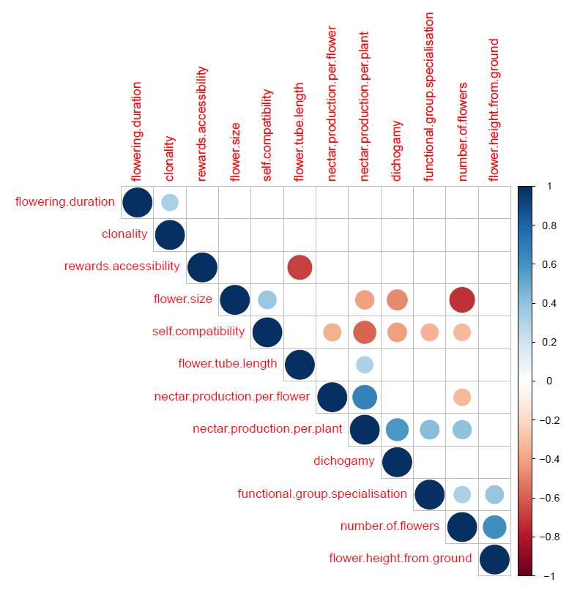

Fig S1. Correlation plot after Spearman method for non-categorical variables at a significance level p<0.05.

Table S3. Significant correlations between categorical and non-categorical variables at a significance level p<0.05, with the Kruskal-Wallis test.

categorical variable | numerical variable | Kruskal-Wallis test | df | p value
flower colour | self-compatibility | 12.617 | 3 | 0.005544
binary variable | numerical variable
nectar guides | rewards accessibility | 7.164 | 2 | 0.02782

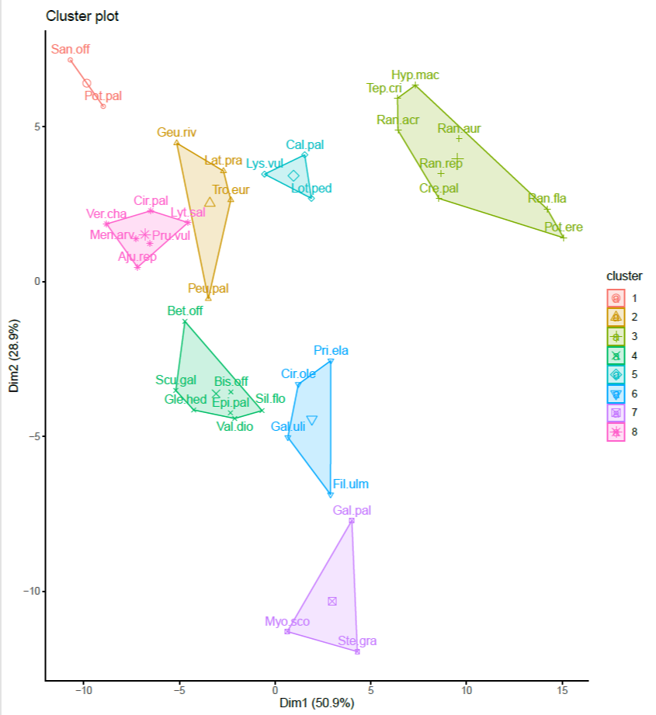

Fig S2. Cluster plot of plant species flower reflectance measured by spectrometer for the flower colour trait. Reflectance ranges from 300 to 700nm.

Table S4. Individual wet meadow species and their Connectivity Relative Presence correlation (CRPc) as a measure of success degree in the fragmented landscape. Higher values show species more affected by lack of habitat connectivity.

species | CRPc
Trollius altissimus | 0.4523
Peucedanum palustre | 0.4459
Primula elatior | 0.4279
Potentilla palustris | 0.4208
Lotus pedunculatus | 0.294
Bistorta officinalis | 0.2656
Potentilla erecta | 0.2634
Scutellaria galericulata | 0.255
Ranunculus auricomus | 0.2278
Betonica officinalis | 0.1922
Valeriana dioica | 0.1885
Silene flos-cuculi | 0.1782
Succisa pratensis | 0.1691
Geum rivale | 0.1609
Sanguisorba officinalis | 0.1329
Mentha arvensis | 0.1255
Lathyrus pratensis | 0.1237
Myosotis sp. | 0.1228
Cirsium palustre | 0.097
Lysimachia vulgaris | 0.0911
Ranunculus repens | 0.0794
Hypericum maculatum | 0.0777
Ajuga reptans | 0
Caltha palustris | 0
Cirsium oleraceum | 0
Crepis paludosa | 0
Epilobium palustre | 0
Filipendula ulmaria | 0
Galium palustre | 0
Galium uliginosum | 0
Glechoma hederacea | 0
Lythrum salicaria | 0
Prunella vulgaris | 0
Ranunculus acris | 0
Ranunculus flammula | 0
Scorzonera humilis | 0
Stellaria graminea | 0
Tephroseris crispa | 0
Veronica chamaedrys | 0

