Table S1
Information of GBM patients
Patient
Gender | Male | Female | Female | Male
Age | 72 | 68 | 57 | 58
Tumor location | Left Thalamus | Left Temporal lobe | Right Frontal lobe | Left Temporal lobe
Tumor Grade | GBM | GBM | GBM | GBM
Survival(in months) | 15 | Alive | Alive | Alive
Ki-67(%) | 50 | 48 | 32 | 30

Table S2
SiRNA sequence
SiHDAC1 | 5’-GAGUCAAAACAGAGGAUGA-3’
SiTP53I11 | 5’-AAGUUUCGUUGAUAACCUGUC-3’

Table S3
Information of antibody
Antibodies | Anti-GAPDH (ab8245, abcam), anti-HDAC1 (ab280198, abcam), anti-MMP7 (#3801, cell signaling technology), anti-COL1A2(ab308455, abcam), BCL3 (#16611, cell signaling technology), anti-L-Kynurenine Hydrolase (ab276053, abcam), anti-HOXD3 (ab221101, abcam), anti-ERBB3(#12708, CST), anti-PDGFRA (ab203491, abcam), anti-SOX10 (ab227680, abcam), anti-p-SMAD3(#9520, CST), anti-H2AK5ac (ab45152, abcam), anti-H2BK5ac (ab40886, abcam), anti-H3K9ac (ab32129, abcam), anti-H3K27ac (ab4729, abcam), anti-H3(ab1791, abcam)
Table S4
Primers of PCR
 | Forward Primer(5'->3') | Reverse Primer(5'->3') | Purpose
HDAC1 | CTCACCGAATCCGCATGACT | CACACTTGGCGTGTCCTTTG | q-PCR
MMP7 | GCTACAGTGGGAACAGGCTC | TGGCCCATCAAATGGGTAGG | q-PCR
HOXD3 | CGTCATTAATCTGCCACGCAAAG | AGGCTCCAGGTGACCACAAT | q-PCR
COL1A2 | CAGCAGGAGGTTTCGGCTAA | GCTGGGCCCTTTCTTACAGT | q-PCR
BCL3 | GCCTACACCCCTATACCCCA | GATGTCGATGACCCTGCGG | q-PCR
KYNU | GGGATCCTAGCTGTTTTAGAGAA | GCTTCCCCACTTCATGACCA | q-PCR
PDGFRA | TGTGGGACATTCATTGCGGA | GCTCACTTCCAAGACCGTCA | q-PCR
ERBB3 | TGCCTCGATGTCCTAGCCT | ATCTCAGCATCTCGGTCCCT | q-PCR
SOX10 | GACGATGACAAGTTCCCCGT | AAGTGGGCGCTCTTGTAGTG | q-PCR
TP53I11#1 | AGCCCAGAATTTGGGGGTG | AATAGCCTTGCGGTGTCTCC | ChIP-qPCR
TP53I11#2 | GTGGGGCCTTGTCTGTAGG | TGTTGGCGCTACAGTTGTCA | ChIP-qPCR

Table S5
Subtype marker genes
Mesenchymal subtype | COL1A2 BCL3 TGFβ1 MMP7 KYNU BNC2 DOCK2 F13A1 NRP1 LHFPL2 PTPRC AIM1 CCL2 ALOX5 PRDM1 IL7R AMPD3 MAPK13 TES CYBB RAB11FIP1 IL15RA LCP1 ST14 NCF2 PLAU SERPINE1 TLR1 C3AR1 IRAK1 PTPN7
Proneual subtype | HOXD3 PDGFRA ERBB3 SOX10 AGPAT4 ALCAM AMOTL2 BEX4 BRD3 C1QL1 CAMTA1 CHD7 CLASP2 DNAJB5 DPF1 EYA1 GSTA4 HDAC2 HN1 ICK KCND2 KIF1A KLF12 MAGEH1 MLLT11 MNX1 NCAM1 NFIB NOL4 NROB1 OLIG2 PATZ1 PELI1 PSIP1 RBPJ RNF144A SATB1 SNAP91 SOX11 SOX4 STMN1 TCEAL2 TCF4 TSPYL4 VAX2 WASF1 ZBTB5 ZNF184 ZNF643 ZNF711

Table S6
P-SMAD3 binding site on TP53I11 transcription initiation region
Gene | Transcript (Including UTRs) | Gene ID | Transcript ID | Distance To TSS | Sequence
TP53I11 | hg38 chr11: 44936843- 44943191 | ENSG00000175274 | ENST00000525683 | -504 → -887 | TGTCTAGACA

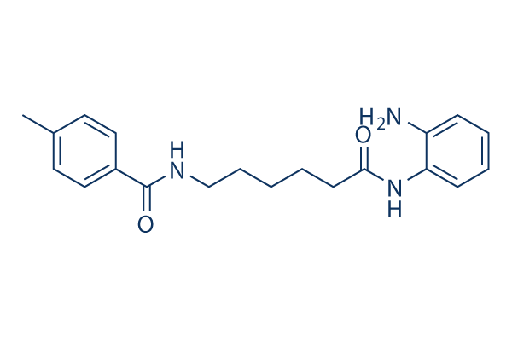
Supplementary figure 1. Structure of RG2833 compound.
Supplementary figure 2. Analyzing the TCGA Data for the correlation between HDAC1 and subtype markers (COL1A2, BCL3, KYNU, MMP7, HOXD3, PDGFRA, ERBB3, SOX10).

Supplementary figure 3. A. Survival rates and median survival time (B) of the 3 subtypes in TCGA.

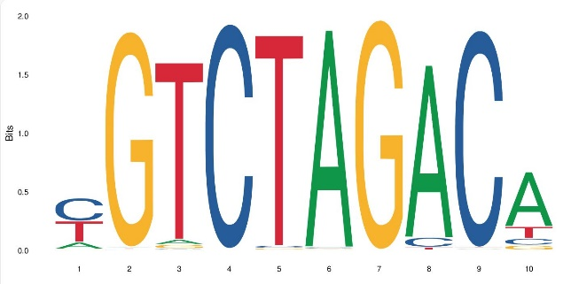

Supplementary figure 4. p-SAMD3 binding sites.

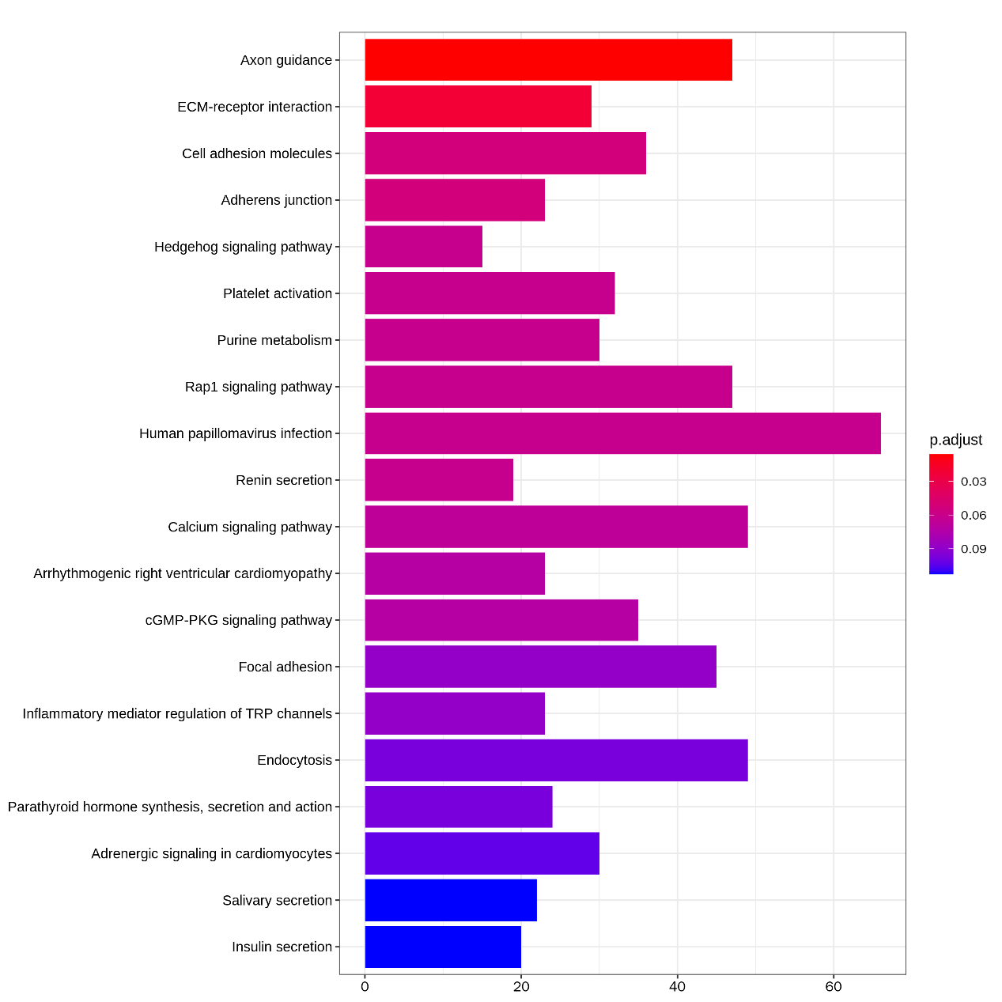

Supplementary figure 5. Analyze the set of differentially expressed genes of ChIP-seq using GO.

Supplementary figure 6. A. Analysis of subtype assignment for different tumor sites in the same patient through sequencing at multiple locations. B. analyzing single cell sequencing databases of GEO, the proportion of cells in each subtype among four glioma patients.

