SUPPLEMENTARY APPENDIX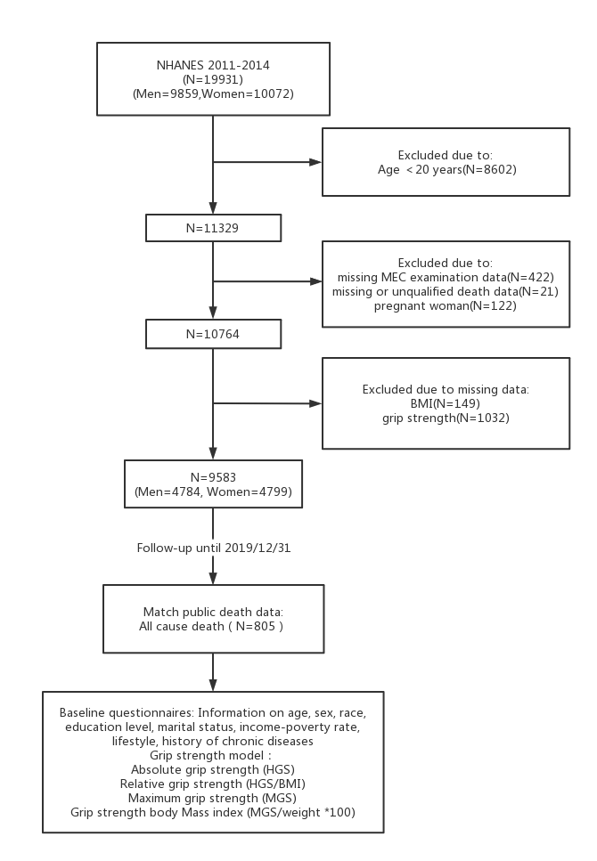
Figure S1 Data cleaning flowchart.
NHANES: National Health and Nutrition Examination Survey.
Text S1
Smoking was defined as a lifetime total of 100 cigarettes, otherwise non-smokers, smokers were divided into former smokers and current smokers. Alcohol consumption was defined as having more than 12 alcoholic drinks in any given year, otherwise non-drinkers. In reference to the World Health Organization's (WHO) 2020 Guidelines on Physical Activity and Sedentary Behavior, the sum of the hours of moderate-intensity and high-intensity exercise was defined as the total number of hours of regular physical activity per week. We calculated physical activity as high-intensity work time * high-intensity MET+ moderate-intensity work time * moderate-intensity MET+ commuting (walking or cycling) time * commuting MET+ high-intensity recreation time * high-intensity MET+ moderate-intensity recreation time * moderate-intensity MET. Hypertension was defined as self-reported hypertension or recent or current use of blood pressure medications, or the mean of the MEC blood pressure measurements (≤3) had a systolic blood pressure ≥ 140 mmHg or a diastolic blood pressure ≥90 mmHg. Hyperlipidemia was defined as self-reported hyperlipidemia or current use of lipid-lowering drugs or fasting total cholesterol ≥240mg/dl or triglycerides ≥200mg/dl or low-density lipoprotein cholesterol ≥160mg/dl or high-density lipoprotein cholesterol ≤40mg/dl as determined by MEC laboratory. Diabetes was defined as self-reported diabetes or use of antidiabetic drugs, insulin injection, or fasting blood glucose ≥7.0 mmol/L or glycosylated hemoglobin ≥ 6.5 mmol/L or 2-hour glucose tolerance test (OGTT) ≥ 11.1 mmol/L as determined by MEC laboratory. According to the questions covered by the NHANES Health questionnaire, CVD was defined as any of coronary heart disease, heart failure, angina, heart disease, or stroke reported by a physician or other health professional. Cancer was defined as having been told by a doctor or other health professional that you have cancer or any kind of malignant tumor.

Table S1 Cut-off for low grip strength stratified by gender and body mass index (BMI) quartiles
BMI category, kg/m² | Cut-off for low grip strength (Kg) criterion
Men
BMI ≤24 | ≤35.4
BMI 24.1–26 | ≤36.2
BMI 26.1–28 | ≤37
BMI ≥ 28 | ≤39.3
Women
BMI ≤ 23 | ≤23.4
BMI 23.1–26 | ≤23.5
BMI 26.1–29 | ≤23.3
BMI ≥29 | ≤24.5
BMI: body mass index.
Table S2 Association between standardized handgrip strength measurements and risk of all-cause mortality by gender
 | Men | Women
HGS | 1.81 (1.55, 2.11) | 1.62 (1.38, 1.90)
HGS/BMI | 1.73 (1.42, 2.09) | 1.26 (1.08, 1.48)
MGS | 1.79 (1.53, 2.09) | 1.60 (1.36, 1.90)
MGS/weight | 1.59 (1.30, 1.94) | 1.19 (1.01, 1.41)
Abbreviations: HGS: Hand grip strength; MGS: Maximum value of dominant hand; MGS/weight: MGS/body weight *100. * The results were presents as per 1 SD decrease. Cox regression model was adjusted for age, race, education level, marital status, income-to-poverty ratio, smoking status, alcohol drinking, regular exercise, baseline chronic diseases (cancer, CVD, hypertension, hyperlipidemia, diabetes). Cox regression was corrected for sample weights. HR (95% CI) in bold indicates P≤0.05.

Table S3 Association between different handgrip strength measurements and risk of all-cause mortality by age in men and women
 | Men |  | P_{interaction} | Women |  | P_{interaction}
 | <65 years | ≥65 years | P_{interaction} | <65 years | ≥65 years | P_{interaction}
Number of deaths | 64 | 122 |  | 49 | 114
Mortality rate (/1,000 PYs) | 5.6 | 43.8 |  | 4.2 | 37.1
HGS | 1.40 (1.26, 1.55) | 1.57 (1.36, 1.80) | 0.443 | 1.32 (1.06, 1.65) | 1.72 (1.45, 2.03) | 0.209
HGS/BMI | 4.13 (2.42, 7.03) | 5.34 (2.49, 11.42) | 0.679 | 1.78 (0.62, 5.11) | 2.50 (1.35, 4.64) | 0.834
MGS | 1.40 (1.25, 1.56) | 1.51 (1.32, 1.73) | 0.691 | 1.27 (0.99, 1.63) | 1.70 (1.44, 2.01) | 0.155
MGS/weight | 1.04 (1.02, 1.06) | 1.04 (1.02, 1.07) | 0.934 | 1.01 (0.98, 1.04) | 1.02 (1.00, 1.03) | 0.972
Abbreviations: HGS: Hand grip strength; MGS: Maximum value of dominant hand; MGS/weight: MGS/body weight *100; PYs: person-years. * The results were presents as per 5kg decrease in HGS and MGS, and per one unit decrease in HGS/BMI and MGS/weight. Cox regression model was adjusted for age, race, education level, marital status, income-to-poverty ratio, smoking status, alcohol drinking, regular exercise, baseline chronic diseases (cancer, CVD, hypertension, hyperlipidemia, diabetes). Cox regression was corrected for sample weights. HR (95% CI) in bold indicates P≤0.05.

Table S4 Association between low grip strength of different definitions and risk of all-cause mortality by age in men and women
 | Men |  | P_{interaction} | Women |  | P_{interaction}
 | <65 years | ≥65 years | P_{interaction} | <65 years | ≥65 years | P_{interaction}
Low reference grip strength | 2.12 (1.47, 3.05) | 1.97 (1.47, 2.65) | 0.371 | 1.69 (1.04, 2.76) | 1.18 (0.91, 1.54) | 0.087
Lowest 20% grip strength | 2.97 (1.78, 4.97) | 2.49 (1.69, 3.68) | 0.514 | 2.16 (1.15, 4.06) | 3.08 (2.13, 4.47) | 0.848
Men≤26kg, women≤16kg | 4.67 (1.20, 18.13) | 2.71 (1.63, 4.48) | 0.230 | 3.44 (0.64, 18.37) | 2.62 (1.66, 4.13) | 0.942
In Cox regression, participants with normal grip strength were used as reference group. Multivariable model was adjusted for age (except for low reference grip strength), race, education level, marital status, income-to-poverty ratio, smoking status, alcohol drinking, regular exercise, baseline chronic diseases (cancer, CVD, hypertension, hyperlipidemia, diabetes). Cox regression was corrected for sample weights. HR (95% CI) in bold indicates P≤0.05.
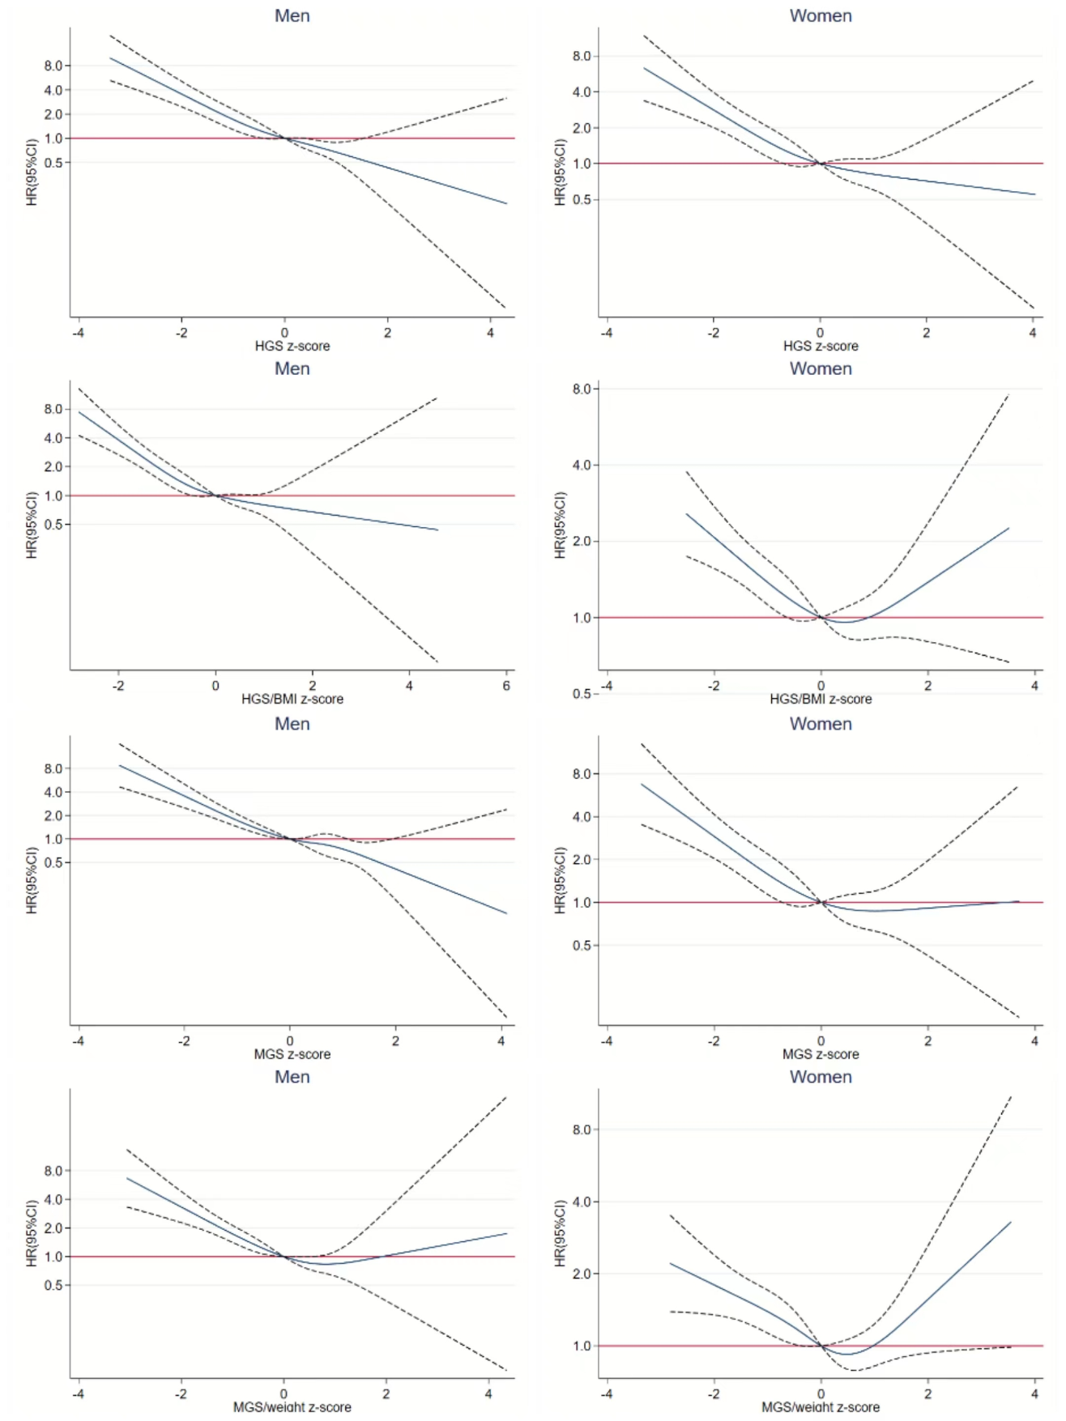
Figure S2 Association between different handgrip strength measurements and mortality in Cox Regression with Restricted Cubic Spline by gender
Estimated in Cox regression with z-scores of handgrip strength measurements modelled as natural cubic splines with four knots. Z-score 0 was used as reference. HGS: hand grip strength; MGS: maximum value of dominant hand; MGS/weight: MGS/body weight *100. Cox regression model was adjusted for age (except for low reference grip strength), race, education level, marital status, income-to-poverty ratio, smoking status, alcohol drinking, regular exercise, baseline chronic diseases (cancer, CVD, hypertension, hyperlipidemia, diabetes). Cox regression was corrected for sample weights.
Table S5 Sensitivity analyses of association between different handgrip strength measurements and risk of all-cause mortality
 | Men | Women
Excluding deaths occurred in the first year of follow-up
HGS | 1.37 (1.26, 1.48) | 1.49 (1.31, 1.69)
HGS/BMI | 3.67 (2.34, 5.74) | 2.19 (1.27, 3.79)
MGS | 1.35 (1.24, 1.45) | 1.45 (1.28, 1.66)
MGS/weight | 1.04 (1.02, 1.05) | 1.02 (1.00, 1.03)
Excluding participants with CVD or cancer at baseline
HGS | 1.31 (1.18, 1.47) | 1.64 (1.40, 1.92)
HGS/BMI | 3.39 (1.87, 6.15) | 4.40 (2.38, 8.14)
MGS | 1.32 (1.17, 1.48) | 1.57 (1.32, 1.88)
MGS/weight | 1.03 (1.01, 1.05) | 1.04 (1.02, 1.05)
Abbreviations: HGS: Hand grip strength; MGS: Maximum value of dominant hand; MGS/weight: MGS/body weight *100. *Continuous was calculated as per 5kg decrease in HGS and MGS, and per one unit decrease in HGS/BMI and MGS/weight. Cox regression model was adjusted for age, race, education level, marital status, income-to-poverty ratio, smoking status, alcohol drinking, regular exercise, baseline chronic diseases (cancer, CVD, hypertension, hyperlipidemia, diabetes), Excluding participants with CVD or cancer at baseline did not adjust for CVD and cancer in the model. Cox regression was corrected for sample weights. HR (95% CI) in bold indicates P≤0.05.

Table S6 Sensitivity analyses of association between low grip strength of different definitions and risk of all-cause mortality
 | Men | Women
Excluding deaths occurred in the first year of follow-up
Low reference grip strength | 1.92 (1.56, 2.37) | 1.22 (0.99, 1.50)
Lowest 20% grip strength | 2.20 (1.71, 2.83) | 2.50 (1.81, 3.45)
Men≤26kg, Women≤16kg | 2.05 (1.32, 3.18) | 2.24 (1.55, 3.25)
Excluding participants with CVD or cancer at baseline
Low reference grip strength | 1.57 (1.20, 2.05) | 1.45 (1.08, 1.95)
Lowest 20% grip strength | 1.94 (1.29, 2.94) | 3.07 (2.01, 4.69)
Men≤26kg, Women≤16kg | 3.19 (1.49, 6.84) | 3.27 (2.21, 4.84)
In Cox regression, participants with normal grip strength were used as reference group. Multivariate model was adjusted for age (except for low reference grip strength), race, education level, marital status, income-to-poverty ratio, smoking status, alcohol drinking, regular exercise, baseline chronic diseases (cancer, CVD, hypertension, hyperlipidemia, diabetes), Excluding participants with CVD or cancer at baseline did not adjust for CVD and cancer in the model. Cox regression was corrected for sample weights. HR (95% CI) in bold indicates P≤0.05.

