Online Supplementary Information
Below is the link to the online supplementary Information.

Phage isolation, DNA extraction, electron microscopy observation, and host range analysis
Phages were isolated from leaf litter compost, using the method described by Sasaki et al. (2021) [1] with some modifications. The method involves casamino acid-peptone-glucose (CPG) medium [1.0% (w/v) peptone, 0.1% (w/v) casamino acid, and 0.5% (w/v) glucose] and R. pseudosolanacearum strain MAFF106603 as the host, with an incubation temperature of 28°C. Phage multiplication and purification were performed using R. pseudosolanacearum MAFF106611. The extraction of phage genome DNA, the determination of complete phage genomes using MiSeq (Illumina, San Diego, CA), and the observation of phage particles with transmission electron microscopy were performed as previously described [1]. The host ranges of the isolated phages were analyzed using the spot test with nine R. pseudosolanacearum strains and three R. syzygii subsp. indonesiensis strains, which were supplied from public resource stock center GeneBank (NARO, Tukuba, Japan) (Table S1).

In silico analyses
Filtered reads were assembled using SPAdes ver. 3.13.0 [2]. The obtained sequences were used for a homologous search with blastn of the NCBI nt database. GeneMarkS ver. 4.28 [3] was used for the prediction of open reading frames (ORFs). An amino acid sequence of the product from each predicted ORF was used as a query for the blastp search (e-value ≤ 1e−5) with NCBI nr limited in Caudoviricetes and annotated following the description of the homologs in the Ralstonia phage RP12(NC_041911.1). tRNA and rRNA sequences were detected using tRNAscan-SE ver. 2.0 [4] and rnammer ver. 1.2 [5], respectively. The complete genome comparison was visualized using EasyFig ver. 2.2.2 [6]. Proteomic tree analysis was performed using ViPTree ver. 4.0 [7]. A phylogenetic tree of the terminase large subunit gene and the SbcC gene was constructed and visualized using the “one click” mode of phylogeny.fr (https://www.phylogeny.fr) [8, 9], based on the amino acid sequences as follows. Multiple alignment was performed using MUSCLE [10], alignment curation was performed using Gblocks [11], the sequence-based maximum likelihood tree was constructed using the PhyML [12, 13], and the tree was drawn using TreeDyn [14].

Ralstonia phage treatment, inoculation with R. pseudosolanacearium, and wilt disease assessment
Bacteria were cultured at 28°C in liquid CPG medium containing 0.001% tetrazolium chloride for 48 h on a rotary shaker [15]. Subsequently, the bacterial cells were collected by centrifugation and resuspended in distilled sterilized water to a final density of 1×10⁷ cfu/mL. The roots of five-leaf-stage tomato nursery plants were soaked in Ralstonia phage FLC4-3B solution (1×10⁷ pfu/mL) or in diluted CPG medium of the same strength as that used to prepare the FLC4-3B solution, for 1 h at 25°C. After soaking the roots of tomato plants with sterilized distilled water five times, the phage-treated plants were inoculated with Ralstonia pseudosolanacearium MAFF106611 (1×10⁷ cfu/mL) by soaking their roots in the bacterial solution. The inoculated plants were cultivated in a growth chamber at 30°C under 16-h light conditions (70 μmol/m²/s). At 10 days after inoculation with R. pseudosolanacearium, the disease severity was categorized on a 0–4 non-parametric scale (0, no wilting; 1, 1%–25% wilting; 2, 26%–50% wilting; 3, 51%–75% wilting; 4, 76%–100% wilting or dead) and the wilt disease severity index (DSI) was calculated [16]. Each assay was repeated in three successive trials, and six plants were inoculated in each experiment. Wilcoxon’s two-sample test was used to check for significant differences in disease severity (α = 0.05).

References
1. Sasaki R, Miyashita S, Ando S, Ito K, Fukuhara T, Takahashi H (2021) Isolation and characterization of a novel jumbo phage from leaf litter compost and its suppressive effect on rice seedling. Viruses 13:591
2. Nurk S, Bankevich A, Antipov D, Gurevich A, Korobeynikov A, Lapidus A, Prjibelsky A, Pyshkin A, Sirotkin A, Sirotkin Y, Stepanauskas R, McLean J, Lasken R, Clingenpeel S, Woyke T, Tesler G, Alekseyev M, Pevzner P (2013) Assembling genomes and mini-metagenomes from highly chimeric reads. In: Deng M, Jiang R, Sun F, Zhang X (eds) Research in Computational Molecular Biology. RECOMB 2013. Lecture Notes in Computer Science. Springer, Berlin, Heidelberg, pp 158-170
3. Besemer J, Lomsadze A, Borodovsky M (2001) GeneMarkS: a self-training method for prediction of gene starts in microbial genomes. Implications for finding sequence motifs in regulatory regions. Nucleic Acids Res 29:2607-2618
4. Chan PP, Lin BY, Mak AJ, Lowe TM (2021) TRNAscan-SE 2.0: Improved detection and functional classification of transfer RNA genes. Nucleic Acids Res 49:9077-9096
5. Lagesen K, Hallin P, Rødland EA, Stærfeldt HH, Rognes T, Ussery DW (2007) RNAmmer: Consistent and rapid annotation of ribosomal RNA genes. Nucleic Acids Res 35:3100-3108
6. Sullivan MJ, Petty NK, Beatson SA (2011) Easyfig: A genome comparison visualizer. Bioinformatics 27:1009-1010
7. Nishimura Y, Yoshida T, Kuronishi M, Uehara H, Ogata H, Goto S (2017) ViPTree: The viral proteomic tree server. Bioinformatics 33:2379-2380
8. Dereeper A, Guignon V, Blanc G, Audic S, Buffet S, Chevenet F, Dufayard JF, Guindon S, Lefort V, Lescot M, Claverie JM, Gascuel O (2008) Phylogeny.fr: robust phylogenetic analysis for the non-specialist. Nucleic Acids Res 36:465-469
9. Dereeper A, Audic S, Claverie JM, Blanc G (2010) BLAST-EXPLORER helps you building datasets for phylogenetic analysis. BMC Evol Biol 10:8-13
10. Edgar RC (2004) MUSCLE: Multiple sequence alignment with high accuracy and high throughput. Nucleic Acids Res 32:1792-1797
11. Castresana J (2000) Selection of conserved blocks from multiple alignments for their use in phylogenetic analysis. Mol Biol Evol 17:540-552
12. Guindon S, Gascuel O (2003) A simple, fast, and accurate algorithm to estimate large phylogenies by maximum likelihood. Syst Biol 52:696-704
13. Anisimova M, Gascuel O (2006) Approximate likelihood-ratio test for branches: A fast, accurate, and powerful alternative. Syst Biol 55:539-552
14. Chevenet F, Brun C, Bañuls AL, Jacq B, Christen R (2006) TreeDyn: Towards dynamic graphics and annotations for analyses of trees. BMC Bioinformatics 7:1-9
15. Hendrick C, Sequeira L (1984) Lipopolysaccharide-defective mutants of the wilt pathogen Pseudomonas solanacearum. Appl Environ Microbiol 48:94-101
16. Roberts DP, Denny TP, Schell MA (1988) Cloning of the egl gene of Pseudomonas solanacearum and analysis of its role in phytopathogenicity. J Bacteriol 170:1445-1451

Fig. S1 Phage particles observed with transmission electron microscopy. Intact particles of (a) FLC1-1B and (b) FLC4-3B. Particles of (c) FLC1-1B and (d) FLC4-3B with a contracted tail. The bars represent a length of 100 nm.

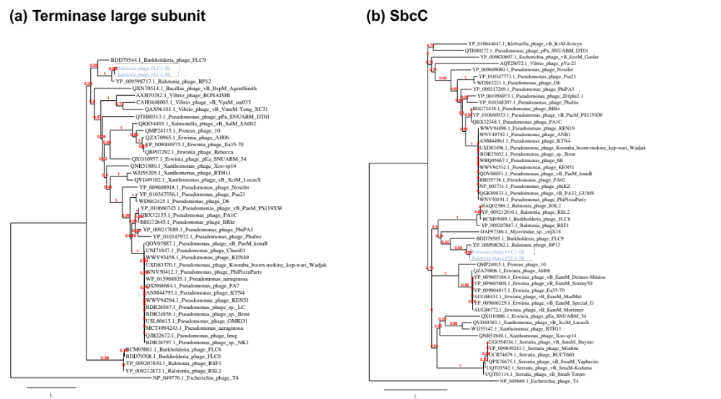
Fig. S2 Phylogenetic tree based on the amino acid sequences of (a) the terminase large subunit and (b) SbcC. Escherichia phage T4 was used as an outgroup. The Ralstonia phages FLC1-1B and FLC4-3B are shown in blue. Red numbers show the branch support value calculated using an approximate likelihood ratio test [1].

[1] Anisimova M, Gascuel O (2006) Approximate likelihood-ratio test for branches: A fast, accurate, and powerful alternative. Syst Biol 55:539-552

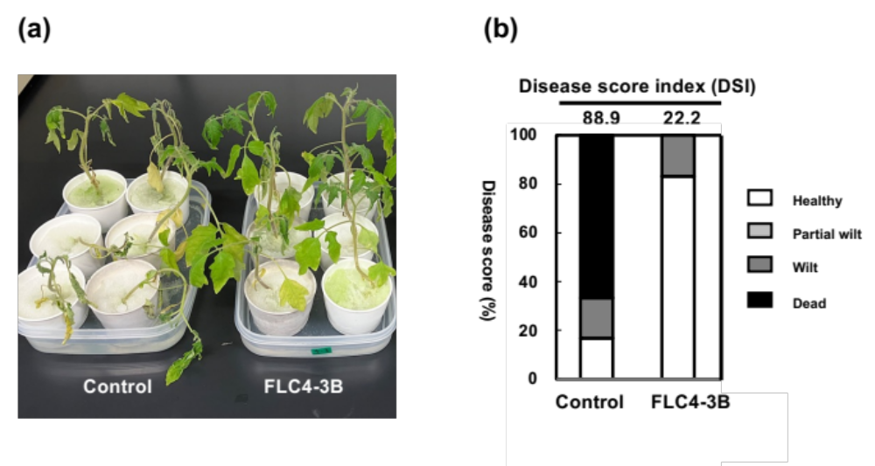
Fig. S3 Assessment of the suppression of wilt disease by treatment with the Ralstonia phage FLC4-3B. (a) Photograph showing representative wilt disease symptoms at 10 days after inoculation with R. pseudosolanacearum. The roots of five-leaf-stage tomato nursery plants were soaked in Ralstonia phage solution (1×10⁷ pfu/mL) (FLC4-3B) or in diluted CPG medium of the same strength as that used to prepare the FLC4-3B solution (Control), for 1 h at 25°C, followed by inoculation with Ralstonia pseudosolanacearum MAFF106611 (1×10⁷ cfu/mL). (b) The proportion of wilt disease severity index (DSI) scores for R. pseudosolanacearum-infected plants that were immersed in Ralstonia phage solution or in diluted CPG medium as a control was assessed. The DSI scores are shown above the bar chart. The disease severity was categorized on a 0–4 non-parametric scale (0, no wilting; 1, 1%–25% wilting; 2, 26%–50% wilting; 3, 51%–75% wilting; 4, 76%–100% wilting or dead) and the DSI was calculated. Wilcoxon’s two-sample test was used to check for significant differences in disease severity (α = 0.05).

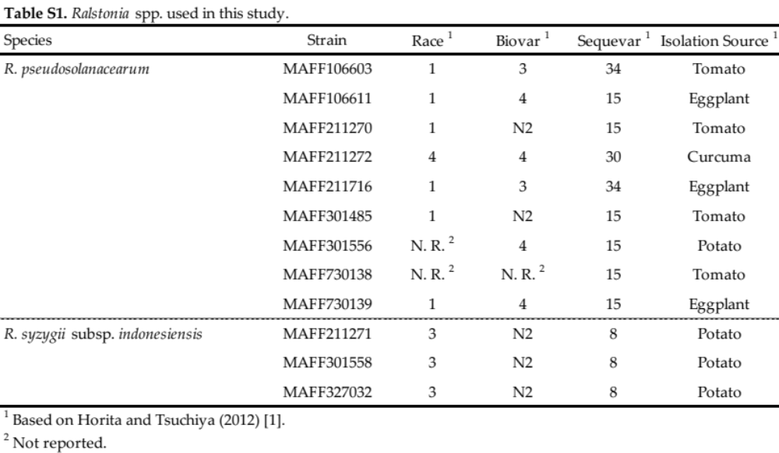

[1] Horita M, Tsuchiya K (2000) Comparative analysis of Japanese and foreign strains of Ralstonia solanacearum based on 16S ribosomal RNA gene sequences. J Gen Plant Pathol 66:132-137

