APPENDIX
Table 2. Exposure to FP programming among non-slum and slum women, by year of survey
Exposition à la FP (%) | 2014 |  |  | 2015 |  |  | 2016 |  |  | 2017 |  |  | 2018 |  |  |  |  | 2020
Exposition à la FP (%) | Slum | Non slum | Total | Slum | Non slum | Total | Slum | Non slum | Total | Slum | Non slum | Total | Slum | Non slum |  |  | Total | Slum | Non slum | Total
Saw something about FP on the TV | 51 | 56 | 53 | 54 | 60 | 55 | 60 | 68 | 63 | 63 | 68 | 60 | 59 |  | 66 | 58 |  | 49 | 57 | 52
Heard about FP on radio | 30 | 29 | 29 | 35 | 35 | 35 | 37 | 30 | 35 | 36 | 39 | 35 | 35 |  | 40 | 35 |  | 35 | 30 | 33
Read about FP in a magazine/newspaper | 10 | 9 | 10 | 9 | 9 | 10 | 14 | 11 | 13 | 13 | 12 | 12 | 14 |  | 9 | 10 |  | 10 | 19 | 13
Received a call about FP | - | - | - | - | - | - | - | - | - | - | - | - | 7 |  | 4 | 5 |  | 4 | 3 | 4
Social media | - | - | - | - | - | - | - | - | - | - | - | - | - |  | - | - |  | 5 | 11 | 7
* A person could be exposed to more than one source of communication

Table 3. Weighted background obstetrical-gynecologic characteristics for women, Kinshasa 2014 to 2020
 | 2014 |  | 2015 |  |  | 2016 |  |  |  | 2017 |  |  |  | 2018 |  |  | 2020 |  |  |  |  | Total |  |  |  | p
 | n | %* | n |  | %* | n |  | %* |  | n |  | %* |  | n |  | %* | n | %* |  | n |  |  |  | %*
Previous delivery/Current pregnancy (dichotomous) |  |  |  |  |  |  |  |  |  |  |  |  |  |  |  |  |  |  |  |  |  |  |  |  |  | 0.001
Intended | 770 | 44.4 | 1,498 |  | 45.4 | 731 |  | 49.6 |  | 634 |  | 40.3 |  | 689 |  | 41.4 | 794 | 50.5 |  | 5,116 |  |  |  | 45.8
Unintended | 989 | 55.6 | 1,853 |  | 54.6 | 803 |  | 50.4 |  | 836 |  | 59.7 |  | 860 |  | 58.6 | 809 | 49.5 |  | 6,15 |  |  |  | 54.2
Number of lifetime births |  |  |  |  |  |  |  |  |  |  |  |  |  |  |  |  |  |  |  |  |  |  |  |  |  | 0.005
None | 1,186 | 40.8 | 2,215 |  | 40.4 | 1,077 |  | 40.3 |  | 1,102 |  | 42.8 |  | 1,086 |  | 40.7 | 1,077 | 41.8 |  | 7,743 |  |  |  | 40.9
1 - 2 children | 832 | 28.6 | 1,595 |  | 28.7 | 749 |  | 28.9 |  | 714 |  | 27.4 |  | 663 |  | 25.9 | 756 | 28.1 |  | 5,309 |  |  |  | 28.2
3 - 4 children | 494 | 17.1 | 965 |  | 17.5 | 448 |  | 17.5 |  | 413 |  | 16.0 |  | 507 |  | 20.1 | 505 | 19.3 |  | 3,332 |  |  |  | 17.8
5 or more children | 387 | 13.5 | 721 |  | 13.4 | 333 |  | 13.3 |  | 362 |  | 13.9 |  | 342 |  | 13.2 | 300 | 10.8 |  | 2,445 |  |  |  | 13.0
Are you pregnant now ? |  |  |  |  |  |  |  |  |  |  |  |  |  |  |  |  |  |  |  |  |  |  |  |  |  | <0.001
Don't know / No response | 35 | 1.2 | 59 |  | 0.9 | 18 |  | 0.6 |  | 24 |  | 1.0 |  | 4 |  | 0.2 | 8 | 0.2 |  | 148 |  |  |  | 0.8
No | 2,701 | 93.1 | 5,124 |  | 93.5 | 2,464 |  | 94.7 |  | 2,387 |  | 93.8 |  | 2,471 |  | 94.2 | 2,473 | 94.1 |  | 17,62 |  |  |  | 93.8
Yes | 166 | 5.6 | 314 |  | 5.6 |  | 125 |  | 4.7 |  | 134 |  | 5.2 | 123 | 5.6 |  | 158 |  | 5.7 |  | 1,02 |  |  |  | 5.4
Reproductive history
Median age at first sex (p25-p75) | 17 (15 - 19) |  | 17 (15 - 18) |  |  | 17 (15 - 18) |  |  |  | 17 (15 - 18) |  |  |  | 17 (15 - 18) |  |  | 17 (15 - 19) |  |  |  |  | 17 (15 - 18)
Median age at first birth (p25- p75) | - |  | 21 (18 - 24) |  |  | 21 (18 - 24) |  |  |  | 20 (18 - 24) |  |  |  | - |  |  | 21 (18 - 24) |  |  |  |  | 20 (18 - 24)
Median Age at first contraceptive use (p25-p75) | 20 (17 -26) |  | 20 (17 -25) |  |  | 20 (17 -26) |  |  |  | 20 (18 -26) |  |  |  | 20 (18 - 25) |  |  | 20 (18 - 25) |  |  |  |  | 20 (17 -25)
Median number of children at first use (p25-p75) | 1 (0 - 2) |  | 1 (0 - 2) |  |  | 1 (0 - 2) |  |  |  | 1 (0 - 3) |  |  |  | 1 (0 - 3) |  |  | 1 (0 - 2) |  |  |  |  | 1 (0 - 2)
* : weight

APPENDIX

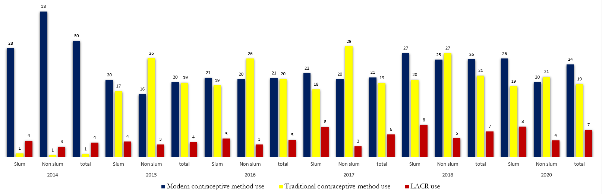
Figure 2. Choice of contraceptive method by type of residence over the years

