Supplementary Table 1. Number of imported malaria cases in the Republic of Korea (ROK) during 2009–2018 (N=601) by country of acquisition
Category |  | P. falciparum |  | P. vivax |  | P. ovale |  | P. malariae |  | Mixed infection* |  | Unclassified |  | Total
 |  | n | (%) | n | (%) | n | (%) | n | (%) | n | (%) | n | (%) | N | (%)
Africa (32)
 | Algeria | 1 | (0.3) | 0 | 0.0 | 0 | 0.0 | 0 | 0.0 | 0 | 0.0 | 0 | 0.0 | 1 | (0.2)
 | Angola | 12 | (3.6) | 0 | 0.0 | 1 | (5.9) | 1 | (8.3) | 0 | 0.0 | 0 | 0.0 | 14 | (2.3)
 | Benin | 1 | (0.3) | 0 | 0.0 | 0 | 0.0 | 0 | 0.0 | 0 | 0.0 | 0 | 0.0 | 1 | (0.2)
 | Cameroon | 21 | (6.3) | 0 | 0.0 | 2 | (11.8) | 0 | 0.0 | 1 | (16.7) | 1 | (2.0) | 25 | (4.2)
 | Central African Republic | 4 | (1.2) | 0 | 0.0 | 0 | 0.0 | 0 | 0.0 | 1 | (16.7) | 0 | 0.0 | 5 | (0.8)
 | Chad | 6 | (1.8) | 0 | 0.0 | 0 | 0.0 | 0 | 0.0 | 0 | 0.0 | 0 | 0.0 | 6 | (1.0)
 | Côte d'Ivoire | 9 | (2.7) | 0 | 0.0 | 1 | (5.9) | 0 | 0.0 | 0 | 0.0 | 1 | (2.0) | 11 | (1.8)
 | Equatorial Guinea | 49 | (14.6) | 3 | (1.6) | 3 | (17.6) | 4 | (33.3) | 1 | (16.7) | 5 | (10.2) | 65 | (10.8)
 | Ethiopia | 0 | 0.0 | 5 | (2.7) | 0 | 0.0 | 0 | 0.0 | 2 | (33.3) | 0 | 0.0 | 7 | (1.2)
 | Gabon | 2 | (0.6) | 0 | 0.0 | 0 | 0.0 | 0 | 0.0 | 0 | 0.0 | 1 | (2.0) | 3 | (0.5)
 | Ghana | 31 | (9.3) | 4 | (2.2) | 1 | (5.9) | 1 | (8.3) | 0 | 0.0 | 1 | (2.0) | 38 | (6.3)
 | Guinea | 19 | (5.7) | 5 | (2.7) | 0 | 0.0 | 0 | 0.0 | 0 | 0.0 | 1 | (2.0) | 25 | (4.2)
 | Kenya | 8 | (2.4) | 1 | (0.5) | 1 | (5.9) | 1 | (8.3) | 0 | 0.0 | 1 | (2.0) | 12 | (2.0)
 | Liberia | 6 | (1.8) | 1 | (0.5) | 0 | 0.0 | 0 | 0.0 | 0 | 0.0 | 1 | (2.0) | 8 | (1.3)
 | Madagascar | 1 | (0.3) | 0 | 0.0 | 0 | 0.0 | 0 | 0.0 | 0 | 0.0 | 1 | (2.0) | 2 | (0.3)
 | Malawi | 7 | (2.1) | 0 | 0.0 | 1 | (5.9) | 0 | 0.0 | 0 | 0.0 | 1 | (2.0) | 9 | (1.5)
 | Mali | 2 | (0.6) | 0 | 0.0 | 0 | 0.0 | 0 | 0.0 | 0 | 0.0 | 0 | 0.0 | 2 | (0.3)
 | Mauritius | 0 | 0.0 | 1 | (0.5) | 0 | 0.0 | 0 | 0.0 | 0 | 0.0 | 0 | 0.0 | 1 | (0.2)
 | Mozambique | 6 | (1.8) | 0 | 0.0 | 0 | 0.0 | 0 | 0.0 | 0 | 0.0 | 0 | 0.0 | 6 | (1.0)
 | Niger | 1 | (0.3) | 0 | 0.0 | 0 | 0.0 | 0 | 0.0 | 0 | 0.0 | 0 | 0.0 | 1 | (0.2)
 | Nigeria | 26 | (7.8) | 7 | (3.8) | 0 | 0.0 | 2 | (16.7) | 0 | 0.0 | 0 | 0.0 | 35 | (5.8)
 | Republic of Congo | 10 | (3.0) | 1 | (0.5) | 0 | 0.0 | 0 | 0.0 | 0 | 0.0 | 2 | (4.1) | 13 | (2.2)
 | Rwanda | 4 | (1.2) | 1 | (0.5) | 0 | 0.0 | 1 | (8.3) | 0 | 0.0 | 0 | 0.0 | 6 | (1.0)
 | Senegal | 1 | (0.3) | 0 | 0.0 | 0 | 0.0 | 0 | 0.0 | 0 | 0.0 | 1 | (2.0) | 2 | (0.3)
 | Sierra Leone | 24 | (7.2) | 2 | (1.1) | 1 | (5.9) | 0 | 0.0 | 1 | (16.7) | 1 | (2.0) | 29 | (4.8)
 | South Africa | 6 | (1.8) | 0 | 0.0 | 0 | 0.0 | 0 | 0.0 | 0 | 0.0 | 0 | 0.0 | 6 | (1.0)
 | South Sudan | 18 | (5.4) | 1 | (0.5) | 1 | (5.9) | 0 | 0.0 | 0 | 0.0 | 1 | (2.0) | 21 | (3.5)
 | Swaziland | 1 | (0.3) | 0 | 0.0 | 0 | 0.0 | 0 | 0.0 | 0 | 0.0 | 0 | 0.0 | 1 | (0.2)
 | Tanzania | 6 | (1.8) | 0 | 0.0 | 0 | 0.0 | 0 | 0.0 | 0 | 0.0 | 0 | 0.0 | 6 | (1.0)
 | Togo | 3 | (0.9) | 0 | 0.0 | 0 | 0.0 | 0 | 0.0 | 0 | 0.0 | 0 | 0.0 | 3 | (0.5)
 | Uganda | 30 | (9.0) | 4 | (2.2) | 2 | (11.8) | 2 | (16.7) | 0 | 0.0 | 6 | (12.2) | 44 | (7.3)
 | Zambia | 5 | (1.5) | 1 | (0.5) | 0 | 0.0 | 0 | 0.0 | 0 | 0.0 | 1 | (2.0) | 7 | (1.2)
Asia(15)
 | Afghanistan | 0 | 0.0 | 1 | (0.5) | 0 | 0.0 | 0 | 0.0 | 0 | 0.0 | 0 | 0.0 | 1 | (0.2)
 | Bangladesh | 1 | (0.3) | 2 | (1.1) | 0 | 0.0 | 0 | 0.0 | 0 | 0.0 | 0 | 0.0 | 3 | (0.5)
 | Cambodia | 4 | (1.2) | 13 | (7.1) | 0 | 0.0 | 0 | 0.0 | 0 | 0.0 | 4 | (8.2) | 21 | (3.5)
 | India | 5 | (1.5) | 23 | (12.6) | 0 | 0.0 | 0 | 0.0 | 0 | 0.0 | 7 | (14.3) | 35 | (5.8)
 | Indonesia | 1 | (0.3) | 10 | (5.5) | 0 | 0.0 | 0 | 0.0 | 0 | 0.0 | 2 | (4.1) | 13 | (2.2)
 | Laos | 0 | 0.0 | 4 | (2.2) | 1 | (5.9) | 0 | 0.0 | 0 | 0.0 | 0 | 0.0 | 5 | (0.8)
 | Malaysia | 0 | 0.0 | 4 | (2.2) | 0 | 0.0 | 0 | 0.0 | 0 | 0.0 | 1 | (2.0) | 5 | (0.8)
 | Myanmar | 0 | 0.0 | 3 | (1.6) | 0 | 0.0 | 0 | 0.0 | 0 | 0.0 | 0 | 0.0 | 3 | (0.5)
 | Pakistan | 1 | (0.3) | 30 | (16.5) | 0 | 0.0 | 0 | 0.0 | 0 | 0.0 | 5 | (10.2) | 36 | (6.0)
 | Philippines | 1 | (0.3) | 18 | (9.9) | 1 | (5.9) | 0 | 0.0 | 0 | 0.0 | 2 | (4.1) | 22 | (3.7)
 | Singapore | 1 | (0.3) | 0 | 0.0 | 0 | 0.0 | 0 | 0.0 | 0 | 0.0 | 0 | 0.0 | 1 | (0.2)
 | Sri Lanka | 0 | 0.0 | 1 | (0.5) | 0 | 0.0 | 0 | 0.0 | 0 | 0.0 | 0 | 0.0 | 1 | (0.2)
 | Thailand | 1 | (0.3) | 12 | (6.6) | 1 | (5.9) | 0 | 0.0 | 0 | 0.0 | 1 | (2.0) | 15 | (2.5)
 | Vietnam | 0 | 0.0 | 17 | (9.3) | 0 | 0.0 | 0 | 0.0 | 0 | 0.0 | 0 | 0.0 | 17 | (2.8)
 | Yemen | 0 | 0.0 | 1 | (0.5) | 0 | 0.0 | 0 | 0.0 | 0 | 0.0 | 0 | 0.0 | 1 | (0.2)
Oceania(2)
 | Papua New Guinea | 0 | 0.0 | 4 | (2.2) | 0 | 0.0 | 0 | 0.0 | 0 | 0.0 | 1 | (2.0) | 5 | (0.8)
 | Solomon Islands | 0 | 0.0 | 1 | (0.5) | 0 | 0.0 | 0 | 0.0 | 0 | 0.0 | 0 | 0.0 | 1 | (0.2)
America(1)
 | Brazil | 0 | 0.0 | 1 | (0.5) | 0 | 0.0 | 0 | 0.0 | 0 | 0.0 | 0 | 0.0 | 1 | (0.2)
* The P. vivax and P. falciparum correspond to 5 cases; the P. falciparum and P. ovale correspond to 1 case

Supplementary Table 2. Comparison of characteristics between groups with and without chemoprophylaxis. (N=538) *Excluding non-responders.
 | Chemoprophylaxis (N=108) | No chemoprophylaxis (N=430) | p-value
Male gender, n(%) | 97 (89.8) | 352 (81.9) | 0.059
Age, median [IQR] | 44 [35 - 52] | 38 [27 - 48] | 0.001
< 20, n(%) | 3 (2.8) | 21 (4.9)
20-29, n(%) | 19 (17.6) | 116 (27.0)
30-39, n(%) | 14 (13.0) | 94 (21.9)
40-49, n(%) | 38 (35.2) | 99 (23.0)
50-59, n(%) | 23 (21.3) | 76 (17.7)
>59, n(%) | 11 (10.2) | 24 (5.6)
Nationality |  |  | < 0.001
Korean | 101 (93.5) | 316 (73.5)
Non-Korean | 7 (6.5) | 114 (26.5)
Visiting Country |  |  | < 0.001
Africa | 94 (87.0) | 288 (67.0)
Asia | 11 (10.2) | 138 (32.1)
Oceania | 3 (2.8) | 3 (0.7)
America | 0 (0) | 1 (0.2)
Plasmodium Species |  |  | 0.004
P. falciparum | 70 (64.8) | 239 (55.6)
P. vivax | 19 (17.6) | 139 (32.3)
P. ovale | 7 (6.5) | 8 (1.9)
P. malariae | 4 (3.7) | 7 (1.6)
Mixed infection§ | 1 (0.9) | 5 (1.2)
Unclassified | 7 (6.5) | 32 (7.4)

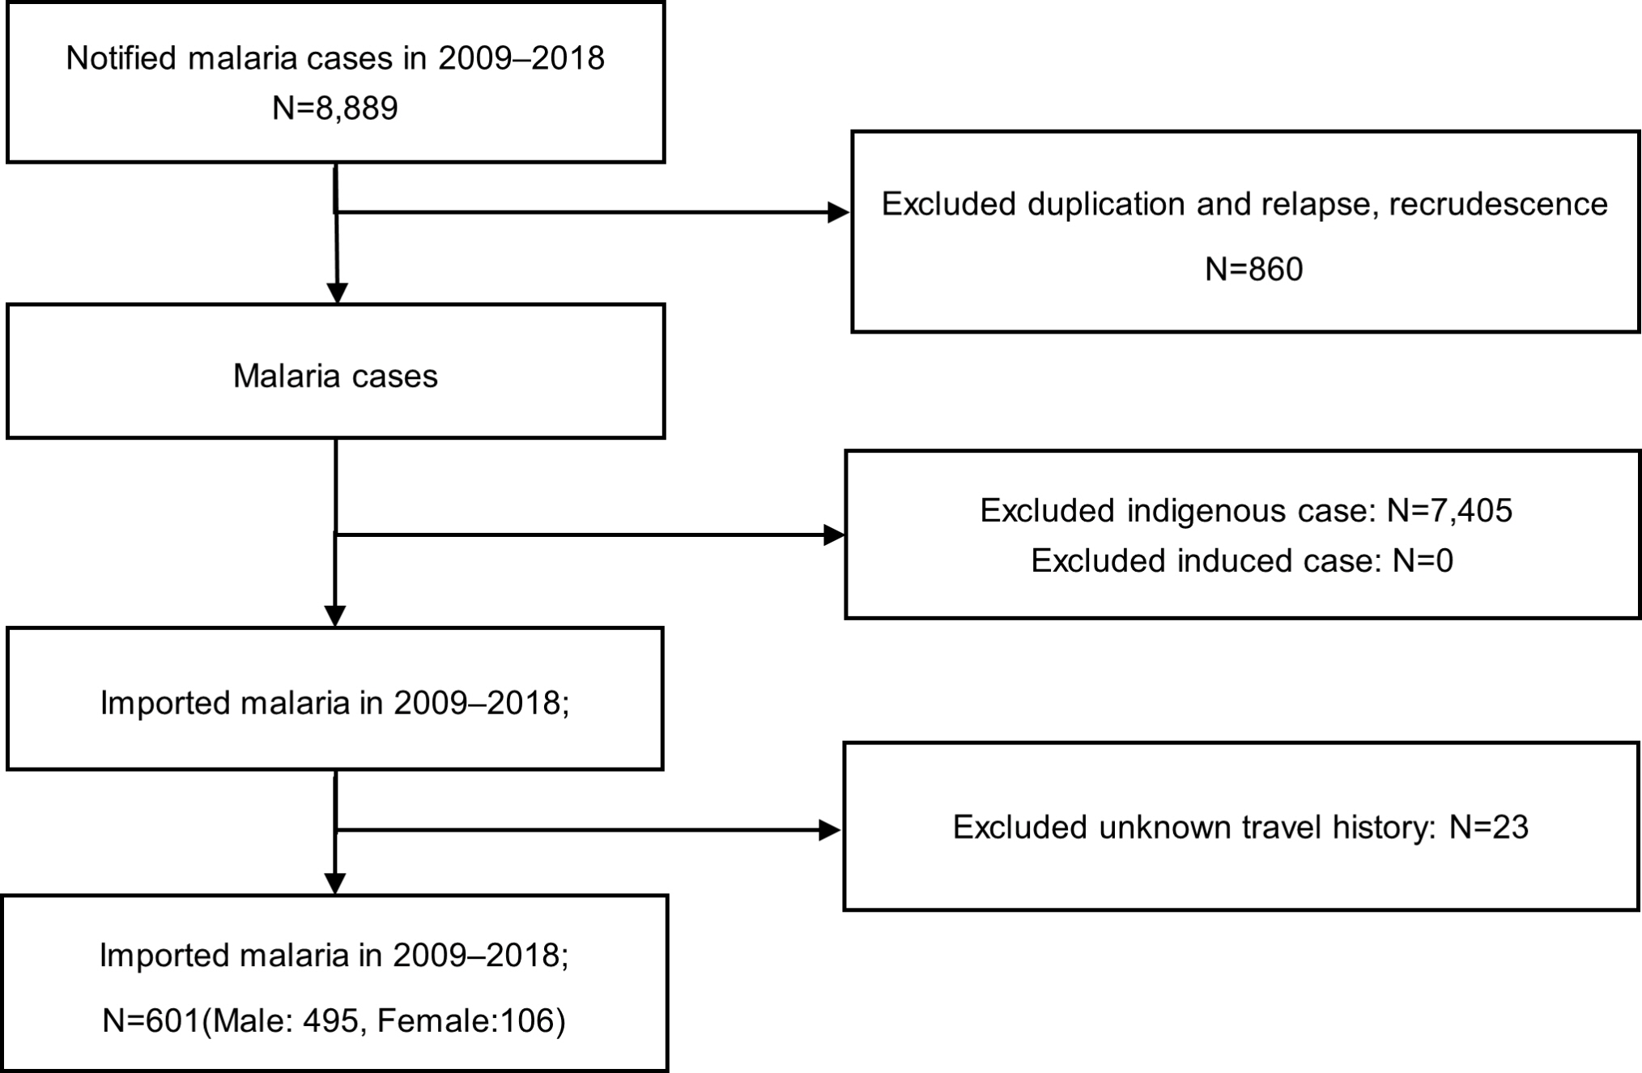
Supplementary Figure 1. Process by which imported malaria cases between 2009 and 2018 was estimated in the Korea National Infectious Disease Surveillance System

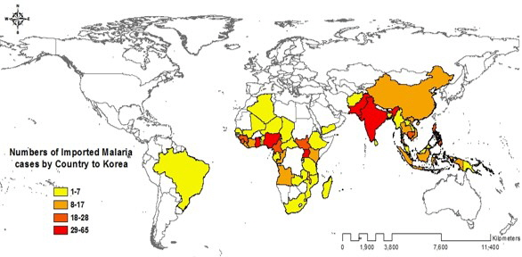
Supplementary Figure 2. Distribution of countries where malaria was acquired by imported cases in South Korea between 2009 and 2018

