Supporting Information

Facet-Specific Gas Transport Properties of Metal–Organic Frameworks in Polymer Nanocomposites
Hyunhee Lee¹, Moein Hajian Z.D²., Taigyu Joo¹, Wan-Ni Wu¹, Jing Ying Yeo¹, Tae Hoon Lee¹, Joshua D. Howe², and Zachary P. Smith^{1*}

1Department of Chemical Engineering, Massachusetts Institute of Technology, Cambridge, MA 02139, USA
2 Department of Chemical Engineering, Texas Tech University, Lubbock, TX 79409, USA
*E-mail: zpsmith@mit.edu

Table of Contents
Section S1: Preparation of ZIF-8 particles and corresponding MMMs 2
Section S2: Characterization of ZIF-8 particles and corresponding MMMs 5
Section S3: Computational study on MOF–polymer interaction 20
Section S4: Gas transport properties measurements 31
Section S5: MMM gas transport model analysis 40
Section S6: Temperature-dependent transport behavior analyses 44

Section S1: Preparation of ZIF-8 particles and corresponding MMMs
Materials
Methanol (HPLC, ≥ 99.9%), N,N-dimethylformamide (DMF, HPLC, ≥ 99.9%), zinc nitrate hexahydrate (purum p.a., crystallized, ≥ 99.0%), 2-methylimidazole (99%), hexadecyltrimethylammonium bromide (CTAB, ≥99%) were purchased from Sigma-Aldrich and used as received. The H₂ (HY UHP300, 99.999%), CH₄ (ME UHP300, 99.99%), N₂ (NI UHP300, 99.999%), O₂ (OX UHP300, 99.994%), C₂H₄, (EY UHP200, 99.9%), C₂H₆ (ET UHP300, 99.9%), C₃H₆ (PP P350, 99.5%), C₃H₈ (PR CP350, 99.0%) gas cylinders were purchased from Airgas. 6FDA-DAM (Batch: ZL11-137. MW: ~283 kDa, PDI: ~2.69) was purchased from Akron Polymer Systems and used as received. Acetic-d3 acid-d for NMR (99.5 atom%) was purchased from Acros Organics.
Synthesis of ZIF-8 Particles
Rhombic Dodecahedra ZIF-8 (RDZ) was synthesized using a modified version of the method described by Lee et al.¹ To start, Zinc nitrate hexahydrate (0.5 g, 1.68 mmol) was dissolved in 20 mL of methanol, while 2-methylimidazole (0.5 g, 6.09 mmol) was separately dissolved in 20 mL of methanol. Both solutions were bath sonicated for 10 minutes. The organic ligand solution was then poured into the metal salt solution, and this combined solution was stirred at a rate of 600 rpm at room temperature for 1 hour. After stirring, the nanoparticles were washed thrice with fresh methanol, and a centrifuge was used to remove any unreacted species. After each centrifugation cycle (operated at 11,000 rpm for 20 minutes at 25 °C), the supernatant was discarded and replaced with fresh methanol. To achieve redispersion of the solution, a high-speed vortex was used for 1–3 minutes, followed by bath-sonication for 1 minute, and a shaker was employed for over 2 hours at a rate of 300 rpm.
Cubic ZIF-8 (CubZ) was synthesized using a modified procedure derived from Pang et al.² Initially, zinc nitrate hexahydrate (0.35 g, 1.18 mmol) was dissolved in 20 mL of deionized water. Concurrently, 2-methylimidazole (4.8 g, 58.47 mmol) and hexadecyltrimethylammonium bromide (8 mg, 21.95 μmol) were dissolved in 60 mL of deionized water. Both solutions were dissolved by applying bath sonication for 10 minutes. The ligand solution was then poured into the metal salt solution to form a mixture, which was stirred at 600 rpm at room temperature for 3 minutes. Following the stirring process, the mixture was transferred to an autoclave and placed in a pre-heated convection oven at 120 °C for 6 hours. After the mixture cooled down to room temperature, the nanoparticles were washed using the same procedure as employed for RDZ. It is worth noting that even though a modulator (CTAB) was used in the synthesis of CubZ, the residual CTAB accounted for less than 1 mol%, as revealed by digestion NMR (Fig S13).
Fabrication of Mixed-Matrix Membranes
The preparation of the polymer solution and the ZIF-8 suspension were conducted separately. First, 6FDA-DAM polymer was dissolved in DMF solvent and stirred for approximately 2 hours until a homogenous solution was achieved. Concurrently, ZIF-8 particles were maintained in a suspension to ensure uniform dispersion prior to their integration with the polymer solution. The ZIF-8 suspension underwent solvent exchange from methanol to DMF through a series of three centrifugations and washing processes.
The fabrication of the desired ZIF-8 weight loadings in mixed matrix membranes (MMMs) was achieved by determining the concentration of ZIF-8 in the solvent-exchanged suspension using Thermogravimetric Analysis (TGA). In brief, a small volume of well-dispersed suspension (100 µL) was heated in the TGA from room temperature to 300 °C at a rate of 10 °C per minute in an N₂ atmosphere to determine the amount of MOF particles. This process helped establish the concentration of ZIF-8 nanoparticles in a suspension.
With these concentration values, pure polymer solutions were prepared with 10, 20, 30, and 40 wt% of ZIF-8 for the MMMs. Polymer solutions were mixed with the MOF suspension by stirring for 1 hour and subsequently probe sonicated (Qsonica, Q500) for 60–90 seconds. The resulting mixture was poured onto a glass petri dish (soda-lime Steriplan from Duran Wheaton Kimble (DWK)) and placed in a vacuum oven (maintained at a static vacuum of 0.04 bar) at 60 °C overnight.
Subsequently, a dynamic vacuum was employed for roughly 3 hours to eliminate residual solvent. The detached membranes (with a thickness ranging between 40–60 µm) were then annealed in a vacuum oven at 180 °C for 18 hours. Each membrane was cast at least three times to ensure reproducibility. The precise loading of the membrane was measured through TGA analysis, as detailed further in Section S2.

Section S2: Characterization of ZIF-8 particles and corresponding MMMs
Transmission electron microscopy (TEM)
TEM images were captured on an FEI Tecnai (G2 Spirit TWIN) digital system, operating at 120 kV. TEM sample preparation involved loading 1–3 drops of the diluted suspension in methanol on fomvar coated 400 mesh copper grid for as-synthesized pure MOF samples. This step was done before MMM preparation to confirm the facet termination and dimensions of the ZIF-8 particles.
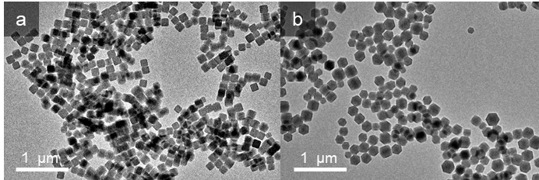
Fig S1. Low-magnification TEM images of (a) CubZ and (b) RDZ as-synthesized MOF particles, showing successful syntheses.

MOF particle size analyses
The particle size distribution of the MOFs was determined by analyzing a series of high-magnification TEM images using the ImageJ program. A total of 261 RDZ particles and 220 CubZ particles were measured, from which average particle dimensions and their corresponding standard deviations were obtained. Assuming ideal rhombic dodecahedron and cube morphologies for RDZ and CubZ, respectively, the average surface area and volume of each sample were calculated and are presented in Table S1.

Table S1. Average values, along with standard deviation, calculated from the measured lengths of over 200 particle counts. Surface area and volume are derived from these measured dimensions.
 | CubZ | RDZ
Measured (yellow arrow) | 117 ± 14 nm | 139 ± 32 nm
Length of one edge | 117 ± 14 nm | 84.9 ± 19 nm
Surface area per particle | 82,600 ± 14,000 nm² | 81,500 ± 26,000 nm²
Volume per particle | 1,610,000 ± 330,000 nm³ | 1,880,000 ± 740,000 nm³

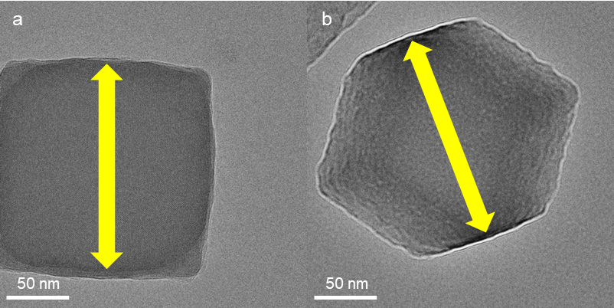
Fig S2. Measurement of MOF particle size, as indicated by the yellow arrows, for (a) CubZ and (b) RDZ.
Powder X-ray diffraction (PXRD)
PXRD spectra of as-synthesized MOF particles and prepared membranes were collected on a Rigaku Smartlab Multipurpose X-ray diffractometer using Cu-Kα radiation (λ=1.5406 Å) at a voltage of 45 kV and 200 mA and a zero-background specimen holder (UniversityWafer, Inc.). The spectra were scanned over the 5–40°.
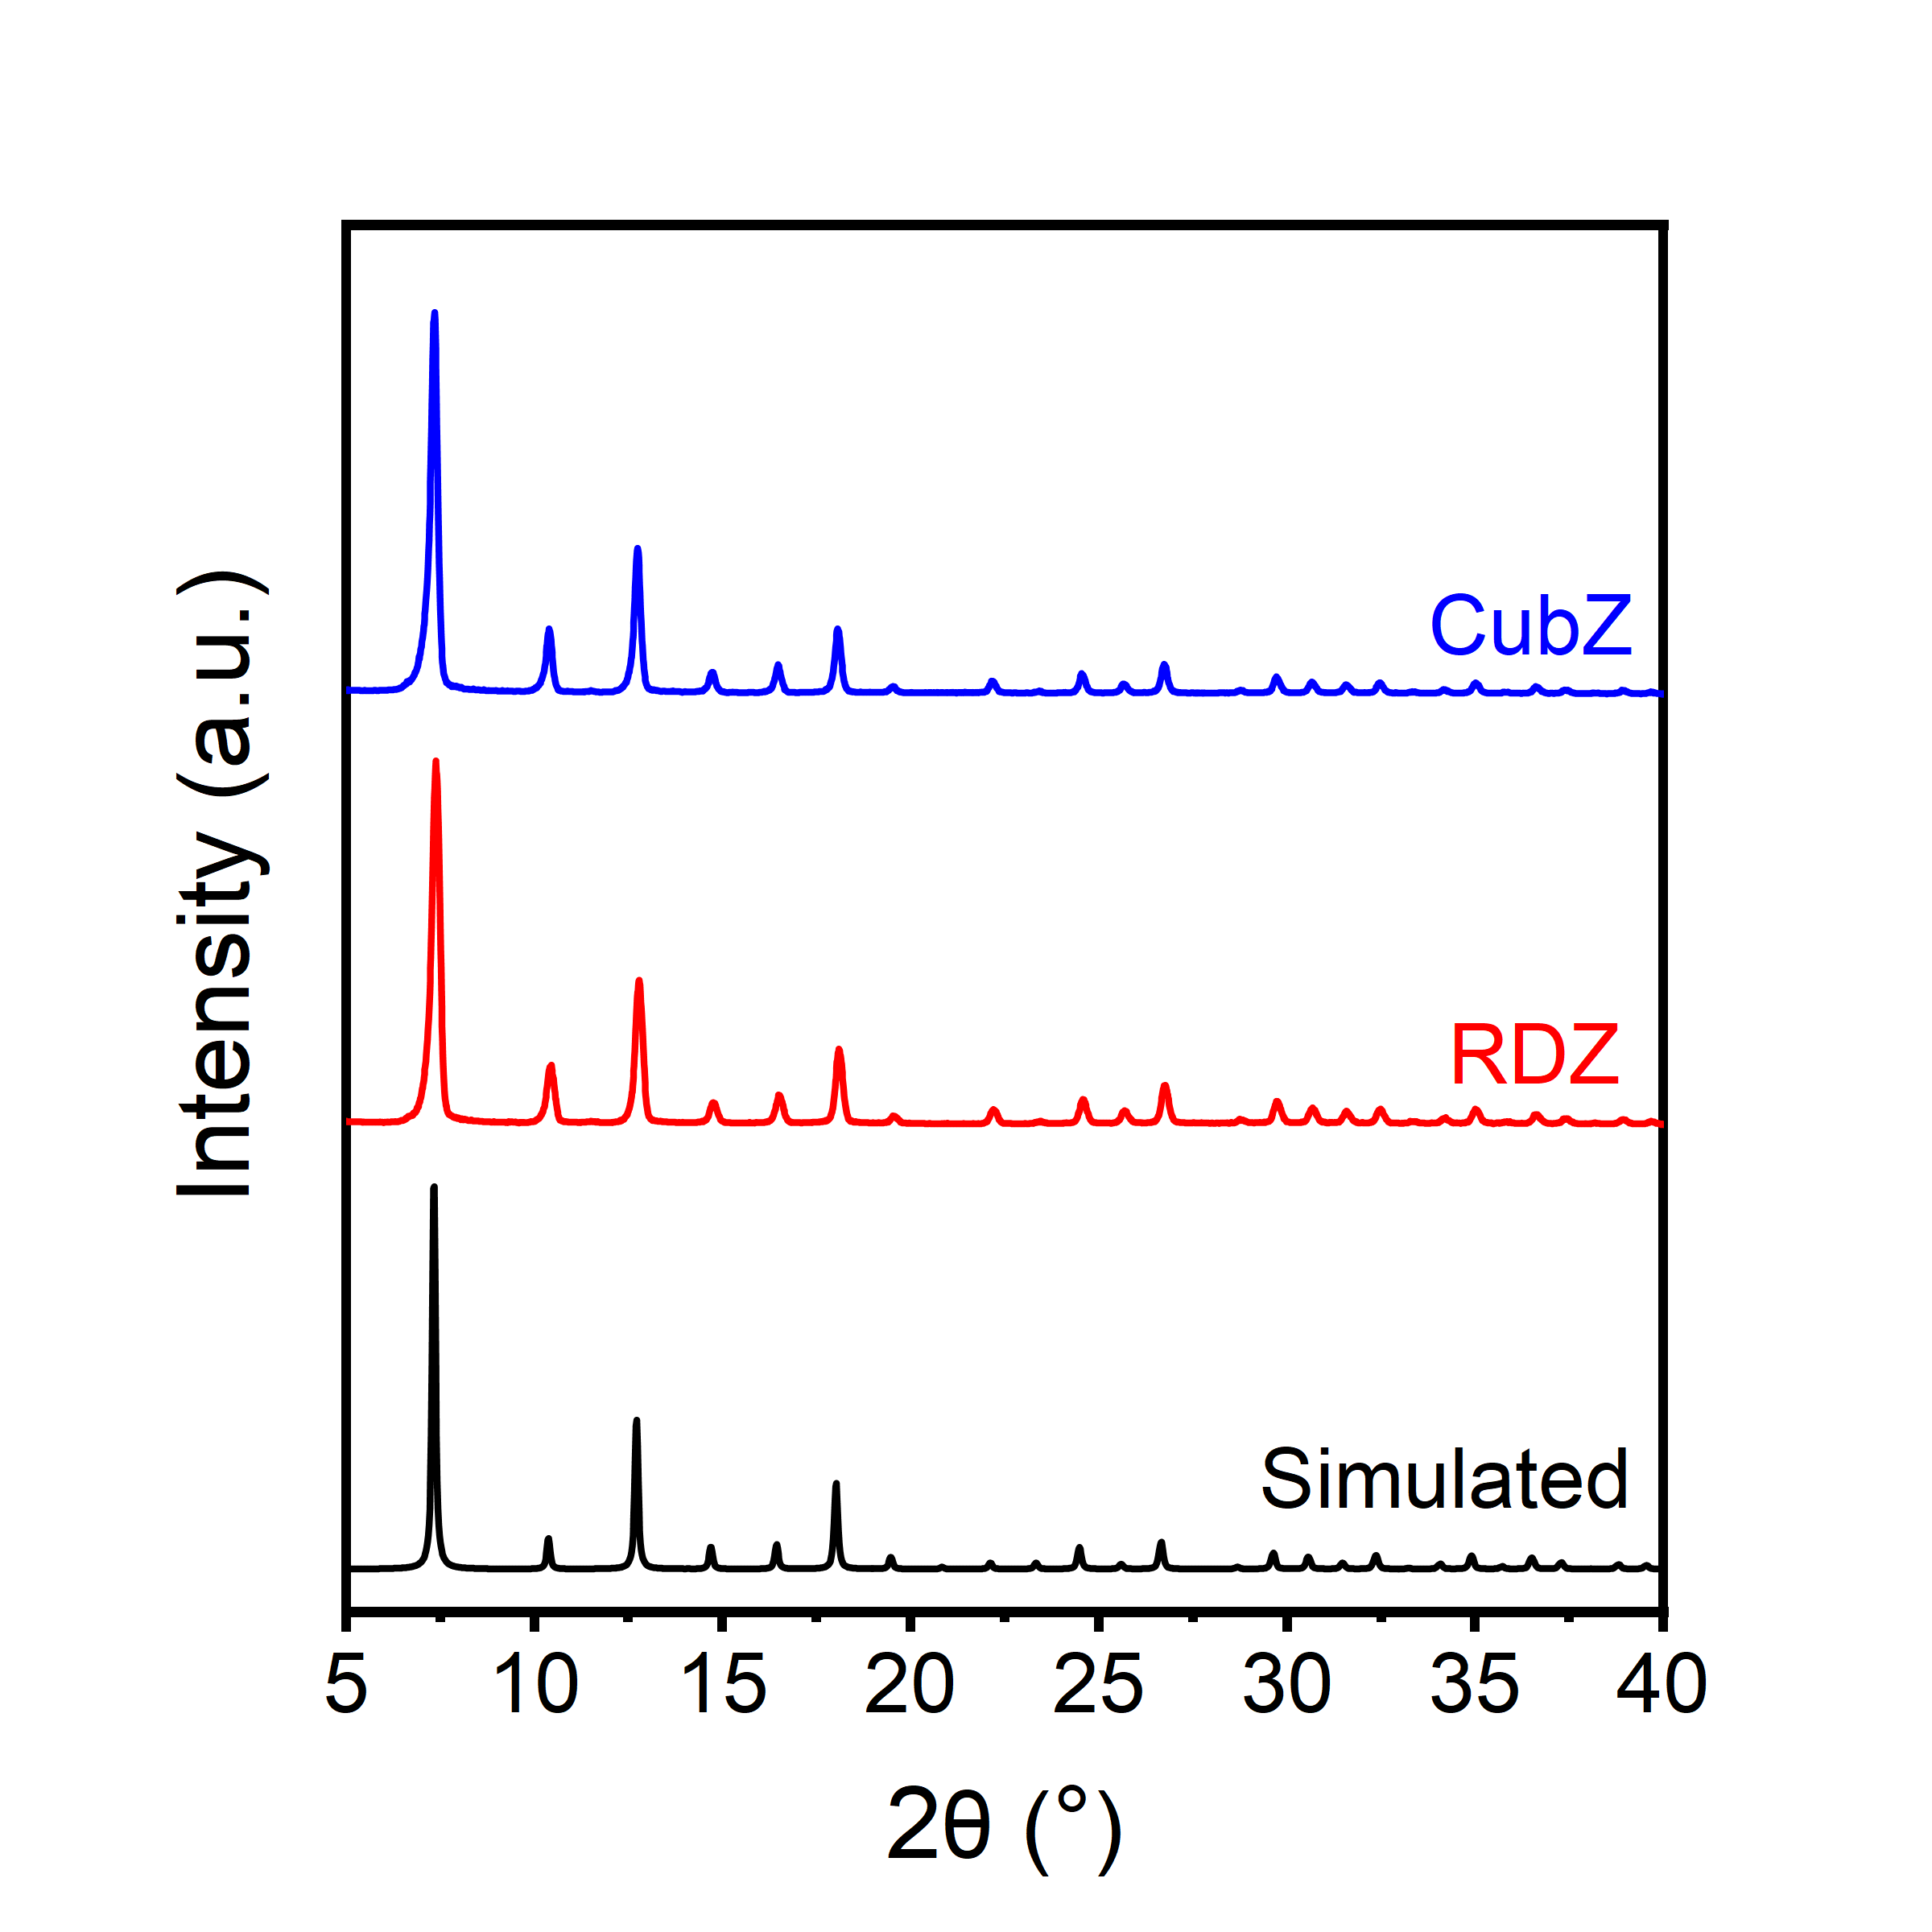
Fig S3. XRD patterns for CubZ and RDZ, displayed alongside a simulated ZIF-8 spectrum. All exhibited peak locations are identical across the patterns.
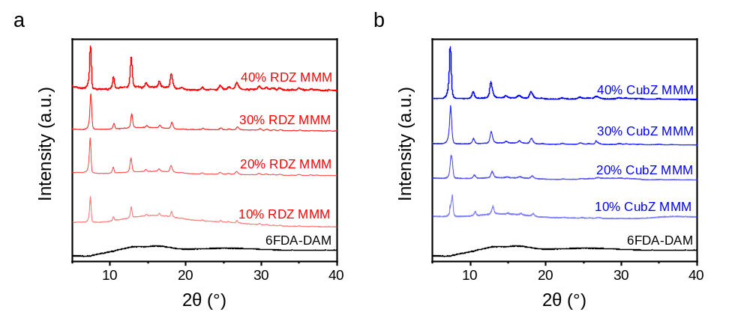
Fig S4. XRD patterns for CubZ MMMs and RDZ MMMs at 10, 20, 30, and 40 wt% loadings along with 6FDA-DAM. Peak locations are shifting to larger 2θ for CubZ MMMs compared to CubZ particles, suggesting lattice stiffening.^{3,4}

Brunauer-Emmett-Teller (BET) N₂ physisorption at 77 K
BET nitrogen physisorption isotherms were gathered using a Micromeritics 3Flex instrument, at a temperature of 77 K. Both MOF powder (Fig S5) and MMM film samples (Fig 2g and 2h), each weighing at least 0.1 g, were placed into pre-weighed BET tubes and subsequently degassed for 12 hours at 120 °C before each measurement, which was conducted in a Micromeritics Smart VacPrep. The apparent surface areas were calculated using the BET method, in the relative pressure range (P/P₀) of 0.02–0.1, as outlined in Osterrieth et al.⁵
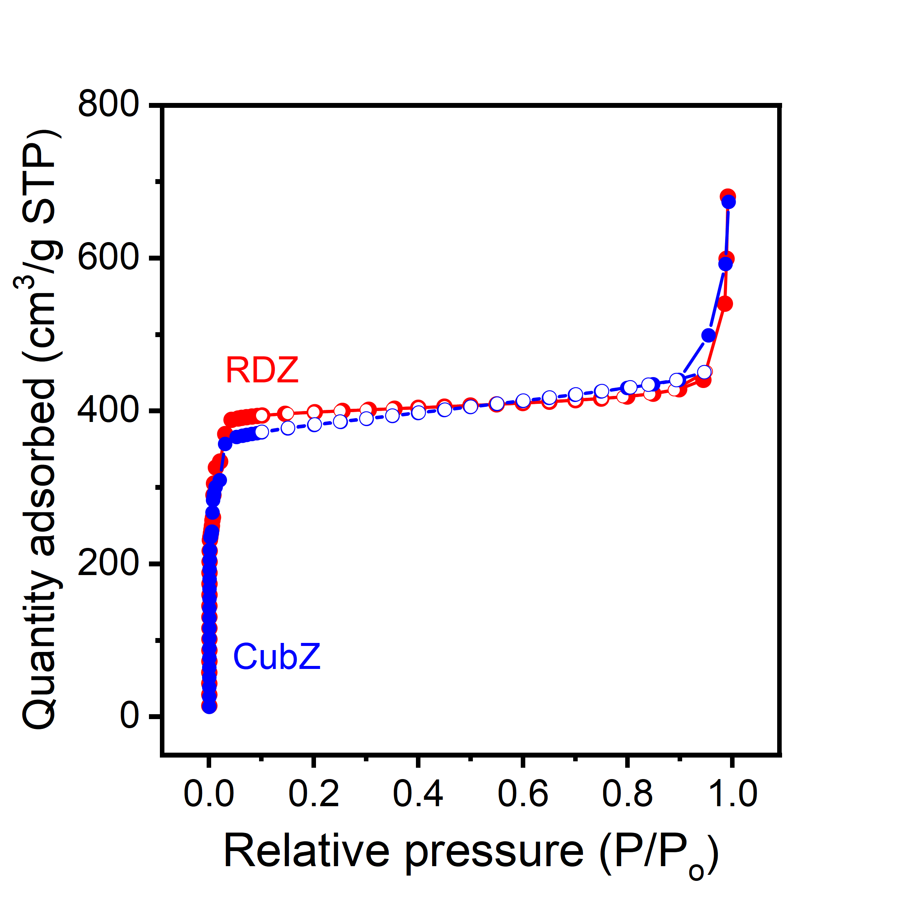
Fig S5. BET N₂ physisorption isotherms at 77 K for the as-synthesized RDZ and CubZ. Filled circles represent the adsorption process, while unfilled circles denote the desorption process. Surface area of RDZ and CubZ is 1587 ± 22 and 1576 ± 29, respectively, which were statistically identical.
Field emission scanning electron microscope (FE-SEM)
FE-SEM images were obtained using a Zeiss Merlin SEM operating at 3 kV. To prepare SEM cross-section samples, membranes were immersed in methanol to minimize air content and reduce the likelihood of non-uniform fracture. Subsequently, methanol-soaked samples were fractured in liquid nitrogen to achieve a uniform cross-section. Prior to imaging, the samples were sputter-coated with a 5 nm layer of gold/palladium alloy using a vacuum Desk II sputter unit from Denton Vacuum LLC to enable imaging of non-conductive samples by neutralizing charge effects. For Energy Dispersive X-ray Spectroscopy (EDX) analysis, the samples were left uncoated to enhance elemental signals, and low-magnification imaging was employed to minimize electron beam damage to the sample. We note that SEM images suggest slight increases in the size of RDZ and potentially CZ during nanocomposite film preparation, potentially due to Ostwald ripening of particles. These changes are difficult to quantify, but they may introduce some uncertainty in surface area estimates we report.
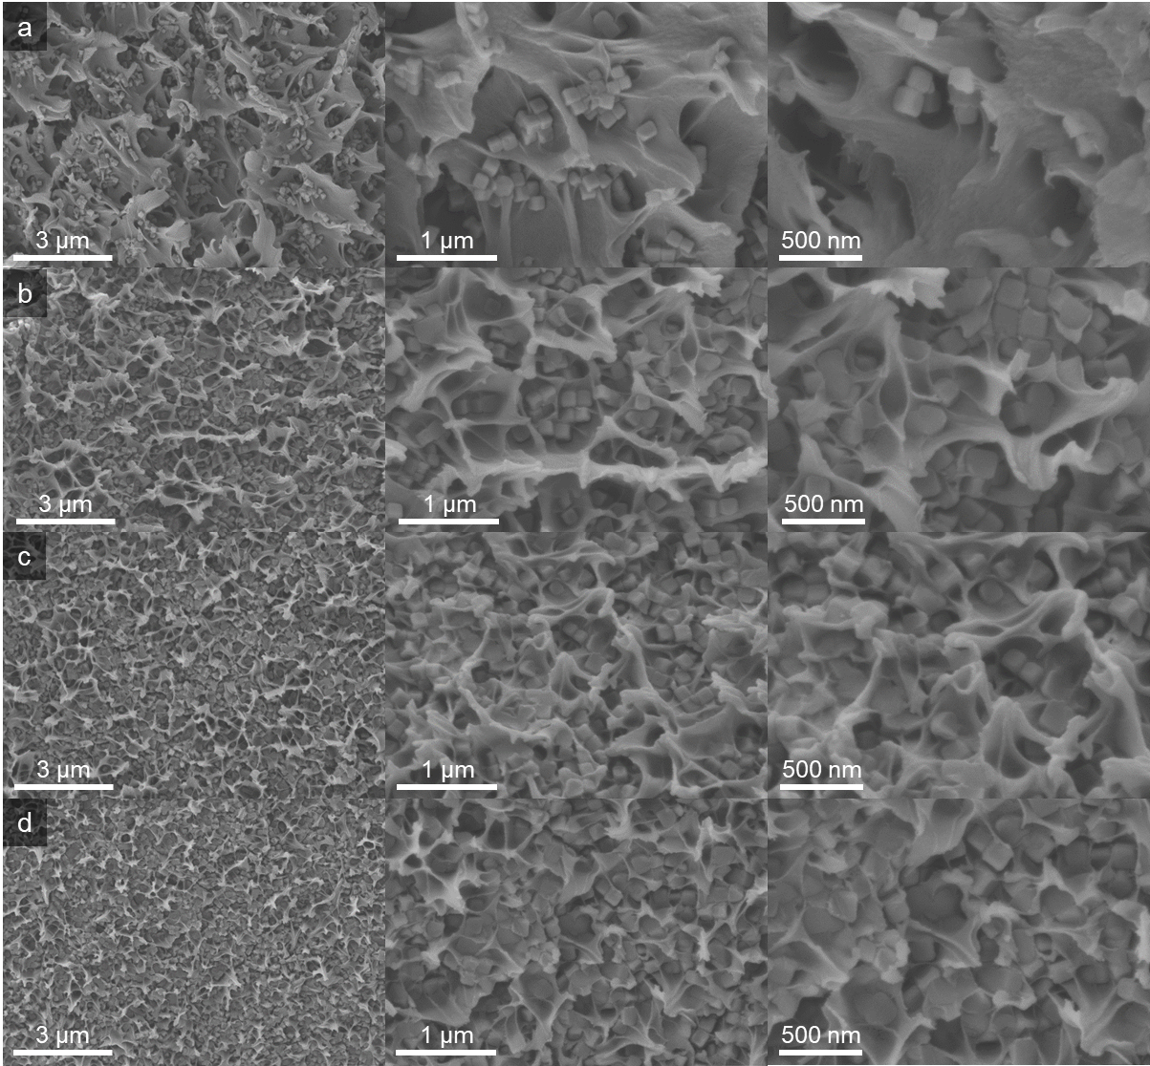
Fig S6. Cross-sectional SEM images with increasing levels of magnification for CubZ MMMs at (a) 10 wt%, (b) 20 wt%, (c) 30 wt%, (d) 40 wt%.
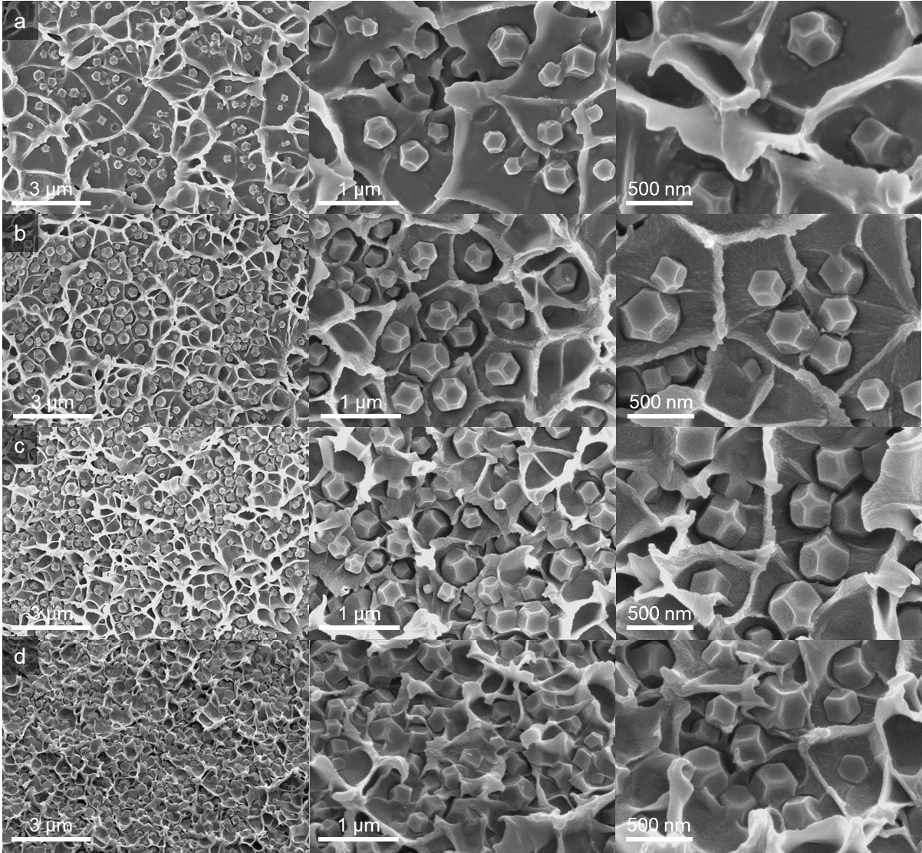
Fig S7. Cross-sectional SEM images with increasing levels of magnification for RDZ MMMs at (a) 10 wt%, (b) 20 wt%, (c) 30 wt%, (d) 40 wt%.

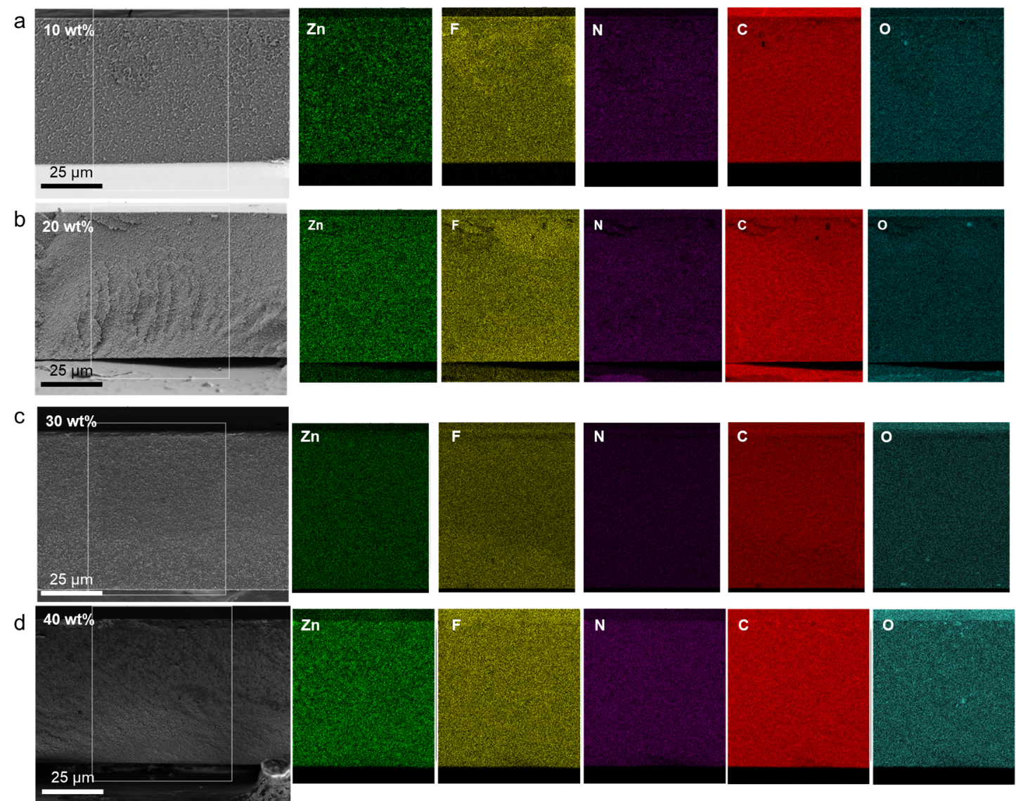
Fig S8. Cross-sectional SEM images showcasing the entire membrane thickness, paired with corresponding EDX analysis (Zn, F, N, C, and O). These are presented for CubZ MMMs at varying MOF loadings: (a) 10 wt%, (b) 20 wt%, (c) 30 wt%, and (d) 40 wt%.

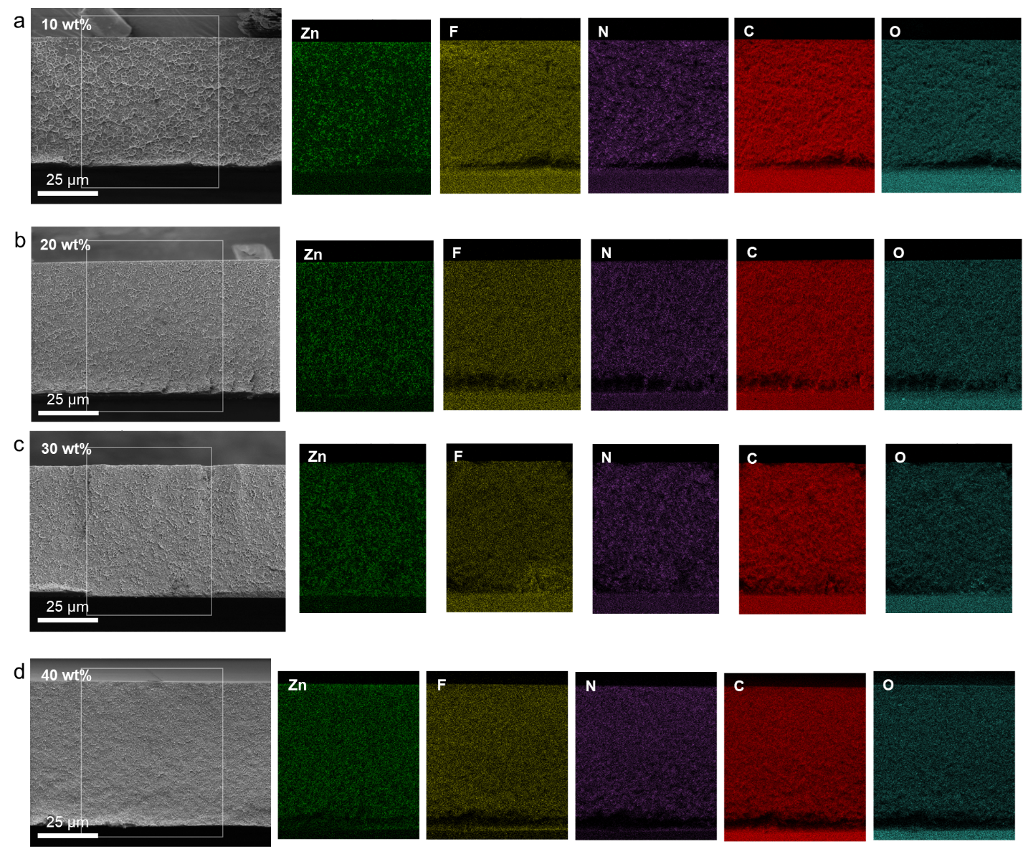
Fig S9. Cross-sectional SEM images showcasing the entire membrane thickness, paired with corresponding EDX analysis (Zn, F, N, C, and O). These are presented for RDZ MMMs at varying MOF loadings: (a) 10 wt%, (b) 20 wt%, (c) 30 wt%, and (d) 40 wt%.
Thermogravimetric analysis (TGA)
TGA was performed with a TA Instruments 550 Thermogravimetric Analyzer to assess as-synthesized MOF particles and the loading of the mixed-matrix membranes (Fig S10b and Table S2). Heating profiles from a 50–800 °C range were collected at a rate of 10 °C per minute in air. Since the final product is pure zinc oxide, we can back-calculate the original MOF quantity in the samples by comparing the final weight of the membranes to the final weight of pure MOF samples following the same procedure.
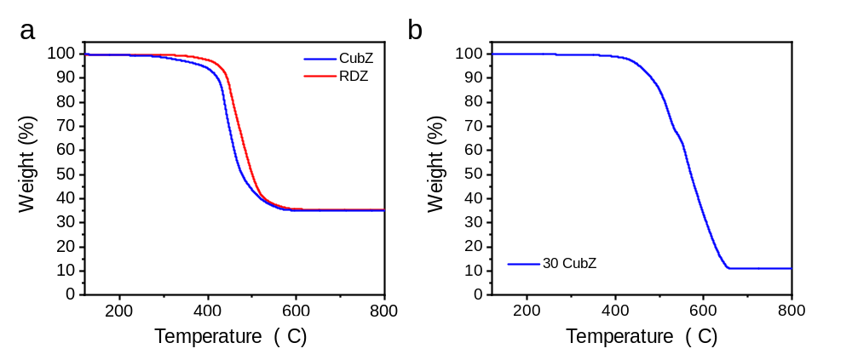
Fig S10. TGA calcination curves under air environment for (a) as-prepared CubZ and RDZ. The earlier downturn in mass at lower temperatures and very slight lower residual in the curve of CubZ may indicate it is less thermodynamically stable compared to RDZ, and (b) 30 wt% CubZ MMMs under identical conditions. After calcination, pure ZIF-8 retained 35.4 wt%, consistent with expectations based on ZnO MW (81.38 g/mol) and ZIF-8 MW (229.6 g/mol). For the 30 wt% CubZ sample, 10.9 wt% remained, indicating a 30.75 wt% MMM composition.
Table S2. Before and after calcination (calc.) weights of CubZ and RDZ MMMs, and the actual loadings, calculated from these weights, are presented alongside the target loadings
Target (wt%) | CubZ MMMs |  |  | RDZ MMMs
Target (wt%) | Before calc.(mg) | After  calc. (mg) | Achieved (wt%) | Before calc.(mg) | After  calc. (mg) | Achieved (wt%)
10 | 13.51 | 0.44 | 9.19 | 18.10 | 0.66 | 10.32
20 | 8.70 | 0.61 | 19.91 | 17.52 | 1.27 | 20.49
30 | 9.59 | 1.02 | 29.85 | 22.84 | 2.50 | 30.88
40 | 14.79 | 2.21 | 39.82 | 10.36 | 1.53 | 41.60

Differential Scanning Calorimeter (DSC) Analyses
A TA Instruments DSC250 was used to identify the glass transition temperature (T_{g}) of membrane samples. Reported T_{g} values are from the second trace from a cyclic heating protocol that oscillated between room temperature and 420 °C, before finally being heated to 550 °C. Both the heating and cooling procedures were conducted at a rate of 20 °C per minute.
Table S3. Glass transition temperatures (T_{g}) for the pure 6FDA-DAM film, as well as BZ and CZ MMMs, as determined by Differential Scanning Calorimetry (DSC).
T_{g} (°C) | 0 wt% | 10 wt% | 20 wt% | 30 wt% | 40 wt%
RDZ | 389.61 | 390.32 | 391.72 | 393.81 | 393.97
CubZ | 389.61 | 390.97 | 391.84 | 393.85 | 394.27

Density of membranes
Density measurements were performed following the Archimedes method (Ohaus 80253384 Solids Density Determination Kit). Each sample's dry weight was measured, and the sample was submerged in distilled water for the submerged weight measurement. This step was repeated five times with different parts of each sample. The density of each sample was calculated using Archimedes' principle:
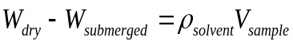 S1
where W_{dry} and W_{submerged} indicate the weight of dry sample and the weight of the same sample when submerged, respectively, and ρ_{solvent} is the density of the reference solvent. From the volume of the sample (V_{sample}) and dry sample weight, the sample’s density can be obtained (W_{dry}/V_{sample}). Measurements were conducted at a consistent room temperature to avoid variations.
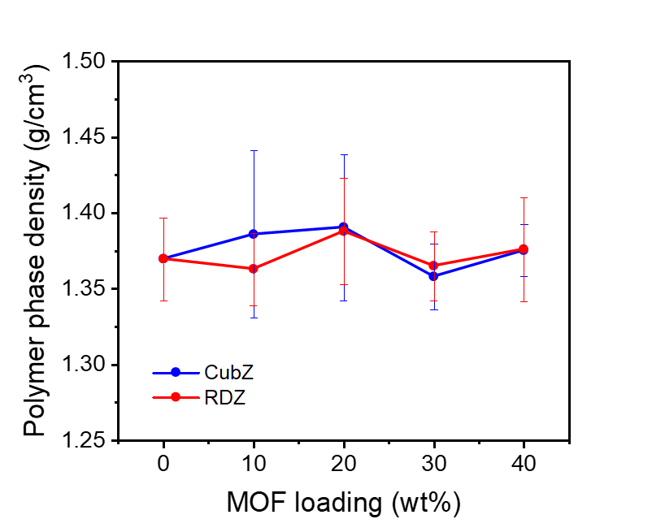
Fig S11. The polymer phase density of all MMM samples (the specific values are provided in Table S4).
Table S4. Density measurements of all membrane samples were conducted, and the polymer phase density was subsequently calculated, assuming a fixed ZIF-8 density of 0.94 g/cm³.^{3,6,7} The average and standard deviation values were determined from 5 different measurements.
Sample | Measured | Std | Polymer | Std
6FDA-DAM | 1.370 | 0.027
CubZ10 | 1.325 | 0.053 | 1.386 | 0.055
CubZ20 | 1.273 | 0.044 | 1.391 | 0.048
CubZ30 | 1.203 | 0.019 | 1.358 | 0.022
CubZ40 | 1.166 | 0.014 | 1.375 | 0.017
RDZ10 | 1.306 | 0.023 | 1.363 | 0.024
RDZ20 | 1.271 | 0.032 | 1.388 | 0.035
RDZ30 | 1.207 | 0.020 | 1.365 | 0.023
RDZ40 | 1.156 | 0.044 | 1.376 | 0.034

Wide-angle X-ray scattering (WAXS) Analysis
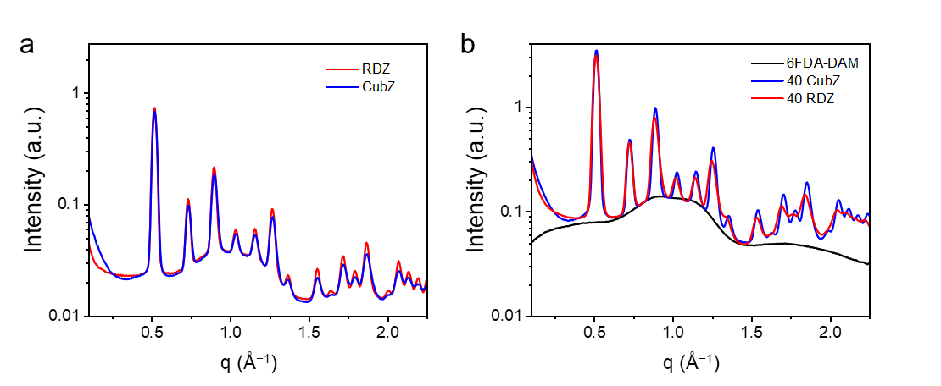
Fig S12. WAXS spectra depicting (a) pure MOFs and (b) pure polymer and MMMs at 40 wt%. The MOF samples exhibit similar peak locations, with slightly smaller d-spacings observed for CubZ MMM compared to RDZ MMM. For instance, the first peak measures 12.3 Å for RDZ MMM and 12.16 Å (~1.1% smaller) for CubZ MMM.
WAXS patterns of pure MOF samples and their corresponding 40 wt% MMMs were recorded under a vacuum of 0.08 mbar using a SAXSLAB system, equipped with a DECTRIS PILATUS3 R 300K detector and a Rigaku 002 microfocus X-ray source. Patterns were gathered over a period of 1,200 seconds. The resulting data were then presented as intensity I(q) against the scattering wavevector q, where q is defined by the equation:
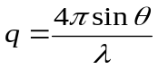 S2
where θ is Bragg’s angle and λ is the X-ray beam's wavelength. Each peak identified from these patterns was processed using the "Gaussian peak + slope background" function in the SAXSGUI software.

Nuclear magnetic resonance (NMR) analyses
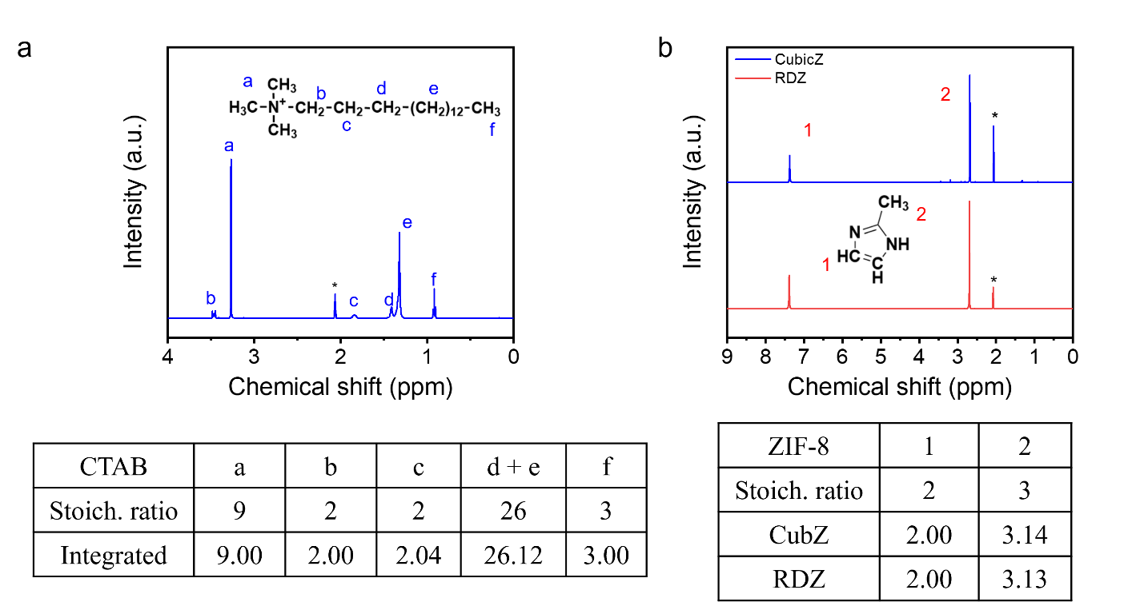Fig S13. ¹H NMR digestion spectra and integrated peak ratio, provided alongside the theoretical stoichiometric ratio, for (a) pure CTAB and (b) as-synthesized RDZ and CubZ samples. The 'a' peak of the spectra presented in (a) appears weakly in the CubZ peak of (b), indicating that only 0.77 mol% of CTAB is retained in CubZ after three washing cycles. Asterisks represent the solvent peak locations.
Solution ¹H-NMR spectra were obtained on an Ascend™ spectrometer (Bruker) with TopSpin™ 3.2 (500 MHz), from 1–5% (w/v) solutions using 0.7 mL of acetic acid-d₄ (CD₃CO₂D) to assess as-synthesized MOF particles as shown in Fig S13. As-synthesized MOF particles were tested to confirm the similar peak ratio, and CTAB was tested under the same conditions to verify the absence of significant modulator post-washing steps for CubZ.
¹³C magic angle spinning (MAS) solid-state nuclear magnetic resonance (SS-NMR) spectra were obtained on a Bruker Avance Neo spectrometer with a power of 500.18 MHz, fitted with a 3.2 mm HX solids probe. All spectra were collected for 1024 scans at a spin rate of 20 kHz, a spectral width of 200 ppm, and spin-lock time of 0.001, 0.01, 0.02, 0.05, 0.1, 1, 2 ms. T_{1ρ} values for each peak were calculated by fitting the integrated peak area values at different spin lock times to the following exponential equation:
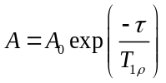 S3
where A is the integrated peak area, A₀ is the pre-factor, and τ is the spin-lock time.
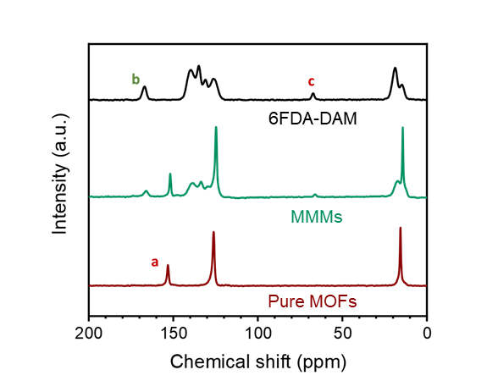
Fig S14. Spectra of 6FDA-DAM pure polymer, 40 wt% MMM composites, and ZIF-8 pure MOFs showing the peak locations. The chemical structures with the corresponding peak location can be found in Fig 2c.
Attenuated total reflection (ATR) Fourier transform infrared (FT-IR) Analyses
ATR FT-IR spectra of 6FDA-DAM pure polymer (PI, polyimide), as-synthesized RDZ and CubZ, and corresponding MMMs at different loading (10, 20, 30, 40 wt%) were collected using a Thermo Fisher FTIR6700 for 32 scans at a resolution of 1 cm⁻¹ within the 400–4000 cm⁻¹ range.
Fig S15. Fourier Transform Infrared (FTIR) spectroscopy spectra are presented for (a) CubZ and its associated MMMs, and (b) RDZ and its related MMMs, at a range of MOF loadings (0, 10, 20, 30, and 40 wt%). Purple dashed boxes highlight Zn–N bonding, while yellow dashed boxes denote the presence of carbonyl stretching with the magnified region on the left depicting 1800 to 1650 cm⁻¹.

Section S3: Computational study on MOF–polymer interaction
Investigating the surfaces of MOFs and their interactions with polymeric materials is important to help with the selection of optimal MOF/polymer matrix compositions for specific applications. Computational developments in this area have lagged behind experimental advances largely due to major challenges in the modeling of MOF/polymer MMMs.⁸
Polymer systems are typically large and require classical molecular simulation methods like Monte Carlo or molecular dynamics, which rely on force fields to describe interparticle interactions. On the other hand, MOFs exhibit unique chemical behaviors influenced by electronic properties, demanding modeling approaches that consider quantum mechanical details. However, force field-based methods struggle to accurately capture these quantum mechanical aspects and adsorption behaviors with simple functions. Therefore, developing computational models suitable for studying MOF surfaces and their interaction with polymers in MMMs is an important challenge to consider for studies such as this one. Here density functional theory (DFT) was employed to allow for the investigation of the relevant electronic interactions, but DFT also limits the length scale of polymer-based functionality accessible in our analysis. Thus, our approach may not encompass the full complexity of the system, but it does provide a valuable framework for investigating the electronic aspects of ZIF-8 and 6FDA-DAM interactions and binding energies, which are the most important molecular features for the lengthscale of diffusion at the MOF–polymer interface.
Computational methods
DFT calculations were performed to investigate the surface properties of the slab model of unsaturated ZIF-8 surfaces {110} and {100} and the MOF–polymer interactions. We used a plane-wave basis set and projector-augmented-wave (PAW)⁹ pseudopotentials in all DFT calculations. DFT calculations were performed within the Vienna Ab initio Simulation Package (VASP)¹⁰ and utilized the Perdew, Burke, and Ernzerhof (PBE) exchange-correlation functional within the generalized gradient approximation.¹¹ Van der Waals interactions were accounted for using Grimme's zero-damping D3 dispersion corrections.¹² A basis set cutoff energy of 600 eV along with electronic energy and interionic force convergence criteria of 10^{–5} eV and 0.03 eV/Å, respectively, were used. The reciprocal space integration with a Monkhorst–Pack grid of Γ point (1 × 1 × 1 k-point sampling in the Brillouin zone) was used.
Models of ZIF-8 Surface
For understanding ZIF-8 interactions with the polymer, published slab models by Pang et al. were used to evaluate the most thermodynamically stable surfaces of ZIF-8 (the {100} and {110} surfaces).² Geometry optimizations were carried out by considering each slab composed of two layers with bottom layer atomic positions held fixed to bulk ZIF-8 geometries and upper layer atomic positions allowed to relax. A vacuum layer of at least 20 Å in the direction of the slab surface normal was maintained to minimize interactions between periodic images. To account for dipole effects in the asymmetric slab models, dipole corrections (IDIPOL, DIPOL, and LDIPOL within VASP) were included.
Slab models were used to investigate the different apertures on each ZIF-8 surface facet. To facilitate the interpretation and analysis of the data, the assumption was made that the linkers connecting two unsaturated zinc sites could be approximately as straight lines for purposes of computation of geometric descriptors. This assumption in part accounts for the flexible nature of the apertures, which are opened through the reorientation of imidazolate linkers during gas transport (known as the 'gate-opening' phenomenon). To calculate the surface area of the apertures (6MRs and 4MRs), it is important to note that the zinc metal sites are not perfectly aligned on the same plane. Therefore, the apertures were divided into triangles defined by treating the metal site locations as triangle vertices. As shown in Fig S16, each aperture was “covered” by two sets of triangles, with each set consisting of different triangles. We estimate the surface area of each aperture by averaging the calculated areas of the two unique sets of triangles in each case.
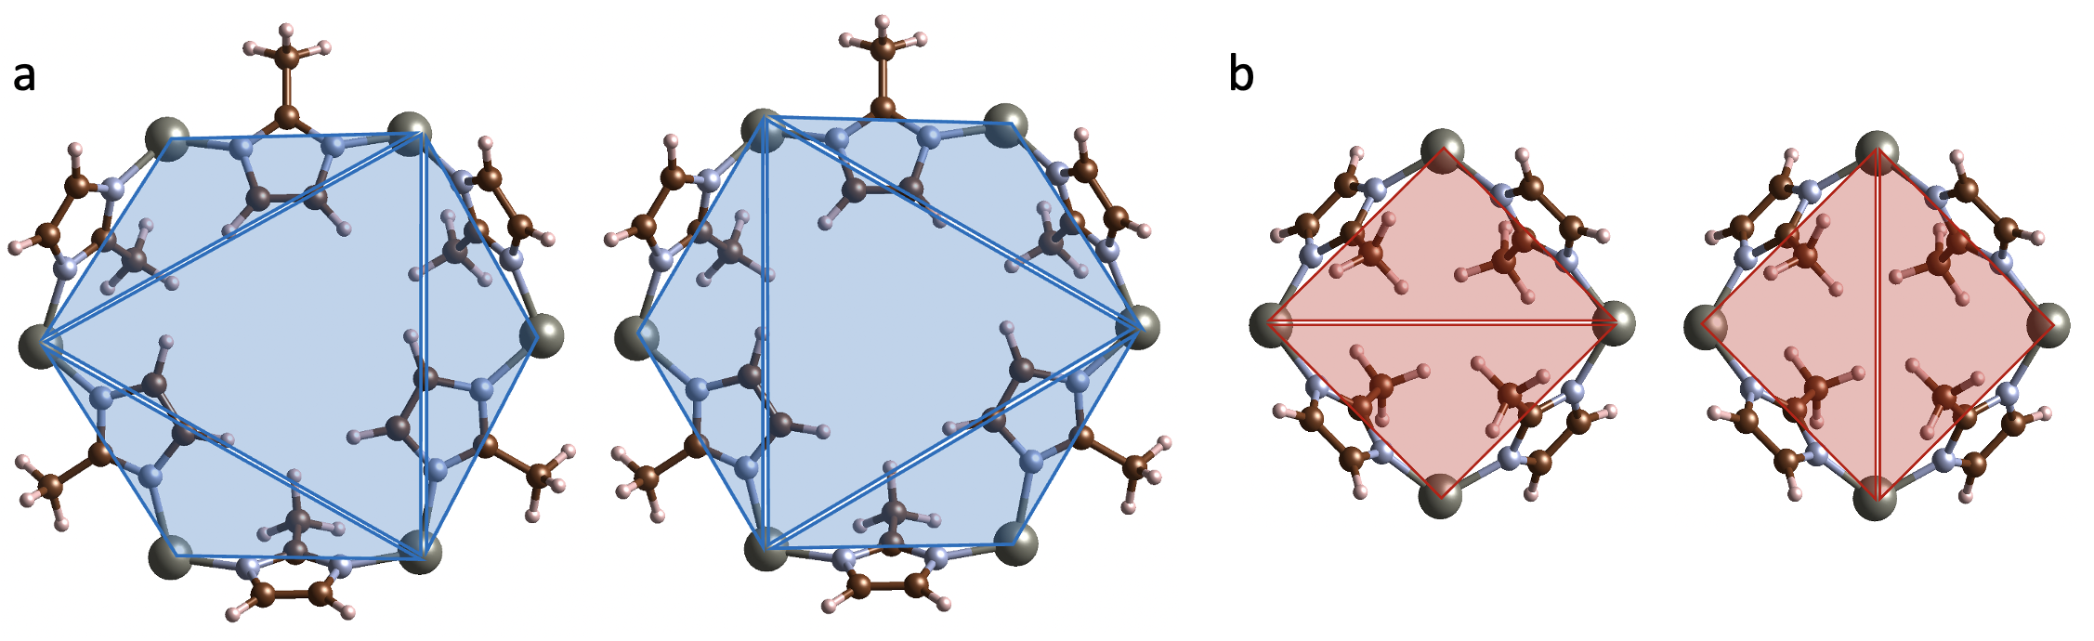
Fig S16. Illustration of the two sets of triangles used to cover each specific aperture, (a) 6MRs and (b) 4MRs, to calculate the surface area of the apertures. Color scheme: zinc (gray), carbon (brown), nitrogen (blue), and hydrogen (white).
To determine the projected angle of the aperture relative to the normal vector of the slab model surface, the projected angle between the surface normal vector and the normal vector of each triangle was computed, and these were averaged, weighted by the area of each triangle, to determine the overall orientation of each 6MR and 4MR aperture. To further compare the two surfaces of ZIF-8, the surface areas and the projected surface areas of apertures were calculated as the average values for each specific aperture in the respective surfaces. Table S5 presents the geometric properties of {110} and {100} ZIF-8 surfaces. As the projections of apertures are shown in Fig S17, surface {110} contains aperatures for four 4MRs and four 6MRs, while surface {100} features apertures for two 4MRs and four 6MRs, as denoted with numbering. The estimated average projected areas reported in Table S5 represent the mean surface area of apertures projected onto the flat 2D horizontal plane. These values are computed by averaging the projected area of each triangle from the two unique sets of triangles. The projected area of each triangle is calculated using the following equation.
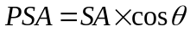 S4
where PSA denotes the Projected Surface Area of each triangle, SA signifies the Surface Area of the triangle, and $θ$ refers to the angle projected to the slab normal of the triangle.
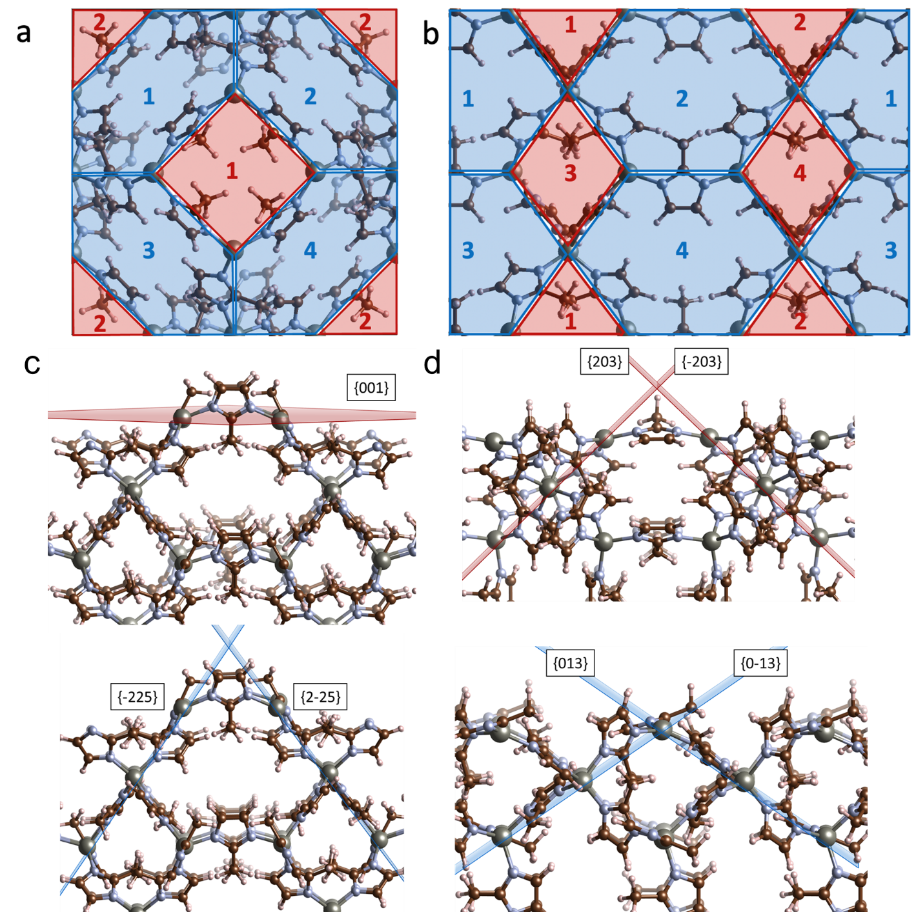
Fig S17. The projected surface area on the flat 2D horizontal plane (top view) of (a) CubZ {100} and (b) RDZ {110} ZIF-8 surfaces are presented. Schematic of the angles of distinct apertures viewed from the side on (c) CubZ {100} and (d) RDZ {110}. 4MR apertures are highlighted as red (top) and 6MR apertures are highlighted as blue (bottom) with the labels of corresponding planes. Color scheme: zinc (gray), carbon (brown), nitrogen (blue), and hydrogen (white).
Table S5. Geometric descriptors of {110} and {100} ZIF-8 surfaces
Facet termination on the surface | Average projected area per aperture (Å²) |  | Average area  per aperture (Å²) |  | Average angle to the horizontal plane (degree) |  | Closest non-neighbor zincs distance (Å)
Facet termination on the surface | 6MRs | 4MRs | 6MRs | 4MRs | 6MRs | 4MRs | Closest non-neighbor zincs distance (Å)
CubZ ({100} facet) | 56.2 | 35.4 | 96.2 | 35.4 | 54 | 1 | 8.5
RDZ ({110} facet) | 78.2 | 25.9 | 93.7 | 35.2 | 33 | 43 | 10.5

As shown in Table S5, the areas of 6MRs and 4MRs in each surface exhibit no significant differences. However, when comparing the projected surface areas, it is evident that surface {110} has a significantly larger surface area for each 6MR compared to the surface area for surface {100}. Conversely, for the other aperture, 4MRs, surface {100} exhibits a larger projected surface area than surface {110}. As 6MR (windows of ca. 3.4 Å) has a major impact on gas transport because 4MR has diminutive pore size (windows of ca. 0.8 Å),¹³ {110} can be viewed as a more accessible surface structure, assuming molecules are approaching the surfaces perpendicularly on average.
Adsorption of 6FDA-DAM on ZIF-8 surfaces
The application of DFT calculations to polymers poses certain challenges and limitations due to their inherent flexibility and the existence of numerous soft modes (including rotations and vibrations) and due to polymers having a large number of atoms.¹⁴ Acknowledging the limitations associated with treating the polymeric materials, employing an established approach previously used for a similar composite system,¹⁵ we developed a simplified manner to study the interaction of the 6FDA-DAM polymer with the different facets of ZIF-8.
In this study, to reduce the soft modes of the long polymer and produce models that are more appropriate for DFT calculations, an identical set of three fragments of 6FDA-DAM polymer were considered and tuned electronically (terminated with functional groups, such as SH, F, and Cl, as detailed in the previous study of the 6FDA-Durene polymer¹⁵), ensuring they represent the polymer electronically for study of primary interactions with the ZIF-8 surface model. Because of the structural similarities between 6FDA-DAM and 6FDA-Durene, the same functional groups for the fragment models were adopted as in the previous work. Fragment models of the 6FDA-DAM structure are presented in Fig S18. DFT calculations of polymer adsorption highlight the significance of electronic interactions between these models of 6FDA-DAM with the surfaces of ZIF-8. Of note, these interactions are specifically significant for fragment model 1, which contains two carbonyl groups.
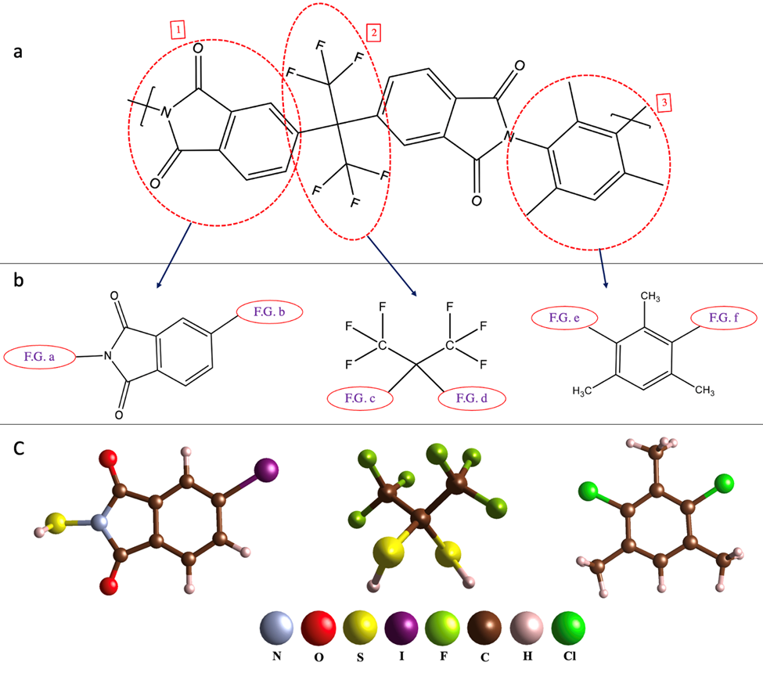
Fig S18. (a) 6FDA-DAM monomer and its decomposition into the fragments. (b) Decomposed monomer into three unique fragments and terminated with functional groups (F.G). (c) Tuned fragment models (fragment 1 terminated with SH and I, fragment 2 terminated with two SH groups, and fragment 3 terminated with two Cl).
The adsorption energetics of the polymer fragment models to the surfaces of ZIF-8 were computed as follows:
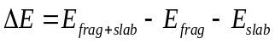 S5
where ΔE, E_{frag+slab}, E_{frag}, and E_{slab} denote the binding energy, the energy of the polymer fragment bonded to the MOF slab, the energy of the isolated polymer fragment molecule in a 20 Å edge-length box, and the energy of the slab model of pure MOF, respectively. To report the binding energy of the polymer to the MOF surfaces, several binding sites for the polymer fragments were considered to find the most thermodynamically stable adsorption site for that fragment model on the surface among all considered configurations. Use of the DFT-D3 approach for interaction geometries and energetics allowed for the determination of the extent to which dispersion forces influence the adsorption of each polymer fragment on multiple MOF surfaces. The dispersion energy contributions to adsorption were calculated using the same equation as described for binding energies, with the distinction that dispersion energies were specifically employed for these calculations.
The calculated binding energy and dispersive contributions to the binding energy of the electronically tuned fragment models of 6FDA-DAM on both surfaces {100} and {110} of ZIF-8 are reported in Table S6.
Table S6. DFT calculated binding energies and their respective dispersion interaction contributions for polymer fragment model adsorption on the {110} and {100} ZIF-8 surfaces
Model | Surface {100} (kJ/mol) |  | Surface {110} (kJ/mol)
Model | Biding Energy | Dispersion interaction contribution | Biding Energy | Dispersion interaction contribution
Fragment 1 | −369 | −76 | −192 | −56
Fragment 2 | −29 | −29 | −36 | −28
Fragment 3 | −75 | −75 | −76 | −68

As shown in Table S6, two of the three polymer fragment models (2 and 3) have weaker binding energies than that of fragment 1 and the adsorptive behavior for these fragments is predominantly governed by dispersion interactions, which are typically associated with poor wetting and adhesion behavior at the interface. However, in fragment model 1, the interaction between the carbonyl groups and the undercoordinated metal site (zinc) on the surface of ZIF-8 is characterized by strong electrostatic and electronic interactions. These interactions have a considerable impact on the adsorption behavior and show a much smaller relative contribution of dispersion.
These observations align with previous studies conducted on the interaction of ZIF-8 surfaces with polymers.^{15,16} Based on our observations, it has been determined that the interactions involving the carbonyl groups contribute to the strongest binding strength between 6FDA-DAM and the surfaces of ZIF-8. Using the tuned polymer fragment, the affinity of the 6FDA-DAM towards ZIF-8 surfaces was quantified. The findings show that the polymer is more exothermically bound to surface {100} than to surface {110}. This strong binding to surface {100} can be attributed to the shorter distances between two non-immediate neighbor unsaturated zinc atoms on this surface, as indicated in Table S5.
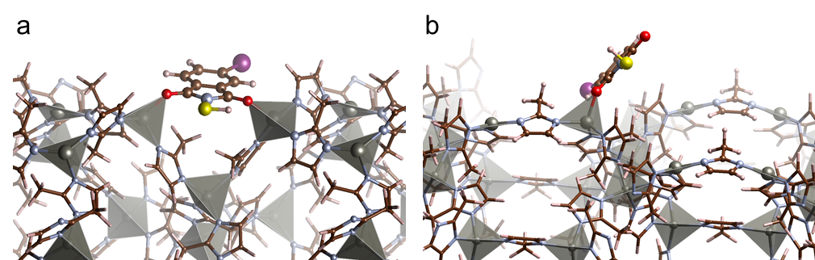
Fig S19. Bonded fragment model 1 on surfaces of ZIF-8 (a) CubZ {100} and (b) RDZ {110}. Color scheme: zinc (gray), carbon (brown), oxygen (red), nitrogen (blue), iodine (purple), hydrogen (white), sulfur (yellow). Note that iodine and sulfur are not in the polymer structure but were used as simplified functionalities for end caps on fragments.¹⁵ Care was taken in developing models of polymer adsorption that primary interactions were only considered involving chemical species in the polymer itself and not functional capping groups used to electronically tune the fragment models.
This proximity allows the polymer to form two binding interactions simultaneously from the two carbonyl groups on only one fragment as is shown in Fig S19. In contrast, the longer distance between these metal sites on the surface {110} prevents the polymer from a comparable bidentate adsorption motif. This discrepancy in distance of the two non-immediate neighbor unsaturated metal sites is a consequence of the orientation of the 6MRs on surface {100}.
Leveraging conclusions regarding primary interactions from the fragment model study, we developed models of adsorbed monomers on the ZIF-8 {100} and {110} surfaces to further explore the binding energetics of the polymer on ZIF-8 surfaces. The results indicate that the extended model also exhibits strong interactions with the carbonyl groups of the phthalimide segments. Fig 1k and 1l display the interactions of the extended monomer models with the {100} and {110} surfaces of ZIF-8. Notably, unlike fragment model 1, which does not bind bidentately by its carbonyl groups due to longer distances between two non-immediate neighbors of unsaturated zinc metal sites on the {110} surface of ZIF-8, the extended monomer model, with its greater length, does adsorb bidentately through carbonyl groups of two distinct phthalimide segments. Of note, bidendate interactions of single pthalamide groups more strongly inhibit gate opening at the surface because this functionality does not have the same rotational freedom of longer polymer segments. Thus, the interactions at the length scale of pthalamide units in an imide relevant to the {100} surface appear to be a key feature in restricting gate-opening behavior in ZIF-8.
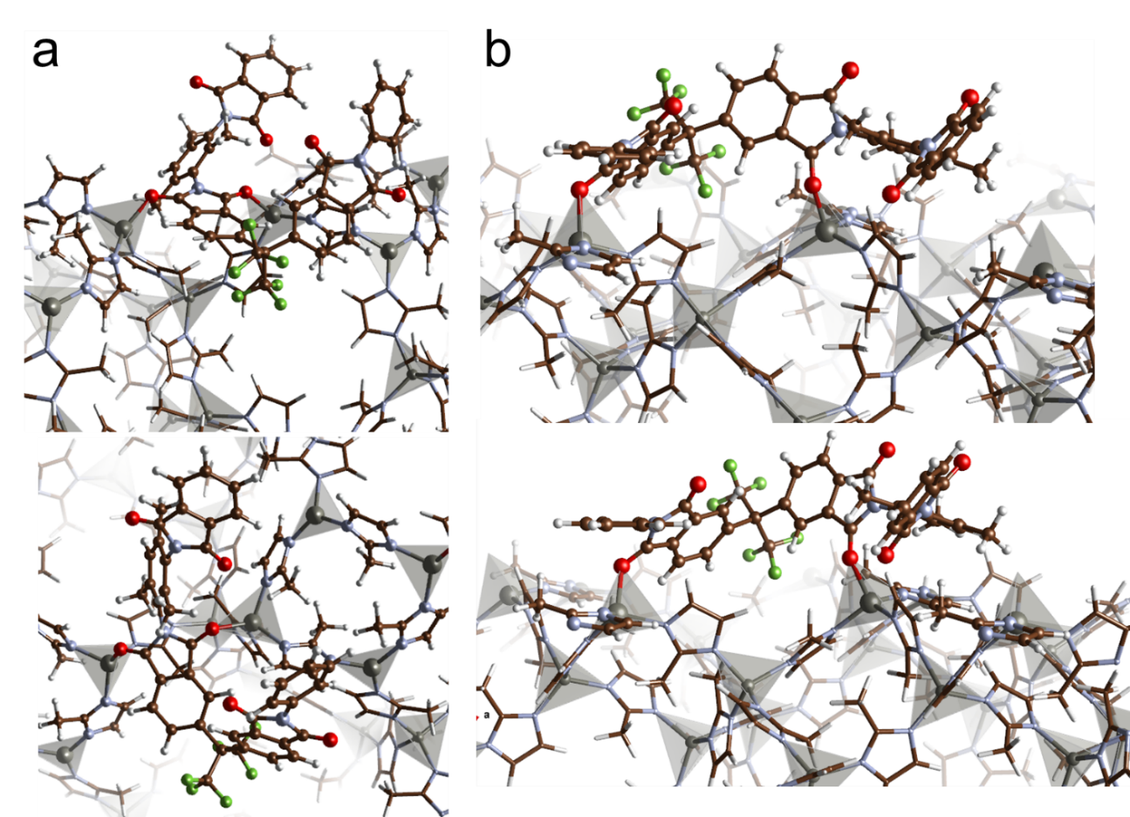
Fig S20. Representative polymer coordination depicting one monomer residue on surfaces of ZIF-8 (a) CubZ {100} and (b) RDZ {110} from two different angles, which are equivalent structures to Fig 1k and 1l. Color scheme: zinc (gray), carbon (brown), oxygen (red), nitrogen (blue), hydrogen (white).
The binding energy of the extended monomer model of 6FDA-DAM was computed using equation S5, replacing the fragment models with the extended monomer model as shown in Fig1k, 1l, and Fig S20. The results in Table S7 reveal that, as anticipated, the dispersion interaction contribution in the binding energy of the model on both surfaces {100} and {110} of ZIF-8 increased due to the larger size of the extended monomer model and the presence of more material. Interestingly, the higher dispersion interaction contribution observed on surface {100} may be attributed to its higher density and close packing surface. Despite the fact that the extended monomer model on surface {100} interacts with only two oxo groups of one phthalimide segment, similar to the fragment model, the binding energy of the extended monomer model on surface {100} (−399 kJ/mol) is still greater than when it binds bidentately on surface {110} (−305 kJ/mol). This result supports that the polymer’s stronger interaction with the {100} surface of ZIF-8 may be underlying the increased inhibition of gate-opening behavior (and reduced selectivity for C3 separations) observed in CubZ-containing MMMs.
Table S7. DFT calculated binding energies and their respective dispersion interaction contributions of the extended monomer model of 6FDA-DAM polymer adsorption on the {110} and {100} ZIF-8 surfaces.
Model | Surface {100} (kJ/mol) |  | Surface {110} (kJ/mol)
Model | Biding Energy | Dispersion interaction contribution | Biding Energy | Dispersion interaction contribution
Extended monomer | −399 | −160 | −305 | −135

Section S4: Gas transport properties measurements
Gas Permeation Measurements
Pure-gas permeation tests of H₂, N₂, CH₄, C₂H₄, C₂H₆, C₃H₆, and C₃H₈ were conducted using an automated, custom-built, constant-volume, variable-pressure permeation system from Maxwell Robotics. Approximately 1 cm² membrane coupons were cut from the prepared films. The thickness of these coupons was measured five times using a micrometer to calculate an average and standard deviation. These coupons were then affixed to the center of a brass shim stock disk with an outer diameter of 47 mm and an inner diameter of 7 mm using impermeable 5-min epoxy glue (Devcon, 14250). This setup resulted in an active permeation area ranging from 5–20 mm², as determined by a scanned image and ImageJ software (NIH). Again, this measurement process was repeated five times to compute an average and standard deviation.
The samples were then sealed in a stainless-steel cell and held at one of five distinct temperatures (7, 20, 35, 50, 65 °C). Temperature regulation was managed by a PID temperature controller (Omega, CNI852-EI) and a chiller (for sub-ambient temperatures, Vevor, B0849YQMY4). Every test implemented a procedure to guarantee a leak rate of less than 10% of the gas permeation rate, as determined under a static vacuum for 1 hour prior to testing. Before the testing procedure, each sample was left under vacuum for a minimum of 8 hours (12 hours for C₂ and C₃ gases). This procedure was followed by a helium flush at 1 atm, further degassing, and an additional 30-minutes vacuum hold before introducing different gases. Each sample was tested at each condition two to three times to determine average values, with the calculated uncertainty reported as the average instrumental error, derived from the leak rate, the area, and the thickness measurements.
The permeation rate of each gas was determined from the steady-state pressure rise in the downstream volume, as illustrated by the following equation:
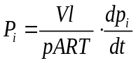 S6
In this equation, P_{i} represents the pure gas permeability (i: H₂, N₂, CH₄, C₂H₄, C₂H₆, C₃H₆, and C₃H₈) in barrer (10⁻¹⁰ cm³(STP) cm cm⁻² s⁻¹ cmHg⁻¹), V denotes the downstream volume (cm³), l stands for the membrane thickness (cm), p refers to the average upstream pressure (cmHg), A is the active area of the film, R is the ideal gas constant, T is the absolute temperature (K), and dp_{i}/dt represents the steady-state pressure rise in the downstream (cmHg s⁻¹) after subtracting the leak rate. The ideal selectivity (α) was determined as the ratio of two pure gas permeabilities (P_{i}/P_{j}), where i is more permeable.
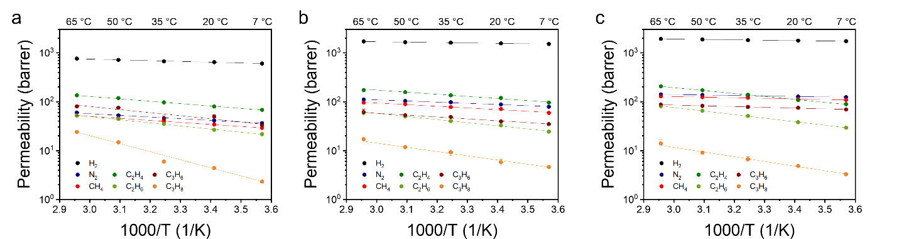
Fig S21. Permeability of all gases evaluated (H₂, N₂, CH₄, C₂H₄, C₂H₆, C₃H₆, C₃H₈) plotted against the inverse temperature for (a) 6FDA-DAM, (b) 30 wt% CubZ MMM, and (c) 30 wt% RDZ MMM. Lines indicate best fits using an Arrhenius expression.
H₂-based binary mixed-gas permeation tests were performed similarly to pure-gas permeation. Triplicates of 6FDA-DAM, 40 wt% CubZ MMM, and 40 wt% RDZ MMM were prepared separately and tested for their mixed-gas performance. In a typical mixed-gas permeation run, a leak test was performed for 1 hour, followed by a pure H₂ hold at 16 psia for 0.2 hour, a pure CH₄ hold for 1 hour, a 50/50 H₂/CH₄ hold at 32 psia. The instrument was degassed for 30 minutes between each step.
The mixed-gas permeability was calculated using the following equation:
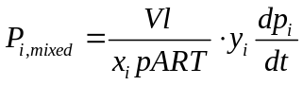 S7
The notations are the same as that described for equation S6. x_{i} and y_{i} represent the mole fractions of gas i (i: H₂, CH₄) in the upstream and downstream, respectively, which were gathered from gas chromatography.
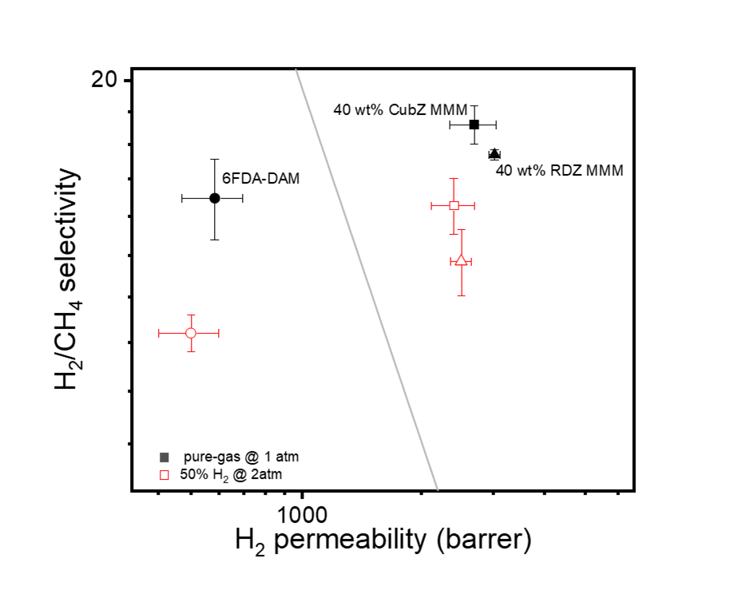
Fig S22. Pure- (black symbols) and 50/50 mixed-gas (red, unfilled symbol) separation performance of 6FDA-DAM (circle symbols), 40 wt% CubZ MMM (square symbols), and RDZ MMM (triangle symbols) H₂/CH₄.
Gas Sorption Measurements
H₂, N₂, CH₄, C₂H₄, C₂H₆, C₃H₆, and C₃H₈ sorption isotherms were collected at the same 5 temperature points (7, 20, 35, 50, 65 °C) for 30 wt% MMMs and pure polymer membrane as shown in Fig S24–S29. For pure MOF samples, the same set of gas was tested at 35 °C to confirm sorption properties as shown in Fig S23.
The measurements were achieved using an automated pressure decay method, facilitated by a dual volume and dual transducer sorption system sourced from Maxwell Robotics. For each test, a sample comprising 0.08–0.2 g of membrane film or MOF powder was used.
Following loading of the sample, the cell was sealed using a VCR gasket, after which the entire system underwent a 12-hour evacuation process. This step was critical for the removal of any dissolved gases and moisture present within the films or powders. The quantity of gas sorbed by the sample at each pressure point was determined through a mole balance calculation, performed between each dosing and equilibration step.
For the membranes, each sorption isotherm was fitted using the dual-mode sorption (DMS) model. This model combines Henry's and Langmuir's sorption laws and is commonly used to describe sorption in glassy polymers.¹⁷ By considering both mechanisms, the dual-mode sorption model provides a more comprehensive understanding of gas sorption behavior in membranes. The DMS equation is shown below, where the first term represents the Henry mode and the second term, the Langmuir mode.
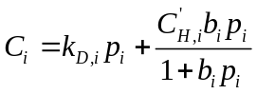 S8
where C_{i} is the concentration of gas i (i = H₂, N₂, CH₄, C₂H₄, C₂H₆, C₃H₆, and C₃H₈) sorbed in the membrane (cm³(STP)cm⁻³), p_{i} is the equilibrated fugacity (atm), k_{D,i} is Henry’s constant (cm³(STP)cm⁻³ atm⁻¹) that shows the properties of polymer phase, 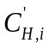 is the Langmuir sorption capacity (cm³(STP)cm⁻³), and b_{i} is the Langmuir affinity constant (atm⁻¹) that shows the combined contributions from polymer and MOF phase.¹⁸ Specifically, k_{D,i} signifies the equilibrium constant of a penetrant transitioning between the gaseous and the dissolved state, while b_{i} is an equilibrium constant that characterizes the relative rates of surface adsorption and desorption pertaining to the Langmuir mode. To address the possibility of multiple equally good fits due to the three-parameter fitting, a cross-correlation analysis using a nonlinear optimization was performed in MATLAB by χ² (propagated error¹⁹) minimization, following the method proposed by Wu et al.²⁰ This approach involves constraining each variable with scientific reasoning to identify the most suitable fit among the alternatives.
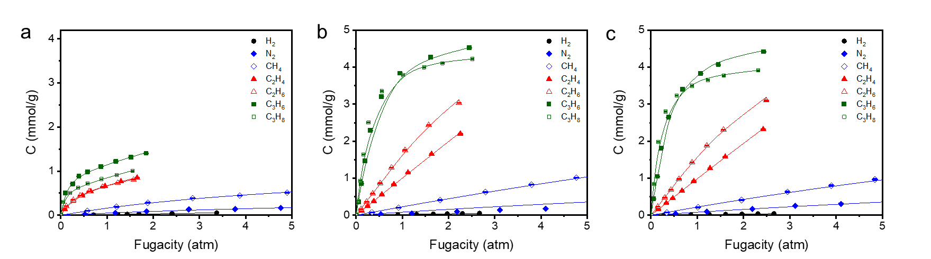
Fig S23. Sorption isotherms of all tested gases (H₂, N₂, CH₄, C₂H₄, C₂H₆, C₃H₆, C₃H₈) are depicted for (a) 6FDA-DAM polymer membrane, (b) pure RDZ, and (c) pure CubZ MOF particles. Individual data points represent experimental findings, while the superimposed lines correspond to fits from either dual-mode sorption model or the Langmuir sorption model. RDZ and CubZ values were consistent with the values from the previously reported data for ZIF-8.²¹ The units of C are converted to mmol/g assuming the density of ZIF-8 is 0.94 g/cm³.^{6,7}
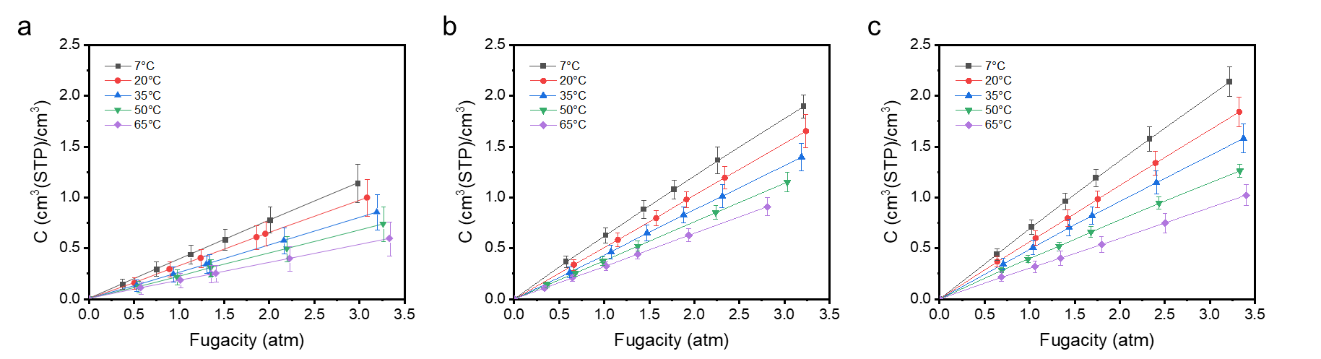
Fig S24. H₂ sorption isotherm for (a) 6FDA-DAM, (b) 30 wt% CubZ MMM, and (c) 30 wt% RDZ MMM, obtained at temperatures of 7, 20, 35, 50, 65 °C. Individual data points correspond to experimental results, with the plotted lines indicating the dual-mode sorption model fit.
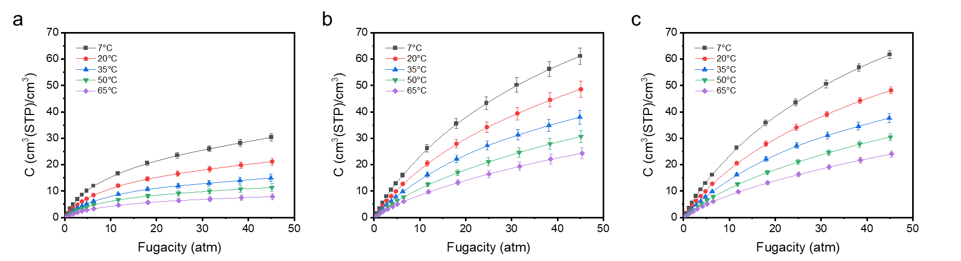
Fig S25. N₂ sorption isotherm for (a) 6FDA-DAM, (b) 30 wt% CubZ MMM, and (c) 30 wt% RDZ MMM, obtained at temperatures of 7, 20, 35, 50, 65 °C. Individual data points correspond to experimental results, with the plotted lines indicating the dual-mode sorption model fit.
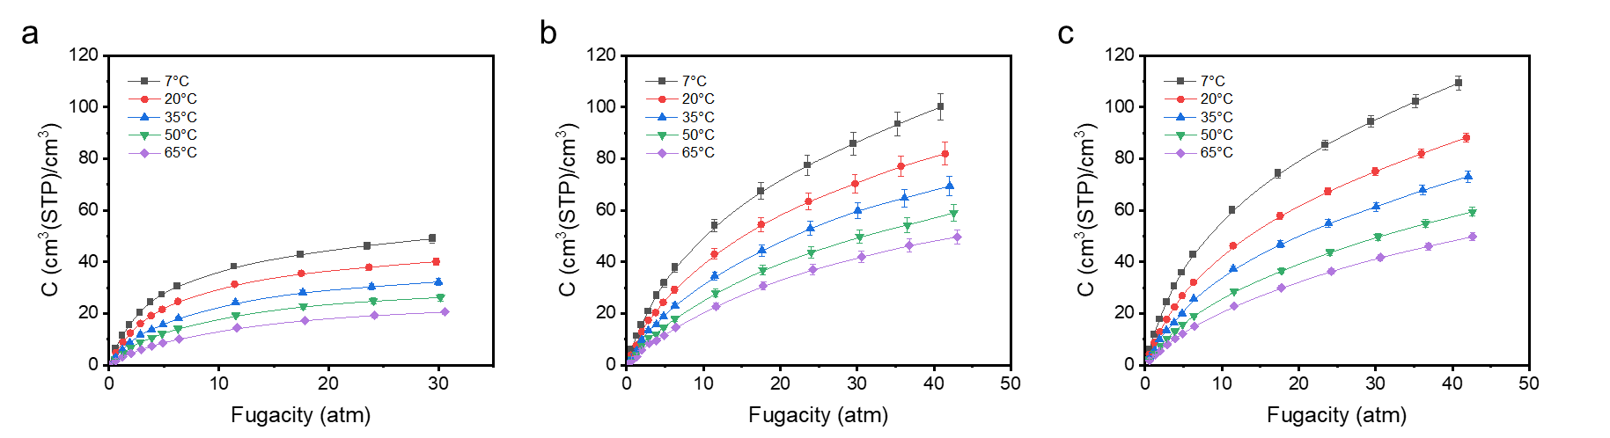
Fig S26. CH₄ sorption isotherm for (a) 6FDA-DAM, (b) 30 wt% CubZ MMM, and (c) 30 wt% RDZ MMM, obtained at temperatures of 7, 20, 35, 50, 65 °C. Individual data points correspond to experimental results, with the plotted lines indicating the dual-mode sorption model fit.
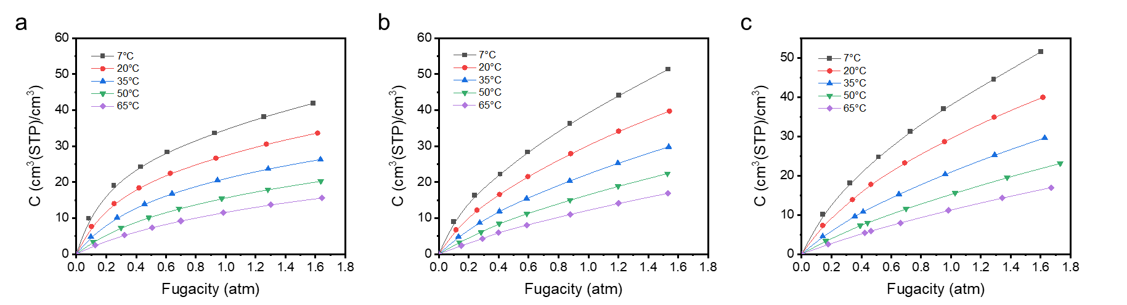
Fig S27. C₂H₄ sorption isotherm for (a) 6FDA-DAM, (b) 30 wt% CubZ MMM, and (c) 30 wt% RDZ MMM, obtained at temperatures of 7, 20, 35, 50, 65 °C. Individual data points correspond to experimental results, with the plotted lines indicating the dual-mode sorption model fit.
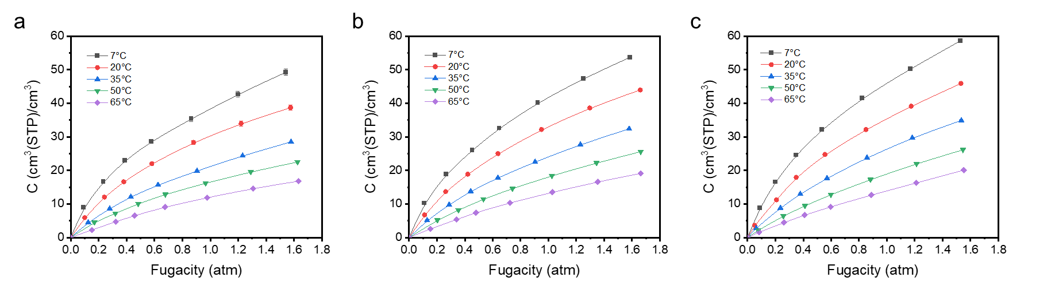
Fig S28. C₂H₆ sorption isotherm for (a) 6FDA-DAM, (b) 30 wt% CubZ MMM, and (c) 30 wt% RDZ MMM, obtained at temperatures of 7, 20, 35, 50, 65 °C. Individual data points correspond to experimental results, with the plotted lines indicating the dual-mode sorption model fit.
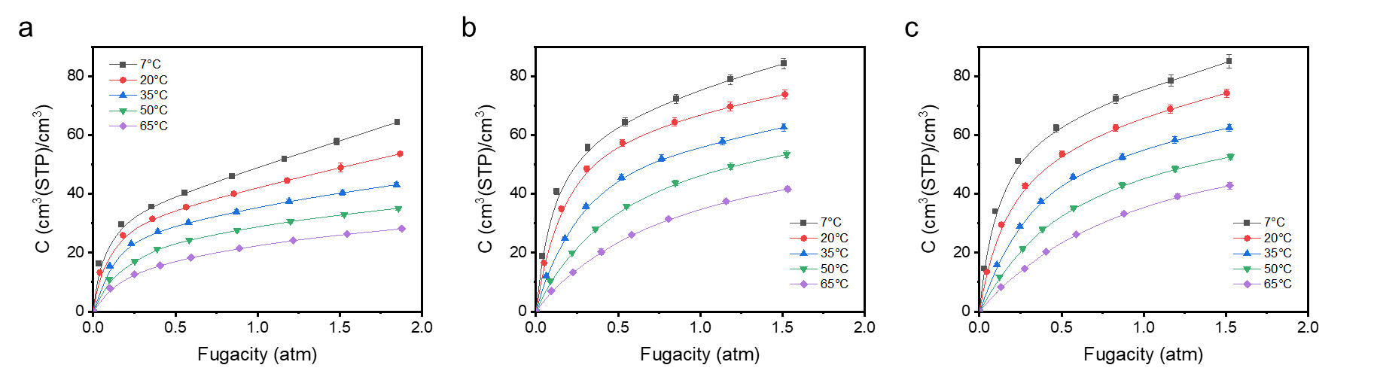
Fig S29. C₃H₆ sorption isotherm for (a) 6FDA-DAM, (b) 30 wt% CubZ MMM, and (c) 30 wt% RDZ MMM, obtained at temperatures of 7, 20, 35, 50, 65 °C. Individual data points correspond to experimental results, with the plotted lines indicating the dual-mode sorption model fit.
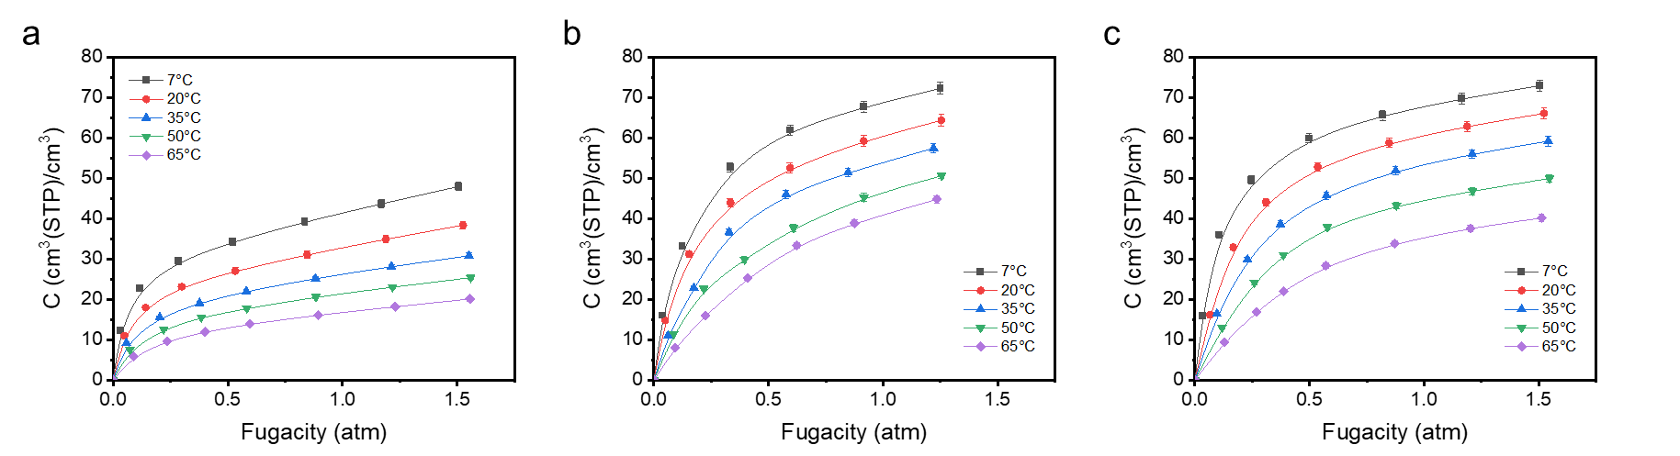
Fig S30. C₃H₈ sorption isotherm for (a) 6FDA-DAM(b) 30 wt% CubZ MMM, and (c) 30 wt% RDZ MMM, obtained at temperatures of 7, 20, 35, 50, 65 °C. Individual data points correspond to experimental results, with the plotted lines indicating the dual-mode sorption model fit.
Sorption coefficients were acquired by dividing the gas concentration at the pressure where the permeation test of the specific gas at a given temperature was determined (≈ 1 bar, S = C/p). Furthermore, diffusion coefficients were computed by applying the sorption–diffusion model (P = D × S).²² Both sorption and diffusion coefficients at 35 °C are plotted in Fig S30.
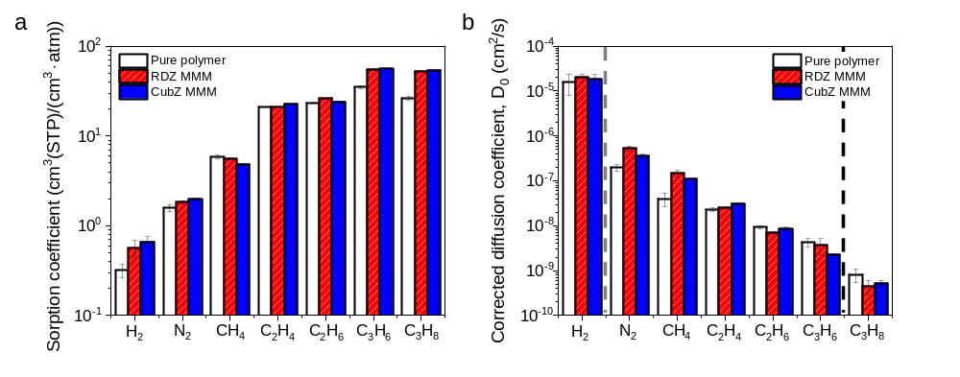
Fig S31. (a) Sorption coefficient and (b) corrected diffusion coefficient presented for the 6FDA-DAM pure polymer film, 30 wt% CubZ MMM, and 30 wt% RDZ MMM. Comparing diffusivity values for two MMMs, hydrogen shows similar values within error yet the CubZ MMM shows a larger decline for N₂ and CH₄ (gray dotted line). C₃H₈ also shows similar values across MMMs, yet C₃H₆ shows much faster diffusion for RDZ (black dotted line).

Section S5: MMM gas transport model analysis
Evaluating transport behavior in MMMs requires an understanding of the permeation properties of each individual component, including the continuous phase and dispersed phase. Multiple modeling approaches have been developed to facilitate the prediction of MMM performance, considering multiple factors such as the MMM's structure and investigating whether the MMM demonstrates an ideal or nonideal behavior.^{8,23} In an ideal MMM morphology, the two-phase system consists of a dispersed filler surrounded by a continuous polymer phase. This arrangement is characterized by a lack of defects at the interface between the polymer and the filler. In this study, due to the high compatibility of the ZIF-8 particles and the 6FDA-DAM polymer and the small size of the synthesized ZIF-8 particles, ideal permeation models were used for our analyses.
The aim of this part of the study is to predict gas permeation through pure MOF phases by using the obtained permeation data in the pure polymer and the MMM at different loadings. The investigation was conducted by employing two models that have been developed for ideal two-phase MMMs, including the Maxwell–Wagner–Sillar (MWS) and Gonzo−Parentis−Gottifredi (GPG) models.^{24–26}
Maxwell's theory was originally developed to calculate the electrical conductivity of composite materials.²⁷ One widely applied version of this model for predicting the performance of an ideal MMM with ellipsoidal fillers is the MWS model.
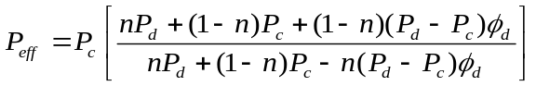 S9
Where P_{c}, P_{d}, n, and $∅_{d}$ are denoted as the permeabilities of the continuous phase (pure polymer), the permeabilities of the dispersed phase (pure MOF), the shape factor, and the volume fraction of particle loading, respectively. Using 𝜌_{6FDA-DAM} = 1.38 g/cm³ and 𝜌_{𝑍𝐼𝐹−8} = 0.94 g/cm³,^{6,7,28,29} the weight fractions of ZIF-8 particles in the 6FDA-DAM matrix were converted to volume fractions. The shape factor reflects the role of particle geometry in permeation through MMM and can range from 0 to 1. Where n = 1/3 is commonly associated with spherical particles and reduces the MWS model to the original Maxwell equation, 0 < 𝑛 < 1/3 corresponds to transport through prolate ellipsoids, and 1/3 < n < 1 represents transport through oblate ellipsoids. This model is only applicable to systems with low concentrations of fillers (volumetric of lower than 0.2) in MMM,²⁶ as it does not account for particle interactions.
The model was initially fit using n = 1/3 (the original Maxwell equation) to predict the permeation of pure ZIF-8 on different facets. However, this model did not fit well with our experimental data, and the predicted permeation showed divergence for some gases. These limitations may arise from the original Maxwell model's assumptions, such as considering only dilute spherical particles randomly dispersed in a continuous phase. Alternatively, the polymer–MOF interactions, as evaluated through DFT, may create a volume-loading dependence on filler property sets, which cannot be accounted for by the model.
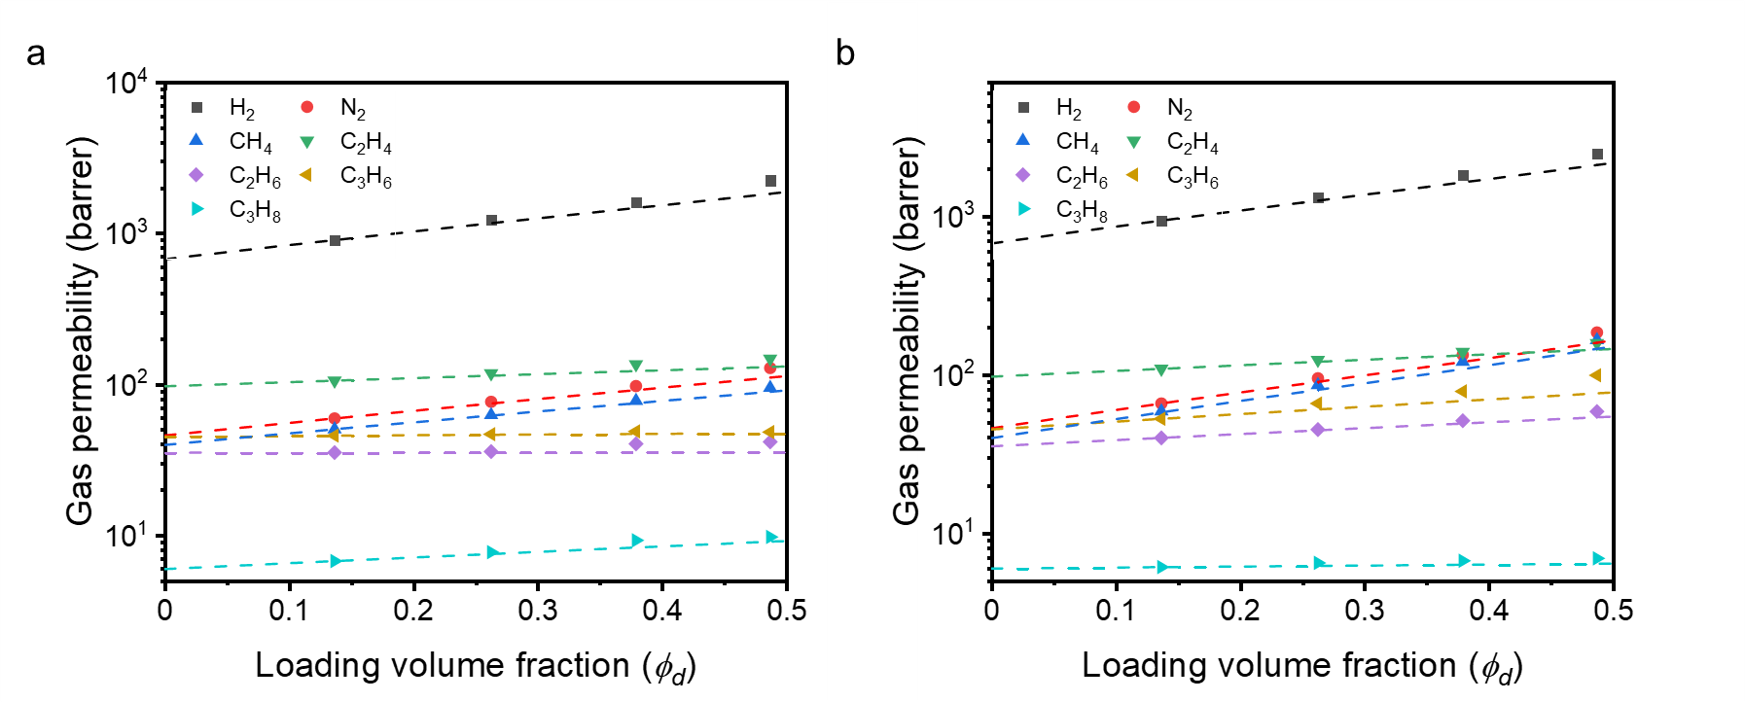
Fig S32. The original Maxwell fitting (n = 1/3 for the MWS model) for (a) CubZ MMM and (b) RDZ MMM. Individual data points correspond to experimental results, with the plotted dashed lines indicating the fitted permeability model.
In a subsequent attempt, the Maxwell model was applied specifically to MMMs with loading volume fractions lower than 0.2, where the model is considered valid.²⁶ However, only one point from the experimental data with such a volume fraction was used for fitting the model, which significantly hinders confidence in the interpretability of the results. As demonstrated in Fig S31, the model underestimates the permeation at higher loadings for all gases. This discrepancy could be attributed to both using only one point for fitting the model and the model's assumptions of spherical filler particles with no interaction between them and the polymer.
The GPG model is an extension model of the original Maxwell model that takes into account both the polymer–particle and particle–particle interactions.
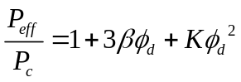 S10
where:
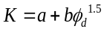 S11
S12
S13
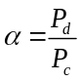, 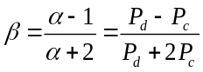 S14
a and b are empirical corrective coefficients of the original Maxwell expression, α is a ratio between two phases, and β (reduced permeation polarizability) is a practical indicator of the difference in penetrant permeability between the two phases, with a range of −0.5 ≤ β ≤ 1. The lower and upper bounds signify totally non-permeable and infinitely permeable filler particles (disperse phase), respectively, and β = 0 indicates equal permeability in both phases (α = 1).
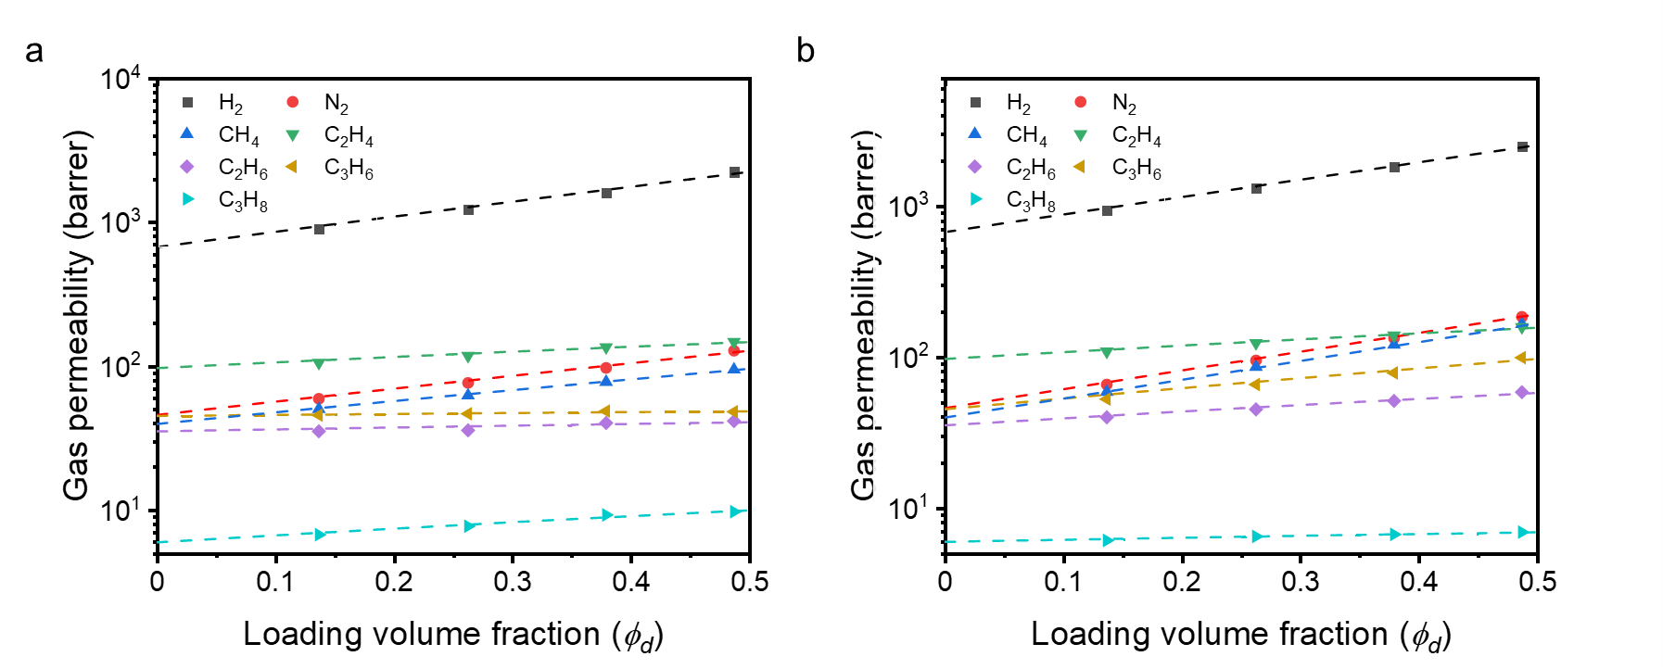
Fig S33. The fitted GPG model for (a) CubZ MMM and (b) RDZ MMM. Individual data points correspond to experimental results, with the plotted dashed lines indicating the fitted permeability model.
Fig S33 presents the results obtained using the GPG model. Unlike the original Maxwell model and the MWS model, the GPG model considers both particle–particle and particle–polymer interactions. This incorporation of interactions leads to improved permeation predictions compared to the previous models. Even for high loadings of the MMMs, the predicted permeations are in good agreement with experimental findings.
The root mean square error (RMSE) and the square of the correlation coefficient (R²) score are the most common statistical tools used to evaluate the accuracy of the models. The accuracy of the estimations and deviation from experimental permeations were assessed using the RMSE. Moreover, R² serves as a statistical metric to elucidate the nature and strength of the relationship between a variable and other variables. The closer to 1 the value of R², the better the prediction accuracy.
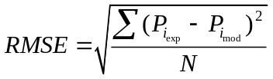 S15
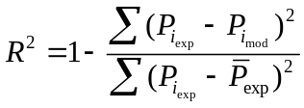 S16
Where 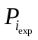, 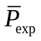, 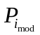and N are the experimental permeation of each gas in each loading, the average of experimental permeation for each gas, related predicted permeation by each model, and the total number of points, respectively. Table S8 shows the obtained results for the RMSE and the R² scores of both models as an average over all gases in different facet terminations.
Table S8. Evaluation of the performance of the MWS and the GPG models
Facet termination on the surface | MWS |  | GPG
Facet termination on the surface | RMSE | R² | RMSE | R²
CubZ | 79.69 | 0.9775 | 20.03 | 0.9986
RDZ | 77.08 | 0.9825 | 10.26 | 0.9997

As can be seen in Table S8, the GPG model exhibits improved fitting performance with respect to the MWS model by having a higher R² score and lower RMSE.

Section S6: Temperature-dependent transport behavior analyses
Permeation and sorption experiments were conducted across five different temperatures (7, 20, 35, 50, 65 °C) on 6FDA-DAM, 30 wt% CubZ MMM, and 30 wt% RDZ MMM samples to elucidate trends in energetics for temperature dependence of permeation, sorption, and diffusion. To achieve a more accurate representation of diffusivity, particularly for larger gases that behave non-ideally, the corrected diffusivity of the membranes was calculated using the effective transport diffusivity (D_{t}) and the Darken equation, as given below:³⁰
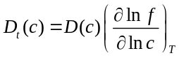 S17
In this equation, D_{t} stands for transport diffusivity, D denotes corrected diffusivity, f is the fugacity of the gas, and c represents the gas concentration.
First, we graphed S and D from all five temperatures against the compressibility measure (critical temperature, T_{c}) and gas size, respectively, using the values in Table S9. The changes in both sorption and diffusion selectivity values were less pronounced upon MOF incorporation, particularly with CubZ. This observation is consistent with that sorption and diffusion selectivity shows lower temperature dependence for the MOF phase compared to the polymer phase, aligning with activation energy values being smaller in MMMs. Furthermore, a general trend of higher selectivity was observed with MOFs.
Table S9. Critical temperature and molecular diameter (van der Waals diameter) values for the studied probe gas molecules
 | H₂ | N₂ | CH₄ | C₂H₄ | C₂H₆ | C₃H₆ | C₃H₈
Critical temperature, T_{c} (K)* | 33.2 | 126.2 | 190.6 | 282.5 | 305.3 | 365.2 | 369.9
Molecular diameter, d (Å)³¹ | 2.76 | 3.13 | 3.25 | 3.59 | 3.72 | 4.03 | 4.16
*www.NIST.gov
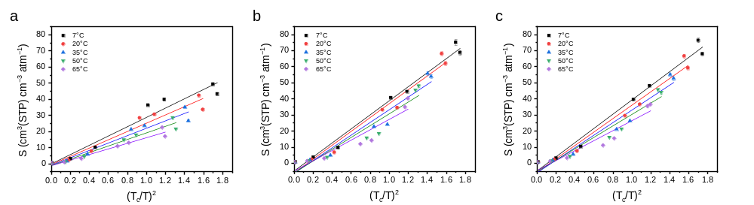
Fig S34. Sorption coefficient at approximately 1 bar pressure (where the permeation test was conducted) is depicted as a function of the unitless compressibility measure, (T_{c}/T)², for (a) 6FDA-DAM, (b) 30 wt% CubZ MMM, and (c) 30 wt% RDZ MMM. Each point represents experimental data and the superimposed lines illustrate the linear fit.
Table S10. The slope values derived from the plotted lines of Fig S33.
Temperature (°C) | 6FDA-DAM | 30 wt% CubZ MMM | 30 wt% RDZ MMM
7 | 28.8 | 43.7 | 44.2
20 | 25.7 | 43.0 | 41.7
35 | 22.9 | 39.5 | 39.0
50 | 20.4 | 36.7 | 35.6
65 | 17.5 | 32.2 | 31.1

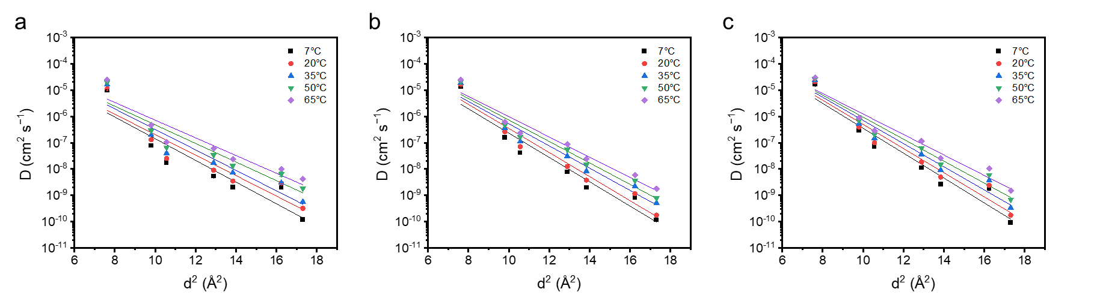
Fig S35. Corrected diffusion coefficients at approximately 1 bar pressure (matching the permeation test pressure) are depicted as a function of the molecular diameter squared, for (a) 6FDA-DAM, (b) CubZ MMM, and (c) RDZ MMM. Each point represents experimental data and the superimposed lines illustrate the fit based on the exponential dependence.
Table S11. The slope values derived from the plotted lines of Fig S34.
Temperature (°C) | 6FDA-DAM | 30 wt% CubZ MMM | 30 wt% RDZ MMM
7 | −0.95 | −1.06 | −1.09
20 | −0.90 | −1.05 | −1.06
35 | −0.89 | −0.97 | −1.01
50 | −0.81 | −0.94 | −0.96
65 | −0.77 | −0.88 | −0.89

To further understand these findings, we modeled the temperature-dependent sorption using the van't Hoff equation, as given below:
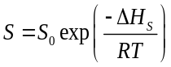 S18
Here, S₀ represents the pre-exponential factor, while ΔH_{s} denotes the sorption enthalpy.
The activation energy of corrected diffusion can be similarly modeled:
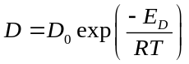 S19
Here, D represents corrected diffusivity, D₀ is the pre-exponential factor, and E_{D} is the activation energy for corrected diffusion.
The temperature dependence of permeability also adheres to a similar relationship, as shown below:
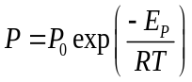 S20
In this equation, P₀ is the pre-exponential factor, and E_{p} is the activation energy of permeation.
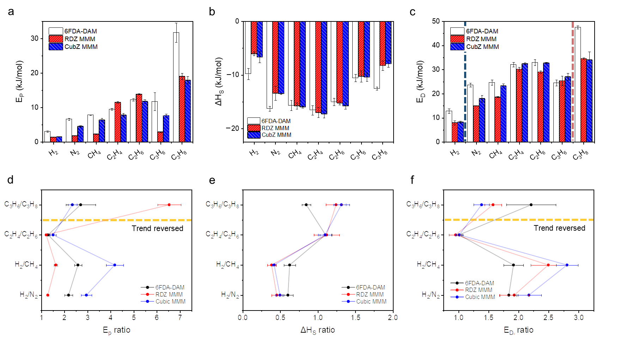
Fig S36. Gas transport energetics comparison of pure 6FDA-DAM and 30 wt% CubZ MMM and 30 wt% RDZ MMMs: (a) effective activation energy values for permeation, (b) sorption enthalpy, and (c) effective activation energy values for diffusion. For enhanced clarity, the ratios of the energetics for different gas pairs are plotted in (d-f), corresponding to (a-c), respectively
First, comparing the activation energy of permeation as shown in Fig S35a and d, CubZ MMM showed a significant increase in selectivity (E_{p} ratio) for H₂-based separations in comparison with the base polymer. The increase was considerably less significant for C₂ separations, and a decrease in selectivity was observed for C₃ separation. On the other hand, RDZ MMM demonstrated a prominent boost for C₃-based gases only and showed smaller selectivity for small gases, with a pronounced decrease for H₂ separations. Interestingly, these findings align with the permeability selectivity trend observed with MOF loading in Fig 3.
When comparing the enthalpy of sorption as shown in Fig S35b and e, the only difference in properties was observed between the base polymer and MMMs. This finding can be attributed to the existence of two distinct phases: ZIF-8 and polymer. Sorption enthalpy of CubZ and RDZ MMMs was found to be within the error bars for all gas pairs tested, suggesting that sorption-based selection was not the primary factor influencing different gas separation trend between MMMs.
To gain further insights, dual-mode sorption analysis was performed (Sections S4 and S6) to deconvolute the sorption into Henry and Langmuir modes. Henry mode is an “equilibrium” sorption mode analogous to dissolution into liquids, and Langmuir mode is a “surface” sorption mode analogous to site-specific binding for classical adsorbents, respectively.¹⁷ For both modes, the affinity coefficient differed little between MMMs, and the main difference between MMMs and pure polymer arose from different Henry sorption where polymer showed the highest selectivities due to the low k_{d} of MOF phase.
The activation energy of diffusion (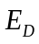) showed similar trends for MMMs as the activation energy of permeation. Of note, there was a significant difference in the ratio of activation energies of diffusion for C₃ separation compared to that of other gas pairs considered (Fig S35f, yellow dashed line), confirming that the main separation mechanism is diffusion selectivity. Indeed, these findings agree with the molecular-level interpretation of suppressed ligand rotation in the CubZ MMM relative to that in the RDZ MMM, resulting in enhanced separation performance for CubZ when separating molecules smaller than propylene and propane. In general, the CubZ MMM exhibited higher diffusion energy barriers for all gases compared to those for the RDZ MMM. Activation energies of diffusion for H₂ were within the range of measurement uncertainties for both MMMs, but there were notably higher activation energies for N₂ and CH₄ in CubZ MMM (Fig S35c, navy dashed line). Based on the Brandt model, plotting as a function of gas molecule size (Fig S36b) provides a rough measure of free volume distribution and hence size-sieving capabilities of a membrane material. As expected, the slope of these plots was the smallest for polymer followed by CubZ MMM and RDZ MMM, consistent with the selectivity trend up to methane where the model is valid. The propylene diffusion activation energy was markedly smaller for RDZ MMMs, while values for propane were similar for both MMMs (Fig S35c, red dashed line).
In the study of diffusion energetics, Brandt's model has been widely adopted:^{32–34}
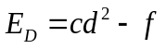 S21
where c and f are best-fit parameters and d is the molecular diameter of penetrants. Although this theory is restricted to light gas molecules where the gas diameter is a good measure of penetrant size in terms of properties (usually up to methane), our data set showed a good fit (R² > 0.95) up to C₂ gases. The fit resulted in the successful extraction of 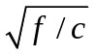values, which represents a rough approximation of the average size of the free volume within the polymer matrix and/or the pore size of the MOFs that require insignificant activation energy of diffusion for molecular diffusion events to occur. These values were 1.83, 2.37, and 2.41 for the pure polymer, CubZ MMM, and RDZ MMM, respectively, in accordance with the size order of hydrogen permeability. When considering C₃ gases in addition to the lighter gases, plotting diffusion versus gas size resulted in concavity with respect to the x-axis, suggesting that this analysis can not be extended to fits with C₃ gases.³²
For many polymers, gas solubility coefficients over short ranges of penetrant critical temperature are well described by a linear relationship between the logarithm of sorption enthalpy and the square of some metric of condensability.¹⁸ Although the enthalpy did not exhibit any noticeable trend (as depicted in Fig S36), it did show almost identical values between RDZ MMM and CubZ MMM. This observation implies that no clear sorption-based selection occurred in the transport studies with the gases we considered.

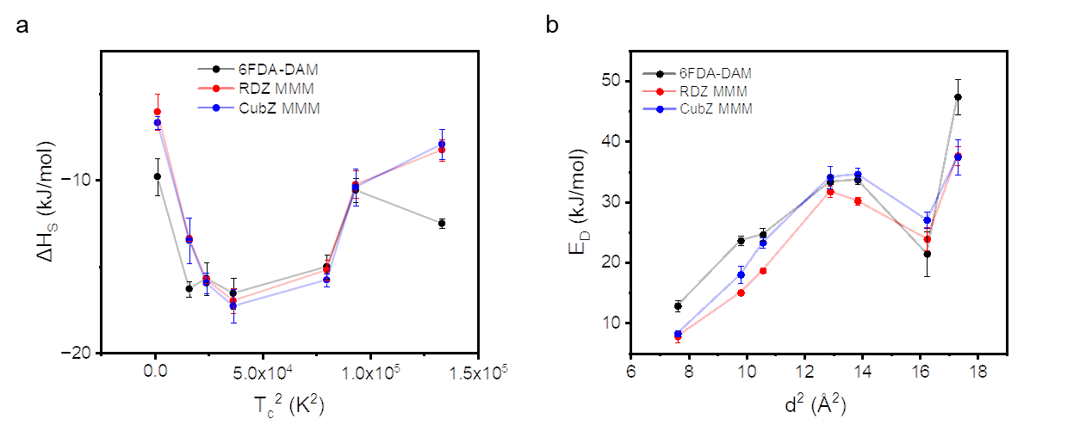
Fig S37. Gas transport energetics for 6FDA-DAM, 30 wt% RDZ MMM, and 30 wt% CubZ MMM are plotted as functions of relevant gas properties: (a) sorption enthalpy of samples as a function of gas compressibility (represented by squared critical temperature, T_{c}), and (b) activation energy of diffusion for the samples as a function of gas size (represented by squared molecular diameter, d).
To probe Henry and Langmuir sorption independently, we applied the dual-mode sorption (DMS) model. This model explores two equilibrium constants, k_{D} and b, which also exhibit an exponential dependence on temperature.³⁵
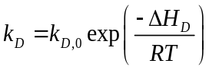 S22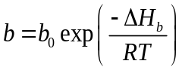 S23
In these equations, k_{D,0} and b₀ are pre-exponential factors (expressed in cm³(STP) cm⁻³ atm⁻¹ and atm⁻¹, respectively), ΔH_{D} is the enthalpy of Henry's sorption (kJ/mol), and ΔH_{b} is the enthalpy of Langmuir sorption (kJ/mol).¹⁸
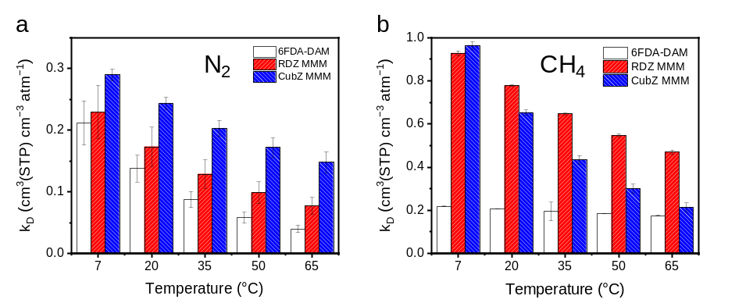
Fig S38. Henry sorption affinity, denoted as ‘k_{D}’, for 6FDA-DAM, 30 wt% RDZ MMM, and 30 wt% CubZ MMM, presented for (a) N₂ and (b) CH₄.
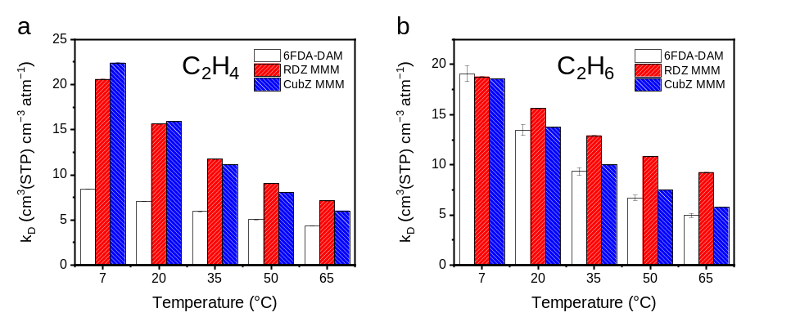
Fig S39. Henry sorption affinity, denoted as ‘k_{D}’, for 6FDA-DAM, 30 wt% RDZ MMM, and 30 wt% CubZ MMM, presented for (a) C₂H₄ and (b) C₂H₆.
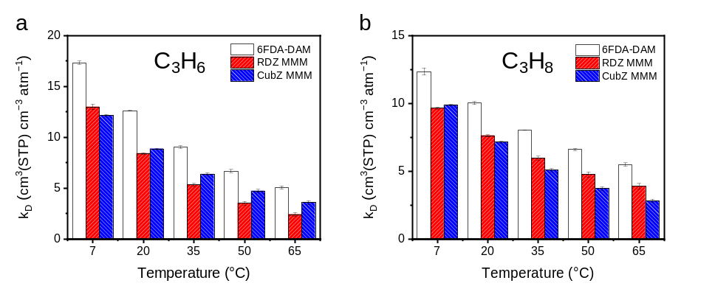
Fig S40. Henry sorption affinity, denoted as ‘k_{D}’, for 6FDA-DAM, 30 wt% RDZ MMM, and 30 wt% CubZ MMM, presented for (a) C₃H₆ and (b) C₃H₈.
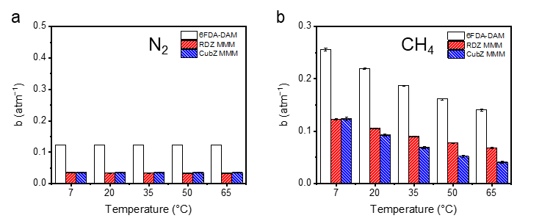
Fig S41. Langmuir sorption affinity, denoted as 'b', for 6FDA-DAM, 30 wt% RDZ MMM, 30 wt% CubZ MMM, and pure MOFs presented for (a) N₂ and (b) CH₄.
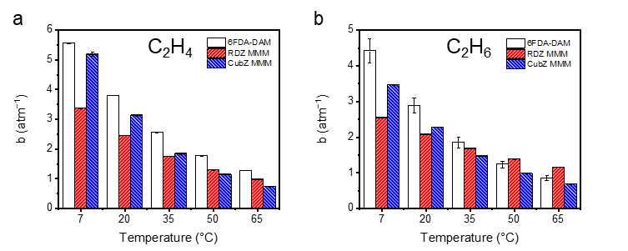
Fig S42. Langmuir sorption affinity, denoted as 'b', for 6FDA-DAM, 30 wt% RDZ MMM, and 30 wt% CubZ MMM, presented for (a) C₂H₄ and (b) C₂H₆.
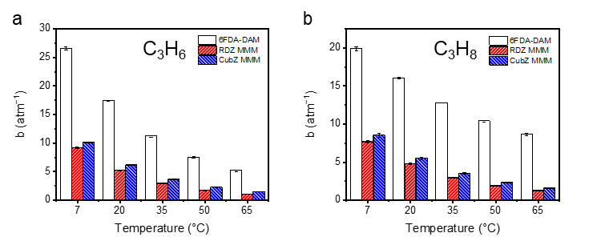
Fig S43. Langmuir sorption affinity, denoted as 'b', for 6FDA-DAM, 30 wt% RDZ MMM, and 30 wt% CubZ MMM, presented for (a) C₃H₆ and (b) C₃H₈.
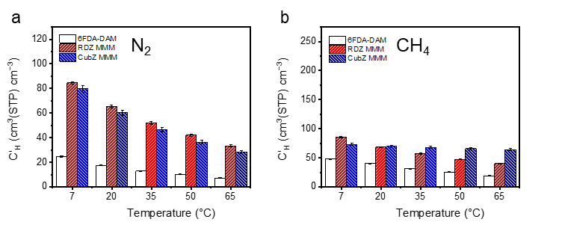
Fig S44. Langmuir sorption capacity, denoted as ‘C_{H}’’, for 6FDA-DAM, 30 wt% RDZ MMM, 30 wt% CubZ MMM with pure RDZ and CubZ presented for (a) N₂ and (b) CH₄.
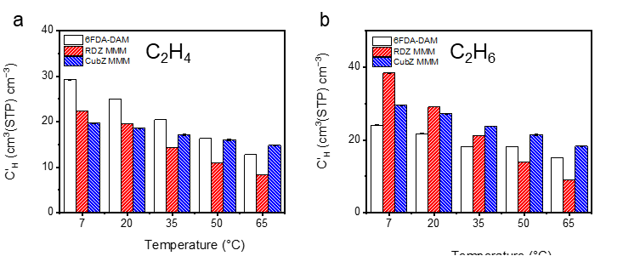
Fig S45. Langmuir sorption capacity, denoted as ‘C_{H}’’, for 6FDA-DAM, 30 wt% RDZ MMM, 30 wt% CubZ MMM with pure RDZ and CubZ presented for (a) C₂H₄ and (b) C₂H₆.
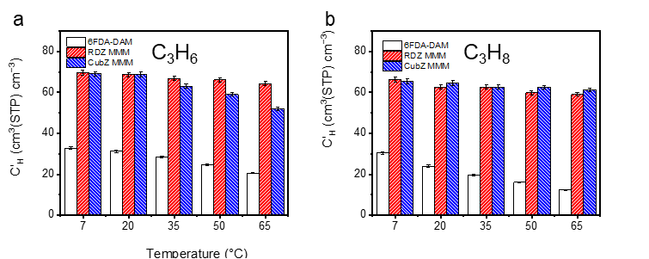
Fig S46. Langmuir sorption capacity, denoted as ‘C_{H}’’, for 6FDA-DAM, 30 wt% RDZ MMM, 30 wt% CubZ MMM with pure RDZ and CubZ presented for (a) C₃H₆ and (b) C₃H₈.
To further compare the relative effects of Henry and Langmuir sorption on total sorption, k_{D} and b values were plotted as a function of T_{c} as below:
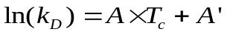 S24
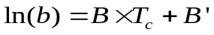 S25
where A, A’, B, and B’ are the best-fit parameters.¹⁸
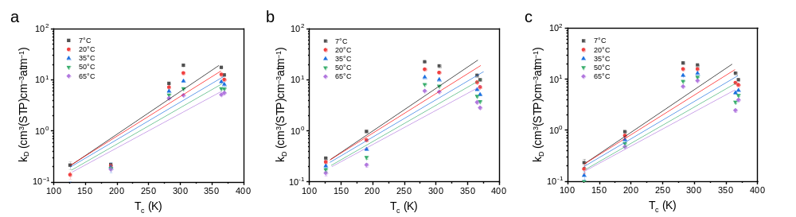
Fig S47. Semi-log plot of Henry's sorption affinity, represented as 'k_{D}', and critical temperature, T_{c}, for (a) 6FDA-DAM, (b) 30 wt% CubZ MMM, and (c) 30 wt% RDZ MMM. Each point indicates experimental data, with a superimposed line representing the linear fit.

Table S12. The slope values (A) derived from the plotted lines of Fig S46.
Temperature (°C) | 6FDA-DAM | 30 wt% CubZ MMM | 30 wt% RDZ MMM
7 | 0.021 | 0.016 | 0.017
20 | 0.021 | 0.016 | 0.017
35 | 0.021 | 0.015 | 0.016
50 | 0.021 | 0.015 | 0.016
65 | 0.021 | 0.015 | 0.016

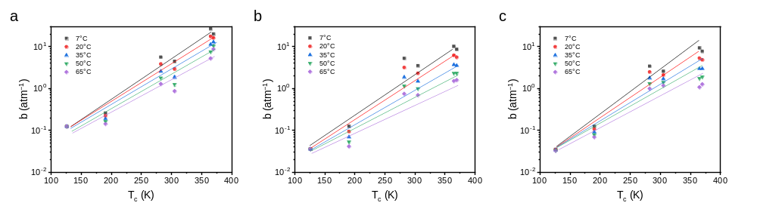
Fig S48. Semi-log plot of Langmuir's sorption affinity, represented as 'b', and critical temperature, T_{c}, for (a) 6FDA-DAM, (b) CubZ MMM, and (c) RDZ MMM. Each point indicates experimental data, with a superimposed line representing the linear fit.
Table S13. The slope values (B) derived from the plotted lines of Fig S47.
Temperature (°C) | 6FDA-DAM | 30 wt% CubZ MMM | 30 wt% RDZ MMM
7 | 0.023 | 0.024 | 0.023
20 | 0.021 | 0.022 | 0.022
35 | 0.020 | 0.021 | 0.020
50 | 0.019 | 0.019 | 0.018
65 | 0.017 | 0.017 | 0.016

Henry sorption is often referred to as "equilibrium sorption," where the penetrant is assumed to be fully dissolved into the polymer matrix. The parameter k_{D} for individual gases is influenced by interactions between the penetrant and polymer, similar to mixing processes in regular solution theory. Hence, within the dual-mode sorption model, incorporating MOF seems to enhance Henry’s sorption selectivity (denoted by a lower slope, A). This trend could be attributed to the increased backbone stiffness that occurs from the higher T_{g} of MMMs, leading to an elevated enthalpic penalty. This finding might also explain the lower A value (indicating higher Henry sorption selectivity) in CubZ MMM, which exhibited a slightly higher T_{g} than RDZ MMM. Notably, non-linearity increased significantly with MOF incorporation, likely because MOFs only exhibit Langmuir sorption, leading to larger deviations for more compressible gases.
Langmuir sorption, also known as "saturated sorption," takes place when the penetrant occupies specific sites in the polymer-free volume or MOF pores, often visualized as an actual or hypothetical monolayer. Contrary to Henry sorption, Langmuir sorption is determined by both b and the C_{H}’ term. The parameter b for individual gases is impacted by the interactions between the penetrant and specific sorption regions, reflecting the relative surface adsorption to desorption rates of the penetrant onto the sorption surface. With the introduction of MOFs, the analysis may become more complex as both parameters are influential. As illustrated in Fig S47, the b trend is very similar for all samples over the temperature range considered, implying the MOF phase has a minor impact on Langmuir sorption selectivity.
Next, the parameter C_{H}’ is closely correlated with the accessible volume for penetrants that are adsorbed, such as the amount of accessible free volume in polymers and pores in the MOFs. These features have a large impact on diffusion-related properties. Owing to the significantly higher amount of Langmuir sorption in pure MOFs, all MMMs demonstrated larger C_{H}’ values compared to the pure polymer, as depicted in Fig S44–S46. While the precise relationship of C_{H}’ with different gases remains unclear, unlike the relationships with b and k_{D}, a distinct trend emerges when comparing the C_{H}’ values of pure components of MMMs (polymer vs. MOF) and the MMMs themselves. In the case of nitrogen, the measured C_{H}’ of the MMMs was almost the same as the values derived from the volume ratio and the C_{H}’ values of pure components (MOFs and polymer) within the errors of just 1.08% and 1.00% for the CubZ and RDZ MMM samples, respectively. This trend shows that nitrogen has a similar accessibility to the Langmuir sorption sites of MOFs even when MOFs are embedded in the polymeric matrix. When considering methane, however, the calculation using the volume ratio and the C_{H}’ values of pure components overestimated the measured MMM values by 52.6% and 52.0%, suggesting the accessibility is reduced by half. For C₂ gases, this trend became more pronounced, with the overestimation reaching between 91.9% and 97.8%. Yet, when examining propane, this deviation fell again to 12.1% and 8.6%. This pattern of increasing deviation with the size of the gas molecules suggests a decrease in the number of available Langmuir sorption sites in the MOF phase when introduced in the polymer phase. Propane appeared to exhibit a lower deviation, potentially due to the pure MOFs having a substantially higher resistance to larger gas molecules already. With minor differences observed for both Henry and Langmuir modes, MMM samples show similar sorption energetics as previously shown in Fig S35c and f.
From this energetics study, clear mechanistic insights could be gleaned on the distinct gas transport performance of MMMs that are formed with unique facet terminations. More specifically, the superior H₂ and C₂ separation performance for CubZ MMM, and the enhanced C₃ separation of RDZ MMM could be explained. By extension, performance trends as a function of temperature provide a useful set of data that could enable more effective process modeling in predicting the performance of MOFs with unique facets. This quantitative gas transport energetic study reveals that permeation activation energy is mainly attributed to diffusion energetics.

Reference
1. Lee, H. et al. Network-Nanostructured ZIF-8 to Enable Percolation for Enhanced Gas Transport. Adv. Funct. Mater. 32, 1–9 (2022).
2. Pang, S. H., Han, C., Sholl, D. S., Jones, C. W. & Lively, R. P. Facet-specific stability of ZIF-8 in the presence of acid gases dissolved in aqueous solutions. Chem. Mater. 28, 6960–6967 (2016).
3. Babu, D. J., He, G., Villalobos, L. F. & Agrawal, K. V. Crystal Engineering of Metal-Organic Framework Thin Films for Gas Separations. ACS Sustain. Chem. Eng. 7, 49–69 (2019).
4. Babu, D. J. et al. Restricting Lattice Flexibility in Polycrystalline Metal-Organic Framework Membranes for Carbon Capture. Adv. Mater. 1900855, 6–11 (2019).
5. Osterrieth, J. W. M. et al. How Reproducible are Surface Areas Calculated from the BET Equation? Adv. Mater. 34, (2022).
6. Deacon, A. et al. Understanding the ZIF-L to ZIF-8 transformation from fundamentals to fully costed kilogram-scale production. Commun. Chem. 2022 51 5, 1–10 (2022).
7. Tan, J. C., Bennett, T. D. & Cheetham, A. K. Chemical structure, network topology, and porosity effects on the mechanical properties of zeolitic imidazolate frameworks. Proc. Natl. Acad. Sci. U. S. A. 107, 9938–9943 (2010).
8. Qian, Q. et al. MOF-Based Membranes for Gas Separations. Chemical Reviews vol. 120 8161–8266 at (2020).
9. Blöchl, P. E. Projector augmented-wave method. Phys. Rev. B 50, 17953 (1994).
10. Kresse, G. & Joubert, D. From ultrasoft pseudopotentials to the projector augmented-wave method. Phys. Rev. B 59, 1758 (1999).
11. Perdew, J. P., Burke, K. & Ernzerhof, M. Generalized Gradient Approximation Made Simple. Phys. Rev. Lett. 77, 3865 (1996).
12. Grimme, S., Antony, J., Ehrlich, S. & Krieg, H. A consistent and accurate ab initio parametrization of density functional dispersion correction (DFT-D) for the 94 elements H-Pu. J. Chem. Phys. 132, 154104 (2010).
13. Hobday, C. L. et al. Understanding the adsorption process in ZIF-8 using high pressure crystallography and computational modelling. Nat. Commun. 9, 1–9 (2018).
14. Egorov, S. A., Milchev, A., Virnau, P. & Binder, K. A new insight into the isotropic–nematic phase transition in lyotropic solutions of semiflexible polymers: density-functional theory tested by molecular dynamics. Soft Matter 12, 4944–4959 (2016).
15. Sadeghi, S. & Howe, J. D. Ab Initio Study of Adsorption of Polymers on Metal − Organic Framework Surfaces. J. Phys. Chem. C 127, 3715–3725 (2023).
16. Semino, R., Ramsahye, N. A., Ghoufi, A. & Maurin, G. Role of MOF surface defects on the microscopic structure of MOF/polymer interfaces: A computational study of the ZIF-8/PIMs systems. Microporous Mesoporous Mater. 254, 184–191 (2017).
17. Paul, D. R. Dual Mode Sorption Model. in Encyclopedia of Membranes 1–2 (Springer, Berlin, Heidelberg, 2014). doi:10.1007/978-3-642-40872-4_662-3.
18. Yampolskii, Y., Pinnau, I. & Freeman, B. D. Materials Science of Membranes for Gas and Vapor Separation. Materials Science of Membranes for Gas and Vapor Separation (2006).
19. Bevington, P. R., Robinson, D. K., Blair, J. M., Mallinckrodt, A. J. & McKay, S. Data Reduction and Error Analysis for the Physical Sciences. Comput. Phys. 7, 415 (1993).
20. Wu, A. X. et al. Elucidating the Role of Fluorine Content on Gas Sorption Properties of Fluorinated Polyimides. Macromolecules 54, 22–34 (2021).
21. Zhang, C. et al. Unexpected molecular sieving properties of zeolitic imidazolate framework-8. J. Phys. Chem. Lett. 3, 2130–2134 (2012).
22. Wijmans, J. G. & Baker, R. W. The solution-diffusion model: a review. Journal of Membrane Science vol. 107 1–21 (1995).
23. Doghieri, F. & Sarti, G. C. Nonequilibrium Lattice Fluids: A Predictive Model for the Solubility in Glassy Polymers. Macromolecules 29, 7885–7896 (1996).
24. Gonzo, E. E., Parentis, M. L. & Gottifredi, J. C. Estimating models for predicting effective permeability of mixed matrix membranes. J. Memb. Sci. 277, 46–54 (2006).
25. Bánhegyi, G. Comparison of electrical mixture rules for composites. Colloid Polym. Sci. 264, 1030–1050 (1986).
26. Bouma, R. H. B., Checchetti, A., Chidichimo, G. & Drioli, E. Permeation through a heterogeneous membrane: The effect of the dispersed phase. J. Memb. Sci. 128, 141–149 (1997).
27. C. Maxwell. Treatise on Electricity and Magnetism. vol. 1 (Oxford University Press, 1973).
28. Roy, P. K. et al. Investigations on 6FDA/BPDA-DAM polymer melt properties and CO2 adsorption using molecular dynamics simulations. J. Memb. Sci. 613, 118377 (2020).
29. Shimazu, A., Miyazaki, T., Maeda, M. & Ikeda, K. Relationships between the chemical structures and the solubility, diffusivity, and permselectivity of propylene and propane in 6FDA-based polyimides. J. Polym. Sci. Part B Polym. Phys. 38, 2525–2536 (2000).
30. Maginn, E. J., Bell, A. T. & Theodorou, D. N. Transport diffusivity of methane in silicalite from equilibrium and nonequilibrium simulations. J. Phys. Chem. 97, 4173–4181 (1993).
31. Ruthven, D. M. Principles of Adsorption and Adsorption Processes. Principles of adsorption and adsorption processes (Wiley-Interscience, 1984).
32. Freeman, B. D. Basis of permeability/selectivity tradeoff relations in polymeric gas separation membranes. Macromolecules 32, 375–380 (1999).
33. Dal-Cin, M. M., Kumar, A. & Layton, L. Revisiting the experimental and theoretical upper bounds of light pure gas selectivity–permeability for polymeric membranes. J. Memb. Sci. 323, 299–308 (2008).
34. Brandt, W. W. Model Calculation of the Temperature Dependence of Small. J. Phys. Chem. 63, 1080–1085 (1959).
35. Koros, W. J., Paul, D. R. & Huvard, G. S. Energetics of gas sorption in glassy polymers. Polymer (Guildf). 20, 956–960 (1979).

