S1 Figure demonstrates the search strategy utilized at PubMed Advanced.

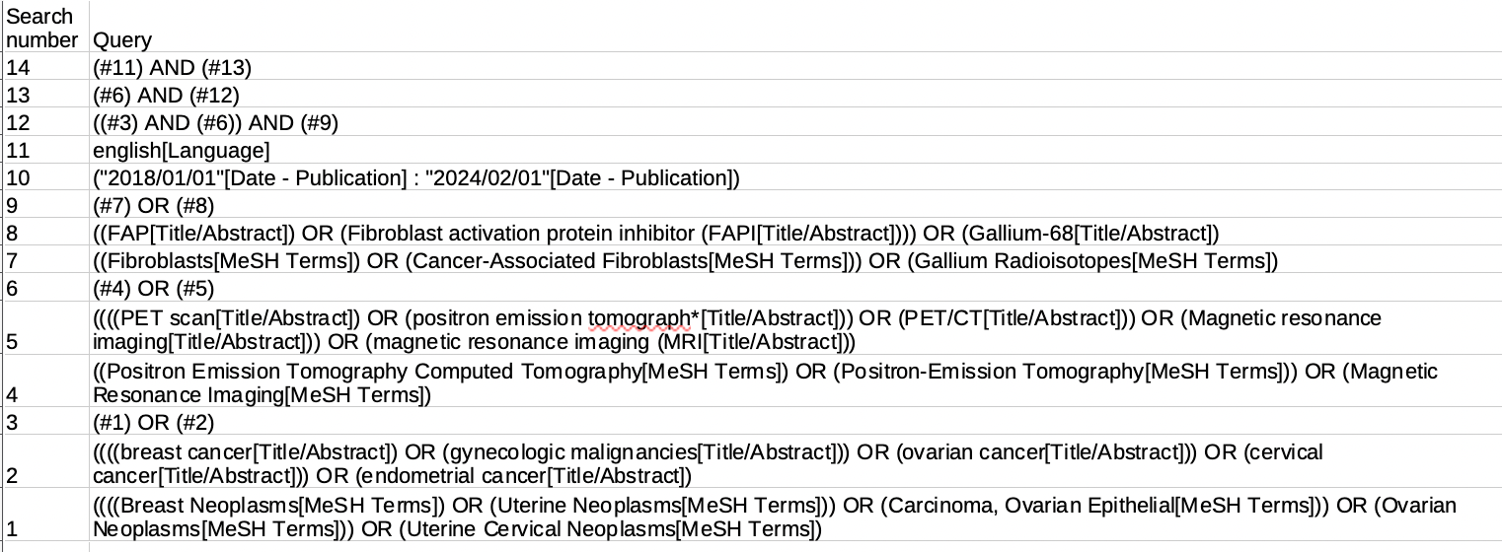
S1 Figure. Search strategy for PubMed

S2 Figure represents SROC curve providing visual representations of the diagnostic efficacy of ⁶⁸Ga-FAPI PET imaging.
S2 Figure. Ruecker-Schumacher (2010) SROC curve for the evaluation of primary lesions by [⁶⁸Ga]-FAPI-based PET imaging techniques in female cancer patients

S3 Figure represents ROC curve providing visual representations of the diagnostic efficacy of ⁶⁸Ga-FAPI PET imaging.
S3 Figure. Confidence Regions on ROC space for the evaluation of primary lesions by [⁶⁸Ga]-FAPI-based PET imaging techniques in female cancer patients

S4 Figure demonstrates the minimal trade-off between sensitivity and specificity across different threshold settings, providing a visual summary of the excellent diagnostic performance of the ⁶⁸Ga-FAPI PET imaging technique

S4 Figure. Ruecker-Schumacher (2010) SROC curve for the evaluation of lymph node metastasis lesions by [⁶⁸Ga]-FAPI-based PET imaging techniques in female cancer patients

S5 Figure demonstrates the reliability of ⁶⁸Ga-FAPI PET imaging in evaluating metastatic lesions

S5 Figure. Confidence Regions on ROC space for the evaluation of lymph node metastatic lesions by [⁶⁸Ga]-FAPI-based PET imaging techniques in female cancer patients

