Table 1 Emergency department visit and patient characteristics, and imaging modality utilization among pediatric patients seen at Emergency Departments for suspected appendicitis, 2018-2023 (N=105,392 ED encounters)
 | N | %
Visit Characteristics
Discharge Year
2018 | 18,295 | 17.4
2019 | 17,689 | 16.8
2020 | 14,835 | 14.1
2021 | 18,229 | 17.3
2022 | 20,048 | 19.0
2023 | 16,296 | 15.5
Admit To Inpatient
No | 84,308 | 80.0
Yes | 21,084 | 20.0
ED Admission Time^
Day Time: 8 am-9 pm | 79,093 | 75.5
Overnight: 10 pm-7 am | 25,604 | 24.5
Patient Characteristics
Sex
Male | 43,391 | 41.2
Female | 62,001 | 58.8
Age Group
Under 5 years | 5,623 | 5.3
5-12 years | 55,306 | 52.5
13 to 17 years | 44,463 | 42.2
Mean (SD) | 11.2 (3.9)
Median (IQR) | 12 (8-14)
Child Opportunity Index
Low/Very Low | 40,687 | 38.6
Moderate | 20,221 | 19.2
High/Very High | 44,484 | 42.2
Race and Ethnicity
Asian | 2,649 | 2.5
Hispanic | 33,369 | 31.7
Non-Hispanic Black | 11,378 | 10.8
Non-Hispanic White | 50,463 | 47.9
Another^^ | 5,745 | 5.5
Unknown | 1,788 | 1.7
Payor Group
Commercial | 48,107 | 45.7
Public | 45,541 | 43.2
Another Payor^^^ | 11,744 | 11.1
Imaging Characteristics
Imaging Type
No Imaging | 15,634 | 14.8
Abdominal or Pelvic X-Ray (any) | 19,093 | 18.1
Abdominal or Pelvic US (any) | 81,232 | 77.1
Abdominal or Pelvic CT (any) | 17,056 | 16.2
Abdominal or Pelvic MRI (any) | 3,498 | 3.3
Imaging Group
No Imaging | 15,634 | 14.8
X-ray only | 4,546 | 4.3
US only | 64,739 | 61.4
CT only | 3,581 | 3.4
MRI only | 399 | 0.4
US and CT | 13,475 | 12.8
US and MRI | 3,018 | 2.9
Suboptimal Imaging
Suboptimal ( No Imaging or X-ray only) | 20,180 | 19.1
Other (any CT/US/MRI) | 85,212 | 80.9
Ionizing Radiation^^^^
Ionizing (any X-ray/CT) | 33,892 | 37.8
Non Ionizing (only US /MRI) | 55,866 | 62.2
Outcomes
Ionizing Radiation Group
No Imaging | 15,634 | 14.8
Ionizing (any x-ray/CT) | 33,892 | 32.2
Nonionizing (US/MRI) | 55,866 | 53.0
Discharge Diagnosis of Acute Appendicitis
No | 90,897 | 86.3
Yes | 14,495 | 13.8
Type of Acute Appendicitis^^^^^
Acute Appendicitis- Non-Perforated | 11,968 | 82.6
Acute Appendicitis- Perforated | 2,527 | 17.4
^ encounters with non-missing data (N=104,697)
^^ includes patients identifying as multiracial, Native Hawaiian or Pacific Islander, American Indian or Alaskan Native,
or as another race or ethnicity
^^^ includes Government: Other, Self-Pay, and Other Payor
^^^^ among encounters utilizing imaging (N=89,758)
^^^^^ among encounters with principal discharge diagnosis of acute appendicitis

Table 2a Imaging modality: Imaging utilization across Child Opportunity Index and patient race and ethnicity
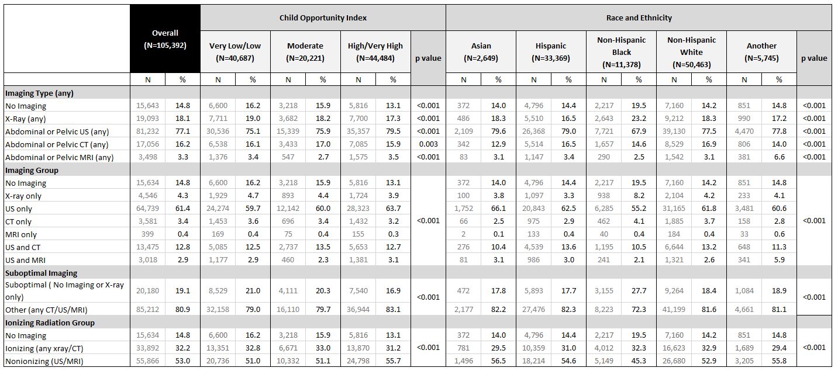

Table 2b Imaging modality: Imaging utilization across insurance type and time of ED admission
