Supplemental Table S1. A list of ICD 10 codes used in this study.

ICD 10 codes
J09 (Influenza due to identified avian influenza virus)
J10.0 (Influenza with pneumonia, influenza virus identified)
J10.1 (Influenza with other respiratory manifestations, influenza virus identified)
J10.8 (Influenza with other manifestations, influenza virus identified)
J11.0 (Influenza with pneumonia, virus not identified)
J11.1 (Influenza with other respiratory manifestations, virus not identified)
J11.8 (Influenza with other manifestations, virus not identified)
J12.0 (Adenoviral pneumonia)
J12.1 (Respiratory syncytial virus pneumonia)
J12.2 (Parainfluenza virus pneumonia)
J12.3 (Human metapneumovirus pneumonia)
J12.8 (Other viral pneumonia)
J12.9 (Viral pneumonia, unspecified)
J13 (Pneumonia due to Streptococcus pneumoniae)
J14 (Pneumonia due to Haemophilus influenzae)
J15.0 (Pneumonia due to Klebsiella pneumoniae)
J15.1 (Pneumonia due to Pseudamonas)
J15.2 (Pneumonia due to staphylococcus)
J15.3 (Pneumonia due to streptococcus, group B)
J15.4 (Pneumonia due to other streptococci)
J15.5 (Pneumonia due to Escherichia coli)
J15.6 (Pneumonia due to other aerobic Gram-negative bacteria)
J15.7 (Pneumonia due to Mycoplasma pneumoniae)
J15.8 (Other bacterial pneumonia)
15.9 (Bacterial pneumonia, unspecified)
J16.0 (Chlamydial pneumonia)
J16.8 (Pneumonia due to other specified infectious organisms)
J18.0 (Bronchopneumonia, unspecified)
J18.1 (Lobar pneumonia, unspecified)
J18.2 (Hypostatic pneumonia, unspecified)
J18.8 (Other pneumonia, organism unspecified)
J18.9 (Pneumonia, unspecified)

Supplemental Table S2. Overall and Gender-Stratified Pneumonia related Age-Adjusted Mortality Rates in the United States, 1999 to 2020.
 | Age-Adjusted Mortality Rate
Year | Overall | Male | Female
1999 | 35.9 | 43.7 | 31.4
2000 | 36.3 | 44.3 | 31.7
2001 | 33.9 | 41.2 | 29.6
2002 | 35.5 | 42.8 | 31.0
2003 | 34.4 | 41.2 | 30.2
2004 | 31.2 | 37.7 | 27.2
2005 | 32.2 | 38.2 | 28.4
2006 | 28.1 | 33.8 | 24.5
2007 | 25.7 | 30.9 | 22.5
2008 | 26.9 | 31.6 | 23.8
2009 | 25.0 | 29.7 | 21.9
2010 | 23.1 | 27.8 | 19.9
2011 | 24.0 | 28.7 | 20.9
2012 | 22.1 | 26.5 | 19.2
2013 | 24.3 | 28.5 | 21.4
2014 | 23.1 | 27.2 | 20.2
2015 | 23.3 | 27.1 | 20.6
2016 | 20.7 | 24.3 | 18.1
2017 | 21.8 | 25.2 | 19.4
2018 | 22.7 | 26.4 | 20.0
2019 | 18.8 | 22.0 | 16.3
2020 | 19.9 | 24.1 | 16.8
Number of Joinpoints (years of Joinpoint) | 1 (2010) | 1 (2010) | 0
APC-Segment 1 (95% CI) | -4.0 (-9.9 to 3.9) | -4.2* (-8.9 to -3.1) | -
APC-Segment 2 (95% CI) | -1.8 (-10.5 to 5.3) | -2.0 (-3.2 to 3.6) | -
Average APC | -3.0* (-3.8 to -2.2) | -3.1* (-3.7 to -2.6) | -3.1 (-3.6 to -2.6)

Supplemental Table S3. Pneumonia–related mortality rates stratified by race/ethnicity in the United States.

Age-Adjusted Mortality Rate
Year | White | Black or African American | Asian or Pacific Islander | American Indian or Alaska Native | Hispanic or Latino
1999 | 35.8 | 38.5 | 24.7 | 42.5 | 28.7
2000 | 36.1 | 39 | 30.3 | 34.1 | 31.6
2001 | 33.6 | 37.1 | 29.5 | 35.9 | 31.6
2002 | 35.4 | 37.5 | 28 | 34.7 | 31.2
2003 | 34.3 | 36.4 | 27.8 | 40.9 | 29.8
2004 | 30.8 | 35.1 | 26.1 | 30.1 | 28.4
2005 | 32.1 | 34.3 | 25.7 | 36.2 | 28.3
2006 | 27.9 | 31 | 24.7 | 24.9 | 25.5
2007 | 25.4 | 29.2 | 22.8 | 24.2 | 22.5
2008 | 26.6 | 29.6 | 24 | 29.7 | 24.3
2009 | 24.7 | 27 | 22.8 | 26.9 | 23.5
2010 | 22.8 | 25.6 | 22.1 | 24.2 | 20.9
2011 | 23.9 | 25.4 | 21.6 | 23.6 | 20.9
2012 | 21.9 | 24 | 21.5 | 20 | 18.4
2013 | 24.1 | 25.4 | 23 | 22.9 | 20.1
2014 | 23 | 24.5 | 19.7 | 23 | 19.6
2015 | 23.2 | 24.1 | 21.5 | 19.1 | 17.5
2016 | 20.4 | 22.7 | 19.7 | 19.3 | 16.9
2017 | 21.7 | 22.5 | 19.8 | 19.9 | 17.2
2018 | 22.6 | 23.9 | 19.5 | 20.8 | 17.8
2019 | 18.7 | 20.2 | 14.7 | 17.3 | 15.1
2020 | 19.5 | 25.1 | 15.8 | 19.8 | 18.5
Total | 26 | 28.1 | 21.4 | 24.6 | 21.2
Number of Joinpoints (years of Joinpoint) | 1 (2010) | 1 (2012) | 1 (2017) | 0 | 1 (2016)
APC-Segment 1 (95% CI) | -4.2 (-8.9 to 6.9) | -3.9* (-7.0 to -3.1) | -2.1 (-2.6 to 0.4) | - | -3.8* (-6.8 to -3.2)
APC-Segment 2 (95% CI) | -1.7 (-3.8 to 5.5) | -0.9 (-2.5 to 5.0) | -8.4* (-15.7 to -3.2) | - | 0.4 (-3.2 to 7.9)
Average APC | -3.0* (-3.9 to -2.2) | -2.7* (-3.3 to -2.2) | -3.0* (-3.6 to -2.1) | -3.7* (-4.5 to -2.9) | -3.0* (-3.7 to -2.5)

Supplemental Table S4. Pneumonia–related crude mortality rates per 100,000 people in the United States, 1999 to 2020.

 | Crude Mortality Rate
Year | Ages 25-39 | Ages 40-54 | Ages 55-69 | Ages 70-84 | Ages 85+
1999 | 1.3 | 3.9 | 15 | 112.2 | 751.8
2000 | 1.2 | 4.1 | 16 | 115.4 | 744.1
2001 | 1.2 | 3.8 | 14.5 | 107.4 | 700.1
2002 | 1.2 | 4 | 14.9 | 113.5 | 732.4
2003 | 1.2 | 4.3 | 15.1 | 109.8 | 703
2004 | 1 | 3.8 | 14 | 102.3 | 622.8
2005 | 1.1 | 4.3 | 14.4 | 104.7 | 644.9
2006 | 1 | 3.9 | 13.1 | 93.5 | 547
2007 | 1 | 3.7 | 12.1 | 83.5 | 506.7
2008 | 1.1 | 4.3 | 13.7 | 87.4 | 512.3
2009 | 2.1 | 5.7 | 14.4 | 78.9 | 433.8
2010 | 1.1 | 3.7 | 12.7 | 75.5 | 426.2
2011 | 1.4 | 4.2 | 13.7 | 76.4 | 439.2
2012 | 1 | 3.5 | 12.7 | 71.2 | 408.4
2013 | 1.3 | 4.3 | 15 | 75.1 | 441
2014 | 1.5 | 5.4 | 16.2 | 70.7 | 385.9
2015 | 1.1 | 3.9 | 14.4 | 73.5 | 421.4
2016 | 1.2 | 4.3 | 15.1 | 65.2 | 340.3
2017 | 1.1 | 4 | 15.1 | 68 | 375.3
2018 | 1.3 | 4.7 | 17.1 | 69.1 | 377.6
2019 | 1.3 | 4.3 | 15.3 | 57 | 294.7
2020 | 1.6 | 5.2 | 18 | 63.4 | 273.6
Total | 1.2 | 4.2 | 14.7 | 83.4 | 481.1
Number of Joinpoints (years of Joinpoint) | - | 0 | 1 (2010) | 0 | 0
APC-Segment 1 (95% CI) | - | - | -1.4 (-7.1 to 0.0) | - | -
APC-Segment 2 (95% CI) | - | - | 2.8* (1.2 to 9.4) | - | -
Average APC | - | 0.8 (-0.1 to 1.8) | 0.5 (-0.2 to 1.2) | -3.2* (-3.8 to -2.6) | -4.4* (-5.0 to -3.9)

Supplemental Table S5. Trends in Pneumonia Related Mortality Stratified by Location of Death in the United States, 1999-2020.

Year | Medical Facility – Inpatient | Medical Facility – Outpatient or ER | Nursing home/long-term care | Hospice | Home
1999 | 39587 | 1661 | 17771 | NA | 2708
2000 | 40791 | 1747 | 17739 | NA | 2902
2001 | 39609 | 1662 | 16001 | NA | 2708
2002 | 41872 | 1818 | 16796 | NA | 2959
2003 | 41619 | 1888 | 16197 | 62 | 3178
2004 | 38377 | 1768 | 14352 | 117 | 3009
2005 | 40481 | 1913 | 15029 | 274 | 3236
2006 | 37112 | 1834 | 12300 | 384 | 2892
2007 | 34761 | 1740 | 11186 | 555 | 2751
2008 | 37492 | 1790 | 10667 | 835 | 2907
2009 | 35907 | 1731 | 8774 | 822 | 2866
2010 | 34461 | 1676 | 8481 | 1108 | 2779
2011 | 36519 | 1816 | 9039 | 1534 | 3048
2012 | 34152 | 1699 | 8579 | 1560 | 2915
2013 | 38176 | 1957 | 9303 | 1882 | 3553
2014 | 38152 | 1952 | 8217 | 2118 | 3190
2015 | 38398 | 1944 | 9294 | 2679 | 3298
2016 | 35947 | 1784 | 6981 | 2468 | 3044
2017 | 38254 | 1955 | 7815 | 2850 | 3379
2018 | 40711 | 2213 | 7608 | 3098 | 3947
2019 | 35499 | 1897 | 5337 | 2570 | 3090
2020 | 37591 | 2504 | 5634 | 2551 | 3890
Total | 835468 | 40949 | 243100 | 27467 | 68249

Supplemental Table S6. Pneumonia–related mortality rates stratified by Urban-Rural classification in the United States, 1999 to 2020.

 | Age-Adjusted Mortality Rate
Year | Large Metropolitan | Medium/Small Metropolitan | Rural
1999 | 34.9 | 35.3 | 39.6
2000 | 36.7 | 34.6 | 38.1
2001 | 34.2 | 32.1 | 36
2002 | 35.1 | 33.7 | 39.3
2003 | 33.6 | 33.1 | 38.9
2004 | 31.2 | 29.4 | 34
2005 | 31.9 | 30.6 | 35.9
2006 | 28 | 26.4 | 31.2
2007 | 25.4 | 24.3 | 29.2
2008 | 26.2 | 25.3 | 31.7
2009 | 24.4 | 23.9 | 28.6
2010 | 22.7 | 21.7 | 26.7
2011 | 23.3 | 22.8 | 28.4
2012 | 21.4 | 21.2 | 26.2
2013 | 23.4 | 23.5 | 28.5
2014 | 22.1 | 22.6 | 27.4
2015 | 21.8 | 23.3 | 28
2016 | 20 | 19.9 | 24.3
2017 | 20.5 | 21.7 | 26.2
2018 | 21.2 | 22.3 | 28.1
2019 | 17.7 | 18.4 | 23.2
2020 | 19.5 | 18.9 | 23.5
Total | 25.4 | 25 | 30.2
Number of Joinpoints (years of Joinpoint) | 1 (2010) | 1 (2010) | 0
APC-Segment 1 (95% CI) | -4.2* (-8.9 to -3.3) | -4.1 (-8.9 to 3.2) | -
APC-Segment 2 (95% CI) | -2.1 (-3.0 to 2.0) | -1.4 (-3.6 to 6.3) | -
Average APC | -3.2* (-3.7 to -2.7) | -2.8* (-3.7 to -2.1) | -2.5* (-3.1 to -2.0)

Supplemental Table S7. State‐level pneumonia-related age‐adjusted mortality rates per 100,000 people in the United States, 1999 to 2020.

State | Rank | Percentile | Average AAMR per 100,000 from 1999 to 2020
Florida | 1 | 0 | 16.1
Vermont | 2 | 2 | 16.9
Oregon | 3 | 4 | 17.7
Minnesota | 4 | 6 | 17.8
Washington | 5 | 8 | 18.7
Alaska | 6 | 10 | 19
Colorado | 7 | 12 | 20.9
District of Columbia | 8 | 14 | 21.5
New Hampshire | 9 | 16 | 22.2
Arizona | 10 | 18 | 22.3
New Jersey | 11 | 20 | 22.3
Delaware | 12 | 22 | 23.1
Idaho | 13 | 24 | 23.2
Montana | 14 | 26 | 23.3
Wisconsin | 15 | 28 | 24
Texas | 16 | 30 | 24.1
Connecticut | 17 | 32 | 24.2
Nebraska | 18 | 34 | 24.4
South Carolina | 19 | 36 | 24.5
Pennsylvania | 20 | 38 | 24.7
Maine | 21 | 40 | 24.7
New Mexico | 22 | 42 | 24.8
Michigan | 22 | 42 | 24.9
Indiana | 24 | 46 | 25.1
Rhode Island | 25 | 48 | 25.2
North Dakota | 26 | 50 | 25.2
Ohio | 27 | 52 | 25.4
Virginia | 28 | 54 | 26.5
Maryland | 29 | 56 | 26.8
Utah | 30 | 58 | 27.3
Iowa | 31 | 60 | 27.7
South Dakota | 32 | 62 | 28.1
California | 33 | 64 | 28.2
Illinois | 34 | 66 | 28.3
Georgia | 35 | 68 | 28.6
Kansas | 36 | 70 | 28.7
Louisiana | 37 | 72 | 29
North Carolina | 38 | 74 | 29.2
Nevada | 39 | 76 | 29.7
Hawaii | 40 | 78 | 29.9
Massachusetts | 41 | 80 | 30.2
Missouri | 42 | 82 | 30.3
Oklahoma | 43 | 84 | 30.4
West Virginia | 44 | 86 | 30.8
Alabama | 45 | 88 | 31.4
Wyoming | 46 | 90 | 31.4
New York | 47 | 92 | 33
Kentucky | 48 | 94 | 33.3
Arkansas | 49 | 96 | 34.5
Tennessee | 50 | 98 | 35.8
Mississippi | 51 | 100 | 36.3
Whole USA |  |  | 26.1

Supplemental Table S8. State-based change in AAMR from 1999 to 2020 for pneumonia-related mortality.

State | 1999 | 2020 | Change in AAMR per 100,000 from 1999 to 2020
Colorado | 38.8 | 11 | -27.8
Montana | 39.6 | 12.3 | -27.3
Wyoming | 45 | 17.9 | -27.1
Utah | 41.6 | 15.3 | -26.3
Idaho | 39 | 12.8 | -26.2
Iowa | 43.8 | 18.7 | -25.1
South Dakota | 43.2 | 18.6 | -24.6
Vermont | 33.6 | 9.5 | -24.1
Virginia | 41.6 | 17.5 | -24.1
Arizona | 41.3 | 17.6 | -23.7
Washington | 36.4 | 13.3 | -23.1
Kentucky | 47.7 | 24.7 | -23
Wisconsin | 37.5 | 14.7 | -22.8
Georgia | 43.3 | 21.1 | -22.2
Rhode Island | 36.5 | 14.4 | -22.1
Oklahoma | 43 | 21.1 | -21.9
Missouri | 43.6 | 21.9 | -21.7
South Carolina | 38.7 | 17.6 | -21.1
Minnesota | 32.2 | 12 | -20.2
Maryland | 38.6 | 18.6 | -20
North Carolina | 40.6 | 21.2 | -19.4
Oregon | 30 | 10.9 | -19.1
Connecticut | 34.8 | 15.7 | -19.1
Massachusetts | 41.1 | 22.4 | -18.7
Louisiana | 39.5 | 21.5 | -18
Alaska | 29.4 | 11.7 | -17.7
Tennessee | 45.5 | 28.1 | -17.4
Nebraska | 35 | 18.4 | -16.6
New Mexico | 36.9 | 20.3 | -16.6
Alabama | 43.2 | 27.1 | -16.1
Illinois | 39.6 | 23.6 | -16
Indiana | 35.3 | 19.3 | -16
Michigan | 37.6 | 21.9 | -15.7
New York | 43.5 | 27.9 | -15.6
Texas | 34.2 | 18.7 | -15.5
New Jersey | 36.6 | 21.6 | -15
Ohio | 35.1 | 20.2 | -14.9
Delaware | 32.3 | 17.9 | -14.4
Hawaii | 29.6 | 16.1 | -13.5
Maine | 30.6 | 17.5 | -13.1
Nevada | 33.8 | 20.7 | -13.1
Kansas | 33.9 | 21.1 | -12.8
District of Columbia | 31.5 | 18.8 | -12.7
Pennsylvania | 31.9 | 19.7 | -12.2
Arkansas | 38.8 | 27.4 | -11.4
West Virginia | 38.5 | 27.2 | -11.3
New Hampshire | 24.6 | 14.6 | -10
Florida | 24.4 | 14.5 | -9.9
Mississippi | 45.3 | 38.5 | -6.8
North Dakota | 29.5 | 23.5 | -6
California | 25.2 | 20.3 | -4.9
USA | 35.9 | 19.9 | -16

Supplemental Table S9. Pneumonia-related mortality was stratified by region in the United States from 1999 to 2020.

 | Age-Adjusted Mortality Rate
Year | Northeast | Midwest | South | West
1999 | 37.7 | 37.6 | 36.6 | 30.8
2000 | 37 | 34.3 | 35.9 | 38.9
2001 | 33.8 | 31.7 | 33.7 | 37
2002 | 35.9 | 33.7 | 35.1 | 37.6
2003 | 34.6 | 32.4 | 34 | 37.4
2004 | 33.9 | 29.4 | 30.4 | 31.5
2005 | 34.1 | 31.5 | 31.1 | 32.6
2006 | 29.3 | 26.2 | 27.5 | 30
2007 | 26.6 | 24.8 | 25.6 | 26
2008 | 27.3 | 27.4 | 26.4 | 26.6
2009 | 25.6 | 24 | 25.1 | 25
2010 | 24 | 22.4 | 23.6 | 22.1
2011 | 26.1 | 23.8 | 23.8 | 22.3
2012 | 22.7 | 22.7 | 22.2 | 20.6
2013 | 25.6 | 24.8 | 23.9 | 22.7
2014 | 23.6 | 23.7 | 23.4 | 21.1
2015 | 25.6 | 23.6 | 23 | 21.1
2016 | 22.3 | 20.5 | 20.3 | 19.9
2017 | 23.2 | 22 | 21.2 | 21.2
2018 | 24.3 | 23.3 | 22.1 | 21.4
2019 | 21 | 18.7 | 18.3 | 17.6
2020 | 22.4 | 19.9 | 20 | 17.5
Total | 27.6 | 25.9 | 25.7 | 25.3
Number of Joinpoints (years of Joinpoint) | 1 (2010) | 1 (2009) | 0 | 2 (2001, 2010)
APC-Segment 1 (95% CI) | -3.9* (-9.9 to -2.3) | -3.9 (-11.0 to 3.8) | - | 10.5 (-3.1 to 27.6)
APC-Segment 2 (95% CI) | -1.2 (-3.2 to 5.6) | -1.5 (-11.5 to 6.2) | - | -6.0* (-13.2 to -4.3)
APC-Segment 3 (95% CI) | - | - | - | -1.9 (-4.0 to 6.3)
Average APC | -2.6* (-3.6 to -1.9) | -2.7* (-3.7 to -1.8) | -3.1* (-3.6 to -2.7) | -2.6* (-3.6 to -1.3)

Supplemental Figure S10. Overall and gender‐stratified age adjusted mortality rates in the United States, 1999 to 2020. *Indicates the APC is significantly different from 0.
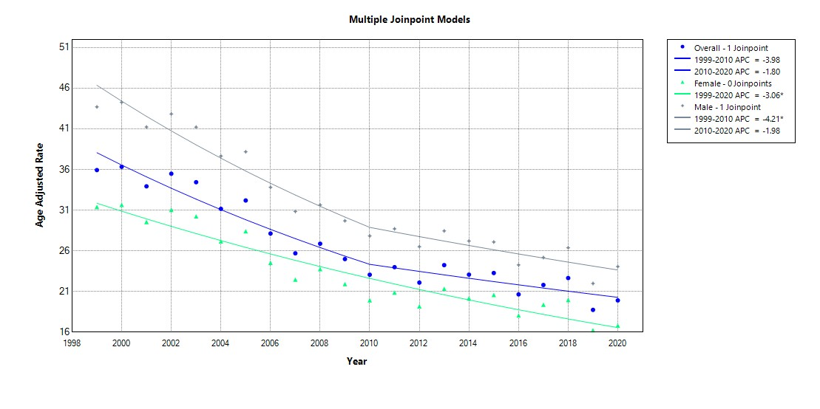

Supplemental Figure S11. Age adjusted mortality rates stratified by race/ethnicity in the United States, 1999 to 2020. *Indicates the APC is significantly different from 0.
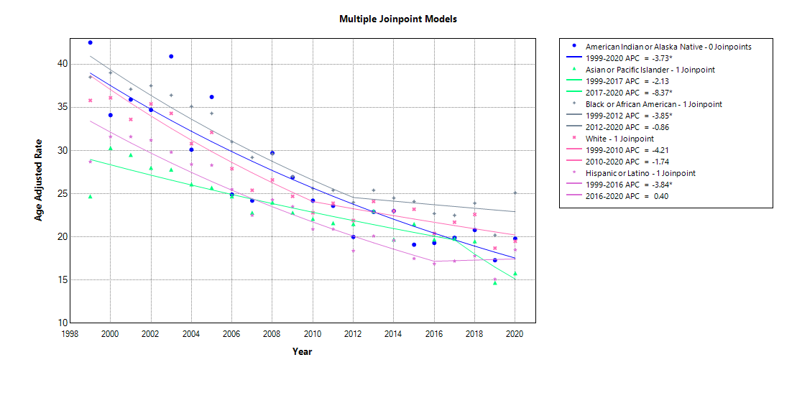

Supplemental Figure S12. Crude mortality rates per 100,000 people in the United States, 1999 to 2020.
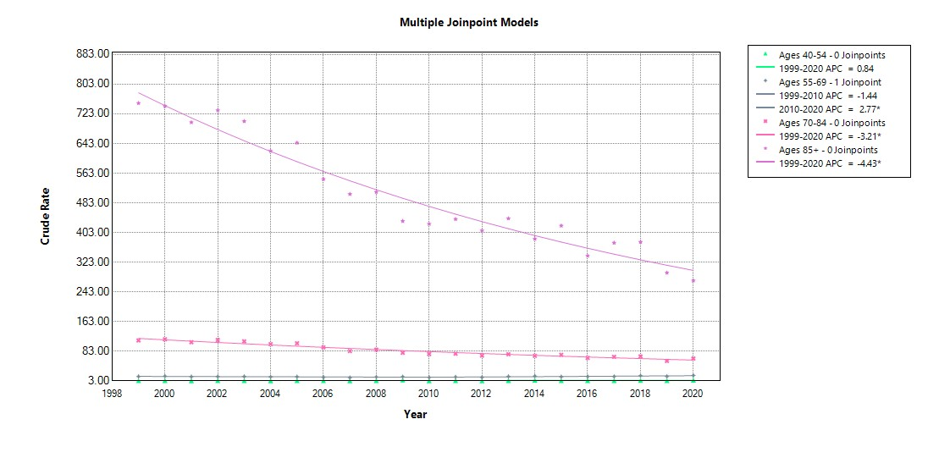

Supplemental Figure S13. Age-adjusted mortality rates were stratified by urban-rural classification in the United States from 1999 to 2020.
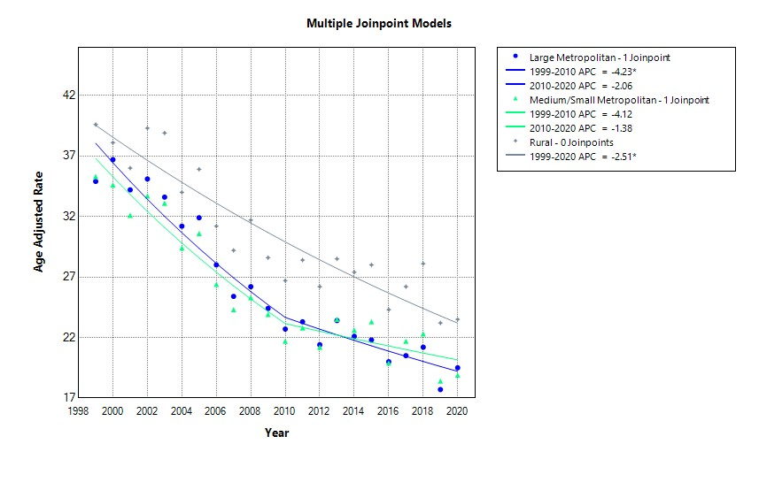

Supplemental Figure S14. Pneumonia Related Mortality Stratified by Region in the United States, 1999-2020.
