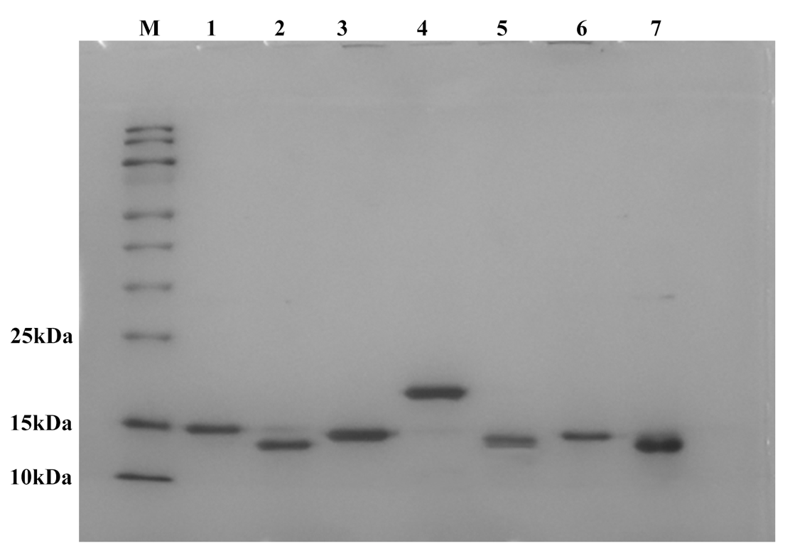
Figure S1. SDS-PAGE analysis of the purified Nbs. M: Marker, lanes 1–6: Nb M1–M6, and lane 7: Nb from another project, respectively.

