Online Resources

Original Article
Impact of Insulin-like Growth Factor System on the Progression and Survival of Gastric Adenocarcinoma
Short running head: IGF and gastric cancer prognosis
Kun-Feng Tsai^{1,2,3}*, Chia-Tung Shun^{4,5}*, Yu-Jen Fang⁶, Tzu-Chan Hong^{7,8}, Chieh-Chang Chen^{7,8}, Chih-Cheng Chen⁹, Yi-Ling Wu⁹, Jaw-Town Lin⁹, I-Rue Lai^{10,11}, Ming-Shiang Wu^{7,8※}, Jyh-Ming Liou^{7,8,12※}

¹Graduate Institute of Clinical Medicine, College of Medicine, National Taiwan University, Taipei, Taiwan
²Department of Internal Medicine, Gastroenterology and Hepatology Section, An Nan Hospital, China Medical University, Tainan, Taiwan
³Department of Medical Sciences Industry, Chang Jung Christian University, Tainan, Taiwan (ROC)
⁴Department of Pathology, National Taiwan University Hospital, National Taiwan University College of Medicine, Taipei, Taiwan
⁵Department of Pathology, Good Liver Clinic, Taipei, Taiwan
⁶Department of Internal Medicine, National Taiwan University Hospital, Yun-Lin Branch, National Taiwan University College of Medicine, Yun-Lin, Taiwan
⁷Department of Internal Medicine, National Taiwan University College of Medicine, Taipei, Taiwan
⁸Division of Gastroenterology and Hepatology, Department of Internal Medicine, National Taiwan University Hospital, Taipei, Taiwan
⁹Department of Internal Medicine, E-DA Hospital and I-Shou University, Kaohsiung City, Taiwan
¹⁰Department of Surgery, National Taiwan University College of Medicine, Taipei, Taiwan
¹¹Department of Surgery, National Taiwan University Hospital, Taipei, Taiwan
¹²Department of Medicine, National Taiwan University Cancer Center, Taipei, Taiwan

*KF Tsai and CT Shun contributed equally.
※MS Wu (https://orcid.org/0000-0002-1940-6428) and JM Liou (https://orcid.org/0000-0002-7945-5408) contributed equally as corresponding authors.

Correspondence and reprints requests to:
Jyh-Ming Liou, MD, PhD
Department of Internal Medicine, National Taiwan University Hospital, National Taiwan University, College of Medicine, Taipei, Taiwan
No. 7, Chung-Shan S. Road, Taipei, Taiwan
Tel.: 886-2-23123456 ext.63541
Fax: 886-2-23947899
E-mail: jyhmingliou@gmail.com or 010002@ntuh.gov.tw

Online Resource 1
Monoclonal antibody for each insulin-like growth factor (IGF) family protein
All the slides were incubated with IGF1R (mouse monoclonal antibody, Merck, clone 24-31), IGF2R (mouse monoclonal antibody, Merck, clone 2C2), IGF binding protein-1 (BP1)(mouse monoclonal antibody, Santa Cruz, sc-25257), IGFBP2 (1F6F6, mouse monoclonal antibody, Santa Cruz, sc-130070), IGFBP3(rabbit polyclonal antibody, Santa Cruz, sc-9028), IGF1(H-70, Rabbit polyclonal antibody, Santa Cruz, sc-9013), and IGF2 (N-20, goat polyclonal antibody, Santa Cruz, sc-1415). The antibodies were titrated at 1:100 for 32 min using an automated Ventana Benchmark XT (Ventana Medical Systems, Inc., Tucson, AZ, USA). Labeling was performed using the UltraView DAB Detection Kit (Ventana Medical Systems, Inc., Tucson, AZ, USA) according to the manufacturer’s protocol.

Online Resource 2
Protocol for measurement of plasma IGF1, IGF2, IFGBP1, IGFBP2, and IGFBP3 levels
Blood samples were centrifuged, divided, stored in tubes coated with lithium heparin, and frozen at -70 C for future use. Plasma levels of these proteins were measured by immunoradiometric assays or enzyme-linked immunosorbent assays (ELISA) using commercially available kits. IGF1 was measured using an Immunoradiometric Assay (IMMUNOTECH s.r.o., Prague, Czech Republic). IGF2 levels were measured using ELISA (BioVendor Laboratories Ltd., Reutlingen, Germany). IGFBP1 levels were measured using ELISA (IBL International GMBH, Hamburg, Germany). IGFBP2 levels were measured using ELISA (BioVendor Laboratories Ltd., Reutlingen, Germany). IGFBP3 levels were measured using an immunoradiometric Assay (IMMUNOTECH s.r.o., Prague, Czech Republic). All assays were performed in duplicates and measured by a laboratory technician who was blinded to the disease status and clinical outcomes.

Online Resource 3
Demographic characteristics according to target markers of the IGF family
Parameter | IGF1  (N=258) | IGF2  (N=397) | IGFBP1  (N=212) | IGFBP2  (N=142) | IGFBP3  (N=258)
Age (years)
> 60 | 468.8 ±46.6 | 912.7 ±40.1 | 3.47 ±0.6 | 504.9 ±40.0 | 3822.6 ±215.3
< 60 | 449.1 ±77.0 | 1049.8 ±58.8 | 3.20 ±1.0 | 416.9 ±45.5 | 4856.3 ±164.3
p-value | 0.81 | 0.05 | 0.82 | 0.17 | 0.0002
Sex
Male | 530.2 ±55.9 | 915.0 ±39.3 | 3.68 ±0.75 | 503.0 ±36.9 | 4127 ±235.2
Female | 330.1 ±53.7 | 1049.8 ±59.4 | 2.78 ±0.74 | 415.1 ±57.4 | 4278 ±162.2
p-value | 0.02 | 0.05 | 0.44 | 0.18 | 0.58
Diabetes mellitus
Yes | 487.1 ±113.5 | 990.5 ±83.2 | 2.43 ±0.9 | 459.5 ±38.7 | 4269.9 ±354.3
No | 453.7 ±47.2 | 995.1 ±42,7 | 2.78 ±0.5 | 495.1 ±65.5 | 4277.1 ±163.8
p-value | 0.77 | 0.96 | 0.76 | 0.67 | 0.98
Helicobacter pylori infection
Yes | 475.3 ±45.0 | 986.6 ±39.8 | 3.30 ±0.6 | 480.5 ±33.4 | 4276.7 ±153.6
No | 403.1 ±107.9 | 862.4 ±89.6 | 2.57 ±1.1 | 380.5 ±83.5 | 4093.2 ±329.1
p-value | 0.55 | 0.22 | 0.65 | 0.37 | 0.61
Smoking status
Yes | 517.2 ±92.8 | 962.4 ±71.6 | 2.57 ±0.8 | 422.8 ±53.9 | 4694.9 ±286.9
No | 445.3 ±47.9 | 1005.4 ±44.8 | 2.78 ±0.5 | 486.7 ±42.2 | 4151.7 ±170.3
p-value | 0.46 | 0.61 | 0.83 | 0.37 | 0.10
Alcohol
Yes | 483.4 ±41.8 | 1081.9 ±84.9 | 5.40 ±1.2 | 510.1 ±86.5 | 4434.2 ±294.1
No | 435.3 ±50.4 | 966.2 ±42.9 | 1.79 ±0.4 | 455.1 ±36.3 | 4223.2 ±169.3
p-value | 0.61 | 0.20 | 0.0003 | 0.50 | 0.53
Lauren classification
Diffuse | 422.6 ±50.7 | 973.9 ±51.3 | 1.8 ±0.4 | 412.9 ±47.9 | 4192.9 ±206.8
Intestinal/ mixed | 480.9 ±60.1 | 963.3 ±43.9 | 4.44 ±1.1 | 449.7 ±36.3 | 4176.2 ±176.5
p-value | 0.48 | 0.87 | 0.02 | 0.42 | 0.95
Tumor location
Proximal | 616.5 ±168.4 | 989.7 ±91.6 | 4.01 ±2.1 | 588.8 ±135.9 | 4609.6 ±433.5
Distal | 435 ±40.6 | 963.8 ±36.0 | 3.28 ±0.5 | 453.7 ±33.8 | 4127.1 ±140.5
p-value | 0.15 | 0.79 | 0.65 | 0.22 | 0.25
Tumor stage
I | 445.7 ±89.3 | 1071.2 ±83.8 | 3.10 ±1.1 | 365.3 ±58.6 | 4370.9 ±322.4
II | 569.3 ±141.3 | 816.2 ±76.2 | 1.23 ±0.7 | 429.1 ±61.9 | 4568.8 ±412.1
III | 470.2 ±75.1 | 1000.9 ±65.3 | 2.63 ±0.6 | 475.4 ±40.2 | 4080.6 ±258.7
IV | 465.4 ±83.8 | 924.6 ±68.1 | 4.75 ±1.2 | 612.6 ±97.8 | 4170.9 ±260.8
p-value | 0.17 | 0.12 | 0.0001 | 0.002 | 0.52
IGF, insulin-like growth factor; IGFBP, insulin-like growth factor binding protein.

Online Resource 4
Demographic features of the patients with GC and healthy individuals
Variable | GC (N=142) | Healthy (N=115) | p-value
Age (years) | 62.1 (60.1-63.9) | 63.1 (61.3-65.1) | 0.24
Sex  Male  Female | 92  50 | 63  52 | 0.06
Diabetes mellitus  Yes  No | 21  121 | 6  109 | 0.12
Helicobacter pylori infection  Yes  No | 130  12 | 74  38 | 0.44
Smoking status  Yes  No | 49  93 | 16  99 | 0.09
Alcohol  Yes  No | 82  60 | 64  51 | 0.89
Blood type |  |  | 0.002
A | 53 | 26
B | 28 | 38
AB | 9 | 6
O | 52 | 45
IGFBP2 | 478.2 ±31.4 | 350.8 ±30.8 | 0.002
Tumour Stage |  |  | 0.002
I N=31 | 365.3 ±58.6
II N=27 | 429.1 ±69.1
III N=53 | 475.4 ±40.2
IV N=31 | 612.6 ±97.8
GC, gastric cancer; IGFBP, insulin-like growth factor binding protein.

Online Resource 5
Clinicopathological features in patients with gastric cancer of sera IGFBP2
Variable | Training cohort IGFBP2 (N=142) | p-value | Validation cohort IGFBP2 (N=255) | p-value
Age (years) |  | P=0.17 |  | P=0.05
> 60 | 504.9 ±40.0 (N=89) |  | 728.9 ±41.8 (N=162)
< 60 | 416.9 ±45.5 (N=53) |  | 598.1 ±53.7 (N=93)
Sex |  | P=0.18 |  | P=0.59
Male | 503.0 ±36.9 (N=92) |  | 698.9 ±42.6 (N=148)
Female | 415.1 ±57.4 (N=50) |  | 663.5 ±52.3 (N=107)
Lauren classification
Diffuse | 412.9 ±47.9 (N=53) |  | 741.1 ±66.7 (N=91)
Intestinal | 485.8 ±53.1 (N=49) | P=0.31 (I vs. D) | 623.5 ±47.1 (N=89) | P=0.15 (I vs. D)
Mixed | 416.1 ±42.8 (N=40) | P=0.65 (M vs. D) | 692.5 ±55.2 (N=75) | P=0.58 (M vs. D)
Tumor location |  | P=0.21 |  | P=0.95
Proximal | 588.8 ±135.9 (N=14) |  | 689.1 ±59.8 (N=33)
Distal | 453.7 ±33.8 (N=128) |  | 683.6 ±40.4 (N=222)
Tumor stage
I | 365.3 ±58.6 (N=31) |  | 379.4 ±21.7 (N=67)
II | 429.1 ±69.1 (N=27) | P=0.44 | 514.1 ±59.9 (N=33) | P=0.0003
III | 475.4 ±40.2 (N=53) | P=0.10 | 745.4 ±69.7 (N=71) | P<0.0001
IV | 612.6 ±97.8 (N=31) | P=0.03 | 927.6 ±68.2 (N=84) | P<0.0001
Distal metastasis |  | P=0.004 |  | P<0.0001
Yes | 683.5 ±122.6 (N=21) |  | 909.6 ±73.6 (N=70)
No | 435.3 ±29.1 (N=121) |  | 598.7 ±34.1 (N=185)
Venous invasion |  | P=0.53 |  | P=0.06
Yes | 479.7 ±40.1 (N=86) |  | 712.1 ±43.9 (N=150)
No | 439.4 ±48.8 (N=51) |  | 582.5 ±53.5 (N=85)
Lymphatic invasion |  | P=0.54 |  | P=0.07
Yes | 479.3 ±47.5 (N=85) |  | 710.5 ±43.7 (N=151)
No | 440.8 ±47.8 (N=52) |  | 583.7 ±54.1 (N=84)
Perineural invasion |  | P=0.55 |  | P=0.04
Yes | 478.8 ±40.2 (N=86) |  | 718.7 ±44.3 (N=149)
No | 440.9 ±48.6 (N=51) |  | 572.6 ±52.4 (N=86)
HP status |  | P=0.37 |  | P=0.06
Negative | 380.5 ±83.5 (N=12) |  | 530.1 ±52.2 (N=41)
Positive | 480.5 ±33.4 (N=130) |  | 700.3 ±37.5 (N= 214)
Serologic atrophic gastritis |  | P=0.88 |  | P=0.16
Yes | 467.6 ±44.6 (N=70) |  | 759.8 ±69.9 (N=103)
No | 477.4 ±48.7 (N=72) |  | 648.7 ±45.4 (N=152)
HP, Helicobacter pylori; IGFBP, insulin-like growth factor binding protein.

Online Resource 6
Univariate analysis for the clinicopathologic predictors of mortality in the gastric cancer cohort
 | IGFBP2 level in training cohort (N=142) |  |  |  |  | IGFBP2 in validation cohort (N=255)
Univariate analysis | Low IGFBP2 level | High IGFBP2 level | HR | 95% CI | P value | Low IGFBP2 level | High IGFBP2 level | HR | 95% CI | p-value
Age (years)
> 60 | 23 | 66 | 1.73 | 1.19-2.81 | 0.006 | 44 | 117 | 1.28 | 0.92-1.79 | 0.12
< 60 | 26 | 27 | 1 |  |  | 44 | 50 | 1
Sex
Male | 28 | 67 | 1.21 | 0.85-2.04 | 0.2 | 49 | 99 | 1.01 | 0.73-1.38 | 0.95
Female | 20 | 27 | 1 |  |  | 39 | 68 | 1
Helicobacter pylori infection
Positive | 44 | 86 | 1.29 | 0.66-2.66 | 0.48 | 72 | 143 | 0.92 | 0.62-1.37 | 0.62
Negative | 5 | 7 |  |  |  | 16 | 24 | 1
Lauren classification
Diffuse | 24 | 39 | 1.32 | 0.93-1.62 | 0.13 | 31 | 60 | 1.27 | 1.00-1.62 | 0.04
Intestinal / Mixed | 25 | 54 | 1 |  |  | 56 | 108 | 1
Tumour location
Proximal | 5 | 10 | 2.62 | 1.45-4.74 | 0.001 | 8 | 29 | 1.84 | 1.21-2.86 | 0.004
Distal | 43 | 84 | 1 |  |  | 80 | 138 | 1
Distal metastasis
Yes | 5 | 17 | 4.33 | 2.58-7.26 | 0.0001 | 9 | 61 | 6.57 | 4.60-9.38 | 0.0001
No | 44 | 76 | 1 |  |  | 79 | 106 | 1
Invasive depth
T3/4 | 36 | 76 | 5.24 | 2.94-9.34 | 0.0001 | 53 | 140 | 12.4 | 5.79-26.5 | 0.0001
T1/2 | 12 | 18 | 1 |  |  | 35 | 27 | 1
Nodal metastasis
N1/2/3 | 30 | 68 | 2.79 | 1.66-4.69 | 0.0001 | 44 | 132 | 5.81 | 3.71-9.10 | 0.0001
N0 | 18 | 26 | 1 |  |  | 44 | 35 | 1
IGFBP, insulin-like growth factor binding protein; HR, hazard ratio; CI, confidence interval.

Online Resource 7
Multivariate analysis for the clinicopathologic predictors of mortality in the gastric cancer cohort
 | Training cohort (N=142) |  |  | Validation cohort (N=255)
Multivariate analysis | HR | CI | p-value | HR | CI | p-value
High IGFBP2 level | 1.77 | 1.09-2.87 | 0.02 | 1.62 | 1.11-2.39 | 0.01
Age > 60 years | 1.96 | 1.25-3.10 | 0.004 | 1.40 | 1.01-1.96 | 0.04
Invasive depth  (T3/4 vs. T1/2) | 3.66 | 1.74-7.69 | 0.001 | 5.63 | 1.57-20.1 | 0.008
Nodal metastasis  (N1/2/3 vs. N0) | 1.81 | 1.09-3.01 | 0.02 | 6.48 | 2.76-15.2 | 0.0001
Diffuse histologic type | 1.37 | 0.89-2.09 | 0.14 | 1.52 | 1.08-2.15 | 0.01
Proximal tumour location | 2.01 | 1.06-3.80 | 0.03 | 1.28 | 0.88-1.87 | 0.19
Distal metastasis | 2.16 | 1.42-3.30 | 0.0001 | 2.77 | 1.90-4.05 | 0.0001
IGFBP, insulin-like growth binding protein; HR, hazard ratio; CI, confidence interval.

Online Resource 8 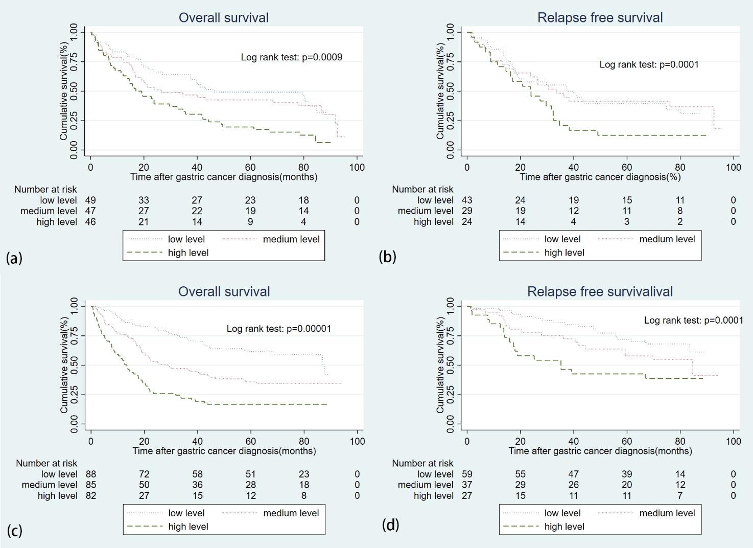
GC Survival analysis according to serum levels of IGFBP2 in the training and validation cohorts—Kaplan–Meier curve
(a) OS in training cohort, (b) RFS in training cohort, (c) OS in validation cohort, and (d) RFS in validation cohort.
GC, gastric cancer; IGFBP, insulin-like growth binding protein; OS, overall survival; RFS, recurrence-free survival.

Online Resource 9
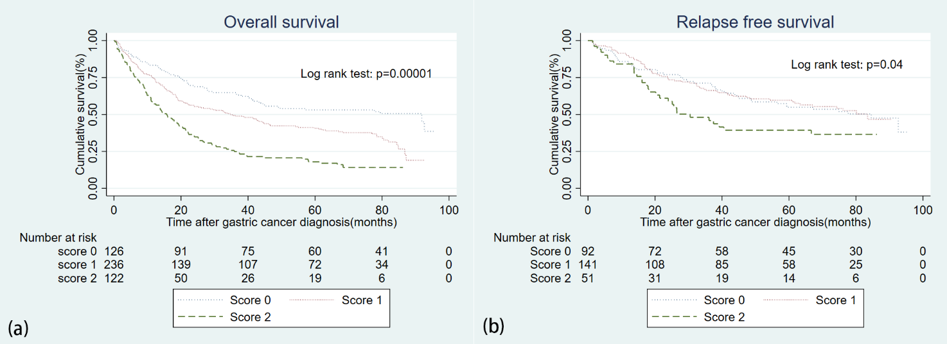
Influence of IGFBP2 expression on survival
(a) OS based on IGFBP2 IHC expression (b) RFS based on IGFBP2 IHC expression
IHC, immunohistochemistry; IGFBP, insulin-like growth binding protein; OS, overall survival; RFS, recurrence-free survival.

Online Resource 10
Multivariate analysis of gastric cancer with distinct IGFBP2 expression levels (N=484)
Variable | HR | CI | p-value
Age > 60 years | 1.37 | 1.11-1.77 | 0.004
Diffuse histologic type | 1.16 | 1.01-1.35 | 0.04
Tumour stage
I | 1
II | 3.04 | 1.73-5.36 | 0.0001
III | 6.82 | 4.27-10.89 | 0.0001
IV | 19.4 | 11.05-32.43 | 0.0001
IGFBP2
Score 0 | 1
Score 1 | 1.39 | 1.02-1.89 | 0.03
Score 2 | 1.53 | 1.10-2.14 | 0.01
Non-curative resection | 1.38 | 1.01-1.92 | 0.04
Location | 1.22 | 0.91-1.67 | 0.19
IGFBP, insulin-like growth factor binding protein; HR, hazard ratio; CI, confidence interval

